Northern Territory of Australia

Government Gazette
ISSN-0157-8324
No. G43 24 October 2018

General information
The Gazette is published by the Office of the Parliamentary Counsel.
The Gazette will be published every Wednesday, with the closing date for notices being the previous Friday at 4.00 pm.
Notices not received by the closing time will be held over until the next issue.
Notices will not be published unless a Gazette notice request form together with a copy of the signed notice and a clean copy of the notice in Word or PDF is emailed to gazettes@nt.gov.au
Notices will be published in the next issue, unless urgent publication is requested.

Availability
The Gazette will be available online at 12 Noon on the day of publication at https://nt.gov.au/about-government/gazettes
Unauthorised versions of Northern Territory Acts and Subordinate legislation are available online at https://legislation.nt.gov.au/

Northern Territory of Australia

Education Act
Establishment of School Management Councils
I, Selena Jane Malijarri Uibo, Minister for Education:
(a) under section 118(1)(a) of the Education Act, establish a school management council for each Government school specified in the Schedule; and
(b) under section 118(4) and with reference to section 118(5) of the Act, appoint the principal of each Government school specified in the Schedule to comprise the school management council established for the school.
Dated 9 October 2018
S. J. M. Uibo
Minister for Education
Schedule
Alekarenge School
Alpurrurulam School
Ampilatwatja School
Canteen Creek School
Elliott School
Epenarra School
Mulga Bore School
Murray Downs School
Neutral Junction School
Newcastle Waters School
Rockhampton Downs School
Stirling School
Ti Tree School
Willowra School
Northern Territory of Australia

Medicines, Poisons and Therapeutic Goods Act
Revocation, Declarations and Approval
I, Hugh Crosbie Heggie, Chief Health Officer:
(a) under sections 250, 252 and 254(1) of the Medicines, Poisons and Therapeutic Goods Act and with reference to section 43 of the Interpretation Act, revoke the declarations and approvals made by:
(i) the instrument entitled "Northern Territory School Health Services" dated 26 February 2015 and published in Gazette No. S18 of 2 March 2015; and
(ii) the instrument entitled "Northern Territory School Health Services" dated 28 April 2014 and published in Gazette No. S22 of 30 April 2014; and
(b) under section 252 of the Medicines, Poisons and Therapeutic Goods Act, declare each health centre or clinic specified in the Schedule, Part A, to be a place to which Part 2.6 of the Act applies; and
(c) under section 254(1) of the Act, approve each Scheduled substance treatment protocol specified in the Schedule, Part B, for each health centre or clinic specified in the Schedule, Part A; and
(d) under section 250(1)(a) of the Act, declare each nurse or midwife practising at a health centre or clinic specified in the Schedule, Part A, to be an approved nurse or approved midwife (as appropriate) to supply, administer to another person and possess the Schedule 4 substances specified in the Schedule, Part C, in accordance with each Scheduled substance treatment protocol specified in the Schedule, Part B; and
(e) under section 250(1)(b) of the Act, declare each Aboriginal and Torres Strait Islander health practitioner practising at a health centre specified in the Schedule, Part A, to be an approved ATSI health practitioner to supply, administer to another person and possess the Schedule 4 substances specified in the Schedule, Part C, in accordance with each Scheduled substance treatment protocol specified in the Schedule, Part B.
Dated 18 October 2018
H. C. Heggie
Chief Health Officer
Schedule
Part A
Acacia Hill School  80 Spearwood Road  Alice Springs NT 0870 | Haileybury Rendall School  Lot 6057 Berrimah Road  Berrimah NT 0828
Araluen Christian College  10 Blain Street  Alice Springs NT 0870 | Henbury School  11 Henbury Ave,  Tiwi NT 0810
Casuarina Senior College  61 Parer Drive  Casuarina NT 0811 | Katherine High School  Grevillea Road  Katherine East NT 0850
Centralian Middle School  56 Milner Road  Gillen NT 0870 | MacKillop Catholic College  285 Farrar Boulevard  Johnston NT 0832
Centralian Senior College  10 Grevillea Drive  Alice Springs NT 0870 | Marrara Christian College  110 Amy Johnson Avenue  Marrara NT 0812
Darwin High School  10 Atkins Drive  The Gardens NT 0820 | Nemarluk School  30 Styles St  Alawa NT 0810
Darwin Middle School  10 Atkins Drive  The Gardens NT 0820 | Nhulunbuy Christian College  Eugenia Avenue  Nhulunbuy NT 0881
Dripstone Middle School  10 Delamere Street  Tiwi NT 0810 | Nhulunbuy High School  51 Matthew Flinders Way  Nhulunbuy NT 0880
Essington School  22 Chapman Road  Nightcliff NT 0811 | Nightcliff Middle School  90 Nightcliff Road  Rapid Creek NT 0810
Essington School International Campus (CDU Campus)  Orange Building, Ellengowan Drive  Casuarina NT 0810 | O'Loughlin Catholic College  70 Mueller Road  Karama NT 0812
Forrest Parade School  120 Forrest Parade  Bellamack NT 0832 | Our Lady of the Sacred Heart Catholic College (Sadadeen)  95 Sadadeen Road  Alice Springs NT 0871
Good Shepherd Lutheran College  Cnr Whitewood Rd and Kundook Place  Howard Springs NT 0835 | Our Lady of the Sacred Heart Catholic College (Traeger)  8 Traeger Avenue  Alice Springs NT 0871
Palmerston Christian School  50 Waler Road  Marlow Lagoon NT 0830 | St Joseph’s Catholic College  Cnr Maluka Road and Chambers Drive  Katherine NT 0850
Palmerston College 7-9 Campus  185 Forrest Parade  Roseberry NT 0832 | St Philip's College  2 Ulpaya Rd  Alice Springs NT 0870
Palmerston College 10-12 Campus  10 Tilston Avenue  Driver NT 0830 | Taminmin College  70 Challoner Circuit  Humpty Doo NT 0836
Sanderson Middle School  60 Matthews Road  Malak NT 0812 | Tennant Creek High School  38 Stuart Street  Tennant Creek NT 0860
Sattler Christian College  15 Sattler Crescent  Freds Pass NT 0822 | Yipirinya School  Lot 7399 Lovegrove Drive  Alice Springs NT 0871
St John's Catholic College  54 Salonika Street  The Gardens NT 0820 | Yirrara College  470 Stuart Highway  Alice Springs NT 0871
Part B
Title | Publication Date | Author
The Australian Immunisation Handbook, 10th Edition | 2018 | Australian Technical Advisory Group on Immunisation (Australian Government Department of Health)
Adult and Special Groups Vaccination Schedule | April 2018 | Centre for Disease Control (Northern Territory Government Department of Health)
Childhood Vaccination Schedule | April 2018 | Centre for Disease Control (Northern Territory Government Department of Health)
NT Pneumococcal Vaccination and Revaccination Guideline | April 2018 | Centre for Disease Control (Northern Territory Government Department of Health)
Guidelines for the Control of Tuberculosis in the Northern Territory | May 2016 | Centre for Disease Control (Northern Territory Government Department of Health)
Management for Anaphylaxis | December 2013 | Centre for Disease Control (Northern Territory Government Department of Health)
Prevaccination Checklist | July 2013 | Centre for Disease Control (Northern Territory Government Department of Health)
School Based Immunisation Program NT Scheduled Medicines SSTP | 2018 | Top End Health Services  Primary Health Care Urban
Part C
Adrenaline | Pneumococcal vaccine
Diphtheria toxoid | Meningococcal vaccine
Human papillomavirus vaccine | Tetanus toxoid
Influenza vaccine | Tuberculin
Pertussis antigen
Police Administration Act
Sale of Goods
Notice is hereby given that pursuant to Section 166 of the Police Administration Act, the following property as shown on the attached schedule has been in the possession of the Officer in Charge, Water Police Section, for a period in excess of three (3) months and this property will be sold or otherwise disposed of in a manner as determined by the Commissioner of Police, if after twenty-eight (28) days from the publication of this notice the property remains unclaimed.
Stefan Herold
Acting /Superintendent
Territory Specialist Services Division
15 October 2018
Item No. | Details
511411 / 001 | 1 x Brooker 10ft dinghy
Northern Territory of Australia

Local Government Act
Vesting of Crown Land in City of Darwin
I, Gerald Francis McCarthy, Minister for Housing and Community Development, under section 185(2) of the Local Government Act, vest in the City of Darwin as a road the part of section 4262, Hundred of Bagot, as shown on Survey Plan S2017/119 in the Schedule.
Dated 17 October 2018
G. F. McCarthy
Minister for Housing and Community Development
Schedule
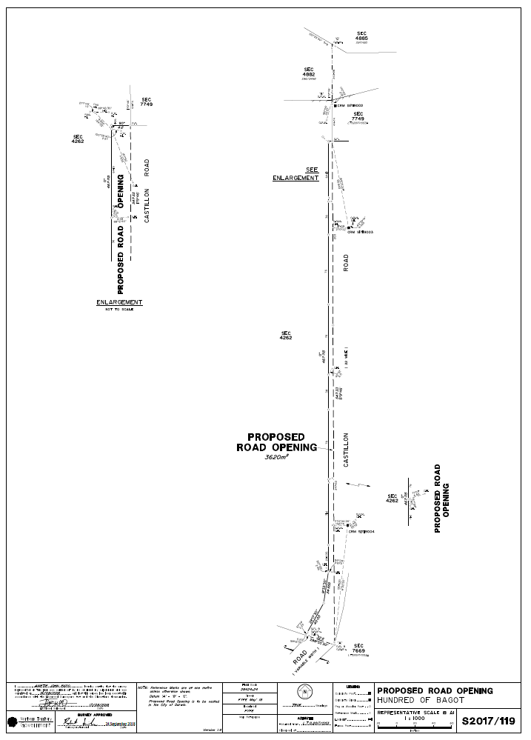
Northern Territory of Australia

Education Act
Establishment of School Representative Body
Robinson River School
I, Selena Jane Malijarri Uibo, Minister for Education, under section 103(2) of the Education Act, establish a school representative body for Robinson River School.
Dated 12 October 2018
S. J. M. Uibo
Minister for Education

