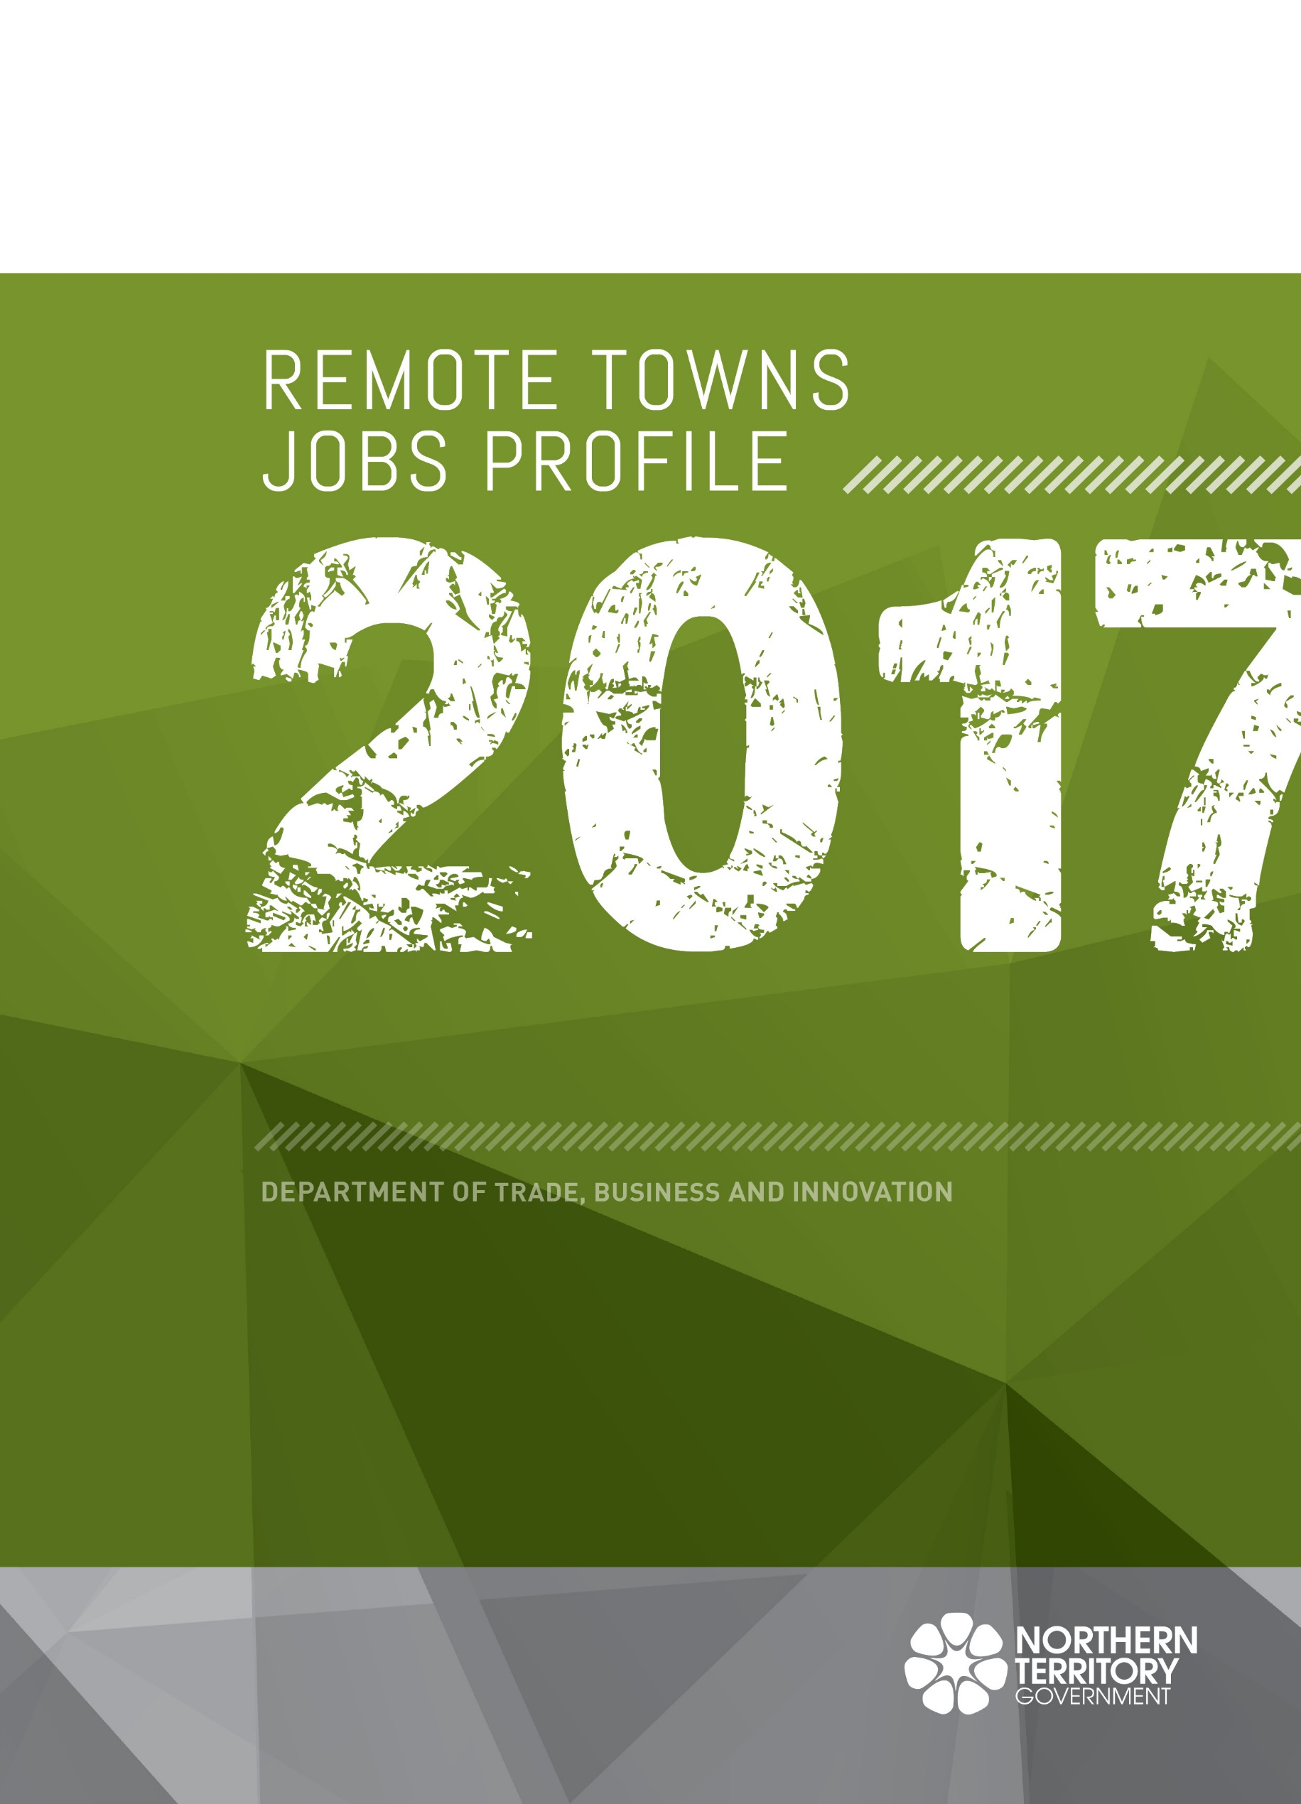
Remote Towns Jobs profile 2017

alyangula (excluding GEMCO)

© Northern Territory of Australia 201
Preferred Reference: Department of Trade, Business and Innovation, 2017 Remote Towns Jobs Profiles, Northern Territory Government, June 2018, Darwin.
Disclaimer
The data in this publication were predominantly collected by conducting a face-to-face survey of businesses within town boundaries during mid-2017. The collection methodology was created in accordance with Australian Bureau of Statistics data quality framework principles. Data in this publication are only reflective of those businesses reported on as operating in the town at the time of data collection (see table at the end of publication for list of businesses reported on).
To comply with privacy legislation or where appropriate, some data in this publication may have been adjusted and will not reflect the actual data reported by businesses. As a result of this, combined with certain data not being reported by some businesses, some components may not add to totals. Changes over time may also reflect business' change in propensity to report on certain data items rather than actual changes over time. Total figures have generally not been adjusted.
Notes for each table and chart are alphabetically ordered and listed at the end of the publication.
Any use of this report for commercial purposes is not endorsed by the Department of Trade, Business and Innovation.
Contents

Alyangula 4
Introduction 5
Summary 6
Jobs Overview 7
Jobs by Aboriginal Status 8
Jobs by Sector: Private and Public 10
Job Status: Permanent and Temporary 13
Job Vacancies 15
Jobs by Industry 17
Jobs by Occupation 20
Jobs by Industry by Occupation 22
Jobs by Gender 23
Jobs by Age 25
Vocational Education and Training 28
Population 31
Community Development Programme 33
Businesses 34
Notes 35
Abbreviations and Acronyms 36

Alyangula
Alyangula is located on Groot Eylandt which is approximately 50 kilometres from the Northern Territory mainland in the Gulf of Carpentaria, with a population of 989 residents.
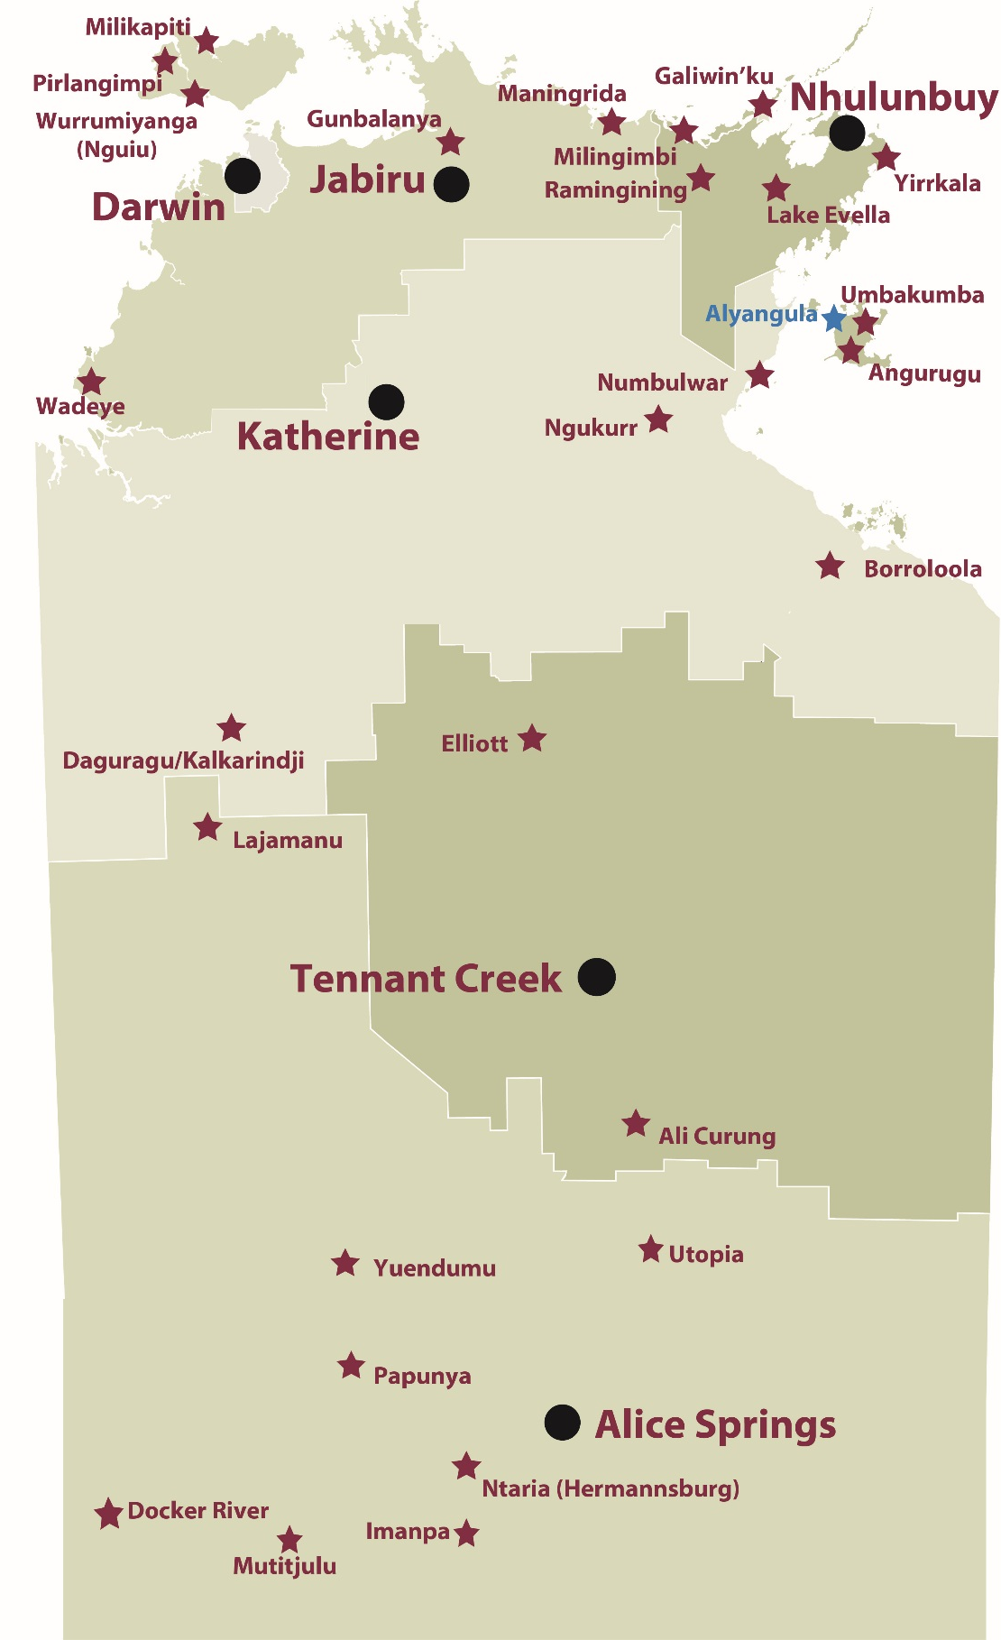

Source: Department of Trade, Business and Innovation

Introduction
This jobs profile provides a snapshot of jobs and the characteristics of job holders in Alyangula as at July 2017.
This job profile is one of 28 profiles developed for remote towns in the Northern Territory. It is anticipated these and subsequent profiles will contribute to a robust evidence base to inform decision making in and relating to these remote Territory towns.
This profile contains information collected by the Northern Territory Department of Trade, Business and Innovation from businesses operating within the town and is supplemented by other administrative data sets and information.
Each profile provides up-to-date information that is intended to inform the planning and design of current and future government programs and as an evidence base to inform decision making relating to workforce development and enterprise and job opportunities.
The data collection methodology and corresponding questionnaire were created in partnership with the Australian Bureau of Statistics (ABS) and in accordance with ABS data quality framework and survey principles.
The surveys were predominantly conducted by the Department’s Small Business Champions and Workforce Training Coordinators, on a face-to-face basis with business representatives.
The information collected and reported on represents a significant goodwill investment by those businesses and organisations that participated. Each business is listed at the end of this publication.

Summary
This is the first survey competed for Alyangula whereas Angurugu and Umbakumba participated in the 2011 and 2014 jobs profile surveys on Groote Eylandt.
This 2017 jobs profile was developed based on responses from 26 businesses operating within the Alyangula town boundary not incorporating the key employer South 32, Groote Eylandt Mining Company (GEMCO) with 874 filled jobs.
- 21 businesses from the private sector, accounting for 140 filled jobs or 72% of total filled jobs
- 5 businesses from the public sector, accounting for 54 filled jobs or 28% of total filled jobs.
A total of 213 filled and vacant jobs in Alyangula were reported.
The 2017 profile highlights:
- there were 194 filled jobs of which:
- 39 jobs (20%) were filled by Aboriginal persons
- 155 jobs (80%) were filled by non-Aboriginal persons
- 72% of employed Aboriginal people are working in the private sector
- Aboriginal females made up 46% of total Aboriginal filled jobs
- there were 19 vacant jobs, of which:
- job vacancies as a percentage of jobs is 9%
- job vacancies equate to 1 in 11 jobs
- 7 of the vacancies were in Professional areas
- Public Administration and Safety was the largest industry employer in 2017
- Transport and Storage had the highest student numbers training activity in 2017.
The overall population in Alyangula decreased by 80 persons (7%) between 2006 and 2016 to 989 persons.
In comparison, the overall Northern Territory population increased by 16.5% between 2006 and 2016.
In 2016, the working age population (15 years and over) in Alyangula was an estimated 739 persons compared to 787 in 2006 a decrease of 6%.
There were 1.6 jobs in Alyangula per working age person compared to 0.4 jobs per working age person across the 28 remote towns in the Northern Territory (this is attributed to the large fly-in fly-out workforce associated with the South 32 - GEMCO resource operation).

Jobs Overview
Table 1: Count of filled jobs and vacancies, 2017 (a)(b)
 | 2017
Total All Jobs | 213
Vacancies | 19
Vacancies as % of Total All Jobs | 8.9%
Filled Jobs | 194
Full-time | 151
Part-time | 43
Source: Department of Trade, Business and Innovation
Chart 1: Count of vacant jobs and filled jobs by full-time/part-time status, 2017 (a)(b)
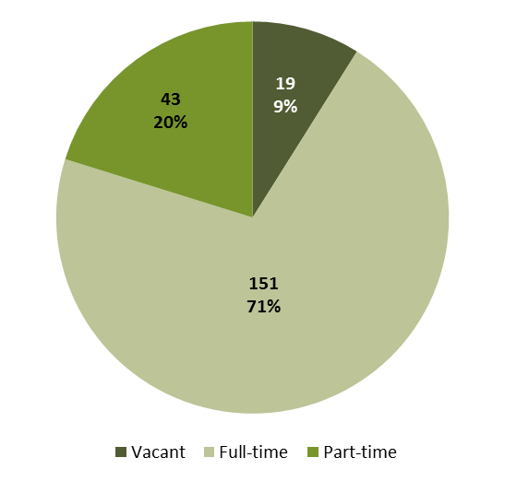
Source: Department of Trade, Business and Innovation
In 2017 in Alyangula, excluding GEMCO:
- there were a total of 194 filled jobs. Of these:
- 151 were full-time jobs
- 43 were part-time jobs
- there were 19 total job vacancies.

Jobs by Aboriginal Status
Chart 2: Count of filled jobs by Aboriginal status, 2017 (a)(c)
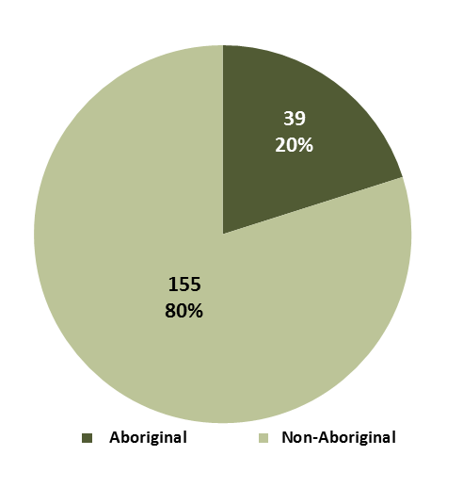
Source: Department of Trade, Business and Innovation
In 2017 in Alyangula, excluding GEMCO:
- of the 194 filled jobs:
- 39 jobs were filled by Aboriginal persons
- 155 jobs were filled by non-Aboriginal persons
- Aboriginal persons accounted for 20% of job holders.
Table 2: Count of filled jobs by full-time/part-time status and Aboriginal status of person in job, 2017 (a)(b)(c)
Indicator | 2017
 | Aboriginal | Non-Aboriginal | Total
Full-time | 29 | 122 | 151
Part-time | 10 | 33 | 43
Total | 39 | 155 | 194
Source: Department of Trade, Business and Innovation
Chart 3: Count of filled jobs by full-time/part-time status and Aboriginal status of person in job, 2017 (a)(b)(c)
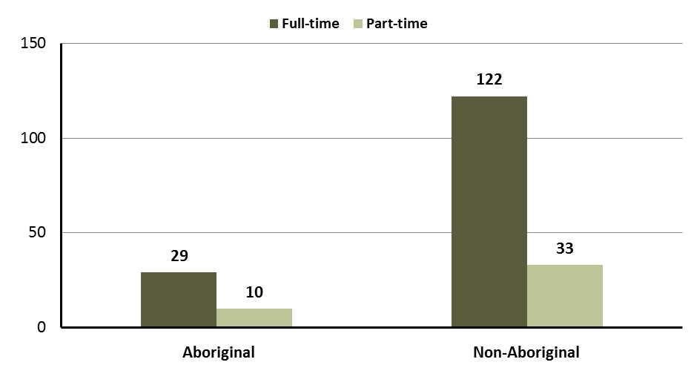
Source: Department of Trade, Business and Innovation
In 2017 in Alyangula, excluding GEMCO:
- of the 194 filled jobs:
- 29 were full-time jobs filled by Aboriginal persons
- 10 were part-time jobs filled by Aboriginal persons
- 122 were full-time jobs filled by non-Aboriginal persons
- 33 were part-time jobs filled by non-Aboriginal persons.

Jobs by Sector: Private and Public
Table 3: Count of filled jobs by sector and Aboriginal status of person in job, 2017 (a)(c)(d)
Indicator | 2017
 | Aboriginal | Non-Aboriginal | Total
Public Sector | 11 | 43 | 54
Australian Government | 1 | 1 | 2
Territory Government | 10 | 42 | 52
Local Government | 0 | 0 | 0
Private Sector | 28 | 112 | 140
Total | 39 | 155 | 194
Source: Department of Trade, Business and Innovation
Chart 4: Count of filled jobs by sector of business, 2017 (a)(d)
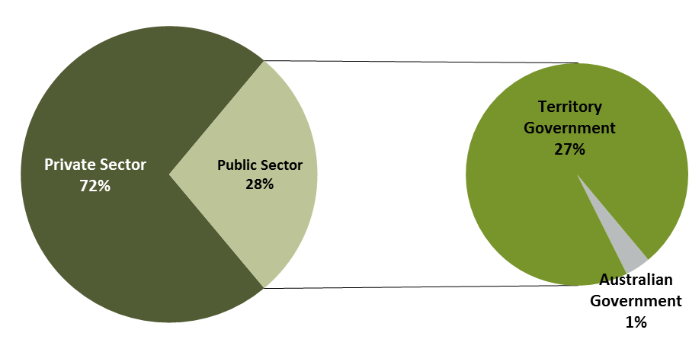
Source: Department of Trade, Business and Innovation
In 2017 in Alyangula, excluding GEMCO:
- of the 54 jobs in the public sector:
- 2 jobs were in the Commonwealth Government
- 52 jobs were in the Territory Government
- none were in the Local Government
- there were 140 jobs in the private sector.
Chart 5: Count of filled jobs by sector and Aboriginal status of person in job, 2017 (a)(c)(d)
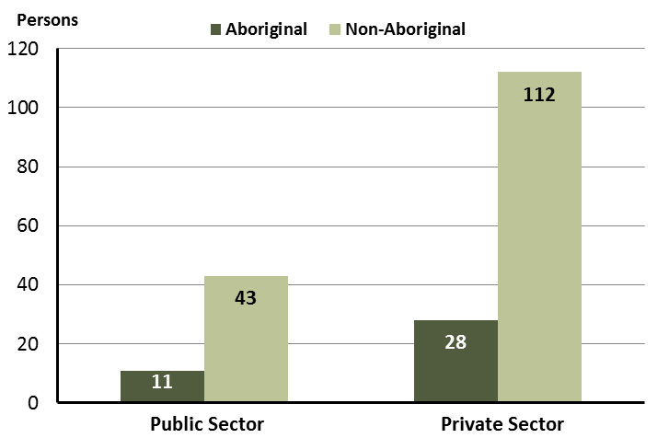
Source: Department of Trade, Business and Innovation
In 2017 in Alyangula, excluding GEMCO:
- of the 54 jobs in the public sector:
- 11 jobs were filled by Aboriginal persons
- 43 jobs were filled by non-Aboriginal persons
- of the 140 jobs in the private sector:
- 28 jobs were filled by Aboriginal persons
- 112 jobs were filled by non-Aboriginal persons.
Chart 6: Count of filled jobs by sector and full-time/part-time status of person in job, 2017 (a)(b)(d)
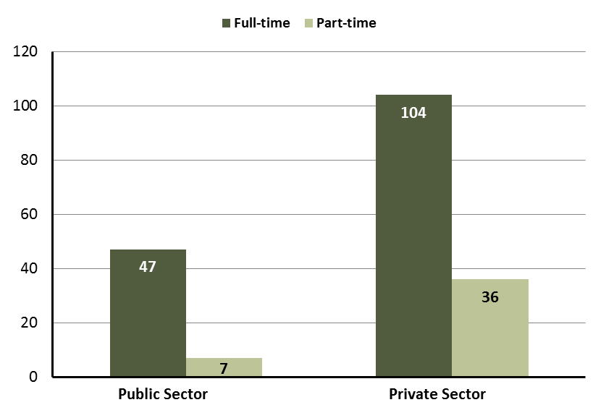
Source: Department of Trade, Business and Innovation

In 2017 in Alyangula, excluding GEMCO:
- of the 54 jobs in the public sector:
- 47 were full-time jobs
- 7 were part-time jobs
- of the 140 jobs in the private sector:
- 104 were full-time jobs
- 36 were part-time jobs.
Table 4: Count of filled jobs by full-time/part-time status and Aboriginal status of person in job by sector, 2017 (a)(b)(c)(d)
Indicator | 2017
 | Aboriginal |  |  | Non-Aboriginal |  |  | Total
 | Full-time | Part-time | Total | Full-time | Part-time | Total | Full-time | Part-time | Total
Public Sector | 9 | 2 | 11 | 38 | 5 | 43 | 47 | 7 | 54
Private Sector | 20 | 8 | 28 | 84 | 28 | 112 | 104 | 36 | 140
Total | 29 | 10 | 39 | 122 | 33 | 155 | 151 | 43 | 194
Source: Department of Trade, Business and Innovation
In 2017 in Alyangula, excluding GEMCO:
- of the 11 jobs in the public sector filled by Aboriginal persons:
- 9 were full-time jobs
- 2 were part-time jobs
- of the 28 jobs in the private sector filled by Aboriginal persons:
- 20 were full-time jobs
- 8 were part-time jobs
- of the 43 jobs in the public sector filled by non-Aboriginal persons:
- 38 were full-time jobs
- 5 were part-time jobs
- of the 112 jobs in the private sector filled by non-Aboriginal persons:
- 84 were full-time jobs
- 28 were part-time jobs.

Job Status: Permanent and Temporary
Table 5: Count of filled jobs by employment status and Aboriginal status of person in job, 2017 (a)(c)(e)
Indicator | 2017
 | Aboriginal | Non-Aboriginal | Total
Permanent | 29 | 107 | 136
Temporary | 10 | 48 | 58
Total | 39 | 155 | 194
Source: Department of Trade, Business and Innovation
Chart 7: Count of filled jobs by employment status and Aboriginal status of person in job, 2017 (a)(c)(e)
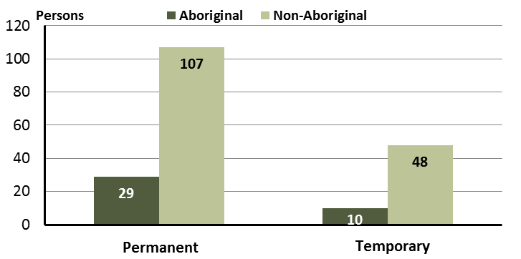
Source: Department of Trade, Business and Innovation
In 2017 in Alyangula, excluding GEMCO:
- there were 136 permanent jobs, of which:
- 29 jobs were filled by Aboriginal persons
- 107 jobs were filled by non-Aboriginal persons
- there were 58 temporary jobs, of which:
- 10 jobs were filled by Aboriginal persons
- 48 jobs were filled by non-Aboriginal persons.
Table 6: Count of filled jobs by sector, Aboriginal status and employment status of person in job, 2017 (a)(c)(d)(e)
Indicator | 2017
 | Aboriginal |  |  | Non-Aboriginal |  |  | Total
 | Perm | Temp | Total | Perm | Temp | Total | Perm | Temp | Total
Public Sector | 8 | 3 | 11 | 25 | 18 | 43 | 33 | 21 | 54
Private Sector | 21 | 7 | 28 | 82 | 30 | 112 | 103 | 37 | 140
Total | 29 | 10 | 39 | 107 | 48 | 155 | 136 | 58 | 194
Source: Department of Trade, Business and Innovation
In 2017 in Alyangula, excluding GEMCO:
- of the 54 jobs in the public sector:
- 33 jobs were permanent, of which:
- 8 jobs were filled by Aboriginal persons
- 25 jobs were filled by non-Aboriginal persons
- 21 jobs were temporary, of which:
- 3 jobs were filled by Aboriginal persons
- 18 jobs were filled by non-Aboriginal persons
- of the 140 jobs in the private sector:
- 103 jobs were permanent, of which:
- 21 jobs were filled by Aboriginal persons
- 82 jobs were filled by non-Aboriginal persons
- 37 jobs were temporary, of which:
- 7 jobs were filled by Aboriginal persons
- 30 jobs were filled by non-Aboriginal persons.

Job Vacancies
Table 7: Job vacancies, 2017
Indicator | 2017
Job vacancies | 19
Source: Department of Trade, Business and Innovation
Table 8: Job vacancies by occupation, 2017 (f)(g)
Occupation (ANZSCO major group) | 2017
Professionals | 7
Clerical and Administrative Workers | 5
Community and Personal Service Workers | 3
Labourers | 2
Sales Workers | 1
Technicians and Trades Workers | 1
Total | 19
Source: Department of Trade, Business and Innovation
Table 9: Job vacancies by job title, July 2017 (f)
Job Vacancy | No.
General Clerk | 5
Primary School Teacher | 2
Registered Nurses nec | 2
Domestic Cleaner | 2
Sales Assistant (General) | 1
Secondary School Teacher | 1
Teacher of English to Speakers of Other Languages | 1
Aboriginal and Torres Strait Islander Health Worker | 1
General Practitioner | 1
Motor Mechanic (General) | 1
Police Officer | 1
Child Care Worker | 1
Total | 19
Source: Department of Trade, Business and Innovation
In 2017 in Alyangula, excluding GEMCO:
- there were 19 vacancies reported
- of the 19 reported vacancies, the largest requirements were for:
- 7 Professionals, the majority of which are in the following jobs:
- Primary School Teacher
- Registered Nurses nec
- 5 Clerical and Administrative Workers in the following job:
- General Clerk.

Jobs by Industry
Table 10: Count of filled jobs by industry of business, 2017 (a)(h)
Industry (ANZSIC Division) | 2017
 | Total | % of Total
Accommodation and Food Services | 32 | 16.5%
Education and Training | 21 | 10.8%
Financial and Insurance Services | 3 | 1.5%
Health Care and Social Assistance | 29 | 14.9%
Other Services | 3 | 1.5%
Public Administration and Safety | 68 | 35.1%
Rental, Hiring and Real Estate Services | 3 | 1.5%
Retail Trade | 23 | 11.9%
Transport, Postal and Warehousing | 12 | 6.2%
Total | 194 | 100.0%
Source: Department of Trade, Business and Innovation
In 2017 in Alyangula, excluding GEMCO:
- the Public Administration and Safety industry was the largest industry employer, with 68 filled jobs or 35.1% of filled jobs
- other significant industry employers were:
- Accommodation and Food Services with 32 jobs (or 16.5% of filled jobs)
- Health Care and Social Assistance with 29 jobs (or 14.9% of filled jobs)
- Retail Trade with 23 jobs (or 11.9% of filled jobs).
Table 11: Count of filled jobs by industry of business and Aboriginal status of person in job, 2017 (a)(c)(h)
Industry (ANZSIC division) | 2017
 | Aboriginal | Non-Aboriginal | Total
Accommodation and Food Services | 3 | 29 | 32
Education and Training | 1 | 20 | 21
Financial and Insurance Services | 0 | 3 | 3
Health Care and Social Assistance | 3 | 26 | 29
Other Services | 0 | 3 | 3
Public Administration and Safety | 28 | 40 | 68
Rental, Hiring and Real Estate Services | 1 | 2 | 3
Retail Trade | 3 | 20 | 23
Transport, Postal and Warehousing | 0 | 12 | 12
Total | 39 | 155 | 194
Source: Department of Trade, Business and Innovation
Chart 8: Count of filled jobs by top 5 industries of business and Aboriginal status of person in job, 2017 (a)(c)(h)
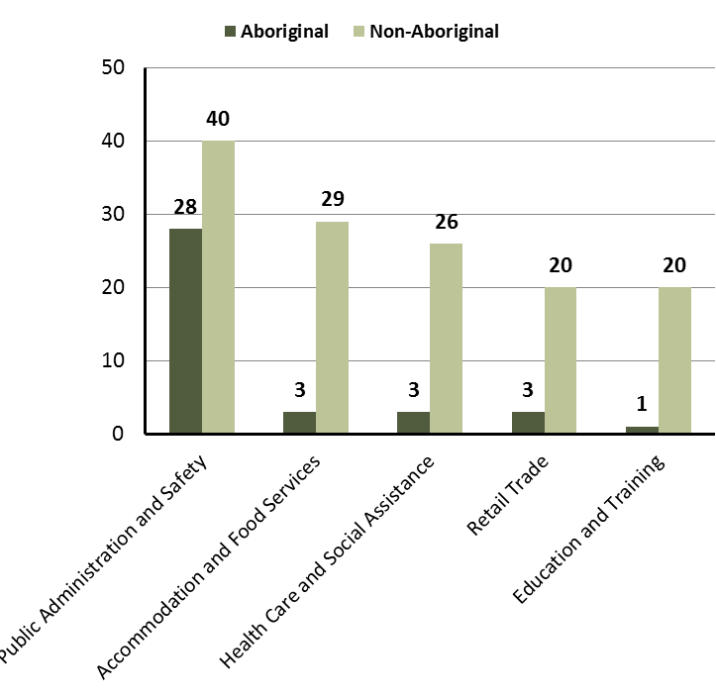
Source: Department of Trade, Business and Innovation
In 2017 in Alyangula, excluding GEMCO:
- of the 39 jobs filled by Aboriginal persons, there were:
- 28 jobs in Public Administration and Safety
- 3 jobs in Accommodation and Food Services
- 3 jobs in Health Care and Social Assistance
- of the 155 jobs filled by non-Aboriginal persons, there were:
- 40 jobs in Public Administration and Safety
- 29 jobs in Accommodation and Food Services
- 26 jobs in Health Care and Social Assistance.
Table 12: Count of filled jobs by industry, employment status and Aboriginal status of person in job, 2017 (a)(c)(e)(h)
Industry (ANZSIC division) | 2017
 | Aboriginal |  |  | Non-Aboriginal |  |  | Total
 | Perm | Temp | Total | Perm | Temp | Total | Perm | Temp | Total
Accommodation and Food Services | 3 | 0 | 3 | 18 | 11 | 29 | 21 | 11 | 32
Education and Training | 1 | 0 | 1 | 10 | 10 | 20 | 11 | 10 | 21
Financial and Insurance Services | 0 | 0 | 0 | 2 | 1 | 3 | 2 | 1 | 3
Health Care and Social Assistance | 1 | 2 | 3 | 13 | 13 | 26 | 14 | 15 | 29
Other Services | 0 | 0 | 0 | 3 | 0 | 3 | 3 | 0 | 3
Public Administration and Safety | 24 | 4 | 28 | 36 | 4 | 40 | 60 | 8 | 68
Rental, Hiring and Real Estate Services | 0 | 1 | 1 | 1 | 1 | 2 | 1 | 2 | 3
Retail Trade | 0 | 3 | 3 | 15 | 5 | 20 | 15 | 8 | 23
Transport, Postal and Warehousing | 0 | 0 | 0 | 9 | 3 | 12 | 9 | 3 | 12
Total | 29 | 10 | 39 | 107 | 48 | 155 | 136 | 58 | 194
Source: Department of Trade, Business and Innovation
In 2017 in Alyangula, excluding GEMCO:
- of the 136 permanent jobs, there were:
- 60 jobs in Public Administration and Safety, including:
- 24 jobs filled by Aboriginal persons
- 36 jobs filled by non-Aboriginal persons
- 21 jobs in Accommodation and Food Services, including:
- 3 jobs filled by Aboriginal persons
- 18 jobs filled by non-Aboriginal persons
- 15 jobs in Retail Trade, including:
- none were filled by Aboriginal persons
- 15 jobs filled by non-Aboriginal persons
- of the 58 temporary jobs, there were:
- 15 jobs in Health Care and Social Assistance, including:
- 2 jobs filled by Aboriginal persons
- 13 jobs filled by non-Aboriginal persons
- 11 jobs in Accommodation and Food Services, including:
- none were filled by Aboriginal persons
- 11 jobs filled by non-Aboriginal persons
- 10 jobs in Education and Training, including:
- none were filled by Aboriginal persons
- 10 jobs filled by non-Aboriginal persons.

Jobs by Occupation
Table 13: Count of filled jobs by occupation, 2017 (a)(f)(g)
Occupation (ANZSCO major group) | 2017
 | Total | % of Total
Clerical and Administrative Workers | 33 | 17.0%
Community and Personal Service Workers | 41 | 21.1%
Labourers | 24 | 12.4%
Managers | 29 | 14.9%
Professionals | 47 | 24.2%
Sales Workers | 12 | 6.2%
Technicians and Trades Workers | 8 | 4.1%
Total | 194 | 100.0%
Source: Department of Trade, Business and Innovation
Chart 9: Count of filled jobs by occupation, 2017 (a)(f)(g)
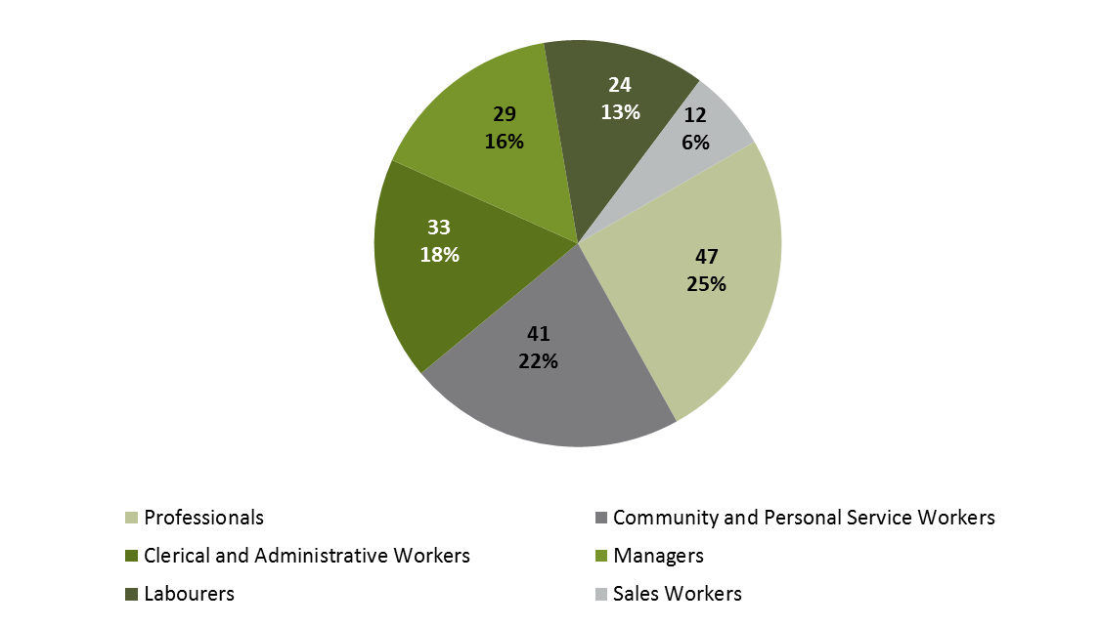
Source: Department of Trade, Business and Innovation
In 2017 in Alyangula, excluding GEMCO:
- Professionals was the largest occupation classification in terms of filled jobs, accounting for 47 jobs (24.2% of total filled jobs)
- other significant occupation classifications were:
- Community and Personal Service Workers (41 jobs or 21.1%)
- Clerical and Administrative Workers (33 jobs or 17%)
- Managers (29 jobs or 14.9%).
Table 14: Count of filled jobs by ANZSCO occupation by Aboriginal status of person employed in job, 2017 (a)(c)(f)(g)
Occupation (ANZSCO major group) | 2017
 | Aboriginal | Non-Aboriginal | Total
Clerical and Administrative Workers | 3 | 30 | 33
Community and Personal Service Workers | 8 | 33 | 41
Labourers | 4 | 20 | 24
Managers | 3 | 26 | 29
Professionals | 19 | 28 | 47
Sales Workers | 2 | 10 | 12
Technicians and Trades Workers | 0 | 8 | 8
Total | 39 | 155 | 194
Source: Department of Trade, Business and Innovation
In 2017 in Alyangula, excluding GEMCO:
- of the 39 jobs filled by Aboriginal persons, there were:
- 19 Professionals
- 8 Community and Personal Service Workers
- 4 Labourers
- of the 155 jobs filled by non-Aboriginal persons, there were:
- 33 Community and Personal Service Workers
- 30 Clerical and Administrative Workers
- 28 Professionals.

Jobs by Industry by Occupation
Table 15: Count of filled jobs by occupation and by industry, 2017 (a)(f)(g)(h)
2017
Industry (ANZSIC Division) |  | Occupation (ANZSCO major group)
 | Clerical and Administrative Workers | Community and Personal Service Workers | Labourers | Machinery Operators and Drivers | Managers | Professionals | Sales Workers | Technicians and Trades Workers | Other occupations | Total
Accommodation and Food Services | 0 | 8 | 12 | 0 | 7 | 0 | 0 | 5 | 0 | 32
Education and Training | 5 | 0 | 1 | 0 | 2 | 13 | 0 | 0 | 0 | 21
Health Care and Social Assistance | 3 | 14 | 1 | 0 | 4 | 7 | 0 | 0 | 0 | 29
Public Administration and Safety | 14 | 19 | 5 | 0 | 5 | 24 | 0 | 1 | 0 | 68
Retail Trade | 0 | 0 | 1 | 0 | 8 | 1 | 12 | 1 | 0 | 23
Transport, Postal and Warehousing | 8 | 0 | 1 | 0 | 1 | 2 | 0 | 0 | 0 | 12
Total | 33 | 41 | 24 | 0 | 29 | 47 | 12 | 8 | 0 | 194
Source: Department of Trade, Business and Innovation
In 2017 in Alyangula, excluding GEMCO:
- the majority of Professionals (47) jobs (the largest occupation group) were shared across the Public Administration and Safety (24) and Education and Training (13) industries
- in Public Administration and Safety (the largest industry), there were 68 filled jobs.

Jobs by Gender
Table 16: Counts of filled jobs by gender and Aboriginal status of person employed in job, 2017 (a)(c)(i)
Indicator | 2017
 | Aboriginal | Non-Aboriginal | Total
Male | 20 | 65 | 85
Female | 18 | 90 | 108
Total | 38 | 155 | 193
Source: Department of Trade, Business and Innovation
Chart 10: Count of filled jobs by gender and Aboriginal status of person in job, 2017 (a)(c)(i)
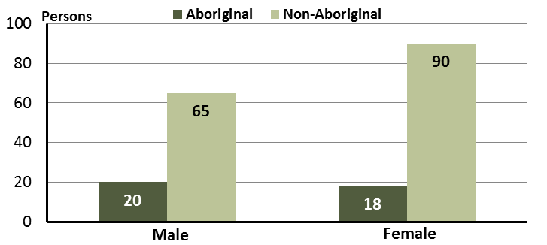
Source: Department of Trade, Business and Innovation
In 2017 in Alyangula, excluding GEMCO:
- of the 85 jobs filled by males, there were:
- 20 were Aboriginal
- 65 were non-Aboriginal
- of the 108 jobs filled by females, there were:
- 18 were Aboriginal
- 90 were non-Aboriginal.
Table 17: Counts of filled jobs by gender, by Aboriginal status of person in the job, by full-time/part-time status, by job permanency, by sector, 2017 (a)(b)(c)(d)(e)(i)
2017
Indicator | Male |  |  | Female |  |  | Total
 | Aboriginal | Non-Aboriginal | Total | Aboriginal | Non-Aboriginal | Total | Aboriginal | Non-Aboriginal | Total
Full-time | 16 | 53 | 69 | 12 | 69 | 81 | 29 | 122 | 151
Part-time | 4 | 12 | 16 | 6 | 21 | 27 | 10 | 33 | 43
Total | 20 | 65 | 85 | 18 | 90 | 108 | 39 | 155 | 194
Permanent | 17 | 51 | 68 | 11 | 56 | 67 | 29 | 107 | 136
Temporary | 3 | 14 | 17 | 7 | 34 | 41 | 10 | 48 | 58
Total | 20 | 65 | 85 | 18 | 90 | 108 | 39 | 155 | 194
Public Sector | 5 | 14 | 19 | 5 | 29 | 34 | 11 | 43 | 54
Private Sector | 15 | 51 | 66 | 13 | 61 | 74 | 28 | 112 | 140
Total | 20 | 65 | 85 | 18 | 90 | 108 | 39 | 155 | 194
Source: Department of Trade, Business and Innovation
In 2017 in Alyangula, excluding GEMCO:
- of the 85 jobs filled by males, there were:
- 20 jobs filled by Aboriginal males, including:
- 16 full-time jobs and 4 part-time jobs
- 17 permanent jobs and 3 temporary jobs
- 5 public sector jobs and 15 private sector jobs
- 65 jobs filled by non-Aboriginal males, including:
- 53 full-time jobs and 12 part-time jobs
- 51 permanent jobs and 14 temporary jobs
- 14 public sector jobs and 51 private sector jobs
- of the 108 jobs filled by females, there were:
- 18 jobs filled by Aboriginal females, including:
- 12 full-time jobs and 6 part-time jobs
- 11 permanent jobs and 7 temporary jobs
- 5 public sector jobs and 13 private sector jobs
- 90 jobs filled by non-Aboriginal females, including:
- 69 full-time jobs and 21 part-time jobs
- 56 permanent jobs and 34 temporary jobs
- 29 public sector jobs and 61 private sector jobs.

Jobs by Age
Table 18: Counts of filled jobs by age and Aboriginal status of person employed in job, 2017 (a)(c)(j)
Indicator | 2017
 | Aboriginal | Non-Aboriginal | Total
15-24 years | 3 | 13 | 16
25-44 years | 19 | 94 | 113
45+ years | 15 | 47 | 62
Total | 39 | 155 | 194
Source: Department of Trade, Business and Innovation
Chart 11: Count of filled jobs by age and Aboriginal status of person in job, 2017 (a)(c)(j)
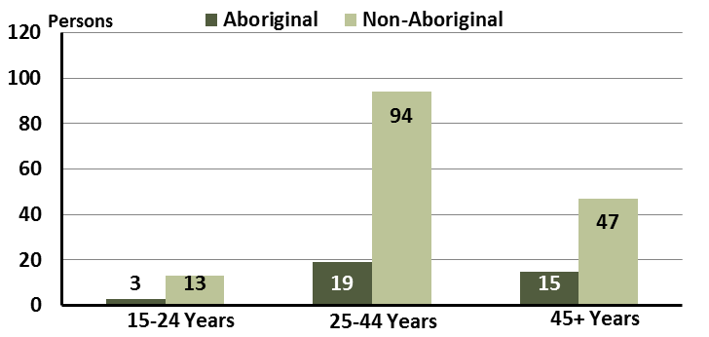
Source: Department of Trade, Business and Innovation
In 2017 in Alyangula, excluding GEMCO:
- of the 16 jobs filled by persons aged 15-24 years, there were:
- 3 jobs were filled by Aboriginal persons
- 13 jobs were filled by non-Aboriginal persons
- of the 113 jobs filled by persons aged 25-44 years, there were:
- 19 jobs were filled by Aboriginal persons
- 94 jobs were filled by non-Aboriginal persons
- of the 62 jobs filled by persons aged 45+ years, there were:
- 15 jobs were filled by Aboriginal persons
- 47 jobs were filled by non-Aboriginal persons.
Table 19: Counts of filled jobs by age, by Aboriginal status of person in the job, by full-time/part-time status, by job permanency, by sector, July 2017 (a)(b)(c)(d)(e)(i)
2017
Indicator | 15-24 years |  |  | 25-44 years |  |  | 45+ years |  |  | Total
 | Aboriginal | Non-Aboriginal | Total | Aboriginal | Non-Aboriginal | Total | Aboriginal | Non-Aboriginal | Total | Aboriginal | Non-Aboriginal | Total
Full-time | 2 | 4 | 6 | 17 | 77 | 94 | 8 | 40 | 48 | 29 | 122 | 151
Part-time | 1 | 9 | 10 | 2 | 17 | 19 | 7 | 7 | 14 | 10 | 33 | 43
Total | 3 | 13 | 16 | 19 | 94 | 113 | 15 | 47 | 62 | 39 | 155 | 194
Permanent | 2 | 3 | 5 | 18 | 71 | 89 | 7 | 32 | 39 | 29 | 107 | 136
Temporary | 1 | 10 | 11 | 1 | 23 | 24 | 8 | 15 | 23 | 10 | 48 | 58
Total | 3 | 13 | 16 | 19 | 94 | 113 | 15 | 47 | 62 | 39 | 155 | 194
Public sector | 0 | 1 | 1 | 6 | 24 | 30 | 4 | 18 | 22 | 11 | 43 | 54
Private sector | 3 | 12 | 15 | 13 | 70 | 83 | 11 | 29 | 40 | 28 | 112 | 140
Total | 3 | 13 | 16 | 19 | 94 | 113 | 15 | 47 | 62 | 39 | 155 | 194
Source: Department of Trade, Business and Innovation
In 2017 in Alyangula, excluding GEMCO:
- of the 16 jobs filled by persons aged 15-24 years, there were:
- 3 jobs filled by Aboriginal persons, of which:
- 2 were full-time jobs and 1 was a part-time job
- 2 were permanent jobs and 1 was a temporary job
- none were public sector jobs and 3 were private sector jobs
- 13 jobs filled by non-Aboriginal persons, of which:
- 4 were full-time jobs and 9 were part-time jobs
- 3 were permanent jobs and 10 were temporary jobs
- 1 was a public sector job and 12 were private sector jobs
- of the 113 jobs filled by persons aged 25-44 years, there were:
- 19 jobs filled by Aboriginal persons, of which:
- 17 were full-time jobs and 2 were part-time jobs
- 18 were permanent jobs and 1 was a temporary job
- 6 were public sector jobs and 13 were private sector jobs

- 94 jobs filled by non-Aboriginal persons, of which:
- 77 were full-time jobs and 17 were part-time jobs
- 71 were permanent jobs and 23 were temporary jobs
- 24 were public sector jobs and 70 were private sector jobs
- of the 62 jobs filled by persons aged 45+ years, there were:
- 15 jobs filled by Aboriginal persons, of which:
- 8 were full-time jobs and 7 were part-time jobs
- 7 were permanent jobs and 8 were temporary jobs
- 4 were public sector jobs and 11 were private sector jobs
- 47 jobs filled by non-Aboriginal persons, of which:
- 40 were full-time jobs and 7 were part-time jobs
- 32 were permanent jobs and 15 were temporary jobs
- 18 were public sector jobs and 29 were private sector jobs.

Vocational Education and Training
Table 20: Northern Territory Vocational Education and Training (VET) students, 2016 (k)
VET Funding Group | 2016
 | No. | % of Total
Arts, Entertainment, Sports and Recreation | 9 | 5
Building and Construction | 25 | 13
Business and Clerical | 1 | 1
Community Services, Health and Education | 31 | 16
Engineering and Mining | 22 | 12
Primary Industry | 24 | 13
Process Manufacturing | 1 | 1
Sales and Personal Service | 14 | 7
Tourism and Hospitality | 10 | 5
Transport and Storage | 51 | 27
Total | 188 | 100
Source: Department of Trade, Business and Innovation
In Alyangula in 2016:
- there were 188 VET students, an increase of 188 students from 2013 and unchanged from 2010
- the areas of VET activity with the most students were Transport and Storage (51), Community Services, Health and Education (31), and Building and Construction (25).
Table 21: Northern Territory Vocational Education and Training (VET) unit enrolments, 2016 (l)
VET Funding Group | 2016
 | No. | % of Total
Arts, Entertainment, Sports and Recreation | 18 | 3
Building and Construction | 29 | 5
Community Services, Health and Education | 46 | 8
Engineering and Mining | 100 | 17
Finance, Banking and Insurance | 0 | 0
Primary Industry | 100 | 17
Process Manufacturing | 3 | 1
Sales and Personal Service | 210 | 36
Tourism and Hospitality | 30 | 5
Transport and Storage | 47 | 8
Total | 583 | 100
Source: Department of Trade, Business and Innovation
In Alyangula in 2016:
- there were 583 VET unit enrolments.
Table 22: Northern Territory Vocational Education and Training (VET) nominal hours, 2017 (m)
VET Funding Group | 2016
 | No. | % of Total
Arts, Entertainment, Sports and Recreation | 230 | 3
Community Services, Health and Education | 2141 | 26
Engineering and Mining | 1688 | 20
Primary Industry | 3140 | 38
Tourism and Hospitality | 1120 | 13
Total | 8319 | 100
Source: Department of Trade, Business and Innovation
In Alyangula in 2016:
- there were 8319 VET nominal hours delivered, an increase of 8319 nominal hours delivered from 2013 and an increase of 8319 nominal hours delivered from 2010
- the areas of VET activity with the most nominal hours delivered were Primary Industry (3140), Community Services, Health and Education (2141), and Engineering and Mining (1688).
Caveat: Nominal hours are based on the hours funded through Department of Trade Business and Innovation contracts; students and units includes delivery that has been funded in a previous year, fee for service or training that did not meet the funding requirements. Because of this a direct match cannot be made between hours and student/units
Table 23: Northern Territory Vocational Education and Training (VET) unit completions, 2016 (n)
VET Funding Group | 2016
 | No. | % of Total
Arts, Entertainment, Sports and Recreation | 19 | 3
Building and Construction | 30 | 5
Business and Clerical | 7 | 1
Community Services, Health and Education | 76 | 11
Engineering and Mining | 100 | 15
Primary Industry | 102 | 15
Sales and Personal Service | 210 | 32
Tourism and Hospitality | 60 | 9
Total | 661 | 100
Source: Department of Trade, Business and Innovation
In Alyangula in 2016:
- there were 661 VET unit completions
- the areas of VET activity with the most unit completions were Sales and Personal Service (210), Primary Industry (102), and Engineering and Mining (100).

Population
Table 24: Population distribution by gender and age (p)(r)
Indicator | 2006 |  |  | 2016 |  |  | Change
 | Male | Female | Total | Male | Female | Total | Male | Female | Total
0-4 years | 62 | 49 | 111 | 51 | 43 | 94 | -11 | -6 | -17
5-14 years | 95 | 76 | 171 | 96 | 60 | 156 | 1 | -16 | -15
15-24 years | 38 | 62 | 100 | 30 | 24 | 54 | -8 | -38 | -46
25-44 years | 226 | 206 | 432 | 222 | 204 | 426 | -4 | -2 | -6
45-64 years | 156 | 92 | 248 | 159 | 75 | 234 | 3 | -17 | -14
65+ years | 5 | 2 | 7 | 13 | 12 | 25 | 8 | 10 | 18
TOTAL | 582 | 487 | 1069 | 571 | 418 | 989 | -11 | -69 | -80
Source: Department of Trade, Business and Innovation

In 2016 in Alyangula:
- there were an estimated 989 persons, of which:
- 571 (57.7%) were male
- 418 (42.3%) were female
- between 2006 and 2016, the overall population in Alyangula decreased by 80 persons from 2006, or an average of -0.8% per year compared to 0.7% across the 28 remote towns and 1.5% Territory wide
- the male population decreased by 11 persons from 2006
- the female population decreased by 69 persons from 2006
- in 2016, the working age population (15 years and over) in Alyangula was an estimated 739 persons (74.7% of the total population) compared with 787 persons (73.6% of the total population) in 2006. Of these:
- 54 (5.5%) were between 15 and 24 years of age
- 426 (43.1%) were between 25 and 44 years of age
- 234 (23.7%) were between 45 and 64 years of age
- 25 (2.5%) were over 65 years of age
- of the 739 persons of working age:
- 424 (57.4%) were male
- 315 (42.6%) were female.
There were 1.6 jobs in Alyangula per working age person compared to 0.4 jobs per working age person across the 28 remote towns in the Northern Territory.
Chart 12: Population by Aboriginal status, 28 remote towns and the NT (p)(q)
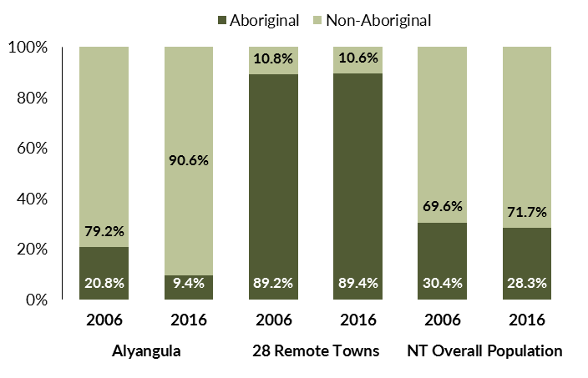
Source: Department of Trade, Business and Innovation
In 2016 in Alyangula:
- 9.4% of the population in Alyangula were Aboriginal, compared to 20.8% in 2006
- 89.4% of the population across all 28 remote towns were Aboriginal
- 28.3% of the NT population were Aboriginal.
Table 25: Unemployment and participation rates by Aboriginal status compared to the NT (q)
 | Alyangula |  |  | Northern Territory
 | Aboriginal | Non-Aboriginal | Total | Aboriginal | Non-Aboriginal | Total
Unemployment rate | 0.0% | 1.3% | 1.2% | 26.7% | 3.8% | 7.0%
Participation rate | 76.6% | 91.9% | 90.9% | 41.0% | 79.9% | 70.6%
Source: Department of Trade, Business and Innovation
In 2016 in Alyangula the:
- total unemployment rate was 1.2% compared to 7% for the total Northern Territory
- Aboriginal unemployment rate was 0% compared to 26.7% for the total Northern Territory
- non-Aboriginal unemployment rate was 1.3% compared to 3.8% for the total Northern Territory
- total participation rate was 90.9% compared to 70.6% for the total Northern Territory
- Aboriginal participation rate was 76.6% compared to 41% for the total Northern Territory
- non-Aboriginal participation rate was 91.9% compared to 79.9% for the total Northern Territory.

Community Development Programme
Table 26: Community Development Programme Aboriginal Job Seekers, 30 April 2018 (o)
Indicator | Aboriginal
 | No. | %
Total Aboriginal Job Seekers | < 20 | N/A
Age (years)
19 and under | < 20 | N/A
20-24 | < 20 | N/A
25-44 | < 20 | N/A
45+ | < 20 | N/A
Total | < 20 | N/A
Gender
Male | < 20 | N/A
Female | < 20 | N/A
Total | < 20 | N/A
Employment Outcome - 1 July 2015 to 30 April 2018
13 Weeks | < 20 | N/A
26 Weeks | < 20 | N/A
Currently in Activities | < 20
Source: Department of Prime Minister and Cabinet
As at 30 April 2018, in Alyangula, there were less than 20 CDP Aboriginal job seekers, of these:
- less than 20 were male and less than 20 were female
- less than 20 were aged 19 years and under, less than 20 were aged 20-24 years, less than 20 were aged 25-44 years, and less than 20 were aged 45+ years
- between 1 July 2015 and 30 April 2018, less than 20 had reached the 13 week reporting milestone and less than 20 had reached the 26 week reporting milestone
- less than 20 were currently in activities.

Businesses
Table 27: Businesses by sector (d)(s)
Business Name
PUBLIC SECTOR
Department of Education
Department of Health
Department of the Prime Minister and Cabinet
Northern Territory Police, Fire Emergency Services
Territory Families
PRIVATE SECTOR
Alyangula Daycare Inc (Seagrass Learning Centre)
Alyangula Golf Club
Alyangula Kiosk and Newsagent
Alyangula Local Post Office
Amangara Aboriginal Corporation t/a Groote Leading Appliances
Anindilyakwa Land Council (ALC)
ANZ Bank
Arirrki Aboriginal Corporation trading as Groote Eylandt Car Rentals
Bartalumba Mini Mart Aboriginal Corporation
Canis Loopus Pty Ltd t/a Arafura Aviation
Capiteq Pty Limited t/a Airnorth
Eylandt Automotive and Marine
Fitzo Midada t/a Fitzos Boutique
Flojo Takeaway
Groote Eylandt Lodge Trust
MJD Foundation
Nick Kenny Investments Pty Ltd trading as Active Performance
Northpharm Pty Ltd trading as Groote Eylandt Health Store
Scoffee Pty Ltd trading as The Coffee Shop
Sea Swift
South32, Groote Eylandt Mining Company Pty Ltd (not included in this profile)
The Bakery-Groote Eylandt
Source: Department of Trade, Business and Innovation
Note: Business names captured have been identified by the current 2017 Business ABN name listed.
In 2017 in Alyangula:
- there were 26 businesses reported on, of which:
- 5 businesses were from the public sector (19%)
- 21 businesses were from the private sector (81%).

Notes
- These counts represent numbers of filled jobs and not numbers of persons. As such the totals represent the total number of filled jobs, not the total number of employees. This count is not directly comparable to the total number of employed persons as a person may have several jobs or one job may be shared by more than one person.
- Full-time is defined as a job usually requiring 35 hours or more per week or that required 35 hours or more work during the reference week. Part-time is defined as a job usually requiring less than 35 hours per week or that required less than 35 hours work during the reference week. The reference week refers to the period that respondents were asked to provide information about. In most instances it would be the week prior to the week the questionnaire was completed. Questionnaires were predominantly conducted in June and July.
- Care needs to be taken when analysing the counts of filled jobs by the Aboriginal status of persons in the jobs. The Aboriginal status of the person employed in a job was reported by the business representative completing the questionnaire.
- Sector was classified using the Standard Economic Sector of Classifications of Australia (SESCA), 2008.
- Job permanency is classified according to what the business believes the level of job permanency is based on guidelines provided by data collectors. Those guidelines state a permanent job has paid annual and/or sick leave entitlements while a temporary job includes casual and fixed-term contract jobs.
- Classified according to the Australian and New Zealand Standard Classification of Occupations (ANZSCO), 2006, major occupation level.
- Other occupations include jobs where occupation was not stated, not known or inadequately described.
- Classified using the Australian and New Zealand Standard Industrial Classification (ANZSIC), 2006, division level.
- Care needs to be taken when analysing the counts of filled jobs by the gender of persons in the jobs. The gender of the person employed in a job is reported by the business representative completing the questionnaire.
- Care needs to be taken when analysing the counts of filled jobs by the age of persons in the jobs. The age of the person employed in a job is reported by the business representative completing the questionnaire.
- Students represent the number of individual clients that enrolled in a Vocational Education and Training unit during the calendar year.
- Unit enrolments represent the count of individual units that students enrolled in during the calendar year.
- Nominal hours delivered is the sum of the nominal hours of the units commenced during the calendar year regardless of when the course enrolment commenced.
- Unit completions are the count of all successfully completed units reported in the calendar year regardless of the year of commencement of the units.
- The Community Development Programme (CDP) supports job seekers in remote Australia to build skills, address barriers and contribute to their communities through a range of flexible activities. Under the CDP, job seekers with activity requirements are expected to do up to 25 hours per week of work-like activities that benefit their community. It should be noted that some CDP participants may be reported on within the profile if they are attached to a filled position with an employer captured in the survey. Due to confidentiality issues, data below 20 people is not published.
- Population estimates for both 2006 and 2016 are taken from the estimated resident population (ERP) data produced by the Australian Bureau of Statistics (ABS) and based on Australian Statistical Geography Standard (ASGS) Statistical Area Level 1 (SA1) regions. ERP are official estimates of the Australian population, which link people to a place of usual residence with Australia. All ERP data sources, including the Census of Population and Housing (Census), are subject to error (including inaccuracies in collection, recording and processing data) and should be used with caution.
- Indigenous population proportions, unemployment and workforce participation rates are based on ABS Census counts at ASGS Indigenous Locations (ILOCs) for each remote town.
- Working-age population includes all residents aged 15 years and over (commonly referred to as the civilian population) and consists of persons that are employed, unemployed or not in the labour force.
- A ‘business’ has been defined as any organisation that has undertaken productive activities in the last year, including companies, non-profit organisations, government departments and enterprises operating within the designated remote geography (town), and has one or more employees in paid employment and an Australian Business Number (ABN).

Abbreviations and Acronyms
ABN Australian Business Number
ABS Australian Bureau of Statistics
ANZSCO Australian and New Zealand Standard Classification of Occupations
ANZSIC Australian and New Zealand Standard Industrial Classification
ASGS Australian Statistical Geography Standard
CDP Community Development Programme
ERP Estimated Resident Population
GEMCO Groote Eylandt Mining Company
ILOC Indigenous Locations
nec Not Elsewhere Classified
No. Number
Perm Permanent
ppt Percentage point
RJCP Remote Jobs and Communities Program
Temp Temporary
SA1 Statistical Area Level 1
VET Vocational Education and Training

The number of filled jobs does not represent numbers of persons as a person may have several jobs or one job may be shared by more than one person.
1 Aboriginal filled job gender status not identified in 2017

