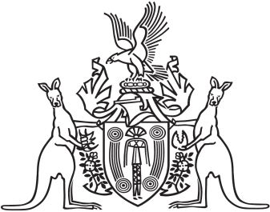
Northern Territory of Australia

Government Gazette
ISSN-0157-833X
No. S66 22 August 2018

Assent to Proposed Laws
Her Honour the Administrator assented to the following proposed law:
17 August 2018
Gaming Control Amendment Act 2018 (Act No. 15 of 2018)
Michael Tatham
Clerk of the Legislative Assembly
Date 20 August 2018

