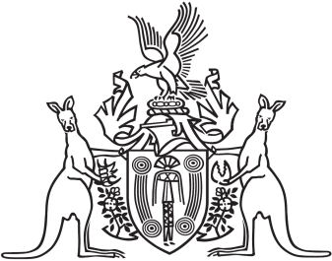
Northern Territory of Australia

Government Gazette
ISSN-0157-833X
No. S62 13 August 2018
Northern Territory of Australia

Local Court Act
Appointment of Judge of the Local Court
I, Vicki Susan O'Halloran, Administrator of the Northern Territory of Australia, acting with the advice of the Executive Council, under section 53(1)(c) of the Local Court Act, appoint Therese Jacinta Austin to be a Judge of the Local Court on and from 13 August 2018.
Dated 25 June 2018
V. S. O'Halloran
Administrator
By Her Honour's Command
N. K. Fyles
Attorney-General and Minister for Justice

