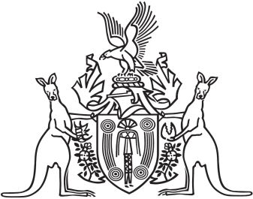
Northern Territory of Australia

Government Gazette
ISSN-0157-833X
No. S48 29 June 2018
Northern Territory of Australia

Revenue Units Act
New Monetary Value of Revenue Unit
I, Michael Ian Butler, Commissioner of Territory Revenue, under section 6(1) of the Revenue Units Act, give notice that the new value of a revenue unit, to take effect on 1 July 2018, is $1.18.
Dated 29 June 2018
M. I. Butler
Commissioner of Territory Revenue

