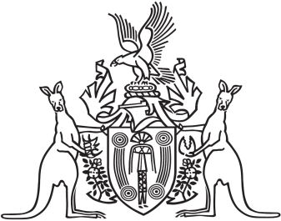
Northern Territory of Australia

Government Gazette
ISSN-0157-833X
No. S45 26 June 2018

Notification of Subordinate Legislation
Notice is given of the making of the following subordinate legislation, effective from the date specified:
Subordinate Legislation | Commencement details | Empowering Act
Planning Amendment Regulations  (No. 14 of 2018) | Date of this Gazette | Planning Act
Penalty Units Amendment Regulations 2018  (No. 16 of 2018) | These Regulations commence  on 1 July 2018 | Penalty Units Act
For copies of legislation please direct your request to the Print Management Unit, email pmu.ntg@nt.gov.au or phone (08) 8999 6727

