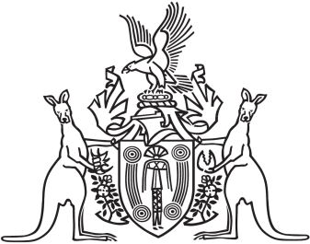
Northern Territory of Australia

Government Gazette
ISSN-0157-833X
No. S92 5 December 2017

Assent to Proposed Laws
Her Honour the Administrator assented to the following proposed law:
30 November 2017
Misuse of Drugs Amendment Act 2017 (Act No 22 of 2017)
Michael Tatham
Clerk of the Legislative Assembly

