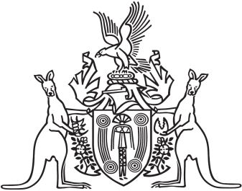
Northern Territory of Australia

Government Gazette
ISSN-0157-833X
No. S87 24 November 2017
Territory Parks and Wildlife Conservation Act
Watarrka National Park and Tjoritja / West MacDonnell National Park Draft Joint Management Plans
In accordance with section 25AD(2) of the Territory Parks and Wildlife Conservation Act the joint management partners of Watarrka National Park and Tjoritja / West MacDonnell National Park give notice that:
- the draft Joint Management Plans for Watarrka National Park and Tjoritja / West MacDonnell National Park have been prepared; and
- interested persons are invited to make representations in connection with the plans by 24 December 2017.
Copies of the Draft Plans may be downloaded at: https://dtc.nt.gov.au/parks-and-wildlife/public-consultation and may be inspected at the Parks and Wildlife Commission Office, Tom Hare Building, AZRI, South Stuart Highway, Alice Springs.
Representations in connection with the Plans may be forwarded to:
Park Planning
Parks and Wildlife Commission
PO Box 1120, Alice Springs NT 0871
Telephone (08) 89518 250
Or parkplanning@nt.gov.au
Dated 24 November 2017
Jonathan Vea
A/Director Park Development
Parks and Wildlife
Department of Tourism and Culture

