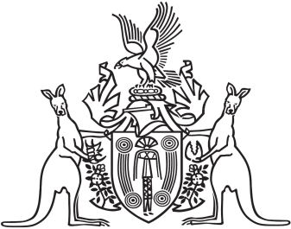
Northern Territory of Australia

Government Gazette
ISSN-0157-833X
No. S63 1 September 2017
Northern Territory of Australia

Alcohol Harm Reduction Act
Appointment of BDR Registrar
I, Catherine Ann Stoddart, Chief Executive Officer of the Department of Health, under section 35(2) of the Alcohol Harm Reduction Act and with reference to section 8 of the Interpretation Act, appoint Christine Marie Kelly to be the BDR Registrar.
Dated 31 August 2017
C. A. Stoddart
Chief Executive Officer

