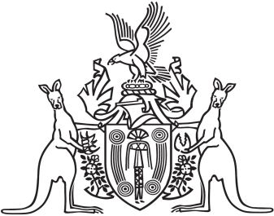
Northern Territory of Australia

Government Gazette
ISSN-0157-833X
No. S54 1 August 2017
Northern Territory Of Australia
Medicines, Poisons and Therapeutic Goods Act
Medimobile Pty Ltd Declarations and Approval
I, Hugh Crosbie Heggie, Chief Health Officer:
- under section 252 of the Medicines, Poisons and Therapeutic Goods Act (Act) declare the clinic specified in in the Schedule, Part A, to be a place to which Part 2.6 of the Act applies; and
- under section 254(1) of the Act, approve each Scheduled substance treatment protocol specified in the Schedule, Part B, for the health centre specified in the Schedule, Part A; and
- under section 250(1)(a) of the Act, declare each nurse practising at the health centre specified in the Schedule, Part A, who has the qualifications specified in the Schedule, Part C, to be an approved nurse to supply, administer to another person and possess the Schedule 4 substances specified in the Schedule, Part D, in accordance with each Schedule substance treatment protocol specified in the Schedule, Part B.
Dated 27 July 2017
H. C. Heggie
Chief Health Officer

Schedule

Part A
Gidsob Pty Ltd 3/11 Vanderlin Drive
Casuraina NT 0810
Part B
Title | Date | Author
Health Management Protocol – Standard Operating Procedures – Clinical Protocols | February 2017 | Medimobile Pty Ltd
Scheduled Substance Treatment Protocol – Adrenaline for Anaphylaxis | 13 March 2017 | Medimobile Pty Ltd
Scheduled Substance Treatment Protocol – Influenza Vaccination for Prevention of Influenza | 13 March 2017 | Medimobile Pty Ltd
Scheduled Substance Treatment Protocol – Antihistamine for Allergy | 13 March 2017 | Medimobile Pty Ltd
Part C
- The qualifications prescribed under section 65(1A) of the Act.
- Successful completion of the unit of competency HLTAID001 – Provide cardiopulmonary resuscitation.
Part D
Vaccine – influenza Adrenaline
Antihistamine – Loratadine

