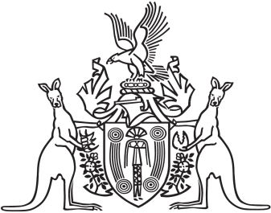
Northern Territory of Australia

Government Gazette
ISSN-0157-833X
No. S46 4 July 2017
Northern Territory of Australia

Plant Health Act
Revocation of Declaration of Quarantine Places for
Control of Banana Freckle
I, Sarah Kathryn Corcoran, Chief Inspector of Plant Health, under section 18(1) of the Plant Health Act and with reference to section 43 of the Interpretation Act, revoke the declaration of quarantine places made under the instrument entitled "Revocation of Declaration and Declaration of Quarantine Places for Control of Banana Freckle" dated 14 July 2016 and published in Gazette No. S71 of 20 July 2016.
Dated 27 June 2017
S. K. Corcoran
Chief Inspector of Plant Health

