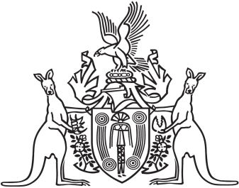
Northern Territory of Australia

Government Gazette
ISSN-0157-833X
No. S40 29 June 2017
Northern Territory of Australia

Local Government Act
Official management – City of Palmerston
I, Gerald Francis McCarthy, Minister for Housing and Community Development:
(a) under section 224(1) of the Local Government Act, place the City of Palmerston under official management; and
(b) under section 224(2)(b)(i) of the Act, appoint Mark Douglas Blackburn to manage the affairs of the council; and
(c) under section 224(2)(b)(ii) of the Act, appoint Russell William Anderson to investigate and report back to me by 29 December 2017 on the conduct of the suspended members and the affairs and financial position of the council.
Dated 29 June 2017
G. F. McCarthy
Minister for Housing and Community Development

