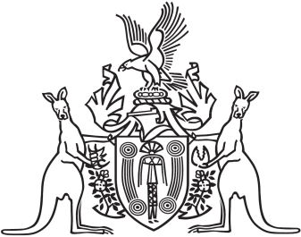
Northern Territory of Australia

Government Gazette
ISSN-0157-833X
No. S10 20 March 2017

Assent to Proposed Laws
His Honour the Administrator assented to the following proposed laws:
17 March 2017
Bail Amendment Act 2017 (Act No 5 of 2017)
Yours sincerely
Michael Tatham
Clerk of the Legislative Assembly
Date 17 March 2017

