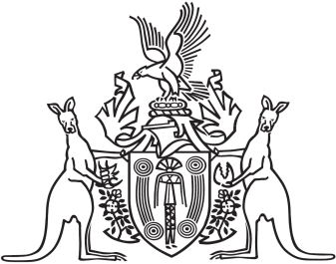
Northern Territory of Australia

Government Gazette
ISSN-0157-833X
No. S106 7 October 2016
Northern Territory of Australia

Northern Territory Land Corporation Act
Appointment of Member
I, Nicole Susan Manison, Minister for Infrastructure, Planning and Logistics, under section 7(2) of the Northern Territory Land Corporation Act, appoint John Anthony Coleman to be a member of the Northern Territory Land Corporation.
Dated 4 October 2016
N. S. Manison
Minister for Infrastructure, Planning and Logistics

