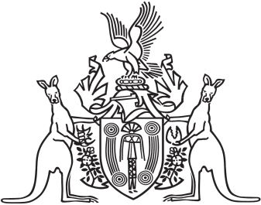
Northern Territory of Australia

Government Gazette
ISSN-0157-833X
No. S102 23 September 2016
Northern Territory of Australia

Northern Territory (Self-Government) Act 1978 (Cth)
Appointment of 1st Session for 13th Legislative Assembly
I, John Laurence Hardy, Administrator of the Northern Territory of Australia, under section 22(1) of the Northern Territory (Self-Government) Act 1978 (Cth), appoint 10 am on Tuesday, 18 October 2016 as the time for holding the 1st session of the 13th Legislative Assembly.
Dated 22 September 2016
J. L. Hardy
Administrator

