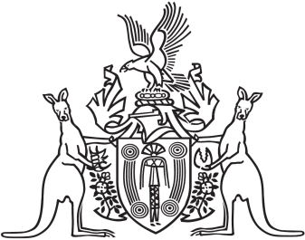
Northern Territory of Australia

Government Gazette
ISSN-0157-833X
No. S91 8 August 2016
Northern Territory of Australia

Weeds Management Act
Appointment of Member
Northern Territory Weed Advisory Committee
I, Gary John Higgins, Minister for Land Resource Management:
(a) under section 16(2) of the Weeds Management Act and with reference to section 43 of the Interpretation Act, revoke the instrument titled "Appointment of Member" dated 4 August 2016 and published in Gazette S86 of 5 August 2016, and
(b) under section 16(2) of the Weeds Management Act, appoint Garry Wayne Fischer to be a member of the Northern Territory Weed Advisory Committee on and from the date of this instrument.
Dated 5 August 2016
G. J. Higgins
Minister for Land Resource Management

