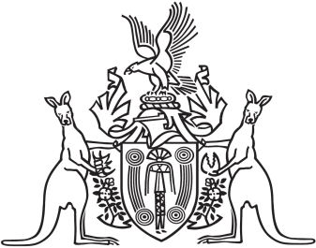
Northern Territory of Australia

Government Gazette
ISSN-0157-833X
No. S87 5 August 2016
Northern Territory of Australia

Bushfires Act
Bushfires Council
Appointment of Members
I, Gary John Higgins, Minister for Land Resource Management:
- under section 17 of the Bushfires Act, appoint each person specified in the Schedule to be a member of the Bushfires Council to 31 October 2016; and
- under section 18(a) of the Act, appoint Elizabeth Marie Bird to be the Chairman of the Council to 31 October 2016; and
- under section 18(b) of the Act, appoint Paul John Blore to be the Deputy Chairman of the Council to 31 October 2016.
Dated 5 August 2016
G. J. Higgins
Minister for Land Resource Management
Schedule
Shaun William Ansell
Alice Maree Beilby
Elizabeth Marie Bird
Paul John Blore
Walter Matthew Braitling
Garry David Cook
Tracey Louise Hayes
Benjamin James Kaethner
Karen Avis May
Patricia Margaret Rigby-Christophersen
Todd Robert Smith
Mark Anthony Spain
Ian James Stewart
Dianne Tynan

