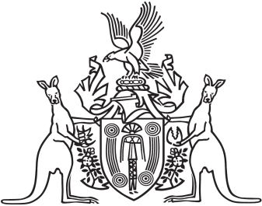
Northern Territory of Australia

Government Gazette
ISSN-0157-833X
No. S57 30 June 2016

Notification of Subordinate Legislation
Notice is given of the making of the following subordinate legislation, effective from the date specified:
Penalty Units Amendment Regulations 2016  (No. 27 of 2016) | These Regulations commence on 1 July 2016 | Penalty Units Act
For copies of legislation please direct your request to the Print Management Unit, email pmu.dcm@nt.gov.au or phone (08) 8999 6727

