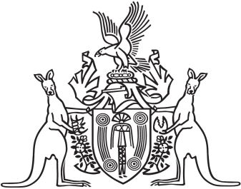
Northern Territory of Australia

Government Gazette
ISSN-0157-833X
No. S49 31 May 2016
Northern Territory of Australia

Interpretation Act
Notification of Making of Rules under
Northern Territory Civil and Administrative Tribunal Act
I, Johan Wessel Elferink, Attorney-General and Minister for Justice, under section 63(3) of the Interpretation Act, give notice that the Rules Committee of the Northern Territory Civil and Administrative Tribunal have made the following rules under section 138 of the Northern Territory Civil and Administrative Tribunal Act:
Subordinate Legislation No. 11 of 2016: Northern Territory Civil and Administrative Tribunal Rules
Copies of the rules may be purchased at the Print Management Unit, Department of the Chief Minister, 22 Mitchell Street, Darwin NT. The Print Management Unit may be contacted by email at pmu.dcm@nt.gov.au.
Dated 30 May 2016
J. W. Elferink
Attorney-General and Minister for Justice

