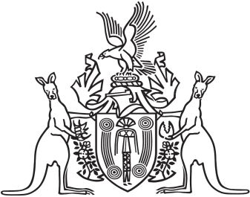
Northern Territory of Australia

Government Gazette
ISSN-0157-833X
No. S47 25 May 2016
Northern Territory of Australia

Crown Lands Act
Reserve No. 1663 (Blatherskite Park Reserve)
Appointment of Chairman of Trustees
I, Bess Nungarrayi Price, Minister for Local Government and Community Services, under section 79(1) of the Crown Lands Act, appoint Kate Louise Freestone to be Chairman of the trustees of Reserve No. 1663 (Blatherskite Park Reserve).
Dated 25 May 2016
B. N. Price
Minister for Local Government and Community Services

