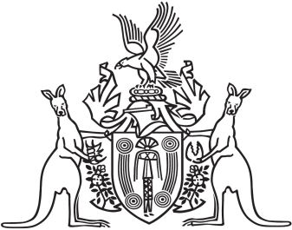
Northern Territory of Australia

Government Gazette
ISSN-0157-833X
No. S2 14 January 2016
Northern Territory of Australia

Superannuation Legislation Amendment Act 2015
Commencement Notice

I, John Laurence Hardy, Administrator of the Northern Territory of Australia, under section 2(b) of the Superannuation Legislation Amendment Act 2015 (No. 32 of 2015), fix 15 January 2016 as the day on which Part 2, Division 3 and Part 3 of that Act commences.
Dated 12 January 2016
J. L. Hardy
Administrator

