Mineral Titles Act 2010
NOTICE OF LAND CEASING TO BE A MINERAL TITLE AREA
Title Type and Number: | Exploration Licence 29862
Area Ceased on: | 25 May 2026
Area: | 11 Blocks, 30.92 km²
Locality: | PINE CREEK
Name of Applicant(s)/Holder(s): | 100% WOODLEIGH NOMINEES PTY LIMITED [ACN. 050 120 057]
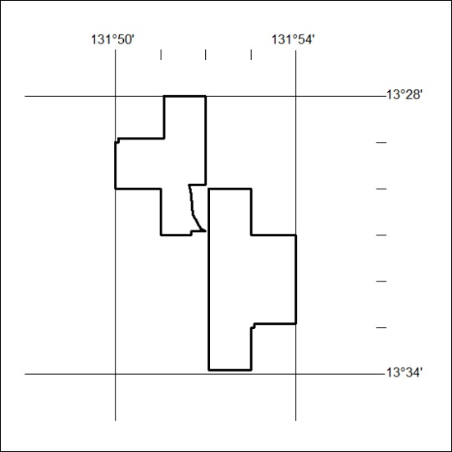
(Area now amalgamated into Exploration Licence 34232 under s102 – EL moratorium period does not apply)

169/26

Mineral Titles Act 2010
NOTICE OF LAND CEASING TO BE A MINERAL TITLE AREA
Title Type and Number: | Exploration Licence 30469
Area Ceased on: | 25 May 2026
Area: | 16 Blocks, 49.14 km²
Locality: | PINE CREEK
Name of Applicant(s)/Holder(s): | 100% WOODLEIGH NOMINEES PTY LIMITED [ACN. 050 120 057]
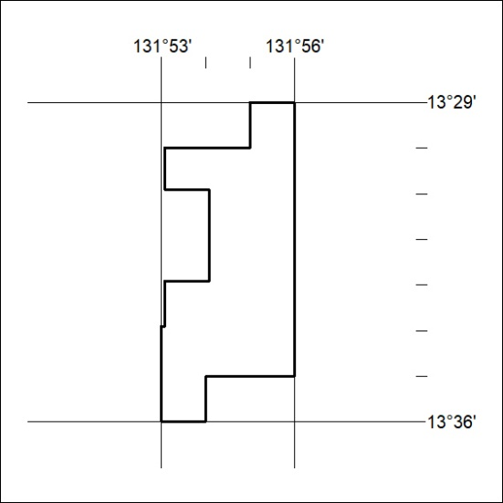
(Area now amalgamated into Exploration Licence 34232 under s102 – EL moratorium period does not apply)

170/26

Mineral Titles Act 2010
NOTICE OF LAND CEASING TO BE A MINERAL TITLE AREA
Title Type and Number: | Exploration Licence 31591
Area Ceased on: | 25 May 2026
Area: | 3 Blocks, 10.02 km²
Locality: | PINE CREEK
Name of Applicant(s)/Holder(s): | 100% WOODLEIGH NOMINEES PTY LIMITED [ACN. 050 120 057]
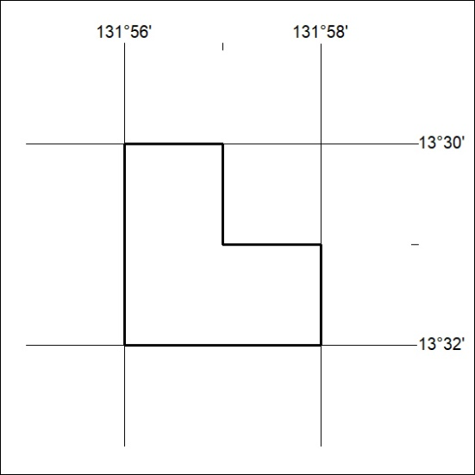
(Area now amalgamated into Exploration Licence 34232 under s102 – EL moratorium period does not apply)

171/26

Mineral Titles Act 2010
NOTICE OF LAND CEASING TO BE A MINERAL TITLE AREA
Title Type and Number: | Exploration Licence 32151
Area Ceased on: | 25 May 2026
Area: | 13 Blocks, 43.41 km²
Locality: | McKINLAY RIVER
Name of Applicant(s)/Holder(s): | 100% WOODLEIGH NOMINEES PTY LIMITED [ACN. 050 120 057]
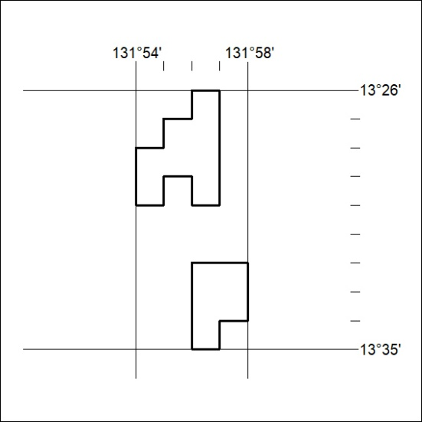
(Area now amalgamated into Exploration Licence 34232 under s102 – EL moratorium period does not apply)

172/26

