Mineral Titles Act 2010
NOTICE OF LAND CEASING TO BE A MINERAL TITLE AREA
Title Type and Number: | Exploration Licence 32780
Area Ceased on: | 07 March 2025
Area: | 89 Blocks, 281.01 km²
Locality: | BRAHMA
Name of Applicant(s)/Holder(s): | 100% IGO NEWSEARCH PTY LTD [ACN. 142 192 701]
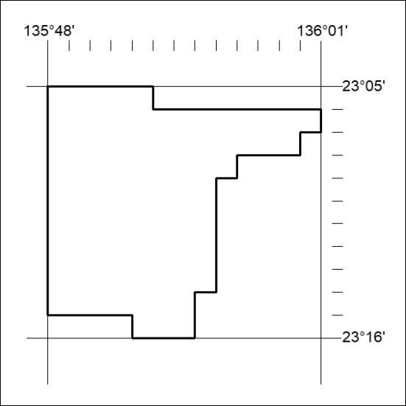

115/26

