Stock assessment of Black Jewfish (Protonibea diacanthus) in the Northern Territory 2023/24
  - Jonathan Smart
  - Jo Randall
  - Brien Roberts
  - Deepak Pazhayamadom

Document title | Stock assessment of Black Jewfish (Protonibea diacanthus) in the Northern Territory 2023/24
Contact details | NT Fisheries
Approved by | Senior Executive Director, NT Fisheries
Date approved | November 2025

Version | Date | Author | Changes made
1 | November 2025 | NT Fisheries | Public release

Acronyms | Full form
CAAL | Conditional age-at-length
CLF | Coastal Line Fishery
CPUE | catch per unit effort
FMSY | Fishing mortality that produces MSY
FRDC | Fisheries Research and Development Corporation
FTO | Fishing Tour Operator
ITQ | Individual Transferable Quota
JCU | James Cook University
MSY | Maximum Sustainable Yield
NT | Northern Territory
SRA | Stock Reduction Analysis
SS3 | Stock Synthesis 3
TACC | Total Allowable Commercial Catch
VBGF | von Bertalanffy growth function
WA | Western Australia

Contents
1. Summary 11
2. Introduction 13
2.1. Species biology 14
2.2. Stock structure 14
2.3. Previous assessments 15
2.3.1. Greater Darwin Region 15
2.3.2. Regional Northern Territory 15
2.3.3. Gulf of Carpentaria 16
2.4. Overview of the fishery 16
2.4.1. Fishing method 17
2.5. Management controls 17
2.5.1. Commercial sector 17
2.5.1.1. Western Zone management areas 18
2.5.1.2. Commercial catch limits for management areas 19
2.5.2. Recreational and Fishing Tourism Operators 20
2.5.3. Aboriginal Coastal Licence 21
2.5.4. Aboriginal traditional fishing 21
2.6. Harvest Strategy 22
2.7. Management history 23
2.8. Catch history 25
2.8.1. Greater Darwin Region assessment unit 25
2.8.1.1. Commercial harvest 25
2.8.1.2. Recreational and FTO harvest 26
2.8.2. Regional NT assessment unit 27
2.8.3. Gulf of Carpentaria assessment unit 28
2.8.4. Aboriginal Traditional harvest 29
2.8.5. Illegal fishing 29
2.9. Stock assessment models 29
2.9.1. Stock Reduction Analysis (SRA) 29
2.9.2. Catch-MSY 30
2.9.3. Stock Synthesis 31
2.10. Criteria for determining stock status 31
2.10.1. Reference points 31
2.10.2. Stock status 32
3. Stock Synthesis - Greater Darwin Region assessment 34
3.1. Model structure 34
3.2. Fleets and selectivity 35
3.2.1. Length selectivity 35
3.2.2. Age selectivity 36
3.3. Data inputs 36
3.3.1. Harvest 36
3.3.2. Abundance indices 37
3.3.3. Length compositions 39
3.3.4. Age compositions & conditional age-at-length 42
3.4. Black Jewfish biology 45
3.4.1. Growth, weight-length relationship, maturity & fecundity 45
3.4.2. Natural mortality 47
3.4.3. Recruitment 48
3.5. Model tuning 48
3.6. Sensitivity scenarios 49
3.7. Model outcomes 50
3.7.1. Base Case model 50
3.7.1.1. Summary 50
3.7.1.2. Estimated quantities 53
3.7.1.3. Model fits to data 59
3.7.2. Sensitivity scenarios 64
3.7.2.1. Inclusion of 1990’s composition data 66
3.7.2.2. Data inputs 67
3.7.2.3. Recreational harvest 68
3.7.2.4. Sex structure 69
4. SRA - Greater Darwin Region assessment 71
4.1. SRA outcomes 72
5. Regional NT Catch-MSY assessment 74
6. Gulf of Carpentaria Catch-MSY assessment 76
7. Discussion 78
7.1. Stock status 78
7.1.1. Greater Darwin Region 78
7.1.2. Regional NT 78
7.1.3. Gulf of Carpentaria 78
7.2. Updates to Greater Darwin Region assessment 79
8. Option to improve assessments 80
8.1. Greater Darwin Region 80
8.1.1. Improved data collection 80
8.1.2. Consideration of spatial structure 80
9. References 83
10. Appendices 87
10.1. CPUE standardisation 87
10.1.1. Model diagnostics 87
10.1.2. Effect size of variables used in CPUE standardisation. 88
10.1.3. Coefficient of variation for CPUE 89
10.2. Model diagnostics 90
10.2.1. Jitter test 90
10.2.2. Goodness of fit 91
10.2.2.1. Root mean-square error 91
10.2.2.2. Runs test 92
10.2.3. Parameter profiling 93
10.2.4. Age structured surplus production model 96
10.2.5. Retrospective analysis 97

List of Figures

Figure 1: The boundaries of Black Jewfish assessment units according to fishing grids (black lines). Grids with no shading have had no Black Jewfish catches reported. 14
Figure 2: The management zones of the Coastal Line Fishery. 16
Figure 3: Map of the aggregation areas identified as priorities for management of Black Jewfish. in the Greater Darwin Region including Channel Point, Mitchell Point and Point Stuart (shown as A, B and C respectively). 18
Figure 4: Catch history for Black Jewfish by fleet for the Greater Darwin Region assessment unit by fishing season (financial year). Note that catches are shown by weight for the commercial fleets (top panel; blue bars) and are shown by number for the recreational and FTO fleets (bottom panel; purple bars). Recreational catch is available in two forms: 1) Estimated from surveys (dark purple bars), or 2) Interpolated across years where no survey was undertaken (light purple bars). Several fleets with negligible catches have been incorporated into the CLF catches for clarity. 26
Figure 5: Annual catches by fleet for the Regional NT Black Jewfish assessment unit. 28
Figure 6: Annual catches by fleet for the Gulf of Carpentaria Black Jewfish assessment unit. 29
Figure 7: Stock status diagram indicating the categories specifies in the National Fishery Status Reporting Framework (Piddocke et al., 2021). 34
Figure 8: Time series of data inputs by fleet for the Greater Darwin Black Jewfish assessment. The size of bubbles indicates the relative size of catches, magnitude of abundance indices or sample sizes of compositions. The x-axis displays integer years where 2025 corresponds to the 2024/25 fishing season, and so forth. 36
Figure 9: Standardised abundance index for Black Jewfish using CLF CPUE data from 2004/05 to 2022/23. Nominal CPUE is displayed as the black points and line with light blue shading. Standardised CPUE is the dark blue points, line and shading. The shading of the standardised CPUE represents standard error determined from the fitted model outputs and loess smoother, while the shading of the nominal CPUE is the standard deviation of the data. Both series have been centred on a mean of 1 for direct comparability rather than being expressed as kg per hour. 39
Figure 10: Length compositions collected by financial year for the CLF (Blue), FTO (Purple) and Research (Orange) fleets. Only years of data included in the Stock Synthesis models (Base Case or sensitivity scenarios) are presented. 41
Figure 11: Age compositions collected by financial year for the CLF (Blue) and Research (Orange) fleets. Only years of data included in the Stock Synthesis models (Base Case or sensitivity scenarios) are presented. 43
Figure 12: Conditional age-at-length data by financial year for the CLF (Blue) and Research (Orange) fleets. Size of bubbles represents the number of fish of that age and length bin. Note the different scales for fish size between fleets. Only years of data included in the Stock Synthesis models (Base Case or sensitivity scenarios) are presented. 44
Figure 13: Bayesian von Bertalanffy growth curve fit to Black Jewfish CAAL data for sexes combined. The black points are individual fish length-at-age estimates, the black line is the fitted relationship, and the lighter blue shading represents the 95% confidence intervals. 46
Figure 14: Weight-length relationship for Black Jewfish for sexes combined. The black points are individual fish measurements, the blue line is the fitted relationship, and the lighter blue shading represents the 95% confidence intervals. 47
Figure 15: Key outcomes of the Base Case Black Jewfish Stock Synthesis model, where Panel A shows spawning biomass (tonnes) with blue shading indicating 95% confidence intervals; Panel B shows relative spawning biomass (B/B₀), with blue shading representing 95% confidence intervals, and dashed lines indicating B₆₀, B₅₀, and B₃₀ reference points, as well as the virgin spawning biomass (B₀) plotted at the 1980 x-axis position; Panel C shows F/F_{MSY}, with the dashed black line representing F_{MSY}; Panel D shows vulnerable biomass; Panel E shows the number of age-zero recruits, with blue shading indicating 95% lognormal confidence intervals; and Panel F shows a phase plot of stock status changes over time. 52
Figure 16: Catch (t) of Black Jewfish by different sectors. The tonnage of the FTO and Recreational fleets is estimated internally in the model and is converted based on the number of fish presented in Figure 4. The x-axis displays integer years where 2025 corresponds to the 2024/25 fishing season, and so forth. 54
Figure 17: Length-at-age estimated within the Stock Synthesis model for Black Jewfish. The red line represents the model estimate, and the red dashed lines show the coefficient of variation which changes with age. The blue contours show the probability of sampling fish of a given length and age based on the CLF selectivity. 55
Figure 18: A) Length selectivity of the five fishing fleets for Black Jewfish. Note that the recreational selectivity is mirrored to FTO selectivity, and these are therefore identical. Age selectivity of the five fishing fleets for Black Jewfish. Note that this is pre-specified as 100% selectivity for all ages for all fleets except the CLF. 56
Figure 19: A) Stock recruitment relationship, B) Recruitment deviations and estimated standard error, and c) The recruitment bias adjustment ramp. The x-axis displays integer years where 2020 corresponds to the 2019/20 fishing season, and so forth. 58
Figure 20: Model fit (blue line) to the abundance index (points) for the CLF fleet. The error bars represent lognormal standard errors input to the model. The x-axis displays integer years where 2021 corresponds to the 2020/21 fishing season, and so forth. 59
Figure 21: Model fit (green line) to CLF length compositions. Lengths were grouped into 2cm bins. The x-axis displays integer years where 2021 corresponds to the 2020/21 fishing season, and so forth. 60
Figure 22: Model fit (green line) to FTO length compositions. Lengths were grouped into 2cm bins. The x-axis displays integer years where 2021 corresponds to the 2020/21 fishing season, and so forth. 61
Figure 23: Model fit (blue line) to A) CLF and B) FTO mean annual lengths. Open circles are the mean length calculated from the data and the black bars are the variance around these mean lengths, which have been tuned according to Francis (2011) weighting. The x-axis displays integer years where 2020 corresponds to the 2019/20 fishing season, and so forth. 62
Figure 24: Annual conditional age-at-length residuals for the CLF fleet. The x-axis displays integer age (years); where 2021 corresponds to the 2020/21 fishing season, and so forth. 63
Figure 25: Estimated mean age of Black Jewfish catches for the CLF fleet. Open circles are the mean age calculated from the data and the black bars are the variance around these mean ages, which have been tuned according to Francis (2011) weighting. Blue lines represent the model estimated mean age. The x-axis displays integer years where 2020 corresponds to the 2019/20 fishing season, and so forth. 64
Figure 26: Relative spawning biomass estimates from sensitivity scenarios encompassing three model runs that include the Base Case model (blue line and shading), Scenario 1 – a scenario with omitted length compositions from the 1990’s reintroduced (red line and shading), and Scenario 2 – a scenario with omitted length compositions and CAAL from the 1990’s reintroduced (green line and shading). Full details or these model runs are provided in Table 8. Note that Scenario 2 could not achieve stable model tuning. The x-axis displays integer years where 2020 corresponds to the 2019/20 fishing season, and so forth. 67
Figure 27: Relative spawning biomass estimates from sensitivity scenarios encompassing five model runs that include the Base Case model (blue line and shading), Scenario 3 – no CPUE used in the model (red line and shading), Scenario 4 – no length compositions included in the model (teal line and shading), Scenario 5 – no CAAL included in the model (green line and shading), and Scenario 6 – no length compositions or CAAL included in the model (red line and shading). Full details or these model runs are provided in Table 8. Note that Scenario 4 did not converge. The x-axis displays integer years where 2020 corresponds to the 2019/20 fishing season, and so forth. 68
Figure 28: Relative spawning biomass estimates from sensitivity scenarios encompassing three model runs that include the Base Case model (blue line and shading), Scenario 7 – a scenario with no equilibrium catch for the recreational sectors estimated (red line and shading), and Scenario 8 – a scenario catch for the FTO and recreational sectors was provided in weight rather than number (green line and shading). Full details or these model runs are provided in Table 8. The x-axis displays integer years where 2020 corresponds to the 2019/20 fishing season, and so forth. 69
Figure 29: Relative spawning biomass estimates from sensitivity scenarios encompassing three model runs that include the Base Case model (blue line and shading), Scenario 9 – a scenario males and females separated in the model structure (red line and shading), and Scenario 10 – a scenario where males and female data were pooled and sex ratio was used separate sexes in the model structure (green line and shading). Full details or these model runs are provided in Table 8. Note that Scenario 9 could not achieve stable model tuning and neither sensitivity scenario converged. The x-axis displays integer years where 2020 corresponds to the 2019/20 fishing season, and so forth. 71
Figure 30: Stock status output from the stochastic SRA assessment scenarios exploring the implications of life history parameters with data to 2023/24. E₂₀₂₃/E₀ is the estimated current egg production as a proportion of virgin egg production, and F₂₀₂₃/F_{MSY} is the estimated current fishing mortality as a proportion of fishing mortality at MSY. Ellipses are the 95% probability region (i.e. 95% chance that the estimated status measures fall within that region). 73
Figure 31: Catch-MSY results for Black Jewfish from the Regional NT. The blue dashed line represents the mean MSY (Panel A), B_{MSY} (Panel B) and H_{MSY} (Panel C), the blue shading around the line shows the 95% confidence intervals. The black lines in panels B and C represent the mean annual values from the Catch-MSY model, and the blue shading represents the 50%, 75% and 95% quantiles. Panel B shows the biomass at the start of the year. 75
Figure 32: Catch-MSY results for Black Jewfish from the Gulf of Carpentaria. The blue dashed line represents the mean MSY (Panel A), B_{MSY} (Panel B) and H_{MSY} (Panel C), the blue shading around this line shows the 95% confidence intervals. The black lines in panels B and C represent the mean annual values from the Catch-MSY model, and the blue shading represents the 50%, 75% and 95% quantiles. Panel B shows the biomass at the start of the year. 77
Figure 33: The model diagnostic plots output from the performance R package 87
Figure 34: The model diagnostic plots output from the DHARMa R package 88
Figure 35: Effect size of independent variables from the CPUE standardisation GLMM: A) Fishing season, B) Month, C) Grid and D) Licence. Note that all variables have been centred on a mean of 1 so that they are comparable. Also licence number has been obscured to protect confidentiality. The licence effect presented is a modelled effect and not an observed result from catch and effort returns. 89
Figure 36: Standardised abundance index and the smooth curve fitted using loess. 90
Figure 37: Log-likelihood estimates of reference model that converged during the jitter analysis. 91
Figure 38: Joint residual plots for A) annual mean CPUE residuals from CLF, B) annual CAAL residuals for the CLF C) annual mean length residuals by multiple fishing fleets. Solid black line show loess smoother through all residuals. Box plots indicate the median and quantiles in cases where residuals from the multiple sectors are available for any given year. The x-axis displays integer years where 2020 corresponds to the 2019/20 fishing season, and so forth. 92
Figure 39: Runs tests results illustrate A) CPUE fit, B) CAAL fit, and mean lengths of length composition data of C) FTO and D) CLF. Green shading indicates no evidence to reject the hypothesis of a randomly distributed time series of residuals. The shaded area spans three residual standard deviations to either side from zero. The x-axis displays integer years where 2020 corresponds to the 2019/20 fishing season, and so forth. 94
Figure 40: Parameter profiling for log virgin recruitment (R₀). The dashed horizontal line indicates a -log-likelihood change cutoff of 1.96. 95
Figure 41: Parameter profiling for Natural mortality (M) and estimates of relative spawning biomass (± standard error) using different M values. The dashed horizontal line on panel A) indicates a -log-likelihood change cutoff of 1.96. The x-axis displays integer years on panel B) where 2020 corresponds to the 2019/20 fishing season, and so forth. 96
Figure 42: Parameter profiling for steepness (h) and estimates of relative spawning biomass (± standard error) using different h values. The dashed horizontal line on panel A) indicates a -log-likelihood change cutoff of 1.96. The x-axis displays integer years on panel B) where 2020 corresponds to the 2019/20 fishing season, and so forth. 96
Figure 43: Parameter profiling for variability of the recruitment deviations (σ_{R}) and estimates of relative spawning biomass (± standard error) using different σ_{R} values. The dashed horizontal line on panel A) indicates a -log-likelihood change cutoff of 1.96. The x-axis displays integer years on panel B) where 2020 corresponds to the 2019/20 fishing season, and so forth. 97
Figure 44: Comparison of the Base Case model (Blue line and shading) to an age structured surplus production model (ASPM; red line and shading) and an ASPM with recruitment deviation estimated (green line and shading) for A) relative spawning biomass, and B) fits to log abundance index (black points and error bars). The x-axis displays integer years where 2020 corresponds to the 2019/20 fishing season, and so forth. 98
Figure 45: Retrospective analysis of spawning biomass estimates when one to five years of data were sequentially removed from the Base Case model. The x-axis displays integer years where 2020 corresponds to the 2019/20 fishing season, and so forth. 99

List of Tables

Table 1: Summary of current management controls for the commercial sector of the Coastal Line Fishery. 17
Table 2: CLF licence catch limits for Black Jewfish inside each management area. 19
Table 3: Summary of current management controls for the recreational and fishing tourism sectors of the Coastal Line Fishery. 20
Table 4. Primary performance indicator for Black Jewfish in the Greater Darwin Region of the Coastal Line Fishery. 21
Table 5. Secondary performance indicator for Black Jewfish in the Greater Darwin Region of the Coastal Line Fishery. 22
Table 6: Chronology of management arrangements of relevance to Black Jewfish in the NT Coastal Line Fishery. 23
Table 7: Stock Status categories defined according to the National Fishery Status Reporting Framework. 33
Table 8: Model parameter results with specifications of how they were treated (estimated, mirrored, etc.) And other pertinent information. 53
Table 9: List and description of modelled sensitivity scenarios, whether they converged and if they were stable following model tuning procedures. Convergence was determined based on whether the final gradient was lower than 0.0001 and the model variance could be estimated. 65
Table 10: Life history and biological parameters provided in SRA for the 2020 and 2025 assessments of Black Jewfish in the Darwin Region. 72
Table 11: Scenarios exploring assessments of Black Jewfish in the Darwin Region. 72
Table 12: Input data for SRA of Black Jewfish in the Darwin Region. 72
Table 13: Catch-MSY results for the Regional NT based on the four in-built resilience options in the datalowsa package (Haddon et al., 2019). 74
Table 14: Catch-MSY results for the Gulf of Carpentaria based on the four in-built resilience options in the datalowsa package (Haddon et al., 2019). 76
Table 15: Root Mean Square Error indicating the Goodness-of-fit statistic of reference model. 91
Table 16: Runs test indicate no residual patterns for the model fits of the reference model in Stock Synthesis. 94

Summary
This document provides quantitative assessments of Black Jewfish that estimate the status of three assessment units in the Northern Territory for 2023/24. The ‘Greater Darwin Region’ assessment unit was assessed using a Stock Synthesis model, while the ‘Regional Northern Territory’ and the ‘Gulf of Carpentaria’ assessment units were assessed using the outcomes of Catch-Maximum Sustainable Yield (Catch-MSY) models.
The biomass estimate for the Greater Darwin Region assessment unit is the primary biological performance indicator for Black Jewfish under the Coastal Line Fishery Harvest Strategy (DITT, 2023). Implemented in 2023 following consultation with sector-based experts, the harvest strategy manages the catch of inshore reef fish across the Territory. It sets biomass reference points for Black Jewfish at target (60% biomass), trigger (50% biomass) and limit (30% biomass) levels.
The Stock Synthesis model for the Greater Darwin Region estimated that the relative spawning biomass in 2023/24 was 41%. This was above the biomass limit reference point of 30% (B₃₀) but below the biomass target reference point of 60% (B₆₀). The stock has previously declined to below 20% of relative spawning biomass during the early to mid-2000’s. This occurred when the expansion of Coastal Line Fishery catches coincided with several years of poor recruitment. However, the stock has been recovering consistently since then, exceeding B₃₀ but not yet reaching B₆₀. In 2023/24 the fishing mortality (F) was below the fishing mortality that equates to the Maximum Sustainable Yield (MSY), demonstrating that overfishing was not occurring. However, current levels of F are too high for the B₆₀ target to be achieved. While the stock is classified as sustainable given the current biomass level, catches need to be further reduced to achieve the targets outlined in the Coastal Line Fishery Harvest Strategy.
On the basis of the evidence provided above, the stock is unlikely to be depleted, and the recruitment is unlikely to be impaired. Black Jewfish in the Greater Darwin Region was classified as Sustainable.
Catch-MSY models were applied to the Regional Northern Territory and Gulf of Carpentaria assessment units. Outcomes for the Regional NT indicated that current fishing mortality is sustainable and that the biomass is unlikely to be depleted. Peak historic fishing by foreign fleets in this region were estimated to be above sustainable limits. However, peak catches were not sustained enough (three years) to deplete the biomass below the limit reference point. The Gulf of Carpentaria has been lightly exploited for most of the time series, but catch levels have increased in recent years through the Demersal Fishery. The harvest fraction for the Regional NT was within sustainable limits, but the MSY and harvest fractions equivalent to MSY (H_{MSY}) were exceeded in recent years in the Gulf of Carpentaria. Catch-MSY models can have difficulty determining sustainable fishing levels when catch time series resemble that of the Regional NT and Gulf of Carpentaria. Therefore, whether or not overfishing is occurring could not be determined from the Catch-MSY models but appeared unlikely given the catch trends and magnitudes for both assessment units.
Based on weight of evidence that includes their relatively low levels of catch, long term periods of light exploitation and biomass estimates that do not demonstrate depletion, the biomass of both stocks was unlikely to be depleted, and the recruitment was unlikely to be impaired. Therefore, Black Jewfish in the Regional NT and Gulf of Carpentaria were both classified as Sustainable.

Acknowledgments
We gratefully acknowledge the work of Nathan Crofts, Kurtly Harvey, Jarrod Gunn, Wayne Baldwin and Will Brown who collected the length samples used in the assessment from fishery observer trips. Wayne Baldwin provided valuable information on sampling locations. Database support was provided by Trevor Guy and Diana Aponte. Sandra Curin- Osorio provided valuable feedback during project presentations and discussions. We thank Andre Punt for useful advice for specifying the Stock Synthesis model and to Malcolm Haddon whose R code was used as a template for our model tuning analyses. Dr. Paul Burch (CSIRO, Southern and Eastern Scalefish and Shark Fishery team) is acknowledged for providing essential R code to facilitate auto-tuning procedures. Matilda Adamson provided useful information on the history of the fishery and its management arrangements. Michael Usher provided valuable advice and guidance throughout the project and reviewed the final report.

Introduction

Species biology
The Black Jewfish (Protonibea diacanthus) is the largest tropical sciaenid inhabiting Australian waters, exceeding 150 cm in total length and 45 kg in weight (Phelan, 2008). The species commonly dominates epibenthic assemblages in near-shore tropical and subtropical coastal regions (e.g., Blaber et al., 1990; Vidthayanon & Premcharoen, 2002). Black Jewfish are fast-growing, reaching 90 cm and reproductive maturity at two years old, with spawning occurring between October-December in the Northern Territory (Phelan, 2008; Randall, Saunders, et al., 2023).
Black Jewfish is a key target of commercial, recreational and Indigenous fishing sectors and has been overfished across its tropical Indo-West Pacific distribution, including large-scale extirpations in India and south-east Asia (James, 1994; Sadovy, 2001). Northern Australia remains one of the last strongholds for the species. However, they are particularly vulnerable to fishing pressure due to their highly aggregative behaviour and strong spatial structure (Randall, Saunders, et al., 2023; Taillebois et al., 2017). Black Jewfish are also highly susceptible to barotrauma when caught in waters deeper than 10 m (Phelan, 2008).

Stock structure
Black Jewfish is a widespread Indo-Pacific species found from the Exmouth Gulf in Western Australia, across Northern Australia to the central east coast of Queensland. The stock structure for this species has been investigated across its entire Australian range. In the Northern Territory (NT) and Western Australia (WA), genetic markers suggested stock connectivity at spatial scales of 100s of kms, while parasites and otolith chemistry have indicated that stocks may exist at scales as low as 10s of kms (Porter et al., 2023; Randall, Saunders, et al., 2023; Taillebois et al., 2017). Genetic stock structure research has shown a shared biological stock is present across Queensland and NT waters within the Gulf of Carpentaria (Williams et al., 2023). Therefore, the assessment of Black Jewfish stocks is presented at the assessment unit level in the NT:
- The Greater Darwin Region
- Regional Northern Territory
- Gulf of Carpentaria
For assessment purposes, catch and effort has been divided into assessment units according to fishing grids (Figure 1).
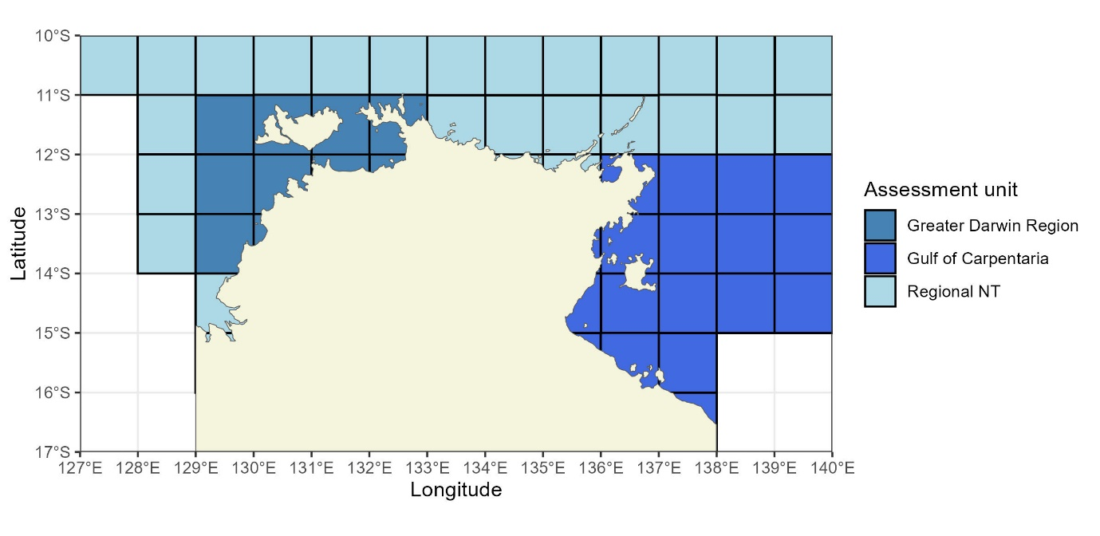
Figure 1: The boundaries of Black Jewfish assessment units according to fishing grids (black lines). Grids with no shading have had no Black Jewfish catches reported.

Previous assessments

Greater Darwin Region assessment unit
This assessment unit supports the highest catches of Black Jewfish in the Northern Territory and extends across an approximate radius of 300 km from Darwin. A 2014 stock assessment using a Stock Reduction Analysis indicated that Black Jewfish were overfished and that overfishing was occurring (Saunders et al., 2016). A subsequent assessment, using data up to 2019, indicated that the biomass had increased significantly to 93% of unfished levels (Saunders et al., 2020). At that time, the stock was considered unlikely to be depleted, and recruitment was unlikely to be impaired. This improvement was attributed to successive years of above-average recruitment, evidenced by a reduction in average length of monitored catches and an increase in the number of fish caught. Model outputs also suggested that fishing mortality was low, at only 24% of the level associated with Maximum Sustainable Yield, meaning that the current level of fishing mortality was unlikely to cause the stock to become recruitment impaired (Saunders et al., 2020).

Regional Northern Territory assessment unit
The Regional NT assessment unit was created in 2018 upon classification of the Greater Darwin Region as a separate unit based on stock structure research by Taillebois et. al. (2017). This management unit represents the NT waters between the Darwin Region and Gulf of Carpentaria management units. The previous assessment was undertaken using catch data from all commercial fisheries to 2019 applied to a modified Catch-MSY model developed by Martell and Froese (2013) and modified by Haddon et al. (2019). The results from this assessment indicated that the stock was unlikely to be depleted, that recruitment was unlikely to be impaired, and annual fishing mortality rates were unlikely to cause the stock to become recruitment impaired.

Gulf of Carpentaria assessment unit
In the Gulf of Carpentaria, Black Jewfish is taken by commercial trawl, net and line fishers as well as by recreational anglers and traditional indigenous fishers. Recent research highlighted that a single shared genetic stock exists in the Gulf of Carpentaria, which extends as far as the top of Cape York Peninsula (Williams et al., 2023). However, this research did not include other methods, such as parasites and otolith chemistry, that have indicated that stocks may exist at finer scales in other areas of the NT. The management unit was previously identified as an undefined stock, with insufficient evidence to confidently classify status (Randall, Williams, et al., 2023).

Overview of the fishery
The Coastal Line Fishery (CLF) is a multi-gear, multi-species and multi-sector fishery that spans the entire NT coastline, from the high-water mark to 15 nm from the low water mark. The CLF fishes for coastal reef species using predominantly hook and line methods. The fishery catches a wide range of coastal reef fish such as Black Jewfish, Golden Snapper, Grass Emperor, Coral Trout, cods and snappers. The majority of fishing activity in this fishery is concentrated around rocky reefs within 150 km of Darwin. To a lesser extent, fishing activity occurs adjacent to other popular coastal locations including Nhulunbuy and Borroloola (King Ash Bay). The CLF is managed as two separate zones that establish management of the commercial and fishing tourism sectors. The Western Zone extends from the Western Australia border to Vashon Head on Cobourg Peninsula at the point of latitude 11° 07.516' south, longitude 131°59.650' east. The Eastern Zone extends east from Vashon Head to the Queensland border (Figure 2). While not exactly aligned, the Western Zone generally corresponds with the Greater Darwin Region assessment unit, while the Eastern Zone incorporates both of the Regional Northern Territory and Gulf of Carpentaria assessment units.
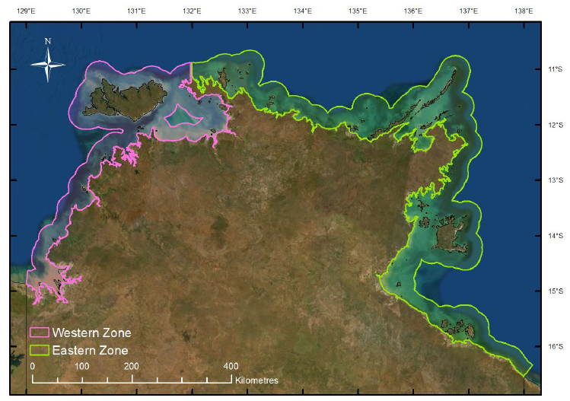
Figure 2: The management zones of the Coastal Line Fishery.

Fishing method
The principal fishing method used by all fishing sectors in the CLF is hook and line. This involves the use of weighted hand or reel lines (generally with baits or jigs). Recreational fishers and tourism clients mainly use rods and lines, while hand reels mounted to vessels (commonly known as deck winches) are used by commercial fishers. Reels are used to deploy and retrieve the line and are usually fitted with a drag system (a ‘brake’ system, which is designed to create resistance in the reel as the fish takes out line). Commercial fishers can also use drop lines that may contain up to 40 hooks. The hook and line methods employed in the CLF do not include fishing from a vessel that is under way and making way (e.g. fishing methods that involve trolling). Hand lines are the simplest form of fishing; they consist of one or more baited hooks attached to a line, which is retrieved by hand.

Management controls

Commercial sector
The commercial sector of the Coastal Line Fishery is managed using a combination of input and output-based management controls. The controls used differ between the two zones of the fishery. A summary of current management controls is shown in Table 1. The main management control used to limit catch in the Western Zone of the fishery is an Individual Transferable Quota (ITQ) system based on a Total Allowable Commercial Catch (TACC) of Black Jewfish (currently set at 143 t). Five spatial closures (Reef Fish Protection Areas) have also been implemented in the Western Zone to aid in the protection and recovery of at-risk reef fish from overfishing. These protection areas are located at Melville Island, Bathurst Island, Lorna Shoal, Charles Point and Port Keats (Howland Shoal and Emu Reef) and apply to all fishing sectors.
Table 1: Summary of current management controls for the commercial sector of the Coastal Line Fishery.
Management tool | Western Zone | Eastern Zone
Limited Entry | 50 licences, minimum quota holdings required | 50 licences
TACC | 145 tonnes of Black Jewfish | -
Permitted gear | Vertical line (1-5 hooks)  Cast nets (bait only)  Scoop net and gaff  Drop line (6-40 hooks)* | Vertical line (1-5 hooks)  Cast nets (bait only)  Scoop net and gaff  Drop line (6-40 hooks)*  Fish trap (5 per licence)*
Closed areas | Reef Fish Protection Areas | -
Catch and effort data | Daily logbook, submitted monthly | Daily logbook, submitted monthly
Pre-departure notice (includes prior landing) | 1-12 hours prior to undocking, specifies time and location of departure point and landing | -
Catch disposal record | Within 1 day of unloading (electronic scales) | -
Prohibited species | Barramundi, King Threadfin, Spanish Mackerel and Mud Crab | Barramundi, King Threadfin, Spanish Mackerel and Mud Crab
Catch restrictions | Shark (500 kg per trip) | Shark (500 kg per trip)
*-when fishing in waters from 2-15 nautical miles away from the coastline

Western Zone management areas
Inside the Western Zone, management areas have been established to improve management of Black Jewfish aggregations (Figure 3). These aggregations are separated by sufficient distance with negligible mixing between aggregations, indicating that they are likely to be separate stocks highly reliant on self-recruitment at time scales relevant to fisheries management (Porter et al., 2023; Randall, Saunders, et al., 2023; Saunders et al., 2017). Independent management of the aggregations is necessary to minimise the risk of overfishing and any associated displaced fishing effort within the broader ITQ management system for the Western Zone. The management areas for Black Jewfish in the Greater Darwin Region include Channel Point, Mitchell Point and Point Stuart (shown as A, B and C respectively in Figure 3). Access to these areas for recreational, commercial and fishing tourism sectors is dependent on the performance of commercial catch rates inside these areas, in accordance with the decision rules of the harvest strategy.

Figure 3: Map of the aggregation areas identified as priorities for management of Black Jewfish. in the Greater Darwin Region including Channel Point, Mitchell Point and Point Stuart (shown as A, B and C respectively).

Commercial catch limits for management areas
Catch limits specify the total amount (in weight) of Black Jewfish that can be taken each year by CLF licences inside the Greater Darwin Region management areas. The catch limits distribute the allowable catch for CLF licences in the Western Zone among known Black Jewfish aggregations and reduces the fishing pressure that could previously be exerted on individual aggregations. The catch limits were determined from the application of a Catch-MSY model adapted from Martell and Froese (2013) by Haddon et al. (2019) (See 2.9.2 for technical details). These catch limits are specified in the harvest strategy (DITT, 2023) and were established for each aggregation (Table 2).
Table 2: CLF licence catch limits for Black Jewfish inside each management area.
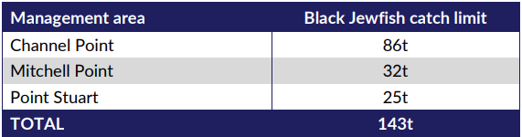

Recreational and Fishing Tourism Operators
The recreational and fishing tourism sectors are managed through a combination of input and output managements controls. These include spatial and temporal closures, personal and vessel possession limits for ‘at risk’ species that share life-history traits that make them vulnerable to overfishing (Table 3). Fishing Tour Operator (FTO) licences must also submit catch and effort logbook data for each day that was fished. In addition, access for FTO licences to reef fish in the Western Zone is restricted to existing licences granted before February 2015.
Table 3: Summary of current management controls for the recreational and fishing tourism sectors of the Coastal Line Fishery.
Management tool | Recreational | Fishing Tourism
General personal possession limit | 15 fish per person | 15 fish per person
Personal possession limits | 2 Black Jewfish | 2 Black Jewfish
Vessel limits | Vessels with 4 or less people on board, each person can take their personal possession limit  Vessels with 5 to 7 people on board can take a maximum of 4 times the personal possession limit of ‘at-risk’ species  Vessels with 8 or more people on board can take a maximum of 8 times the personal possession limit of designated ‘at risk’ species | Vessels with 4 or less people on board, each person can take their personal possession limit  Vessels with 5 to 7 people on board can take a maximum of 4 times the personal possession limit of ‘at-risk’ species  Vessels with 8 or more people on board can take a maximum of 8 times the personal possession limit of designated ‘at risk’ species
Catch and effort data | Recreational fishing surveys | Daily logbooks, submitted monthly
Licence restrictions | N/A | Reef fishing in the Western Zone is restricted to licences granted before February 2015.
Closed areas | Reef Fish Protection Areas | Reef Fish Protection Areas

Aboriginal Coastal Licence
Under Section 183 of the Fisheries Regulations 1992, an Aboriginal person who is a member of a community or group in respect of which land has been granted to a trust for the benefit of Aboriginals entitled by Aboriginal tradition to the use or occupation of that land under the Aboriginal Land Rights (Northern Territory) Act 1976 (Cth), may apply for an Aboriginal Coastal licence. The Aboriginal Coastal Licence allows Aboriginal people to establish small-scale fishing enterprises as a ‘stepping stone’ for entry into larger scale commercial fishing business. Entry into larger scale business would be through normal means of purchasing an existing licence in a commercial fishery. The main species caught using these licences are Mullet, Blue Salmon, Queenfish, Milkfish and Trevally. In addition, licence holders operating in the Western Zone of the fishery are only permitted to sell five Golden Snapper per month.

Aboriginal traditional fishing
The Aboriginal traditional fishing sector is entitled to use the resources of an area of land or water in a traditional manner. The Fisheries Act 1988 states that “Unless expressly provided otherwise, nothing in this Act derogates or limits the right of Aboriginal people who have traditionally used the resources of an area of land or water in a traditional manner to continue to use those resources in that area in that manner.” This entitlement does not extend to engaging in commercial fishing activities without a licence.

Harvest Strategy
The NT Coastal Line Fishery Harvest Strategy (the Harvest Strategy) was implemented on 1 July 2023 to guide the sustainable management of inshore reef fish under the NT Fisheries Act 1988. The Harvest Strategy monitor’s the fisheries performance and makes sure its operation is achieving its objectives.
The Harvest Strategy outlines the need to undertake regular stock assessments of inshore reef species including Black Jewfish and Golden Snapper, and take pre-determined management actions in response to the declining stock conditions. When a stock is found to be in decline, a recovery plan will be developed to ensure the management actions are bound by clear targets and timeframes.
The Harvest Strategy was developed in consultation with the Coastal Line Advisory Group, consisting of recreational, fishing charter, commercial and traditional fishing experts to ensure that fisheries managers, fishers and other stakeholders have a shared understanding of the how the Territory will manage inshore reef fish resources into the future.
The biomass estimate for the Greater Darwin Region assessment unit is the primary biological performance indicator for Black Jewfish under the Coastal Line Fishery Harvest Strategy (Table 4) (DITT, 2023). It sets biomass reference points for Black Jewfish at target (60% biomass), trigger (50% biomass) and limit (30% biomass) levels that are linked to decision rules that guides management actions should a reference point be met.
Table 4. Primary performance indicator for Black Jewfish in the Greater Darwin Region of the Coastal Line Fishery.
Performance Indicator | Method /  review period | Reference Points | Decision Rules
Biomass estimates | Stock assessment conducted on an annual basis | Target: 60% Biomass | Continue management aimed at achieving long-term fishery goals and if above Target for three consecutive years then consider providing an increase in the Total Allowable Catch as determined by scientific modelling.
Biomass estimates | Stock assessment conducted on an annual basis | Trigger: 50% Biomass | If below Trigger then reduce the total mortality by 10 to 50% as determined by scientific modelling to enable a return to Target within one generation (9.5 years) by:  Commercial: Reducing the previous year’s catch by an appropriate reduction in quota.  Recreational & FTO: Reducing the previous year’s catch by implementing a temporal or spatial closure.  All sectors: Implementing an education and awareness program.  Note: Management actions will be applied at a scale commensurate with sector specific use/risks
Biomass estimates | Stock assessment conducted on an annual basis | Limit: 30% Biomass | If below Limit then reduce the total mortality by 50 to 100% as determined by scientific modelling to enable a return to Target within one generation (9.5 years) by:  Commercial: Reducing the previous year’s catch by an appropriate reduction in quota.  Recreational & FTO: Reducing the previous year’s catch by implementing a temporal or spatial closure.  All sectors: Implementing an education and awareness program.  Note: Management actions will be applied at a scale commensurate with sector specific use/risks

A secondary biological performance indicator is in place for Black Jewfish to maintain the catch rate of Black Jewfish in the management areas within sustainable levels. This sets reference points using the mean standardised quarterly CPUE inside each management area between 2015/16 and 2019/20 for Black Jewfish at target (mean CPUE), trigger (50% of mean CPUE) and limit (25% of mean CPUE) levels.

Management history
Table 6 outlines the historic management changes of relevance to Black Jewfish in the Coastal Line Fishery. Over time management has sought to restrict the catch of Black Jewfish and other reef species, particularly in the Greater Darwin Region. Management changes include commercial licence reductions, spatial licence restrictions, reductions in recreational possession limits, Reef Fish Protection Areas and the introduction of commercial TACC and quota.
Table 6: Chronology of management arrangements of relevance to Black Jewfish in the NT Coastal Line Fishery.
Year | Management milestone
<1980 | - Commercial fishing carried out under a General Fishing Licence and general logbooks submitted
1980 | - Inshore Reef Fish Fishery licences introduced for commercial fishing of inshore reef fish.
1993 | - Licence moratorium and reduction scheme for Inshore Reef Fish Fishery licences.
1994 | - Declaration of the Coastal Line Fishery.
1995 | - Coastal Line Fishery outer boundary extended from 2 nm to 15 nm.  - A survey of recreational fishing in the Northern Territory (FISHCOUNT)
1996 | - “2 for 1” licence reduction scheme initiated for Coastal Line Fishery licences.  - A personal amateur possession limit of five Black Jewfish was introduced.
1997 | - A general amateur possession limit set to 30 fish per person was introduced.
2000 | - The National Recreational Fishing and Indigenous Survey.
2008 | - Sustainability concerns identified for stocks of Black Jewfish and Golden Snapper in the greater Darwin region.
2009 | - Ecological Risk Assessment conducted reinforced concerns overfishing was occurring for Black Jewfish and Golden Snapper.  - NT wide Recreational Fishing Survey.
2010 | - Personal amateur possession limit reduced from five to two Black Jewfish
2011 | - Commercial catch limits of 185 tonnes of Black Jewfish and 9 tonnes for Golden snapper were introduced for the greater Darwin area.  - Stock assessments indicated that Black Jewfish and Golden Snapper required a harvest reduction of 20% and 30%, respectively.
2012 | - Consultation paper ‘Proposed Future Management Arrangements for the Northern Territory Commercial Coastal Line Fishery’ released.
2013 | - Consultation paper ‘Protecting our Reef Fish and the future quality of our recreational fishery’ released.
2014 | - Stock assessments indicated that Black Jewfish and Golden Snapper now required a harvest reduction of 20% and 50%, respectively.  - Commercial catch limits revised to 145 tonnes of Black Jewfish and 4.5 tonnes for Golden snapper.  - Annual recreational fishing surveys commenced around the greater Darwin area.
2015 | - Fishery restructured to achieve desired harvest reductions and included:  - Restricting access to the Western Zone of the fishery for commercial and FTO fishers.  - Reef Fish Protection Areas were implemented in the Western Zone.  - General possession limit reduced from 30 to 15 fish per person.  - Vessel limits introduced to limit the catch of ‘at-risk’ species.  - Individual transferable quota of 145 tonnes of Black Jewfish and 4.5 tonnes of Golden Snapper introduced for commercial fishers in the Western Zone.  - CLF licences were made unrestricted and became transferable.  - Fish traps no longer permitted for use within the Western Zone.
2016 | - Stock structure of Black Jewfish and Golden Snapper identified as a series of discrete populations along the coastline.
2017 | - Management measures introduced to improve traceability of swim bladders from commercially caught product (including swim bladder tags).
2018 | - Amateur fishing regulations introduced for the possession of swim bladders.  - Black Jewfish and Golden Snapper listed as priority species under the Fisheries Act.  - Ecological Risk Assessment for the fishery completed.
2023 | - Coastal Line Fishery Harvest Strategy introduced, including:  - Black Jewfish Commercial catch limits for management areas (i.e. key aggregations).  - Performance indicators monitoring Black Jewfish stock status and catch rates in key aggregation sites.

Catch history

Greater Darwin Region assessment unit

Commercial harvest
Catches are presented on a financial year timestep, which matches the fishing season. Commercial catches from the Greater Darwin Region assessment unit have been spread across multiple fisheries, with the CLF, Barramundi and Demersal fisheries accounting for more than 99% of the catch (Figure 4). Each of these fleets complete daily logbook returns, which report catch by weight for each fishing event. Logbook records of commercial catches of Black Jewfish began in the early 1980’s and were initially taken by the Barramundi Fishery. Prior to this catch is poorly quantified but considered to be small. However, catches by the CLF increased considerably through time and it became the dominant fleet by the mid 1990’s. Catches then increased substantially over subsequent years, peaking at approximately 180 t in 2004/05 (Figure 4). Since then, total commercial catch has oscillated between ~ 90 – 160 t (Figure 4). In 2015 a TACC of 145 t was implemented through the introduction of quota management for Coastal Line Fishery commercial licences. Over the past ten years, almost the entire catch was taken by the CLF (Figure 4).
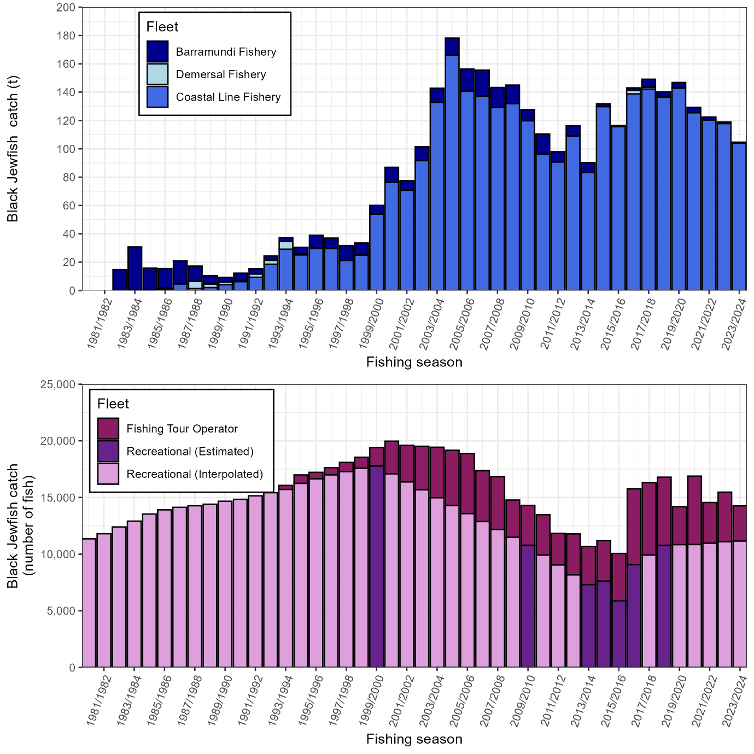
Figure 4: Catch history for Black Jewfish by fleet for the Greater Darwin Region assessment unit by fishing season (financial year). Note that catches are shown by weight for the commercial fleets (top panel; blue bars) and are shown by number for the recreational and FTO fleets (bottom panel; purple bars). Recreational catch is available in two forms: 1) Estimated from surveys (dark purple bars), or 2) Interpolated across years where no survey was undertaken (light purple bars). Several fleets with negligible catches have been incorporated into the CLF catches for clarity.

Recreational and FTO harvest
Catch is reported as number of fish by the FTO through daily logbook returns. Recreational catch is estimated in specific years from recreational fishing surveys. Fish recorded as ‘retained’ and ‘released’ are included in these harvest estimates (Figure 4) given the high post-release mortality suffered by Black Jewfish. However, the authors note this as a source of uncertainty regarding the total harvest estimates.
Statewide recreational fishery surveys were undertaken in 1999/00 (Henry & Lyle, 2003), 2009/10 (West et al., 2012) and 2017/18 (West et al., 2022) using a combination of phone diary and creel surveys. Boat ramp surveys have been undertaken within the Greater Darwin area in 2014, 2015, 2016, 2017, 2021 and 2022. Expanded catch estimates for the 2021 and 2022 were not yet available for this assessment. An additional Territory wide survey from 1995 is available but has not been used in the recreational catch reconstruction. The choice to exclude the data is based on expert advice from Kewagama Research, which noted the statistical methods employed by the survey are not comparable to more recent surveys. A lack of methodological detail in the survey report prevents further examination of the expansion methods and the data has been excluded based on the expert advice.
Estimates of recreational catch from these surveys are used as direct inputs into stock assessments. For years where surveys were not undertaken, estimates of recreational catch were linearly interpolated between intermittent years. Recreational catches prior to the first available survey in 1999/00 and following the most recent survey in 2018/19 were scaled according to changes in the population size of NT residents.
To enhance precision, catch data used in the Stock Synthesis assessment were entered as numbers of fish, superseding tonnage estimates derived from recreational surveys. Stock Synthesis converts these numbers to tonnage internally, leveraging the population dynamics model and length composition data to reflect fish size variability over time. This approach explicitly addresses size variation, a factor often poorly represented in direct tonnage surveys. Catch in weight was used in the Stock Reduction Analyses (SRA) as this assessment model does not internally convert fish from numbers to weight.
Recreational catch was highest in the 2000/2001 survey at 18,012 fish (Henry & Lyle, 2003) which subsequently declined to 10,779 (±1525) fish in 2009/10 (West et al., 2012)(Figure 4). Due to the large catch level estimated during the 1999/00 survey, it is understood that the recreational fishery initially dominated catches until the later development of the CLF in the early 2000’s. More recent survey estimates from 2013/14 to 2018/19 averaged lower estimates of 8,100 fish. This corresponds with reduced recreational possession limits for Black Jewfish from five to two in 2010 and implementation of reef fish protection areas in 2015.

Regional NT assessment unit
Domestic commercial catches of Black Jewfish in Regional NT have been below 32 t throughout the time series (Figure 5). Since 2011/12, catches by the Demersal Fishery have increased and now account for the majority of the catch. Total catch peaked at 32 t in 2020/21 (Figure 5). There is limited information on recreational fishing available for the Regional NT. Fishing Tour Operators catches are negligible and are reported as number of fish, rather than catch by weight. Therefore, these are not displayed in Figure 5.

Historic fishing by foreign vessels occurred in northern Australia from the 1950s through to 1990. The catch by these foreign fleets could be large, in 1987 the total allowable catch for trawlers in the foreign access zone was 7000 tonnes (Cann et al. 1989). Like domestic trawlers, Black Jewfish likely made a small component of the catch for foreign trawlers. Cann et al. (1989) provided the catch composition from surveys of foreign stern trawlers in the Araura Sea in 1987, however, as Black Jewfish or sciaenids are not singled out in the composition, catch for this fleet has been estimated by applying recent observed compositions to the total catch. Total Black Jewfish catch for this fleet peak at 70 tonnes in 1988/89 shortly before the fleet ceased operating within Australia waters in 1990.
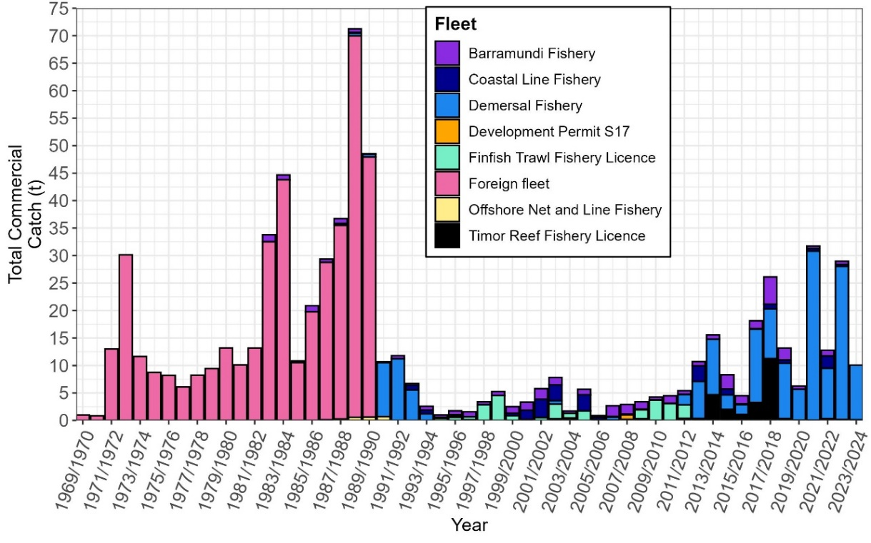
Figure 5: Annual catches by fleet for the Regional NT Black Jewfish assessment unit.

Gulf of Carpentaria assessment unit
Commercial catches of Black Jewfish in the Gulf of Carpentaria have been below 22 t in all but the two most recent fishing seasons (Figure 6). Similar to the Regional NT, the Demersal Fishery has increased its catches since 2012/13 and is the dominant fleet. The highest annual catch was 35t in 2022/23 which was more than 3 times larger than any annual catch prior to this (Figure 6). Catches by foreign fleets in this region are poorly defined and not included in this assessment. There is limited information on recreational fishing in the Gulf of Carpentaria. Fishing Tour Operators catches are negligible and are reported as number of fish, rather than catch by weight. Therefore, these are not displayed in Figure 6
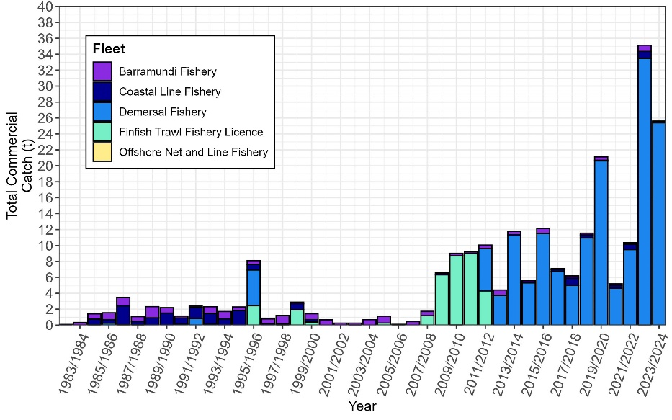
Figure 6: Annual catches by fleet for the Gulf of Carpentaria Black Jewfish assessment unit.

Aboriginal Traditional harvest
Black Jewfish harvest by the Aboriginal Traditional sector is poorly quantified in the NT and there are no contemporary estimates of Black Jewfish harvest available for this assessment. A modified creel survey was undertaken in 2001, which estimated fishing effort and harvest by Aboriginal fishers across northern Australia (Henry and Lyle, 2003). However, the survey contained no estimate of Black Jewfish harvest. Future assessments would benefit from the inclusion of an estimate of Aboriginal Traditional harvest.

Illegal fishing
High market value encourages illegal trade of Black Jewfish swim bladders. In 2017, several management arrangements were implemented to improve transparency of commercial fishing operations, including the requirement for commercial fishers to use authentication tags on all Black Jewfish swim bladders. New recreational fishing regulations were implemented in July 2018 to protect reef fish stocks from further depletion driven by the risk of an illegal swim bladder trade. The objectives of the management changes were to restrict opportunity to partake in illegal trade of swim bladders, increase awareness of the issues, improve stewardship of resources and ensure the enforcement risks are sufficient to act as a disincentive to target vulnerable species for profit. Despite these measures the high value of bladders still provides strong incentive for illegal trade. The extent of illegal fishing is poorly quantified and is acknowledged as a source of uncertainty for this assessment.

Stock assessment models

Stock Reduction Analysis (SRA)
Stock Reduction Analysis (SRA) is a population dynamics model consisting of life history parameters that describe the underlying production and carrying capacity of a population over time (Walters et al., 2006). Inputs include long term catch history and a time series index of abundance with the option of including age/length composition data (Lombardi & Walters, 2011). Stochastic SRA uses MSY (Maximum Sustainable Yield) and harvest fraction equivalent to MSY (HMSY) as leading parameters for the assessment.
The model simulates changes in biomass by subtracting estimates of mortality and adding new recruits, where the new recruits are a function of the current stock size and the leading parameters. Stochastic SRA provides probability distributions of population parameters over time, given alternative hypotheses about unfished recruitment rates and variability around the assumed stock-recruitment relationships. These distributions are generated by conducting a very large number of simulation trials and retaining those sample trials for which the stock would not have been driven to extinction by historical catches. A detailed description of Stochastic SRA can be found in Walters et al. (2006) and a summary in Grubert et al. (2013).
Stochastic SRA’s have previously been applied to Black Jewfish and used to assign stock status (Penny et al., 2018; Randall, Williams, et al., 2023; Saunders et al., 2016, 2020). However, the results of this modelling framework have yielded contrasting results for the Greater Darwin Region across assessments. Consequently, a new assessment framework (Stock Synthesis) was applied to the Greater Darwin Region and compared to the SRA results in this assessment report.

Catch-MSY
The Catch-MSY is a data-limited stock assessment method evolved from stock reduction analyses (Walters et al., 2006) but can be implemented for stocks that are relatively data poor. Catch-MSY is a ‘model-assisted’ stock assessment method (Martell & Froese, 2013) that only requires a time series of catch data and basic information on species productivity. The underlying stock dynamics are described by a simple biomass-based production model with parameters ‘r’ (the population growth rate), and ‘K’ (the population carrying capacity or unfished biomass). The model computes ratios of the initial and final catches relative to the maximum catch to set up arrays of potential values for the initial and final depletion levels. It also determines the potential range of r and K values, these can be modified by the user. The method randomly selects initial pairs of r-K values and sequentially steps through the years moving the population dynamics forward and subtracting the catches. A large number of iterations of the Catch-MSY model is run to generate 100,000s of possible stock reduction trajectories (Haddon et al., 2019).
The Catch-MSY model is implemented using the 'datalowSA' package in R (Haddon et al., 2019). Catch-MSY provides harvest fraction estimates to indicate fishing pressure on the stock. The harvest fraction (H, annual mortality rate) is converted to fully selected fishing mortality (F, instantaneous mortality rate) using the equation H = 1-exp^{-F}.
By using the average estimate of the r-K pairs from successful trajectories, reference points such as the virgin stock biomass (B0) and H_{MSY} can be derived. Both B0 and HMSY can be used to visualise and interpret how the history of catches from the fishery have impacted the stock being assessed. Stock estimates in the final model year can be related to these reference points to determine stock status. However, caution should be used in stock biomass trends from Catch-MSY as there is greater uncertainty as a consequence of using limited information to inform the model. As a general rule, Catch-MSY approaches should only be used when there is evidence of population responses in catch history series, and when catch has not been limited through management measures.

Stock Synthesis
Stock Synthesis is a fisheries population dynamics and stock assessment modelling framework developed by NOAA (Methot & Wetzel, 2013). It is an age-and-size-structured integrated stock assessment model that can be readily adapted to suit a broad range of species and fisheries. Stock Synthesis integrates multiple data sources including catch records, length composition, age composition, abundance indices, and tagging studies into a unified population dynamics model. Its main advantages are that it is highly customisable but uses a consistent structure for model inputs and provides standardised outputs that are familiar to the wider stock assessment scientific community. As a result, models implemented in Stock Synthesis can be developed effectively, within shorter time periods than bespoke models, are easy to review by external scientists, and can easily be tailored to run detailed sensitivity scenarios and explore parameter uncertainty. A series of auxiliary packages including r4ss (Taylor et al., 2021) and ss3diags (Carvalho et al., 2021; Winker et al., 2025) are available to provide detailed model outputs such as estimated quantities, model fits to data, diagnostics and model comparisons. The Stock Synthesis model presented in this report is the first developed for Black Jewfish in the NT and makes use of these features.
This is the first stock assessment report to apply a Stock Synthesis model to Black Jewfish in the Greater Darwin Region assessment unit and follows on from a recent application of this framework to Golden Snapper in the NT.

Criteria for determining stock status

Reference points
The state of fish stocks are classified based on two indicators:
1) B30% - 30% of unfished biomass (B30%) is specified as the limit reference point in the Coastal Line Fishery Harvest Strategy (DITT, 2023). A biomass of less than 30% was determined to be an unacceptable level of depletion for the management of the species in the Coastal Line Fishery.
2) F_{MSY} – Fishing mortality at Maximum Sustainable Yield (F_{MSY}) is the fishing mortality that would produce maximum sustainable yield (MSY).

Stock status
Stock Status was assigned according to the National Fishery Status Reporting Framework (Piddocke et al., 2021). There are six stock status categories that can be assigned, with four of these determined through defined biological and exploitation reference points (Table 7).

Table 7: Stock Status categories defined according to the National Fishery Status Reporting Framework.
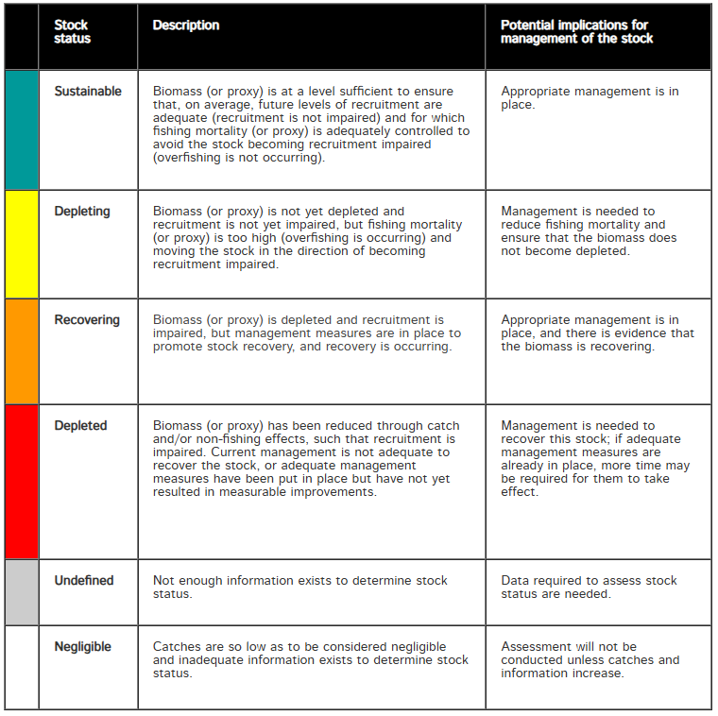
The reference points B₃₀ and F_{MSY} are used to determine stock status and are provided in a phase plot to determine the appropriate category (Figure 7). The relative stock biomass for the most recent year (B_{2023/24}/B₀) is compared with B₃₀ to determine whether the stock is ‘recruitment overfished’. The harvest from the same assessment year (F_{2023/24}) is compared with F_{MSY}.
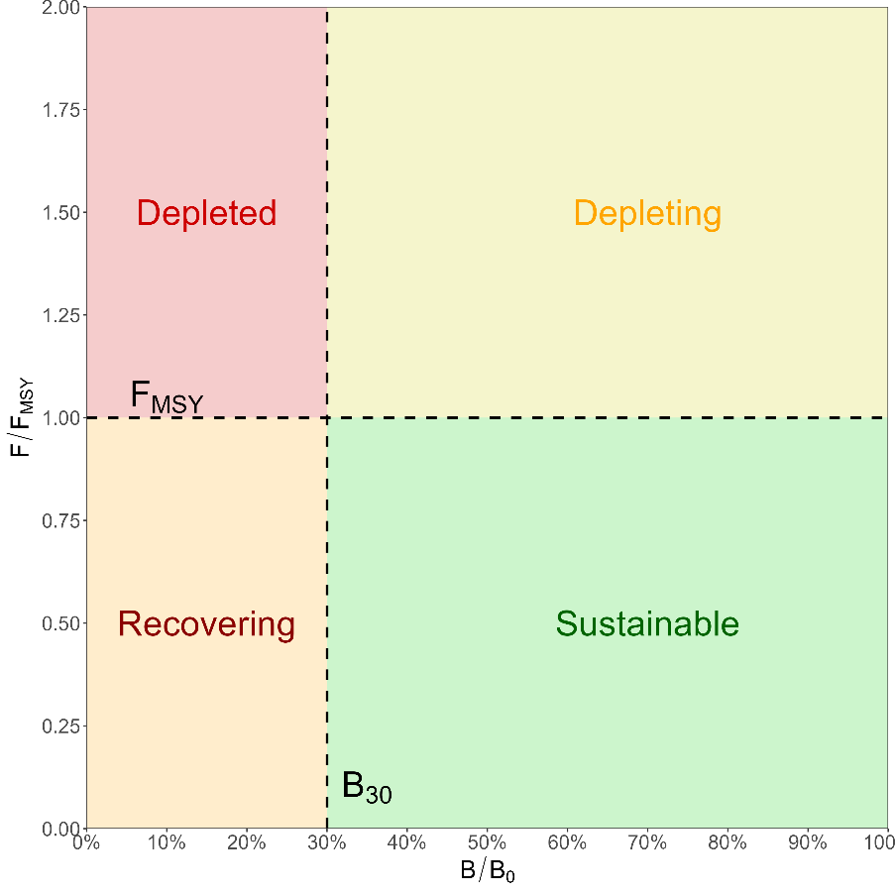
Figure 7: Stock status diagram indicating the categories specifies in the National Fishery Status Reporting Framework (Piddocke et al., 2021).

Stock Synthesis - Greater Darwin Region assessment

Model structure
The Stock Synthesis model for Black Jewfish in the Greater Darwin Region had an underlying structure that encompassed a single area, combined sexes, and a population that reached a maximum age of 14 years. The growth, recruitment and mortality of the population were estimated using an annual time step based on a financial year (June to July), which aligns with the licensing year, with recruitment occurring in January. The data inputs included harvest estimates from all commercial and recreational fishing fleets, an index of abundance estimated from standardised catch per unit effort (CPUE) for the CLF, length compositions and conditional age-at-length (CAAL) data from the CLF. Key data inputs and information of the model are informed by two FRDC funded reports on NT Black Jewfish populations (Phelan, 2008; Randall, Saunders, et al., 2023).
The Stock Synthesis assessment conducted in this report refers to a ‘Base Case’ model as well as sensitivity scenarios (Section 3.6). The Base Case is the final model used to infer all conclusions on Black Jewfish population trends and stock status. It represents a culmination of model development where many iterations of Stock Synthesis models were created, explored and critiqued by using various data inputs, sources of information and structural decisions. Ultimately, the Base Case model made the best use of all available data, was underpinned by judicious and defensible decisions, and provided a final model that fit the data well, passed all diagnostic checks and remained stable following tuning procedures.
Sensitivity scenarios represent alternative models that would be presented as a Base Case if different decisions were made, or they provided superior data fits to the eventual Base Case. The purpose of presenting multiple sensitivity scenarios is to demonstrate support for the Base Case model, illustrate how and why key modelling decisions were made, provide transparency into the model development process, and thoroughly explore feasible alternative model configurations.

Fleets and selectivity
The Stock Synthesis model was composed of five fleets:
- Coastal Line Fishery
- Barramundi Fishery
- Demersal Fishery
- Fishing Tour Operators (FTO)
- Recreational Fishery
A sixth fleet, “Research”, was also included in early stages of model development to attempt to include length and age data that were collected by a targeted research project from 1995/96 to 1999/00 (Williams unpublished data). However, these data conflicted with the other model inputs and any attempt to incorporate them through using different fleet selectivites were unsuccessful. These data are provided for completeness in Sections 3.3.3 and 3.3.4. Versions of the Stock Synthesis model that include these data are also provided as sensitivity scenarios (Section 3.6). However, they are not included in the Base Case nor the broader suite of sensitivity scenarios.

Length selectivity
Length selectivity was used for all five fleets and the shape of the function was based on the available length data (Section 3.3.3). A length selectivity incorporating a cubic spline with six knots was used for the CLF, FTO and Recreational fleets (as well as the Research fleet in the corresponding sensitivity scenarios). This was performed to accommodate a bimodal length distribution that differed in shape for these fleets. A logistic function was applied to the Barramundi and Demersal fleets where no length data were available.
The selectivity functions were estimated for the CLF and FTO fleets (as well as the Research fleet in the corresponding sensitivity scenarios). No length data were available for the Recreational Fishery, but the FTO data are used to inform this fleet in this assessment. Therefore, the FTO selectivity was mirrored to the recreational fleet. The logistic selectivity for the Barramundi and Demersal fleets was pre-specified with an inflection of 62 cm and a slope of 9 cm.

Age selectivity
Age selectivity was only used for the CLF (as well as the Research fleet in the corresponding sensitivity scenarios) as no age data were available for any other fleets. Age selectivity was estimated as a logistic function for these fleets. All other fleets had age selectivity set to 100% for all age classes, which means that only length selectivity is applied.

Data inputs
The Greater Darwin Region assessment spanned from 1981/82 to 2023/24 and included total removals by the commercial, FTO and recreational sectors (Figure 4). The assessment also includes standardised CLF CPUE as an index of abundance, length compositions for the CLF and FTO fleets and CAAL for the CLF fleet (Figure 8).
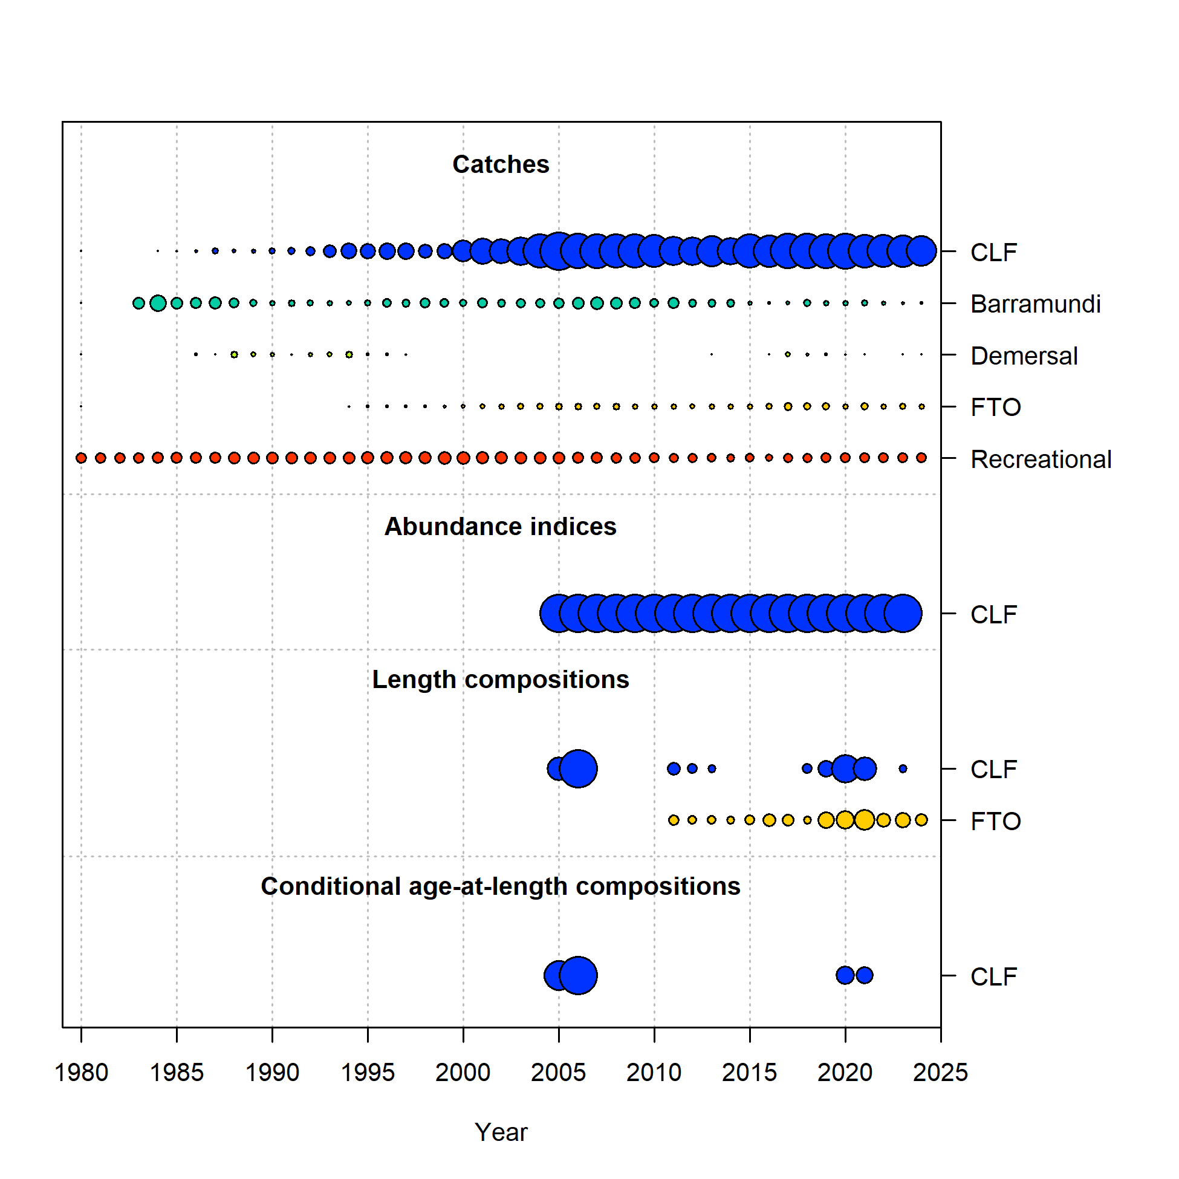
Figure 8: Time series of data inputs by fleet for the Greater Darwin Black Jewfish assessment. The size of bubbles indicates the relative size of catches, magnitude of abundance indices or sample sizes of compositions. The x-axis displays integer years where 2025 corresponds to the 2024/25 fishing season, and so forth.

Harvest
The fleet specific harvest estimates presented in Section 2.7 were used in the Stock Synthesis assessment (Figure 4). This included the input of FTO and recreational catch as catch in numbers, rather than weight (Section 2.8.1.2). An initial equilibrium catch was set for the recreational fleet to indicate likely levels of catch prior to the model start year (1980/81). This level of catch was determined based on the interpolated estimate of recreational catch for 1980/81 and represented the long-term average catch that was being sustained by the population before the model start year. This allowed the model to estimate an initial level of exploitation prior to the introduction of other data sources, with the assumption that the population was in equilibrium at the start of the model time period (1980/81) (Figure 4).
Black Jewfish would also have been harvested as bycatch in the Barramundi and Reef and Line fisheries, however, the total amount landed would have been within the interpolated catch for recreational fishing specified here. It is likely that the interpolated recreational fishing on its own is an over-estimate. This is because the population of Darwin increased substantially over the period 1970 to 1990, and infrastructure to support fishing increased correspondingly. Standard of living and technology (boats motors, fishing gear, etc.) increased as did the infrastructure of Darwin, including road access and facilities such as boat ramps. It is notable that through the 1990s to 2000, GPS became generally available and fish finding improved markedly, 4-stroke motors (with their increased reliability) became more available as did mobile phones (and coverage) became more widespread and useable. Recreational fishing that targeted Jewfish aggregations, including FTO opportunities, would have also increased in this period.
Post-release mortality is high for Black Jewfish (Phelan, 2008) which is why there are no minimum legal-size limits for this species in the NT. Recent evidence suggests that this mortality is particularly pronounced for large fish, as collection of large mature Black Jewfish for aquaculture purposes has failed. Despite being landed delicately and receiving substantial post-capture care, all large fish perished, sometimes several hours after capture (C. Errity, personal communication, 2 August, 2023). Accordingly, estimates of released fish by the FTO and recreational fleets have been included in the retained catch (Figure 4), which is equivalent to applying a 100% mortality to released fish.

Abundance indices
Standardised CPUE for the CLF was the only abundance index used in the Stock Synthesis assessment, as ambiguity in species targeting and effort reporting prevented CPUE from being used for any other fleet. Catch and effort records reported in CLF logbooks were used to standardise CPUE between 2004/05 and 2022/23. Data prior to this were not included as effort entries were deemed inconsistent during earlier periods of logbook reporting. These inconsistencies in effort units would disrupt the CPUE series and prevent it from being a reliable index of abundance.
Given the multi-species and multi-gear characteristics of the CLF, the data was filtered so that appropriate records were used to derive an index of abundance. The following data rules were applied:
- Only handline data were included, with all other gears removed. Handlines constitute the majority of the catch and effort in the CLF.
- Seven zero-catch records occurred, which were removed to allow log-link functions to be applied across a greater number of potential error structures.
- Only grids within the Greater Darwin Region were included.
- Licences that had not reported Black Jewfish catch in at least 10 fishing seasons (did not need to be consecutive) were removed.
CPUE was defined as the total whole catch of a fishing event (which can include multiple days) divided by the total fishing hours, which was defined as the number of reported hours multiplied by the number of lines used:
$$CPUE= \frac{Catch (kg)}{Fishing duration x Number of lines}$$
A Generalised Linear Mixed Model (GLMM) was used to standardise CPUE using the glmmTMB R package (Brooks et al., 2017). The model considered variables that included fishing season, month, grid code and licence number. A stepwise approach was used to determine the most appropriate variables for the model by applying a multi-model analysis through the dredge function in the MuMIn R package (Bartoń, 2024). This function fits a GLM to all possible combination of variables and ranks their fit according to AIC. All variables were supported and included in the final model formula. A series of fixed and random effects (which do not get included in dredge analyses) were then added and examined across variables. The resulting abundance index was determined using the coefficients of the ‘Year’ variable on the response scale. Further, the predicted abundance index values are ‘scaled’ by dividing each value through by the mean of the time series. This sets the average value to 1.0, which permits simple visual comparison with other time-series.
Several error structures were examined which included Gaussian, Tweedie and gamma distributions with identity, inverse and log-link functions. Model diagnostics were examined using the performance and DHARMa R packages to determine the appropriate model structure with regards to included variables and error structure (Hartig, 2024; Lüdecke et al., 2021). Ultimately, these diagnostics and AIC determined the following model, fit with a gamma distribution with a log-link function, best suited the data:
CPUE ~ 0 + Year + (1|Grid:Year) + Month + (1|Licence)
where Licence was fitted as a random effect while Grid and Year were treated as a crossed random effect (i.e. neither Grid nor Year is “nested” in the other).
Model diagnostics demonstrated that the final model fit the data well, did not contain any collinear variables, was not influenced by outliers and had no overdispersion. The full methods, diagnostics and results of the CPUE standardisation analysis are provided in Section 10.1.
Standard errors estimated from a GLMM can be very small as they are based on a large number of data points. Therefore, a loess smoother was fit through the point estimates of the standardised CPUE and the deviation between the two series was used to express the variability of the standardised CPUE (Punt, 2023). However, this error estimate was still comparatively small relative to the nominal CPUE (Figure 9).
The final GLMM demonstrated that the standardised CPUE index showed a similar trend to nominal CPUE but accounted for the variability introduced by other factors such as licence and spatial heterogeneity (Figure 9). The similarity between the nominal and standardised CPUE trends is to be expected given the commercial CLF fleet consists of relatively few vessels that targets spatially consistent aggregations.
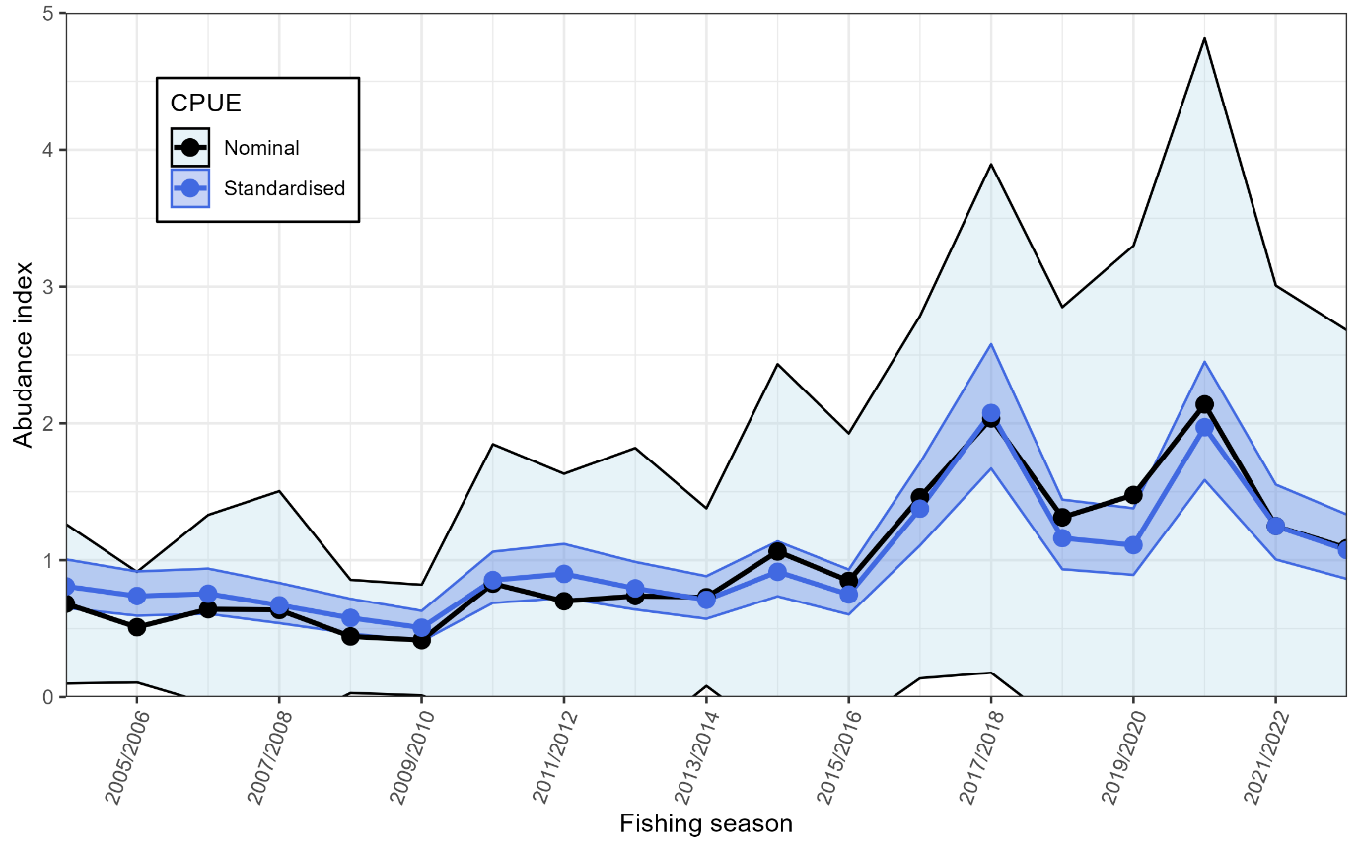
Figure 9: Standardised abundance index for Black Jewfish using CLF CPUE data from 2004/05 to 2022/23. Nominal CPUE is displayed as the black points and line with light blue shading. Standardised CPUE is the dark blue points, line and shading. The shading of the standardised CPUE represents standard error determined from the fitted model outputs and loess smoother, while the shading of the nominal CPUE is the standard deviation of the data. Both series have been centred on a mean of 1 for direct comparability rather than being expressed as kg per hour.

Length compositions
Length compositions were collected by observers on board CLF and FTO vessels from 2004/05 and 2010/11 onwards, respectively (Figure 10). Length samples for the CLF were also sampled through FRDC funded research projects in similar locations, and with similar gear to the CLF (Phelan, 2008; Randall, Saunders, et al., 2023). Between 1995/96 and 1999/00, length samples were also collected on research sampling trips conducted by James Cook University (JCU; Williams, unpublished data) and these data are stored in NT Fisheries databases. The selectivity of the samples collected by JCU (Williams, unpublished data) appeared to change across years, accessing greater proportions of smaller fish prior to 1998/99 (Figure 10). Therefore, these samples were not included as part of the CLF fleet and were separated into a specific ‘Research’ fleet (Figure 10). The same distinction was performed for age samples (Section 3.3.4). Length samples collected by Randall et al. (2023) and Phelan (2008) were indistinguishable to CLF samples collected by observers and were therefore combined with the observer data.
All fish were grouped into 2 cm total length (TL) bins to better estimate faster growth for earlier ages in Stock Synthesis. Data were filtered for the CLF so that years with small sample sizes (< 100 fish) were not included. No data were filtered from the FTO length samples given the low sample sizes that occurred in most years. Sexes were combined in the Base Case Stock Synthesis model as male and female length compositions had indistinguishable distributions for all fleets. This provided larger sample sizes and meant that fewer years were filtered from the data. Sensitivity scenarios were performed where sex specific length and age data were provided to Stock Synthesis (Section 0). The relative sample sizes (by year and fleet) used in the Stock Synthesis model were based on the number of fishing trips that lengths were collected from.
The length compositions of each fleet were bimodal, but the modes differed between all three fleets (Figure 10). The FTO length samples comprised far smaller fish than from CLF and Research fleets, with a modal range of less than 60 cm TL in most years (Figure 10). While the CLF and Research fleets did capture fish less than 60 cm TL, most of the length samples were greater than 100 cm TL (Figure 10), demonstrating a markedly different selectivity to the FTO fleet. The largest fish measured was 140 cm TL and was captured by the CLF fleet (Figure 10).
The variable sampling of smaller fish by the JCU Research fleet from 1995/96 to 1999/00 caused model estimation issues when included in initial Stock Synthesis model runs. The lack of information on how these lengths were sampled, combined with what appeared to be inter-annual changes in selectivity meant that they could not be included in the final Stock Synthesis Base Case model (Section 3.7.1) and were instead included in sensitivity scenarios (Section 0). Length compositions for the Research fleet are still presented here for completeness (Figure 10).
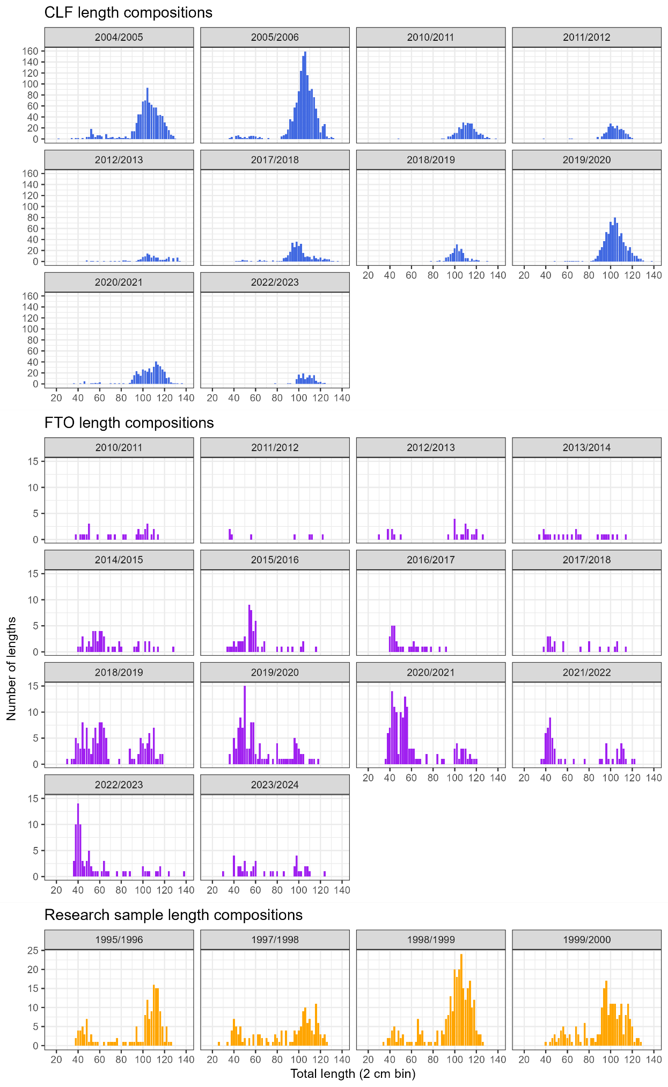
Figure 10: Length compositions collected by financial year for the CLF (Blue), FTO (Purple) and Research (Orange) fleets. Only years of data included in the Stock Synthesis models (Base Case or sensitivity scenarios) are presented.

Age compositions & conditional age-at-length
Length-at-age data have not been collected by fisheries observers’ onboard CLF or FTO vessels and have instead been collected by three research projects at different points in time
- JCU research sampling from 1995/96 to 1999/00 (Williams unpublished data).
- From 2004/05 to 2006/07 by Phelan (2008).
- From 2018/19 to 2020/21 by Randall et al. (2023).
As noted in Section 3.3.3, the samples collected by Phelan (2008) and Randall et al. (2023) are representative of the CLF and are therefore associated with this fleet. However, the samples collected by the Research fleet (Williams unpublished data), appear to have changing selectivity across years where greater numbers of smaller and younger fish were sampled in comparison with the CLF. An attempt was made to capture these differences in Stock Synthesis by assigning these samples to a Research fleet, rather than the CLF (Section 3.6). However, these attempts were unsuccessful and samples from the Research fleet were not included in the Base Case model. Age compositions and conditional age-at-length (CAAL) data for the Research fleet are still presented here for completeness (Figure 11, Figure 12).
The sexes were also combined for the age compositions and CAAL data. Years with fewer than 20 fish ages were not included in the Stock Synthesis model. This excluded fish sampled in 2006/07 and 2018/19 (Figure 11, Figure 12). Twenty five age-zero fish were sampled across the two periods by Phelan (2008) and Randall et al. (2023). These fish were relatively large (> 40 cm TL) and were likely approaching 1 year of age based on this size. These fish did not influence the final growth curve estimated by the Stock Synthesis model but produced overly large residuals as they suggest a large and implausible length-at-birth. They were therefore treated as spurious data and were excluded from the final stock assessment model and are not displayed in Figure 11 or Figure 12.
Age compositions are presented here as they provide useful insight into the changing age structures through time (Figure 11). However, only CAAL data are input to Stock Synthesis as these data serve a dual purpose for estimating population age structure and fish growth. They also allow the same fish to be included in the length compositions (Figure 10) by avoiding ‘double counting’. The use of age compositions rather than CAAL in Stock Synthesis would therefore reduce the amount of length data.
A greater number of ages were sampled by Phelan (2008) than Randall et al. (2023), with a greater proportion of older fish occurring in 2004/05 to 2005/06 than 2019/20 to 2020/21 (Figure 11). The oldest fish sampled in the later period was 8 years old (Randall, Saunders, et al., 2023) whereas several fish older than this were sampled by Phelan (2008), with the oldest being 13 years old (Figure 11). Notably, the oldest fish sampled by the Research fleet from 1997/98 to 2000/01 was 7 years old (Figure 11), despite a much lower level of exploitation occurring prior to and during this period (Figure 4). As more older fish would be expected from this period, this discrepancy is one of the reasons why selectivity was believed to differ between these samples (Williams, unpublished data) to that of the CLF fleet and Phelan (2008) and Randall et al. (2023).
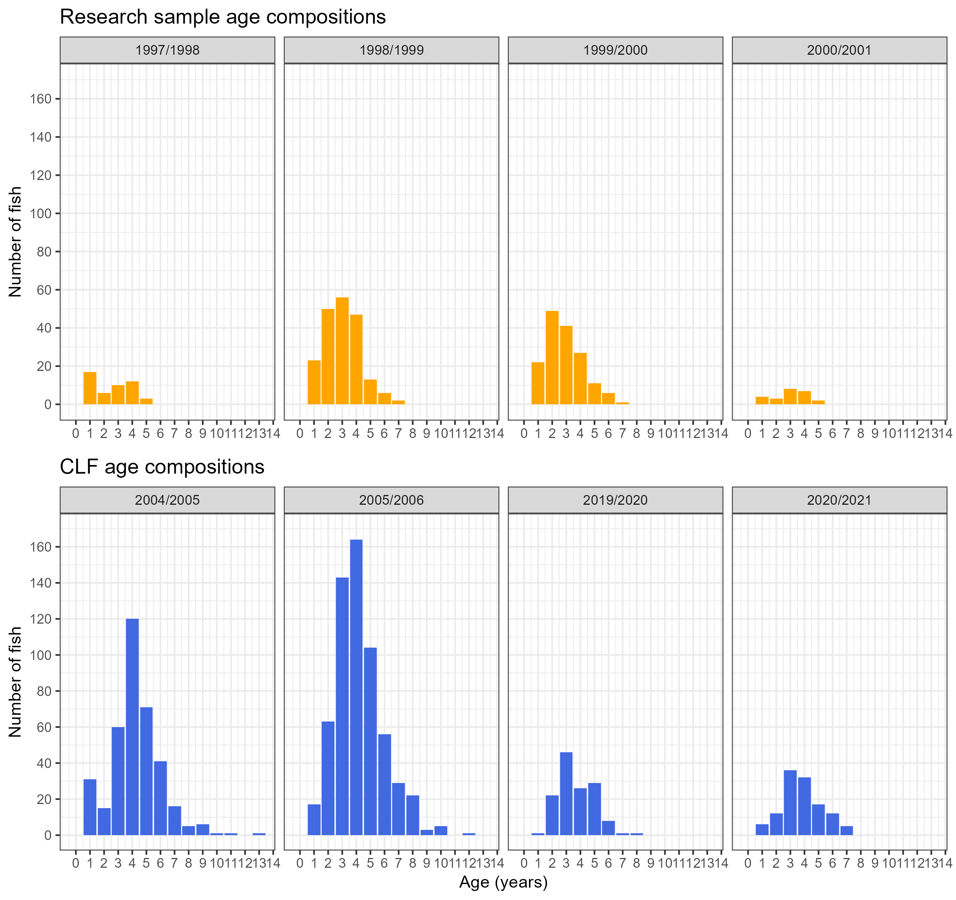
Figure 11: Age compositions collected by financial year for the CLF (Blue) and Research (Orange) fleets. Only years of data included in the Stock Synthesis models (Base Case or sensitivity scenarios) are presented.

The CAAL data showed that ages from large fish (> 100 cm TL) were relatively well sampled across all years, although older fish (> 5 years old) were sampled far more frequently from 2004/05 to 2005/06 (Figure 12). The fast growth of Black Jewfish is apparent in these samples as fish can grow beyond 100 cm TL by age two (Figure 12). Black Jewfish can grow to ~140 cm TL and the largest fish aged was 133 cm TL at 7 years of age, demonstrating that fish reach their maximum size at a relatively young age (Figure 12).
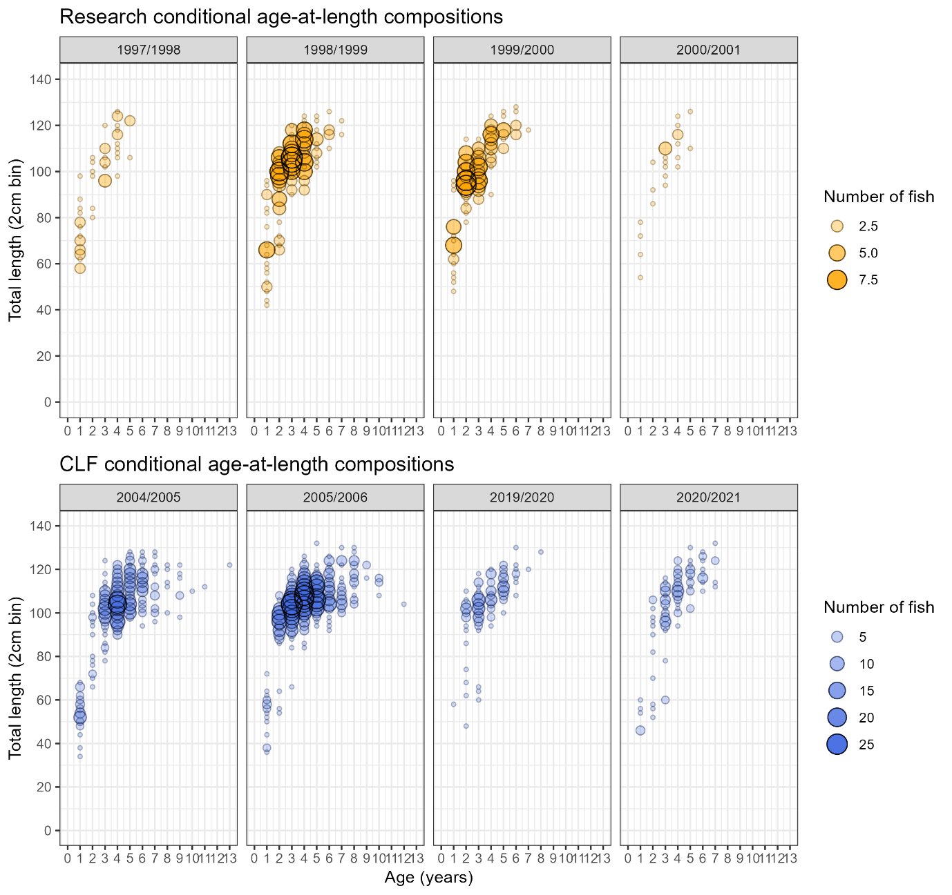
Figure 12: Conditional age-at-length data by financial year for the CLF (Blue) and Research (Orange) fleets. Size of bubbles represents the number of fish of that age and length bin. Note the different scales for fish size between fleets. Only years of data included in the Stock Synthesis models (Base Case or sensitivity scenarios) are presented.

Ageing error was incorporated in the Stock Synthesis model from multiple growth band reads undertaken for age samples collected in 2019/20 and 2020/21. Information on multiple growth band reads was not available from earlier periods so no information on ageing error is provided from other years. The ageing error matrix for ages from 2019/20 to 2020/21 was estimated using the AgeingError R package (Punt et al., 2025) which implements the methods of Punt et al. (2008).

Black Jewfish biology

Growth, weight-length relationship, maturity & fecundity
Growth was estimated within the Stock Synthesis model using a von Bertalanffy growth function (VBGF). Stock Synthesis uses a different parameterisation to the typical VBGF (Beverton & Holt, 1957; von Bertalanffy, 1938), where two specified lengths-at-age are estimated (L₁ and L₂) (Methot & Wetzel, 2013). These were defined as L₁ = the length at 0.5 years old and L₂ = the asymptotic length (L∞). Early model versions that assigned no priors tended to estimate a L∞ that was larger than the species’ known length range (~140 cm TL). To produce more realistic L2 estimates and overcome bias associated with length selectivity (Section 3.3.3) priors were placed on L₂ to estimate a parameter posterior distribution within Stock Synthesis. To provide these priors, as well as parameter starting values, a Bayesian VBGF was first fitted to the CAAL data, before application in the SS model, using the BayesGrowth R package (Smart, 2020; Smart & Grammer, 2021). This was performed for sexes combined as previous research has shown that growth does not differ between sexes (Randall, Saunders, et al., 2023) and omitted age zero fish, as discussed in Section 3.3.4.
The Bayesian growth curve was fit using informative priors for L∞ (N[130, 15]),length-at-birth L₀ (p_{[0, ∞]}N[0, 0.001]), uniform priors for the growth coefficient k (U[0.001, 2]) and the residual standard deviation σ (U[0.00, 200]) (Smart & Grammer, 2021). Model estimation was performed using Markov Chain Monte Carlo with 10,000 iterations, across three chains, with a burn-in of 1,000 iterations. Model diagnostics were examined using the bayesplot R package (Gabry & Mahr, 2020) to ensure that the chains had mixed, posterior distributions were not multimodal, that each parameter had reached convergence and that no autocorrelation was present. The resulting growth model estimated L∞ = 114.1 cm (± 0.46 se), k= 0.75 yr⁻¹ (± 0.01 se) and L₀ = 0 cm (± 0.001 se) (Figure 13).
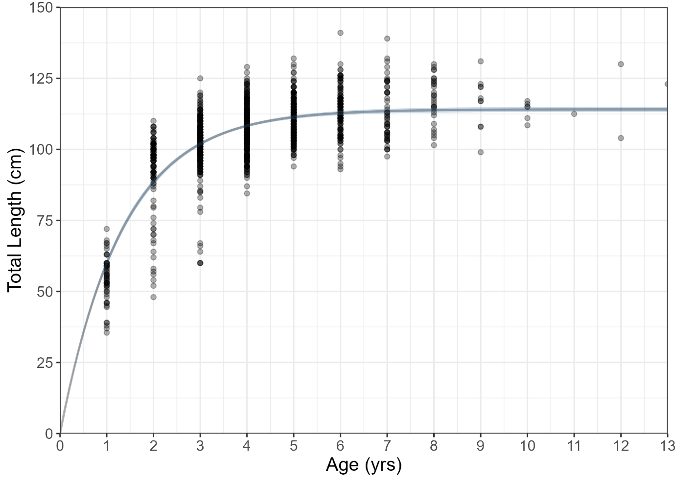
Figure 13: Bayesian von Bertalanffy growth curve fit to Black Jewfish CAAL data for sexes combined. The black points are individual fish length-at-age estimates, the black line is the fitted relationship, and the lighter blue shading represents the 95% confidence intervals.

The resulting growth estimates were used to apply lognormal priors to L₂. The coefficient of variation (CV) of length-at-age at L₁ and L₂ was estimated in the Stock Synthesis model without any priors.
The weight-length relationship was estimated externally to stock synthesis using data from Randall et al. (2023) (Figure 14). This was performed by fitting a linear model to fish weight (kg) and length (cm) data in log₁₀ space, and then converting back to natural space after applying a bias conversion factor (Ogle, 2016). These parameter values were then provided as pre-specified inputs to Stock Synthesis.
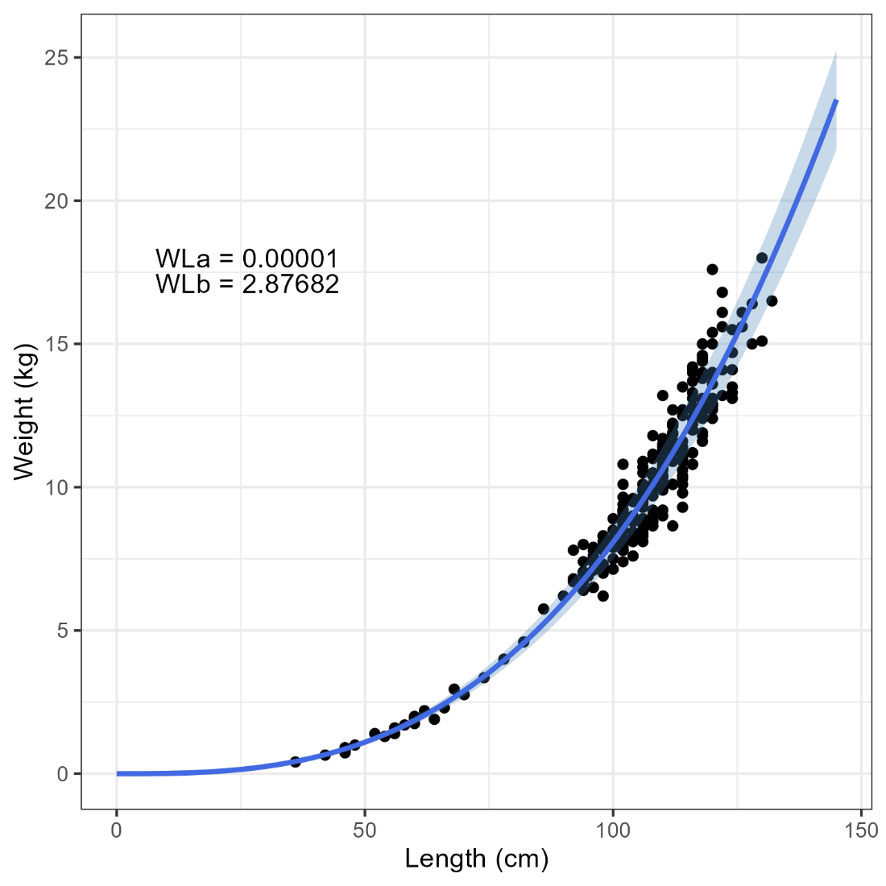
Figure 14: Weight-length relationship for Black Jewfish for sexes combined. The black points are individual fish measurements, the blue line is the fitted relationship, and the lighter blue shading represents the 95% confidence intervals.

Length-at-maturity was pre-specified in the model as L₅₀ = 89 cm and L₉₅ = 95 cm (Randall, Saunders, et al., 2023). No information on fecundity was available. Therefore, this was pre-specified to be equivalent to spawning biomass.

Natural mortality
Natural mortality (M) was estimated in the model using a lognormal prior based on empirical estimators, as recommended by best practices outlined in Maunder et al (2023). The lognormal prior was determined using the natural mortality estimator tool (Cope & Hamel, 2022; https://connect.fisheries.noaa.gov/natural-mortality-tool/) using the composite inverse variance approach for the following empirical methods (as per their names used in the natural mortality estimator tool): Then_nls, Then_lm, Then_VBGF (Then et al., 2015), Hamel_Amax, Hamel_K (Hamel, 2015), Jensen_K1, Jensen_K2, Jensen_Amat (Jensen, 1996), Pauly_lt (Pauly, 1980), Roff (Roff, 1984), and Ri_Ef_Amat (Rikhter & Efanov, 1976). Each of these methods provides an indirect estimate of M and is based on biological information such as growth, longevity or maturity (Section 3.4.1). However, each individual method has its own uncertainty and methods typically provide different estimates to one another. Combining these indirect estimates of M in a composite approach better encapsulates the uncertainty that exists in M and incorporates it within a stock assessment model through a prior (Cope & Hamel, 2022; Maunder et al., 2023). Estimating M within Stock Synthesis in this fashion also incorporates its uncertainty into model estimated quantities such as spawning biomass and relative spawning biomass (Maunder et al., 2023). This would not occur if M were pre-specified as the modelled uncertainty of these processes would be underestimated.

Recruitment
Recruitment was estimated within the model using a Beverton and Holt stock recruitment relationship (Beverton & Holt, 1957). The level of virgin (i.e., unfished) recruitment (R₀) was estimated in Stock Synthesis as a leading parameter while recruitment steepness (h) was pre-specified as 0.7. Steepness is a parameter that indicates recruitment compensation as spawning biomass decreases. An h value of 0.7 indicates that a recruitment equal to 70% of R₀ would be expected if spawning biomass were reduced to 20% of unfished levels. The value of 0.7 was determined based on the relatively productive biology of Black Jewfish and was assessed for appropriateness through parameter profiling (Appendix 10.2.3).
Recruitment deviations for the main time series were estimated between 1990/91 and 2020/21, while early phase recruitment deviations were estimated from the beginning of the time series. The timeframe of the main recruitment time series was determined based on the availability of length and age samples which are the key data that inform recruitment strength. The asymptotic standard error of annual recruitments (outputted using r4ss) was referred to when determining this period. Estimating recruitment in the most recent model years is rarely possible, as there should ideally be several years of composition data available to adequately estimate recruitment strength, which are never available for the most recent model timesteps.
The standard deviation of the natural log recruitment (σ_{R}) was initially pre-specified at 0.6 to represent that recruitment can fluctuate to a reasonable degree around the stock recruitment relationship based on environmental influences. This parameter was subsequently updated as part of the modelling tuning procedure (Section 3.5). The recruitment bias adjustment ramp was adjusted using recommended settings outputted through r4ss (Methot & Taylor, 2011) and was also updated through the modelling tuning procedure (Section 3.5).

Model tuning
Following the estimation of a Base Case model, a series of model tuning procedures were performed. The purpose of these procedures was to ensure that different data inputs or model settings were appropriately weighted or optimised for the model. The model tuning procedures included:
- Tuning the length and age composition data using the Francis method (Francis, 2011).
- Updating the recruitment bias adjustment ramp (Methot & Taylor, 2011) based on the alternative settings recommended by the initial Stock Synthesis Base Case run.
- Updating the pre-specified value of σ_{R} based on recommendations from r4ss.
- Re-applying the length and age composition tuning using the Francis method (Francis, 2011).
An additional tuning step was tested which included allowing Stock Synthesis to estimate an additional level of variance for the CLF abundance index. However, estimating additional variance for the CLF abundance index yielded no update to the model as no additional variance was estimated. Therefore, this step was not included in the final model tuning.
The methods outlined here follow the best practices recommended by Punt (2023). Any scenario that considered different sex structures or treatment of length and age compositions was also tuned using these procedures.
The process of tuning length and age compositions involved iteratively re-running the model and updating variance adjustment factors until the resulting model was stable. This occurred when the total likelihood of iterations changed by less than 1.96, and the current relative biomass level remained stable across iterations. Any model or scenario that did not achieve stability was not considered appropriate for the Base Case and is noted in Table 9.

Sensitivity scenarios
Conducting sensitivity scenarios is an important component of any stock assessment, as population dynamics models need to be carefully specified, and the outcomes of different input parameter and procedural choices need to be considered. As a result, it is valuable and transparent to show the effect of different model specifications on the final outcomes. This builds support for the adoption of the Base Case model when the alternative model scenarios do not provide substantially different outcomes by using alternative specifications.
Numerous scenarios were conducted through the model development process, and ten of these are presented to demonstrate the impact of important model considerations. Each scenario used the model specifications of the Base Case model with updates made to specified components. Scenarios examining related specifications were grouped together and include 1) The inclusion of length and age compositions collected in the 1990’s that were not included in the Base Case model, 2) Influence of different data inputs, 3) Specification of recreational harvest, and 4) Difference in sex structure assumptions.
Model parameter profiling was also undertaken to demonstrate the appropriateness of M, h and σ_{R} values that were pre-specified in the model. These are analogous to sensitivity scenarios and are performed by re-running the model across a larger number of potential values. Likelihood profiles and key model quantities are then examined to determine the impact of different parameter values on the assessment. These profiles are used to determine the most appropriate values to use in the model, rather than justify model specification and decision making. These profiles are therefore presented separately in Appendix 10.2.3.

Model outcomes

Base Case model

Summary
The relative spawning biomass of Black Jewfish in the Greater Darwin regional was 41% in 2023/24 and has been relatively stable since 2016/17 (Figure 15). At the beginning of the model time series (1980/81), the population was estimated to be at 82% of relative spawning biomass, having been reduced through existing exploitation from the commercial and recreational sectors (Figure 15). The population remained above the target biomass level of B₆₀ until 2001/02 when a period of poor recruitment 1998/99 – 2002/03 coincided with the expansion of the CLF catches (Figure 15; Figure 16). The population declined to its lowest level of 20% relative spawning biomass in 2008/09, following which the population has been slowly recovering to its current level of 41% (Figure 15). This recovery can be attributed to improved recruitment since 2002/03 and steady reductions to exploitation levels since 2007/08 (Figure 15). These reductions in exploitation have been driven by decreased levels of recreational catch and lower CLF catches from 2010/11 to 2015/16 (Figure 15; Figure 16). The vulnerable biomass (i.e., the biomass available for capture based on fleet selectivity) by the CLF had a relative biomass estimate of 42% in 2023/24 (Figure 15). This demonstrates that different biomass definitions (spawning vs vulnerable) do not change the assessment outcome.
It is worth noting that these stock assessment results may differ to the expected outcomes of fishers based on their on-water perspectives of the stock. Any such discrepancy can be explained by the relative biomass levels at the start of the CLF time series. Catches started to increase for the CLF from 2001/02 onwards, at which point the relative spawning biomass had been reduced to 75% (Figure 15). This creates a sliding baseline effect where the population was not in an unfished condition as the CLF began its expansion into the dominant fleet catching Black Jewfish. Therefore, a relative spawning biomass estimate of 41% in 2023/24 could seem lower than anticipated to many stakeholders if the already depressed state of the population in the early 2000’s were not considered.
While the population is currently below the biomass target (B₆₀) and trigger (B₅₀), it should be noted that population has been increasing for the past 15 years and has recovered from below the biomass limit (B₃₀) since 2015/16 (Figure 15). Since 2018/19 F/F_{MSY} has been below 1, indicating that exploitation levels are being reduced through increasing biomass and reductions in harvest (Figure 15). The total harvest was 119 t in 2023/24 which is below the MSY of 199 t. However, fishing levels must be reduced below F_{MSY} in order to recover the population to the biomass target of 60%. Once the population has recovered to B₆₀, the Base Case model estimated that a long-term catch of 139 t would be sustainable.
In summary, the Stock Synthesis model for the Greater Darwin Region showed that:
- The relative spawning biomass (41%) is above B₃₀ but below B₆₀.
- The fishing mortality rate was below F/F_{MSY} =1 in 2023/24, so that the population would probably remain above B_{MSY} but further reductions in exploitation are required to increase the population to the B₆₀ target.
- The main period of population decline occurred in the early 2000’s due to contemporaneous poor recruitment and increasing exploitation levels.
- The stock has recovered from 20% relative spawning biomass since 2008/09.
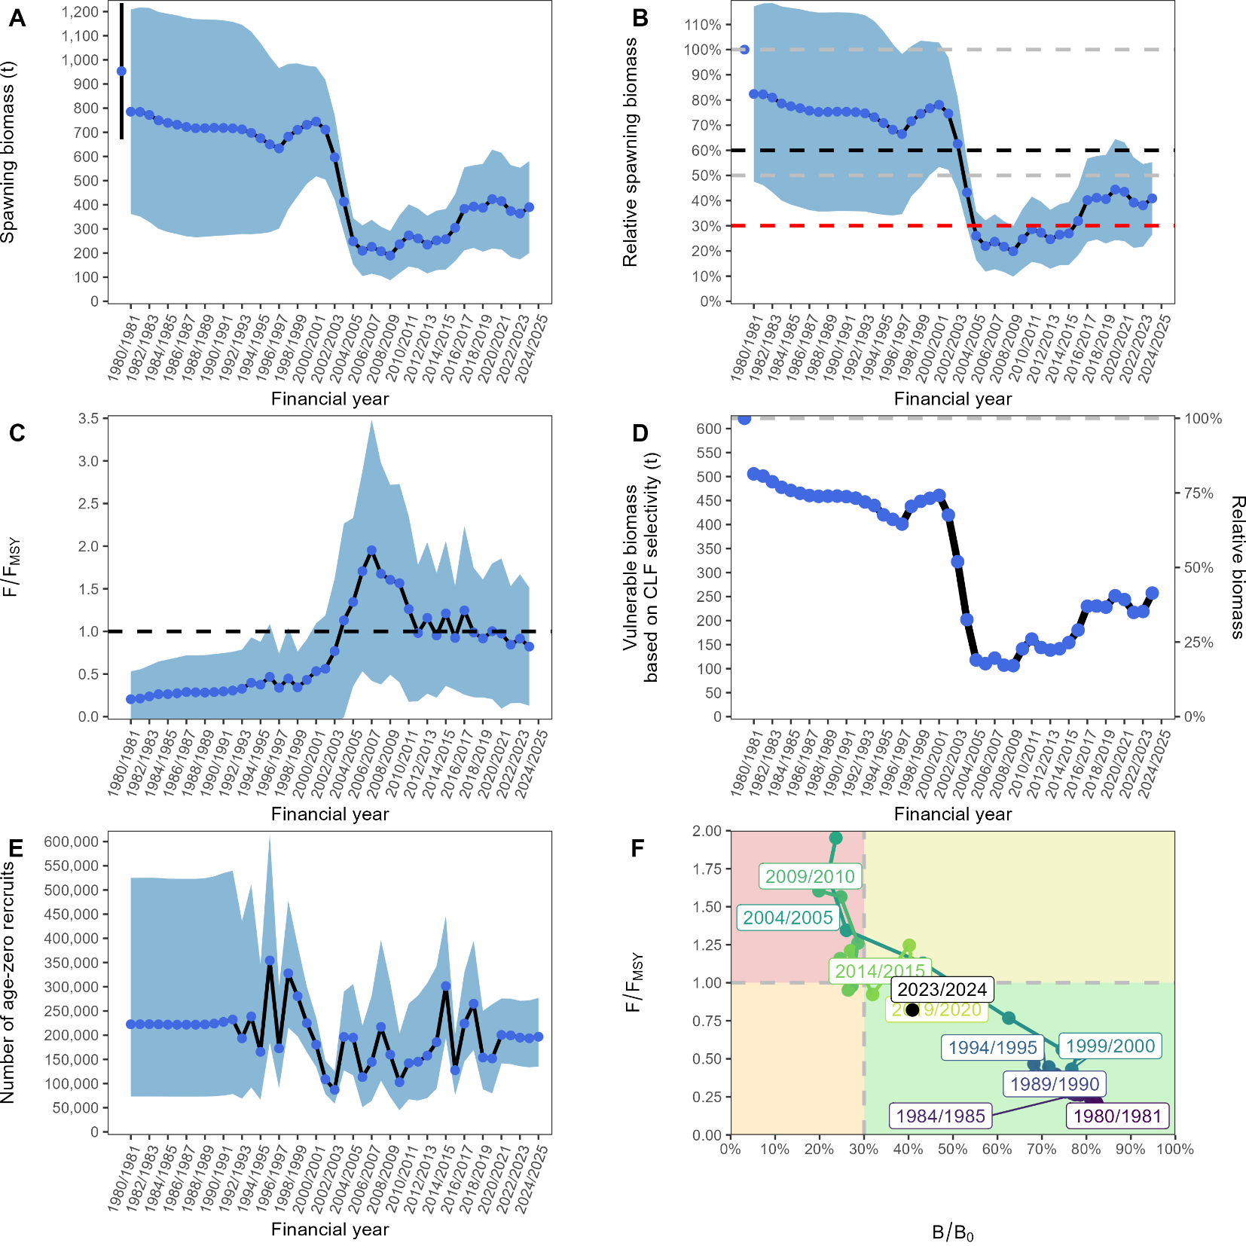
Figure 15: Key outcomes of the Base Case Black Jewfish Stock Synthesis model, where Panel A shows spawning biomass (tonnes) with blue shading indicating 95% confidence intervals; Panel B shows relative spawning biomass (B/B₀), with blue shading representing 95% confidence intervals, and dashed lines indicating B₆₀, B₅₀, and B₃₀ reference points, as well as the virgin spawning biomass (B₀) plotted at the 1980 x-axis position; Panel C shows F/F_{MSY}, with the dashed black line representing F_{MSY}; Panel D shows vulnerable biomass; Panel E shows the number of age-zero recruits, with blue shading indicating 95% lognormal confidence intervals; and Panel F shows a phase plot of stock status changes over time.

Estimated quantities
Information on parameter estimates and fixed or mirrored quantities is provided in Table 8. The Base Case model converged and was successfully tuned. The only point of note was that a cubic spline selectivity parameter for the CLF was close to a bound. This selectivity function estimates 15 parameters when 6 knots are used, and the parameter that was close to a bound was explored to determine whether or not an issue was present. It was determined that the parameter in question was appropriately estimated and that it would not estimate beyond the bound if the model was altered to allow this. Therefore, this result was considered acceptable.
Each parameter (or set of parameters) is discussed in detail in Subsections 3.7.1.2.1 to 3.7.1.2.4, as well as the fits to data. Detailed diagnostics, including model profiles, are provided in the appendices and demonstrate that they were suitably estimated and that alternative model settings did not need to be considered (Appendix 10.2.3).
Table 8: Model parameter results with specifications of how they were treated (estimated, mirrored, etc.) and other pertinent information.
Type | Parameter | Value | Treatment | Notes
Biology | Natural mortality (M) | 0.51yr⁻¹ | Estimated with prior N(ln[0.52], 0.05)
 | Length-at-age 1 (L₂) | 123.5 cm TL | Estimated with prior N(ln[114], 0.05) | Set as asymptotic length (L∞)
 | Length-at-age 1 (L₁) | 38.6 cm TL | Estimated | Set as length at 0.5 years (L_{0.5})
 | Growth coefficient (k) | 0.37yr⁻¹ | Estimated
 | CV at L₁ | 0.18 | Estimated
 | CV at L₂ | 0.09 | Estimated
Recruitment dynamics | Virgin recruitment (log R₀) | 5.42 | Estimated
 | Steepness (h) | 0.7 | Pre-specified
 | Recruitment variability (σ_{R}) | 0.51 | Tuned | Tuned using SS alternative value
Fishery dynamics | Recreational fleet initial equilibrium F | 0.2yr⁻¹ | Estimated
 | CLF catchability (log Q) | -2.35 | Estimated
 | Selectivity-at-length CLF | - | Estimated | Cubic spline with 15 estimated parameters/quantities
 | Selectivity-at-length FTO | - | Estimated | Cubic spline with 15 estimated parameters/quantities
 | Selectivity-at-length Recreational | - | Mirrored to FTO
 | Selectivity-at-length inflection Barramundi & Demersal | 62 cm | Pre-specified | Logistic function
 | Selectivity-at-length width Barramundi & Demersal | 9 cm | Pre-specified | Logistic function
 | Selectivity-at-age inflection CLF | 1.24 years | Estimated | Logistic function
 | Selectivity-at-age width CLF | 1.35 years | Estimated | Logistic function
 | Selectivity-at-age remaining fleets | 1 | Pre-specified | Set as 1.0 for all ages (no age selectivity)

Catch
The Stock Synthesis model internally calculated the catches by weight (Figure 4) of the FTO and Recreational fleets, which were input as number of fish. These results show that the Recreational fleet accounted for the majority of historical catch and was the dominant sector until 2002/03 (Figure 16). Following this point, the CLF catches increased, while the Recreational catches declined, and the CLF became the dominant fleet in the fishery (Figure 16). The equilibrium fishing mortality for the recreational sector was estimated as 0.2 yr⁻¹ (Table 8).
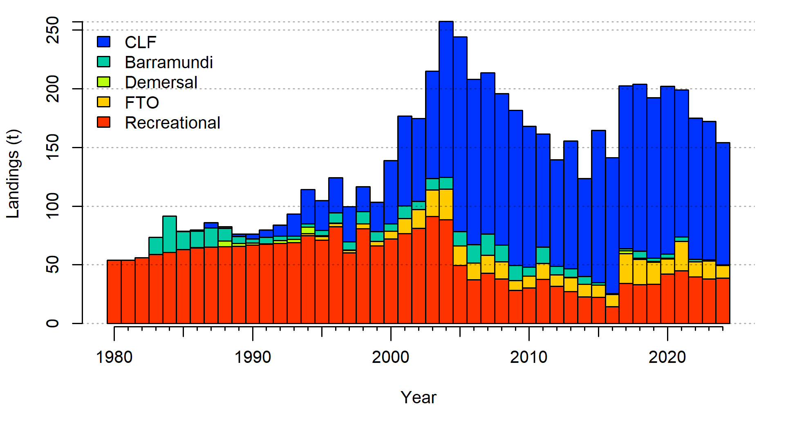
Figure 16: Catch (t) of Black Jewfish by different sectors. The tonnage of the FTO and Recreational fleets is estimated internally in the model and is converted based on the number of fish presented in Figure 4. The x-axis displays integer years where 2025 corresponds to the 2024/25 fishing season, and so forth.

Growth and Natural mortality
The length-at-age estimated by the Stock Synthesis model was consistent with the biology of Black Jewfish but differed to the externally estimated growth curve (Figure 13). A lower k was estimated than in the external length-at-age model, producing slower growth at younger ages (Table 8; Figure 13; Figure 17). This distinction occurred as the length-at-age estimated by the Stock Synthesis model considered the length compositions from the CLF fleet which is highly selective (Figure 18). This selectivity indicates a lower probability of sampling fish smaller than 90 cm TL by the CLF which would result in length-at-age samples that have faster growing fish at younger ages (Figure 17). Therefore, an externally estimated growth curve based on samples from this fishery would indicate faster early growth due to the over-representation of these fast-growing fish, whereas an internally estimated growth curve by Stock Synthesis accounts for their increased probability of capture (Figure 17).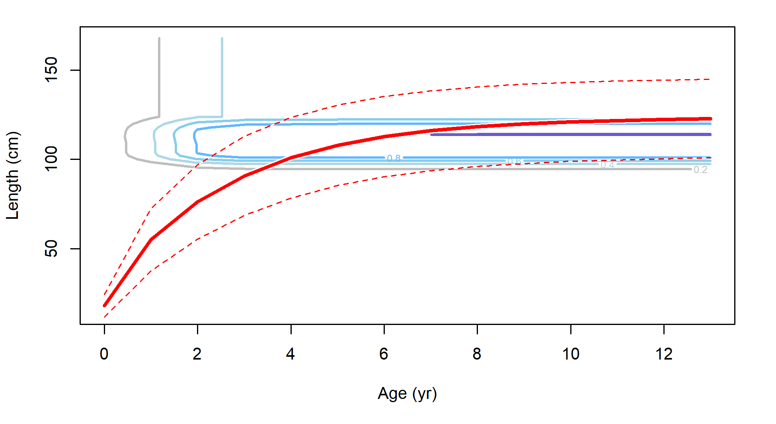
Figure 17: Length-at-age estimated within the Stock Synthesis model for Black Jewfish. The red line represents the model estimate, and the red dashed lines show the coefficient of variation which changes with age. The blue contours show the probability of sampling fish of a given length and age based on the CLF selectivity.

Natural mortality (M) was estimated as 0.51 yr⁻¹ which was similar to the mean of the applied lognormal prior (Table 8). This indicated that there was little information in the model to update the value of M from this distribution and that this value was not in conflict with any data. This was further demonstrated in the likelihood profile, where a large range of M values had similar total likelihood values (Figure 41). While the prior distribution of M was not updated in model posterior, its inclusion was useful and preferable to pre-specifying M as the uncertainty in this parameter is encapsulated in the uncertainty of key model quantities (Figure 15).

Selectivity
The length selectivities of the CLF and FTO fleets had highly distinct modes (Figure 18). The FTO length selectivity was bimodal and peaked at near 45 cm TL and to a lesser extent at approximately 110 cm TL (Figure 18). However, the CLF had an extended peak from 100 – 120 cm TL (Figure 18). These differences are likely caused by an operational difference of the two fleets. There are relatively few Commercial CLF fishers who typically target larger fish in specific aggregations, whereas the FTO fleet is larger and more diverse, and target a greater number of species. A cubic spline selectivity was used for both fleets which had clear benefits for the FTO selectivity. However, given that the CLF selectivity appeared to have one mode, a dome shaped function was also examined. This resulted in a poorer fit to the CLF length compositions and therefore the cubic spline selectivity function was maintained. The age at 50% selectivity for the CLF was 1.2 years old and ages above 4 years old were fully selected (Table 8; Figure 18).
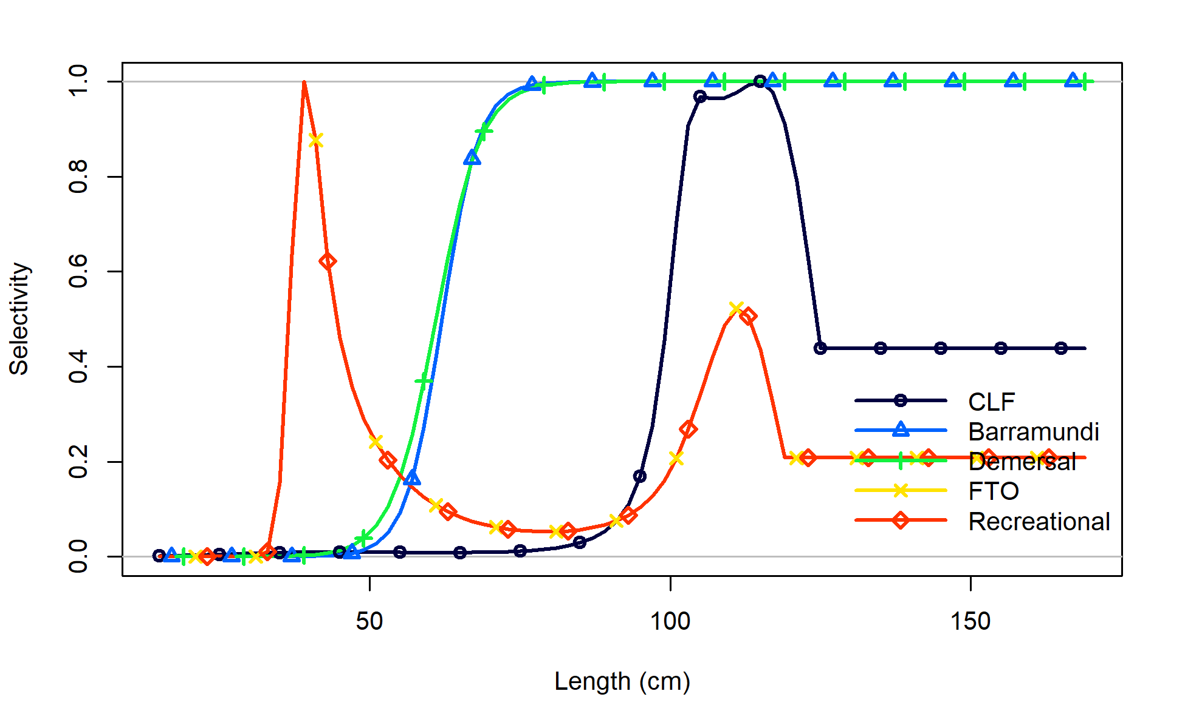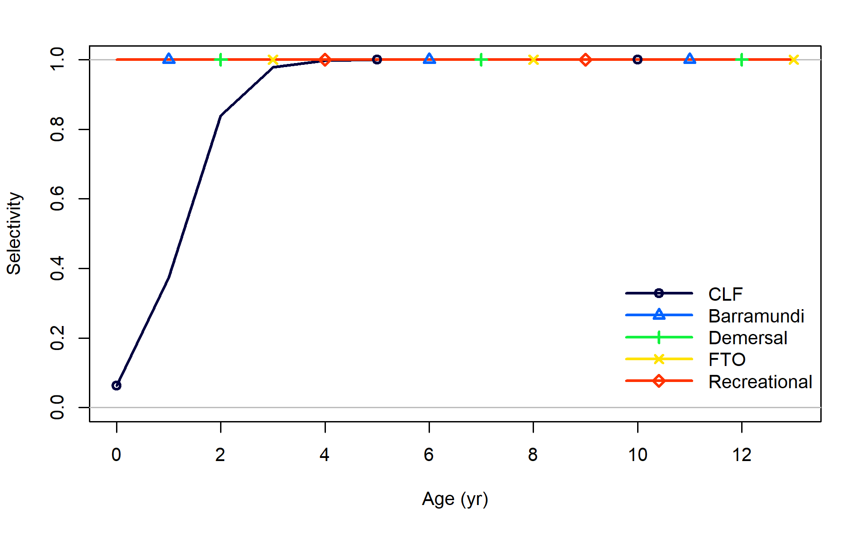
A)
B)
Figure 18: A) Length selectivity of the five fishing fleets for Black Jewfish. Note that the recreational selectivity is mirrored to FTO selectivity, and these are therefore identical. Age selectivity of the five fishing fleets for Black Jewfish. Note that this is pre-specified as 100% selectivity for all ages for all fleets except the CLF.

Recruitment
The Stock Synthesis model estimated an unfished recruitment (R₀) in log-space of 5.43 (Table 8), which converts to 227,257 age-zero recruits, based on a pre-specified h of 0.7. The σ_{R} was pre-specified at 0.51 after it was updated through the model tuning process (Section 3.5). The recruitment was well estimated as 1) recruitment deviations about the stock recruitment relationship showed no signs of autocorrelation, 2) early recruitment deviations were estimated according to the stock recruitment relationship and 3) the bias adjustment ramp was suitably updated to match that recommended by the Stock Synthesis model (Figure 19). The bias adjustment ramp shows the years where little to no information is available on recruitment versus years where more information is available (Figure 19c). This demonstrates that recruitment could be estimated between 1989/90 to 2019/20, with years either side of this period having limited data, insufficient to provide information to estimate recruitment (Figure 19c). Likelihood profiles supported the final estimates or pre-specified values for R₀, h, and σ_{R} (Appendix 10.2.3).
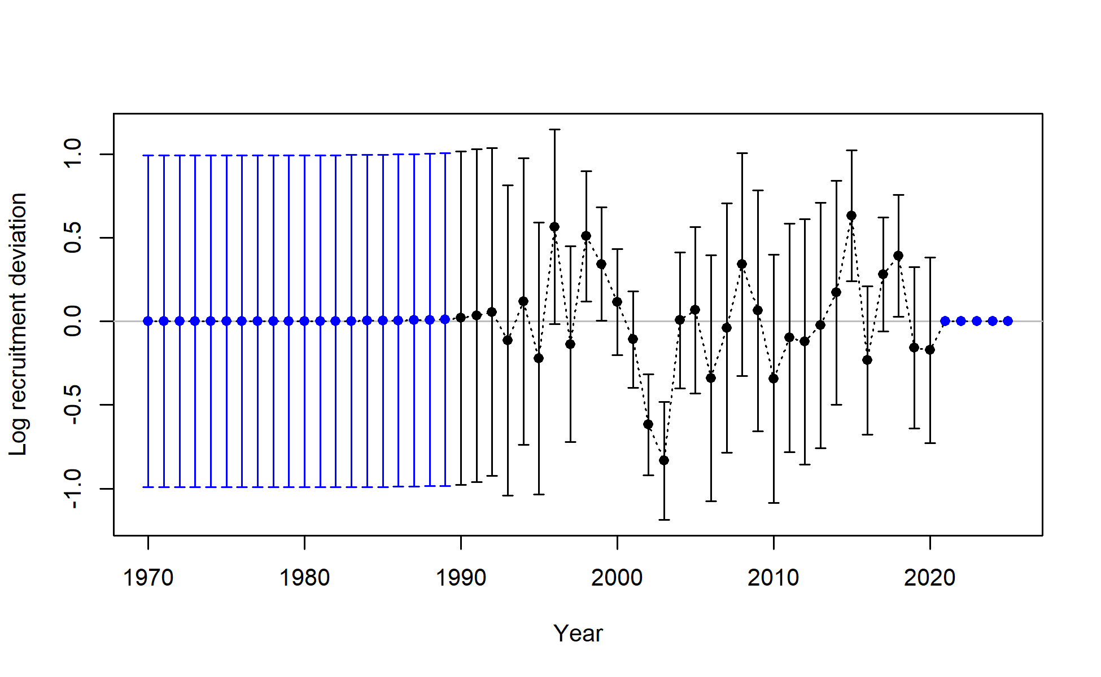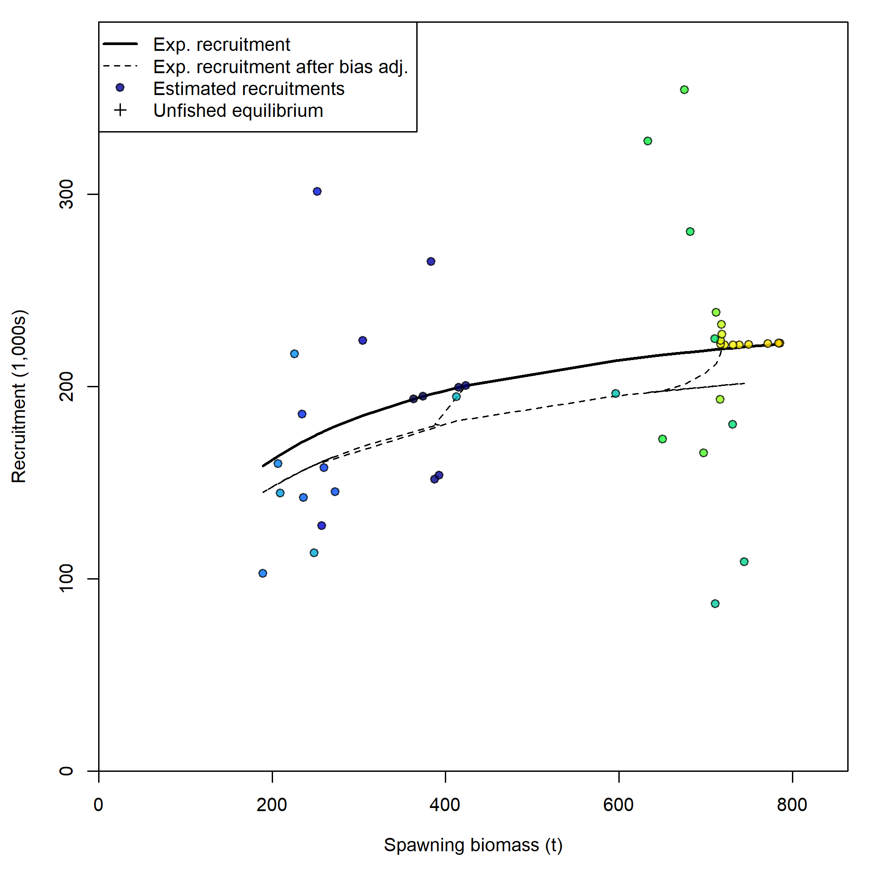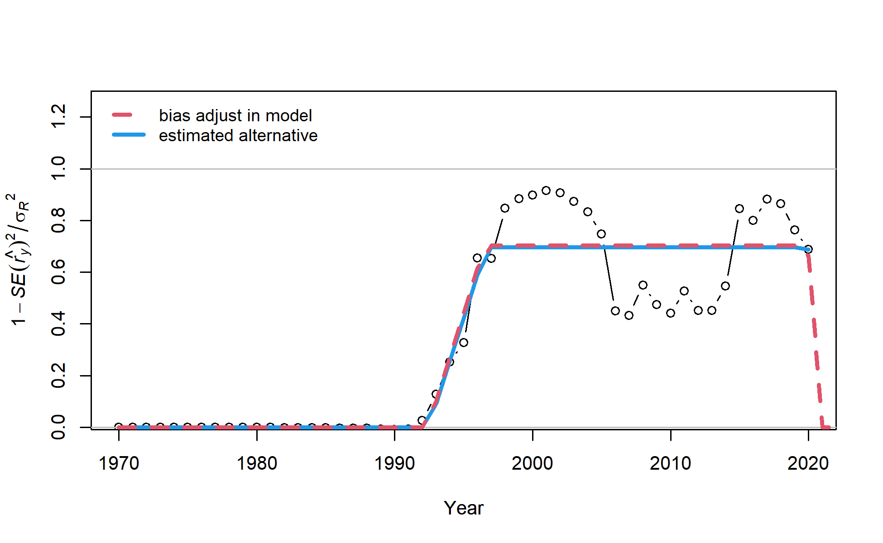
C)
B)
A)
Figure 19: A) Stock recruitment relationship, B) Recruitment deviations and estimated standard error, and c) The recruitment bias adjustment ramp. The x-axis displays integer years where 2020 corresponds to the 2019/20 fishing season, and so forth.

Model fits to data

Abundance indices
The model fit to the CLF abundance index determined through CPUE standardisation (Section 3.3.2) was adequate with estimates passing within the standard errors for all years except 2018/19 (Figure 20).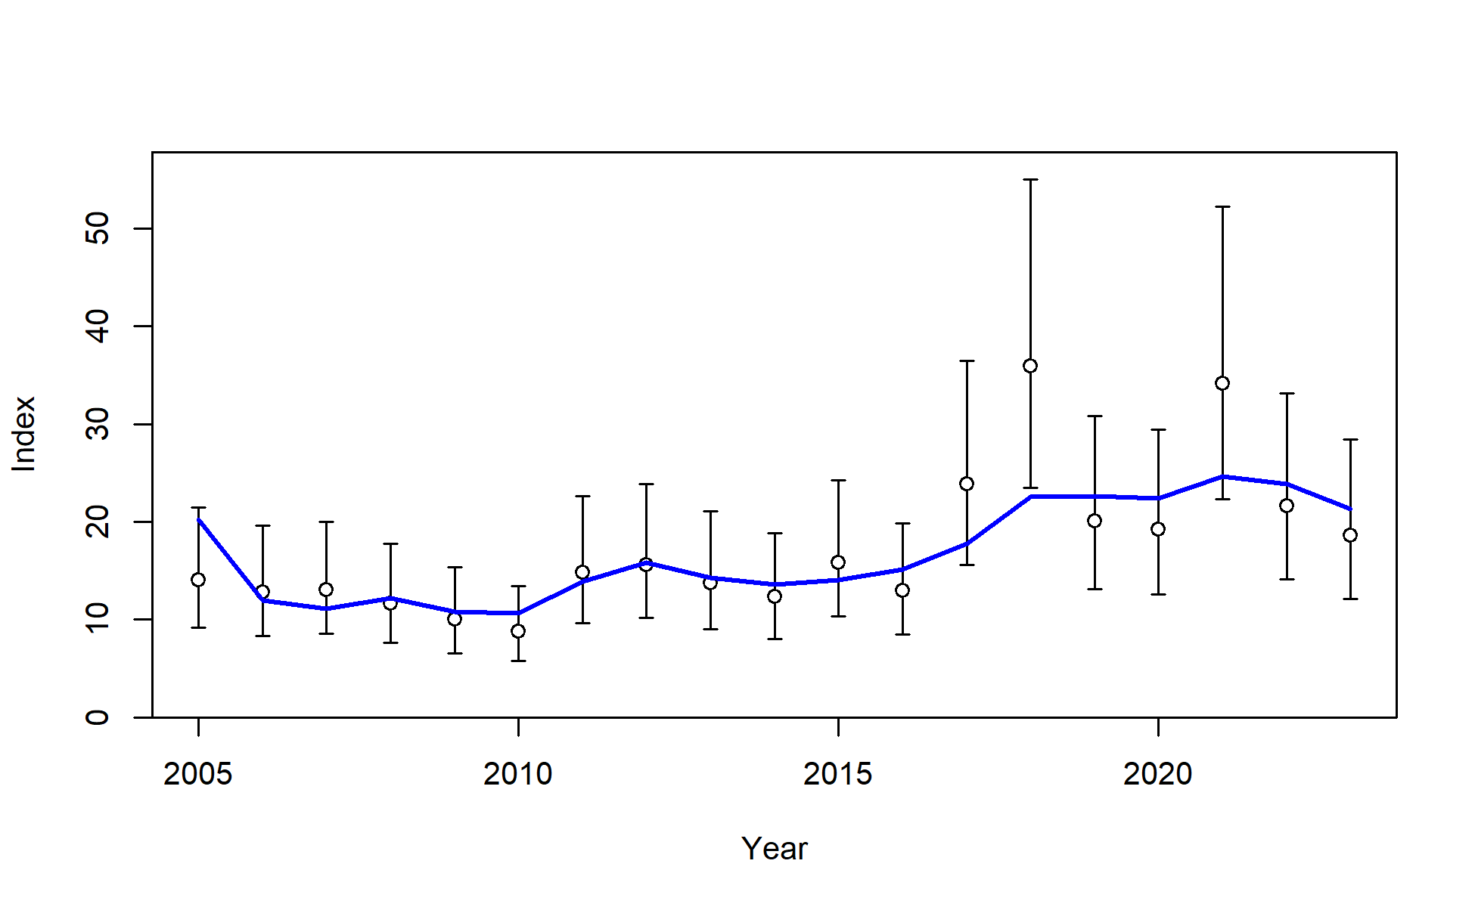
Figure 20: Model fit (blue line) to the abundance index (points) for the CLF fleet. The error bars represent lognormal standard errors input to the model. The x-axis displays integer years where 2021 corresponds to the 2020/21 fishing season, and so forth.

Length compositions
Good fits to length compositions were generally achieved for the CLF and FTO fleets (Figure 21; Figure 22). Model fits were poorest for years with lower sample sizes, which occurred more frequently for the FTO length compositions (Figure 21; Figure 22). The model had good fits to mean lengths for both fleets, with model estimated mean lengths passing through the standard errors for all years, except 2012/13 for the CLF (Figure 23). The tuning procedure was adequately applied so that all variances matched those recommended by the Francis (2011) weighting approach (Figure 23).

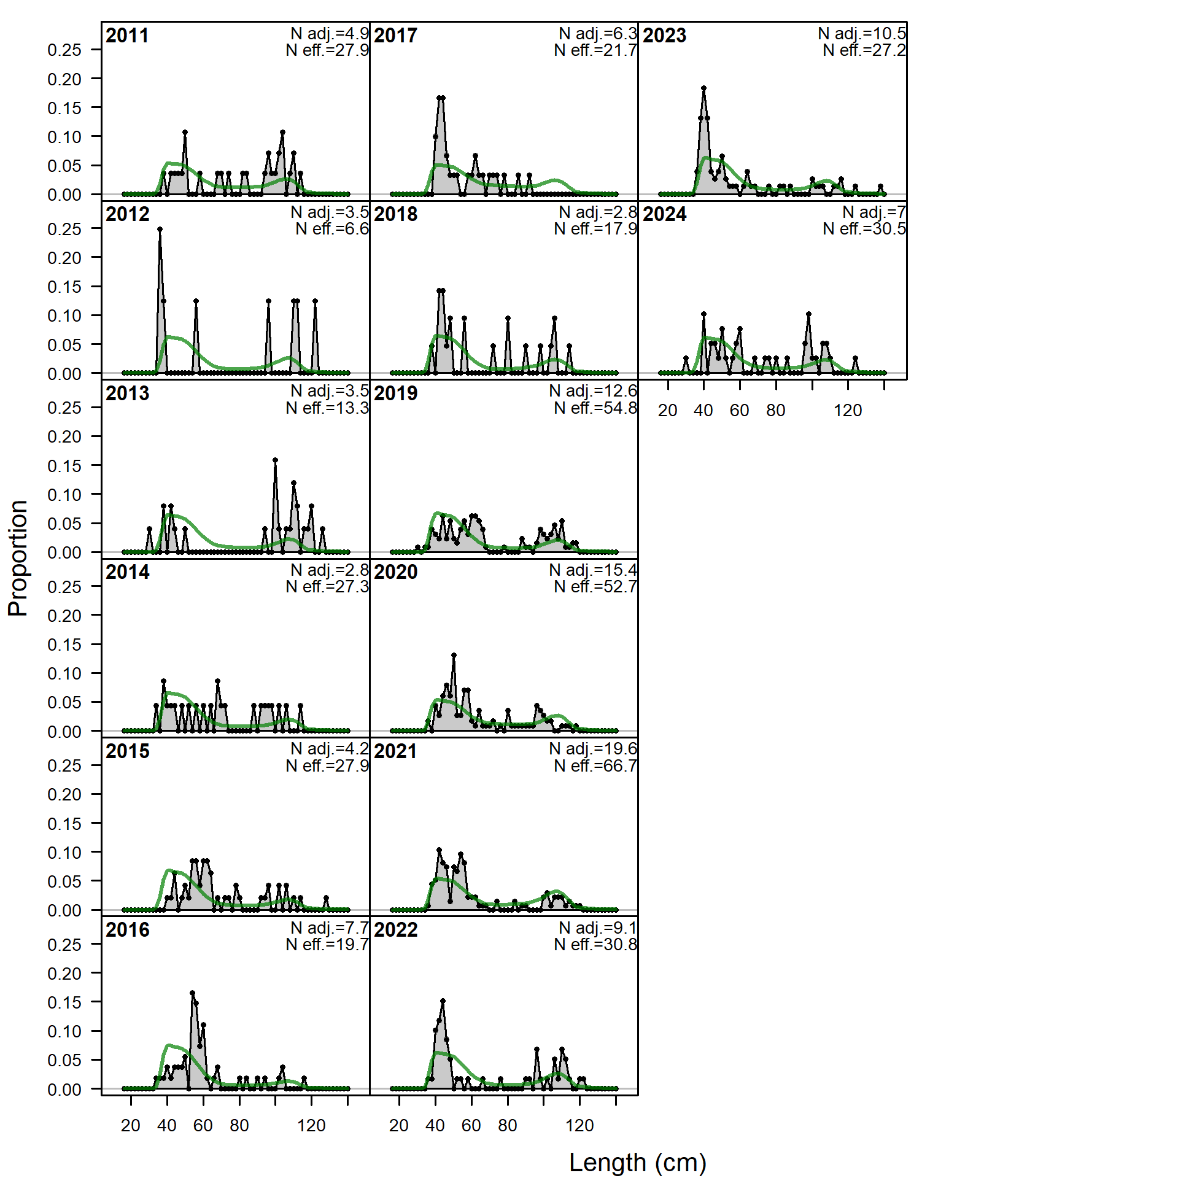
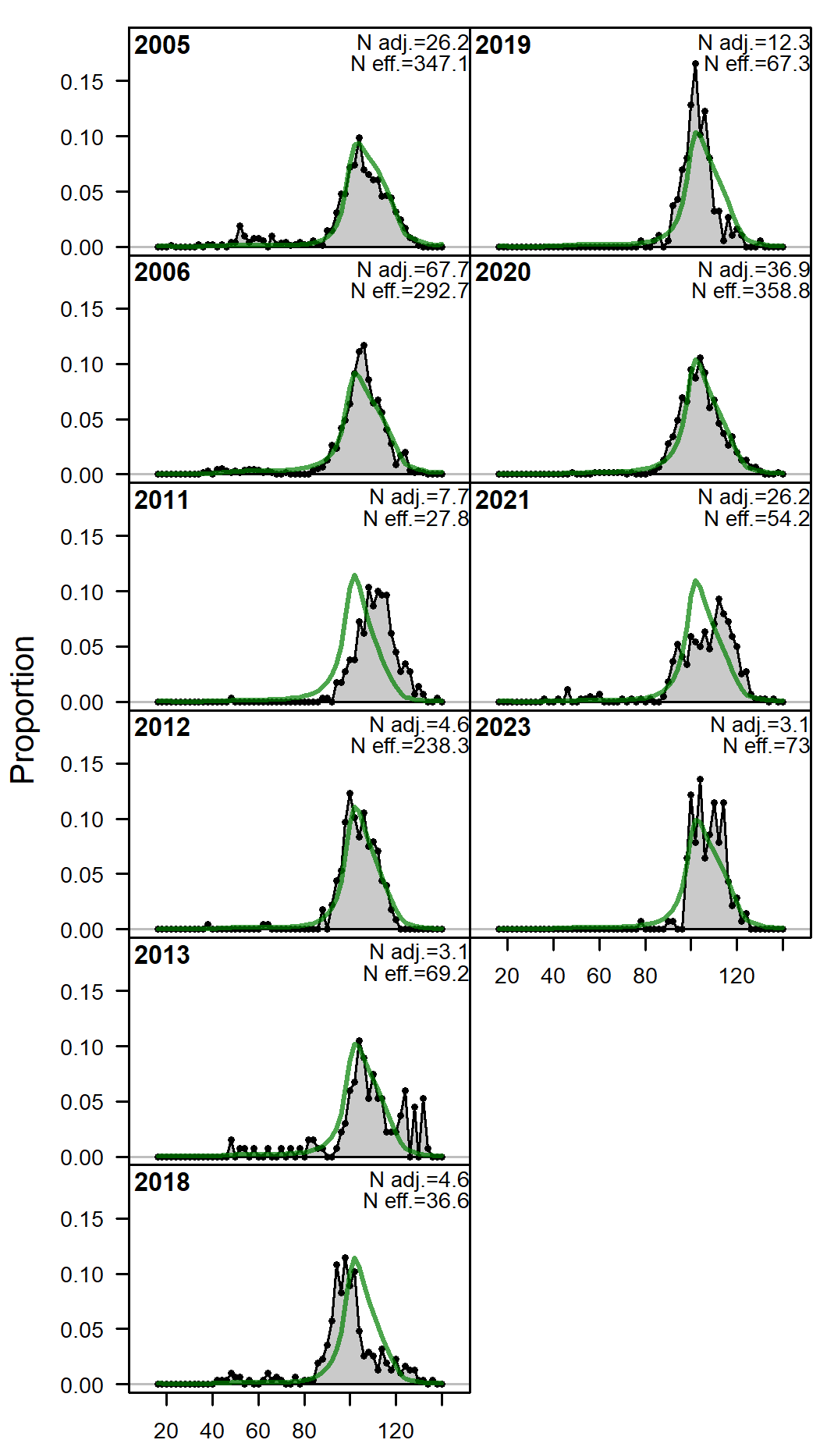
Figure 21: Model fit (green line) to CLF length compositions. Lengths were grouped into 2cm bins. The x-axis displays integer years where 2021 corresponds to the 2020/21 fishing season, and so forth.
Figure 22: Model fit (green line) to FTO length compositions. Lengths were grouped into 2cm bins. The x-axis displays integer years where 2021 corresponds to the 2020/21 fishing season, and so forth.
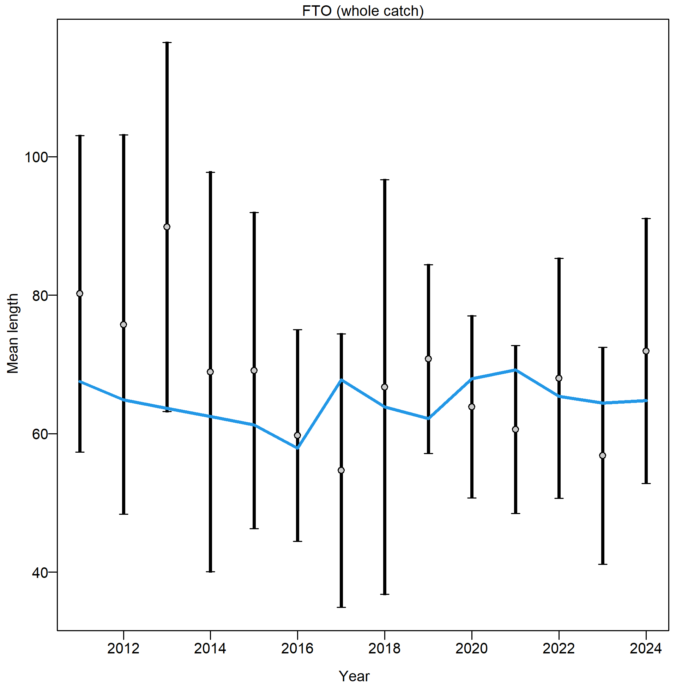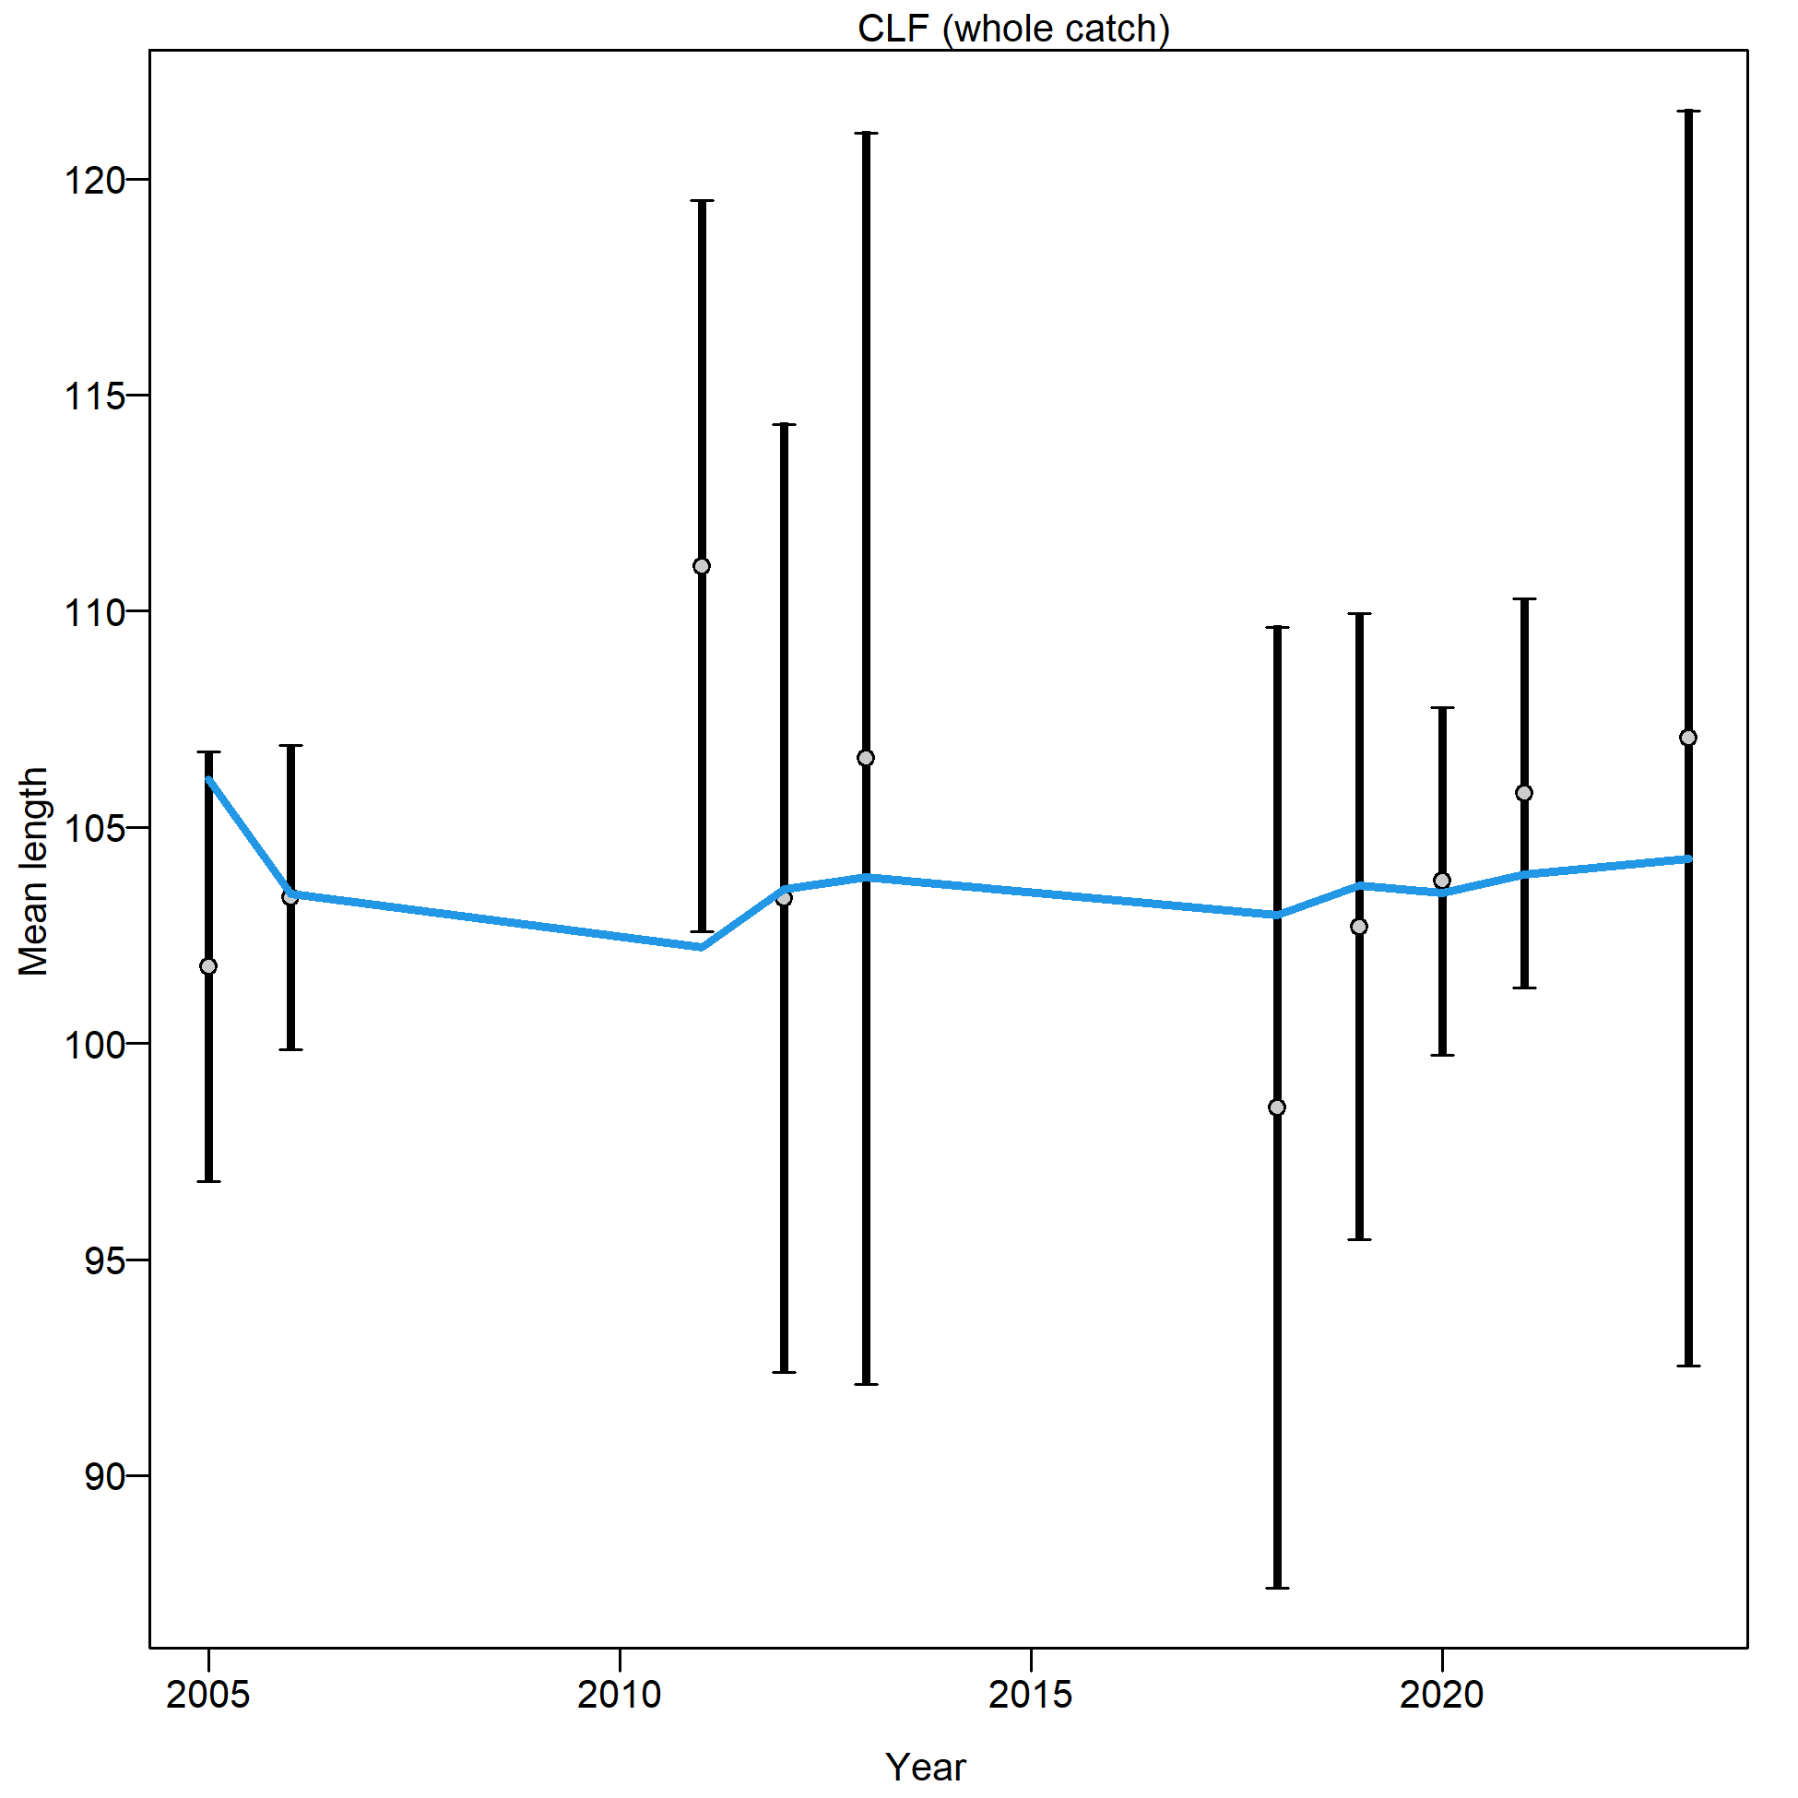
A)
B)
Figure 23: Model fit (blue line) to A) CLF and B) FTO mean annual lengths. Open circles are the mean length calculated from the data and the black bars are the variance around these mean lengths, which have been tuned according to Francis (2011) weighting. The x-axis displays integer years where 2020 corresponds to the 2019/20 fishing season, and so forth.

Conditional age-at-Length
Good model fits to CAAL data were achieved in each of the four available years (Figure 24). All the residuals were small and no clear patterns across lengths or ages were apparent (Figure 24). The tuning procedure was adequately applied so that all variances matched those recommended by the Francis (2011) weighting approach (Figure 25).

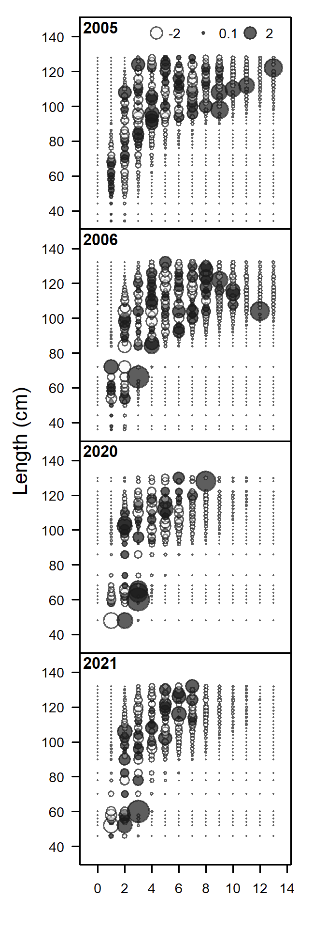
Figure 24: Annual conditional age-at-length residuals for the CLF fleet. The x-axis displays integer age (years); where 2021 corresponds to the 2020/21 fishing season, and so forth.

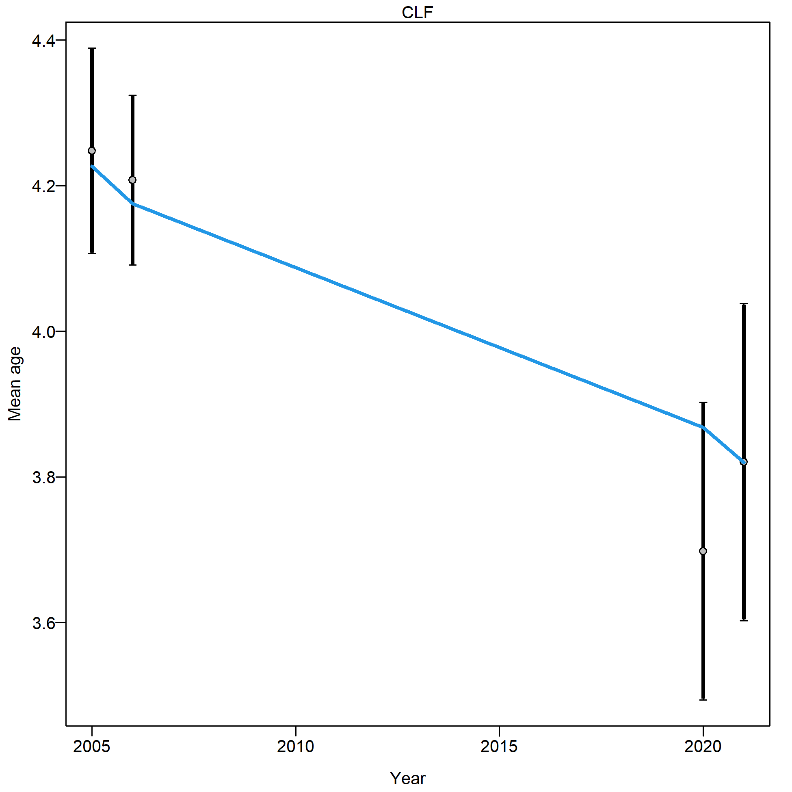
Figure 25: Estimated mean age of Black Jewfish catches for the CLF fleet. Open circles are the mean age calculated from the data and the black bars are the variance around these mean ages, which have been tuned according to Francis (2011) weighting. Blue lines represent the model estimated mean age. The x-axis displays integer years where 2020 corresponds to the 2019/20 fishing season, and so forth.

Sensitivity scenarios
Ten sensitivity scenarios are presented to demonstrate the impact of decision making and data exploration that was part of the stock assessment modelling process. Each of the scenarios presented use variations to the Base Case model to examine the effect of specific considerations. Each scenario culminates in one of three conclusions: 1) The scenario did not differ to the Base Case, indicating that the model is uninfluenced by this decision or consideration, 2) the omission of a particular data type (e.g. length compositions, abundance indices or CAAL) was influential on the model outcomes, but its inclusion remains justified, or 3) a scenario provides a different outcome to the Base Case model, but the scenario provided a poorer fit to the data or did not achieve convergence nor stability and therefore should be dismissed. Model convergence was determined based on whether any model had a final gradient less than 0.0001 (a standard threshold for Stock Synthesis). Model stability following length and age tuning (using the Francis (2011) method) was determined by whether running several tuning iterations and examining whether the model’s likelihood and key quantities (i.e., B₀ and B_{2023/24}) were consistent in later iterations.
Given the large number of scenarios performed, these were grouped for clear presentation and exploration of results. The scenarios, groupings, descriptions and a summary of convergence and stability are provided in Table 9.

Table 9: List and description of modelled sensitivity scenarios, whether they converged and if they were stable following model tuning procedures. Convergence was determined based on whether the final gradient was lower than 0.0001 and the model variance could be estimated.
Group | Scenario | Description | Converged | Tuned successfully
Early composition data | 1 – 1990s lengths included | Length compositions for the Research fleet are included and have a separate selectivity. | Yes | Yes
Early composition data | 2 – 1990s lengths and CAAL | Length compositions and CAAL for the Research fleet are included and have a separate selectivity. | Yes | No – unstable final relative spawning biomass estimate
Data inputs | 3 – No CPUE index | CPUE index is removed from the model. | Yes | NA
Data inputs | 4 – No length data | All length compositions are removed from the model. A pre-specified logistic length selectivity is applied. | No – gradient was 0.0004 | Yes
Data inputs | 5 – No CAAL data | All CAAL data are removed. Growth is not estimated. | Yes | Yes
Data inputs | 6 – No length data or CAAL data | All composition data are removed. No length selectivity is applied. Age selectivity is a pre-specified logistic function. Growth is not estimated. | Yes | NA
Recreational harvest | 7 – No equilibrium recreational catch | Initial equilibrium catch is not estimated for the recreational fleet. The model starts at 100% relative spawning biomass in the first year. | Yes | NA
Recreational harvest | 8 – FTO & recreational catch in weight | Catch is input as a tonnage (as per the SRA input data) rather than as number of fish for the recreational and FTO fleets. | Yes | NA
Sex structure | 9 – Two sex model | Two sexes are specified in the model. Length compositions for CAAL are fit to for each sex with selectivity and growth were estimated for females and mirrored to males. | No – gradient was 6430.15 | No – unstable final relative spawning biomass estimate
Sex structure | 10 – Pooled sex model | Sex specific compositions are combined, and sex ratios are used to separate males and females. Selectivity and growth were estimated for females and mirrored to males. | No – gradient was 0.0004 | Yes

Inclusion of 1990’s composition data
As discussed in Sections 3.2 and 3.3, length and age data were collected through dedicated research program operated by JCU (Williams, unpublished data). While these data were available for inclusion in the assessment, information on how they were collected was unavailable. These data are presented in Sections 3.3.3 and 3.3.4. However, as already noted, they were not included in the final model as it appeared that this data set had a different selectivity to the five fleets included in the Stock Synthesis model. A sixth fleet, representing these data, was unsuccessfully included in early versions of the Base Case model but subsequently disregarded as changes in selectivity across years (particularly for ages) were apparent. Data collected for research purposes can be valuable as it potentially allows a more representative sample of the population to estimate important biological information, such as growth and maturity. However, samples that represent the population may not represent the individuals captured by fishing fleets, which are needed for annual composition data to be considered by the model. Research data can be included in a stock assessment by defining its own selectivity functions (as was attempted here). However, this was precluded as there is a lack of knowledge of how and why samples were collected.
For completeness and transparency, these attempts are presented here as the first two sensitivity scenarios. Notably, Scenario 2 (both length compositions and CAAL included), provided more optimistic outputs than the Base Case model (Figure 26). However, this scenario had poorer fits to the data and could not achieve stable model tuning (Table 9). Ultimately, the inclusion of the CAAL data (Section 3.3.4) could not be justified. While the model supported the inclusion of length information from this period, these data were also omitted as they were collected through the same sampling as the omitted CAAL data (Figure 26; Table 9). It was determined that if one data type (CAAL) were omitted due to uncertainty and potential bias, then it was not justifiable to include the other data type (Length compositions) either. Nevertheless, inclusion of these data resulted in a model that agreed with the Base Case, demonstrating that this decision was inconsequential to the final model outcomes (Figure 26).

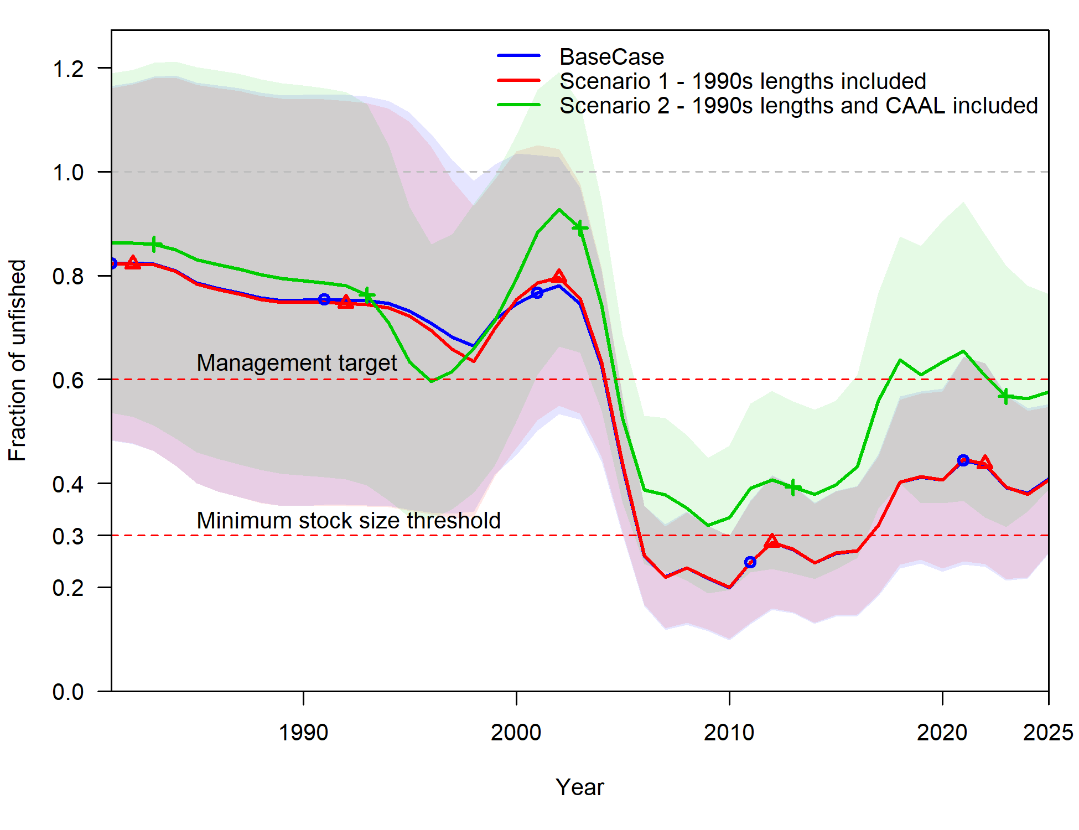
Figure 26: Relative spawning biomass estimates from sensitivity scenarios encompassing three model runs that include the Base Case model (blue line and shading), Scenario 1 – a scenario with omitted length compositions from the 1990’s reintroduced (red line and shading), and Scenario 2 – a scenario with omitted length compositions and CAAL from the 1990’s reintroduced (green line and shading). Full details or these model runs are provided in Table 9. Note that Scenario 2 could not achieve stable model tuning. The x-axis displays integer years where 2020 corresponds to the 2019/20 fishing season, and so forth.

Data inputs
Four scenarios that removed different data inputs were examined: Scenario 3 which removed the index of abundance determined through standardised CPUE, Scenario 4 which removed the length composition data from all fleets, Scenario 5 which removed CAAL data and Scenario 6 which removed both the length compositions and CAAL data. Where a particular composition data type was removed, selectivity was accordingly adjusted to pre-specified values that would be used if no data were available to estimate it (Table 9).
The scenarios demonstrated that each of these data inputs improved the Stock Synthesis model as removing them worsened the model fits and led to poorer diagnostics. Scenarios 4 and 5 estimated more pessimistic relative spawning biomass trajectories than the Base Case model (Figure 27). Meanwhile Scenarios 3 and 6 estimated different relative spawning biomass trajectories to the Base Case, even though these trajectories would provide the same conclusions regarding stock status (Figure 27). Explanations for the deviations away from the Base Case become quite nuanced as the removal of indices and compositions means that different selectivity’s are used or growth becomes fixed, and each of these considerations impacts model performance. The main conclusion from these sensitivity analyses is that the omission or inclusion of particular data types does not lead to consequentially different stock assessment outcomes nor stock status conclusions than the Base Case model (Figure 27).
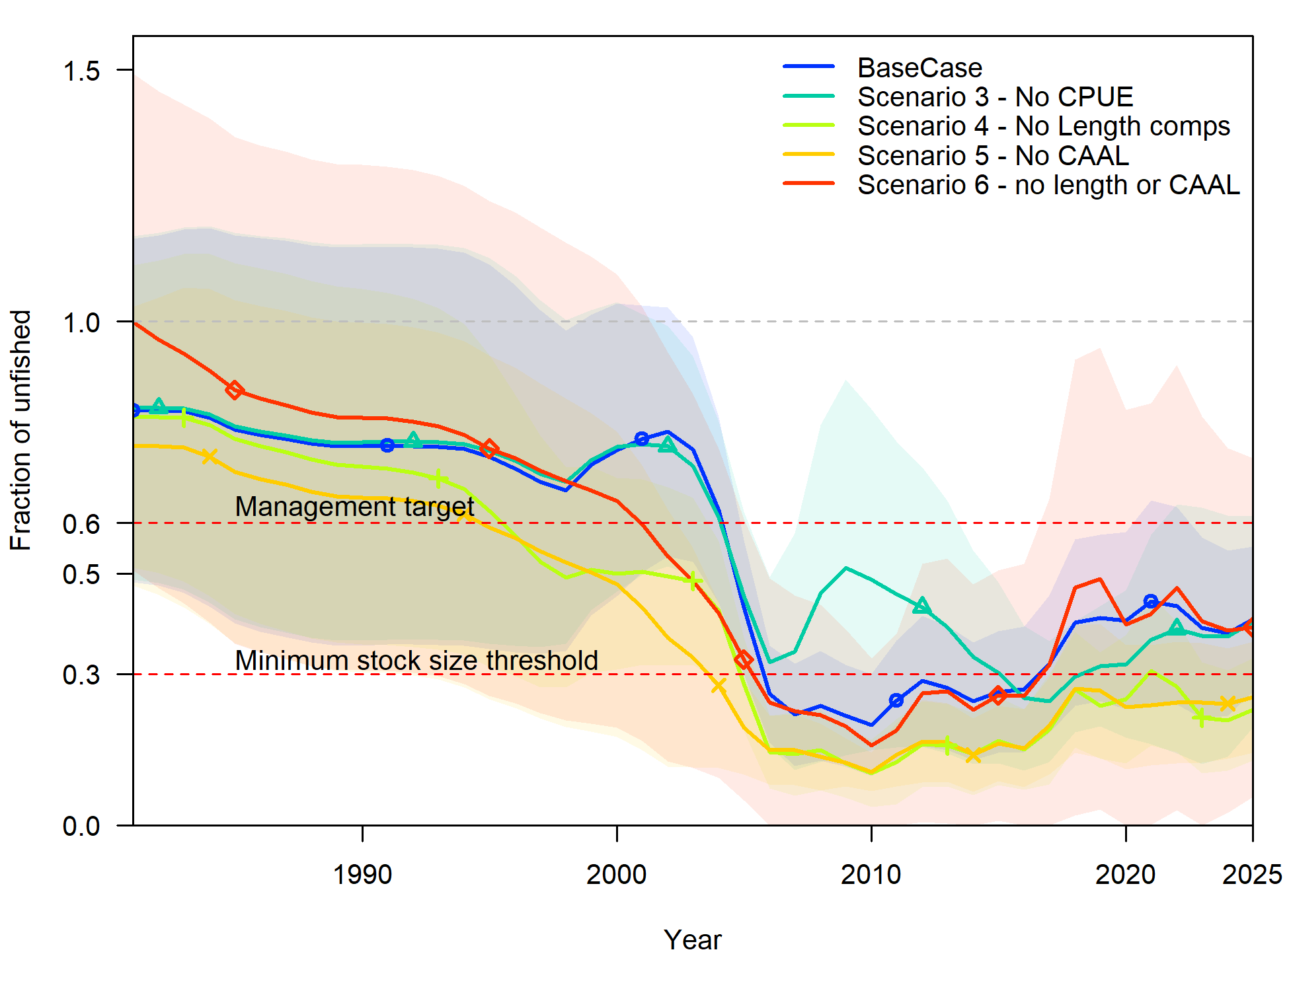
Figure 27: Relative spawning biomass estimates from sensitivity scenarios encompassing five model runs that include the Base Case model (blue line and shading), Scenario 3 – no CPUE used in the model (red line and shading), Scenario 4 – no length compositions included in the model (teal line and shading), Scenario 5 – no CAAL included in the model (green line and shading), and Scenario 6 – no length compositions or CAAL included in the model (red line and shading). Full details or these model runs are provided in Table 9. Note that Scenario 4 did not converge. The x-axis displays integer years where 2020 corresponds to the 2019/20 fishing season, and so forth.

Recreational harvest
Two key decisions regarding recreational harvest were included in the Base Case model and were examined through Scenarios 7 and 8 (Table 9; Figure 28). We tested the decision to estimate an equilibrium level of fishing mortality prior to the model time series in 1980/81 (which is reversed for Scenario 7) and the decision to input catch by number of fish for recreational and FTO fleets, rather than externally converting these to tonnages (which is reversed for Scenario 8). Scenario 7 is particularly important to examine as it directly leads to relative spawning biomass in 1980/81 being estimated at 100% rather than 81%. This leads to a justifiable question of whether or not this would lead to a lower relative spawning biomass in 2023/24, given that the model is effectively starting at a lower population level. However, Scenario 7 demonstrates that a similar relative spawning biomass result to the Base Case in 2023/24 was achieved (Figure 28). While Scenario 7 starts at 100% relative spawning biomass in 1980/81, the Base Case model estimated that the population is more productive and therefore there was less of a decline between 1980/81 and 2023/24. This result was achieved as higher levels of exploitation were experienced for longer which indicates higher levels of productivity to sustain these harvest levels. The input of catch by number, rather than weight, for the recreational and FTO fleets (Scenario 8) yielded similar relative spawning biomass results to the Base Case model and was therefore inconsequential (Figure 28).
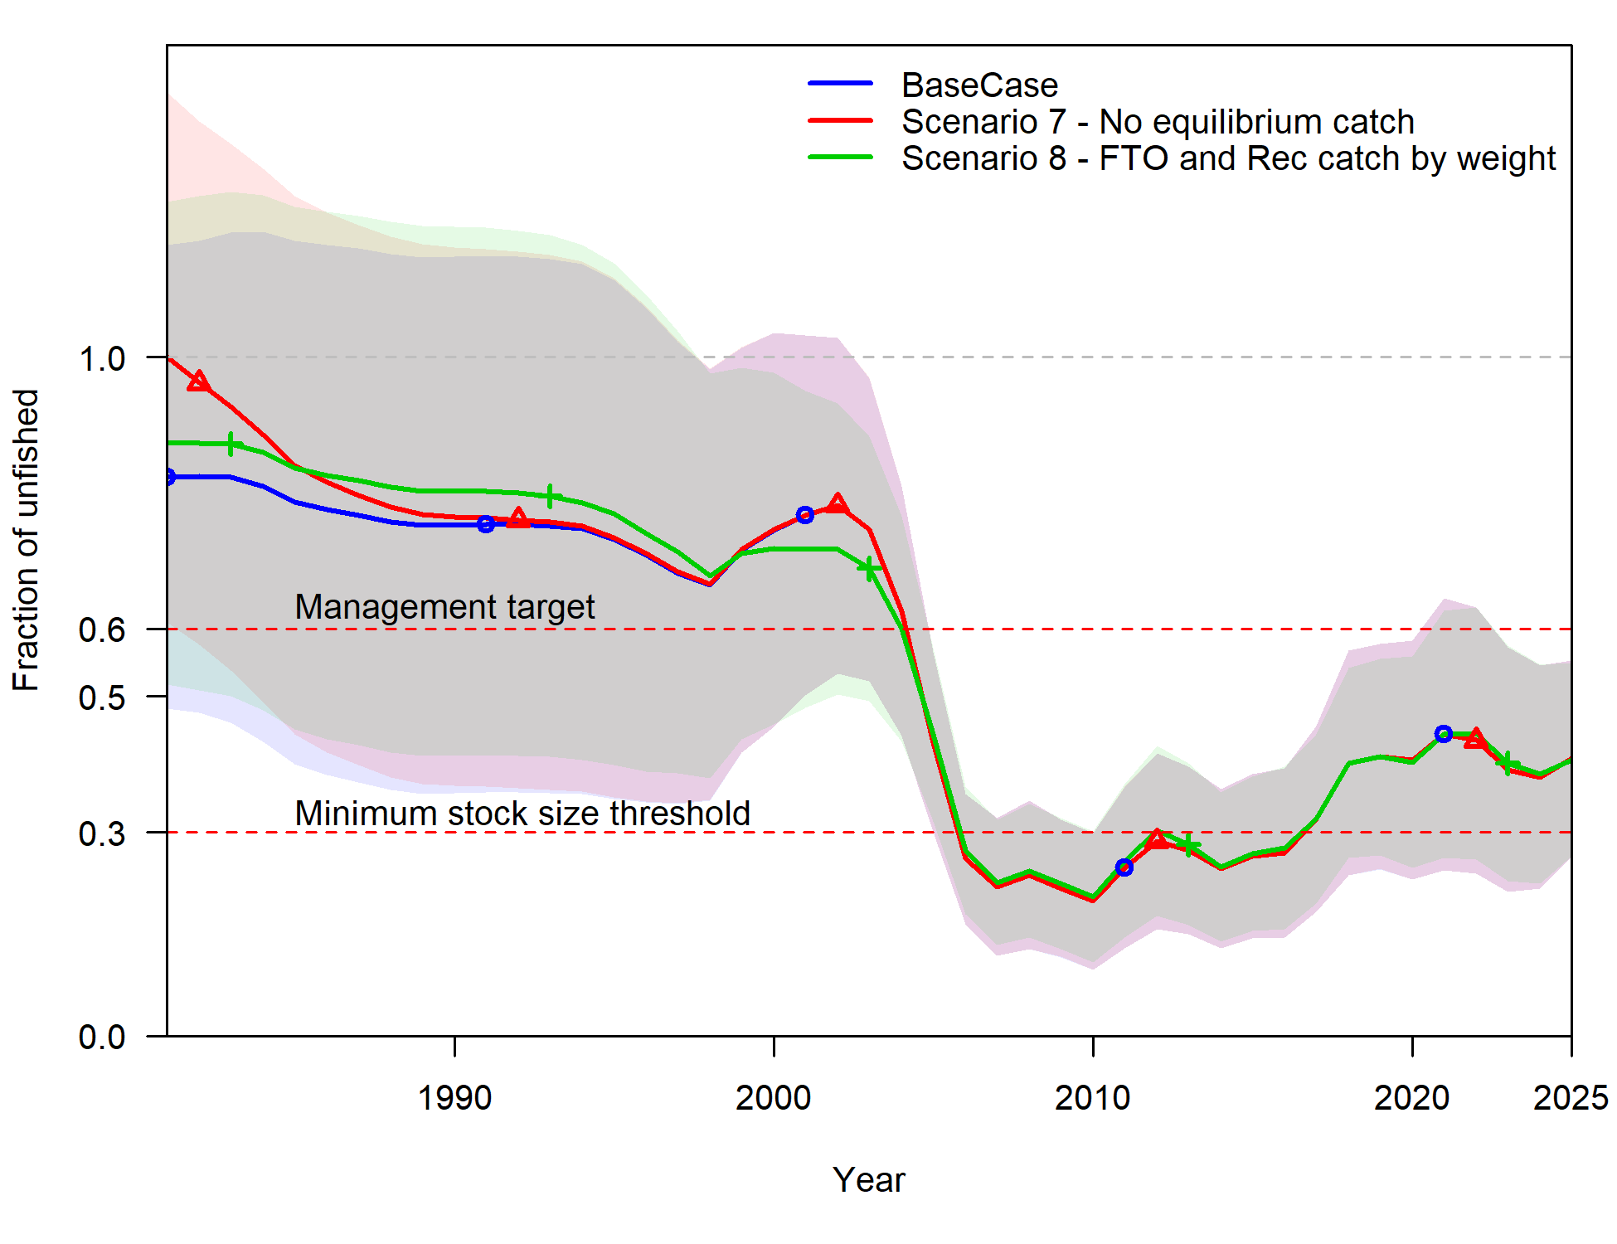
Figure 28: Relative spawning biomass estimates from sensitivity scenarios encompassing three model runs that include the Base Case model (blue line and shading), Scenario 7 – a scenario with no equilibrium catch for the recreational sectors estimated (red line and shading), and Scenario 8 – a scenario catch for the FTO and recreational sectors was provided in weight rather than number (green line and shading). Full details or these model runs are provided in Table 9. The x-axis displays integer years where 2020 corresponds to the 2019/20 fishing season, and so forth.

Sex structure
Stock Synthesis can consider sex structure through three methods, each of which was trialled and are presented here as sensitivity scenarios. The Base Case model used a combined sex structure where males are not differentiated from females according to biology, nor in the composition data. This structure should only be used when growth is not sexually dimorphic, sex ratios in the catch demonstrate parity and selectivity does not differ between the sexes. All these pre-requisites apply to Black Jewfish. A two-sex model (Scenario 9) differentiated males and females in the composition data but estimated a combined sex growth curve. This scenario did not converge and could not achieve stable tuning (Table 9). It also produced a more volatile relative spawning biomass trajectory than the Base Case (Figure 29). This result is attributed to the fragmentation of composition data which has lower annual sample sizes once it is separated by sex. This reduced the ability of the model to effectively estimate key quantities and fit to data inputs.
Scenario 10 used a pooled sex structure (sex is assigned as ‘3’ rather than ‘1’ for females, ‘2’ for males or ‘0’ for unknown). Here, composition data are combined for the sexes and the proportions of males and females in the data are used to account for sex structure, as opposed to the Base Case, which retained a single sex model throughout. This Scenario performed better than Scenario 9 as it maintained larger sample sizes for the composition data. It also provided a more optimistic relative spawning biomass trajectory in comparison to the Base Case model (Figure 29). Therefore, this scenario was examined closely to determine if it should be considered as an alternative Base Case. Ultimately, it was rejected with the following justifications: 1) Scenario 10 did not meet convergence criteria (although it was close to the threshold) despite achieving stable tuning (Table 9), and 2) a greater level of uncertainty for relative spawning biomass was estimated from the mid 2000’s onwards. This uncertainty was the main justification for its rejection as the Base Case model, given that the 95% confidence intervals spanned ~30 – 80% for relative spawning biomass in 2023/24 (Figure 29). This level of uncertainty in the results means the outputs are relatively uninformative and can be difficult to appropriately apply in management. Therefore, this alternative scenario did not provide a more appropriate model than the Base Case (Figure 29).
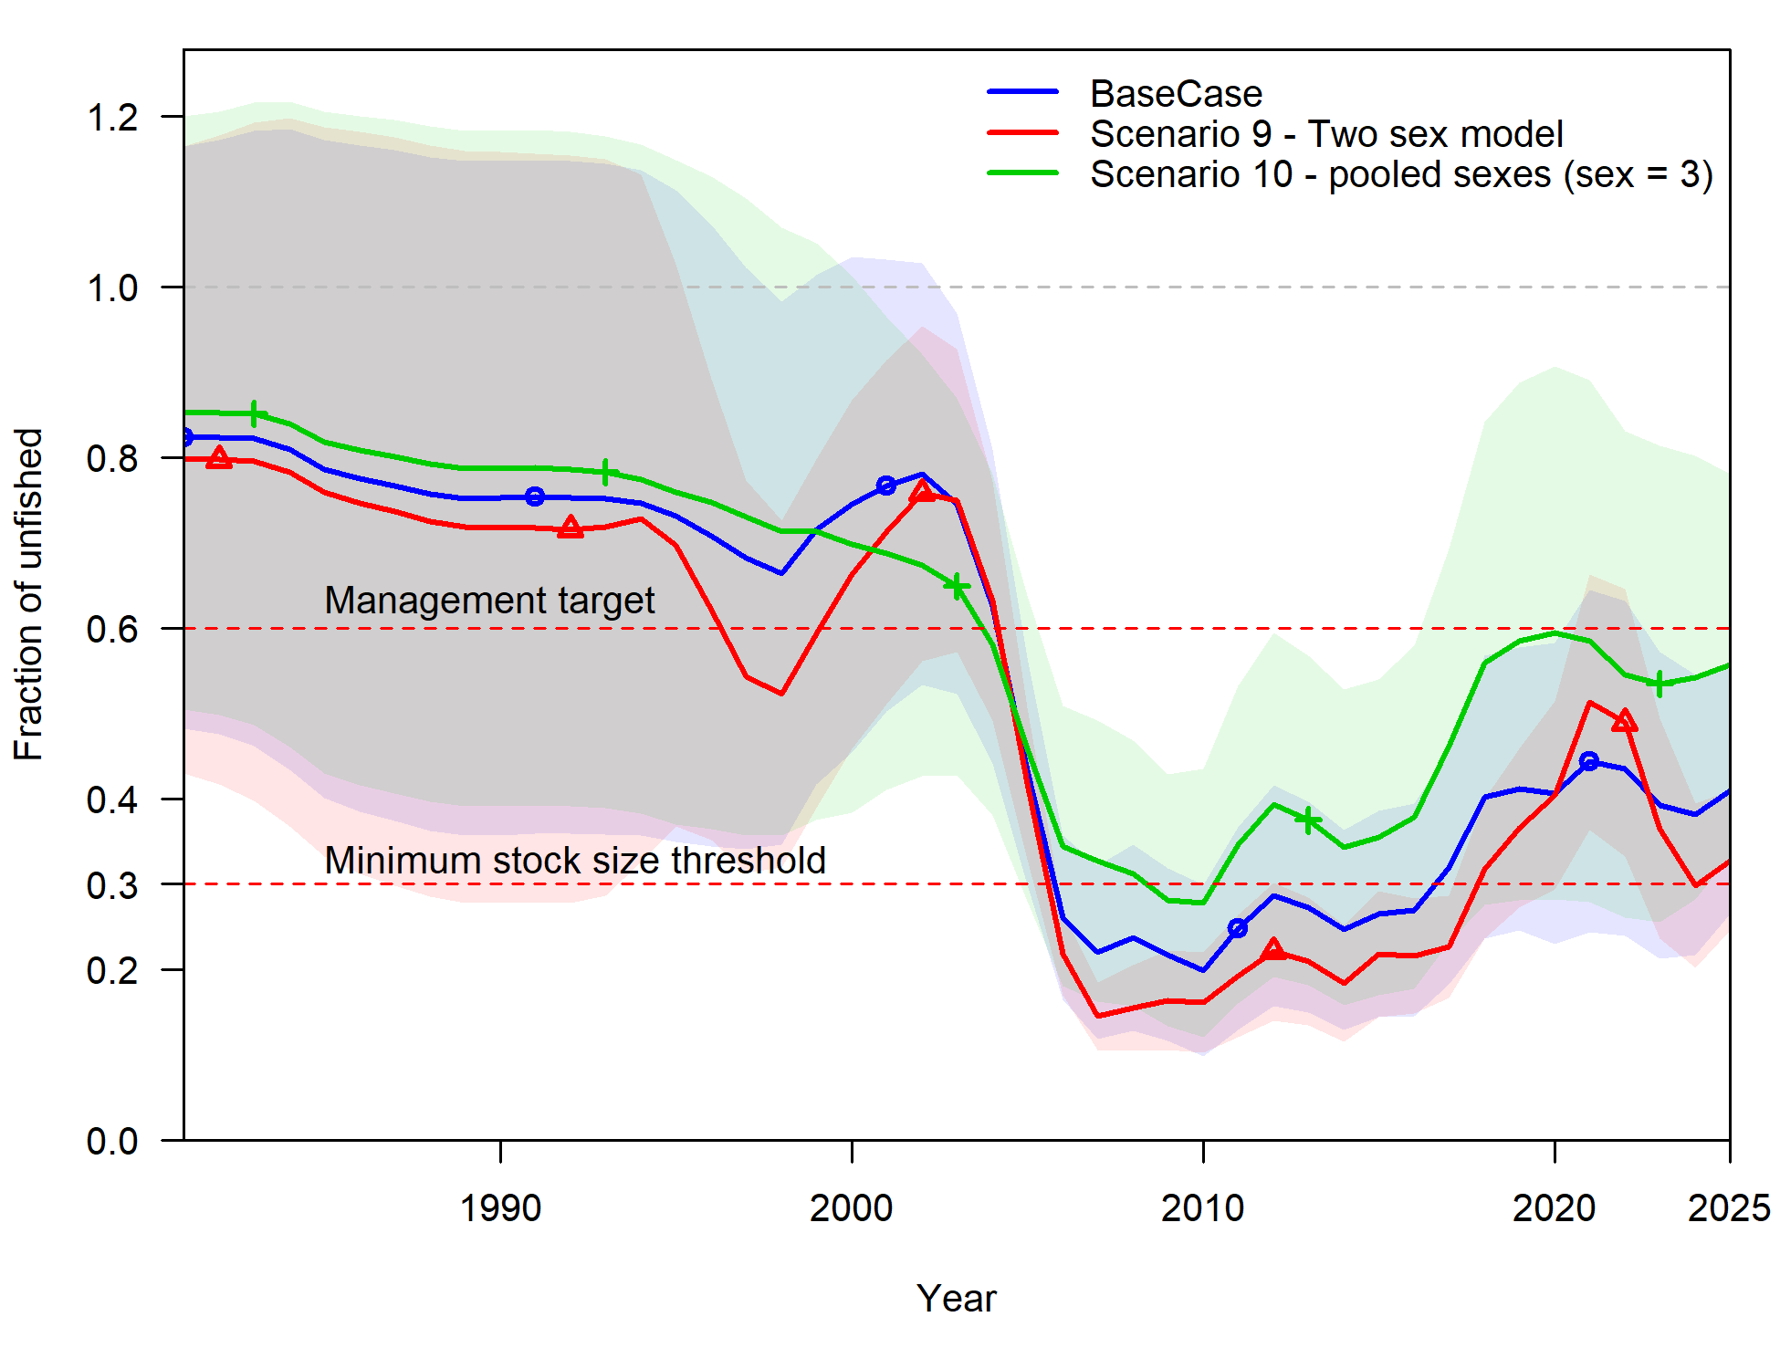
Figure 29: Relative spawning biomass estimates from sensitivity scenarios encompassing three model runs that include the Base Case model (blue line and shading), Scenario 9 – a scenario males and females separated in the model structure (red line and shading), and Scenario 10 – a scenario where males and female data were pooled and sex ratio was used separate sexes in the model structure (green line and shading). Full details or these model runs are provided in Table 9. Note that Scenario 9 could not achieve stable model tuning and neither sensitivity scenario converged. The x-axis displays integer years where 2020 corresponds to the 2019/20 fishing season, and so forth.

SRA - Greater Darwin Region assessment
Previous assessments of Black Jewfish in the Greater Darwin Region have been undertaken using a stochastic Stock Reduction Analysis (SRA) (Lombardi & Walters, 2011; Walters et al., 2006), a description for which is provided in Section 2.9.1. An SRA was undertaken in the current assessment with data up to 2023/24 with several refinements made since the last SRA conducted for Black Jewfish (Saunders et al., 2020). To assess the effects of these refinements on model outcomes, two stochastic SRA models were developed (Table 11; Table 12). These implemented refinements included:
- Updating the life history parameters to match those used as inputs for Stock Synthesis (see Table 10).
- Using updated standardised CPUE series that matched the inputs for Stock Synthesis.
- Changing the catch time series and abundance index from calendar to financial year.
- Incorporating age and length data that were used as inputs for Stock Synthesis.
Table 10: Life history and biological parameters provided in SRA for the 2020 and 2025 assessments of Black Jewfish in the Darwin Region.
Parameter | Description | 2020 value |  | 2025 value
K | Von Bertalanffy Growth Parameter | 0.32 | 0.750
L_{inf} | Asymptotic length | 136 cm | 114 cm
L_{mat} | Length at 50% maturity | 80 cm | 89 cm
A_{mat} | Age at 50% maturity | 3 | 3
S | Survival (exp(-M)) | 50% to 80% | 50% to 80%
CV_{age} | Coefficient of variation in length at age | 0.09 | 0.09
Wt₁₀₀ | Weight at length of 100 cm | 12.82 kg | 8.08 kg
t₀ | Length at age 0 | 0 cm | 0 cm
SD_{rec} | Standard deviation in recruitment | 0.2 | 0.6
ρ | Autocorrelation in recruitment | 0 | 0

Table 11: Scenarios exploring assessments of Black Jewfish in the Darwin Region.
Scenario | Abundance Index | Life history parameters | Data inputs | Last year of assessment
Scenario A | Updated GLM standardised catch rate | 2025 values | Catch, Index | 2023/2024
Scenario B | Updated GLM standardised catch rate | 2025 values | Catch, Index, Age composition, Length composition | 2023/2024

Table 12: Input data for SRA of Black Jewfish in the Darwin Region.
Data Type | Description
Catch Time Series | Total removals from all sectors and discards in each year (tonnes)
Abundance Index | GLM standardised catch rate from 2004/05 to 2022/23
Age composition | Age composition data from 2004/05, 2005/06, 2018/19, 2020/21
Length composition | Length composition data from 2005/06, 2006/07, 2011/12, 2012/13, 2013/14, 2018/19, 2019/20, 2020/21, 2021/22, 2023/24
Vulnerability / Selectivity | Age selectivity is a pre-specified logistic function. No length selectivity is applied.

SRA outcomes
The two stochastic SRAs resulted in divergent outcomes depending on the data sources included in the model (Figure 30). The addition of updated life history parameters, catch time series calculated by financial rather than calendar year, and updated CPUE standardisation model (Figure 30; Scenario A) did not lead to major changes to the model outcomes compared to the 2020 assessment, which determined a similar relative biomass culminating at 93% in 2019 (Saunders et al., 2020). The relative biomass in 2023/24 was estimated to be 85% in Scenario A. However, the inclusion of length and age composition information resulted in a substantially lower relative biomass estimate in 2023/24 of 33% (Scenario B). Similarly, Scenario B produced lower estimates of egg production (as a proportion of virgin egg production) and higher estimates of fishing mortality (as a proportion of F_{MSY}) (Figure 30).
While direct comparisons between Stock Synthesis and SRA models might be nuanced, SRA Scenario A, which included only catch and CPUE (similar to the 2020 assessment (Saunders et al., 2020)), produced a substantially more optimistic assessment than the Base Case stock synthesis model. Meanwhile Scenario B, which included the length and age compositions (similar to Stock Synthesis), had an outcome that was similar to Stock Synthesis. The reasons behind this discrepancy are discussed in Section 7.2.
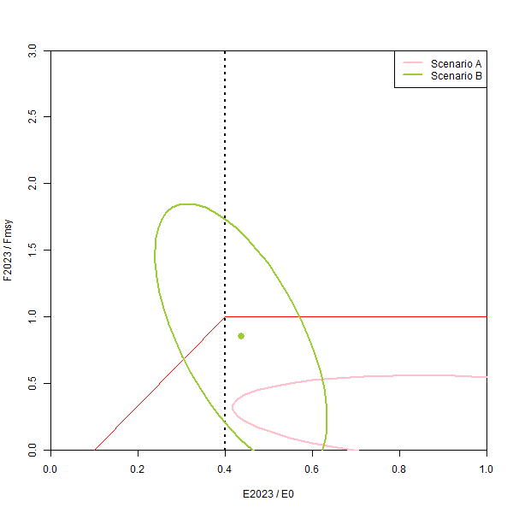
Figure 30: Stock status output from the stochastic SRA assessment scenarios exploring the implications of life history parameters with data to 2023/24. E₂₀₂₃/E₀ is the estimated current egg production as a proportion of virgin egg production, and F₂₀₂₃/F_{MSY} is the estimated current fishing mortality as a proportion of fishing mortality at MSY. Ellipses are the 95% probability region (i.e. 95% chance that the estimated status measures fall within that region).

Regional NT Catch-MSY assessment
A Catch-MSY model was undertaken for the Regional NT assessment unit using total commercial catch estimates and a ‘medium’ resilience setting. This resilience level is one of four in-built options available in the datalowSA package (Haddon et al., 2019) which also includes ‘very low’, ‘low’ and ‘high’. Black Jewfish are considered a relatively productive species warranting a medium resilience setting. A ‘high’ setting would refer to a very productive species such as small pelagic fish species. The resilience levels used in the Catch-MSY model provide defined ranges of r and K that are considered in iterations, which can affect the Catch-MSY results. Therefore, sensitivity scenarios were performed by running the commercial catch series with all four resilience settings to examine the results (Table 13). The results of all but the ‘very low’ resilience setting agreed with the Base Case setting, demonstrating that the choice of resilience was not consequential. A ‘very low’ resilience setting does not match the biology of Black Jewfish.
Table 13: Catch-MSY results for the Regional NT based on the four in-built resilience options in the datalowSA package (Haddon et al., 2019).
Parameter | Base Case (Medium) | Very low | Low | High
MSY | 32 t | 10 t | 28 t | 47 t
R | 0.62 | 0.08 | 0.38 | 1.17
K | 209 t | 485 t | 296 t | 162 t
B_{MSY} | 105 t | 243 t | 148 t | 81 t
H_{MSY} | 0.31 | 0.04 | 0.19 | 0.58
B_{2023/24} | 84% | 48% | 81% | 93%

The Catch-MSY model determined an MSY of 32 t for the Regional NT assessment unit with a B_{MSY} of 105 t and an H_{MSY} of 0.31 (Table 13; Figure 31). The harvest fraction peaked at unstainable levels in 1988/1989 followed by a sharp decline after foreign fleets ceased fishing northern Australia in 1990. The harvest rate remained low for the next 15 years but has increased in the last 10 years in line with the domestic trawl fishery (Figure 31). From the information available, a relative biomass of 84% was estimated at the beginning of 2024/25 (Table 13).
Catch-MSY assessments rely on changes in biomass to be evident in the catch series. Over time the contrast in catch in the regional assessment unit has been driven strongly by management change (i.e. the exit of the foreign fleet and the emergence of domestic trawl), which may mask the biomass driven changes in catch (Figure 31). This makes it difficult to determine the exact harvest fraction that may be estimated. Catch-MSY models perform best when catches fluctuate through time with relative stable fishing dynamics, which indicates changes in biomass. Greater contrast and consistent management would demonstrate more certain Catch-MSY estimates and provide more confident estimates of stock status. In situations where there is insufficient contrast in catches, Catch-MSY assessments will tend to estimate MSY as an approximate average catch of the time series. The Catch-MSY assessment determined H_{2023/24}/H_{MSY} to be less than one, which indicates that fishing is sustainable. It is important to note that Catch-MSY is a data-limited stock assessment approach, and that model uncertainty is unavoidable.
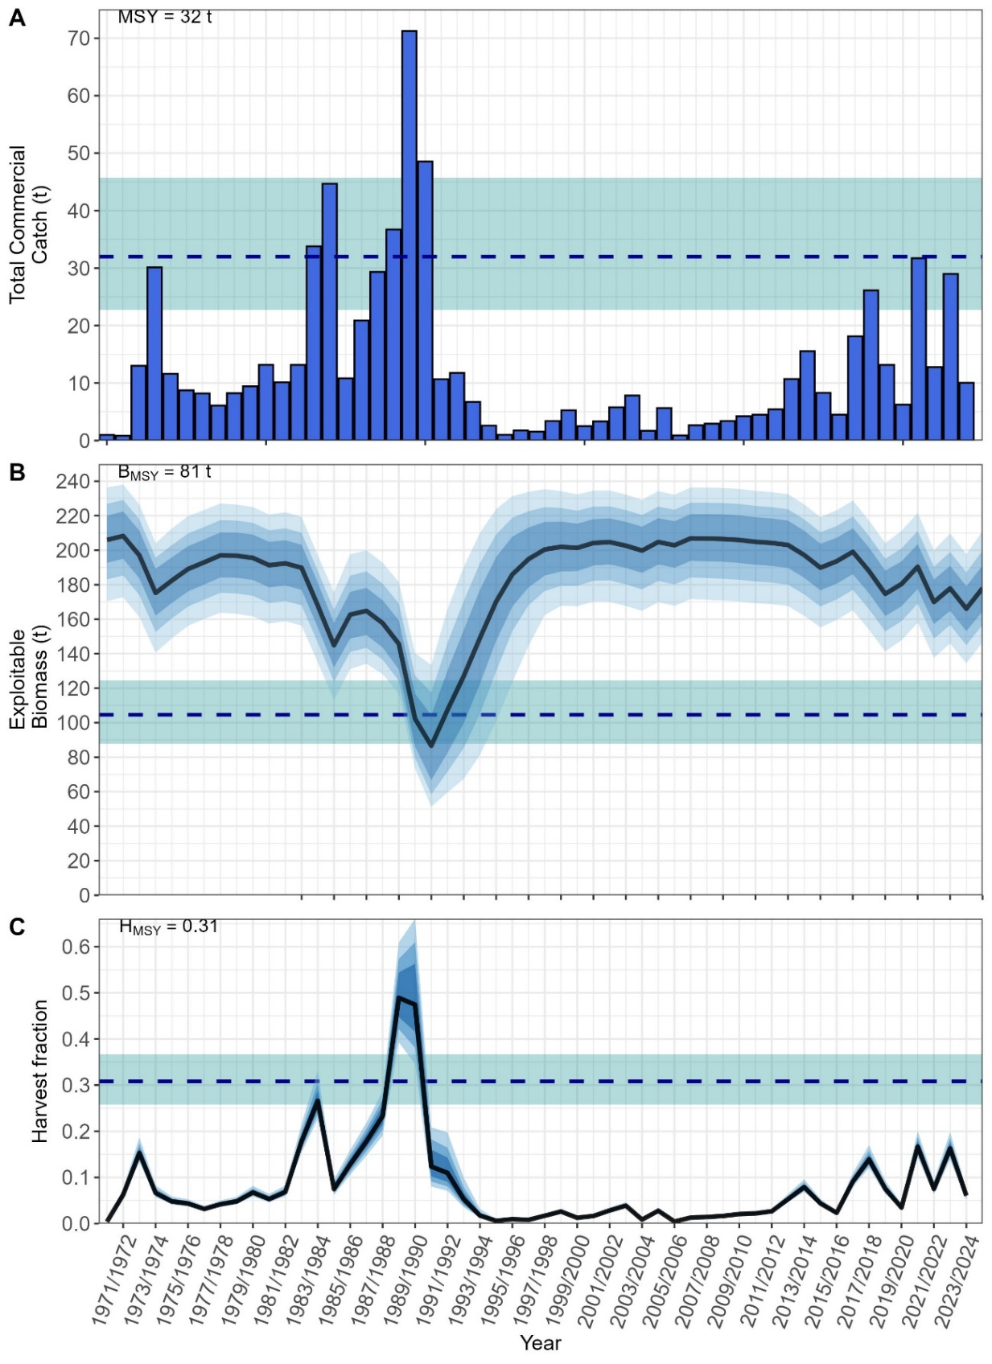
Figure 31: Catch-MSY results for Black Jewfish from the Regional NT. The blue dashed line represents the mean MSY (Panel A), B_{MSY} (Panel B) and H_{MSY} (Panel C), the blue shading around the line shows the 95% confidence intervals. The black lines in panels B and C represent the mean annual values from the Catch-MSY model, and the blue shading represents the 50%, 75% and 95% quantiles. Panel B shows the biomass at the start of the year.

Gulf of Carpentaria Catch-MSY assessment
A Catch-MSY model was undertaken for the Gulf of Carpentaria assessment unit using the same methods as the Regional NT Catch-MSY assessment (Section 5). As was the case with the Regional NT assessment, all but the ‘very low’ resilience setting approximately agreed with the Base Case setting in the Gulf of Carpentaria, demonstrating that the choice of resilience was not consequential (Table 14).
Table 14: Catch-MSY results for the Gulf of Carpentaria based on the four in-built resilience options in the datalowSA package (Haddon et al., 2019).
Parameter | Base Case (Medium) | Very low | Low | High
MSY | 13 t | 4 t | 10 t | 15 t
r | 0.5 | 0.09 | 0.28 | 0.71
K | 102 t | 198 t | 142 t | 85 t
B_{MSY} | 51 t | 99 t | 71 t | 43 t
H_{MSY} | 0.25 | 0.04 | 0.14 | 0.36
B_{2024/25} | 35% | 25% | 35% | 37%

The Catch-MSY model determined an MSY of 13 t for the Gulf of Carpentaria assessment unit with a B_{MSY} of 51 t and an H_{MSY} of 0.25 (Table 14; Figure 32). The harvest fraction was below 0.2 until 2021/22 at which point it increased above H_{MSY} when two higher years of catches occurred (Figure 32). From the information available, a relative biomass of 35% was determined at the beginning of 2024/25 (Table 14). There is very little contrast in the catches from the Gulf of Carpentaria and the assessment unit has likely been lightly exploited. Therefore, the exact exploitation levels for the Gulf of Carpentaria assessment unit remain unclear. It is important to note that Catch-MSY is a data-limited stock assessment approach, and that model uncertainty is unavoidable.
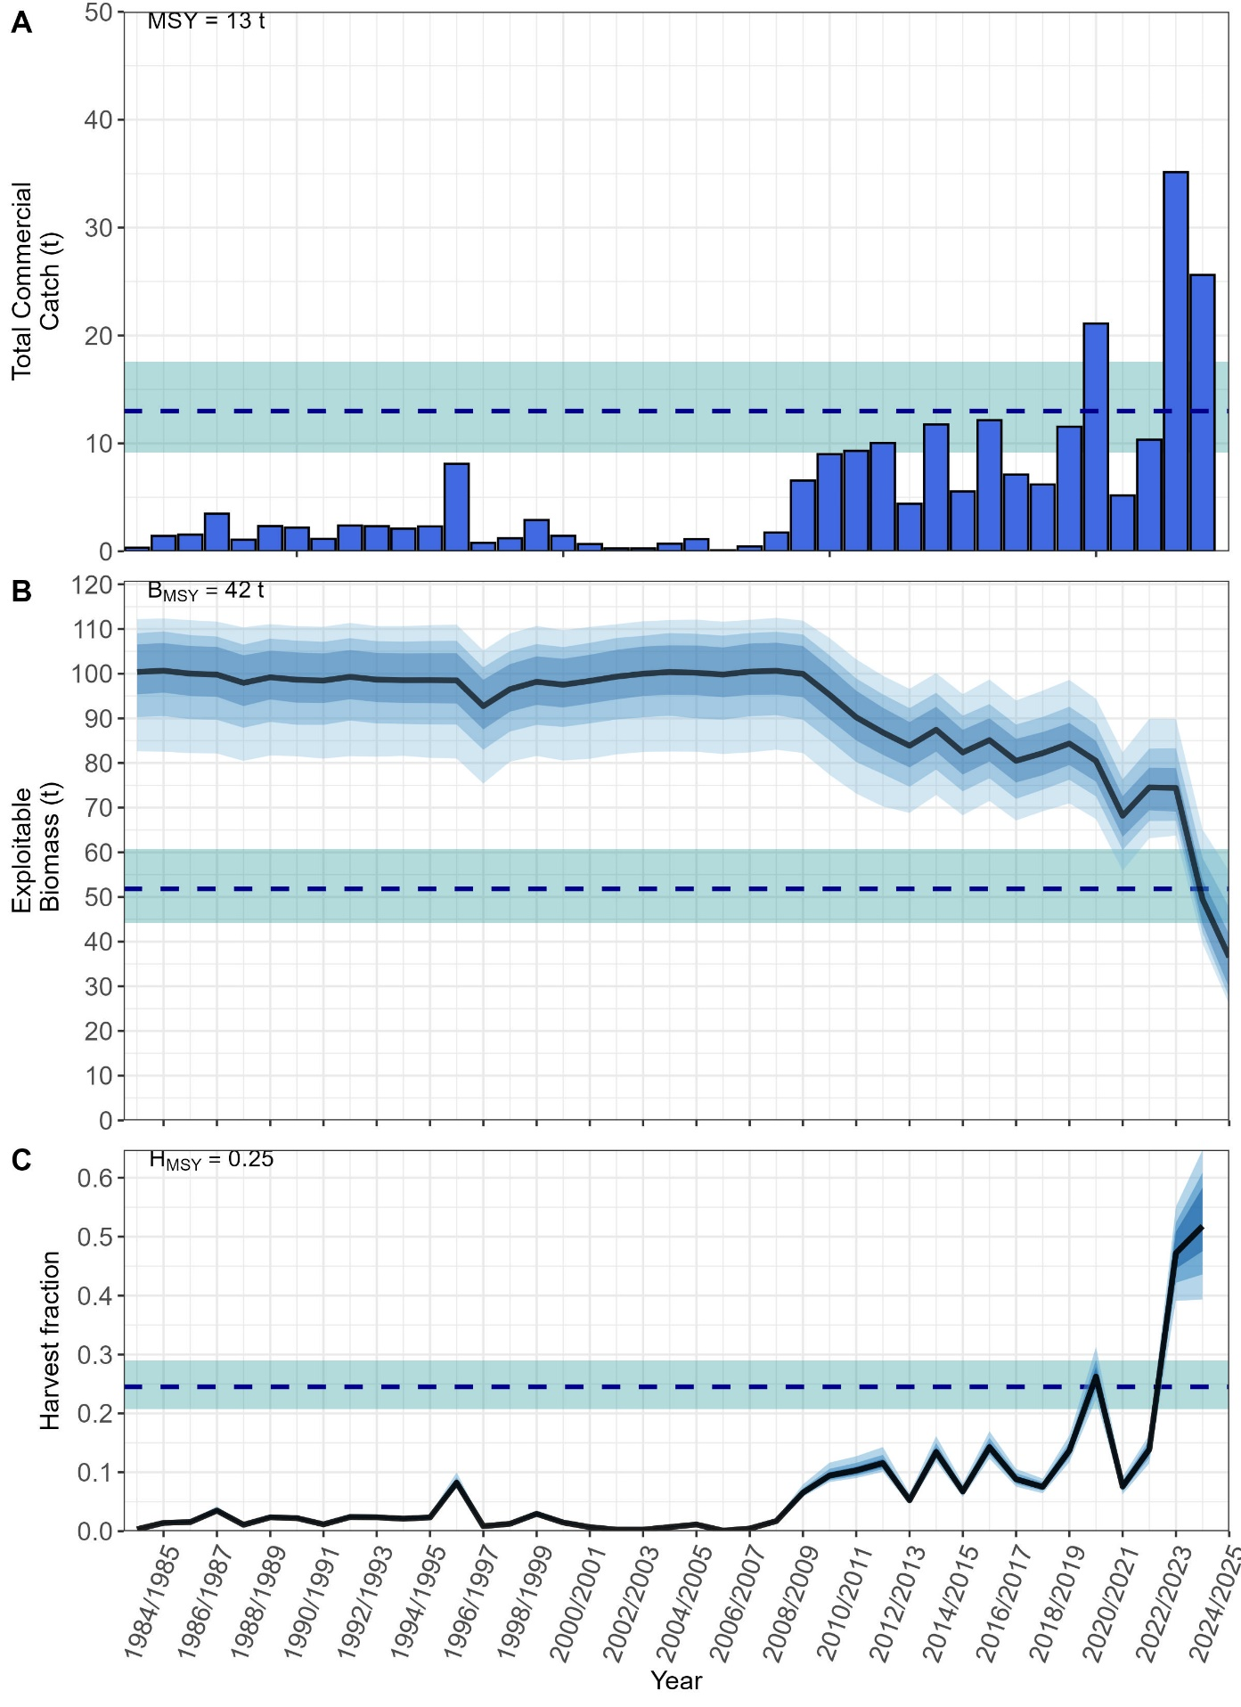
Figure 32: Catch-MSY results for Black Jewfish from the Gulf of Carpentaria. The blue dashed line represents the mean MSY (Panel A), B_{MSY} (Panel B) and H_{MSY} (Panel C), the blue shading around this line shows the 95% confidence intervals. The black lines in panels B and C represent the mean annual values from the Catch-MSY model, and the blue shading represents the 50%, 75% and 95% quantiles. Panel B shows the biomass at the start of the year.

Discussion

Stock status

Greater Darwin Region
Stock status for the Greater Darwin Region was determined from the Stock Synthesis Base Case model outputs. The relative spawning biomass (41%) of Black Jewfish was above the 30% biomass limit reference point and F/F_{MSY} was less than 1 in 2023/24. However, current exploitation levels remain too high to allow the population to achieve the target biomass reference point of 60%. While the stock meets the criteria for ‘Sustainable’ specified in National Fishery Status Reporting Framework (Piddocke et al., 2021), the Stock Synthesis assessment indicated that it does not meet the management criteria specified in the Coastal Line Fishery Harvest Strategy (DITT, 2023). For this to occur, catches will need to be further decreased so that the relative spawning biomass can increase from 41% to the target of 60%. The Stock Synthesis model estimated that a long-term catch of 139 t would be sustainable once the population has reached the target of 60% relative spawning biomass.
On the basis of the evidence provided above, the stock is unlikely to be depleted, and the recruitment is unlikely to be impaired. Black Jewfish in the Greater Darwin Region was classified as Sustainable.

Regional NT
The spatial scale of the regional NT assessment is vast with relatively little catch. The Catch-MSY assessment indicated that catches have previously exceeded sustainable levels, but have been sustainable since 1990. It is important to note that Catch-MSY is a data-limited stock assessment approach and that model uncertainty can be unavoidable. However, from the results provided, it can be concluded that biomass is unlikely to have declined to a point where recruitment could be impaired.
On the basis of the evidence provided above, the stock is unlikely to be depleted, and the recruitment is unlikely to be impaired. Black Jewfish in Regional NT was classified as Sustainable.

Gulf of Carpentaria
The Catch-MSY assessment indicated that catches have been historically low and well beneath the H_{MSY}. However, there is insufficient information available to determine if H_{MSY} has been exceeded, given that only a few years of higher catches have occurred. It is important to note that Catch-MSY is a data-limited stock assessment approach and that model uncertainty is unavoidable. From the results provided, it can be concluded that biomass is unlikely to have declined to a point where recruitment could be impaired.
On the basis of the evidence provided above, the stock is unlikely to be depleted, and the recruitment is unlikely to be impaired. Black Jewfish in the Gulf of Carpentaria was classified as Sustainable.

Updates to Greater Darwin Region assessment
The previous Black Jewfish stock assessment used an SRA to determine stock status (Saunders et al., 2020). This SRA analysis was considered a data limited approach as it only incorporated catch, CPUE and information on species biology. From this information, the past assessment (Scenario A) determined that Black Jewfish were lightly exploited and had high levels of relative biomass in the final assessment years. However, this contrasts with the newly developed Stock Synthesis model which demonstrated that the Black Jewfish population in the Greater Darwin Region has undergone stock declines and presently has a relative spawning biomass estimate of 41%. This produces two key questions regarding model specification and performance:
Why are the results different between the previous SRA and the Stock Synthesis model presented in this stock assessment? An answer to this lies in Scenario B for the SRA which included length and age compositions. This SRA scenario has a relative low biomass trajectory that more closely resembled the Stock Synthesis model and had a final depletion of 33% of B₀ in 2023/24. This indicates the impact of the length and age data to the SRA, which did not appropriately determine the level of exploitation for Black Jewfish without these inputs. If a Stock Synthesis model had not been implemented in the current assessment, then SRA Scenario B would have led to the same stock status outcome. Scenario B primarily differs to the previous SRA by including age data collected since the assessment was published in 2020, along with length compositions across the time series. Without these data, SRA Scenario A performed similarly to the last assessment, indicating the key point of difference is the length and age information.
The length-and age-based selectivities estimated by Stock Synthesis indicate the importance of including biological data, as the effects of fishing on the highly selected components of the population (e.g. fish between 80 – 120 cm TL) would be difficult to model in their absence. The Stock Synthesis scenario that approximated the structure of SRA Scenario A, by only using catch and CPUE (Scenario 6), estimated a relative spawning biomass that was not contradictory to the Base Case model. However, this Scenario was sensitive to parameter starting values to R₀ which affects the scale of the population size. When a larger starting value for R₀ was used, a relative biomass trajectory with higher biomass levels was estimated, similar to SRA Scenario A. This more closely aligns with the results of the last SRA (Saunders et al., 2020) and infers that the same issue may have occurred in that assessment. However, this Stock Synthesis scenario did not initially converge, and its performance was addressed by using a lower starting value for R₀. The key differences between the previous and current assessment were therefore due to the inclusion of length and age data that 1) provided more information on the exploited components of the population, and 2) were needed by the SRA to determine the scale of the population biomass, which could not be achieved from CPUE alone. These modelling difficulties were identified through the application of Stock Synthesis in the current assessment, whereas the issues with the previous assessment stem from a lack of diagnostic ability for SRA model performance. This leads us to the next question:
Why were the results of the previous SRA overly optimistic? This can be related to the extent of information provided from an SRA analysis versus Stock Synthesis. An SRA is a data limited approach which determines appropriate relative biomass trajectories based on prior information and limited data, which previously included only catch and CPUE for Black Jewfish. Black Jewfish are known to aggregate and catch rates for this species are hyperstable, whereby cate rates remain high even while fish densities decrease. This hyperstability does undermine the assumption that catch rates are a proxy for abundance for this species, particularly where no other biological information is used (i.e. length and age information). In addition, an SRA does not fit to the data and there are no model fits to be examined. Therefore, it is far more difficult to determine if a suitable model has been developed. Instead, the user is provided with a relative biomass trend and a range of leading parameter values that resulted in successful model implementations. Conversely, Stock Synthesis fits to multiple data sources and routinely provides information on model performance through warnings, errors and plots of model fits to data. It also has a corresponding R package (ss3diags (Winker et al., 2025)) which provides detailed diagnostics to determine model appropriateness. The development of a Stock Synthesis model is therefore a data driven process where model misspecification becomes far easier to detect and address. While an SRA is valuable method in the stock assessment toolbox and outperforms other data-limited methods, it does not provide the same level of comprehensiveness and insight as a Stock Synthesis model.

Option to improve assessments

Greater Darwin Region

Improved data collection
Estimates of recreational catch were reconstructed for many years of this assessment as annual surveys have not been conducted across most of the time series. Instead, semi-regular recreational fishing surveys were linearly interpolated across years and included in the models as annual harvests. In reality, these are estimates rather than data and should have a measure of uncertainty associated with them. However, this is a challenge faced across Australian and international fisheries and methods to account for this remain limited. More regular recreational fishery data collection would improve the data being provided to the model, increasing the level of certainty in the stock assessment outputs. The assessment would also benefit from improved reporting in FTO logbooks and improved validation across the entire fleet.
The value of length and age information when assessing Black Jewfish has been demonstrated in this assessment. Ongoing collection length and age information will further improve model estimation and provide greater confidence in assessment outcomes.

Consideration of spatial structure
The greatest improvement that could be made to the Greater Darwin Region stock assessment is the consideration of spawning aggregations through greater spatial structure. Black Jewfish are known to form aggregations that can result in high levels of targeting and catch rates tend to be hyperstable (Randall, Saunders, et al., 2023; Taillebois et al., 2017). Available evidence suggests that adult movement of Black Jewfish is limited, and these aggregations could also suffer from localised depletion (Randall, Saunders, et al., 2023). Three main aggregation areas are known for Black Jewfish in the Greater Darwin Region with these recently recognised in the Coastal Line Fishery Harvest Strategy (DITT, 2023). However, the Stock Synthesis model developed in this assessment could not consider this fine scale spatial structure, nor the dynamics related to it, given the paucity of data at the aggregation level. It is therefore possible that different relative spawning biomass trajectories exist for these aggregations.
A spatially structured Stock Synthesis model was simultaneously developed during this assessment to examine these effects. However, the application of this spatially structured model was unsuccessful. While appropriate spatial population dynamics were successfully specified using Stock Synthesis, this model did not achieve suitable convergence and was clearly unstable during the tuning process. As a result, this model could not be considered in management and has not been presented. It does, however, remain an important area of future model improvement. Therefore, a description of this attempted model is summarised here, with advice provided for its future development. The single-area Stock Synthesis model presented in this report (Section 3) remains the most appropriate scientific evidence for the management of the stock until such a time as this spatially structured model can be successfully implemented.
The spatially structured Stock Synthesis model was adapted from the single-area model in the following ways:
- The three aggregation sites referred to in the CLF harvest strategy (DITT, 2023) were defined as three areas in the model, with intermediary areas associated with each aggregation. Most of the catch and effort of the fishing fleets occurs within small geographic areas surrounding these aggregations.
- Sub-populations within each model area had recruitment linked to a global stock recruitment relationship (i.e., recruitment is shared across all three areas) with time varying fractions of annual recruitment estimated. No adult movement occurred between model areas, so sub-population dynamics were only driven through recruitment and exploitation, as no migration occurred.
- Catch, CPUE, length compositions and CAAL were disaggregated and associated with each model area according to fishing grids, which were used to define model area boundaries. Catches from the recreational sector were not available at this scale. Therefore, the spatial distribution of FTO catches were applied to total recreational catch to separate these by model area. The average distribution of FTO catches was used to separate recreational catch across areas prior to the commencement of FTO logbooks. There is no further information that can be used to separate recreational catch by area, and this consideration is a key point of uncertainty in a spatially structured model.
- Most recreational and FTO catch occurred in the model area associated with the Mitchell Point aggregation (which is the aggregation nearest to Darwin), with relatively minor catches occurring in the other two model areas. Therefore, equilibrium fishing mortality for the recreational fleet was only estimated for the Mitchell Point model area.
- Catchability was mirrored to the Channel Point area rather than being estimated individually for each model area. This improves model stability when there is no reason to believe that catchability is spatially variable. This area was selected as it was where most CLF catch and effort occurs.
- Growth estimation was trialled as a single growth pattern across model areas, as well as area specific growth to improve model stability. Whether or not growth was area specific was not resolved due to model instability.
- A combined sex model was used for model development as a two-sex model further reduced the sample sizes of length and CAAL data.
The value of a spatially structured model is that relative spawning biomass can be estimated for each spawning aggregation, allowing spatially explicit management be applied when stock status differs between each of these areas. However, these spatially explicit relative spawning biomass estimates were not reliably estimated during the model development process. This was concluded as relatively minor changes to model structure or decision making led to volatility in model results. One model specification might have estimated a higher level of biomass in one area, with a greater decline in another, while a minor change to the model specification would provide the opposite results that altered stock status conclusions for all areas. This degree of uncertainty was unacceptable, leading to any degree of spatial structure being disregarded in this report.
This attempt to specify a spatially structured stock assessment model remained a valuable exercise as it: 1) demonstrated that the correct model structure for Black Jewfish biology and population structure might be designed if sufficient data become available, and 2) demonstrated that the single area presented here is the best available science to manage the Black Jewfish population in the Greater Darwin Region as further model extension was not possible.
Future development of the spatially structured model is possible and would allow the stock assessment to match the management units of the fishery (i.e., the spawning aggregations). However, its successful application would require expanded sampling of catch and effort information as well as lengths and ages to provide sufficient data to model sub-populations. The extent of this expanded sampling has not been determined within this assessment, although future attempts to do so would be valuable in order to evaluate the resources required for this extension. Determining and quantifying aspects of the spatial dynamics, such as movement between aggregations at different life history stages, and spatial attributes of spawning and recruitment, would also be informative but would also likely be experimentally and economically challenging.

References
Bartoń, K. (2024). MuMIn: Multi-Model Inference. https://CRAN.R-project.org/package=MuMIn
Beverton, R. J. H., & Holt, S. J. (1957). On the Dynamics of Exploited Fish Populations (1st ed.). Chapman and Hall.
Blaber, S., Brewer, D., Salini, J., & Kerr, J. (1990). Biomasses, catch rates and abundances of demersal fishes, particularly predators of prawns, in a tropical bay in the Gulf of Carpentaria, Australia. Marine Biology, 107(3), 397–408.
Breheny, P., & Burchett, W. (2017). Visualization of Regression Models Using visreg. The R Journal, 9(2), 56–71.
Brooks, M. E., Kristensen, K., Benthem, K. J. van, Magnusson, A., Berg, C. W., Nielsen, A., Skaug, H. J., Maechler, M., & Bolker, B. M. (2017). glmmTMB Balances Speed and Flexibility Among Packages for Zero-inflated Generalized Linear Mixed Modeling. The R Journal, 9(2), 378–400.
Cadrin, S. X. (1997). Retrospective analysis of virtual population estimates for Atlantic menhaden stock assessment. Fish. Bull. US, 95, 445–455.
Carvalho, F., Winker, H., Courtney, D., Kapur, M., Kell, L., Cardinale, M., Schirripa, M., Kitakado, T., Yemane, D., Piner, K. R., Maunder, M. N., Taylor, I., Wetzel, C. R., Doering, K., Johnson, K. F., & Methot, R. D. (2021). A cookbook for using model diagnostics in integrated stock assessments. Fisheries Research, 240, 105959. https://doi.org/10.1016/j.fishres.2021.105959
Cope, J. & Hamel O. (2022). Upgrading from M version 0.2: An application-based method for practical estimation, evaluation and uncertainty characterization of natural mortality. Fisheries Research, 256, 106493. https://doi.org/10.1016/j.fishres.2022.106493
DITT. (2023). Coastal Line Fishery harvest strategy. Department of Industry, Tourism and Trade (DITT). Darwin, NT, Australia.
Francis, R. I. C. C. (2011). Data weighting in statistical fisheries stock assessment models. Canadian Journal of Fisheries and Aquatic Sciences, 68(6), 1124–1138. https://doi.org/10.1139/f2011-025
Gabry, J., & Mahr, T. (2020). Bayesplot: Plotting for Bayesian Models. R package version 1.7.2, https://mc-stan.org/bayesplot.
Grubert, M. A., Saunders, T. (Thor), Martin, J. M., Lee, H., & Walters, C. J. (2013). Stock assessments of selected Northern Territory fishes.
Haddon, M., Burch, P., & Dowling, N. (2019). Reducing the Number of Undefined Species in Future Status of Australian Fish Stocks Reports: Phase Two—Training in the assess- ment of data-poor stocks.
Hamel, O. S. (2015). A method for calculating a meta-analytical prior for the natural mortality rate using multiple life history correlates. ICES Journal of Marine Science, 72(1), 62–69. https://doi.org/10.1093/icesjms/fsu131
Hartig, F. (2024). DHARMa: Residual Diagnostics for Hierarchical (Multi-Level / Mixed) Regression Models. https://CRAN.R-project.org/package=DHARMa
Henry, G., & Lyle, J. (2003). The national recreational and indigenous fishing survey: Vol. FRDC project 99/158, Final Report.
Hurtado-Ferro, F., Szuwalski, C. S., Valero, J. L., Anderson, S. C., Cunningham, C. J., Johnson, K. F., Licandeo, R., McGilliard, C. R., Monnahan, C. C., Muradian, M. L., & others. (2015). Looking in the rear-view mirror: Bias and retrospective patterns in integrated, age-structured stock assessment models. ICES Journal of Marine Science, 72(1), 99–110.
James, P. (1994). Endangered, vulnerable and rare marine fishes and animals.
Jensen, A. L. (1996). Beverton and Holt life history invariants result from optimal trade-off of reproduction and survival. Canadian Journal of Fisheries and Aquatic Sciences, 53(4), 820–822. https://doi.org/10.1139/f95-233
Lombardi, L., & Walters, C. (2011). Stochastic Stock Reduction Analysis (SRA) User Guide. NOAA Fisheries Service, Southeast Fisheries Science Center, Panama City Laboratory, 3500, 11–03.
Lüdecke, D., Ben-Shachar, M. S., Patil, I., Waggoner, P., & Makowski, D. (2021). performance: An R Package for Assessment, Comparison and Testing of Statistical Models. Journal of Open Source Software, 6(60), 3139. https://doi.org/10.21105/joss.03139
Martell, S., & Froese, R. (2013). A simple method for estimating MSY from catch and resilience. Fish and Fisheries, 14(4), 504–514.
Maunder, M. N., Hamel, O. S., Lee, H.-H., Piner, K. R., Cope, J. M., Punt, A. E., Ianelli, J. N., Castillo-Jordán, C., Kapur, M. S., & Methot, R. D. (2023). A review of estimation methods for natural mortality and their performance in the context of fishery stock assessment. Fisheries Research, 257, 106489. https://doi.org/10.1016/j.fishres.2022.106489
Methot, R. D., & Taylor, I. G. (2011). Adjusting for bias due to variability of estimated recruitments in fishery assessment models. Canadian Journal of Fisheries and Aquatic Sciences, 68(10), 1744–1760. https://doi.org/10.1139/f2011-092
Methot, R. D., & Wetzel, C. R. (2013). Stock synthesis: A biological and statistical framework for fish stock assessment and fishery management. Fisheries Research, 142, 86–99. https://doi.org/10.1016/j.fishres.2012.10.012
Mohn, R. (1999). The retrospective problem in sequential population analysis: An investigation using cod fishery and simulated data. ICES Journal of Marine Science, 56(4), 473–488.
Ogle, D. H. (2016). FSA: Fisheries Stock Analysis. R package version 0.8.5.
O'Neill, MF, Leigh, GM, Martin, JM, Newman, SJ, Chambers, M, Dichmont, CM and Buckworth, RC 2011, Sustaining productivity of tropical red snappers using new monitoring and reference points, Fisheries Research and Development Corporation Project Number 2009/037.
Pauly, D. (1980). On the interrelationships between natural mortality, growth parameters, and mean environmental temperature in 175 fish stocks. ICES Journal of Marine Science, 39(2), 175–192. https://doi.org/10.1093/icesjms/39.2.175
Penny, S., Lovett, R. A., Trinnie, F., & Newman, S. J. (2018). Black jewfish Protonibea diacanthus. Status of Australian fish stocks. Canberra, Fisheries Research and Development Corporation.
Phelan, M. (2008). Assessment of the Implications of Target Fishing on Black Jewfish (Protonibea Diacanthus) Aggregations in Northern Territory.
Piddocke, T., Ashby, C., Hartmann, K., Hesp, A., Hone, P., Klemke, J., Mayfield, S., Roelofs, A., Saunders, T., Stewart, J., Wise, B., & Woodhams, J. (eds). (2021). Status of Australian fish stocks reports 2020. Fisheries Research and Development Corporation, Canberra.
Porter, M., Barton, D. P., Hearnden, M., Randall, J., Crook, D. A., & Shamsi, S. (2023). Relationships between local variability in parasite communities of the black-spotted croaker (Protonibea diacanthus)(Teleostei: Sciaenidae) and host population structure and seasonality. Scientific Reports, 13(1), 10291.
Punt, A. E. (2023). Those who fail to learn from history are condemned to repeat it: A perspective on current stock assessment good practices and the consequences of not following them. Fisheries Research, 261, 106642. https://doi.org/10.1016/j.fishres.2023.106642
Punt, A. E., Johnson, K. F., Taylor, I. G., & Burch, P. (2025). AgeingError: Estimating ageing error with “TMB” from double reads. https://github.com/pfmc-assessments/AgeingError
Punt, A. E., Smith, D. C., KrusicGolub, K., & Robertson, S. (2008). Quantifying age-reading error for use in fisheries stock assessments, with application to species in Australia’s southern and eastern scalefish and shark fishery. Canadian Journal of Fisheries and Aquatic Sciences, 65, 1991–2005. https://doi.org/10.1139/F08-111
Randall, J., Saunders, T., Barton, D., Porter, M., King, A., Kaestli, M., Gibb, K., Adair, B., Wedd, D., Roberts, B., Kopf, K., & Crook, D. A. (2023). Biology of Black Jewfish (Protonibea diacanthus) in the Northern Territory: Information to Support Stock Assessment (Project No. 2018/027). Fisheries Research and Development Corporation. Available at Https://Www. Frdc. Com. Au/Project/2018-027.
Randall, J., Williams, S., Trinnie, F., & Newman, S. J. (2023). Black jewfish Protonibea diacanthus. Status of Australian Fish Stocks. Canberra, Fisheries Research and Development Corporation.
Rikhter, V. A., & Efanov, V. N. (1976). On one of the approaches to estimation of natural mortality of fish populations. ICNAF Res. Doc. 79/VI/8, 12.
Roelofs, A., Piddocke, T., Ashby, Crispian, Conron, S., Hartmann, K., Hesp, A., Hone, P., Jacobsen, I., Jesson-Kerr, M., Mayfield, S., Stewart, J., Usher, M., Woodhams, J., & Wright, D. (Eds.). (2024). Status of Australian Fish Stocks Reports 2024. Fisheries Research and Development Corporation. https://www.fish.gov.au/about/authors
Roff, D. A. (1984). The Evolution of Life History Parameters in Teleosts. Canadian Journal of Fisheries and Aquatic Sciences, 41(6), 989–1000. https://doi.org/10.1139/f84-114
Sadovy, Y. (2001). The threat of fishing to highly fecund fishes. Journal of Fish Biology, 59, 90–108. https://doi.org/10.1111/j.1095-8649.2001.tb01381.x
Saunders, T., Barton, D. P., Crook, D., Ovenden, J., Newman, S. J., Saunders, R., Taillebois, L., Taylor, J., Travers, M. J., Dudgeon, C., & others. (2017). Optimising the management of tropical reef fish through the development of indigenous scientific capability.
Saunders, T., Pidd, A., & Newman, S. J. (2020). Black jewfish Protonibea diacanthus. Status of Australian Fish Stocks. Canberra, Fisheries Research and Development Corporation.
Saunders, T., Roelofs, A., & Newman, S. J. (2016). Black jewfish Protonibea diacanthus. Status of Australian fish stocks. Canberra, Fisheries Research and Development Corporation.
Smart, J. J. (2020). BayesGrowth: Estimate fish growth using MCMC analysis. R package version 0.3.0. Https://github.com/jonathansmart/BayesGrowth.
Smart, J. J., & Grammer, G. L. (2021). Modernising fish and shark growth curves with Bayesian length-at-age models. PLOS ONE, 16(2), e0246734. https://doi.org/10.1371/journal.pone.0246734
Taillebois, L., Barton, D. P., Crook, D. A., Saunders, T., Taylor, J., Hearnden, M., Saunders, R. J., Newman, S. J., Travers, M. J., Welch, D. J., Greig, A., Dudgeon, C., Maher, S., & Ovenden, J. R. (2017). Strong population structure deduced from genetics, otolith chemistry and parasite abundances explains vulnerability to localized fishery collapse in a large Sciaenid fish, Protonibea diacanthus. Evolutionary Applications, 10(10), 978–993. https://doi.org/10.1111/eva.12499
Taylor, I. G., Doering, K. L., Johnson, K. F., Wetzel, C. R., & Stewart, I. J. (2021). Beyond visualizing catch-at-age models: Lessons learned from the r4ss package about software to support stock assessments. Fisheries Research, 239, 105924. https://doi.org/10.1016/j.fishres.2021.105924
Then, A. Y., Hoenig, J. M., Hall, N. G., & Hewitt, D. A. (2015). Evaluating the predictive performance of empirical estimators of natural mortality rate using information on over 200 fish species. ICES Journal of Marine Science, 72(1), 82–92. https://doi.org/10.1093/icesjms/fsu136
Vidthayanon, C., & Premcharoen, S. (2002). The status of estuarine fish diversity in Thailand. Marine and Freshwater Research, 53(2), 471–478.
von Bertalanffy, L. (1938). A quantitative theory of organic growth (inquires on growth laws. II). Human Biology, 10(2), 181–213. https://doi.org/10.2307/41447359
Walters, C. J., Martell, S. J. D., & Korman, J. (2006). A stochastic approach to stock reduction analysis. Canadian Journal of Fisheries and Aquatic Sciences, 63(1), 212–223. https://doi.org/10.1139/f05-213
West, L., Lyle, J., Matthews, S., Stark, K., & Steffe, A. (2012). Survey of recreational fishing in the Northern Territory, 2009-10.
West, L., Stark, K., Dysart, K., & Lyle, J. (2022). Survey of recreational fishing in the Northern Territory: 2018 to 2019. Northern Territory Fisheries.
Williams, S. M., Mitchell, J. D., Barnett, A., & Leahy, S. M. (2023). Assessing the population biology of Black Jewfish (Protonibea diacanthus) in Queensland [Monograph]. FRDC. https://era.daf.qld.gov.au/id/eprint/9544/
Winker, H., Carvalho, F., Cardinale, M., Kell, L., Oshima, M., & Fletcher, E. (2025). ss3diags: Stock Synthesis Model Diagnostics for Intergated Stock Assessments. https://github.com/PIFSCstockassessments/ss3diags
Winker, H., Carvalho, F., & Kapur, M. (2018). JABBA: Just Another Bayesian Biomass Assessment. Fisheries Research, 204, 275–288. https://doi.org/10.1016/j.fishres.2018.03.010

Appendices

CPUE standardisation

Model diagnostics
A large range of models were tested before selecting the final model (Section 3.3.2). The selection was based on multiple criteria such as lowest Akaike Information Criterion (AIC), no over or under dispersion and no strong residual patterns. The models were examined using the performance and DHARMa R packages (Hartig, 2024; Lüdecke et al., 2021) which provide several useful statistics and visual diagnostics to determine if the model has been fit appropriately to the data.
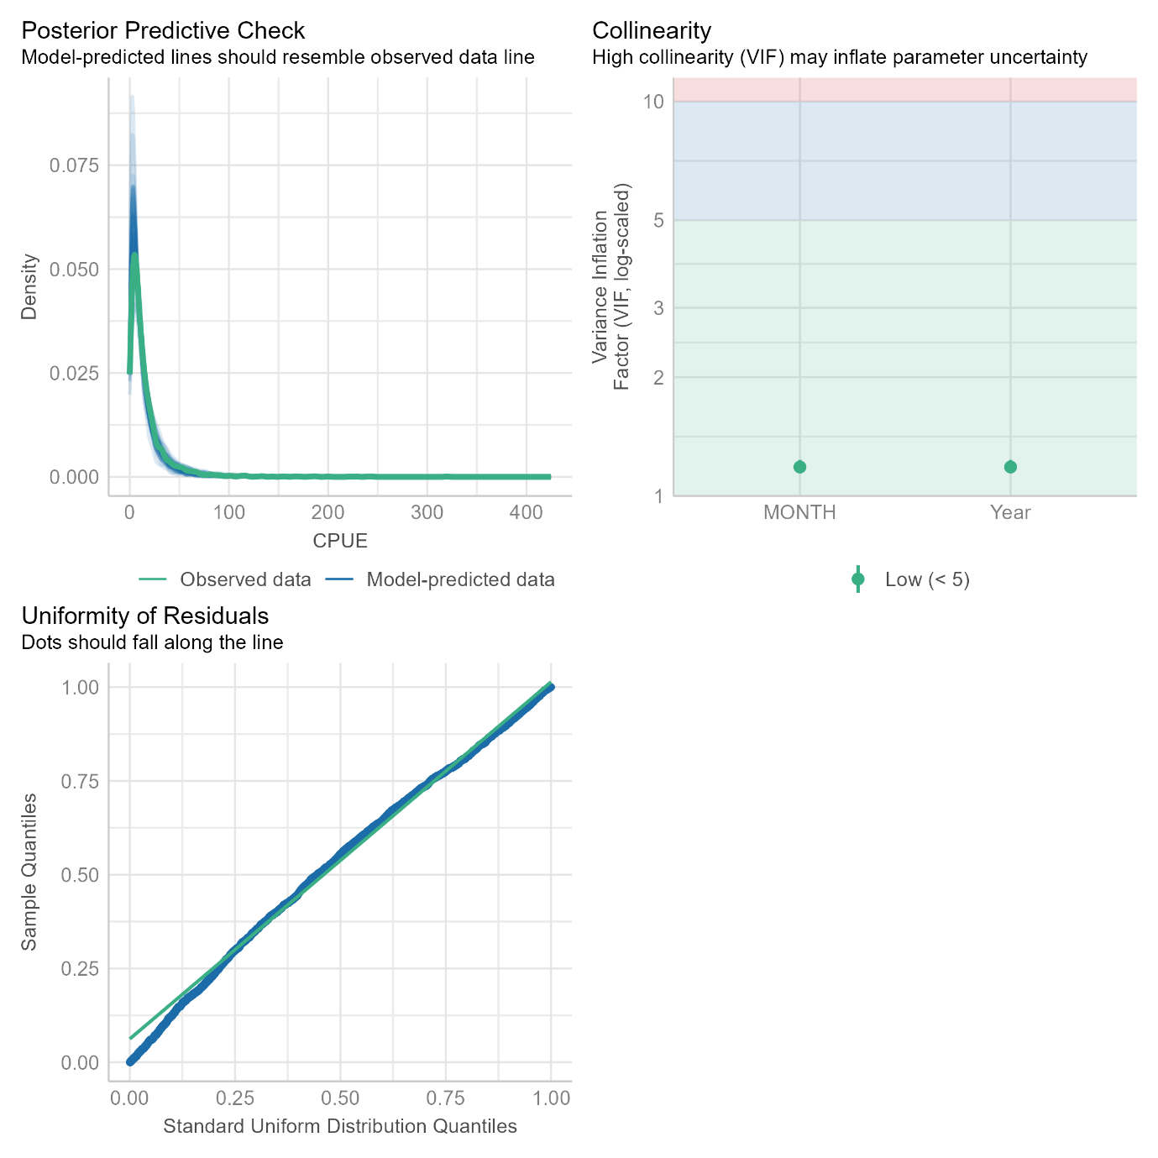
Figure 33: The model diagnostic plots output from the performance R package
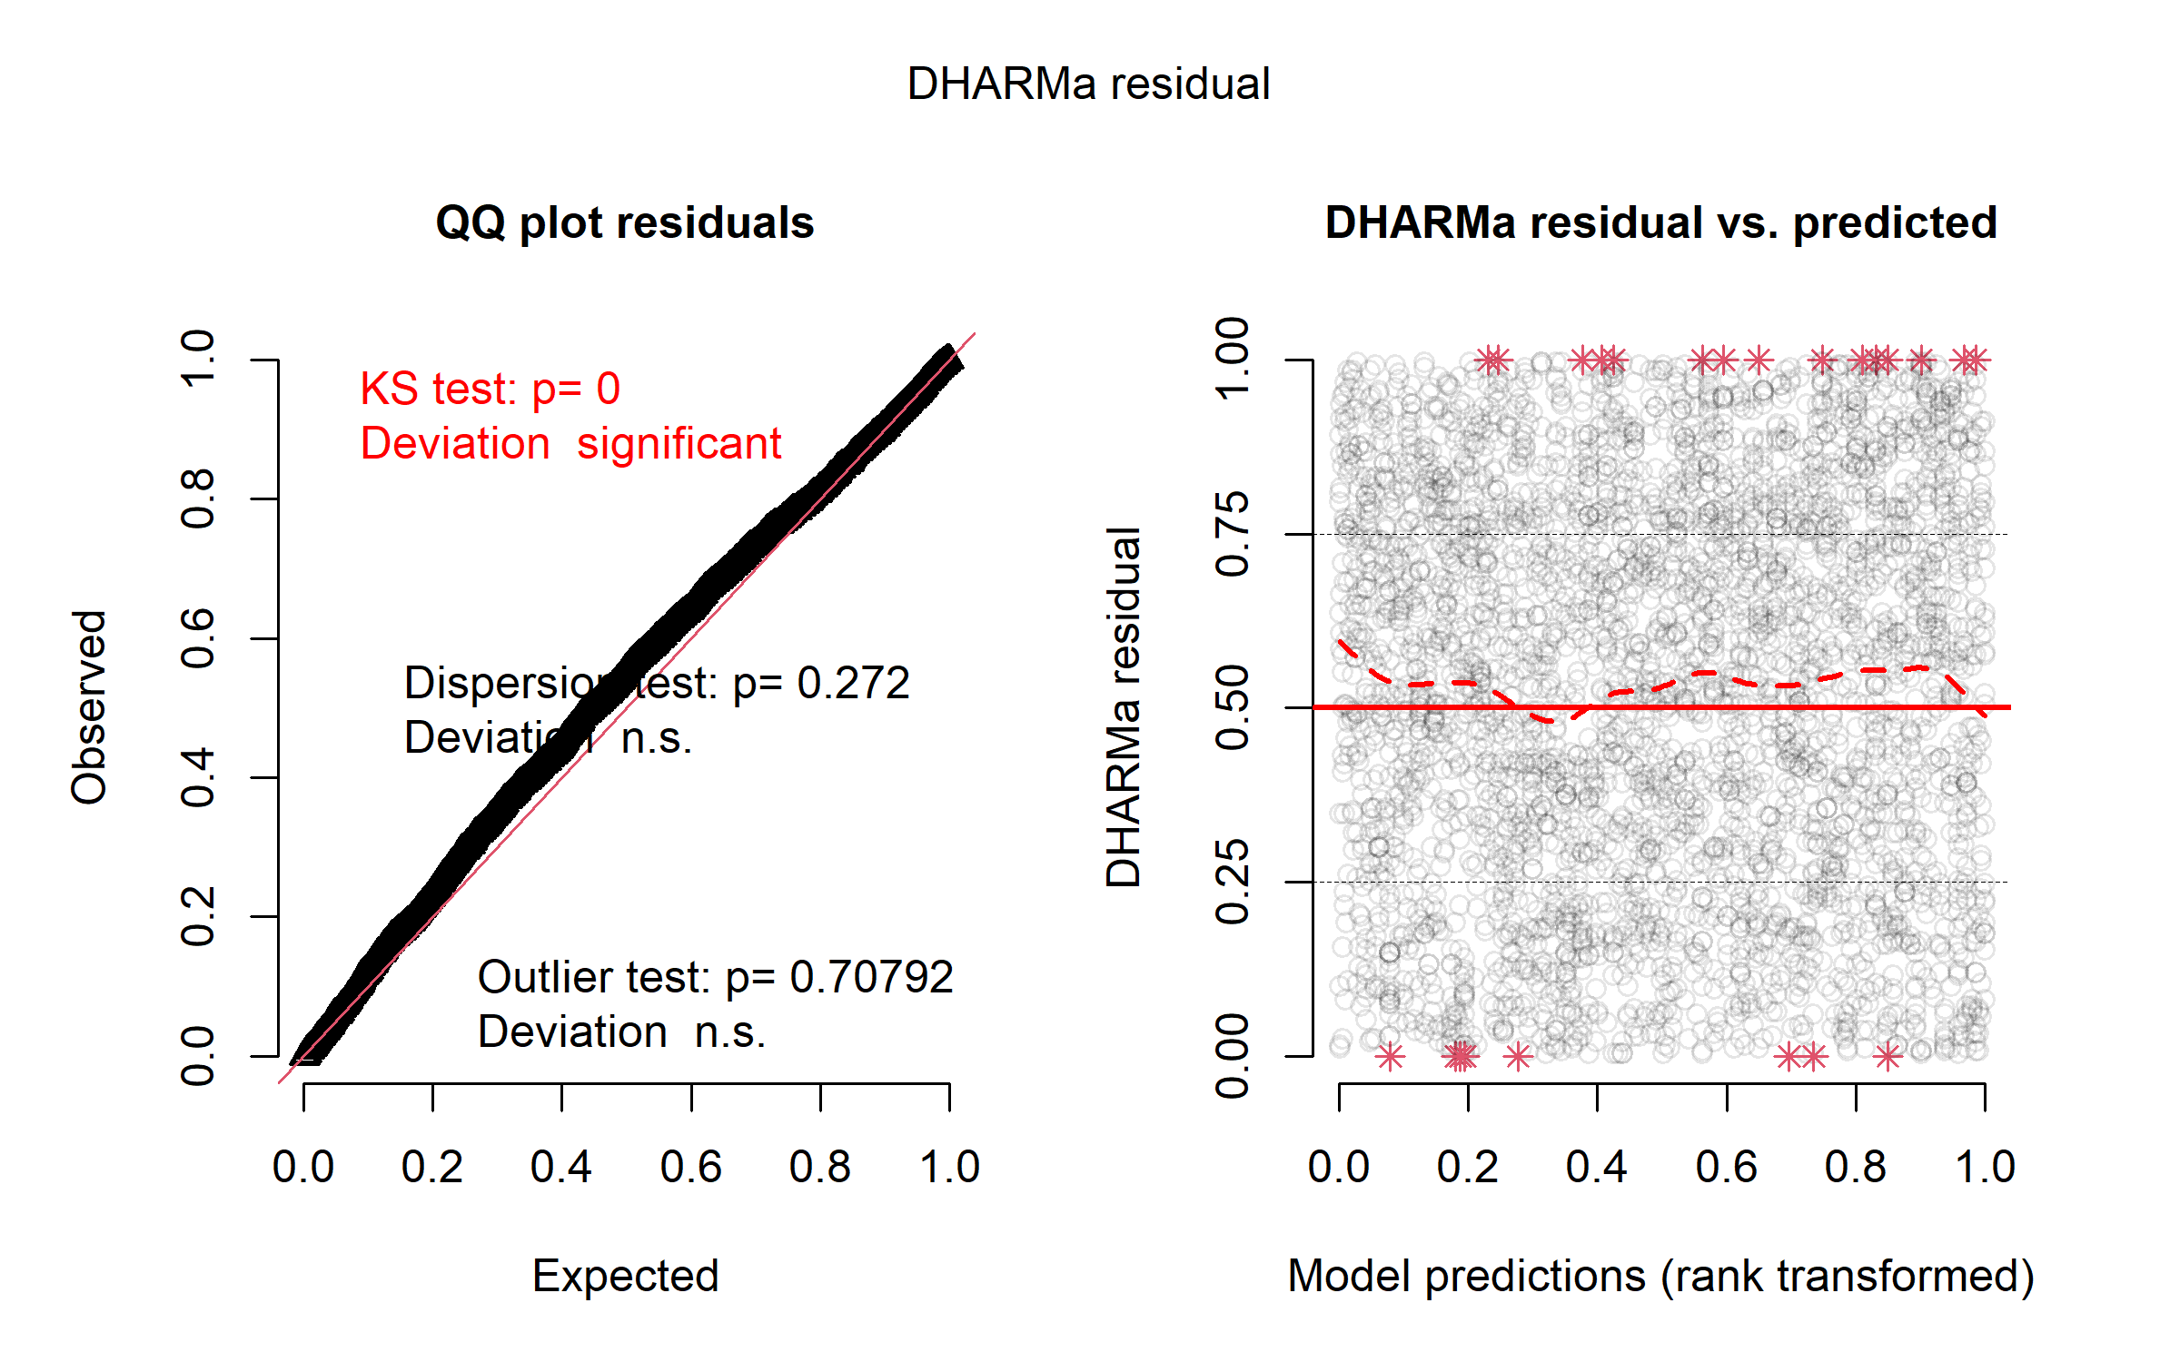
Figure 34: The model diagnostic plots output from the DHARMa R package

Effect size of variables used in CPUE standardisation.
The effect sizes of the independent variables were similarly calculated individually using model predictions that held all other variables constant. These were produced using the visreg R package (Breheny & Burchett, 2017). These demonstrate that there were strong effects of month and licence on CPUE, whereas the effect of grid was relatively weak (Figure 35). However, the Year variable had a much stronger influence on CPUE (Figure 35), which demonstrates why standardised CPUE closely matched nominal CPUE.
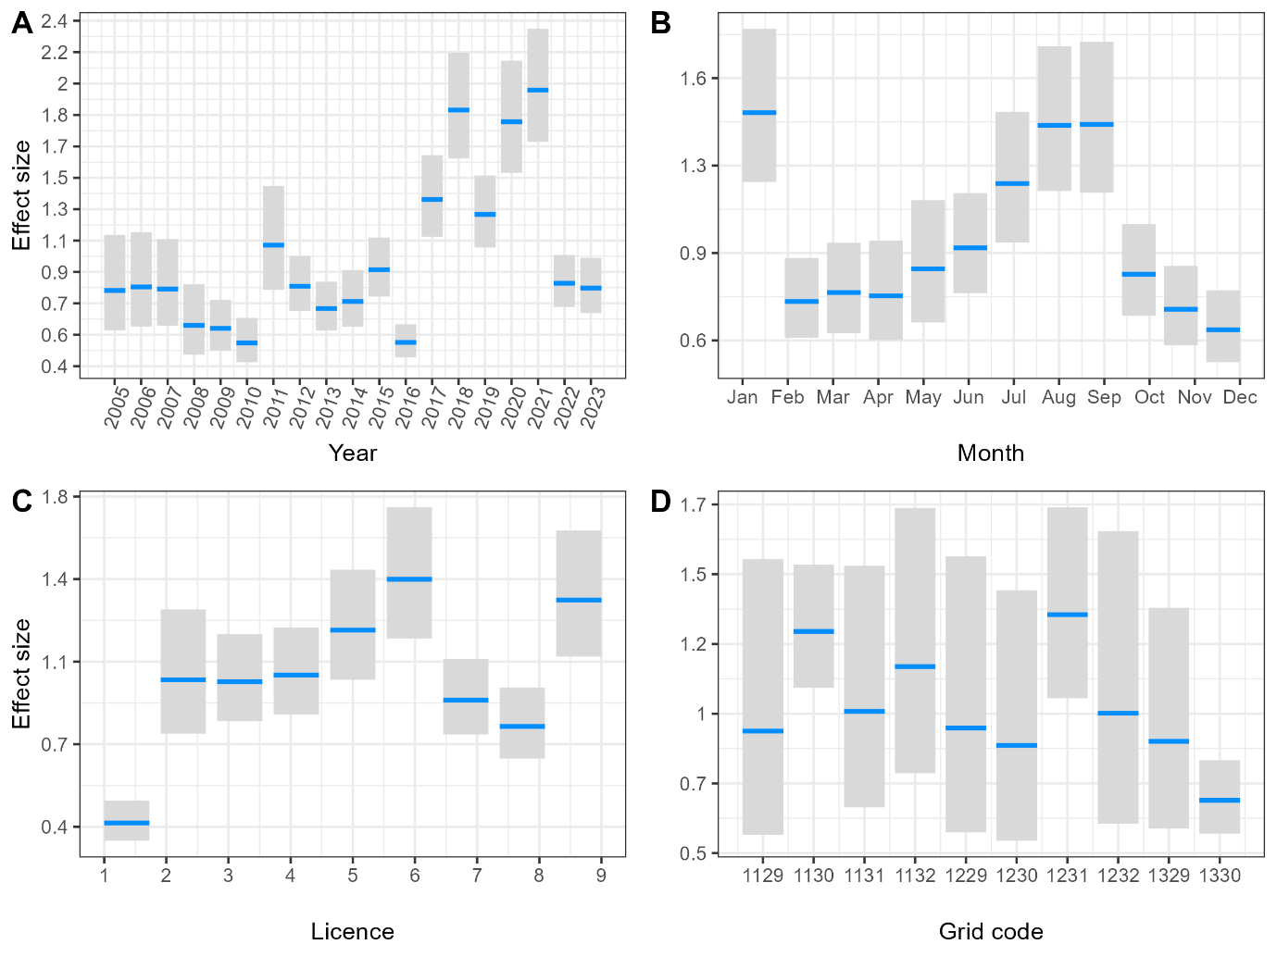
Figure 35: Effect size of independent variables from the CPUE standardisation GLMM: A) Fishing season, B) Month, C) Grid and D) Licence. Note that all variables have been centred on a mean of 1 so that they are comparable. Also licence number has been obscured to protect confidentiality. The licence effect presented is a modelled effect and not an observed result from catch and effort returns.

Coefficient of variation for CPUE
The Stock Synthesis requires a standard error in log space of the abundance index. This was developed by fitting a loess smoother to the point estimates of the abundance indices (Figure 36). The standard error of the abundance indices (constant across years) was calculated as the standard error of the residuals between the abundance indices and the loess smoother (Punt, 2023).
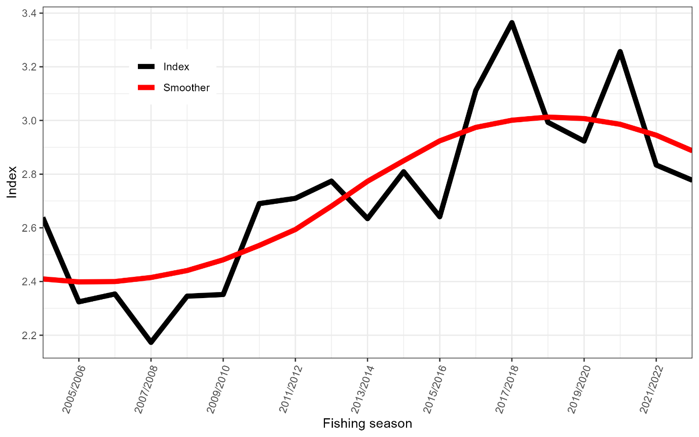
Figure 36: Standardised abundance index and the smooth curve fitted using loess.

Model diagnostics
Model diagnostics were performed for the Stock Synthesis model using the processes outlined in (Carvalho et al., 2021) which use the supporting R packages of r4ss and ss3diags (Taylor et al., 2021; Winker et al., 2025).

Jitter test
A jitter test is conducted to determine whether models are sensitive to the initial parameter values and that the model converged to a global minimum rather than at local minimum. Jitter analysis is a technique used to test the optimality, robustness and stability of the maximum likelihood estimate obtained for a particular model. This involves randomly changing the starting values used for all estimated parameters and re-running the model, to test what alternative solutions may be found by the optimisation algorithm from different initial locations, which is sometimes referred to as sensitivity to initial conditions. Two diagnostics are of interest with a jitter analysis, a check on whether a better “optimal solution” may be found, with a higher likelihood value, and also to see how frequently the optimal solution is found. As all estimated parameters are randomly modified, or “jittered,” simultaneously, this can sometimes result in a model either failing to converge or finding a local minimum in a different (suboptimal) part of the multi-dimensional parameter space. A jitter analysis was conducted with 50 replications, modifying initial parameter values by 10%. Jittering was implemented in using the r4ss R package (Taylor et al., 2021) and followed the process outlined by Carvalho et al. (2021).The jitter test did not provide evidence to reject the hypothesis that the parameter optimization converged to a global solution (Figure 37).
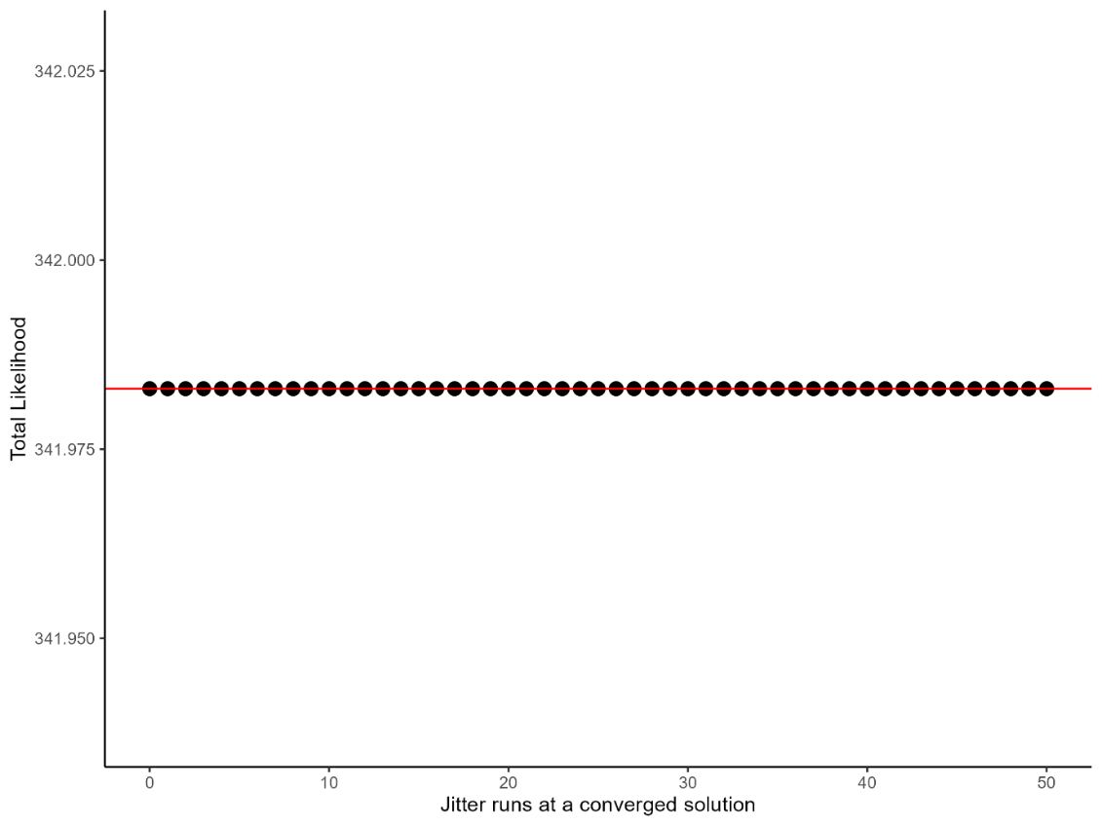
Figure 37: Log-likelihood estimates of reference model that converged during the jitter analysis.

Goodness of fit

Root mean-square error
Root mean-square error (RMSE) describes the standard deviation of residuals, such that:
$$RMSE=\sqrt{\frac{\sum_{t}^{ }{({\hat{y_{t}}-y_{t})}^{2}}}{n}}$$
Where $\hat{y_{t}}$ is the predicted value at the time step t, $y_{t}$ is the observed value, and n is the number of observations. A relatively small RMSE (<30%) indicates a reasonably precise model fit to relative abundance indices (Winker et al., 2018).
Table 15 shows the RMSE score obtained for the model fit to the relative abundance index and estimated mean length and mean age. Results indicate a good fit to the abundance index and mean length estimates (Figure 38).
Table 15: Root Mean Square Error indicating the Goodness-of-fit statistic of reference model.
Data type | Fleet | RMSE | Number of observations
Abundance index | CLF | 19.7% | 19
Mean length | CLF | 3.5% | 10
Mean length | FTO | 14.9% | 14
Mean age | CLF | 2.3% | 4
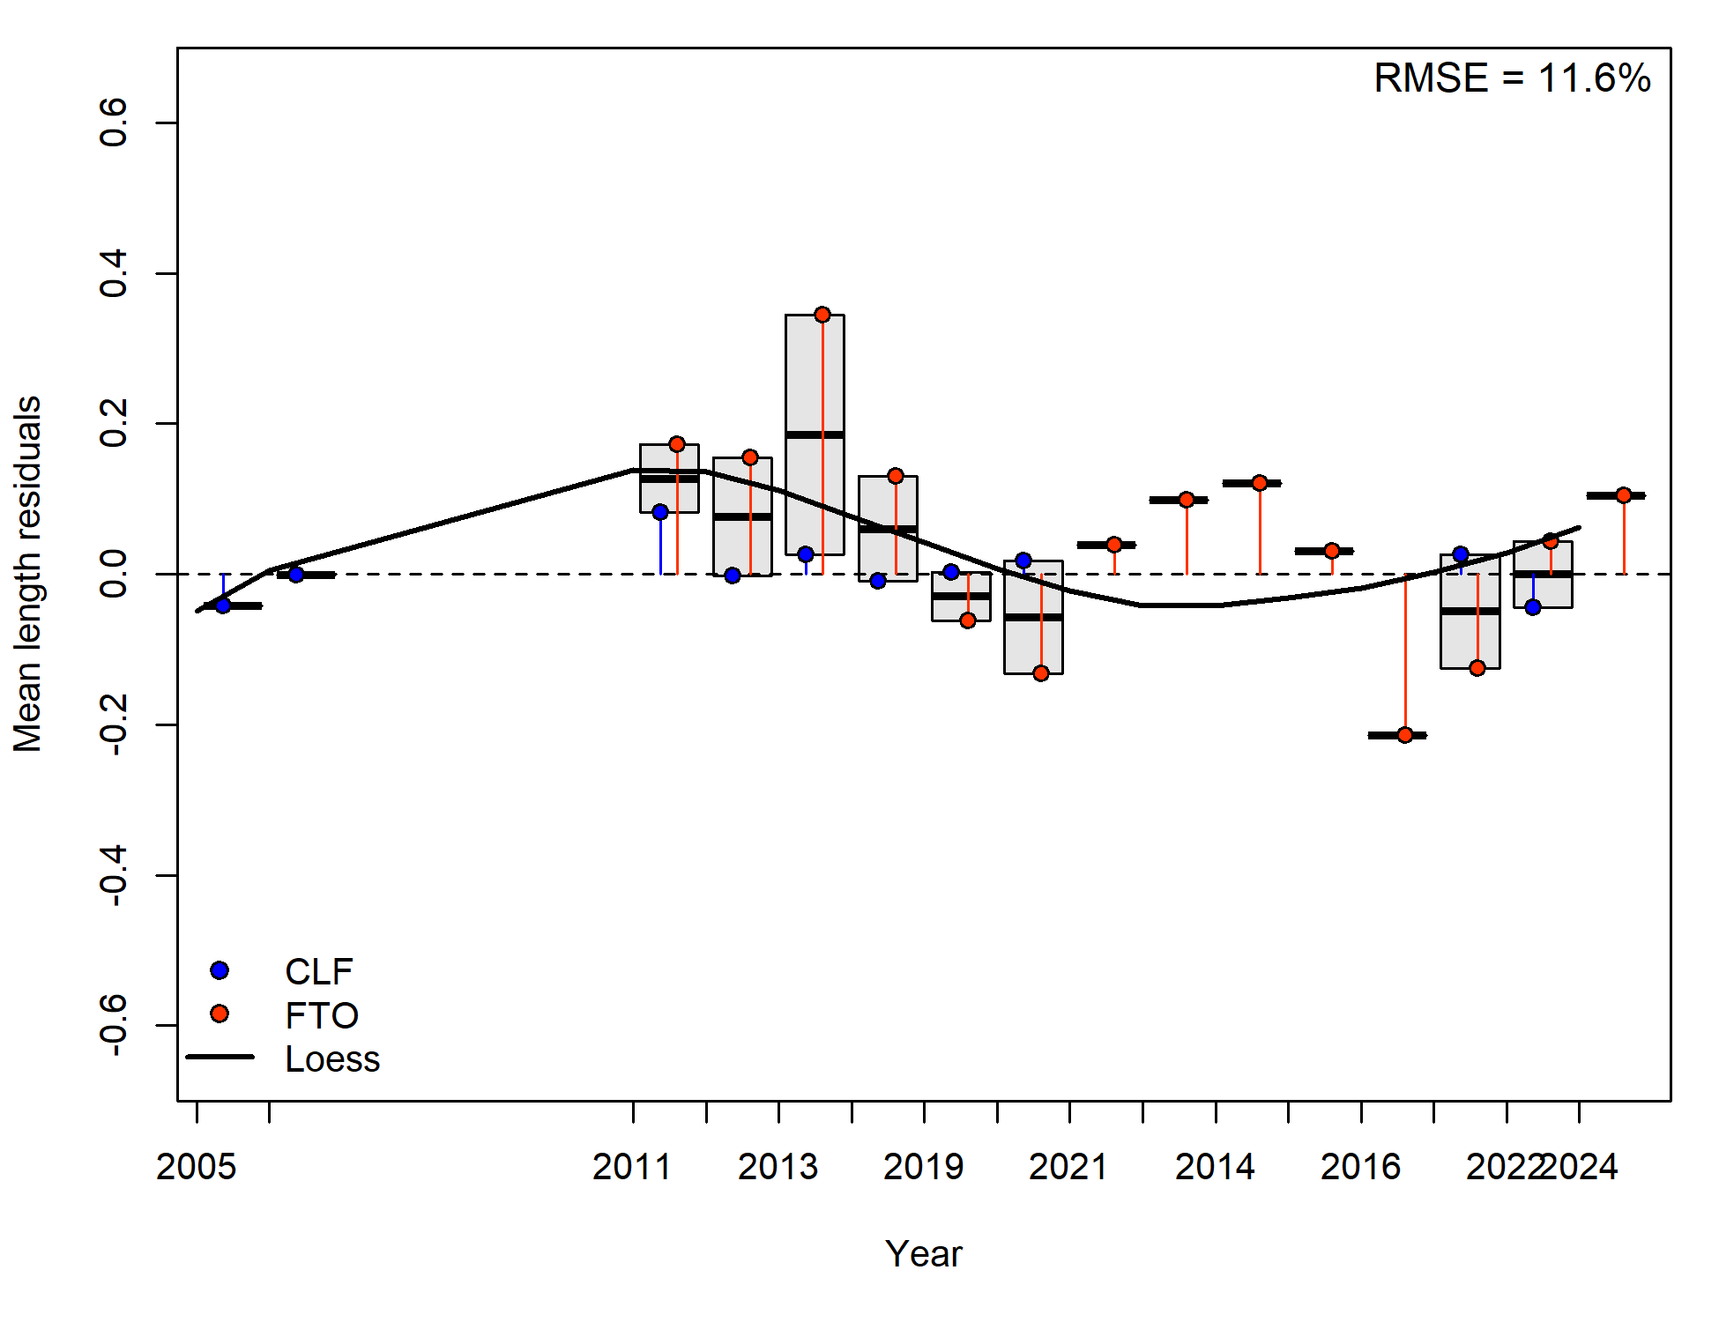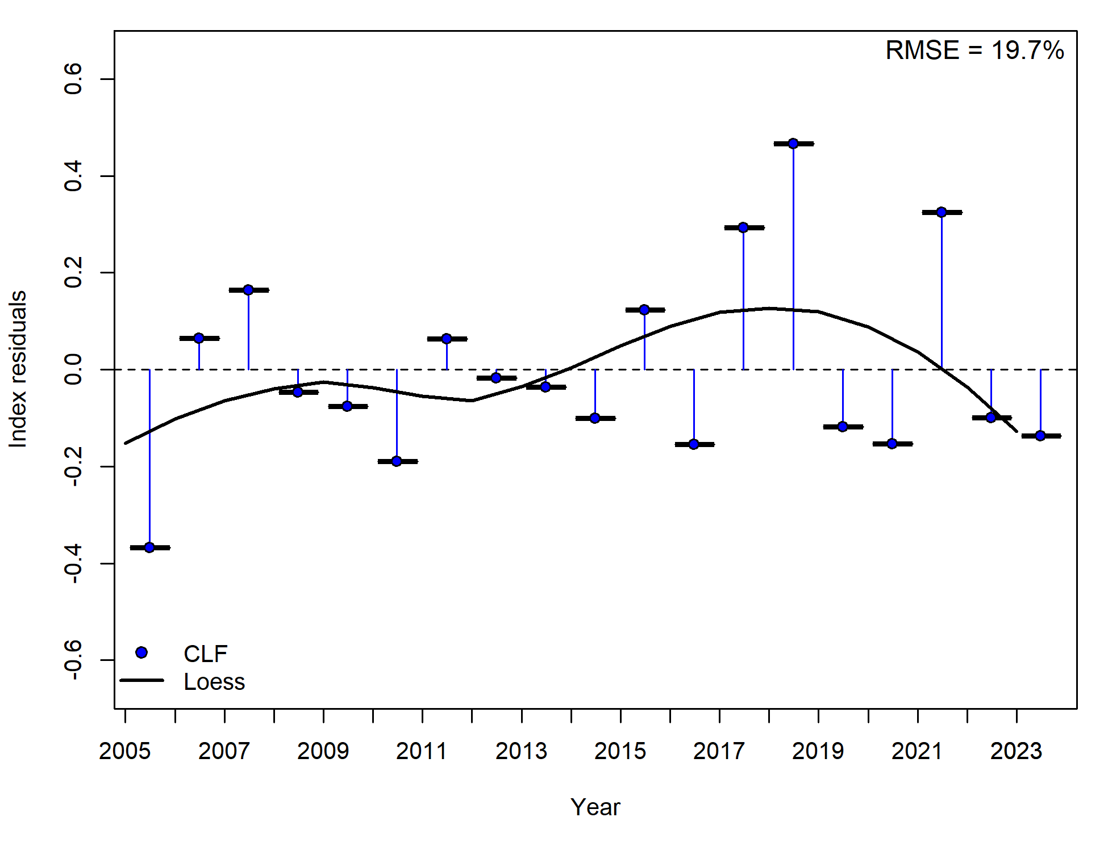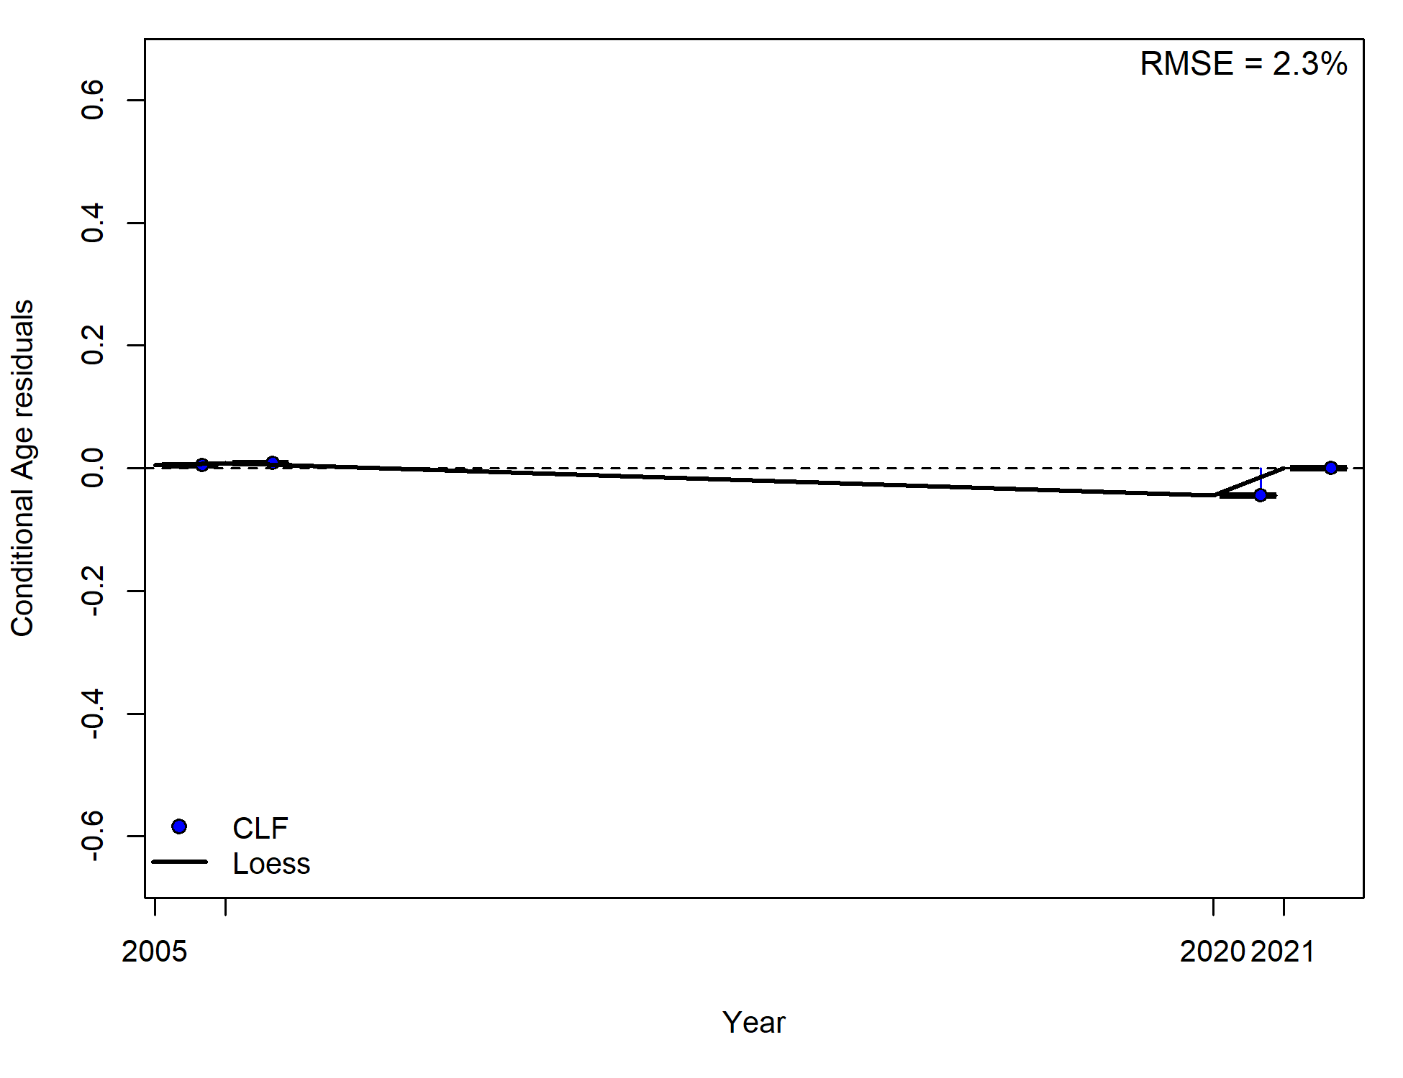
A)
C)
B)
Figure 38: Joint residual plots for A) annual mean CPUE residuals from CLF, B) annual CAAL residuals for the CLF C) annual mean length residuals by multiple fishing fleets. Solid black line show loess smoother through all residuals. Box plots indicate the median and quantiles in cases where residuals from the multiple sectors are available for any given year. The x-axis displays integer years where 2020 corresponds to the 2019/20 fishing season, and so forth.

Runs test
The Wald-Wolfowitz runs test is a non-parametric test that evaluates the null hypothesis that the elements of a sequence are not independent from each other. We specify an α = 0.05 threshold when applying the runs test to the reference model residuals. To assist in interpretation, green shading on the figure presenting the time series of residuals indicates the runs test has passed (randomly distributed time series of residuals, p≥0.05), while red indicates it has failed (p<0.05).
There was no evidence (p ≥0.05) to reject the hypothesis of randomly distributed residuals for the abundance index fit (CLF), mean length fit (CLF and FTO), nor CAAL (CLF) as all data points fell inside the three-sigma limit (Table 16 and Figure 39).

Table 16: Runs test indicate no residual patterns for the model fits of the reference model in Stock Synthesis.
Data type | Fleet | p-value | Test
Abundance index | CLF | 0.72 | Passed
Mean length | CLF | 0.5 | Passed
Mean length | FTO | 0.58 | Passed
Mean age | CLF | 0.84 | Passed

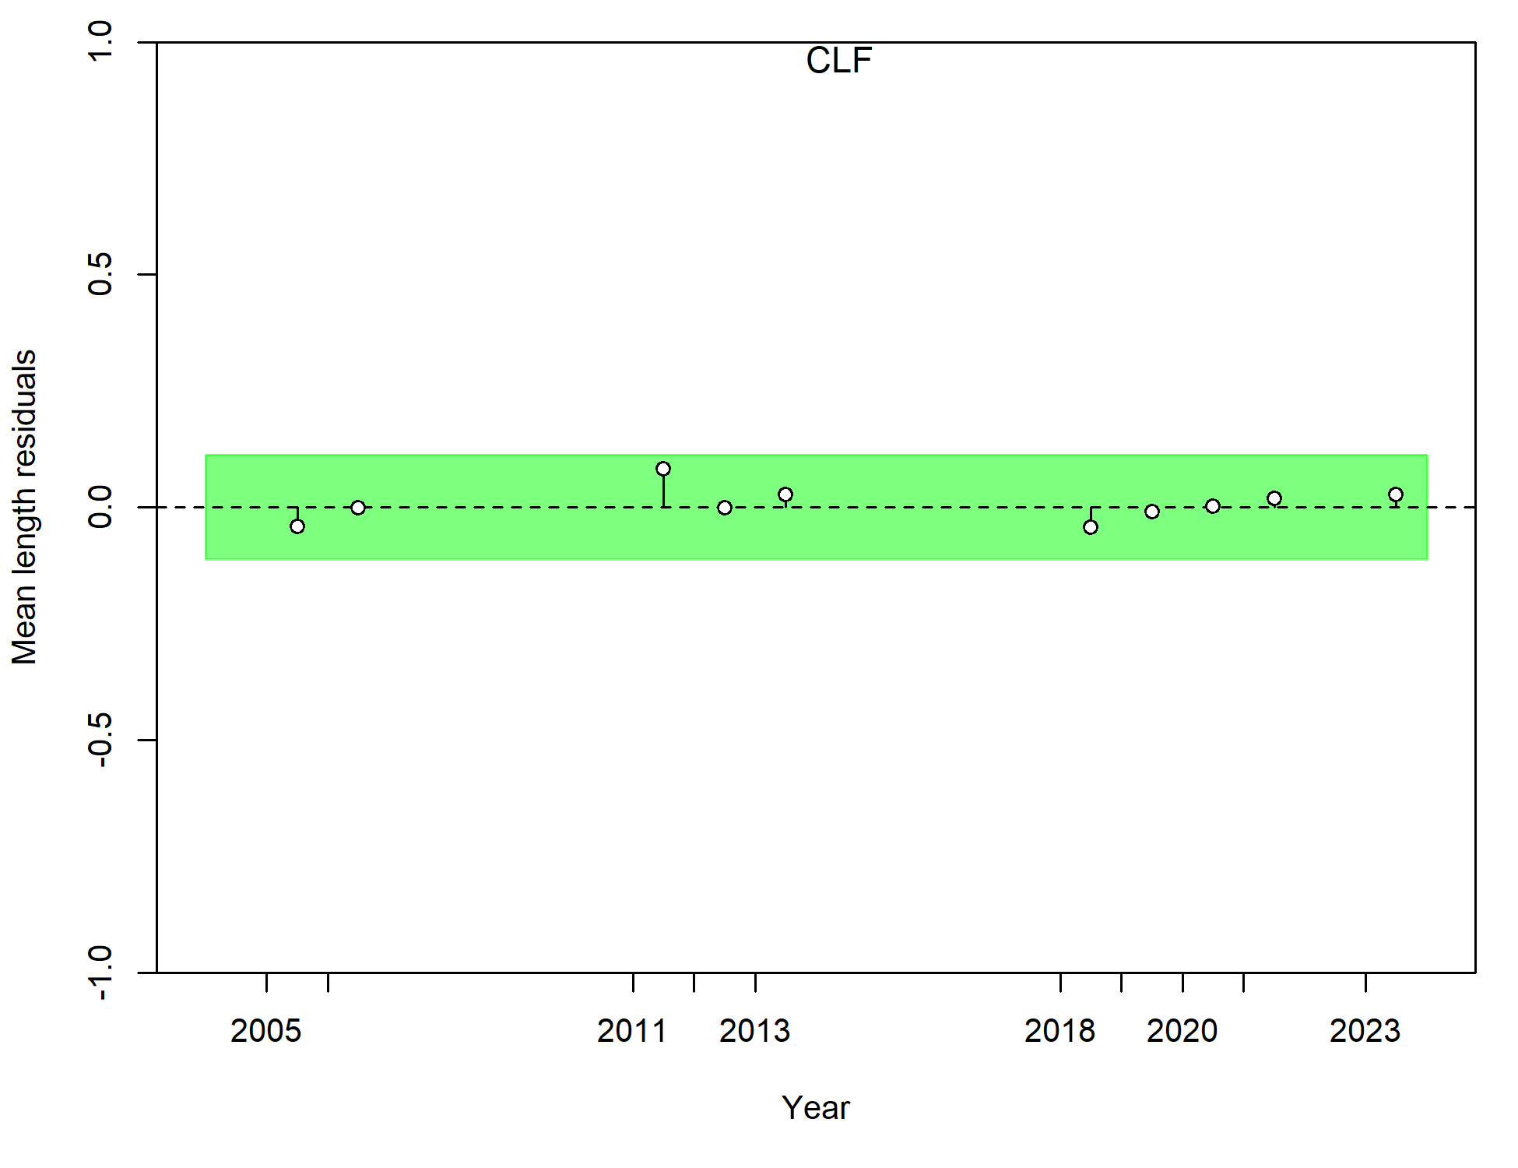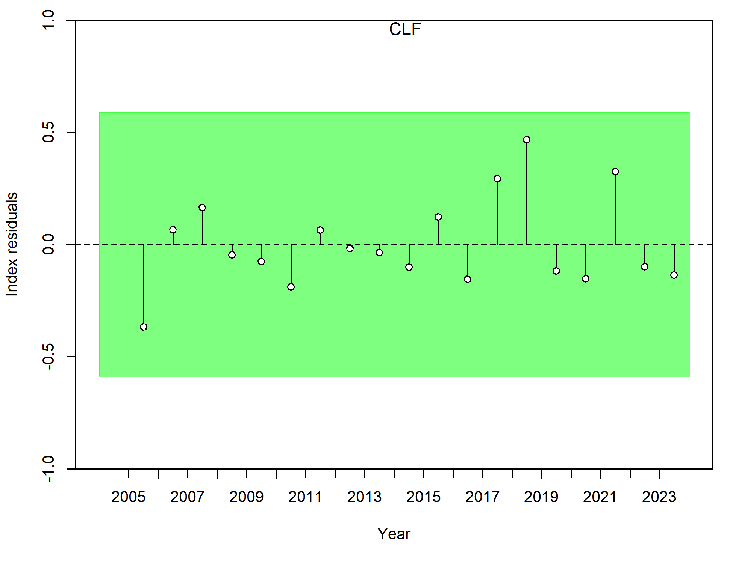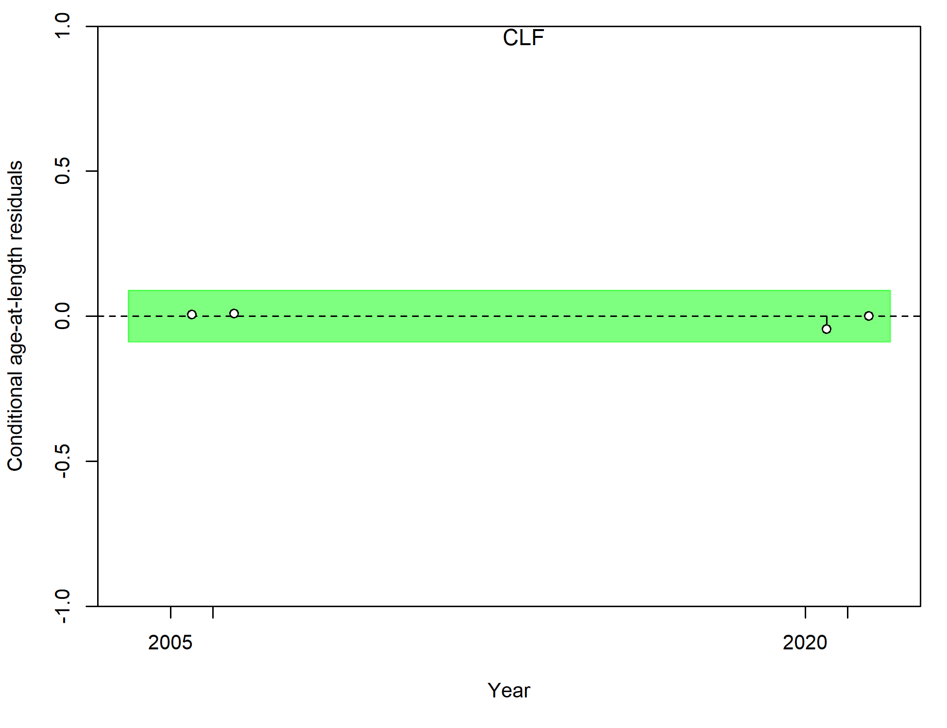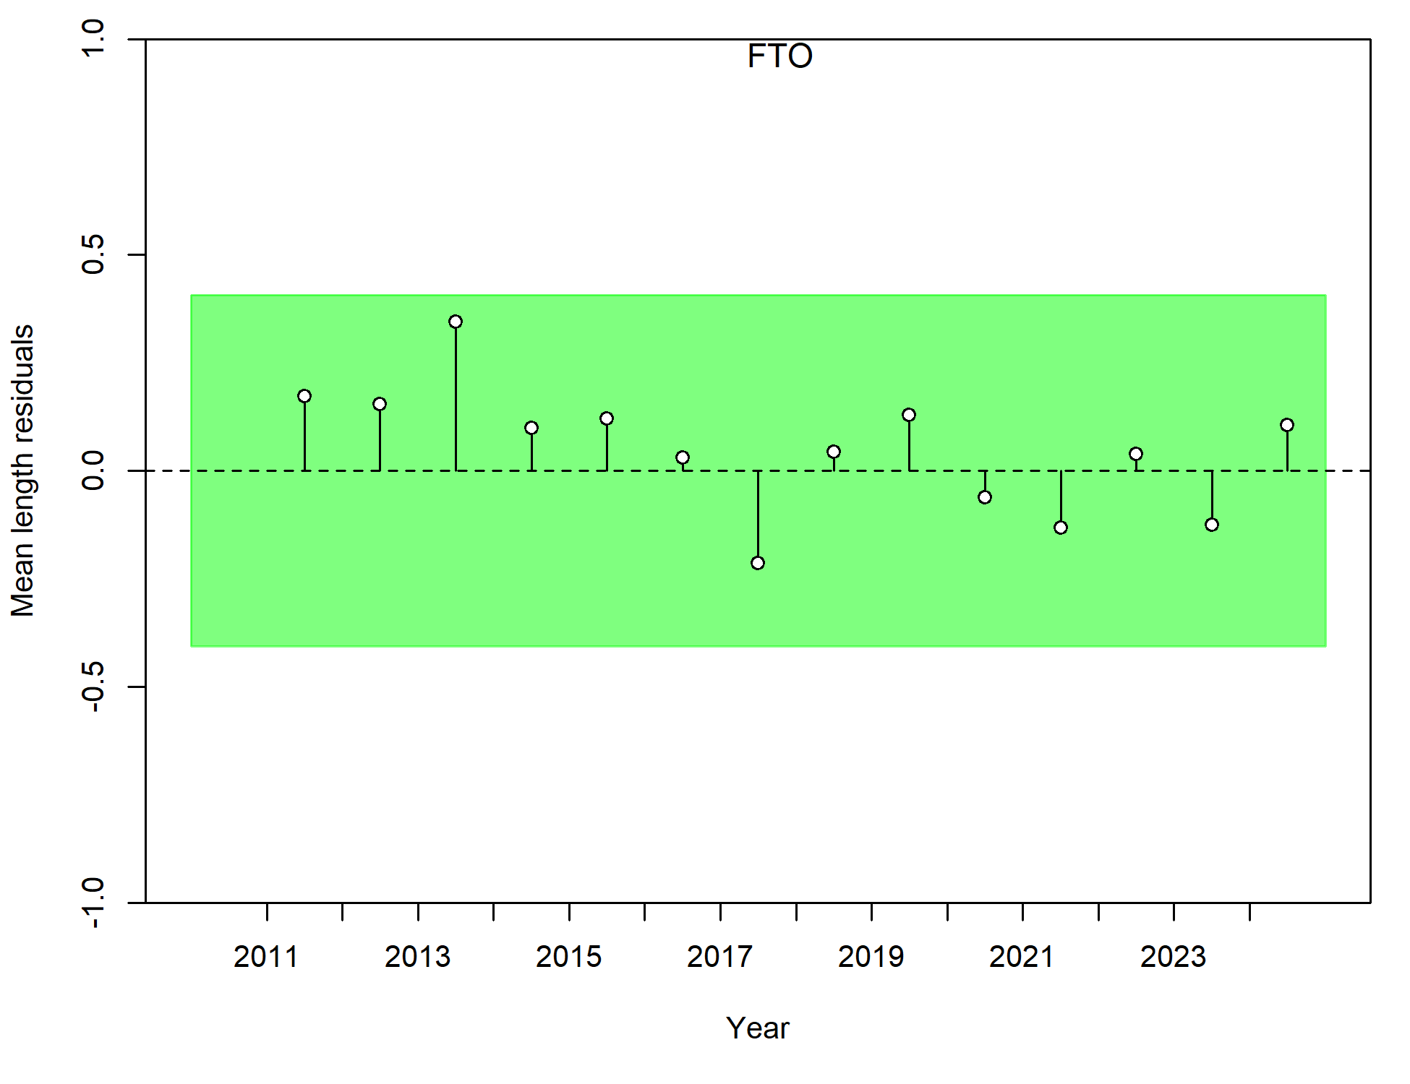
A)
C)
B)
D)
Figure 39: Runs tests results illustrate A) CPUE fit, B) CAAL fit, and mean lengths of length composition data of C) FTO and D) CLF. Green shading indicates no evidence to reject the hypothesis of a randomly distributed time series of residuals. The shaded area spans three residual standard deviations to either side from zero. The x-axis displays integer years where 2020 corresponds to the 2019/20 fishing season, and so forth.

Parameter profiling
Parameter profiling involves examining model parameters or quantities individually, by pre-specifying them across a range of values and re-running the model to determine the differences that may occur. These differences were examined here using the change in total likelihood and likelihood components, as well as changes in relative spawning biomass (Figure 40; Figure 41; Figure 42; Figure 43). Parameter profiling demonstrates that a model parameter or quantity has been suitably estimating or pre-specified if changes in negative log-likelihoods change by less than 1.96.
Similarly, if the range of parameter values examined produce similar quantities of interest (such as relative spawning biomass), then consideration of alternative values or settings becomes less consequential. Profiling of leading parameters such as R₀ can be a useful exercise in determining which data or model components are providing the most information.
For Black Jewfish, the Base Case model was profiled for R₀ (Figure 40), M (Figure 41), h (Figure 42) and σ_{R} (Figure 43) which are all important parameters. The profile for R₀ (estimated in the Base Case as 5.42) demonstrated that the recruitment and age composition likelihoods had the greatest influence. The profile of the total likelihood was mostly smooth, although peaks occurred at particular values that were driven by the age data (Figure 40). These likely resulted from Francis (2011) tunings that were implemented in the Base Case model, but are not updated as part of the profiling analysis and so become suboptimal in the profiling. Therefore, these model runs may have encountered local minima as a result. Similar results occurred for h (Figure 42) and σ_{R} (Figure 43).
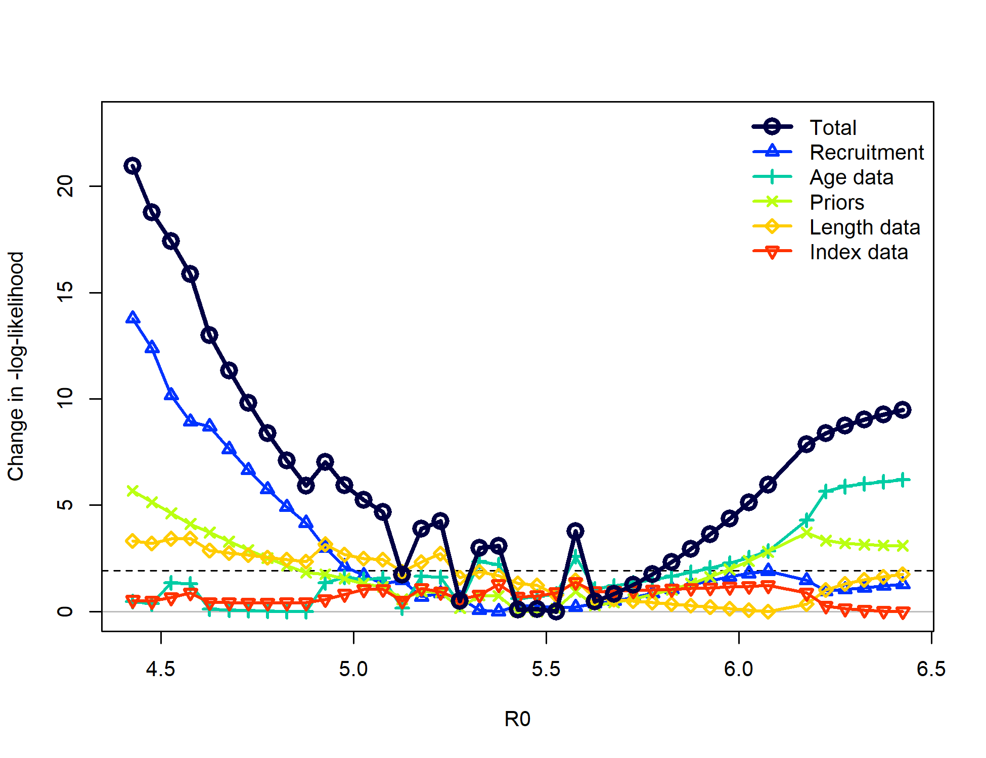
Figure 40: Parameter profiling for log virgin recruitment (R₀). The dashed horizontal line indicates a -log-likelihood change cutoff of 1.96.

M was estimated in the model as 0.51yr⁻¹ using a lognormal prior. It’s likelihood profile demonstrated that this parameter was largely driven by its prior, with other likelihood components providing little information to inform estimates of M (Figure 41). Estimates of M were influential on relative spawning biomass (Figure 41), which is common in stock assessments and the mechanics of this are well understood. Higher values of M will result in lower values of F, which in turn estimate higher absolute estimates of biomass. Therefore, specification of M in a stock assessment is a critical process that must be treated carefully. Here, best practice procedures were followed to estimate M externally using a variety of life history correlates (Section 3.4.2). A composite distribution was then determined and used as a prior in the Stock Synthesis model (Hamel & Cope, 2022; Hamel, 2015; Maunder et al., 2023). While their remains some uncertainty of the true value of M, the estimated value here is justified and defensible as it represents the collective information available for this parameter and its appropriate application within the Stock Synthesis model.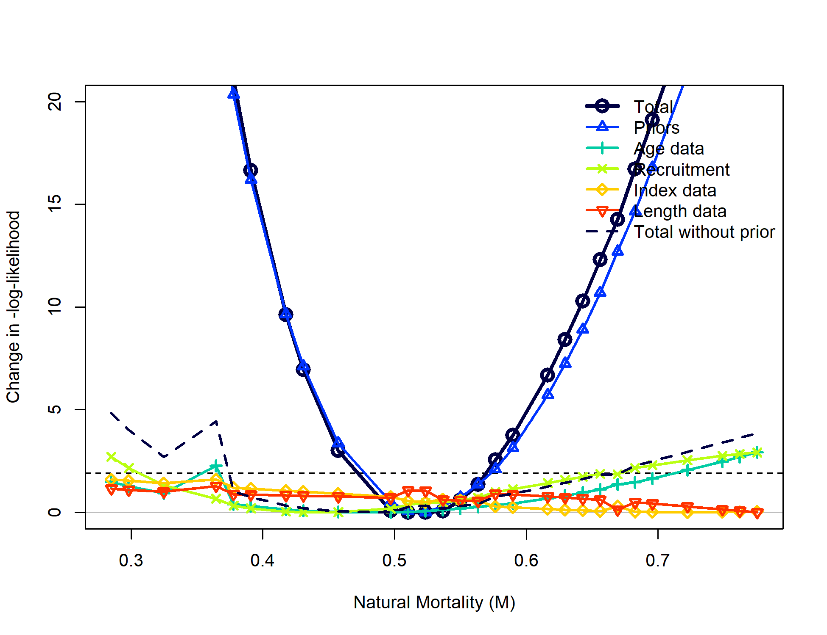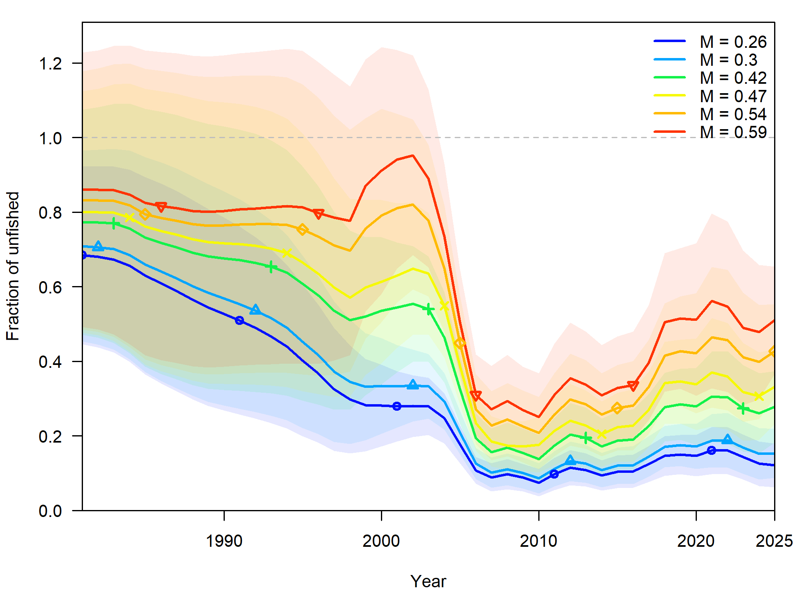
Figure 41: Parameter profiling for Natural mortality (M) and estimates of relative spawning biomass (± standard error) using different M values. The dashed horizontal line on panel A) indicates a -log-likelihood change cutoff of 1.96. The x-axis displays integer years on panel B) where 2020 corresponds to the 2019/20 fishing season, and so forth.

A wide range of h values had similar support in the Base Case model as values higher than 0.5 had similar levels of support (Figure 42). The value pre-specified in the in Base Case model was 0.7 which provided similar relative biomass estimates to all values above 0.5 (Figure 42). Therefore, the profiling indicates no reason to update this value.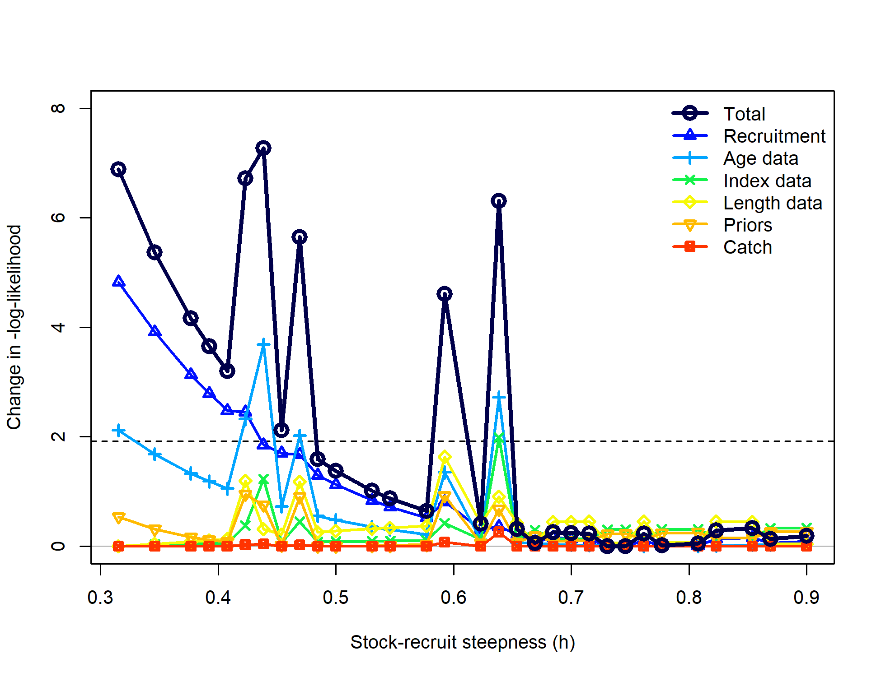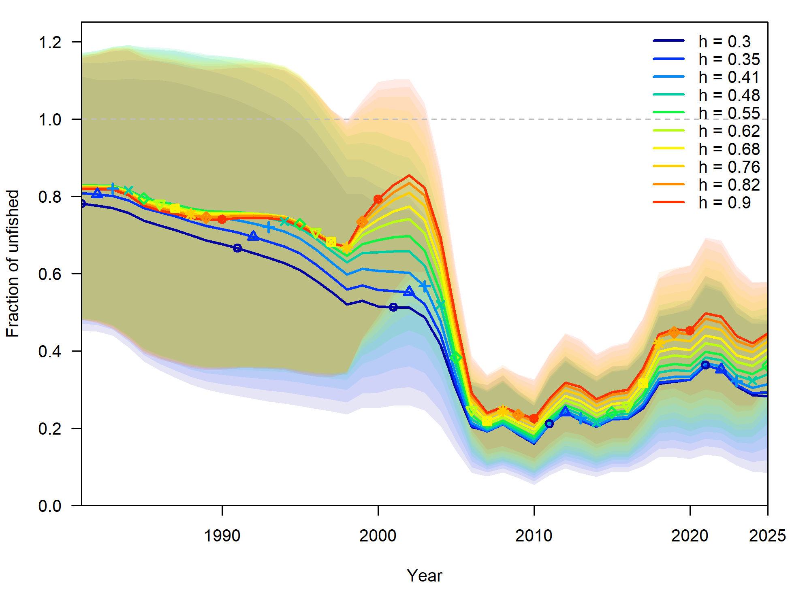
Figure 42: Parameter profiling for steepness (h) and estimates of relative spawning biomass (± standard error) using different h values. The dashed horizontal line on panel A) indicates a -log-likelihood change cutoff of 1.96. The x-axis displays integer years on panel B) where 2020 corresponds to the 2019/20 fishing season, and so forth.
The σ_{R} profile demonstrated that lower values had greater support in the model, although values below 0.54 had similar support (Figure 43). This trend was driven by the recruitment likelihood, which is to be expected, although the age data had the opposite trend (Figure 43). While the profile suggests that values of σ_{R} below that pre-specified (and subsequently tuned) in the Base Case model (0.51) could be considered, this was not entertained for the following reasons: 1) the biology of Black Jewfish suggests that its recruitment can be environmentally driven, and therefore quite variable; this is at odds with low values of σ_{R}; 2) the value used in the Base Case model was within the 1.96 threshold for changes in total log likelihood; 3) there were no large changes in relative spawning biomass nor other key model quantities that occurred through different values of σ_{R} (Figure 43); and 4) changes to the parameter were largely inconsequential as illustrated by Figure 43. It is recognised that σ_{R} cannot be estimated nor solved for within a stock assessment model and that a suitable value must be determined externally (A. Punt, pers comms). Therefore, the pre-specified and tuned value of σ_{R} used in the Base Case model was not further refined for these reasons.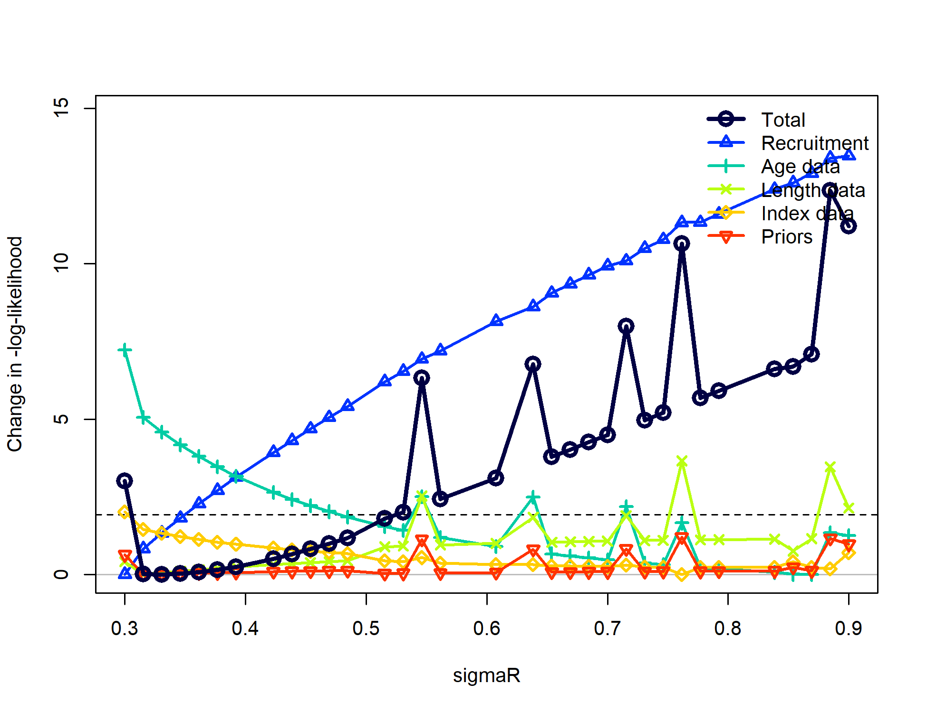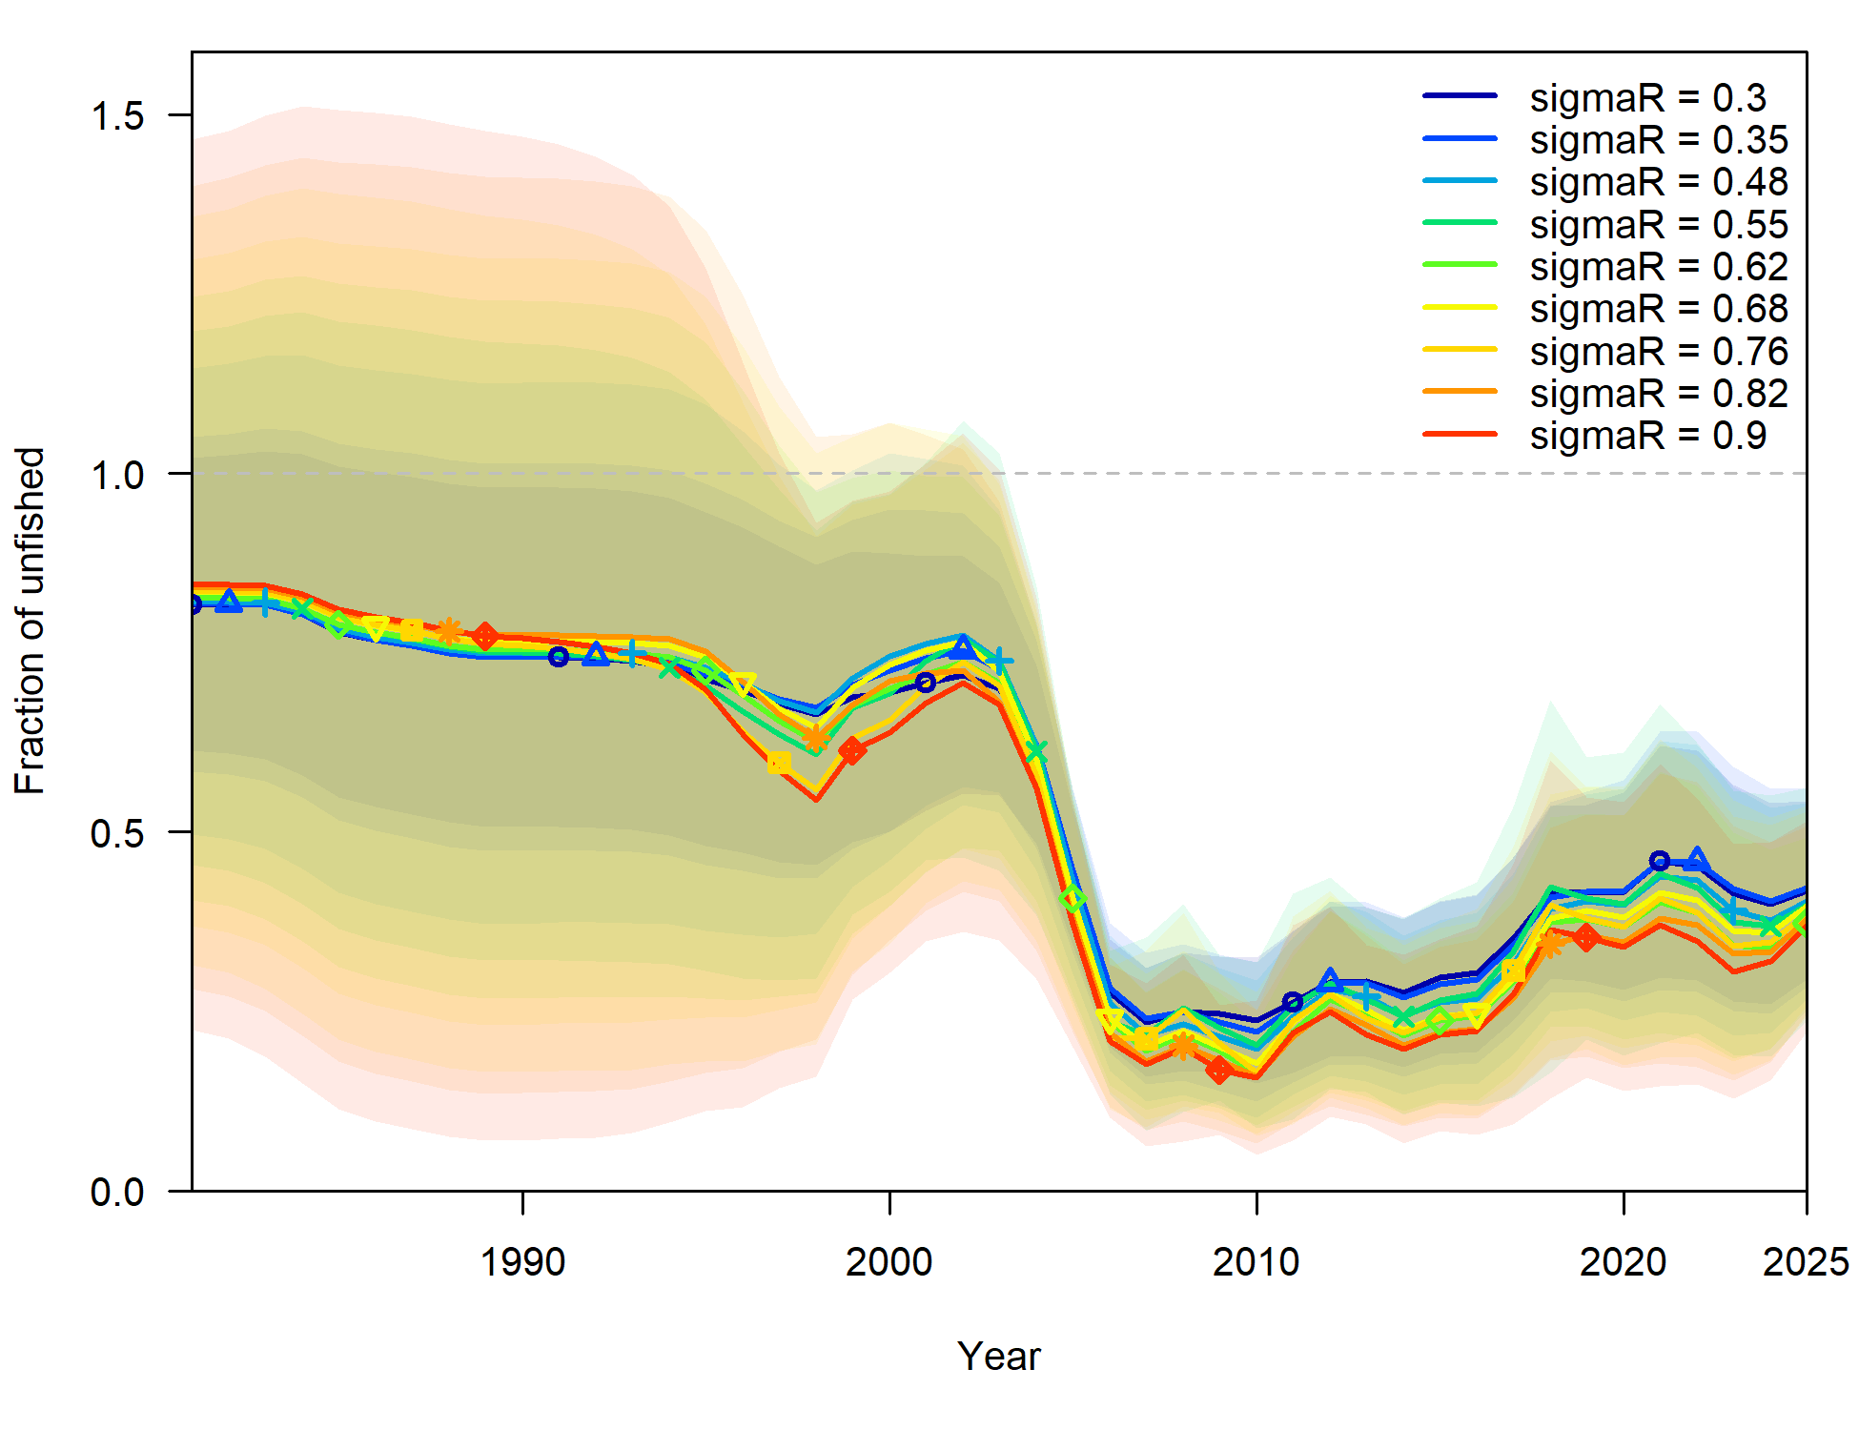
Figure 43: Parameter profiling for variability of the recruitment deviations (σ_{R}) and estimates of relative spawning biomass (± standard error) using different σ_{R} values. The dashed horizontal line on panel A) indicates a -log-likelihood change cutoff of 1.96. The x-axis displays integer years on panel B) where 2020 corresponds to the 2019/20 fishing season, and so forth.

Age structured surplus production model
The Age-Structured Production Model (ASPM) diagnostic serves as an effective tool for identifying misspecifications in key processes that shape production functions in fisheries modelling. This approach compares whether trends in abundance indices can be explained by the balance between surplus production and observed catches, or if a more sophisticated model incorporating recruitment fluctuations provides better explanatory power (Carvalho et al., 2021). When implementing the ASPM, selectivity parameters were fixed to values from the Base Case model, deliberately excluding length and age composition data and not estimating recruitment deviations. A good fit to abundance indices with significant variation suggests that stock dynamics are primarily driven by the production function, and these indices likely provide reliable information about absolute abundance. Conversely, poor fit may indicate several possibilities: the stock is predominantly influenced by recruitment patterns, catch has minimal impact on abundance, the model oversimplifies complex dynamics like stock structure, or the abundance indices fail to accurately represent true abundance. An ASPM with recruitment deviations estimated (ASPM_dev) evaluates whether composition data is necessary for estimating recruitment variability by fitting abundance indices while estimating recruitment deviations without composition data. Significant differences between ASPM_dev results and those from the Base Case model would suggest that composition data plays a crucial role in accurately estimating recruitment fluctuations.
For Black Jewfish, both the ASPM and ASPM_dev estimated similar relative spawning biomass trajectories to the Base Case model, indicating the underlying production function of the Base Case model was informative (Figure 44). The fit to the log index data was poor for the ASPM but improved for the ASPM_dev (Figure 44). However, conclusions regarding the improvement in fit of the ASPM_dev are limited given the short series of index data (19 years), versus the total model timeframe (43 years).
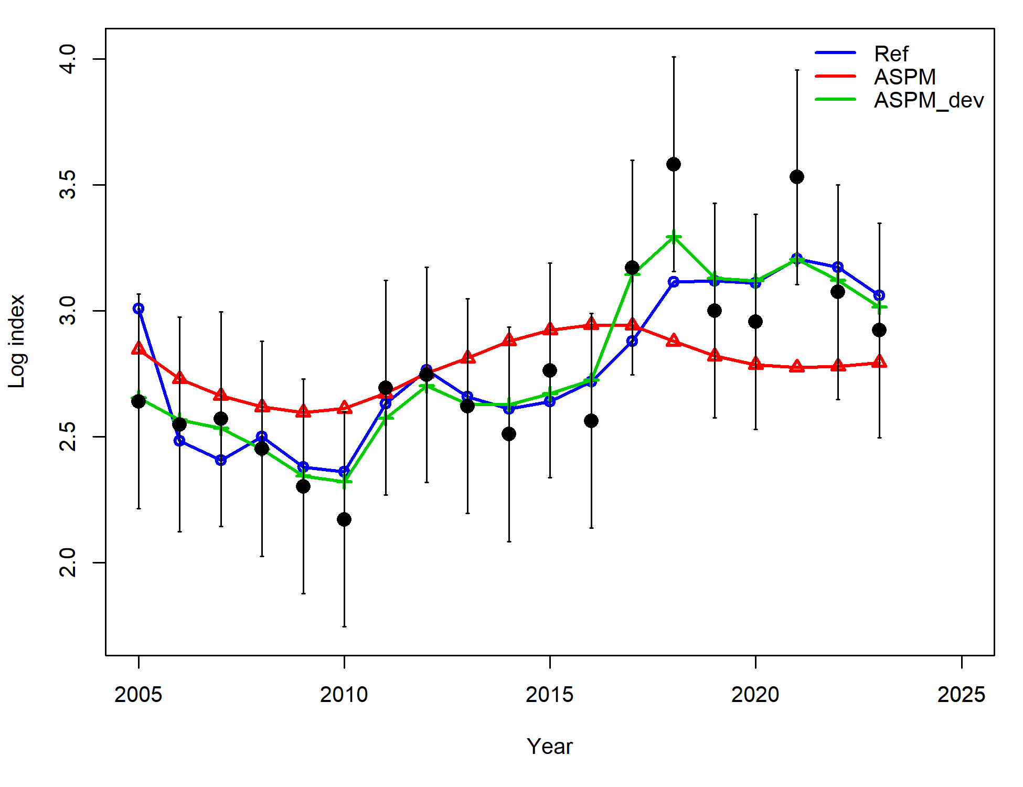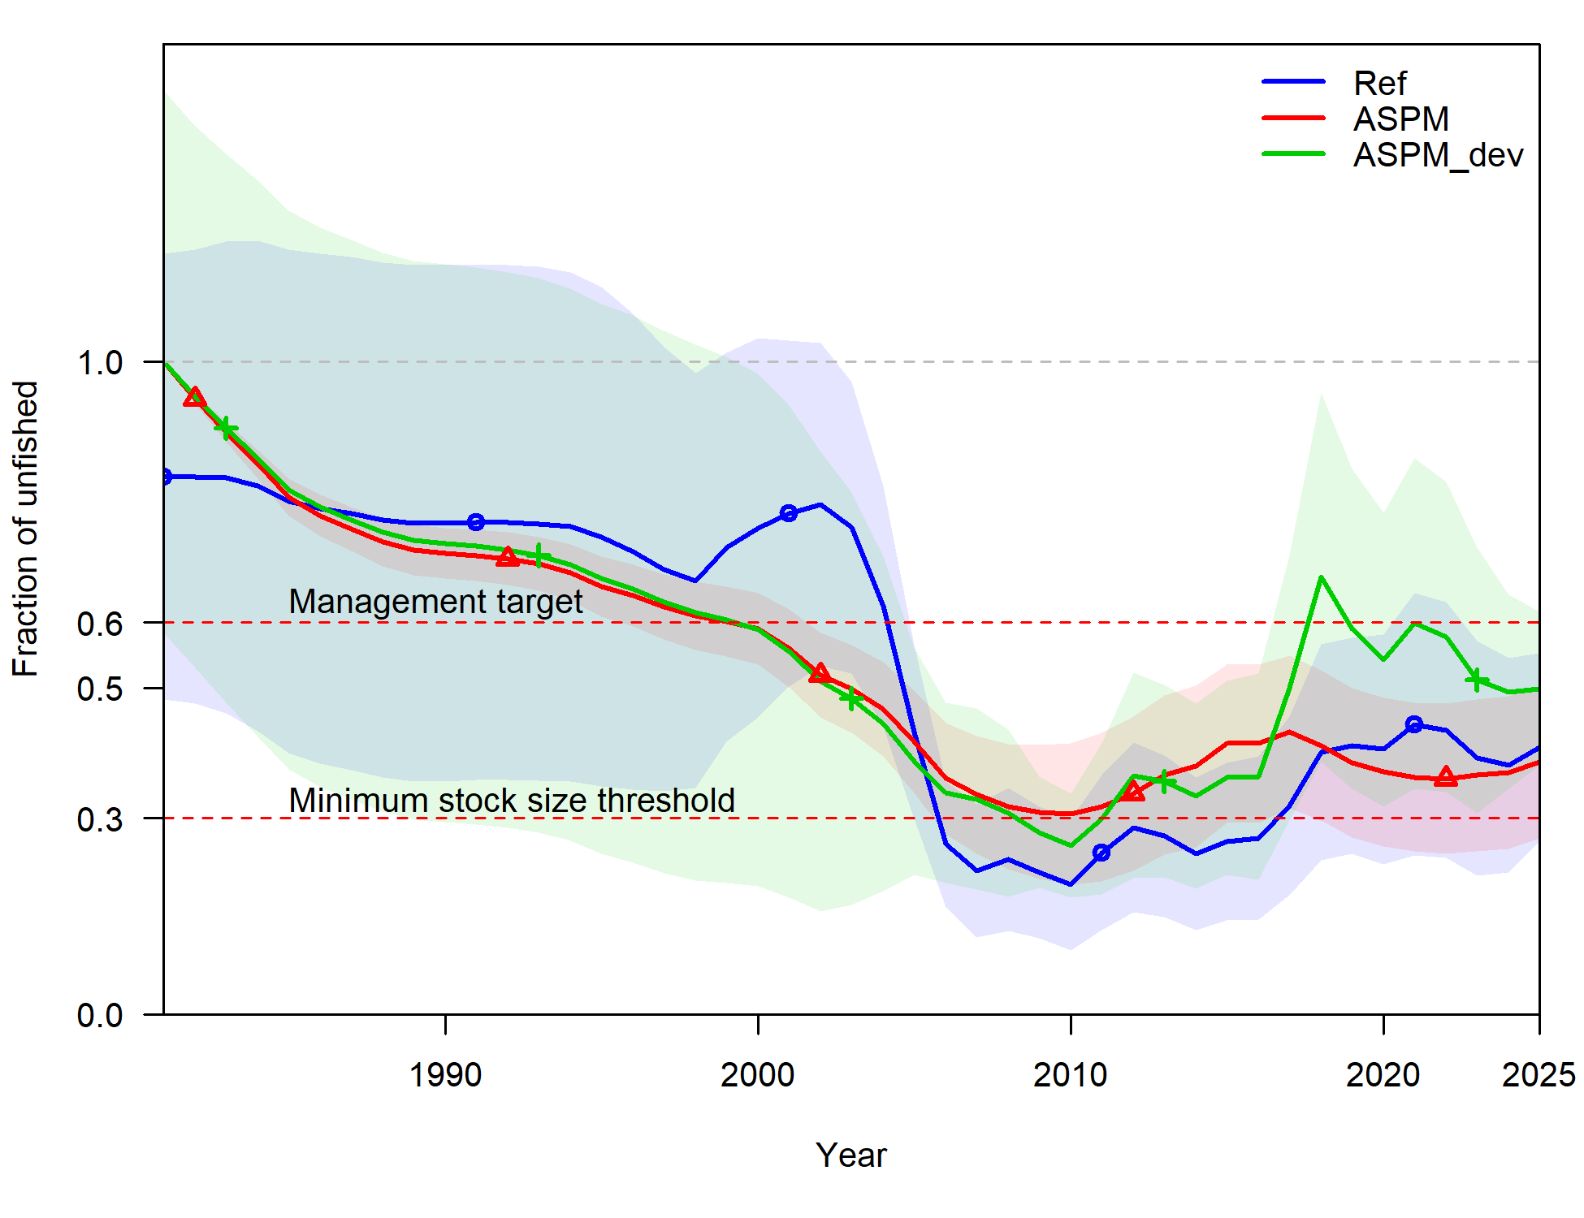
B)
A)
Figure 44: Comparison of the Base Case model (Blue line and shading) to an age structured surplus production model (ASPM; red line and shading) and an ASPM with recruitment deviation estimated (green line and shading) for A) relative spawning biomass, and B) fits to log abundance index (black points and error bars). The x-axis displays integer years where 2020 corresponds to the 2019/20 fishing season, and so forth.

Retrospective analysis
A retrospective analysis (Cadrin, 1997; Mohn, 1999) has been undertaken to identify whether assessment outcomes change as data are removed from the assessment. The retrospective analysis was undertaken using the following procedure:
1) One year of data was removed sequentially from the Base Case model, while maintaining the same assumptions and tuning.
2) Time dependent model parameters (e.g. the last year of estimated recruitment) were changed to be one year earlier.
3) The model was run to determine stock status estimates when less data were available (i.e. in the past).
4) Steps 1–3 were repeated five times (i.e. sequentially removing five years of data).
Trends in biomass, stock status, fishing mortality and recruitment are then examined to help understand how reliable the assessment is at estimating the relative biomass in recent years.
The severity of retrospective patterns can be quantified using Mohn’s rho (ρ_{M}), which is defined as the average of relative differences between an estimate from assessment using a truncated time series and an estimate from assessment using the full time series (Hurtado-Ferro et al., 2015). As a general rule of thumb, values of ρ_{M} that fall outside -0.22 to 0.30 for shorter-lived species indicates an undesirable retrospective pattern or cause for concern in an assessment (Hurtado-ferro et al., 2015).
The ρ_{M} for the spawning biomass of Black Jewfish was 0.12, indicating that no retrospective patterns were present when data was progressively removed from the terminal years (Figure 45). The ‘peeled’ estimates of biomass from models with fewer numbers of years removed remained very similar to the Base Case model. Results only differed once five years of data had been removed which aligns with the availability of recent CAAL data which were available from 2019/20 onwards.
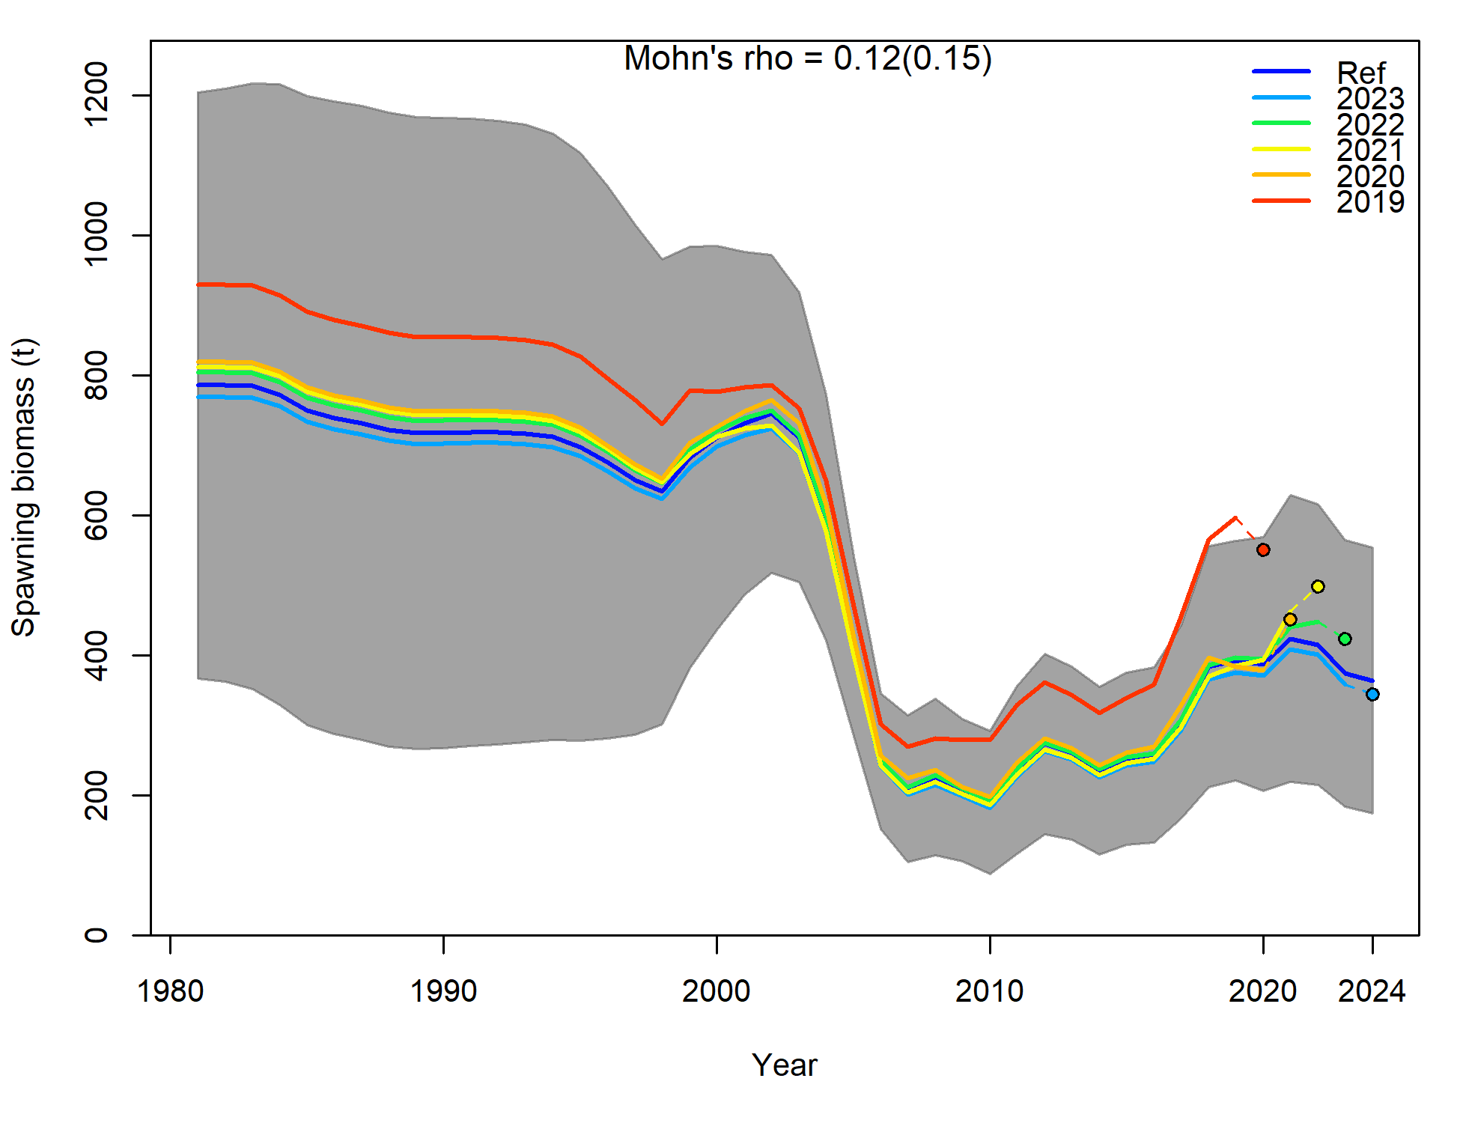
Figure 45: Retrospective analysis of spawning biomass estimates when one to five years of data were sequentially removed from the Base Case model. The x-axis displays integer years where 2020 corresponds to the 2019/20 fishing season, and so forth.

Harvest fraction is defined as the annual catch divided by the biomass of that year and can be expressed as a proportion. The exact definition depends on the measure of biomass used (e.g., spawning vs vulnerable).
More information on the National Fishery Status Reporting Framework can be found at https://www.fish.gov.au/about/how-are-the-status-of-australian-fish-stock-reports-done#:~:text=Toggle%20content,increased%20risk%20of%20recruitment%20failure.
The term ‘B₀’ represents the biomass of the stock at unfished level (virgin biomass), ‘B_{20223/24}’ indicates the biomass in 2023/24 fishing year and B₃₀ is the biomass at 30% of unfished levels.
For the purposes of this assessment B_{30%} is used a proxy for ‘recruitment overfished’.
Scenario 7 explores the implication of setting an equilibrium catch by modelling the population without an initial equilibrium, that is applying the assumption that biomass is unfished at the start of the timeseries.
The spawning biomass is the total weight of all adult (reproductively mature) fish in a population (Roelofs et al., 2024).
An important point of clarity around F_{MSY} is needed, as the MSY estimated by Stock Synthesis is linked to species productivity through the stock recruitment relationship. This means that more productive species (such as Black Jewfish) will achieve MSY at lower levels of biomass. As a result, the relative spawning biomass that equates to F_{MSY} for Black Jewfish is 29%. This is below the limit reference point which means that fishing at levels of F_{MSY} will actually reduce the population below the B₃₀ limit. For a biomass target of 60% to be achieved, F/F_{MSY} needs to be far less than 1.

