Mineral Titles Act 2010
NOTICE OF LAND CEASING TO BE A MINERAL TITLE AREA
Title Type and Number: | Exploration Licence 33228
Area Ceased on: | 13 May 2025
Area: | 5 Blocks, 15.79 km²
Locality: | QUARTZ
Name of Applicant(s)/Holder(s): | 100% PEREGIAN MINERALS PTY LTD [ACN. 656 661 586]
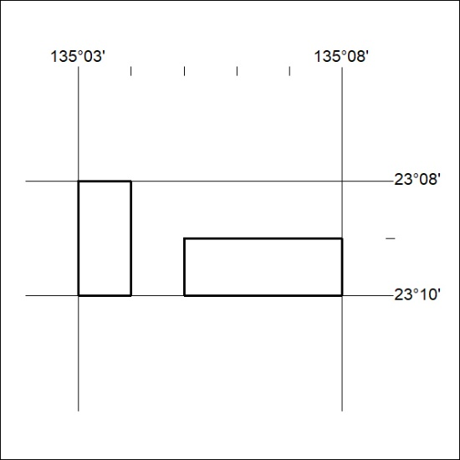

301/25

