Mineral Titles Act 2010
NOTICE OF LAND CEASING TO BE A MINERAL TITLE AREA
Title Type and Number: | Exploration Licence 32178
Area Ceased on: | 16 April 2025
Area: | 206 Blocks, 650.09 km²
Locality: | NARWIETOOMA
Name of Applicant(s)/Holder(s): | 100% NEW AGE RESOURCES PTY LTD [ACN. 622 780 072]
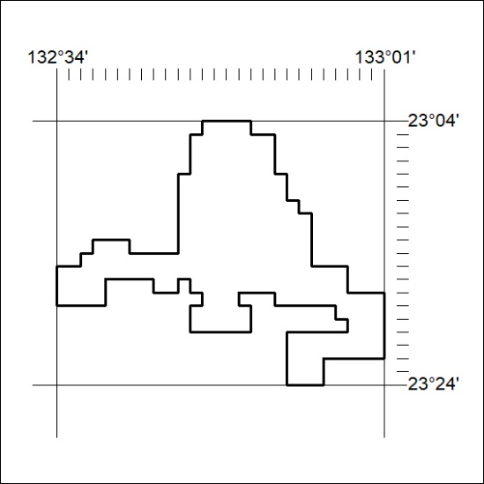

284/25

Mineral Titles Act 2010
NOTICE OF LAND CEASING TO BE A MINERAL TITLE AREA
Title Type and Number: | Exploration Licence 32179
Area Ceased on: | 16 April 2025
Area: | 250 Blocks, 785.37 km²
Locality: | TEA TREE
Name of Applicant(s)/Holder(s): | 100% NEW AGE RESOURCES PTY LTD [ACN. 622 780 072]
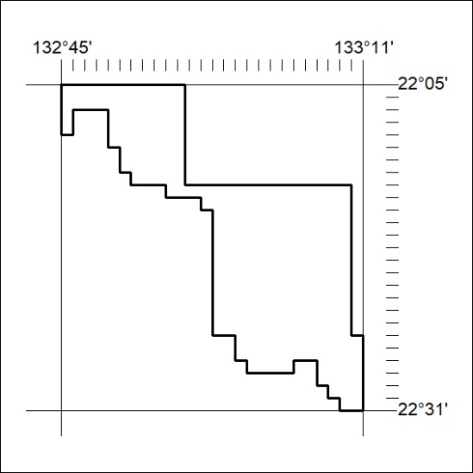

285/25

Mineral Titles Act 2010
NOTICE OF LAND CEASING TO BE A MINERAL TITLE APPLICATION AREA
Title Type and Number: | Exploration Licence 34021
Area Ceased on: | 17 April 2025
Area: | 85 Blocks, 275.92 km²
Locality: | LULU
Name of Applicant(s)/Holder(s): | 100% BAUDIN RESOURCES PTY LTD [ACN. 618 455 593]
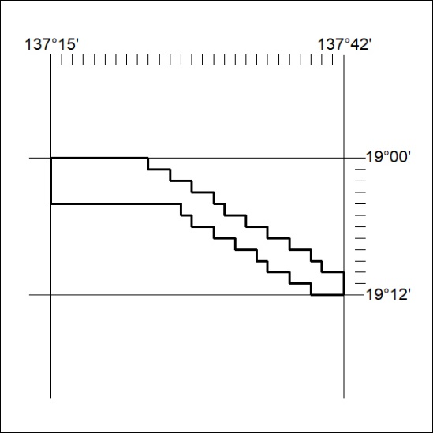

286/25

