Mineral Titles Act 2010
NOTICE OF LAND CEASING TO BE A MINERAL TITLE APPLICATION AREA
Title Type and Number: | Exploration Licence 33473
Area Ceased on: | 11 April 2025
Area: | 96 Blocks, 312.64 km²
Locality: | HITCHCOCK
Name of Applicant(s)/Holder(s): | 100% ASIAN MINERALS PTY LTD [ACN. 099 804 467]
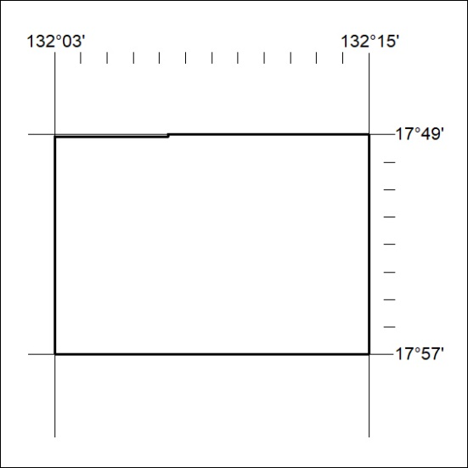

262/25

Mineral Titles Act 2010
NOTICE OF LAND CEASING TO BE A MINERAL TITLE APPLICATION AREA
Title Type and Number: | Exploration Licence 33474
Area Ceased on: | 11 April 2025
Area: | 36 Blocks, 117.68 km²
Locality: | HITCHCOCK
Name of Applicant(s)/Holder(s): | 100% ASIAN MINERALS PTY LTD [ACN. 099 804 467]
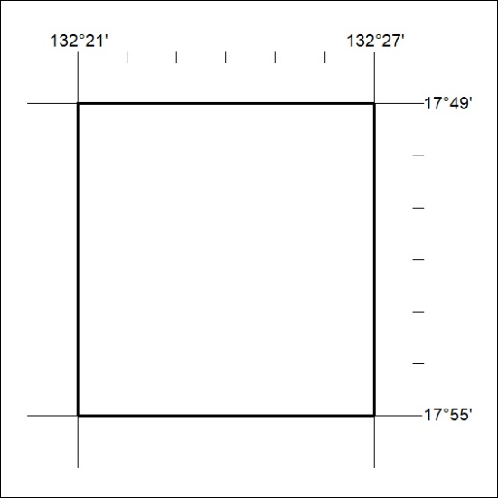

263/25

Mineral Titles Act 2010
NOTICE OF LAND CEASING TO BE A MINERAL TITLE APPLICATION AREA
Title Type and Number: | Exploration Licence 33475
Area Ceased on: | 11 April 2025
Area: | 42 Blocks, 137.37 km²
Locality: | FREW
Name of Applicant(s)/Holder(s): | 100% ASIAN MINERALS PTY LTD [ACN. 099 804 467]
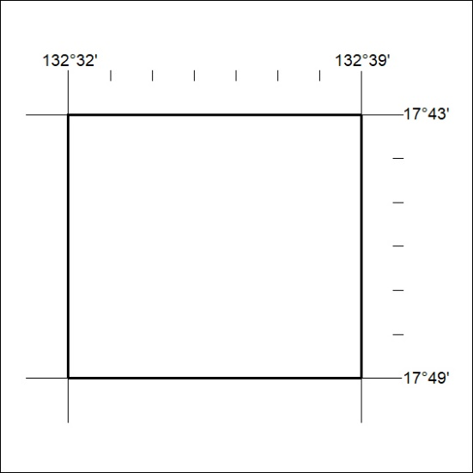

264/25

