Mineral Titles Act
NOTICE OF GRANT OF A MINERAL TITLE
Title Type and Number: | Extractive Mineral Exploration Licence 34017
Granted: | 31 March 2025, for a period of 2 Years
Area: | 1 Block, 2.58 km²
Locality: | BYNOE
Name of Holder/s: | 100% KING Mitch Kyle
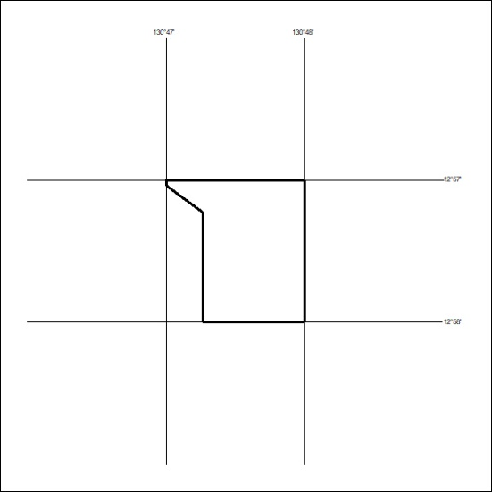
Area granted is indicated above. The titleholder is not permitted to exercise occupational rights on any land that is subject to a development title, or an application for a development title. Any land the subject of a Reserved Land gazettal under the Mineral Titles Act and all land vested in the Commonwealth of Australia is also excluded by description but not excised from the grant area.

236/25

