Mineral Titles Act 2010
NOTICE OF LAND CEASING TO BE A MINERAL TITLE AREA
Title Type and Number: | Exploration Licence 29725
Area Ceased on: | 13 March 2025
Area: | 72 Blocks, 229.95 km²
Locality: | HOME OF BULLION
Name of Applicant(s)/Holder(s): | 90% PURE MINING PTY LTD [ACN. 627 691 721], 10% PRODIGY GOLD NL* [ACN. 009 127 020]
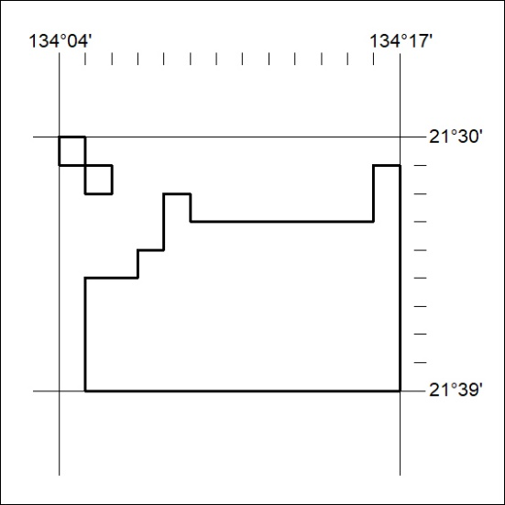

101/25

Mineral Titles Act 2010
NOTICE OF LAND CEASING TO BE A MINERAL TITLE AREA
Title Type and Number: | Exploration Licence 30470
Area Ceased on: | 13 March 2025
Area: | 116 Blocks, 370.97 km²
Locality: | TAYLOR
Name of Applicant(s)/Holder(s): | 90% PURE MINING PTY LTD [ACN. 627 691 721], 10% PRODIGY GOLD NL* [ACN. 009 127 020]
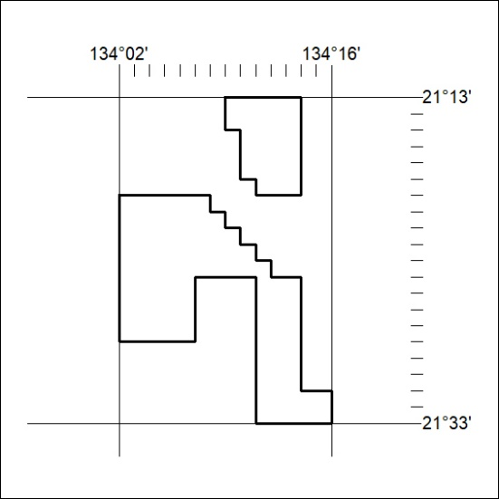

102/25
Mineral Titles Act 2010
NOTICE OF LAND CEASING TO BE A MINERAL TITLE AREA
Title Type and Number: | Exploration Licence 30507
Area Ceased on: | 13 March 2025
Area: | 4 Blocks, 12.78 km²
Locality: | TAYLOR
Name of Applicant(s)/Holder(s): | 90% PURE MINING PTY LTD [ACN. 627 691 721], 10% PRODIGY GOLD NL* [ACN. 009 127 020]
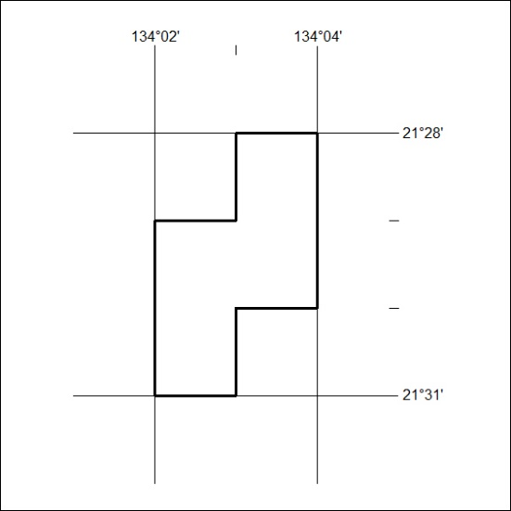

103/25

Mineral Titles Act 2010
NOTICE OF LAND CEASING TO BE A MINERAL TITLE AREA
Title Type and Number: | Exploration Licence 32357
Area Ceased on: | 13 March 2025
Area: | 16 Blocks, 50.67 km²
Locality: | NAPPERBY
Name of Applicant(s)/Holder(s): | 100% MIOXIDE NT PTY LTD [ACN. 636 686 747]
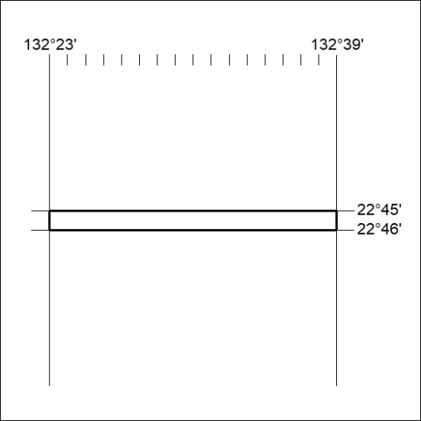

104/25

