**© Northern Territory of Australia 2025**

**Preferred Reference:** Department of Trade, Business and Asian Relations, 2023 Remote Towns Jobs Profiles, Northern Territory Government, January 2025, Darwin.

**Front cover image:** Vitex rotundifolia – known commonly as Beach Vitex

**Image credit:** Robyn Wing

**Disclaimer**

The data in this publication was collected by conducting a survey of businesses located in the 28 remote town boundaries. This body of work was completed in 2023 by the former Northern Territory Department of Industry, Tourism and Trade.

The collection methodology was created in accordance with Australian Bureau of Statistics data quality framework principles. Data in this publication is only reflective of those businesses reported on as operating in the town at the time of data collection (see table at the end of publication for list of businesses reported on). To comply with privacy legislation or where appropriate, some data in this publication may have been adjusted and will not reflect the actual data reported by businesses. As a result of this, combined with certain data not being reported by some businesses, some components may not add to totals. Changes over time may also reflect change in business propensity to report on certain data items rather than actual changes over time. Total figures have generally not been adjusted. Caution is advised when interpreting the comparisons made to the earlier 2011, 2014 and 2017 publications as the businesses identified and reported on and the corresponding jobs may differ between publications. The surveys have not always gathered data on training and jobs in the same years.

**Notes for each table and chart are ordered alphabetically and listed at the end of the publication.**

The Northern Territory of Australia exercised due care and skill to ensure that at the time of publication the information contained in this publication is true and correct. However, it is not intended to be relied on as professional advice or used for commercial purposes. The Territory gives no warranty or assurances as to the accuracy of the information contained in the publication and to the maximum extent permitted by law accepts no direct or indirect liability for reliance on its content.

Any use of this report for commercial purposes is not endorsed by the Department of Trade, Business and Asian Relations.

Contents

Contents 3

Yirrkala 4

Introduction 5

Summary 6

Jobs Overview 7

Jobs filled by Aboriginality 8

Jobs by Sector: Private and Public 11

Job Status: Permanent and Temporary 18

Job Vacancies 22

Jobs by Industry 24

Jobs by Occupation 30

Jobs by Industry by Occupation 34

Jobs by Gender 37

Jobs by Age 43

Vocational Education and Training 49

Population 56

Community Development Program 58

Businesses 59

Notes 60

Abbreviations and Acronyms 61

# Yirrkala

Yirrkala is located on the eastern side of Arnhem Land on the Gove Peninsula, about 700 kilometres east of Darwin and 29 kilometres south-east from the mining township of Nhulunbuy (Gove); with a population of 657 residents.

*Source: Northern Territory Department of Industry, Tourism and Trade*

# Introduction

This jobs profile provides a snapshot of jobs and the characteristics of job holders in Yirrkala as of September 2023. Trends from the surveys conducted in 2011, 2014, and 2017 are also described. Additionally, it presents data on Community Development Program activity, Population, and Vocational Education and Training.

This job profile is one of 28 profiles developed for remote towns in the Northern Territory. It is anticipated these, and subsequent profiles will contribute to a robust evidence base to inform decision making in and relating to these remote Territory towns.

This profile contains information collected by the Northern Territory Department of Industry, Tourism and Trade from businesses operating within the town and is supplemented by other administrative data sets and information.

Each profile provides up-to-date information that is intended to inform the planning and design of current and future government programs and as an evidence base to inform decision making relating to workforce development, enterprise and job opportunities.

The profile may best be understood as a point-in-time tool. The number of business surveys from which the data was drawn is significantly less than in earlier surveys, and business participation has decreased with each survey. For Yirrkala, 60% fewer businesses than in 2017 are reported here.

The data collection methodology and corresponding questionnaire were created in partnership with the Australian Bureau of Statistics (ABS) and in accordance with ABS data quality framework and survey principles.

The Northern Territory Department of Industry, Tourism and Trades’ Territory Engagement and Delivery, Skills Initiative and VET data teams collaborated with the Northern Institute at Charles Darwin University to facilitate the surveys and reports.

The information collected and reported on represents a significant goodwill investment by those businesses and organisations that participated. Each business is listed at the end of this publication.

# Summary

The 2023 jobs profile was developed based on responses from 6 businesses operating within the Yirrkala town boundary, 9 less than in the 2017 survey. Of these, there were:

* 4 businesses from the Private Sector, accounting for 54 filled jobs or 40% of total filled jobs
* 2 businesses from the Public Sector, accounting for 81 filled jobs or 60% of total filled jobs
* 3 businesses participated in all four surveys (completed in 2011, 2014, 2017 and 2023).

A total of 156 filled and vacant jobs in Yirrkala were reported, a decrease of 184 jobs from 2017.[1]

The 2023 profile highlights:

* there were 135 filled jobs of which:
* 80 jobs (59%) were filled by Aboriginal people, a decrease of 91 jobs from 2017
* 55 jobs (41%) were filled by non-Aboriginal people, a decrease of 80 jobs from 2017
* 33% of employed Aboriginal people are working in the Public Sector
* Aboriginal people accounted for 59% of job holders in the town compared to 56% in 2017
* Aboriginal females made up 60% of total Aboriginal filled jobs in the town compared to 45% in 2017
* there were 21 vacant jobs, of which:
* job vacancies as a percentage of jobs increased to 13.5% in 2023 from 10% in 2017
* job vacancies equate to 1 in 7 jobs
* 12 of the vacancies were in Community and Personal Service Works and Professional areas
* Public Administration and Safety was the largest industry employer in 2023 the highest increase in filled jobs 25 between 2017 and 2023
* Education and Training was the 2nd highest industry employer in 2023 despite having a decrease of 19 filled jobs between 2017 and 2023
* Construction had the largest decrease in filled jobs of 147 between 2017 and 2023
* Training had a decrease in student numbers between 2016 and 2023
* Primary Industry was the largest training activity sector in 2023 with student numbers of 34, despite having the largest decrease in student numbers of 62 between 2017 and 2023.

The overall population in Yirrkala decreased by 182 people (-21.6%) between 2011 and 2021 to 661 people.

In comparison, the overall Northern Territory population increased by 9.7% between 2011 and 2021.

In 2021, the working age population (15 years and over) in Yirrkala was an estimated 514 people compared to 635 in 2011, a decrease of 19.1%.

There were 0.3 jobs in Yirrkala per working age person. There were 0.3 jobs per working age person across the 28 remote towns in the Northern Territory.

# Jobs Overview

Table 1: Count of filled jobs and vacancies, 2011, 2014, 2017 & 2023 (a)(b)

|  |  |  |  |  |  |  |  |
| --- | --- | --- | --- | --- | --- | --- | --- |
|  | **2011** | **2014** | **2017** | **2023** | **Change 2011-2014** | **Change 2014-2017** | **Change 2017-2023** |
| **Total All Jobs** | **301** | **372** | **340** | **156** | **71** | **-32** | **-184** |
| **Vacancies** | **12** | **29** | **34** | **21** | **17** | **5** | **-13** |
| Vacancies as % of Total All Jobs | 4.0% | 7.8% | 10.0% | 13.5% | 3.8 ppt | 2.2 ppt | 3.5 ppt |
| **Filled Jobs** | **289** | **343** | **306** | **135** | **54** | **-37** | **-171** |
| Full-time | 255 | 190 | 164 | 98 | -65 | -26 | -66 |
| Part-time | 34 | 153 | 142 | 37 | 119 | -11 | -105 |

Source: Northern Territory Department of Industry, Tourism and Trade

Chart 1: Count of vacant jobs and filled jobs by full-time/part-time status, 2011, 2014, 2017 & 2023 (a)(b)

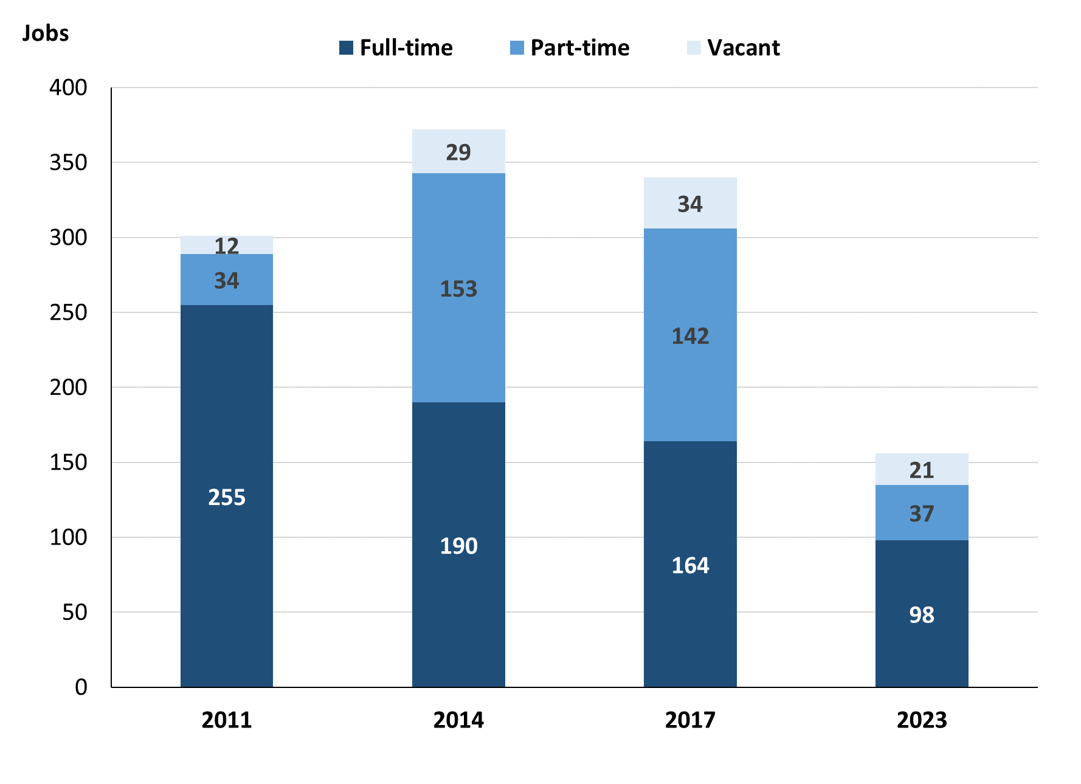

Source: Northern Territory Department of Industry, Tourism and Trade

In 2023 in Yirrkala:

* there was a total of 135 **filled jobs**, a decrease of 171 jobs from 2017 and a decrease of 208 jobs from 2014
* of the 135 **filled jobs** in 2023:
* 98 were **full-time** jobs, a decrease of 66 jobs from 2017 and a decrease of 92 jobs from 2014
* 37 were **part-time** jobs, a decrease of 105 jobs from 2017 and a decrease of 116 jobs from 2014
* there were 21 total **job vacancies** in 2023, a decrease of 13 vacancies from 2017 and a decrease of 8 vacancies from 2014.

# Jobs filled by Aboriginality

Chart 2: Count of filled jobs by Aboriginality, 2011, 2014, 2017 & 2023 (a)(c)

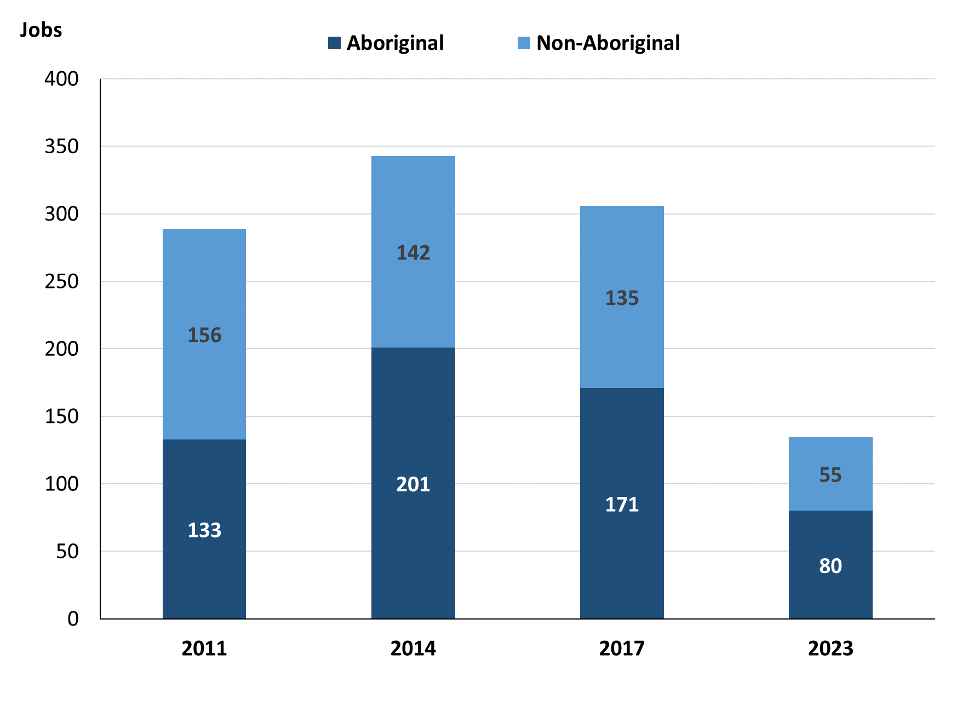

Source: Northern Territory Department of Industry, Tourism and Trade

In 2023 in Yirrkala:

* of the 135 filled jobs:
* **Aboriginal** people filled 80 jobs, a decrease of 91 jobs from 2017 and a decrease of 121 jobs from 2014
* **non-Aboriginal** people filled 55 jobs, a decrease of 80 jobs from 2017 and a decrease of 87 jobs from 2014
* **Aboriginal** people accounted for 59% of job holders compared to 56% in 2017 and 59% in 2014.

Table 2a: Count of filled jobs by full-time/part-time status, 2011, 2014, 2017 & 2023 (a)(b)(c)

|  |  |  |  |  |  |  |  |  |  |  |  |  |
| --- | --- | --- | --- | --- | --- | --- | --- | --- | --- | --- | --- | --- |
| **Indicator** | **2011** | | | **2014** | | | **2017** | | | **2023** | | |
| **Aboriginal** | **Non-Aboriginal** | **Total** | **Aboriginal** | **Non-Aboriginal** | **Total** | **Aboriginal** | **Non-Aboriginal** | **Total** | **Aboriginal** | **Non-Aboriginal** | **Total** |
| Full-time | 117 | 138 | **255** | 69 | 121 | **190** | 52 | 112 | **164** | 51 | 47 | **98** |
| Part-time | 16 | 18 | **34** | 132 | 21 | **153** | 119 | 23 | **142** | 29 | 8 | **37** |
| **Total** | **133** | **156** | **289** | **201** | **142** | **343** | **171** | **135** | **306** | **80** | **55** | **135** |

Source: Northern Territory Department of Industry, Tourism and Trade

Table 2b: Count of filled jobs by full-time/part-time status, 2011-2014, 2014-2017 & 2017-2023 (a)(b)(c)

|  |  |  |  |  |  |  |  |  |  |
| --- | --- | --- | --- | --- | --- | --- | --- | --- | --- |
| **Indicator** | **Change 2011-2014** | | | **Change 2014-2017** | | | **Change 2017-2023** | | |
| **Aboriginal** | **Non-Aboriginal** | **Total** | **Aboriginal** | **Non-Aboriginal** | **Total** | **Aboriginal** | **Non-Aboriginal** | **Total** |
| Full-time | -48 | -17 | **-65** | -17 | -9 | **-26** | -1 | -65 | **-66** |
| Part-time | 116 | 3 | **119** | -13 | 2 | **-11** | -90 | -15 | **-105** |
| **Total** | **68** | **-14** | **54** | **-30** | **-7** | **-37** | **-91** | **-80** | **-171** |

Source: Northern Territory Department of Industry, Tourism and Trade

Chart 3: Count of filled jobs by full-time/part-time status, 2011, 2014, 2017 & 2023 (a)(b)(c)

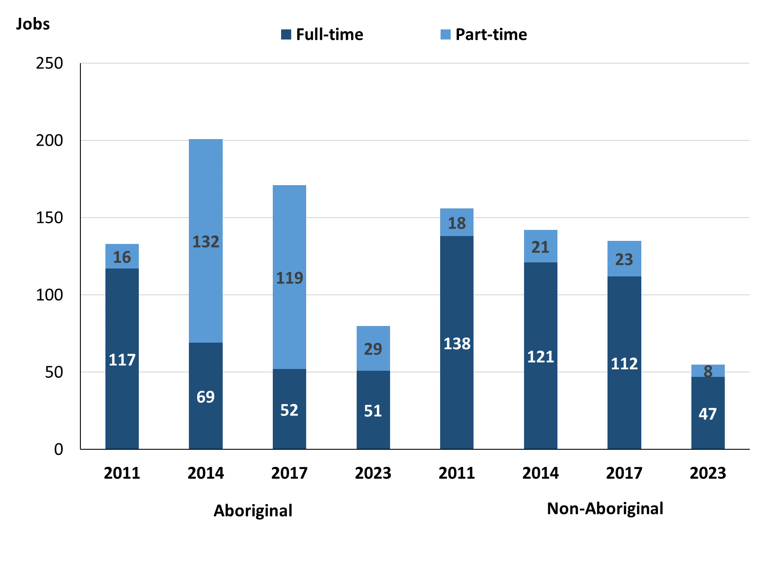

Source: Northern Territory Department of Industry, Tourism and Trade

In 2023 in Yirrkala:

* of the 135 **filled jobs:**
* 51 were **full-time** jobs filled by **Aboriginal** people, a decrease of 1 job from 2017 and a decrease of 18 jobs from 2014
* 29 were **part-time** jobs filled by **Aboriginal** people, a decrease of 90 jobs from 2017 and a decrease of 103 jobs from 2014
* 47 were **full-time** jobs filled by **non-Aboriginal** people, a decrease of 65 jobs from 2017 and a decrease of 74 jobs from 2014
* 8 were **part-time** jobs filled by **non-Aboriginal** people, a decrease of 15 jobs from 2017 and a decrease of 13 jobs from 2014.

# Jobs by Sector: Private and Public

Table 3a: Count of filled jobs by sector of business, 2011, 2014, 2017 & 2023 (a)(b)(c)

|  |  |  |  |  |  |  |  |  |  |  |  |  |
| --- | --- | --- | --- | --- | --- | --- | --- | --- | --- | --- | --- | --- |
| **Indicator** | **2011** | | | **2014** | | | **2017** | | | **2023** | | |
| **Aboriginal** | **Non-Aboriginal** | **Total** | **Aboriginal** | **Non-Aboriginal** | **Total** | **Aboriginal** | **Non-Aboriginal** | **Total** | **Aboriginal** | **Non-Aboriginal** | **Total** |
| **Public Sector** | 41 | 68 | **109** | 44 | 57 | **101** | 46 | 55 | **101** | 45 | 36 | **81** |
| Australian Government | 0 | 1 | **1** | 1 | 1 | **2** | 0 | 1 | **1** | 0 | 0 | **0** |
| Territory Government | 30 | 48 | **78** | 34 | 38 | **72** | 34 | 35 | **69** | 27 | 22 | **49** |
| Local Government | 11 | 19 | **30** | 9 | 18 | **27** | 12 | 19 | **31** | 18 | 14 | **32** |
| **Private Sector** | 92 | 88 | **180** | 157 | 85 | **242** | 125 | 80 | **205** | 35 | 19 | **54** |
| **Total** | **133** | **156** | **289** | **201** | **142** | **343** | **171** | **135** | **306** | **80** | **55** | **135** |

Source: Northern Territory Department of Industry, Tourism and Trade

Table 3b: Count of filled jobs by sector of business, 2011-2014, 2014-2017 & 2017-2023 (a)(b)(c)

|  |  |  |  |  |  |  |  |  |  |
| --- | --- | --- | --- | --- | --- | --- | --- | --- | --- |
| **Indicator** | **Change 2011-2014** | | | **Change 2014-2017** | | | **Change 2017-2023** | | |
| **Aboriginal** | **Non-Aboriginal** | **Total** | **Aboriginal** | **Non-Aboriginal** | **Total** | **Aboriginal** | **Non-Aboriginal** | **Total** |
| **Public Sector** | 3 | -11 | **-8** | 2 | -2 | **0** | -1 | -19 | **-20** |
| Australian Government | 1 | 0 | **1** | -1 | 0 | **-1** | 0 | -1 | **-1** |
| Territory Government | 4 | -10 | **-6** | 0 | -3 | **-3** | -7 | -13 | **-20** |
| Local Government | -2 | -1 | **-3** | 3 | 1 | **4** | 6 | -5 | **1** |
| **Private Sector** | 65 | -3 | **62** | -32 | -5 | **-37** | -90 | -61 | **-151** |
| **Total** | **68** | **-14** | **54** | **-30** | **-7** | **-37** | **-91** | **-80** | **-171** |

Source: Northern Territory Department of Industry, Tourism and Trade

**Chart 4: Count of filled jobs by sector of business, 2011, 2014, 2017 & 2023 (a)(d)**

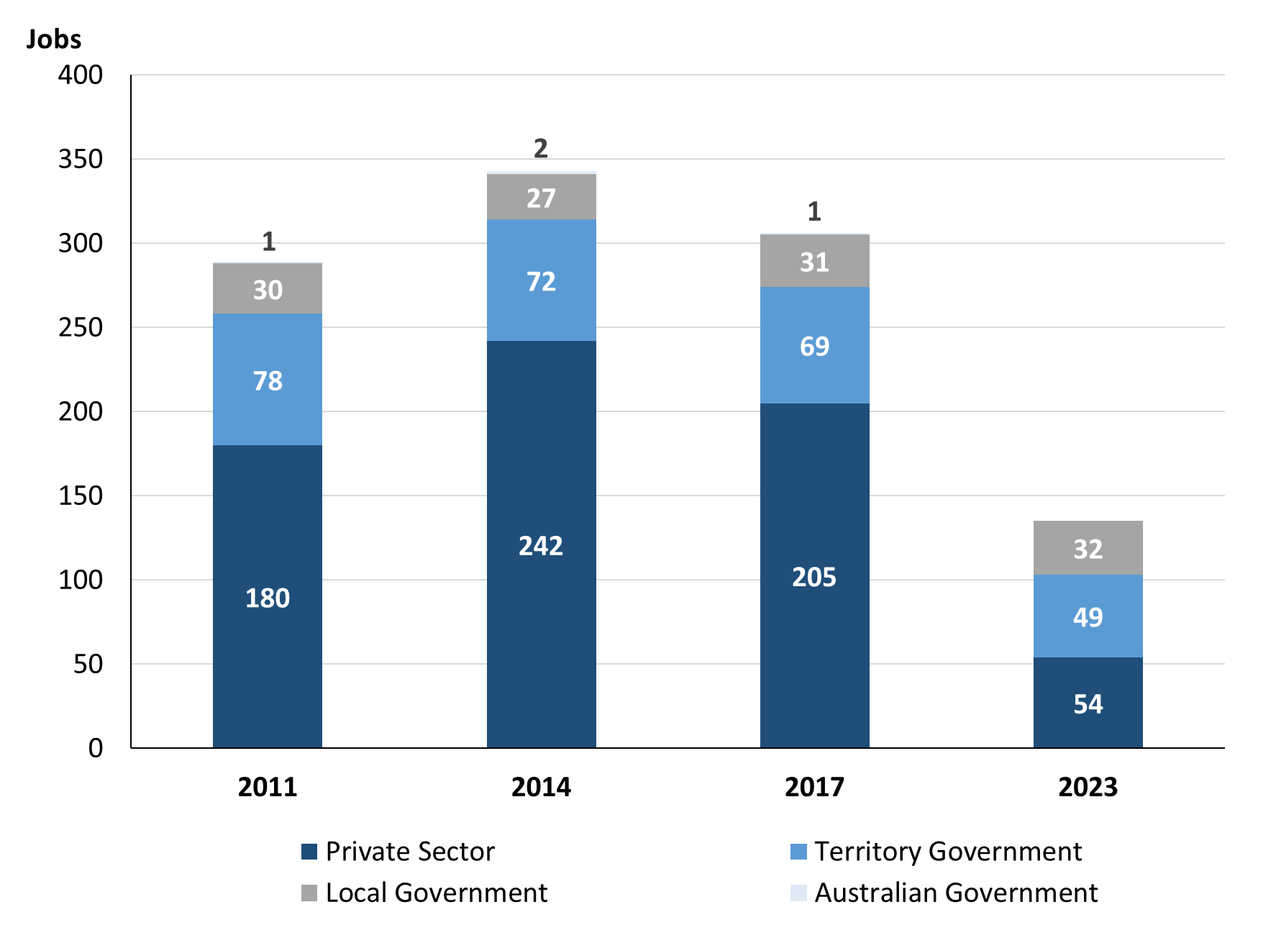

Source: Northern Territory Department of Industry, Tourism and Trade

Chart 5: Percentage of filled jobs by sector of business in 2023 (a)(d)

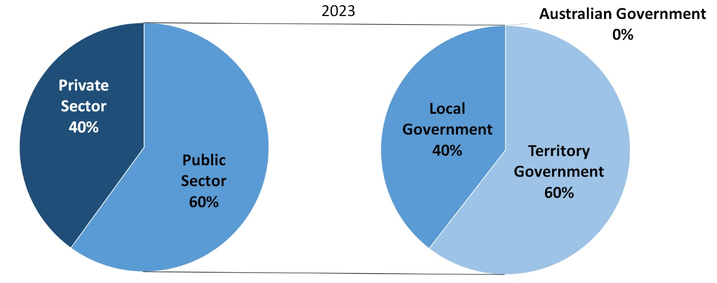

Source: Northern Territory Department of Industry, Tourism and Trade

In 2023 in Yirrkala:

* there were 81 jobs in the **Public Sector**, a decrease of 20 jobs from 2017 and a decrease of 20 jobs from 2014
* of the 81 jobs in the **Public Sector** in 2023:
* none were in the Australian Government, a decrease of 1 job from 2017 and a decrease of 2 jobs from 2014
* 49 jobs were in the Territory Government, a decrease of 20 jobs from 2017 and a decrease of 23 jobs from 2014
* 32 jobs were in the Local Government, an increase of 1 job from 2017 and an increase of 5 jobs from 2014
* there were 54 jobs in the **Private Sector** in 2023, a decrease of 151 jobs from 2017 and a decrease of 188 jobs from 2014.

Chart 6: Count of filled jobs by sector, 2011, 2014, 2017 & 2023 (a)(c)(d)

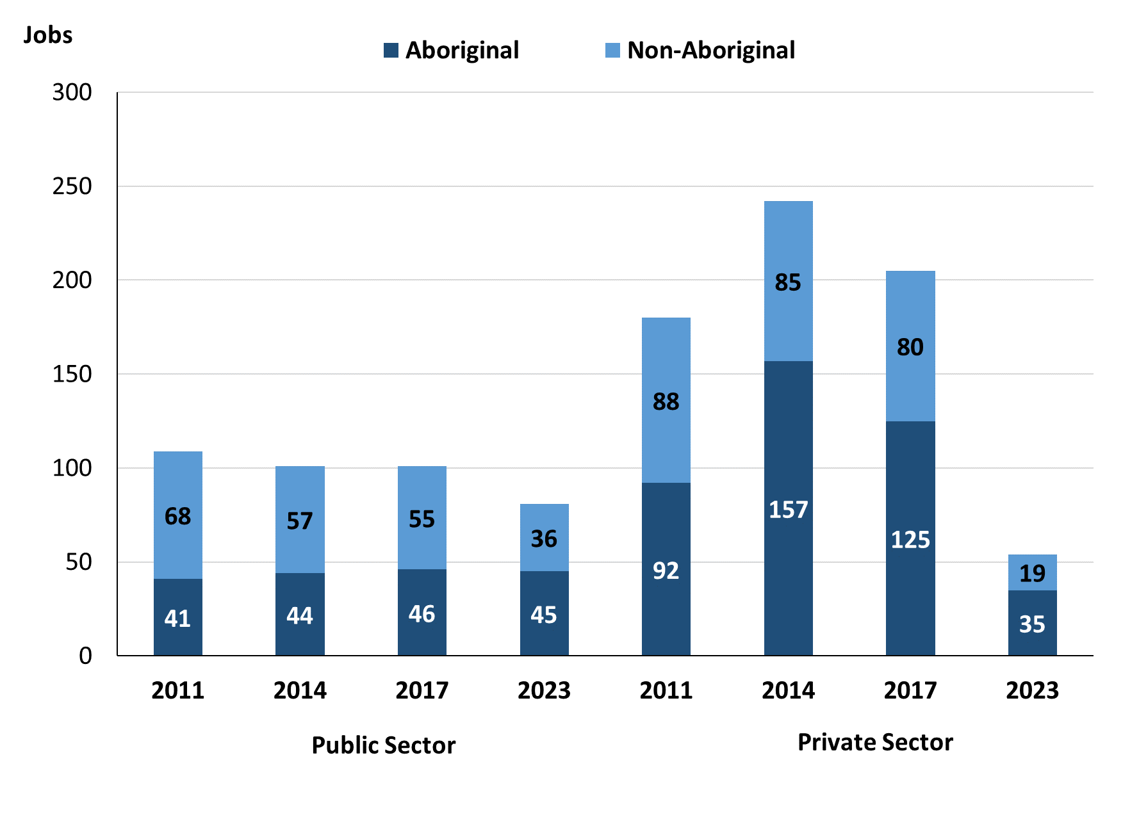

Source: Northern Territory Department of Industry, Tourism and Trade

In 2023 in Yirrkala:

* of the 81 jobs in the **Public Sector**:
* **Aboriginal** people filled 45 jobs, a decrease of 1 job from 2017 and an increase of 1 job from 2014
* **non-Aboriginal** people filled 36 jobs, a decrease of 19 jobs from 2017 and a decrease of 21 jobs from 2014
* of the 54 jobs in the **Private Sector**:
* **Aboriginal** people filled 35 jobs, a decrease of 90 jobs from 2017 and a decrease of 122 jobs from 2014
* **non-Aboriginal** people filled 19 jobs, a decrease of 61 jobs from 2017 and a decrease of 66 jobs from 2014.

Chart7: Count of filled jobs by sector and full-time/part-time status, 2011, 2014, 2017 & 2023 (a)(b)(d)

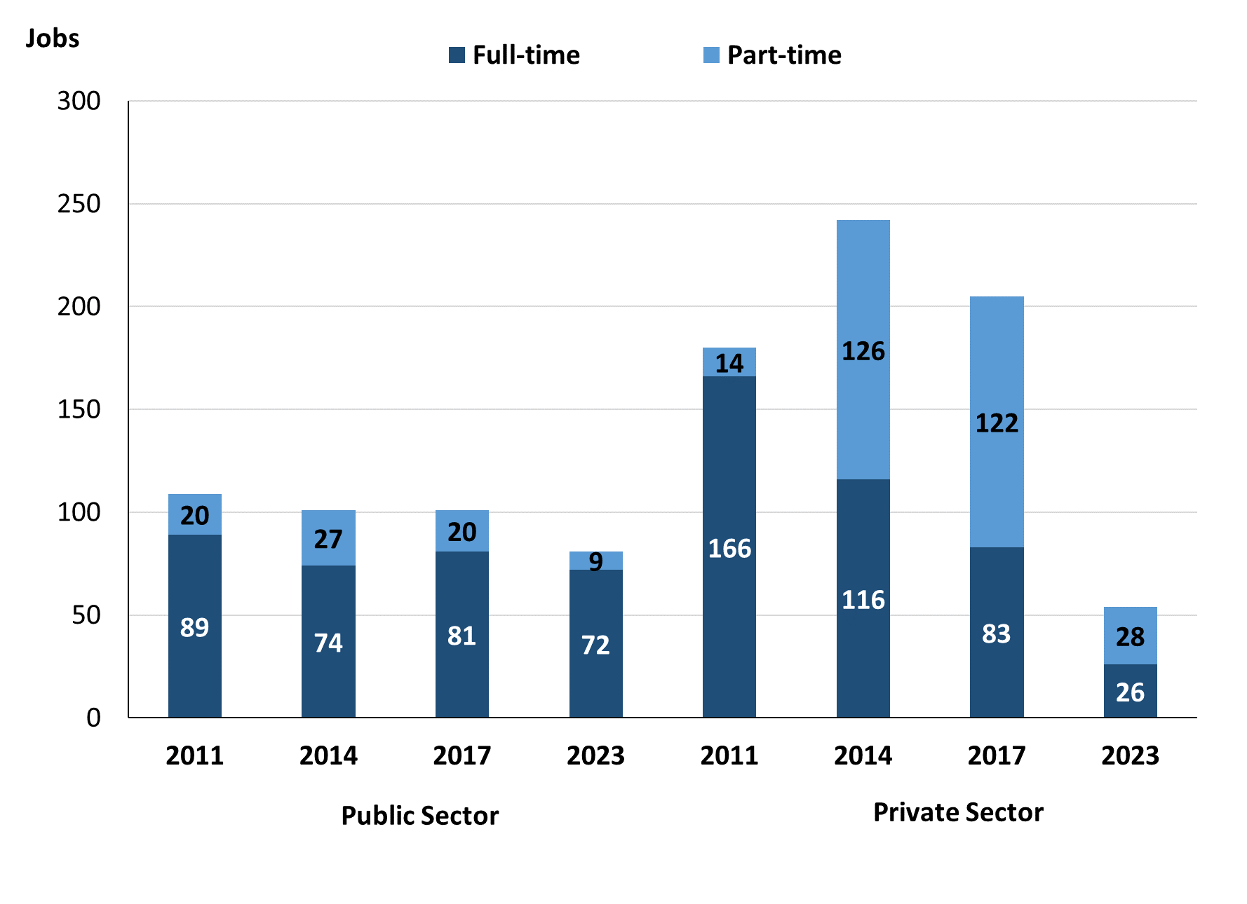

Source: Northern Territory Department of Industry, Tourism and Trade

In 2023 in Yirrkala there were:

* of the 81 jobs in the **Public Sector**:
* 72 were **full-time** jobs, a decrease of 9 jobs from 2017 and a decrease of 2 jobs from 2014
* 9 were **part-time** jobs, a decrease of 11 jobs from 2017 and a decrease of 18 jobs from 2014
* of the 54 jobs in the **Private Sector**:
* 26 were **full-time** jobs, a decrease of 57 jobs from 2017 and a decrease of 90 jobs from 2014
* 28 were **part-time** jobs, a decrease of 94 jobs from 2017 and a decrease of 98 jobs from 2014.

Table 4: Count of filled jobs by full-time/part-time status by sector, 2011, 2014, 2017 & 2023 (a)(b)(c)(d)

|  |  |  |  |  |  |  |  |  |  |
| --- | --- | --- | --- | --- | --- | --- | --- | --- | --- |
| **Indicator** | **2011** | | | | | | | | |
| **Aboriginal** | | | **Non-Aboriginal** | | | **Total** | | |
| **Full-time** | **Part-time** | **Total** | **Full-time** | **Part-time** | **Total** | **Full-time** | **Part-time** | **Total** |
| Public Sector | 30 | 11 | **41** | 59 | 9 | **68** | 89 | 20 | **109** |
| Private Sector | 87 | 5 | **92** | 79 | 9 | **88** | 166 | 14 | **180** |
| **Total** | **117** | **16** | **133** | **138** | **18** | **156** | **255** | **34** | **289** |

|  |  |  |  |  |  |  |  |  |  |
| --- | --- | --- | --- | --- | --- | --- | --- | --- | --- |
| **Indicator** | **2014** | | | | | | | | |
| **Aboriginal** | | | **Non-Aboriginal** | | | **Total** | | |
| **Full-time** | **Part-time** | **Total** | **Full-time** | **Part-time** | **Total** | **Full-time** | **Part-time** | **Total** |
| Public Sector | 25 | 19 | **44** | 49 | 8 | **57** | 74 | 27 | **101** |
| Private Sector | 44 | 113 | **157** | 72 | 13 | **85** | 116 | 126 | **242** |
| **Total** | **69** | **132** | **201** | **121** | **21** | **142** | **190** | **153** | **343** |

|  |  |  |  |  |  |  |  |  |  |
| --- | --- | --- | --- | --- | --- | --- | --- | --- | --- |
| **Indictor** | **2017** | | | | | | | | |
| **Aboriginal** | | | **Non-Aboriginal** | | | **Total** | | |
| **Full-time** | **Part-time** | **Total** | **Full-time** | **Part-time** | **Total** | **Full-time** | **Part-time** | **Total** |
| Public Sector | 32 | 14 | **46** | 49 | 6 | **55** | 81 | 20 | **101** |
| Private Sector | 20 | 105 | **125** | 63 | 17 | **80** | 83 | 122 | **205** |
| **Total** | **69** | **132** | **171** | **112** | **23** | **135** | **164** | **142** | **306** |

|  |  |  |  |  |  |  |  |  |  |
| --- | --- | --- | --- | --- | --- | --- | --- | --- | --- |
| **Indictor** | **2023** | | | | | | | | |
| **Aboriginal** | | | **Non-Aboriginal** | | | **Total** | | |
| **Full-time** | **Part-time** | **Total** | **Full-time** | **Part-time** | **Total** | **Full-time** | **Part-time** | **Total** |
| Public Sector | 39 | 6 | **45** | 33 | 3 | **36** | 72 | 9 | **81** |
| Private Sector | 12 | 23 | **35** | 14 | 5 | **19** | 26 | 28 | **54** |
| **Total** | **51** | **29** | **80** | **47** | **8** | **55** | **98** | **37** | **135** |

Source: Northern Territory Department of Industry, Tourism and Trade

In 2023 in Yirrkala there were:

* 45 jobs in the **Public Sector** filled by **Aboriginal** people, a decrease of 1 job from 2017 and an increase of 1 job from 2014, of which:
* 39 were **full-time** jobs, an increase of 7 jobs from 2017 and an increase of 14 jobs from 2014
* 6 were **part-time** jobs, a decrease of 8 jobs from 2017 and a decrease of 13 jobs from 2014
* 35 jobs in the **Private Sector** filled by **Aboriginal** people, a decrease of 90 jobs from 2017 and a decrease of 122 jobs from 2014, of which:
* 12 were **full-time** jobs, a decrease of 8 jobs from 2017 and a decrease of 32 jobs from 2014
* 23 were **part-time** jobs, a decrease of 82 jobs from 2017 and a decrease of 90 jobs from 2014
* 36 jobs in the **Public Sector** filled by **non-Aboriginal** people, a decrease of 19 jobs from 2017 and a decrease of 21 jobs from 2014, of which:
* 33 were **full-time** jobs, a decrease of 16 jobs from 2017 and a decrease of 16 jobs from 2014
* 3 were **part-time** jobs, a decrease of 3 jobs from 2017 and a decrease of 5 jobs from 2014
* 19 jobs in the **Private Sector** filled by **non-Aboriginal** people, a decrease of 61 jobs from 2017 and a decrease of 66 jobs from 2014, of which:
* 14 were **full-time** jobs, a decrease of 49 jobs from 2017 and a decrease of 58 jobs from 2014
* 5 were **part-time** jobs, a decrease of 12 jobs from 2017 and a decrease of 8 jobs from 2014.

# Job Status: Permanent and Temporary

Table 5a: Count of filled jobs by employment status, 2011, 2014, 2017 & 2023 (a)(c)(e)

|  |  |  |  |  |  |  |  |  |  |  |  |  |
| --- | --- | --- | --- | --- | --- | --- | --- | --- | --- | --- | --- | --- |
| **Indicator** | **2011** | | | **2014** | | | **2017** | | | **2023** | | |
| **Aboriginal** | **Non-Aboriginal** | **Total** | **Aboriginal** | **Non-Aboriginal** | **Total** | **Aboriginal** | **Non-Aboriginal** | **Total** | **Aboriginal** | **Non-Aboriginal** | **Total** |
| Permanent | 108 | 114 | **222** | 134 | 103 | **237** | 58 | 67 | **125** | 50 | 36 | **86** |
| Temporary | 25 | 42 | **67** | 67 | 39 | **106** | 113 | 68 | **181** | 30 | 19 | **49** |
| **Total** | **133** | **156** | **289** | **201** | **142** | **343** | **171** | **135** | **306** | **80** | **55** | **135** |

Source: Northern Territory Department of Industry, Tourism and Trade

Table 5b: Count of filled jobs by employment status, 2011-2014, 2014-2017 & 2017-2023 (a)(c)(e)

|  |  |  |  |  |  |  |  |  |  |
| --- | --- | --- | --- | --- | --- | --- | --- | --- | --- |
| **Indicator** | **Change 2011-2014** | | | **Change 2014-2017** | | | **Change**  **2017-2023** | | |
| **Aboriginal** | **Non-Aboriginal** | **Total** | **Aboriginal** | **Non-Aboriginal** | **Total** | **Aboriginal** | **Non-Aboriginal** | **Total** |
| Permanent | 26 | -11 | **15** | -76 | -36 | **-112** | -8 | -31 | **-39** |
| Temporary | 42 | -3 | **39** | 46 | 29 | **75** | -83 | -49 | **-132** |
| **Total** | **68** | **-14** | **54** | **-30** | **-7** | **-37** | **-91** | **-80** | **-171** |

Source: Northern Territory Department of Industry, Tourism and Trade

Chart 8: Count of filled jobs by employment status, 2011, 2014, 2017 & 2023 (a)(c)(e)

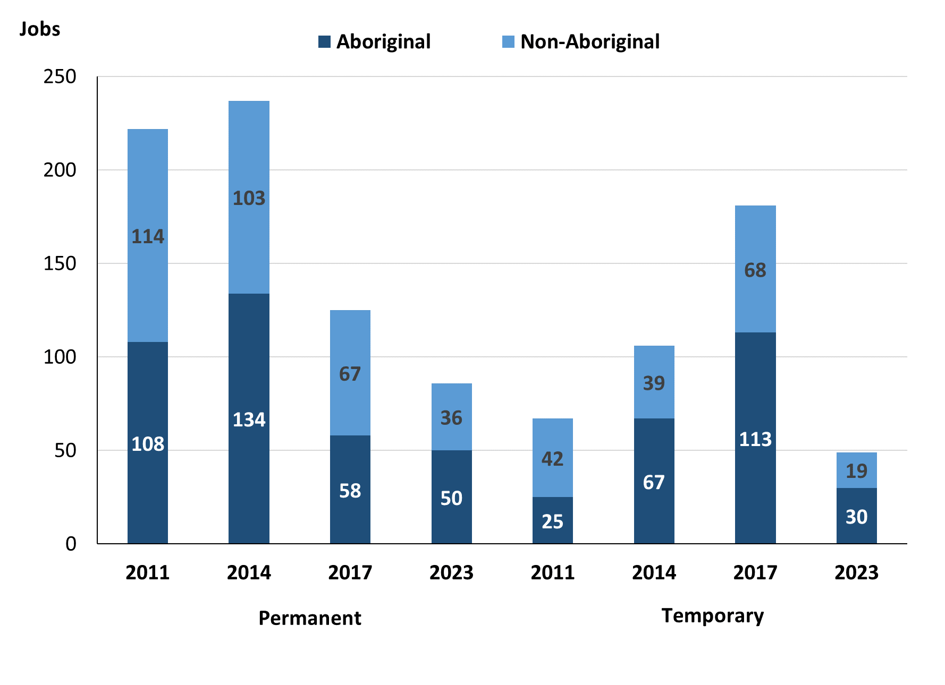

Source: Northern Territory Department of Industry, Tourism and Trade

In 2023 in Yirrkala:

* there were 86 **permanent** **jobs,** a decrease of 39 jobs from 2017, and a decrease of 151 jobs from 2014, of which:
* **Aboriginal** people filled 50 jobs, a decrease of 8 jobs from 2017 and a decrease of 84 jobs from 2014
* **non-Aboriginal** people filled 36 jobs, a decrease of 31 jobs from 2017 and a decrease of 64 jobs from 2014
* there were 49 **temporary jobs**, a decrease of 132 jobs from 2017 and a decrease of 57 jobs from 2014, of which:
* **Aboriginal** people filled 30 jobs, a decrease of 83 jobs from 2017 and a decrease of 37 jobs from 2014
* **non-Aboriginal** people filled 19 jobs, a decrease of 49 jobs from 2017 and a decrease of 20 jobs from 2014.

Table 6: Count of filled jobs by sector and employment status, 2011, 2014, 2017 & 2023 (a)(c)(d)(e)

|  |  |  |  |  |  |  |  |  |  |
| --- | --- | --- | --- | --- | --- | --- | --- | --- | --- |
| **Indicator** | **2011** | | | | | | | | |
| **Aboriginal** | | | **Non-Aboriginal** | | | **Total** | | |
| **Perm** | **Temp** | **Total** | **Perm** | **Temp** | **Total** | **Perm** | **Temp** | **Total** |
| Public Sector | 21 | 20 | **41** | 35 | 33 | **68** | 56 | 53 | **109** |
| Private Sector | 87 | 5 | **92** | 79 | 9 | **88** | 166 | 14 | **180** |
| **Total** | **108** | **25** | **133** | **114** | **42** | **156** | **222** | **67** | **289** |

|  |  |  |  |  |  |  |  |  |  |
| --- | --- | --- | --- | --- | --- | --- | --- | --- | --- |
| **Indicator** | **2014** | | | | | | | | |
| **Aboriginal** | | | **Non-Aboriginal** | | | **Total** | | |
| **Perm** | **Temp** | **Total** | **Perm** | **Temp** | **Total** | **Perm** | **Temp** | **Total** |
| Public Sector | 26 | 18 | **44** | 42 | 15 | **57** | 68 | 33 | **101** |
| Private Sector | 108 | 49 | **157** | 61 | 24 | **85** | 169 | 73 | **242** |
| **Total** | **134** | **67** | **201** | **103** | **39** | **142** | **237** | **106** | **343** |

|  |  |  |  |  |  |  |  |  |  |  |  |  |
| --- | --- | --- | --- | --- | --- | --- | --- | --- | --- | --- | --- | --- |
| **Indicator** | **2017** | | | | | | | | | | | |
| **Aboriginal** | | | | **Non-Aboriginal** | | | | **Total** | | | |
| **Perm** | **Temp** | **Total** | **Perm** | | **Temp** | **Total** | **Perm** | | **Temp** | **Total** |
| Public Sector | 26 | 20 | **46** | 35 | | 20 | **55** | 61 | | 40 | **101** |
| Private Sector | 32 | 93 | **125** | 32 | | 48 | **80** | 64 | | 141 | **205** |
| **Total** | **58** | **113** | **171** | **67** | | **68** | **135** | **125** | | **181** | **306** |

|  |  |  |  |  |  |  |  |  |  |  |  |  |
| --- | --- | --- | --- | --- | --- | --- | --- | --- | --- | --- | --- | --- |
| **Indicator** | **2023** | | | | | | | | | | | |
| **Aboriginal** | | | | **Non-Aboriginal** | | | | **Total** | | | |
| **Perm** | **Temp** | **Total** | **Perm** | | **Temp** | **Total** | **Perm** | | **Temp** | **Total** |
| Public Sector | 22 | 23 | **45** | 21 | | 15 | **36** | 43 | | 38 | **81** |
| Private Sector | 28 | 7 | **35** | 15 | | 4 | **19** | 43 | | 11 | **54** |
| **Total** | **50** | **30** | **80** | **36** | | **19** | **55** | **86** | | **49** | **135** |

Source: Northern Territory Department of Industry, Tourism and Trade

In 2023 in Yirrkala there were:

* 81 jobs in the **Public Sector**, a decrease of 20 jobs from 2017 and a decrease of 20 jobs from 2014, of which:
* 43 jobs were **permanen**t, a decrease of 18 jobs from 2017 and a decrease of 25 jobs from 2014, of which:
* **Aboriginal** people filled 22 jobs, a decrease of 4 jobs from 2017 and a decrease of 4 jobs from 2014
* **non-Aboriginal** people filled 21 jobs, a decrease of 14 jobs from 2017 and a decrease of 21 jobs from 2014
* 38 jobs were **temporary**, a decrease of 2 jobs from 2017 and an increase of 5 jobs from 2014, of which:
* **Aboriginal** people filled 23 jobs, an increase of 3 jobs from 2017 and an increase of 5 jobs from 2014
* **non-Aboriginal** people filled 15 jobs, a decrease of 5 jobs from 2017 and unchanged from 2014
* 54 jobs in the **Private Sector**, a decrease of 151 jobs from 2017 and a decrease of 188 jobs from 2014, of which:
* 43 jobs were **permanent**, a decrease of 21 jobs from 2017 and a decrease of 126 jobs from 2014, of which:
* **Aboriginal** people filled 28 jobs, a decrease of 4 jobs from 2017 and a decrease of 80 jobs from 2014
* **non-Aboriginal** people filled 15 jobs, a decrease of 17 jobs from 2017 and a decrease of 46 jobs from 2014
* 11 jobs were **temporary**, a decrease of 130 jobs from 2017 and a decrease of 62 jobs from 2014, of which:
* **Aboriginal** people filled 7 jobs, a decrease of 86 jobs from 2017 and a decrease of 42 jobs from 2014
* **non-Aboriginal** people filled 4 jobs, a decrease of 44 jobs from 2017 and a decrease of 20 jobs from 2014.

# Job Vacancies

Table 7: Job vacancies, 2011, 2014, 2017 & 2023

|  |  |  |  |  |  |  |  |
| --- | --- | --- | --- | --- | --- | --- | --- |
| **Indicator** | **2011** | **2014** | **2017** | **2023** | **Change 2011-2014** | **Change 2014-2017** | **Change 2017-2023** |
| **Job vacancies** | **12** | **29** | **34** | **21** | **17** | **5** | **-13** |

Source: Northern Territory Department of Industry, Tourism and Trade

Table 8a: Job vacancies by occupation, 2011, 2014, 2017 & 2023 (f)(g)

|  |  |  |  |  |
| --- | --- | --- | --- | --- |
| **Occupation (ANZSCO major group)** | **2011** | **2014** | **2017** | **2023** |
| Clerical and Administrative Workers | 2 | 2 | 5 | 3 |
| Community and Personal Service Workers | 4 | 13 | 14 | 5 |
| Labourers | 3 | 1 | 4 | 0 |
| Managers | 0 | 2 | 1 | 0 |
| Professionals | 2 | 11 | 10 | 7 |
| Other Occupations | 1 | 0 | 0 | 6 |
| **Total** | **12** | **29** | **34** | **21** |

Source: Northern Territory Department of Industry, Tourism and Trade

Table 8b: Job vacancies by occupation, 2011-2014, 2014-2017 & 2017-2023 (f)(g)

|  |  |  |  |
| --- | --- | --- | --- |
| **Occupation (ANZSCO major group)** | **Change 2011-2014** | **Change 2014-2017** | **Change 2017-2023** |
| Clerical and Administrative Workers | 0 | 3 | -2 |
| Community and Personal Service Workers | 9 | 1 | -9 |
| Labourers | -2 | 3 | -4 |
| Managers | 2 | -1 | -1 |
| Professionals | 9 | -1 | -3 |
| Other Occupations | -1 | 0 | 6 |
| **Total** | **17** | **5** | **-13** |

Source: Northern Territory Department of Industry, Tourism and Trade

Table 9: Job vacancies by job title, 2023 profile (f)(g)

|  |  |
| --- | --- |
| **Job Vacancy** | **No.** |
| Aboriginal and Torres Strait Islander Education Worker | 4 |
| Accounting Clerk and Bookkeeper | 1 |
| Classroom Teacher | 2 |
| Early Childhood Senior Teacher | 1 |
| General Clerk | 1 |
| Liaison Officer | 1 |
| Program or Project Administrator | 1 |
| Senior Teacher | 3 |
| Vocational Education Teacher | 1 |
| Other (inadequately described) | 6 |
| **Total** | **21** |

Source: Northern Territory Department of Industry, Tourism and Trade

In 2023 in Yirrkala:

* there were 21 **vacancies** reported, a decrease of 13 vacancies from 2017 and a decrease of 8 vacancies from 2014
* of the 21 reported **vacancies,** the highest demand was for:
* 7 Professionals, the majority in the following jobs:
* Classroom Teacher
* Senior Teacher
* 5 Community and Personal Service Workers, the majority in the following job:
* Aboriginal and Torres Strait Islander Education Worker
* 3 Clerical and Administrative Workers, the majority in the following jobs:
* Accounting Clerk and Bookkeeper
* General Clerk
* Program or Project Administrator.

# Jobs by Industry

Table 10: Count of filled jobs by industry of business, 2011, 2014, 2017, 2023 and change in count of filled jobs by industry 2011-2014, 2014-2017 & 2017-2023 (a)(h)

|  |  |  |  |  |  |  |  |  |  |  |  |
| --- | --- | --- | --- | --- | --- | --- | --- | --- | --- | --- | --- |
| **Industry (ANZSIC Division)** | **2011** | | **2014** | | **2017** | | **2023** | | **Change 2011-2014** | **Change 2014-2017** | **Change 2017-2023** |
| **Total** | **% of Total** | **Total** | **% of Total** | **Total** | **% of Total** | **Total** | **% of Total** | **Total** | **Total** | **Total** |
| Accommodation and Food Services | 0 | 0.0% | 3 | 0.9% | 0 | 0.0% | 2 | 1.5% | 3 | -3 | 2 |
| Administrative and Support Services | 0 | 0.0% | 0 | 0.0% | 14 | 4.6% | 0 | 0.0% | 0 | 14 | -14 |
| Agriculture, Forestry and Fishing | 0 | 0.0% | 10 | 2.9% | 0 | 0.0% | 0 | 0.0% | 10 | -10 | 0 |
| Arts and Recreation Services | 25 | 8.7% | 29 | 8.5% | 0 | 0.0% | 0 | 0.0% | 4 | -29 | 0 |
| Construction | 21 | 7.3% | 5 | 1.5% | 147 | 48.0% | 0 | 0.0% | -16 | 142 | -147 |
| Education and Training | 66 | 22.8% | 127 | 37.0% | 68 | 22.2% | 49 | 36.3% | 61 | -59 | -19 |
| Health Care and Social Assistance | 14 | 4.8% | 12 | 3.5% | 18 | 5.9% | 20 | 14.8% | -2 | 6 | 2 |
| Other Services | 0 | 0.0% | 3 | 0.9% | 1 | 0.3% | 0 | 0.0% | 3 | -2 | -1 |
| Public Administration and Safety | 149 | 51.6% | 147 | 42.9% | 33 | 10.8% | 58 | 43.0% | -2 | -114 | 25 |
| Rental, Hiring and Real Estate Services | 0 | 0.0% | 0 | 0.0% | 2 | 0.7% | 0 | 0.0% | 0 | 2 | -2 |
| Retail Trade | 12 | 4.2% | 7 | 2.0% | 23 | 7.5% | 6 | 4.4% | -5 | 16 | -17 |
| Transport, Postal and Warehousing | 2 | 0.7% | 0 | 0.0% | 0 | 0.0% | 0 | 0.0% | -2 | 0 | 0 |
| **Total** | **289** | **100.0%** | **343** | **100.0%** | **306** | **100.0%** | **135** | **100.0%** | **54** | **-37** | **-171** |

Source: Northern Territory Department of Industry, Tourism and Trade

In 2023 in Yirrkala:

* the Public Administration and Safety industry was the **largest** **industry** **employer**, with 58 filled jobs or 43% of filled jobs, an increase of 25 jobs from 2017 and a decrease of 89 jobs from 2014
* **other** **significant** industry employers were:
* Education and Training with 49 jobs (or 36.3% of filled jobs), a decrease of 19 jobs from 2017 and a decrease of 78 jobs from 2014
* Health Care and Social Assistance with 20 jobs (or 14.8% of filled jobs), an increase of 2 jobs from 2017 and an increase of 8 jobs from 2014.

Table 11a: Count of filled jobs by industry of business, 2011, 2014, 2017 & 2023 (a)(c)(h)

|  |  |  |  |  |  |  |  |  |  |  |  |  |
| --- | --- | --- | --- | --- | --- | --- | --- | --- | --- | --- | --- | --- |
| **Industry (ANZSIC division)** | **2011** | | | **2014** | | | **2017** | | | **2023** | | |
| **Aboriginal** | **Non-Aboriginal** | **Total** | **Aboriginal** | **Non-Aboriginal** | **Total** | **Aboriginal** | **Non-Aboriginal** | **Total** | **Aboriginal** | **Non-Aboriginal** | **Total** |
| Accommodation and Food Services | 0 | 0 | **0** | 0 | 3 | **3** | 0 | 0 | **0** | 2 | 0 | **2** |
| Administrative and Support Services | 0 | 0 | **0** | 0 | 0 | **0** | 7 | 7 | **14** | 0 | 0 | **0** |
| Agriculture, Forestry and Fishing | 0 | 0 | **0** | 7 | 3 | **10** | 0 | 0 | **0** | 0 | 0 | **0** |
| Arts and Recreation Services | 21 | 4 | **25** | 25 | 4 | **29** | 0 | 0 | **0** | 0 | 0 | **0** |
| Construction | 5 | 16 | **21** | 4 | 1 | **5** | 95 | 52 | **147** | 0 | 0 | **0** |
| Education and Training | 20 | 46 | **66** | 78 | 49 | **127** | 33 | 35 | **68** | 27 | 22 | **49** |
| Health Care and Social Assistance | 10 | 4 | **14** | 2 | 10 | **12** | 4 | 14 | **18** | 8 | 12 | **20** |
| Other Services | 0 | 0 | **0** | 0 | 3 | **3** | 1 | 0 | **1** | 0 | 0 | **0** |
| Public Administration and Safety | 75 | 74 | **149** | 82 | 65 | **147** | 13 | 20 | **33** | 42 | 16 | **58** |
| Rental, Hiring and Real Estate Services | 0 | 0 | **0** | 0 | 0 | **0** | 2 | 0 | **2** | 0 | 0 | **0** |
| Retail Trade | 1 | 11 | **12** | 3 | 4 | **7** | 16 | 7 | **23** | 1 | 5 | **6** |
| Transport, Postal and Warehousing | 1 | 1 | **2** | 0 | 0 | **0** | 0 | 0 | **0** | 0 | 0 | **0** |
| **Total** | **133** | **156** | **289** | **201** | **142** | **343** | **171** | **135** | **306** | **80** | **55** | **135** |

Source: Northern Territory Department of Industry, Tourism and Trade

Table 11b: Count of filled jobs by industry of business, 2011-2014, 2014-2017 & 2017-2023 (a)(c)(h)

|  |  |  |  |  |  |  |  |  |  |  |
| --- | --- | --- | --- | --- | --- | --- | --- | --- | --- | --- |
| **Industry (ANZSIC division)** | **Change 2011-2014** | | | | **Change  2014-2017** | | | **Change 2017-2023** | | |
| **Aboriginal** | **Non-Aboriginal** | **Total** | **Aboriginal** | | **Non-Aboriginal** | **Total** | **Aboriginal** | **Non-Aboriginal** | **Total** |
| Accommodation and Food Services | 0 | 3 | **3** | 0 | | -3 | **-3** | 2 | 0 | **2** |
| Administrative and Support Services | 0 | 0 | **0** | 7 | | 7 | **14** | -7 | -7 | **-14** |
| Agriculture, Forestry and Fishing | 7 | 3 | **10** | -7 | | -3 | **-10** | 0 | 0 | **0** |
| Arts and Recreation Services | 4 | 0 | **4** | -25 | | -4 | **-29** | 0 | 0 | **0** |
| Construction | -1 | -15 | **-16** | 91 | | 51 | **142** | -95 | -52 | **-147** |
| Education and Training | 58 | 3 | **61** | -45 | | -14 | **-59** | -6 | -13 | **-19** |
| Health Care and Social Assistance | -8 | 6 | **-2** | 2 | | 4 | **6** | 4 | -2 | **2** |
| Other Services | 0 | 3 | **3** | 1 | | -3 | **-2** | -1 | 0 | **-1** |
| Public Administration and Safety | 7 | -9 | **-2** | -69 | | -45 | **-114** | 29 | -4 | **25** |
| Rental, Hiring and Real Estate Services | 0 | 0 | **0** | 2 | | 0 | **2** | -2 | 0 | **-2** |
| Retail Trade | 2 | -7 | **-5** | 13 | | 3 | **16** | -15 | -2 | **-17** |
| Transport, Postal and Warehousing | -1 | -1 | **-2** | 0 | | 0 | **0** | 0 | 0 | **0** |
| **Total** | **68** | **-14** | **54** | **-30** | | **-7** | **-37** | **-91** | **-80** | **-171** |

*Source: Northern Territory Department of Industry, Tourism and Trade*

Chart 9: Count of filled jobs by top 5 industries, 2023 (a)(c)(h)

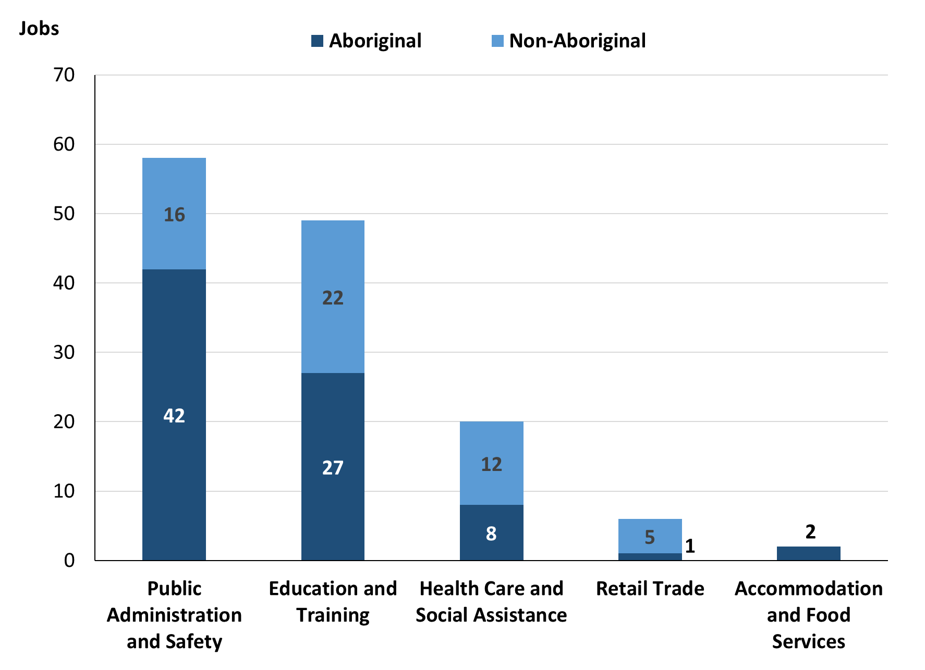

Source: Northern Territory Department of Industry, Tourism and Trade

In 2023 in Yirrkala:

* of the 80 **jobs filled** by **Aboriginal** people, there were:
* 42 jobs in Public Administration and Safety, an increase of 29 jobs from 2017 and a decrease of 40 jobs from 2014
* 27 jobs in Education and Training, a decrease of 6 jobs from 2017 and a decrease of 51 jobs from 2014
* 8 jobs in Health Care and Social Assistance, an increase of 4 jobs from 2017 and an increase of 6 jobs from 2014
* of the 55 **jobs filled** by **non-Aboriginal** people, there were:
* 22 jobs in Education and Training, a decrease of 13 jobs from 2017 and a decrease of 27 jobs from 2014
* 16 jobs in Public Administration and Safety, a decrease of 4 jobs from 2017 and a decrease of 49 jobs from 2014
* 12 jobs in Health Care and Social Assistance, a decrease of 2 jobs from 2017 and an increase of 2 jobs from 2014.

Table 12: Count of filled jobs by industry and employment status, 2011 (a)(c)(e)(h)

|  |  |  |  |  |  |  |  |  |  |
| --- | --- | --- | --- | --- | --- | --- | --- | --- | --- |
| **Industry (ANZSIC division)** | **2011** | | | | | | | | |
| **Aboriginal** | | | **Non-Aboriginal** | | | **Total** | | |
| **Perm** | **Temp** | **Total** | **Perm** | **Temp** | **Total** | **Perm** | **Temp** | **Total** |
| Arts and Recreation Services | 17 | 4 | **21** | 4 | 0 | **4** | 21 | 4 | **25** |
| Construction | 5 | 0 | **5** | 16 | 0 | **16** | 21 | 0 | **21** |
| Education and Training | 7 | 13 | **20** | 16 | 30 | **46** | 23 | 43 | **66** |
| Health Care and Social Assistance | 3 | 7 | **10** | 3 | 1 | **4** | 6 | 8 | **14** |
| Public Administration and Safety | 75 | 0 | **75** | 70 | 4 | **74** | 145 | 4 | **149** |
| Retail Trade | 1 | 0 | **1** | 5 | 6 | **11** | 6 | 6 | **12** |
| Transport, Postal and Warehousing | 0 | 1 | **1** | 0 | 1 | **1** | 0 | 2 | **2** |
| **Total** | **108** | **25** | **133** | **114** | **42** | **156** | **222** | **67** | **289** |

Source: Northern Territory Department of Industry, Tourism and Trade

Table 13: Count of filled jobs by industry and employment status, 2014 (a)(c)(e)(h)

|  |  |  |  |  |  |  |  |  |  |
| --- | --- | --- | --- | --- | --- | --- | --- | --- | --- |
| **Industry (ANZSIC division)** | **2014** | | | | | | | | |
| **Aboriginal** | | | **Non-Aboriginal** | | | **Total** | | |
| **Perm** | **Temp** | **Total** | **Perm** | **Temp** | **Total** | **Perm** | **Temp** | **Total** |
| Accommodation and Food Services | 0 | 0 | **0** | 0 | 3 | **3** | 0 | 3 | **3** |
| Agriculture, Forestry and Fishing | 7 | 0 | **7** | 1 | 2 | **3** | 8 | 2 | **10** |
| Arts and Recreation Services | 22 | 3 | **25** | 3 | 1 | **4** | 25 | 4 | **29** |
| Construction | 0 | 4 | **4** | 0 | 1 | **1** | 0 | 5 | **5** |
| Education and Training | 27 | 51 | **78** | 36 | 13 | **49** | 63 | 64 | **127** |
| Health Care and Social Assistance | 0 | 2 | **2** | 0 | 10 | **10** | 0 | 12 | **12** |
| Other Services | 0 | 0 | **0** | 3 | 0 | **3** | 3 | 0 | **3** |
| Public Administration and Safety | 75 | 7 | **82** | 60 | 5 | **65** | 135 | 12 | **147** |
| Retail Trade | 3 | 0 | **3** | 0 | 4 | **4** | 3 | 4 | **7** |
| **Total** | **134** | **67** | **201** | **103** | **39** | **142** | **237** | **106** | **343** |

Source: Northern Territory Department of Industry, Tourism and Trade

Table 14: Count of filled jobs by industry and employment status, 2017 (a)(c)(e)(h)

|  |  |  |  |  |  |  |  |  |  |
| --- | --- | --- | --- | --- | --- | --- | --- | --- | --- |
| **Industry (ANZSIC division)** | **2017** | | | | | | | | |
| **Aboriginal** | | | **Non-Aboriginal** | | | **Total** | | |
| **Perm** | **Temp** | **Total** | **Perm** | **Temp** | **Total** | **Perm** | **Temp** | **Total** |
| Administrative and Support Services | 2 | 5 | **7** | 1 | 6 | **7** | 3 | 11 | **14** |
| Construction | 12 | 83 | **95** | 16 | 36 | **52** | 28 | 119 | **147** |
| Education and Training | 21 | 12 | **33** | 18 | 17 | **35** | 39 | 29 | **68** |
| Health Care and Social Assistance | 4 | 0 | **4** | 12 | 2 | **14** | 16 | 2 | **18** |
| Other Services | 1 | 0 | **1** | 0 | 0 | **0** | 1 | 0 | **1** |
| Public Administration and Safety | 5 | 8 | **13** | 17 | 3 | **20** | 22 | 11 | **33** |
| Rental, Hiring and Real Estate Services | 2 | 0 | **2** | 0 | 0 | **0** | 2 | 0 | **2** |
| Retail Trade | 11 | 5 | **16** | 3 | 4 | **7** | 14 | 9 | **23** |
| **Total** | **58** | **113** | **171** | **67** | **68** | **135** | **125** | **181** | **306** |

Source: Northern Territory Department of Industry, Tourism and Trade

Table 15: Count of filled jobs by industry and employment status, 2023 (a)(c)(e)(h)

|  |  |  |  |  |  |  |  |  |  |
| --- | --- | --- | --- | --- | --- | --- | --- | --- | --- |
| **Industry (ANZSIC division)** | **2023** | | | | | | | | |
| **Aboriginal** | | | **Non-Aboriginal** | | | **Total** | | |
| **Perm** | **Temp** | **Total** | **Perm** | **Temp** | **Total** | **Perm** | **Temp** | **Total** |
| Accommodation and food services | 0 | 2 | **2** | 0 | 0 | **0** | 0 | 2 | **2** |
| Education and Training | 4 | 23 | **27** | 7 | 15 | **22** | 11 | 38 | **49** |
| Health Care and Social Assistance | 4 | 4 | **8** | 10 | 2 | **12** | 14 | 6 | **20** |
| Public Administration and Safety | 42 | 0 | **42** | 16 | 0 | **16** | 58 | 0 | **58** |
| Retail Trade | 0 | 1 | **1** | 3 | 2 | **5** | 3 | 3 | **6** |
| **Total** | **50** | **30** | **80** | **36** | **19** | **55** | **86** | **49** | **135** |

Source: Northern Territory Department of Industry, Tourism and Trade

In 2023 in Yirrkala:

* of the 86 **permanent** **jobs,** there were:
* 58 jobs in Public Administration and Safety, an increase of 36 jobs from 2017 and a decrease of 77 jobs from 2014, including:
* **Aboriginal** people filled 42 jobs, an increase of 37 jobs from 2017 and a decrease of 33 jobs from 2014
* **non-Aboriginal** people filled 16 jobs, a decrease of 1 job from 2017 and a decrease of 44 jobs from 2014
* 14 jobs in Health Care and Social Assistance, a decrease of 2 jobs from 2017 and an increase of 14 jobs from 2014, including:
* **Aboriginal** people filled 4 jobs, unchanged from 2017 and an increase of 4 jobs from 2014
* **non-Aboriginal** people filled 10 jobs, a decrease of 2 jobs from 2017 and an increase of 10 jobs from 2014
* 11 jobs in Education and Training, a decrease of 28 jobs from 2017 and a decrease of 52 jobs from 2014, including:
* **Aboriginal** people filled 4 jobs, a decrease of 17 jobs from 2017 and a decrease of 23 jobs from 2014
* **non-Aboriginal** people filled 7 jobs, a decrease of 11 jobs from 2017 and a decrease of 29 jobs from 2014
* of the 49 **temporary jobs**, there were:
* 38 jobs in Education and Training, an increase of 9 jobs from 2017 and a decrease of 26 jobs from 2014, including:
* **Aboriginal** people filled 23 jobs, an increase of 11 jobs from 2017 and a decrease of 28 jobs from 2014
* **non-Aboriginal** people filled 15 jobs, a decrease of 2 jobs from 2017 and an increase of 2 jobs from 2014
* 6 jobs in Health Care and Social Assistance, an increase of 4 jobs from 2017 and a decrease of 6 jobs from 2014, including:
* **Aboriginal** people filled 4 jobs, an increase of 4 jobs from 2017 and an increase of 2 jobs from 2014
* **non-Aboriginal** people filled 2 jobs, unchanged from 2017 and a decrease of 8 jobs from 2014
* 3 jobs in Retail Trade, a decrease of 6 jobs from 2017 and a decrease of 1 job from 2014, including
* an **Aboriginal** person filled 1 job, a decrease of 4 jobs from 2017 and an increase of 1 job from 2014
* **non-Aboriginal** people filled 2 jobs, a decrease of 2 jobs from 2017 and a decrease of 2 jobs from 2014.

# Jobs by Occupation

Table 16a: Count of filled jobs by occupation, 2011, 2014, 2017 & 2023 (a)(f)(g)

|  |  |  |  |  |  |  |  |  |
| --- | --- | --- | --- | --- | --- | --- | --- | --- |
| **Occupation (ANZSCO major group)** | **2011** | | **2014** | | **2017** | | **2023** | |
| **Total** | **% of Total** | **Total** | **% of Total** | **Total** | **% of Total** | **Total** | **% of Total** |
| Clerical and Administrative Workers | 38 | 13.1% | 29 | 8.5% | 37 | 12.1% | 16 | 11.9% |
| Community and Personal Service Workers | 68 | 23.5% | 102 | 29.7% | 89 | 29.1% | 46 | 34.1% |
| Labourers | 19 | 6.6% | 23 | 6.7% | 28 | 9.2% | 5 | 3.7% |
| Machinery Operators and Drivers | 3 | 1.0% | 3 | 0.9% | 3 | 1.0% | 5 | 3.7% |
| Managers | 37 | 12.8% | 27 | 7.9% | 24 | 7.8% | 8 | 5.9% |
| Professionals | 97 | 33.6% | 137 | 39.9% | 108 | 35.3% | 46 | 34.1% |
| Sales Workers | 12 | 4.2% | 2 | 0.6% | 6 | 2.0% | 3 | 2.2% |
| Technicians and Trades Workers | 13 | 4.5% | 20 | 5.8% | 11 | 3.6% | 6 | 4.4% |
| Other Occupations | 2 | 0.7% | 0 | 0.0% | 0 | 0.0% | 0 | 0.0% |
| **Total** | **289** | **100.0%** | **343** | **100.0%** | **306** | **100.0%** | **135** | **100.0%** |

Source: Northern Territory Department of Industry, Tourism and Trade

Table 16b: Count of filled jobs by occupation, 2011-2014, 2014-2017 & 2017-2023 (a)(f)(g)

|  |  |  |  |
| --- | --- | --- | --- |
| **Occupation (ANZSCO major group)** | **Change 2011-2014** | **Change 2014-2017** | **Change 2017-2023** |
| **Total** | **Total** | **Total** |
| Clerical and Administrative Workers | -9 | 8 | -21 |
| Community and Personal Service Workers | 34 | -13 | -43 |
| Labourers | 4 | 5 | -23 |
| Machinery Operators and Drivers | 0 | 0 | 2 |
| Managers | -10 | -3 | -16 |
| Professionals | 40 | -29 | -62 |
| Sales Workers | -10 | 4 | -3 |
| Technicians and Trades Workers | 7 | -9 | -5 |
| Other Occupations | -2 | 0 | 0 |
| **Total** | **54** | **-37** | **-171** |

Source: Northern Territory Department of Industry, Tourism and Trade

Chart 10: Percentage and count of top 6 filled jobs by occupation, 2011, 2014, 2017 & 2023 (a)(f)(g)

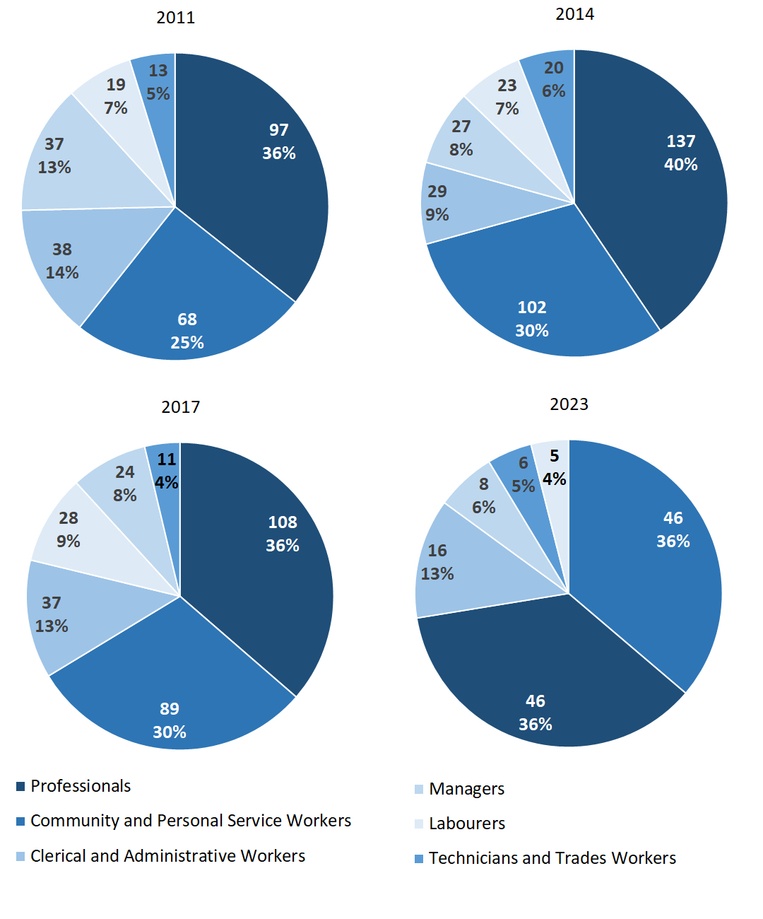

Source: Northern Territory Department of Industry, Tourism and Trade

In 2023 in Yirrkala, of 135 filled jobs:

* Community and Personal Service Workers and Professionals were the two **largest** **occupation** **classifications** in terms of filled jobs, accounting for 46 jobs each (34.1% of total filled jobs each), a decrease of 43 and 62 jobs from 2017 and a decrease of 56 and 91 jobs from 2014 respectively
* **other** **significant** occupation classifications were:
* Clerical and Administrative Workers accounting for 16 jobs or 12.6% of total jobs, a decrease of 21 jobs from 2017 and a decrease of 13 jobs from 2014
* Managers accounting for 8 jobs or 5.9% of total jobs, a decrease of 16 jobs from 2017 and a decrease of 19 jobs from 2014.

**Table 17a: Count of filled jobs by ANZSCO occupation, 2011, 2014, 2017 & 2023 (a)(c)(f)(g)**

|  |  |  |  |  |  |  |  |  |  |  |  |  |  |
| --- | --- | --- | --- | --- | --- | --- | --- | --- | --- | --- | --- | --- | --- |
| **Occupation (ANZSCO major group)** | **2011** | | | **2014** | | | **2017** | | | **2023** | | | |
| **Aboriginal** | **Non-Aboriginal** | **Total** | **Aboriginal** | **Non-Aboriginal** | **Total** | **Aboriginal** | **Non-Aboriginal** | **Total** | **Aboriginal** | **Non-Aboriginal** | **Total** |
| Clerical and Administrative Workers | 13 | 25 | **38** | 10 | 19 | **29** | 12 | 25 | **37** | 7 | 9 | **16** |
| Community and Personal Service Workers | 42 | 26 | **68** | 78 | 24 | **102** | 69 | 20 | **89** | 41 | 5 | **46** |
| Labourers | 7 | 12 | **19** | 14 | 9 | **23** | 21 | 7 | **28** | 4 | 1 | **5** |
| Machinery Operators and Drivers | 0 | 3 | **3** | 2 | 1 | **3** | 1 | 2 | **3** | 3 | 2 | **5** |
| Managers | 13 | 24 | **37** | 1 | 26 | **27** | 3 | 21 | **24** | 2 | 6 | **8** |
| Professionals | 54 | 43 | **97** | 86 | 51 | **137** | 61 | 47 | **108** | 19 | 27 | **46** |
| Sales Workers | 2 | 10 | **12** | 2 | 0 | **2** | 2 | 4 | **6** | 1 | 2 | **3** |
| Technicians and Trades Workers | 1 | 12 | **13** | 8 | 12 | **20** | 2 | 9 | **11** | 3 | 3 | **6** |
| Other Occupations | 1 | 1 | **2** | 0 | 0 | **0** | 0 | 0 | **0** | 0 | 0 | **0** |
| **Total** | **133** | **156** | **289** | **201** | **142** | **343** | **171** | **135** | **306** | **80** | **55** | **135** |

Source: Northern Territory Department of Industry, Tourism and Trade

**Table 17b: Count of filled jobs by ANZSCO occupation, 2011-2014, 2014-2017 & 2017-2023 (a)(c)(f)(g)**

|  |  |  |  |  |  |  |  |  |  |  |
| --- | --- | --- | --- | --- | --- | --- | --- | --- | --- | --- |
| **Occupation (ANZSCO major group)** | **Change 2011-2014** | | | **Change 2014-2017** | | | | **Change 2017-2023** | | |
| **Aboriginal** | **Non-Aboriginal** | **Total** | **Aboriginal** | **Non-Aboriginal** | **Total** | **Aboriginal** | | **Non-Aboriginal** | **Total** |
| Clerical and Administrative Workers | -3 | -6 | **-9** | 2 | 6 | **8** | -5 | | -16 | **-21** |
| Community and Personal Service Workers | 36 | -2 | **34** | -9 | -4 | **-13** | -28 | | -15 | **-43** |
| Labourers | 7 | -3 | **4** | 7 | -2 | **5** | -17 | | -6 | **-23** |
| Machinery Operators and Drivers | 2 | -2 | **0** | -1 | 1 | **0** | 2 | | 0 | **2** |
| Managers | -12 | 2 | **-10** | 2 | -5 | **-3** | -1 | | -15 | **-16** |
| Professionals | 32 | 8 | **40** | -25 | -4 | **-29** | -42 | | -20 | **-62** |
| Sales Workers | 0 | -10 | **-10** | 0 | 4 | **4** | -1 | | -2 | **-3** |
| Technicians and Trades Workers | 7 | 0 | **7** | -6 | -3 | **-9** | 1 | | -6 | **-5** |
| Other Occupations | -1 | -1 | **-2** | 0 | 0 | **0** | 0 | | 0 | **0** |
| **Total** | **68** | **-14** | **54** | **-30** | **-7** | **-37** | **-91** | | **-80** | **-171** |

Source: Northern Territory Department of Industry, Tourism and Trade

In 2023 in Yirrkala:

* of the 80 **jobs filled** by **Aboriginal** people, there were:
* 41 Community and Personal Service Workers, a decrease of 28 jobs from 2017 and a decrease of 37 jobs from 2014
* 19 Professionals, a decrease of 42 jobs from 2017 and a decrease of 67 jobs from 2014
* 7 Clerical and Administrative Workers, a decrease of 5 jobs from 2017 and a decrease of 3 jobs from 2014
* of the 55 **jobs filled** by **non-Aboriginal** people, there were:
* 27 Professionals, a decrease of 20 jobs from 2017 and a decrease of 24 jobs from 2014
* 9 Clerical and Administrative Workers, a decrease of 16 jobs from 2017 and a decrease of 10 jobs from 2014
* 6 Managers, a decrease of 15 jobs from 2017 and a decrease of 20 jobs from 2014.

# Jobs by Industry by Occupation

Table 18: Count of filled jobs by industry by occupation, 2011 (a)(f)(g)(h)

|  |  |  |  |  |  |  |  |  |  |  |
| --- | --- | --- | --- | --- | --- | --- | --- | --- | --- | --- |
| **2011** | | | | | | | | | | |
| **Industry (ANZSIC Division)** |  | **Occupation (ANZSCO major group)** | | | | | | | | |
| **Clerical and Administrative Workers** | **Community and Personal Service Workers** | **Labourers** | **Machinery Operators and Drivers** | **Managers** | **Professionals** | **Sales Workers** | **Technicians and Trades Workers** | **Other Occupations** | **Total** |
| Arts and Recreation Services | 9 | 4 | 0 | 0 | 4 | 7 | 0 | 1 | 0 | **25** |
| Construction | 4 | 0 | 11 | 0 | 0 | 0 | 4 | 2 | 0 | **21** |
| Education and Training | 5 | 23 | 1 | 0 | 2 | 34 | 0 | 0 | 1 | **66** |
| Health Care and Social Assistance | 1 | 6 | 2 | 0 | 0 | 2 | 0 | 2 | 1 | **14** |
| Public Administration and Safety | 18 | 35 | 3 | 2 | 28 | 54 | 1 | 8 | 0 | **149** |
| Retail Trade | 1 | 0 | 1 | 1 | 3 | 0 | 6 | 0 | 0 | **12** |
| Transport, Postal and Warehousing | 0 | 0 | 1 | 0 | 0 | 0 | 1 | 0 | 0 | **2** |
| **Total** | **38** | **68** | **19** | **3** | **37** | **97** | **12** | **13** | **2** | **289** |

Source: Northern Territory Department of Industry, Tourism and Trade

Table 19: Count of filled jobs by industry by occupation, 2014 (a)(f)(g)(h)

|  |  |  |  |  |  |  |  |  |  |  |
| --- | --- | --- | --- | --- | --- | --- | --- | --- | --- | --- |
| **2014** | | | | | | | | | | |
| **Industry (ANZSIC Division)** |  | **Occupation (ANZSCO major group)** | | | | | | | | |
| **Clerical and Administrative Workers** | **Community and Personal Service Workers** | **Labourers** | **Machinery Operators and Drivers** | **Managers** | **Professionals** | **Sales Workers** | **Technicians and Trades Workers** | **Other Occupations** | **Total** |
| Accommodation and Food Services | 1 | 0 | 0 | 0 | 2 | 0 | 0 | 0 | 0 | **3** |
| Agriculture, Forestry and Fishing | 0 | 0 | 0 | 0 | 3 | 0 | 0 | 7 | 0 | **10** |
| Arts and Recreation Services | 0 | 2 | 0 | 0 | 5 | 22 | 0 | 0 | 0 | **29** |
| Construction | 0 | 0 | 4 | 0 | 0 | 0 | 0 | 1 | 0 | **5** |
| Education and Training | 9 | 65 | 2 | 1 | 4 | 45 | 0 | 1 | 0 | **127** |
| Health Care and Social Assistance | 3 | 1 | 0 | 1 | 0 | 7 | 0 | 0 | 0 | **12** |
| Other Services | 0 | 0 | 0 | 0 | 1 | 0 | 0 | 2 | 0 | **3** |
| Public Administration and Safety | 15 | 34 | 16 | 1 | 11 | 63 | 0 | 7 | 0 | **147** |
| Retail Trade | 1 | 0 | 1 | 0 | 1 | 0 | 2 | 2 | 0 | **7** |
| **Total** | **29** | **102** | **23** | **3** | **27** | **137** | **2** | **20** | **0** | **343** |

Source: Northern Territory Department of Industry, Tourism and Trade

Table 20: Count of filled jobs by occupation and by industry, 2017 (a)(f)(g)(h)

|  |  |  |  |  |  |  |  |  |  |  |  |
| --- | --- | --- | --- | --- | --- | --- | --- | --- | --- | --- | --- |
| **2017** | | | | | | | | | | | |
| **Industry (ANZSIC Division)** |  | **Occupation (ANZSCO major group)** | | | | | | | | | |
| **Clerical and Administrative Workers** | **Community and Personal Service Workers** | **Labourers** | **Machinery Operators and Drivers** | **Managers** | **Professionals** | **Sales Workers** | **Technicians and Trades Workers** | **Other Occupations** | **Total** |
| Administrative and Support Services | 0 | 1 | 4 | 0 | 3 | 5 | 0 | 1 | 0 | **14** |
| Construction | 16 | 32 | 17 | 1 | 9 | 63 | 1 | 8 | 0 | **147** |
| Education and Training | 16 | 21 | 2 | 0 | 3 | 26 | 0 | 0 | 0 | **68** |
| Health Care and Social Assistance | 2 | 3 | 0 | 2 | 2 | 9 | 0 | 0 | 0 | **18** |
| Other Services | 0 | 0 | 0 | 0 | 0 | 0 | 0 | 1 | 0 | **1** |
| Public Administration and Safety | 3 | 16 | 5 | 0 | 3 | 5 | 0 | 1 | 0 | **33** |
| Rental, Hiring and Real Estate Services | 0 | 2 | 0 | 0 | 0 | 0 | 0 | 0 | 0 | **2** |
| Retail Trade | 0 | 14 | 0 | 0 | 4 | 0 | 5 | 0 | 0 | **23** |
| **Total** | **37** | **89** | **28** | **3** | **24** | **108** | **6** | **11** | **0** | **306** |

Source: Northern Territory Department of Industry, Tourism and Trade

Table 21: Count of filled jobs by occupation and by industry, 2023 (a)(f)(g)(h)

|  |  |  |  |  |  |  |  |  |  |  |  |
| --- | --- | --- | --- | --- | --- | --- | --- | --- | --- | --- | --- |
| **2023** | | | | | | | | | | | |
| **Industry (ANZSIC Division)** |  | **Occupation (ANZSCO major group)** | | | | | | | | | |
| **Clerical and Administrative Workers** | **Community and Personal Service Workers** | **Labourers** | **Machinery Operators and Drivers** | **Managers** | **Professionals** | **Sales Workers** | **Technicians and Trades Workers** | **Other Occupations** | **Total** |
| Accommodation and Food Services | 0 | 2 | 0 | 0 | 0 | 0 | 0 | 0 | 0 | **2** |
| Education and Training | 7 | 18 | 5 | 0 | 1 | 17 | 0 | 1 | 0 | **49** |
| Health Care and Social Assistance | 1 | 0 | 0 | 5 | 3 | 11 | 0 | 0 | 0 | **20** |
| Public Administration and Safety | 7 | 26 | 0 | 0 | 3 | 18 | 0 | 4 | 0 | **58** |
| Retail Trade | 1 | 0 | 0 | 0 | 1 | 0 | 3 | 1 | 0 | **6** |
| **Total** | **16** | **46** | **5** | **5** | **8** | **46** | **3** | **6** | **0** | **135** |

Source: Northern Territory Department of Industry, Tourism and Trade

In 2023 in Yirrkala:

* Professionals filled 46 jobs (one of the two largest occupation groups) were shared across the Public Administration and Safety with 18 jobs, Education and Training with 17 jobs and Health Care and Social Assistance industries with 11 jobs,
* Community and Personal Service Workers had the majority of 46 jobs (one of the two largest occupation groups) which were shared across the Public Administration and Safety with 26 jobs and Education and Training industries with 18 jobs,
* Community and Personal Service Workers and Professionals showed a decrease of 43 and 62 filled jobs between 2023 and 2017 respectively,
* in Public Administration and Safety (the largest industry), there was an increase of 25 filled jobs between 2023 and 2017,
* Construction industry had nil filled jobs in 2023 compared to a total of 147 filled jobs in 2017
* Accommodation and Food Services filled 2 jobs in 2023, and nil jobs filled in 2017.

# Jobs by Gender

Table 22a: Count of filled jobs by gender[2], 2011, 2014, 2017 & 2023 (a)(c)(i)

|  |  |  |  |  |  |  |  |  |  |  |  |  |  |  |  |  |
| --- | --- | --- | --- | --- | --- | --- | --- | --- | --- | --- | --- | --- | --- | --- | --- | --- |
| **Indicator** | **2011** | | | | **2014** | | | | **2017** | | | | **2023** | | | |
| **Aboriginal** | **Non-Aboriginal** | **Total** | **Aboriginal** | | **Non-Aboriginal** | **Total** | **Aboriginal** | | **Non-Aboriginal** | **Total** | **Aboriginal** | | **Non-Aboriginal** | **Total** |
| Male | 67 | 69 | **136** | 89 | | 69 | **158** | 91 | | 58 | **149** | 32 | | 19 | **51** |
| Female | 66 | 87 | **153** | 112 | | 73 | **185** | 74 | | 77 | **151** | 48 | | 36 | **84** |
| **Total** | **133** | **156** | **289** | **201** | | **142** | **343** | **165** | | **135** | **300** | **80** | | **55** | **135** |

Source: Northern Territory Department of Industry, Tourism and Trade

Table 22b: Count of filled jobs by gender, 2011-2014, 2014-2017 & 2017-2023 (a)(c)(i)

|  |  |  |  |  |  |  |  |  |  |
| --- | --- | --- | --- | --- | --- | --- | --- | --- | --- |
| **Indicator** | **2011-2014 Change** | | **2014-2017 Change** | | | **2017-2023 Change** | | | |
| **Aboriginal** | **Non-Aboriginal** | **Total** | **Aboriginal** | **Non-Aboriginal** | **Total** | **Aboriginal** | **Non-Aboriginal** | **Total** |
| Male | 22 | 0 | **22** | 2 | -11 | **-9** | -59 | -39 | **-98** |
| Female | 46 | -14 | **32** | -38 | 4 | **-34** | -26 | -41 | **-67** |
| **Total** | **68** | **-14** | **54** | **-36** | **-7** | **-43** | **-85** | **-80** | **-165** |

Source: Northern Territory Department of Industry, Tourism and Trade

Chart 11: Count of filled jobs by gender, 2011, 2014, 2017 & 2023 (a)(c)(i)

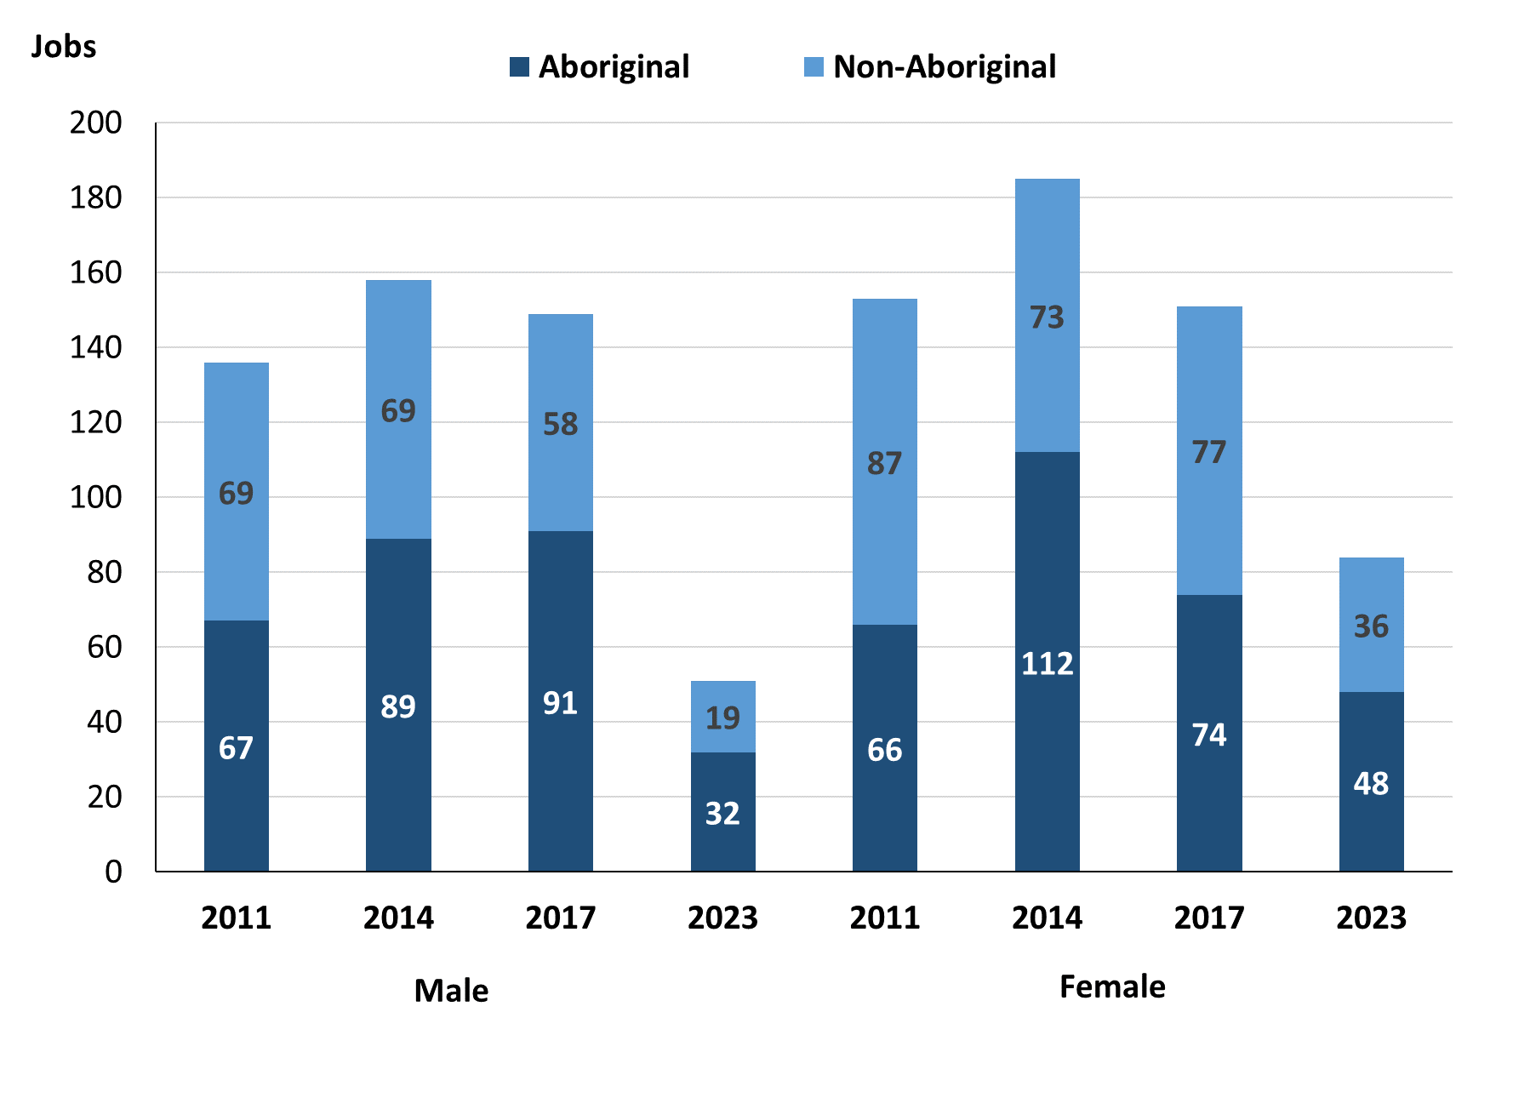

Source: Northern Territory Department of Industry, Tourism and Trade

In 2023 in Yirrkala:

* there were 51 **jobs** **filled** **by** **males**, a decrease of 98 jobs from 2017 and a decrease of 107 jobs from 2014
* of the 51 jobs filled by males:
* 32 were **Aboriginal**, a decrease of 59 jobs from 2017 and a decrease of 57 jobs from 2014
* 19 were **non-Aboriginal**, a decrease of 39 jobs from 2017 and a decrease of 50 jobs from 2014
* there were 84 **jobs** **filled** **by** **females**, a decrease of 67 jobs from 2017 and a decrease of 101 jobs from 2014
* of the 84 jobs filled by females:
* 48 were **Aboriginal**, a decrease of 26 jobs from 2017 and a decrease of 64 jobs from 2014
* 36 were **non-Aboriginal**, a decrease of 41 jobs from 2017 and a decrease of 37 jobs from 2014.

Table 23: Count of filled jobs by gender, by full-time/part-time status, by job permanency and by sector 2011 (a)(b)(c)(d)(e)(i)

|  |  |  |  |  |  |  |  |  |  |
| --- | --- | --- | --- | --- | --- | --- | --- | --- | --- |
| **2011** | | | | | | | | | |
| **Indicator** | **Male** | | | **Female** | | | **Total** | | |
| **Aboriginal** | **Non-Aboriginal** | **Total** | **Aboriginal** | **Non-Aboriginal** | **Total** | **Aboriginal** | **Non-Aboriginal** | **Total** |
| Full-time | 61 | 63 | **124** | 56 | 75 | **131** | 117 | 138 | **255** |
| Part-time | 6 | 6 | **12** | 10 | 12 | **22** | 16 | 18 | **34** |
| **Total** | **67** | **69** | **136** | **66** | **87** | **153** | **133** | **156** | **289** |
| Permanent | 62 | 57 | **119** | 46 | 57 | **103** | 108 | 114 | **222** |
| Temporary | 5 | 12 | **17** | 20 | 30 | **50** | 25 | 42 | **67** |
| **Total** | **67** | **69** | **136** | **66** | **87** | **153** | **133** | **156** | **289** |
| Public Sector | 9 | 20 | **29** | 32 | 48 | **80** | 41 | 68 | **109** |
| Private Sector | 58 | 49 | **107** | 34 | 39 | **73** | 92 | 88 | **180** |
| **Total** | **67** | **69** | **136** | **66** | **87** | **153** | **133** | **156** | **289** |

Source: Northern Territory Department of Industry, Tourism and Trade

Table 24: Count of filled jobs by gender, by full-time/part-time status, by job permanency and by sector 2014 (a)(b)(c)(d)(e)(i)

|  |  |  |  |  |  |  |  |  |  |
| --- | --- | --- | --- | --- | --- | --- | --- | --- | --- |
| **2014** | | | | | | | | | |
| **Indicator** | **Male** | | | **Female** | | | **Total** | | |
| **Aboriginal** | **Non-Aboriginal** | **Total** | **Aboriginal** | **Non-Aboriginal** | **Total** | **Aboriginal** | **Non-Aboriginal** | **Total** |
| Full-time | 29 | 62 | **91** | 40 | 59 | **99** | 69 | 121 | **190** |
| Part-time | 60 | 7 | **67** | 72 | 14 | **86** | 132 | 21 | **153** |
| **Total** | **89** | **69** | **158** | **112** | **73** | **185** | **201** | **142** | **343** |
| Permanent | 64 | 51 | **115** | 70 | 52 | **122** | 134 | 103 | **237** |
| Temporary | 25 | 18 | **43** | 42 | 21 | **63** | 67 | 39 | **106** |
| **Total** | **89** | **69** | **158** | **112** | **73** | **185** | **201** | **142** | **343** |
| Public Sector | 9 | 20 | **29** | 35 | 37 | **72** | 44 | 57 | **101** |
| Private Sector | 80 | 49 | **129** | 77 | 36 | **113** | 157 | 85 | **242** |
| **Total** | **89** | **69** | **158** | **112** | **73** | **185** | **201** | **142** | **343** |

Source: Northern Territory Department of Industry, Tourism and Trade

Table 25: Count of filled jobs by gender[3], by full-time/part-time status, by job permanency and by sector 2017 (a)(b)(c)(d)(e)(i)

|  |  |  |  |  |  |  |  |  |  |
| --- | --- | --- | --- | --- | --- | --- | --- | --- | --- |
| **2017** | | | | | | | | | |
| **Indicator** | **Male** | | | **Female** | | | **Total** | | |
| **Aboriginal** | **Non-Aboriginal** | **Total** | **Aboriginal** | **Non-Aboriginal** | **Total** | **Aboriginal** | **Non-Aboriginal** | **Total** |
| Full-time | 15 | 52 | **67** | 32 | 60 | **92** | 52 | 112 | **164** |
| Part-time | 76 | 6 | **82** | 42 | 17 | **59** | 119 | 23 | **142** |
| **Total** | **91** | **58** | **149** | **74** | **77** | **151** | **171** | **135** | **306** |
| Permanent | 18 | 27 | **45** | 34 | 40 | **74** | 58 | 67 | **125** |
| Temporary | 73 | 31 | **104** | 40 | 37 | **77** | 113 | 68 | **181** |
| **Total** | **91** | **58** | **149** | **74** | **77** | **151** | **171** | **135** | **306** |
| Public Sector | 9 | 20 | **29** | 31 | 35 | **66** | 46 | 55 | **101** |
| Private Sector | 82 | 38 | **120** | 43 | 42 | **85** | 125 | 80 | **205** |
| **Total** | **91** | **58** | **149** | **74** | **77** | **151** | **171** | **135** | **306** |

Source: Northern Territory Department of Industry, Tourism and Trade

Table 26: Count of filled jobs by gender, by full-time/part-time status, by job permanency and by sector 2023 (a)(b)(c)(d)(e)(i)

|  |  |  |  |  |  |  |  |  |  |
| --- | --- | --- | --- | --- | --- | --- | --- | --- | --- |
| **2023** | | | | | | | | | |
| **Indicator** | **Male** | | | **Female** | | | **Total** | | |
| **Aboriginal** | **Non-Aboriginal** | **Total** | **Aboriginal** | **Non-Aboriginal** | **Total** | **Aboriginal** | **Non-Aboriginal** | **Total** |
| Full-time | 20 | 18 | **38** | 31 | 29 | **60** | 51 | 47 | **98** |
| Part-time | 12 | 1 | **13** | 17 | 7 | **24** | 29 | 8 | **37** |
| **Total** | **32** | **19** | **51** | **48** | **36** | **84** | **80** | **55** | **135** |
| Permanent | 24 | 13 | **37** | 26 | 23 | **49** | 50 | 36 | **86** |
| Temporary | 8 | 6 | **14** | 22 | 13 | **35** | 30 | 19 | **49** |
| **Total** | **32** | **19** | **51** | **48** | **36** | **84** | **80** | **55** | **135** |
| Public Sector | 13 | 11 | **24** | 32 | 25 | **57** | 45 | 36 | **81** |
| Private Sector | 19 | 8 | **27** | 16 | 11 | **27** | 35 | 19 | **54** |
| **Total** | **32** | **19** | **51** | **48** | **36** | **84** | **80** | **55** | **135** |

Source: Northern Territory Department of Industry, Tourism and Trade

In 2023 in Yirrkala:

* of the 51 **jobs** **filled** **by** **males**, there were:
* 32 jobs filled by **Aboriginal males**, a decrease of 59 jobs from 2017 and a decrease of 57 jobs from 2014, including:
* 20 full-time jobs, an increase of 5 jobs from 2017 and a decrease of 9 jobs from 2014
* 12 part-time jobs, a decrease of 64 jobs from 2017 and a decrease of 48 jobs from 2014
* 24 permanent jobs, an increase of 6 jobs from 2017 and a decrease of 40 jobs from 2014
* 8 temporary jobs, a decrease of 65 jobs from 2017 and a decrease of 17 jobs from 2014
* 13 Public Sector jobs, an increase of 4 jobs from 2017 and an increase of 4 jobs from 2014
* 19 Private Sector jobs, a decrease of 63 jobs from 2017 and a decrease of 61 jobs from 2014
* 19 jobs filled by **non-Aboriginal** **males**, a decrease of 39 jobs from 2017 and a decrease of 50 jobs from 2014, including:
* 18 full-time jobs, a decrease of 34 jobs from 2017 and a decrease of 44 jobs from 2014
* 1 part-time job, a decrease of 5 jobs from 2017 and a decrease of 6 jobs from 2014
* 13 permanent jobs, a decrease of 14 jobs from 2017 and a decrease of 38 jobs from 2014
* 6 temporary jobs, a decrease of 25 jobs from 2017 and a decrease of 12 jobs from 2014
* 11 Public Sector jobs, a decrease of 9 jobs from 2017 and a decrease of 9 jobs from 2014
* 8 Private Sector jobs, a decrease of 30 jobs from 2017 and a decrease of 41 jobs from 2014
* of the 84 **jobs** **filled** **by** **females**, there were:
* 48 jobs filled by **Aboriginal** **females**, a decrease of 26 jobs from 2017 and a decrease of 64 jobs from 2014, including:
* 31 full-time jobs, a decrease of 1 job from 2017 and a decrease of 9 jobs from 2014
* 17 part-time jobs, a decrease of 25 jobs from 2017 and a decrease of 55 jobs from 2014
* 26 permanent jobs, a decrease of 8 jobs from 2017 and 44 jobs from 2014
* 22 temporary jobs, a decrease of 18 jobs from 2017 and a decrease of 20 jobs from 2014
* 32 Public Sector jobs, an increase of 1 job from 2017 and a decrease of 3 jobs from 2014
* 16 Private Sector jobs, a decrease of 27 jobs from 2017 and a decrease of 61 jobs from 2014
* 36 jobs filled by **non-Aboriginal** **females**, a decrease of 41 jobs from 2017 and a decrease of 37 jobs from 2014, including:
* 29 full-time jobs, a decrease of 31 jobs from 2017 and a decrease of 30 jobs from 2014
* 7 part-time jobs, a decrease of 10 jobs from 2017 and a decrease of 7 jobs from 2014
* 23 permanent jobs, a decrease of 17 jobs from 2017 and a decrease of 29 jobs from 2014
* 13 temporary jobs, a decrease of 24 jobs from 2017 and a decrease of 8 jobs from 2014
* 25 Public Sector jobs, a decrease of 10 jobs from 2017 and a decrease of 12 jobs from 2014
* 11 Private Sector jobs, a decrease of 31 jobs from 2017 and a decrease of 25 jobs from 2014.

# Jobs by Age

Table 27a: Count of filled jobs by age, 2011, 2014, 2017 & 2023 (a)(c)(j)

|  |  |  |  |  |  |  |  |  |  |  |  |  |
| --- | --- | --- | --- | --- | --- | --- | --- | --- | --- | --- | --- | --- |
| **Indicator** | **2011** | | | **2014** | | | **2017** | | | **2023** | | |
| **Aboriginal** | **Non-Aboriginal** | **Total** | **Aboriginal** | **Non-Aboriginal** | **Total** | **Aboriginal** | **Non-Aboriginal** | **Total** | **Aboriginal** | **Non-Aboriginal** | **Total** |
| 15-24 years | 12 | 12 | **24** | 17 | 9 | **26** | 10 | 8 | **18** | 8 | 4 | **12** |
| 25-44 years | 76 | 62 | **138** | 111 | 69 | **180** | 92 | 67 | **159** | 49 | 23 | **72** |
| 45+ years | 45 | 82 | **127** | 73 | 64 | **137** | 63 | 60 | **123** | 23 | 28 | **51** |
| **Total** | **133** | **156** | **289** | **201** | **142** | **343** | **171** | **135** | **306** | **80** | **55** | **135** |

Source: Northern Territory Department of Industry, Tourism and Trade

Table 27b: Count of filled jobs by age, 2011-2014, 2014-2017 & 2017-2023 (a)(c)(j)

|  |  |  |  |  |  |  |  |  |  |
| --- | --- | --- | --- | --- | --- | --- | --- | --- | --- |
| **Indicator** | **Change 2011-2014** | | | **Change 2014-2017** | | | **Change 2017-2023** | | |
| **Aboriginal** | **Non-Aboriginal** | **Total** | **Aboriginal** | **Non-Aboriginal** | **Total** | **Aboriginal** | **Non-Aboriginal** | **Total** |
| 15-24 years | 5 | -3 | **2** | -7 | -1 | **-8** | -2 | -4 | **-6** |
| 25-44 years | 35 | 7 | **42** | -19 | -2 | **-21** | -43 | -44 | **-87** |
| 45+ years | 28 | -18 | **10** | -10 | -4 | **-14** | -40 | -32 | **-72** |
| **Total** | **68** | **-14** | **54** | **-30** | **-7** | **-37** | **-85** | **-80** | **-165** |

Source: Northern Territory Department of Industry, Tourism and Trade

Chart 12: Count of filled jobs by age, 2011, 2014, 2017 & 2023 (a)(c)(j)

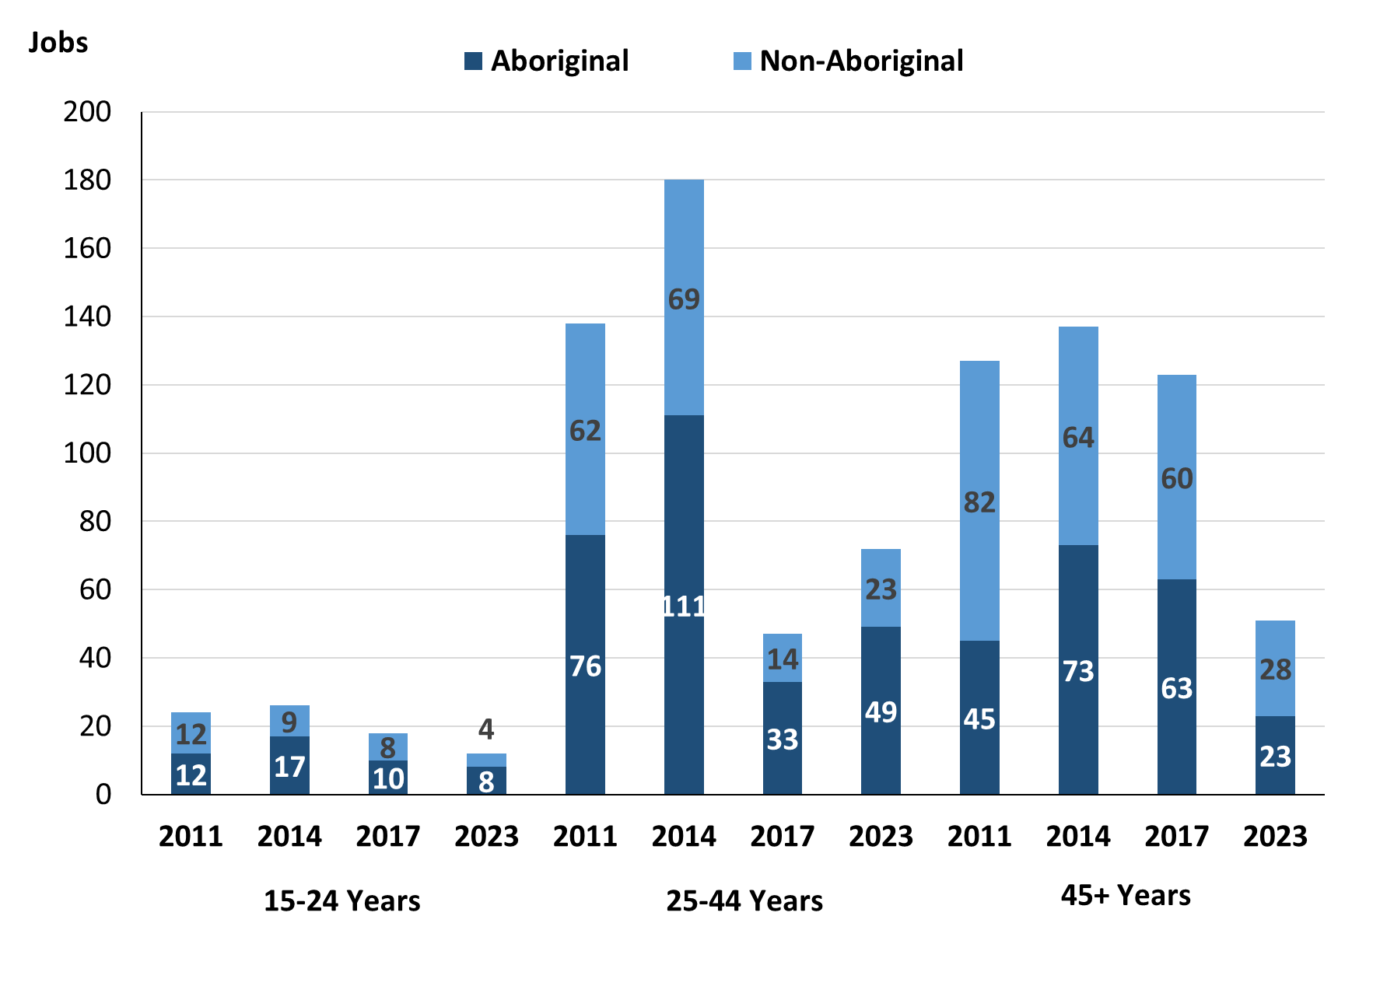

Source: Northern Territory Department of Industry, Tourism and Trade

In 2023 in Yirrkala:

* there were 12 **jobs** **filled** by people aged **15-24 years**, a decrease of 6 jobs from 2017 and a decrease of 14 jobs from 2014. Of these:
* **Aboriginal** people filled 8 jobs, a decrease of 2 jobs from 2017 and a decrease of 9 jobs from 2014
* **non-Aboriginal** people filled 4 jobs, a decrease of 4 jobs from 2017 and a decrease of 5 jobs from 2014
* there were 72 **jobs** **filled** by people aged **25-44 years**, a decrease of 87 jobs from 2017 and a decrease of 108 jobs from 2014. Of these:
* **Aboriginal** people filled 49 jobs, a decrease of 43 jobs from 2017 and a decrease of 62 jobs from 2014
* **non-Aboriginal** people filled 23 jobs, a decrease of 44 jobs from 2017 and a decrease of 46 jobs from 2014
* there were 51 **jobs** **filled** by people aged **45+ years**, a decrease of 72 jobs from 2017 and a decrease of 86 jobs from 2014. Of these:
* **Aboriginal** people filled 23 jobs, a decrease of 40 jobs from 2017 and a decrease of 50 jobs from 2014
* **non-Aboriginal** people filled 28 jobs, a decrease of 32 jobs from 2017 and a decrease of 36 jobs from 2014.

Table 28: Count of filled jobs by age, by full-time/part-time status, by job permanency and by sector June-July 2011 (a)(b)(c)(d)(e)(i)

|  |  |  |  |  |  |  |  |  |  |  |  |  |  |
| --- | --- | --- | --- | --- | --- | --- | --- | --- | --- | --- | --- | --- | --- |
| **2011** | | | | | | | | | | | | | |
| **Indicator** | **15-24 years** | | | **25-44 years** | | | **45+ years** | | | **Total** | | | |
| **Aboriginal** | **Non-Aboriginal** | **Total** | **Aboriginal** | **Non-Aboriginal** | **Total** | **Aboriginal** | **Non-Aboriginal** | **Total** | **Aboriginal** | **Non-Aboriginal** | **Total** |
| Full-time | 12 | 8 | **20** | 67 | 54 | **121** | 38 | 76 | **114** | 117 | 138 | **255** |
| Part-time | 0 | 4 | **4** | 9 | 8 | **17** | 7 | 6 | **13** | 16 | 18 | **34** |
| **Total** | **12** | **12** | **24** | **76** | **62** | **138** | **45** | **82** | **127** | **133** | **156** | **289** |
| Permanent | 11 | 5 | **16** | 62 | 44 | **106** | 35 | 65 | **100** | 108 | 114 | **222** |
| Temporary | 1 | 7 | **8** | 14 | 18 | **32** | 10 | 17 | **27** | 25 | 42 | **67** |
| **Total** | **12** | **12** | **24** | **76** | **62** | **138** | **45** | **82** | **127** | **133** | **156** | **289** |
| Public Sector | 2 | 6 | **8** | 19 | 25 | **44** | 20 | 37 | **57** | 41 | 68 | **109** |
| Private Sector | 10 | 6 | **16** | 57 | 37 | **94** | 25 | 45 | **70** | 92 | 88 | **180** |
| **Total** | **12** | **12** | **24** | **76** | **62** | **138** | **45** | **82** | **127** | **133** | **156** | **289** |

Source: Northern Territory Department of Industry, Tourism and Trade

Table 29: Count of filled jobs by age, by full-time/part-time status, by job permanency and by sector June-July 2014 (a)(b)(c)(d)(e)(i)

|  |  |  |  |  |  |  |  |  |  |  |  |  |  |
| --- | --- | --- | --- | --- | --- | --- | --- | --- | --- | --- | --- | --- | --- |
| **2014** | | | | | | | | | | | | | |
| **Indicator** | **15-24 years** | | | **25-44 years** | | | **45+ years** | | | **Total** | | | |
| **Aboriginal** | **Non-Aboriginal** | **Total** | **Aboriginal** | **Non-Aboriginal** | **Total** | **Aboriginal** | **Non-Aboriginal** | **Total** | **Aboriginal** | **Non-Aboriginal** | **Total** |
| Full-time | 0 | 7 | **7** | 40 | 58 | **98** | 29 | 56 | **85** | 69 | 121 | **190** |
| Part-time | 17 | 2 | **19** | 71 | 11 | **82** | 44 | 8 | **52** | 132 | 21 | **153** |
| **Total** | **17** | **9** | **26** | **111** | **69** | **180** | **73** | **64** | **137** | **201** | **142** | **343** |
| Permanent | 5 | 5 | **10** | 73 | 54 | **127** | 56 | 44 | **100** | 134 | 103 | **237** |
| Temporary | 12 | 4 | **16** | 38 | 15 | **53** | 17 | 20 | **37** | 67 | 39 | **106** |
| **Total** | **17** | **9** | **26** | **111** | **69** | **180** | **73** | **64** | **137** | **201** | **142** | **343** |
| Public Sector | 2 | 0 | **2** | 24 | 29 | **53** | 18 | 28 | **46** | 44 | 57 | **101** |
| Private Sector | 15 | 9 | **24** | 87 | 40 | **127** | 55 | 36 | **91** | 157 | 85 | **242** |
| **Total** | **17** | **9** | **26** | **111** | **69** | **180** | **73** | **64** | **137** | **201** | **142** | **343** |

Source: Northern Territory Department of Industry, Tourism and Trade

Table 30: Count of filled jobs by age, by full-time/part-time status, by job permanency and by sector June-July 2017 (a)(b)(c)(d)(e)(i)

|  |  |  |  |  |  |  |  |  |  |  |  |  |  |
| --- | --- | --- | --- | --- | --- | --- | --- | --- | --- | --- | --- | --- | --- |
| **2017** | | | | | | | | | | | | | |
| **Indicator** | **15-24 years** | | | **25-44 years** | | | **45+ years** | | | **Total** | | | |
| **Aboriginal** | **Non-Aboriginal** | **Total** | **Aboriginal** | **Non-Aboriginal** | **Total** | **Aboriginal** | **Non-Aboriginal** | **Total** | **Aboriginal** | **Non-Aboriginal** | **Total** |
| Full-time | 0 | 4 | **4** | 24 | 54 | **78** | 23 | 54 | **77** | 52 | 112 | **164** |
| Part-time | 10 | 4 | **14** | 68 | 13 | **81** | 40 | 6 | **46** | 119 | 23 | **142** |
| **Total** | **10** | **8** | **18** | **92** | **67** | **159** | **63** | **60** | **123** | **171** | **135** | **306** |
| Permanent | 2 | 3 | **5** | 29 | 33 | **62** | 21 | 31 | **52** | 58 | 67 | **125** |
| Temporary | 8 | 5 | **13** | 63 | 34 | **97** | 42 | 29 | **71** | 113 | 68 | **181** |
| **Total** | **10** | **8** | **18** | **92** | **67** | **159** | **63** | **60** | **123** | **171** | **135** | **306** |
| Public Sector | 2 | 2 | **4** | 20 | 33 | **53** | 18 | 20 | **38** | 46 | 55 | **101** |
| Private Sector | 8 | 6 | **14** | 72 | 34 | **106** | 45 | 40 | **85** | 125 | 80 | **205** |
| **Total** | **10** | **8** | **18** | **92** | **67** | **159** | **63** | **60** | **123** | **171** | **135** | **306** |

Source: Northern Territory Department of Industry, Tourism and Trade

Table 31: Count of filled jobs by age, by full-time/part-time status, by job permanency and by sector September 2023 (a)(b)(c)(d)(e)(i)

|  |  |  |  |  |  |  |  |  |  |  |  |  |  |
| --- | --- | --- | --- | --- | --- | --- | --- | --- | --- | --- | --- | --- | --- |
| **2023** | | | | | | | | | | | | | |
| **Indicator** | **15-24 years** | | | **25-44 years** | | | **45+ years** | | | **Total** | | | |
| **Aboriginal** | **Non-Aboriginal** | **Total** | **Aboriginal** | **Non-Aboriginal** | **Total** | **Aboriginal** | **Non-Aboriginal** | **Total** | **Aboriginal** | **Non-Aboriginal** | **Total** |
| Full-time | 6 | 2 | **8** | 32 | 17 | **49** | 13 | 28 | **41** | 51 | 47 | **98** |
| Part-time | 2 | 2 | **4** | 17 | 6 | **23** | 10 | 0 | **10** | 29 | 8 | **37** |
| **Total** | **8** | **4** | **12** | **49** | **23** | **72** | **23** | **28** | **51** | **80** | **55** | **135** |
| Permanent | 3 | 3 | **6** | 30 | 15 | **45** | 17 | 18 | **35** | 50 | 36 | **86** |
| Temporary | 5 | 1 | **6** | 19 | 8 | **27** | 6 | 10 | **16** | 30 | 19 | **49** |
| **Total** | **8** | **4** | **12** | **49** | **23** | **72** | **23** | **28** | **51** | **80** | **55** | **135** |
| Public Sector | 7 | 2 | **9** | 32 | 14 | **46** | 6 | 20 | **26** | 45 | 36 | **81** |
| Private Sector | 1 | 2 | **3** | 17 | 9 | **26** | 17 | 8 | **25** | 35 | 19 | **54** |
| **Total** | **8** | **4** | **12** | **49** | **23** | **72** | **23** | **28** | **51** | **80** | **55** | **135** |

Source: Northern Territory Department of Industry, Tourism and Trade

In 2023 in Yirrkala:

* of the 12 **jobs** **filled** by people aged **15-24 years**, there were:
* 8 jobs filled by **Aboriginal** people, of which
* 6 were full-time jobs, an increase of 6 jobs from 2017 and an increase of 6 jobs from 2014
* 2 were part-time jobs, a decrease of 8 jobs from 2017 and a decrease of 15 jobs from 2014
* 3 were permanent jobs, an increase of 1 job from 2017 and a decrease of 2 jobs from 2014
* 5 were temporary jobs, a decrease of 3 jobs from 2017 and a decrease of 7 jobs from 2014
* 7 were Public Sector jobs, an increase of 5 jobs from 2017 and an increase of 5 jobs from 2014
* 1 was a Private Sector job, a decrease of 7 jobs from 2017 and a decrease of 14 jobs from 2014
* 4 jobs filled by **non-Aboriginal** people, of which:
* 2 were full-time jobs, a decrease of 2 jobs from 2017 and a decrease of 5 jobs from 2014
* 2 were part-time jobs, a decrease of 2 jobs from 2017 and unchanged from 2014
* 3 were permanent jobs, unchanged from 2017 and a decrease of 2 jobs from 2014
* 1 was a temporary job, a decrease of 4 jobs from 2017 and a decrease of 3 jobs from 2014
* 2 were Public Sector jobs, unchanged from 2017 and an increase of 2 jobs from 2014
* 2 were Private Sector jobs, a decrease of 4 jobs from 2017 and a decrease of 7 jobs from 2014
* of the 72 **jobs** **filled** by people aged **25-44 years**, there were:
* 49 jobs filled by **Aboriginal** people, of which:
* 32 were full-time jobs, an increase of 8 jobs from 2017 and a decrease of 8 jobs from 2014
* 17 were part-time jobs, a decrease of 51 jobs from 2017 and a decrease of 54 jobs from 2014
* 30 were permanent jobs, an increase of 1 job from 2017 and a decrease of 43 jobs from 2014
* 19 were temporary jobs, a decrease of 44 jobs from 2017 and a decrease of 19 jobs from 2014
* 32 were Public Sector jobs, an increase of 12 jobs from 2017 and an increase of 8 jobs from 2014
* 17 were Private Sector jobs, a decrease of 55 jobs from 2017 and a decrease of 70 jobs from 2014
* 23 jobs filled by **non-Aboriginal** people, of which:
* 17 were full-time jobs, a decrease of 37 jobs from 2017 and a decrease of 41 jobs from 2014
* 6 were part-time jobs, a decrease of 7 jobs from 2017 and a decrease of 5 jobs from 2014
* 15 were permanent jobs, a decrease of 18 jobs from 2017 and a decrease of 39 jobs from 2014
* 8 were temporary jobs, a decrease of 26 jobs from 2017 and a decrease of 7 jobs from 2014
* 14 were Public Sector jobs, a decrease of 19 jobs from 2017 and a decrease of 15 jobs from 2014
* 9 were Private Sector jobs, a decrease of 25 jobs from 2017 and a decrease of 31 jobs from 2014
* of the 51 **jobs** **filled** by people aged **45+ years**, there were:
* 23 jobs filled by **Aboriginal** people, of which:
* 13 were full-time jobs, a decrease of 10 jobs from 2017 and a decrease of 16 jobs from 2014
* 10 were part-time jobs, a decrease of 30 jobs from 2017 and a decrease of 34 jobs from 2014
* 17 were permanent jobs, a decrease of 4 jobs from 2017 and a decrease of 39 jobs from 2014
* 6 were temporary jobs, a decrease of 36 jobs from 2017 and a decrease of 11 jobs from 2014
* 6 were Public Sector jobs, a decrease of 12 jobs from 2017 and a decrease of 12 jobs from 2014
* 17 were Private Sector jobs, a decrease of 28 jobs from 2017 and a decrease of 38 jobs from 2014
* 28 jobs filled by **non-Aboriginal** people, of which:
* 28 were full-time jobs, a decrease of 26 jobs from 2017 and a decrease of 28 jobs from 2014
* none were part-time jobs, a decrease of 6 jobs from 2017 and a decrease of 8 jobs from 2014
* 18 were permanent jobs, a decrease of 13 jobs from 2017 and a decrease of 26 jobs from 2014
* 10 were temporary jobs, a decrease of 19 jobs from 2017 and a decrease of 10 jobs from 2014
* 20 were Public Sector jobs, unchanged from 2017 and a decrease of 8 jobs from 2014
* 8 were Private Sector jobs, a decrease of 32 jobs from 2017 and a decrease of 28 jobs from 2014.

# Vocational Education and Training

Note: *The 2010 data is in accordance with the new, standardised reporting procedures that focus on all training activities conducted in the remote town, irrespective of funding source, as compared to earlier publications. As a result, the 2010 VET data values in this publication might not match those in earlier publications.*

*The impact of the Remote Jobs and Communities Program (RJCP), established in 2013, has played a significant role in the reduction of accredited training in many remote towns across the Territory.*

Table 32a: Northern Territory Vocational Education and Training (VET) students, 2010, 2013, 2016 and 2023 (k)

|  |  |  |  |  |  |  |  |  |
| --- | --- | --- | --- | --- | --- | --- | --- | --- |
| **VET Funding Group** | **2010** | | **2013** | | **2016** | | **2023** | |
| **No.** | **% of Total** | **No.** | **% of Total** | **No.** | **% of Total** | **No.** | **% of Total** |
| Arts, Entertainment, Sports and Recreation | 0 | 0% | 36 | 23% | 7 | 4% | 0 | 0% |
| Building and Construction | 97 | 28% | 4 | 3% | 4 | 2% | 7 | 8% |
| Business and Clerical | 24 | 7% | 0 | 0% | 1 | 1% | 9 | 10% |
| Community Services, Health and Education | 121 | 35% | 81 | 52% | 48 | 26% | 16 | 17% |
| Engineering and Mining | 6 | 2% | 0 | 0% | 17 | 9% | 0 | 0% |
| General Education and Training | 40 | 12% | 0 | 0% | 10 | 5% | 8 | 9% |
| Primary Industry | 29 | 8% | 26 | 17% | 96 | 52% | 34 | 37% |
| Sales and Personal Service | 0 | 0% | 0 | 0% | 0 | 0% | 5 | 5% |
| Tourism and Hospitality | 19 | 6% | 10 | 6% | 0 | 0% | 0 | 0% |
| Transport and Storage | 6 | 2% | 0 | 0% | 0 | 0% | 13 | 14% |
| **Total** | **342** | **100%** | **157** | **100%** | **183** | **100%** | **83** | **100%** |

Source: Northern Territory Department of Industry, Tourism and Trade

Table 32b: Northern Territory Vocational Education and Training (VET) students, 2010-2013, 2013-2016 and 2016-2023 (k)

|  |  |  |  |
| --- | --- | --- | --- |
| **VET Funding Group** | **Change** | | |
| **2010-2013** | **2013-2016** | **2016-2023** |
| Arts, Entertainment, Sports and Recreation | 36 | - 29 | -7 |
| Building and Construction | - 93 | 0 | 3 |
| Business and Clerical | - 24 | 1 | 8 |
| Community Services, Health and Education | - 40 | - 33 | -32 |
| Engineering and Mining | - 6 | 17 | -17 |
| General Education and Training | - 40 | 10 | -2 |
| Primary Industry | - 3 | 70 | -62 |
| Sales and Personal Service | 0 | 0 | 5 |
| Tourism and Hospitality | - 9 | - 10 | 0 |
| Transport and Storage | - 6 | 0 | 13 |
| **Total** | **- 185** | **26** | **-100** |

Source: Northern Territory Department of Industry, Tourism and Trade

In 2023 in Yirrkala:

* there were 83 **VET students**, a decrease of 100 students from 2016 and a decrease of 74 students from 2013,
* VET activity with the most students were Primary Industry with 34 students,
* Community Services, Health and Education had 16 students,
* Transport and Storage had 13 students,
* Transport and Storage reported the largest increase in students with 13 more students compared to 2016,
* Primary Industry reported the largest decrease in students with 62 less students over the same period.

Table 33a: Northern Territory Vocational Education and Training (VET) unit enrolments, 2010, 2013, 2016 and 2023 (l)

|  |  |  |  |  |  |  |  |  |
| --- | --- | --- | --- | --- | --- | --- | --- | --- |
| **VET Funding Group** | **2010** | | **2013** | | **2016** | | **2023** | |
| **No.** | **% of Total** | **No.** | **% of Total** | **No.** | **% of Total** | **No.** | **% of Total** |
| Arts, Entertainment, Sports and Recreation | 0 | 0% | 36 | 23% | 7 | 4% | 0 | 0% |
| Building and Construction | 97 | 28% | 4 | 3% | 4 | 2% | 7 | 2% |
| Business and Clerical | 24 | 7% | 0 | 0% | 1 | 1% | 53 | 12% |
| Community Services, Health and Education | 121 | 35% | 81 | 52% | 48 | 26% | 66 | 15% |
| Engineering and Mining | 6 | 2% | 0 | 0% | 17 | 9% | 0 | 0% |
| General Education and Training | 40 | 12% | 0 | 0% | 10 | 5% | 10 | 2% |
| Primary Industry | 29 | 8% | 26 | 17% | 96 | 52% | 244 | 55% |
| Sales and Personal Service | 0 | 0% | 0 | 0% | 0 | 0% | 5 | 1% |
| Tourism and Hospitality | 19 | 6% | 10 | 6% | 0 | 0% | 0 | 0% |
| Transport and Storage | 6 | 2% | 0 | 0% | 0 | 0% | 61 | 14% |
| **Total** | **342** | **100%** | **157** | **100%** | **183** | **100%** | **446** | **100%** |

Source: Northern Territory Department of Industry, Tourism and Trade

Table 33b: Northern Territory Vocational Education and Training (VET) unit enrolments, 2010-2013, 2013-2016 and 2016-2023 (l)

|  |  |  |  |
| --- | --- | --- | --- |
| **VET Funding Group** | **Change** | | |
| **2010-2013** | **2013-2016** | **2016-2023** |
| Arts, Entertainment, Sports and Recreation | 36 | - 29 | -7 |
| Building and Construction | - 93 | 0 | 3 |
| Business and Clerical | - 24 | 1 | 52 |
| Community Services, Health and Education | - 40 | - 33 | 18 |
| Engineering and Mining | - 6 | 17 | -17 |
| General Education and Training | - 40 | 10 | 0 |
| Primary Industry | - 3 | 70 | 148 |
| Sales and Personal Service | 0 | 0 | 5 |
| Tourism and Hospitality | - 9 | - 10 | 0 |
| Transport and Storage | - 6 | 0 | 61 |
| **Total** | **- 185** | **26** | **263** |

Source: Northern Territory Department of Industry, Tourism and Trade

In 2023 in Yirrkala:

* there were 446 **VET unit enrolments**, an increase of 263-unit enrolments from 2016 and an increase of 289-unit enrolments from 2013,
* VET activity with the most unit enrolments were Primary Industry with 244-unit enrolments,
* Community Services, Health and Education had 66-unit enrolments,
* Transport and Storage had 61-unit enrolments,
* Primary Industry reported the largest increase in unit enrolments with 148 more-unit enrolments compared to 2016,
* Engineering and Mining reported the largest decrease in unit enrolments with 17 less unit enrolments over the same period.

Table 34a: Northern Territory Vocational Education and Training (VET) nominal hours, 2010, 2013, 2016 and 2023 (m)

|  |  |  |  |  |  |  |  |  |  |
| --- | --- | --- | --- | --- | --- | --- | --- | --- | --- |
| **VET Funding Group** | **2010** | | **2013** | | **2016** | | | **2023** | |
| **No.** | **% of Total** | **No.** | **% of Total** | **No.** | **% of Total** | **No.** | | **% of Total** |
| Arts, Entertainment, Sports and Recreation | 0 | 0% | 7,012 | 36% | 740 | 4% | 0 | | 0% |
| Building and Construction | 4,656 | 11% | 616 | 3% | 1,868 | 10% | 42 | | 0% |
| Business and Clerical | 1,925 | 4% | 0 | 0% | 85 | 0% | 1,895 | | 11% |
| Community Services, Health and Education | 16,169 | 37% | 8,023 | 41% | 1,249 | 6% | 3,350 | | 19% |
| Computing | 0 | 0% | 0 | 0% | 0 | 0% | 0 | | 0% |
| Engineering and Mining | 1,080 | 2% | 0 | 0% | 4,420 | 23% | 0 | | 0% |
| General Education and Training | 11,205 | 25% | 0 | 0% | 2,325 | 12% | 540 | | 3% |
| Primary Industry | 4,140 | 9% | 3,710 | 19% | 8,845 | 45% | 9,165 | | 52% |
| Sales and Personal Service | 0 | 0% | 0 | 0% | 0 | 0% | 200 | | 1% |
| Tourism and Hospitality | 4,674 | 11% | 290 | 1% | 0 | 0% | 0 | | 0% |
| Transport and Storage | 140 | 0% | 0 | 0% | 0 | 0% | 2,315 | | 13% |
| **Total** | **43,989** | **100%** | **19,651** | **100%** | **19,532** | **100%** | **17,507** | | **100%** |

Source: Northern Territory Department of Industry, Tourism and Trade

Table 34b: Northern Territory Vocational Education and Training (VET) nominal hours, 2010-2013, 2013-2016 and 2016-2023 (m)

|  |  |  |  |
| --- | --- | --- | --- |
| **VET Funding Group** | **Change** | | |
| **2010-2013** | **2013-2016** | **2016-2023** |
| Arts, Entertainment, Sports and Recreation | 7,012 | -6,272 | -740 |
| Building and Construction | -4,040 | 1,252 | -1,826 |
| Business and Clerical | -1,925 | 85 | 1,810 |
| Community Services, Health and Education | -8,146 | -6,774 | 2,101 |
| Computing | 0 | 0 | 0 |
| Engineering and Mining | -1,080 | 4,420 | -4,420 |
| General Education and Training | -11,205 | 2,325 | -1,785 |
| Primary Industry | - 430 | 5,135 | 320 |
| Sales and Personal Service | 0 | 0 | 200 |
| Tourism and Hospitality | -4,384 | - 290 | 0 |
| Transport and Storage | - 140 | 0 | 2,315 |
| **Total** | **-24,338** | **- 119** | **-2,025** |

Source: Northern Territory Department of Industry, Tourism and Trade

In 2023 in Yirrkala:

* there were 17,507 **VET nominal hours** delivered, a decrease of 2,025 nominal hours delivered from 2016, and a decrease of 2,144 nominal hours delivered from 2013,
* VET activity with the most nominal hours delivered were Primary Industry with 9,165 nominal hours,
* Community Services, Health and Education delivered 3,350 nominal hours,
* Transport and Storage delivered 2,315 nominal hours,
* Transport and Storage reported the largest increase in nominal hours delivered with 2,315 more nominal hours compared to 2016,
* Engineering and Mining reported the largest decrease in nominal hours delivered with 4,420 less hours over the same period.

Caveat: *Nominal hours are based on the hours funded through Northern Territory Government contracts and fee for service. Students and units include delivery that may have been funded in a previous year. Because of these factors, a direct match cannot be made between hours and student/units.*

Table 35a: Northern Territory Vocational Education and Training (VET) unit completions, 2010, 2013, 2016 and 2023 (n)

|  |  |  |  |  |  |  |  |  |
| --- | --- | --- | --- | --- | --- | --- | --- | --- |
| **VET Funding Group** | **2010** | | **2013** | | **2016** | | **2023** | |
| **No.** | **% of Total** | **No.** | **% of Total** | **No.** | **% of Total** | **No.** | **% of Total** |
| Arts, Entertainment, Sports and Recreation | 0 | 0% | 49 | 24% | 11 | 3% | 0 | 0% |
| Building and Construction | 189 | 22% | 0 | 0% | 37 | 8% | 7 | 2% |
| Business and Clerical | 36 | 4% | 0 | 0% | 1 | 0% | 33 | 11% |
| Community Services, Health and Education | 230 | 26% | 125 | 62% | 65 | 15% | 52 | 18% |
| Engineering and Mining | 0 | 0% | 0 | 0% | 95 | 22% | 0 | 0% |
| General Education and Training | 80 | 9% | 0 | 0% | 85 | 19% | 1 | 0% |
| Primary Industry | 105 | 12% | 7 | 3% | 142 | 33% | 138 | 47% |
| Sales and Personal Service | 0 | 0% | 0 | 0% | 0 | 0% | 5 | 2% |
| Tourism and Hospitality | 228 | 26% | 20 | 10% | 0 | 0% | 0 | 0% |
| Transport and Storage | 0 | 0% | 0 | 0% | 0 | 0% | 57 | 19% |
| **Total** | **868** | **100%** | **201** | **100%** | **436** | **100%** | **293** | **100%** |

Source: Northern Territory Department of Industry, Tourism and Trade

Table 35b: Northern Territory Vocational Education and Training (VET) unit completions, 2010-2013, 2013-2016 and 2016-2023 (n)

|  |  |  |  |
| --- | --- | --- | --- |
| **VET Funding Group** | **Change** | | |
| **2010-2013** | **2013-2016** | **2016-2023** |
| Arts, Entertainment, Sports and Recreation | 49 | - 38 | -11 |
| Building and Construction | - 189 | 37 | -30 |
| Business and Clerical | - 36 | 1 | 32 |
| Community Services, Health and Education | - 105 | - 60 | -13 |
| Engineering and Mining | 0 | 95 | -95 |
| General Education and Training | - 80 | 85 | -84 |
| Primary Industry | - 98 | 135 | -4 |
| Sales and Personal Service | 0 | 0 | 5 |
| Tourism and Hospitality | - 208 | - 20 | 0 |
| Transport and Storage | 0 | 0 | 57 |
| **Total** | **- 667** | **235** | **-143** |

Source: Northern Territory Department of Industry, Tourism and Trade

In 2023 in Yirrkala:

* there were 293 **VET unit completions**, a decrease of 143-unit completions from 2016 and an increase of 92-unit completions from 2013,
* VET activity with the most unit completions were Primary Industry with 138-unit completions,
* Transport and Storage had 57-unit completions,
* Community Services, Health and Education had 52-unit completions,
* Transport and Storage reported the largest increase in unit completions with 57 more-unit completions compared to 2016,
* Engineering and Mining reported the largest decrease in unit completions with 95 less unit completions over the same period.

# Population

**Table 36: Population distribution by gender and age (p)(r)**

|  |  |  |  |  |  |  |  |  |  |
| --- | --- | --- | --- | --- | --- | --- | --- | --- | --- |
| **Indicator** | **2011** | | | **2021** | | | **Change (2011-2021)** | | |
| **Male** | **Female** | **Total** | **Male** | **Female** | **Total** | **Male** | **Female** | **Total** |
| **0-4 years** | 33 | 35 | **68** | 29 | 17 | **46** | -4 | -18 | **-22** |
| **5-14 years** | 53 | 75 | **128** | 42 | 58 | **100** | -11 | -17 | **-28** |
| **15-24 years** | 99 | 76 | **175** | 52 | 56 | **108** | -47 | -20 | **-67** |
| **25-44 years** | 133 | 134 | **267** | 96 | 129 | **225** | -37 | -5 | **-42** |
| **45-64 years** | 86 | 91 | **177** | 69 | 78 | **147** | -17 | -13 | **-30** |
| **65+ years** | 4 | 12 | **16** | 13 | 21 | **34** | 9 | 9 | **18** |
| **Total** | **419** | **424** | **843** | **303** | **358** | **661** | **-116** | **-66** | **-182** |

*Source: Australian Bureau of Statistics*

In 2021 in Yirrkala:

* there were an estimated 661 people, of which:
* 303 (45.8%) were male
* 358 (54.2%) were female
* between 2011 and 2021, the **overall population** in Yirrkala decreased by 182 people from 2011, or an average of -2.2% per year compared to -0.5% across the 28 remote towns and 1.0% Territory wide
* the **male population** decreased by 116 people from 2011
* the **female population** decreased by 66 people from 2011
* in 2021, the **working age population** (15 years and over) in Yirrkala was an estimated 514 people (77.8% of the total population) compared with 635 people (75.3% of the total population) in 2011. Of these:
* 108 (16.3%) were between 15 and 24 years of age
* 225 (34.0%) were between 25 and 44 years of age
* 147 (22.2%) were between 45 and 64 years of age
* 34 (5.1%) were over 65 years of age
* of the 514 people of **working age**:
* 230 (44.7%) were male
* 284 (55.3%) were female.

There were 0.3 jobs in Yirrkala per working age person compared to 0.3 jobs per working age person across the 28 remote towns in the Northern Territory.

**Chart 13: Population comparison (p)(q)**

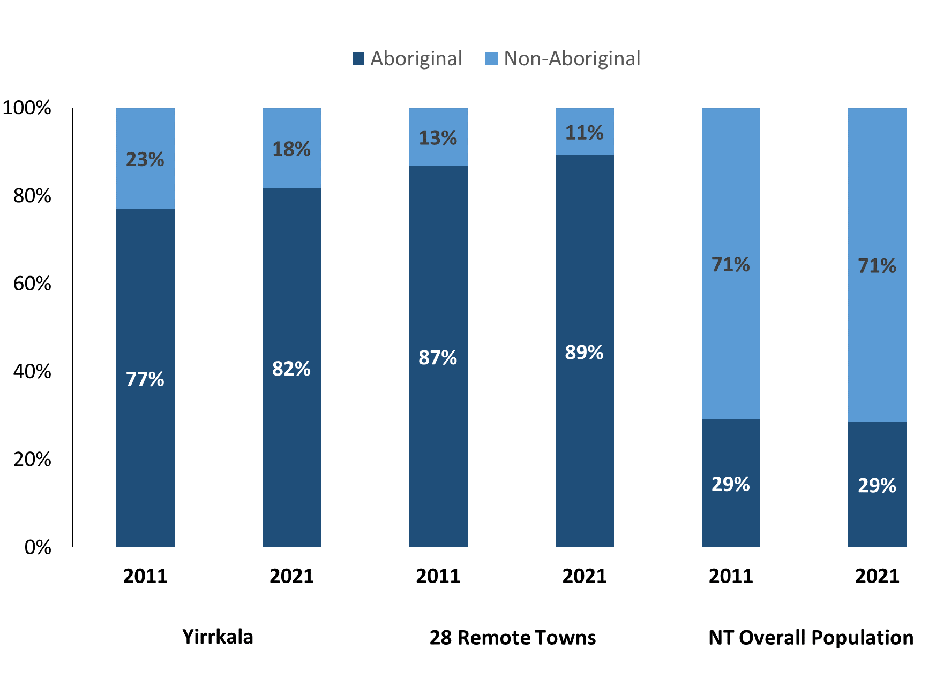

*Source: Australian Bureau of Statistics*

In 2021, Aboriginal people made up:

* 82% of the population in Yirrkala, compared to 77% in 2011
* 89% of the population across all 28 remote towns
* 29% of the NT population.

**Table 37: Unemployment and Aboriginal participation rates (q)**

|  |  |  |  |  |  |  |
| --- | --- | --- | --- | --- | --- | --- |
|  | **Yirrkala** | | | **Northern Territory** | | |
| **Aboriginal** | **Non-Aboriginal** | **Total** | **Aboriginal** | **Non-Aboriginal** | **Total** |
| **Unemployment rate** | 17.9% | 0.0% | 11.8% | 20.8% | 3.2% | 5.6% |
| **Participation rate** | 34.3% | 75.5% | 45.6% | 35.4% | 78.3% | 64.9% |

*Source: Australian Bureau of Statistics*

In 2021 in Yirrkala the:

* **total unemployment rate** was 11.8% compared to 5.6% for the total Northern Territory
* **Aboriginal** **unemployment rate** was 17.9% compared to 20.8% for the total Northern Territory
* **non-Aboriginal unemployment rate** was 0.0% compared to 3.2% for the total Northern Territory
* **total participation rate** was 45.6% compared to 64.9% for the total Northern Territory
* **Aboriginal participation rate** was 34.3% compared to 35.4% for the total Northern Territory
* **non-Aboriginal participation rate** was 75.5% compared to 78.3% for the total Northern Territory.

# Community Development Program

**Table 38: Community Development Program Aboriginal Job Seekers, 31 December 2023 (o)**

|  |  |  |
| --- | --- | --- |
| **Indicator** | **Aboriginal** | |
| **No.** | **%** |
| **Total Aboriginal Job Seekers** | 301 | N/A |
| **Age (years)** | | |
| 15-24 | 66 | 22.0% |
| 25-44 | 147 | 48.8% |
| 45+ | 88 | 29.2% |
| **Total** | 301 | 100.0% |
| **Gender** | | |
| Male | 153 | 50.8% |
| Female | 148 | 49.2% |
| **Total** | 301 | 100.0% |
| **Employment Outcome – 1 January 2023 to 31 December 2023** | | |
| 13 Weeks | 20 | N/A |
| 26 Weeks | <20 | N/A |

*Source: Department of Prime Minister and Cabinet*

**Chart 14: Community Development Program Aboriginal Job Seekers by Gender and Age Group, 31 December 2023 (o)**

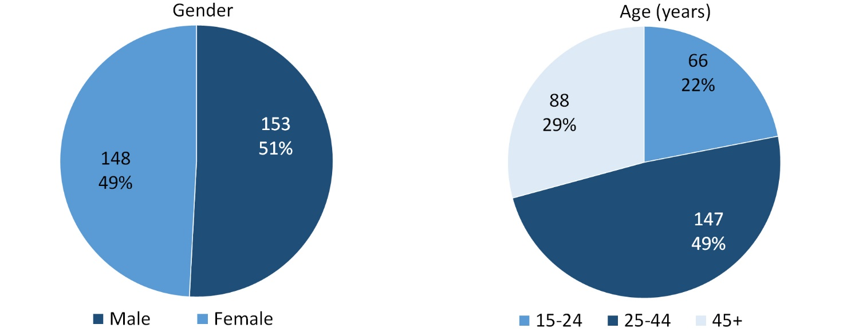

*Source: Department of Prime Minister and Cabinet*

As of 31 December 2023, in Yirrkala, there were 301 CDP **Aboriginal** job seekers, of these:

* 153 (50.8%) were male and 148 (49.2%) were female
* 66 (22.0%) were aged 15-24 years, 147 (48.8%) were aged 25-44 years, and 88 (29.2%) were aged 45+ years
* between 1 January 2023 to 31 December 2023, 20 had reached the 13 week reporting milestone and less than 20 had reached the 26 week reporting milestone.

# Businesses

**Table 39: Businesses by sector (d)(s)**

|  |  |  |  |  |
| --- | --- | --- | --- | --- |
| **Business Name** | **Reported on in 2011** | **Reported on in 2014** | **Reported on in 2017** | **Reported on in 2023** |
| **PUBLIC SECTOR** | | | | |
| **Department of Education** | Yes | Yes | Yes | **Yes** |
| Department of Health | Yes | No | Yes | No |
| Department of the Prime Minister and Cabinet | Yes | Yes | Yes | No |
| **East Arnhem Regional Council** | Yes | Yes | Yes | **Yes** |
| Territory Families | No | No | Yes | No |
| **PRIVATE SECTOR** | | | | |
| Bawaka Cultural Experiences | Yes | No | No | No |
| Buku Larrnggay Mulka Incorporated | Yes | Yes | No | No |
| Bunuwal Industrial Pty Ltd | Yes | Yes | No | No |
| Bunuwal Investment | No | Yes | No | No |
| Charles Darwin University - Office of Indigenous Academic Support | No | Yes | No | No |
| **East Arnhem Real Estate** | No | No | Yes | **Yes** |
| Laynhapuy Homelands Aboriginal Corporation | Yes | Yes | Yes | No |
| Lirrwi Yolngu Tourism Aboriginal Corporation | No | Yes | Yes | No |
| Miwatj Employment and Participation Ltd | No | Yes | Yes | No |
| **Miwatj Health Aboriginal Corporation** | No | Yes | Yes | **Yes** |
| Nuwul Environmental Services Incorporated | No | Yes | Yes | No |
| STEPS Disability Qld Inc | No | Yes | No | No |
| **The Arnhem Land Progress Aboriginal Corporation (ALPA)** | No | No | Yes | **Yes** |
| Yamuna Mechanical Repair | No | Yes | Yes | No |
| YBE (2) Pty Ltd | No | No | Yes | No |
| Yirrkala Banana Farm | No | Yes | No | No |
| **Yirrkala Community Store** | Yes | Yes | Yes | **Yes** |

*Source: Department of Industry, Tourism and Trade*

Note: Business names captured across the four survey periods have been identified by the ABN name listed in 2023.

In 2023 in Yirrkala:

* there were 6 businesses reported on, of which:
* 2 businesses were from the Public Sector (33%)
* 4 businesses were from the Private Sector (67%)
* there were nil businesses operating that were not operating in 2017.

# Notes

1. These counts represent numbers of filled jobs and not the number of people. As such the totals represent the total number of filled jobs, not the total number of employees. This count is not directly comparable to the total number of employed people as a person may have several jobs or one job may be shared by more than one person.
2. Full-time is defined as a job usually requiring 35 hours or more per week or that required 35 hours or more work during the reference week. Part-time is defined as a job usually requiring less than 35 hours per week or that required less than 35 hours work during the reference week. The reference week refers to the period that respondents were asked to provide information about. In most instances it would be the week prior to the week the questionnaire was completed. Questionnaires were predominantly conducted in June and July 2023.
3. Care needs to be taken when analysing the counts of jobs filled by Aboriginal people. Aboriginality was reported by the business representative completing the questionnaire.
4. Sector was classified using the Standard Economic Sector of Classifications of Australia (SESCA), 2008.
5. Job permanency is classified according to what the business believes is the level of job permanency, is based on guidelines provided by data collectors. Those guidelines state a permanent job has paid annual and/or sick leave entitlements while a temporary job includes casual work and fixed-term contracts.
6. Classified according to the Australian and New Zealand Standard Classification of Occupations (ANZSCO), 2006, major occupation level.
7. Other Occupations include jobs where occupation was not stated, not known or inadequately described.
8. Classified using the Australian and New Zealand Standard Industrial Classification (ANZSIC), 2006, division level.
9. Care needs to be taken when analysing the counts of filled jobs by the gender of people in the jobs. The gender of the person employed in a job is reported by the business representative completing the questionnaire.
10. Care needs to be taken when analysing the counts of filled jobs by the age of people in the jobs. The age of the person employed in a job is reported by the business representative completing the questionnaire.
11. Students is the number of individual clients who enrolled in a Vocational Education and Training unit during the calendar year.
12. Unit enrolments represent the count of individual units that students enrolled in during the calendar year.
13. Nominal hours delivered is the sum of the nominal hours of the units commenced during the calendar year regardless of when the course enrolment commenced.
14. Unit completions are the count of all successfully completed units reported in the calendar year regardless of the year of commencement of the units.
15. The Community Development Program (CDP) supports job seekers in remote Australia to build skills, address barriers and contribute to their communities through a range of flexible activities. Under the CDP, job seekers with activity requirements are expected to do up to 25 hours per week of work-like activities that benefit their community. It should be noted that some CDP participants may be reported on within the profile if they are attached to a filled position with an employer captured in the survey. Due to confidentiality issues, data below 20 people is not published.
16. Population estimates for both 2011 and 2021 are taken from the estimated resident population (ERP) data produced by the Australian Bureau of Statistics (ABS) and based on Australian Statistical Geography Standard (ASGS) Statistical Area Level 1 (SA1) regions. ERP are official estimates of the Australian population, which link people to a place of usual residence with Australia. All ERP data sources, including the Census of Population and Housing (Census), are subject to error (including inaccuracies in collection, recording and processing data) and should be used with caution.
17. Indigenous population proportions, unemployment and workforce participation rates are based on ABS Census counts at ASGS Indigenous Locations (ILOCs) for each remote town.
18. Working-age population includes all residents aged 15 years and over (commonly referred to as the civilian population) and consists of people that are employed, unemployed or not in the labour force.
19. A ‘business’ has been defined as any organisation that has undertaken productive activities in the last year, including companies, non-profit organisations, government departments and enterprises operating within the designated remote geography (town), and has one or more employees in paid employment and an Australian Business Number (ABN).

# Abbreviations and Acronyms

ABN Australian Business Number

ABS Australian Bureau of Statistics

ANZSCO Australian and New Zealand Standard Classification of Occupations

ANZSIC Australian and New Zealand Standard Industrial Classification

ASGS Australian Statistical Geography Standard

CDP Community Development Program

ERP Estimated Resident Population

ILOC Indigenous Locations

nec Not elsewhere classified

No. Number

Perm Permanent

ppt Percentage point

RJCP Remote Jobs and Communities Program

Temp Temporary

SA1 Statistical Area Level 1

VET Vocational Education and Training

1. The number of filled jobs does not represent numbers of people as a person may have several jobs or one job may be shared by more than one person.
2. Gender status was not identified for 6 Aboriginal filled jobs in 2017.
3. 6 Aboriginal filled jobs gender status not identified in 2017