**T**

**© Northern Territory of Australia 2025**

**Preferred Reference:** Department of Trade, Business and Asian Relations, 2023 Remote Towns Jobs Profiles, Northern Territory Government, January 2025, Darwin.

**Front cover image:** *Vitex rotundifolia* – known commonly as Beach Vitex

**Image Credit:** Robyn Wing

**Disclaimer**

The data in this publication was collected by conducting a survey of businesses located in the 28 remote town boundaries. This body of work was completed in 2023 by the former Northern Territory Department of Industry, Tourism and Trade.

The collection methodology was created in accordance with Australian Bureau of Statistics data quality framework principles. Data in this publication is only reflective of those businesses reported on as operating in the town at the time of data collection (see table at the end of publication for list of businesses reported on). To comply with privacy legislation or where appropriate, some data in this publication may have been adjusted and will not reflect the actual data reported by businesses. As a result of this, combined with certain data not being reported by some businesses, some components may not add to totals. Changes over time may also reflect change in business propensity to report on certain data items rather than actual changes over time. Total figures have generally not been adjusted. Caution is advised when interpreting the comparisons made to the earlier 2011, 2014 and 2017 publications as the businesses identified and reported on and the corresponding jobs may differ between publications. The surveys have not always gathered data on training and jobs in the same years.

**Notes for each table and chart are ordered alphabetically and listed at the end of the publication.**

The Northern Territory of Australia exercised due care and skill to ensure that at the time of publication the information contained in this publication is true and correct. However, it is not intended to be relied on as professional advice or used for commercial purposes. The Territory gives no warranty or assurances as to the accuracy of the information contained in the publication and to the maximum extent permitted by law accepts no direct or indirect liability for reliance on its content.

Any use of this report for commercial purposes is not endorsed by the Department of Trade, Business and Asian Relations.

Contents

Galiwin’ku 4

Introduction 5

Summary 6

Jobs Overview 7

Jobs filled by Aboriginality 8

Jobs by Sector: Private and Public 11

Job Status: Permanent and Temporary 18

Job Vacancies 22

Jobs by Industry 24

Jobs by Occupation 31

Jobs by Industry by Occupation 35

Jobs by Gender 39

Jobs by Age 45

Vocational Education and Training 51

Population 58

Community Development Program 60

Businesses 61

Notes 63

Abbreviations and Acronyms 64

.

# Galiwin’ku

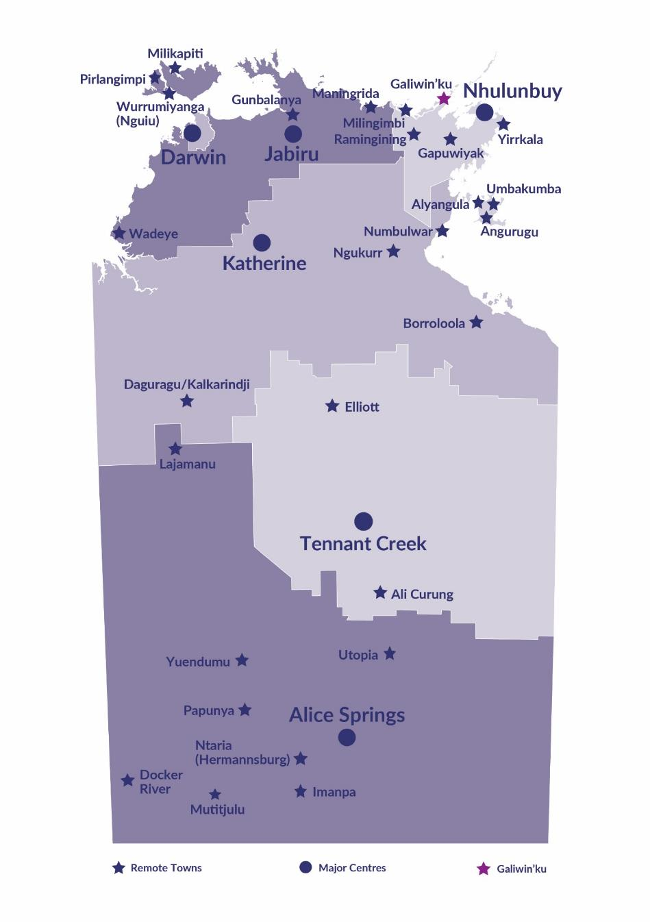Galiwin’ku is located on Elcho Island in the East Arnhem region 550 kilometres northeast of Darwin, with a population of 2199 residents.

*Source: Northern Territory Northern Territory Department of Industry, Tourism and Trade*

# Introduction

This jobs profile provides a snapshot of jobs and the characteristics of job holders in Galiwin’ku as of September 2023. It also outlines trends from the 2011, 2014 and 2017 surveys.

This job profile is one of 28 profiles developed for remote towns in the Northern Territory. It is anticipated these, and subsequent profiles will contribute to a robust evidence base to inform decision making in, and relating to, these remote Territory towns.

This profile contains information collected by the Northern Territory Northern Territory Department of Industry, Tourism and Trade from businesses operating within the town and supplemented by other administrative data sets and information.

Each profile provides up-to-date information that is intended to inform the planning and design of current and future government programs and as an evidence base to inform decision making relating to workforce development, enterprise, and job opportunities.

The profile may best be understood as a point-in-time tool. The number of business surveys from which the data was drawn is significantly less than in earlier surveys, and business participation has decreased with each survey. For Galiwin’ku, 26% fewer businesses than in 2017 are reported here.

The data collection methodology and corresponding questionnaire were created in partnership with the Australian Bureau of Statistics (ABS) and in accordance with ABS data quality framework and survey principles.

The Northern Institute at Charles Darwin University facilitated the surveys with the support of the Northern Territory Northern Territory Department of Industry, Tourism and Trades’ Territory Engagement and Delivery teams.

The information collected and reported on represents a significant goodwill investment by those businesses and organisations that participated. Each business is listed at the end of this publication.

# Summary

The 2023 jobs profile was developed based on responses from 20 businesses operating within the Galiwin’ku town boundary, 7 less than in the 2017 survey. Of these, there were:

* 15 businesses from the Private Sector, accounting for 242 filled jobs or 64% of total filled jobs
* 5 businesses from the Public Sector, accounting for 134 filled jobs or 36% of total filled jobs
* 7 businesses participated in all four surveys (completed in 2011, 2014, 2017 and 2023)

A total of 425 filled and vacant jobs in Galiwin’ku were reported, a decrease of 136 jobs from 2017.[1]

The 2023 profile highlights:

* there were 376 filled jobs of which:
* 253 jobs (67%) were filled by Aboriginal people, a decrease of 106 jobs from 2017
* 123 jobs (33%) were filled by non-Aboriginal people, a decrease of 47 jobs from 2017
* 51% of employed Aboriginal people are working in the Private Sector
* Aboriginal people accounted for 67% of job holders in the town compared to 68% in 2017
* Aboriginal females made up 47% of total Aboriginal filled jobs in the town compared to 45% in 2017.
* there were 49 vacant jobs, of which:
* job vacancies as a percentage of jobs increased to 11.5% in 2023 from 5.7% in 2017. (1 in 8.7 jobs vacant)
* 35 of the vacancies were in Professionals and Community and Personal Service Workers areas
* Health Care and Social Assistance has steadily increased its filled jobs since 2014 and was the largest industry employer in 2023
* the Construction industry had a decrease of 109 jobs between 2017 and 2023
* Retail Trade had a decrease of 65 filled jobs between 2017 and 2023
* training had a decrease of 164 student numbers between 2016 and 2023
* Community Services, Health and Education was the largest training activity sector in 2023, followed by Sales and Personal Service
* General Education and Training had the largest increase in student numbers and Building and Construction had the largest decrease in student numbers between 2016 and 2023.

The overall population in Galiwin’ku increased by 70 people (3.3%) between 2011 and 2021 to 2,199 people.

In comparison, the overall Northern Territory population increased by 9.7% between 2011 and 2021.

In 2021, the working age population (15 years and over) in Galiwin’ku was an estimated 1,614 people compared to 1,368 in 2011 an increase of 18%.

There were 0.3 jobs in Galiwin'ku per working age person compared to 0.3 jobs per working age person across the 28 remote towns in the Northern Territory.

# Jobs Overview

Table 1: Count of filled jobs and vacancies, 2011, 2014, 2017 & 2023 (a)(b)

|  |  |  |  |  |  |  |  |
| --- | --- | --- | --- | --- | --- | --- | --- |
|  | **2011** | **2014** | **2017** | **2023** | **Change 2011-2014** | **Change 2014-2017** | **Change 2017-2023** |
| **Total All Jobs** | **423** | **454** | **561** | **425** | **31** | **107** | **-136** |
| **Vacancies** | **28** | **32** | **32** | **49** | **4** | **0** | **17** |
| Vacancies as % of Total All Jobs | 6.6% | 7.0% | 5.7% | 11.5% | 0.4 ppt | -1.3 ppt | 5.8 ppt |
| **Filled Jobs** | **395** | **422** | **529** | **376** | **27** | **107** | **-153** |
| Full-time | 303 | 268 | 270 | 214 | -35 | 2 | -56 |
| Part-time | 92 | 154 | 259 | 162 | 62 | 105 | -97 |

Source: Northern Territory Department of Industry, Tourism and Trade

Chart 1: Count of vacant jobs and filled jobs by full-time/part-time status, 2011, 2014, 2017 & 2023 (a)(b)

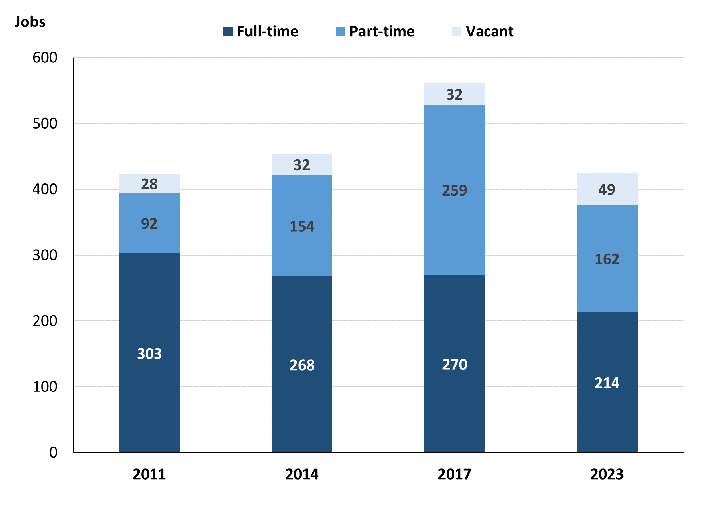

Source: Northern Territory Department of Industry, Tourism and Trade

In 2023 in Galiwin'ku:

* there was a total of 376 **filled jobs**, a decrease of 153 jobs from 2017 and a decrease of 46 jobs from 2014
* of the 376 **filled jobs** in 2023:
* 214 were full-time jobs, a decrease of 56 jobs from 2017 and a decrease of 54 jobs from 2014
* 162 were part-time jobs, a decrease of 97 from 2017 and an increase of 8 from 2014
* there were 49 total **job vacancies** in 2023, an increase of 17 vacancies from 2017 and an increase of 17 vacancies from 2014.

# Jobs filled by Aboriginality

Chart 2: Count of filled jobs by Aboriginality, 2011, 2014, 2017 & 2023 (a)(c)

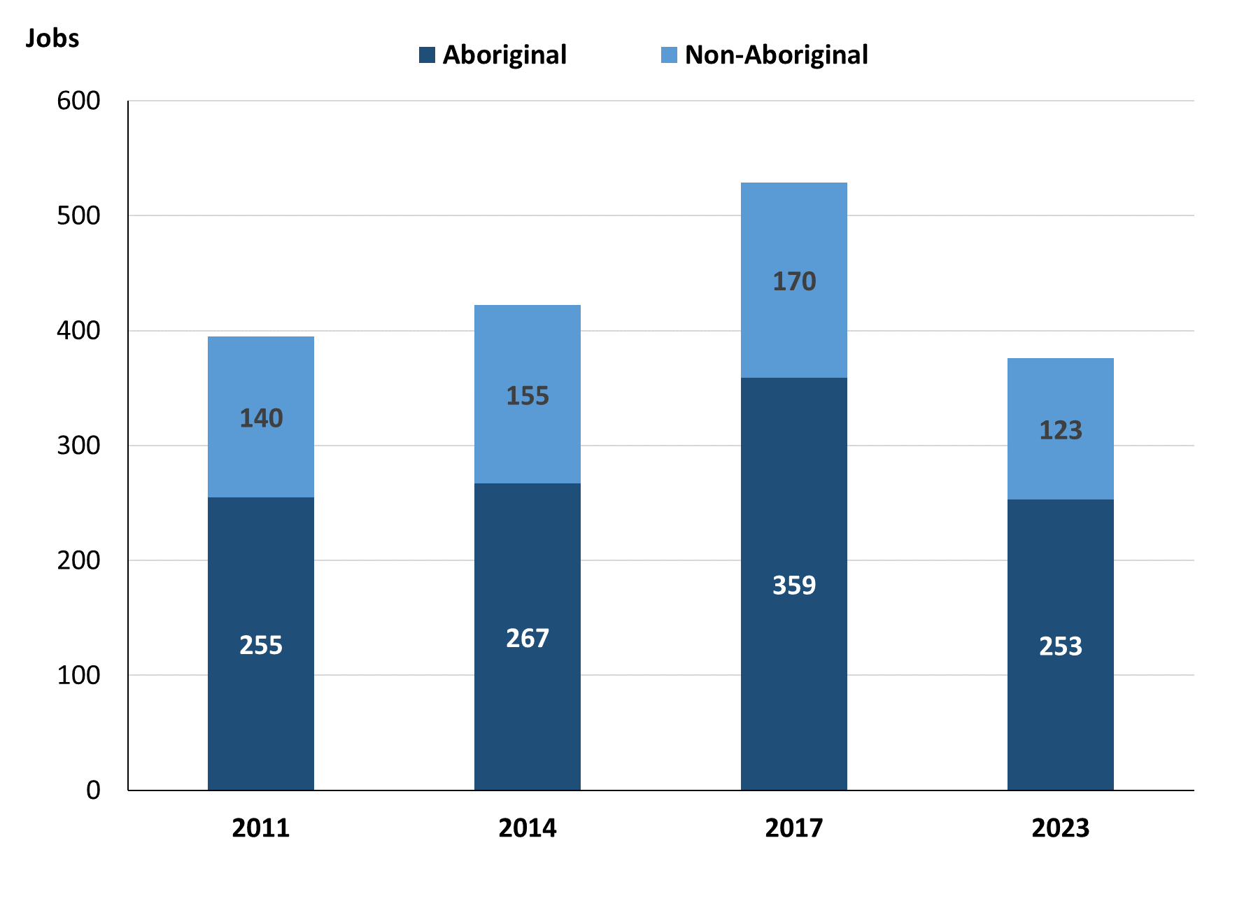

Source: Northern Territory Department of Industry, Tourism and Trade

In 2023 in Galiwin'ku:

* of the 376 **filled jobs**:
* **Aboriginal** people filled 253 jobs, a decrease of 106 jobs from 2017 and a decrease of 14 jobs from 2014
* **non-Aboriginal** people filled 123 jobs, a decrease of 47 jobs from 2017 and a decrease of 32 jobs from 2014
* **Aboriginal** people accounted for 67% of job holders compared to 68% in 2017 and 63% in 2014.

Table 2a: Count of filled jobs by full-time/part-time status, 2011, 2014, 2017 & 2023 (a)(b)(c)

|  |  |  |  |  |  |  |  |  |  |  |  |  |
| --- | --- | --- | --- | --- | --- | --- | --- | --- | --- | --- | --- | --- |
| **Indicator** | **2011** | | | **2014** | | | **2017** | | | **2023** | | |
| **Aboriginal** | **Non-Aboriginal** | **Total** | **Aboriginal** | **Non-Aboriginal** | **Total** | **Aboriginal** | **Non-Aboriginal** | **Total** | **Aboriginal** | **Non-Aboriginal** | **Total** |
| Full-time | 165 | 138 | **303** | 120 | 148 | **268** | 115 | 155 | **270** | 114 | 100 | **214** |
| Part-time | 90 | 2 | **92** | 147 | 7 | **154** | 244 | 15 | **259** | 139 | 23 | **162** |
| **Total** | **255** | **140** | **395** | **267** | **155** | **422** | **359** | **170** | **529** | **253** | **123** | **376** |

Source: Northern Territory Department of Industry, Tourism and Trade

Table 2b: Count of filled jobs by full-time/part-time status, 2011-2014, 2014-2017 & 2017-2023 (a)(b)(c)

|  |  |  |  |  |  |  |  |  |  |
| --- | --- | --- | --- | --- | --- | --- | --- | --- | --- |
| **Indicator** | **Change 2011-2014** | | | **Change 2014-2017** | | | **Change 2017-2023** | | |
| **Aboriginal** | **Non-Aboriginal** | **Total** | **Aboriginal** | **Non-Aboriginal** | **Total** | **Aboriginal** | **Non-Aboriginal** | **Total** |
| Full-time | -45 | 10 | **-35** | -5 | 7 | **2** | -1 | -55 | **-56** |
| Part-time | 57 | 5 | **62** | 97 | 8 | **105** | -105 | 8 | **-97** |
| **Total** | **12** | **15** | **27** | **92** | **15** | **107** | **-106** | **-47** | **-153** |

Source: Northern Territory Department of Industry, Tourism and Trade

Chart 3: Count of filled jobs by full-time/part-time status, 2011, 2014, 2017 & 2023 (a)(b)(c)

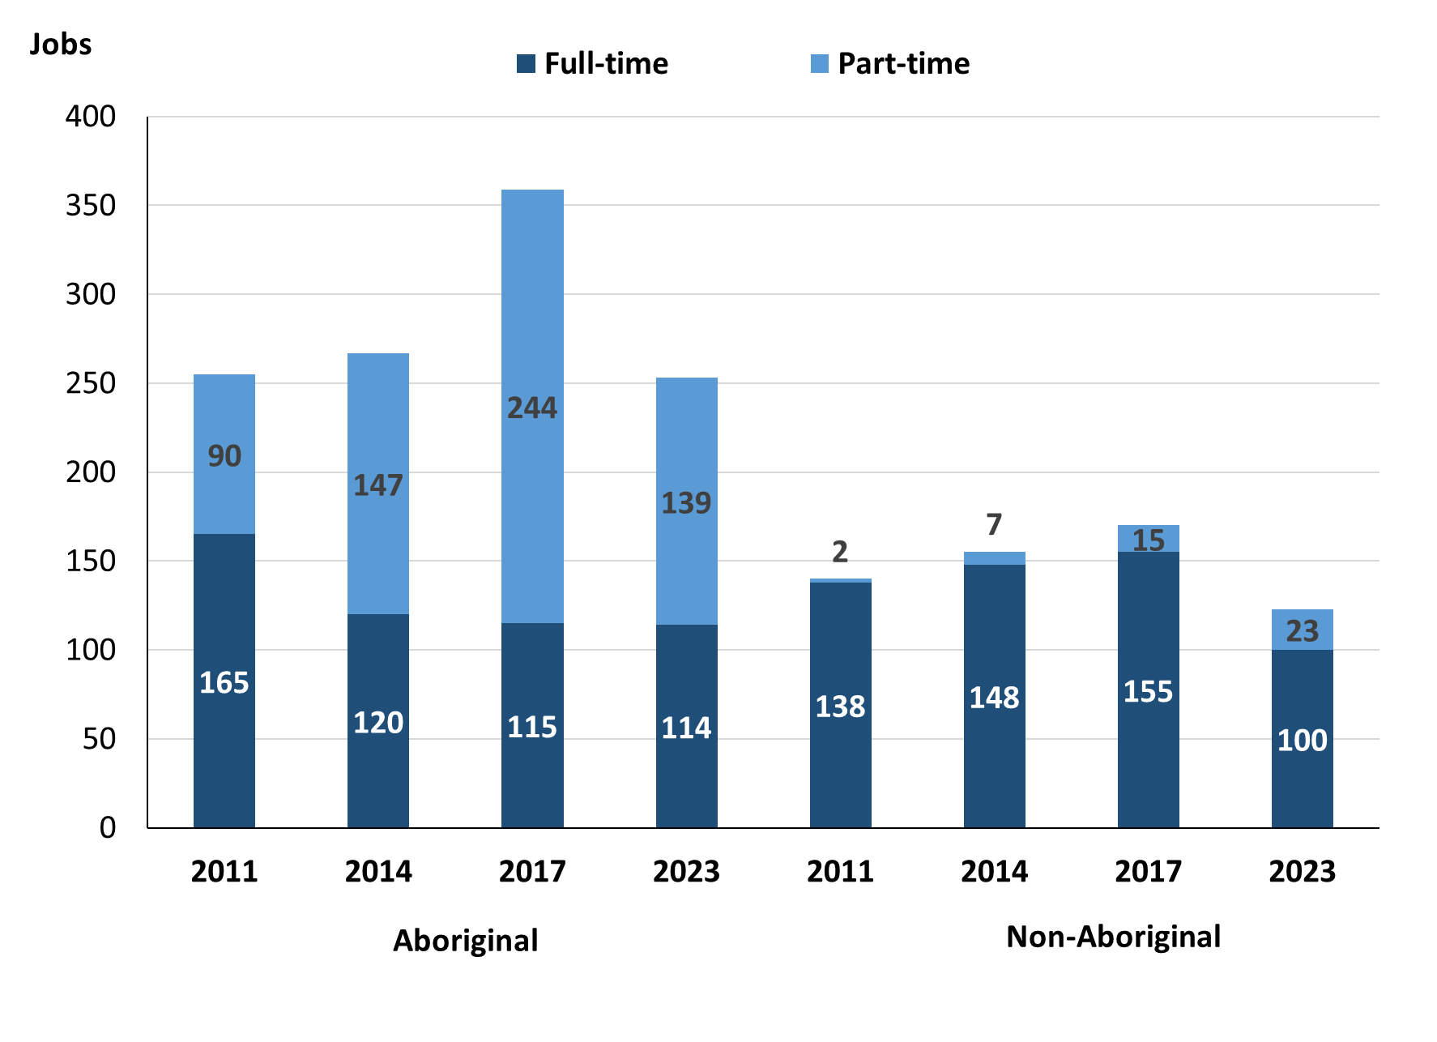

Source: Northern Territory Department of Industry, Tourism and Trade

In 2023 in Galiwin'ku:

* of the 376 **filled jobs**:
* 114 were **full-time jobs** filled by **Aboriginal** people, a decrease of 1 job from 2017 and a decrease of 6 jobs from 2014
* 139 were **part-time jobs** filled by **Aboriginal** people, a decrease of 105 jobs from 2017 and a decrease of 8 jobs from 2014
* 100 were **full-time jobs** filled by **non-Aboriginal** people, a decrease of 55 jobs from 2017 and a decrease of 48 jobs from 2014
* 23 were **part-time jobs** filled by **non-Aboriginal** people, an increase of 8 jobs from 2017 and an increase of 16 jobs from 2014.

# Jobs by Sector: Private and Public

Table 3a: Count of filled jobs by business sector, 2011, 2014, 2017 & 2023 (a)(b)(c)

|  |  |  |  |  |  |  |  |  |  |  |  |  |
| --- | --- | --- | --- | --- | --- | --- | --- | --- | --- | --- | --- | --- |
| **Indicator** | **2011** | | | **2014** | | | **2017** | | | **2023** | | |
| **Aboriginal** | **Non-Aboriginal** | **Total** | **Aboriginal** | **Non-Aboriginal** | **Total** | **Aboriginal** | **Non-Aboriginal** | **Total** | **Aboriginal** | **Non-Aboriginal** | **Total** |
| **Public Sector** | 77 | 77 | **154** | 78 | 62 | **140** | 70 | 57 | **127** | 63 | 71 | **134** |
| Australian Government | 4 | 2 | **6** | 7 | 1 | **8** | 6 | 1 | **7** | 1 | 1 | **2** |
| Territory Government | 23 | 59 | **82** | 27 | 52 | **79** | 25 | 45 | **70** | 25 | 58 | **83** |
| Local Government | 50 | 16 | **66** | 44 | 9 | **53** | 39 | 11 | **50** | 37 | 12 | **49** |
| **Private Sector** | 178 | 63 | **241** | 189 | 93 | **282** | 289 | 113 | **402** | 190 | 52 | **242** |
| **Total** | **255** | **140** | **395** | **267** | **155** | **422** | **359** | **170** | **529** | **253** | **123** | **376** |

Source: Northern Territory Department of Industry, Tourism and Trade

Table 3b: Count of filled jobs by business sector, 2011-2014, 2014-2017 & 2017-2023 (a)(b)(c)

|  |  |  |  |  |  |  |  |  |  |
| --- | --- | --- | --- | --- | --- | --- | --- | --- | --- |
| **Indicator** | **Change 2011-2014** | | | **Change 2014-2017** | | | **Change 2017-2023** | | |
| **Aboriginal** | **Non-Aboriginal** | **Total** | **Aboriginal** | **Non-Aboriginal** | **Total** | **Aboriginal** | **Non-Aboriginal** | **Total** |
| **Public Sector** | 1 | -15 | **-14** | -8 | -5 | **-13** | -7 | 14 | **7** |
| Australian Government | 3 | -1 | **2** | -1 | 0 | **-1** | -5 | 0 | **-5** |
| Territory Government | 4 | -7 | **-3** | -2 | -7 | **-9** | 0 | 13 | **13** |
| Local Government | -6 | -7 | **-13** | -5 | 2 | **-3** | -2 | 1 | **-1** |
| **Private Sector** | 11 | 30 | **41** | 100 | 20 | **120** | -99 | -61 | **-160** |
| **Total** | **12** | **15** | **27** | **92** | **15** | **107** | **-106** | **-47** | **-153** |

Source: Northern Territory Department of Industry, Tourism and Trade

Chart 4: Count of filled jobs by business sector, 2011, 2014, 2017 & 2023 (a)(d)

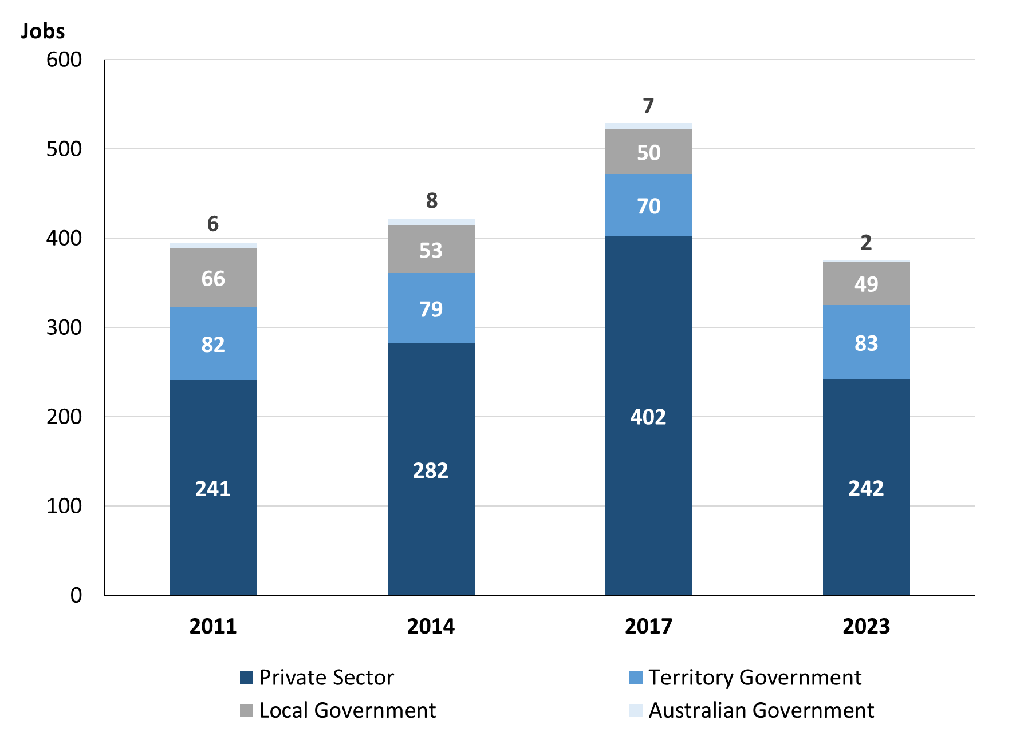

Source: Northern Territory Department of Industry, Tourism and Trade

Chart 5: Percentage of filled jobs by business sector in 2023 (a)(d)

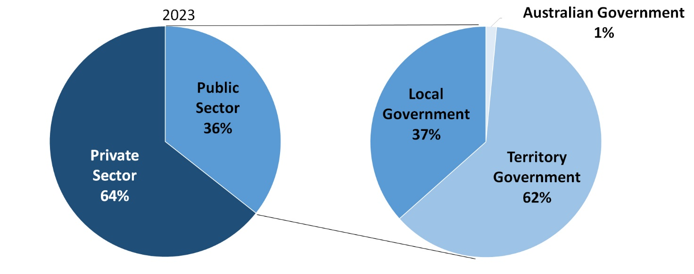

Source: Northern Territory Department of Industry, Tourism and Trade

In 2023 in Galiwin'ku:

* there were 134 jobs in the **Public Sector**, an increase of 7 jobs from 2017 and a decrease of 6 jobs from 2014
* of the 134 jobs in the **Public Sector**:
* 2 jobs were in the Australian Government, a decrease of 5 jobs from 2017 and a decrease of 6 jobs from 2014
* 83 jobs were in the Territory Government, an increase of 13 jobs from 2017 and an increase of 4 jobs from 2014
* 49 jobs were in the Local Government, a decrease of 1 job from 2017 and a decrease of 4 jobs from 2014
* there were 242 jobs in the **Private Sector**, a decrease of 160 jobs from 2017 and a decrease of 40 jobs from 2014.

Chart 6: Count of filled jobs by sector, 2011, 2014, 2017 & 2023 (a)(c)(d)

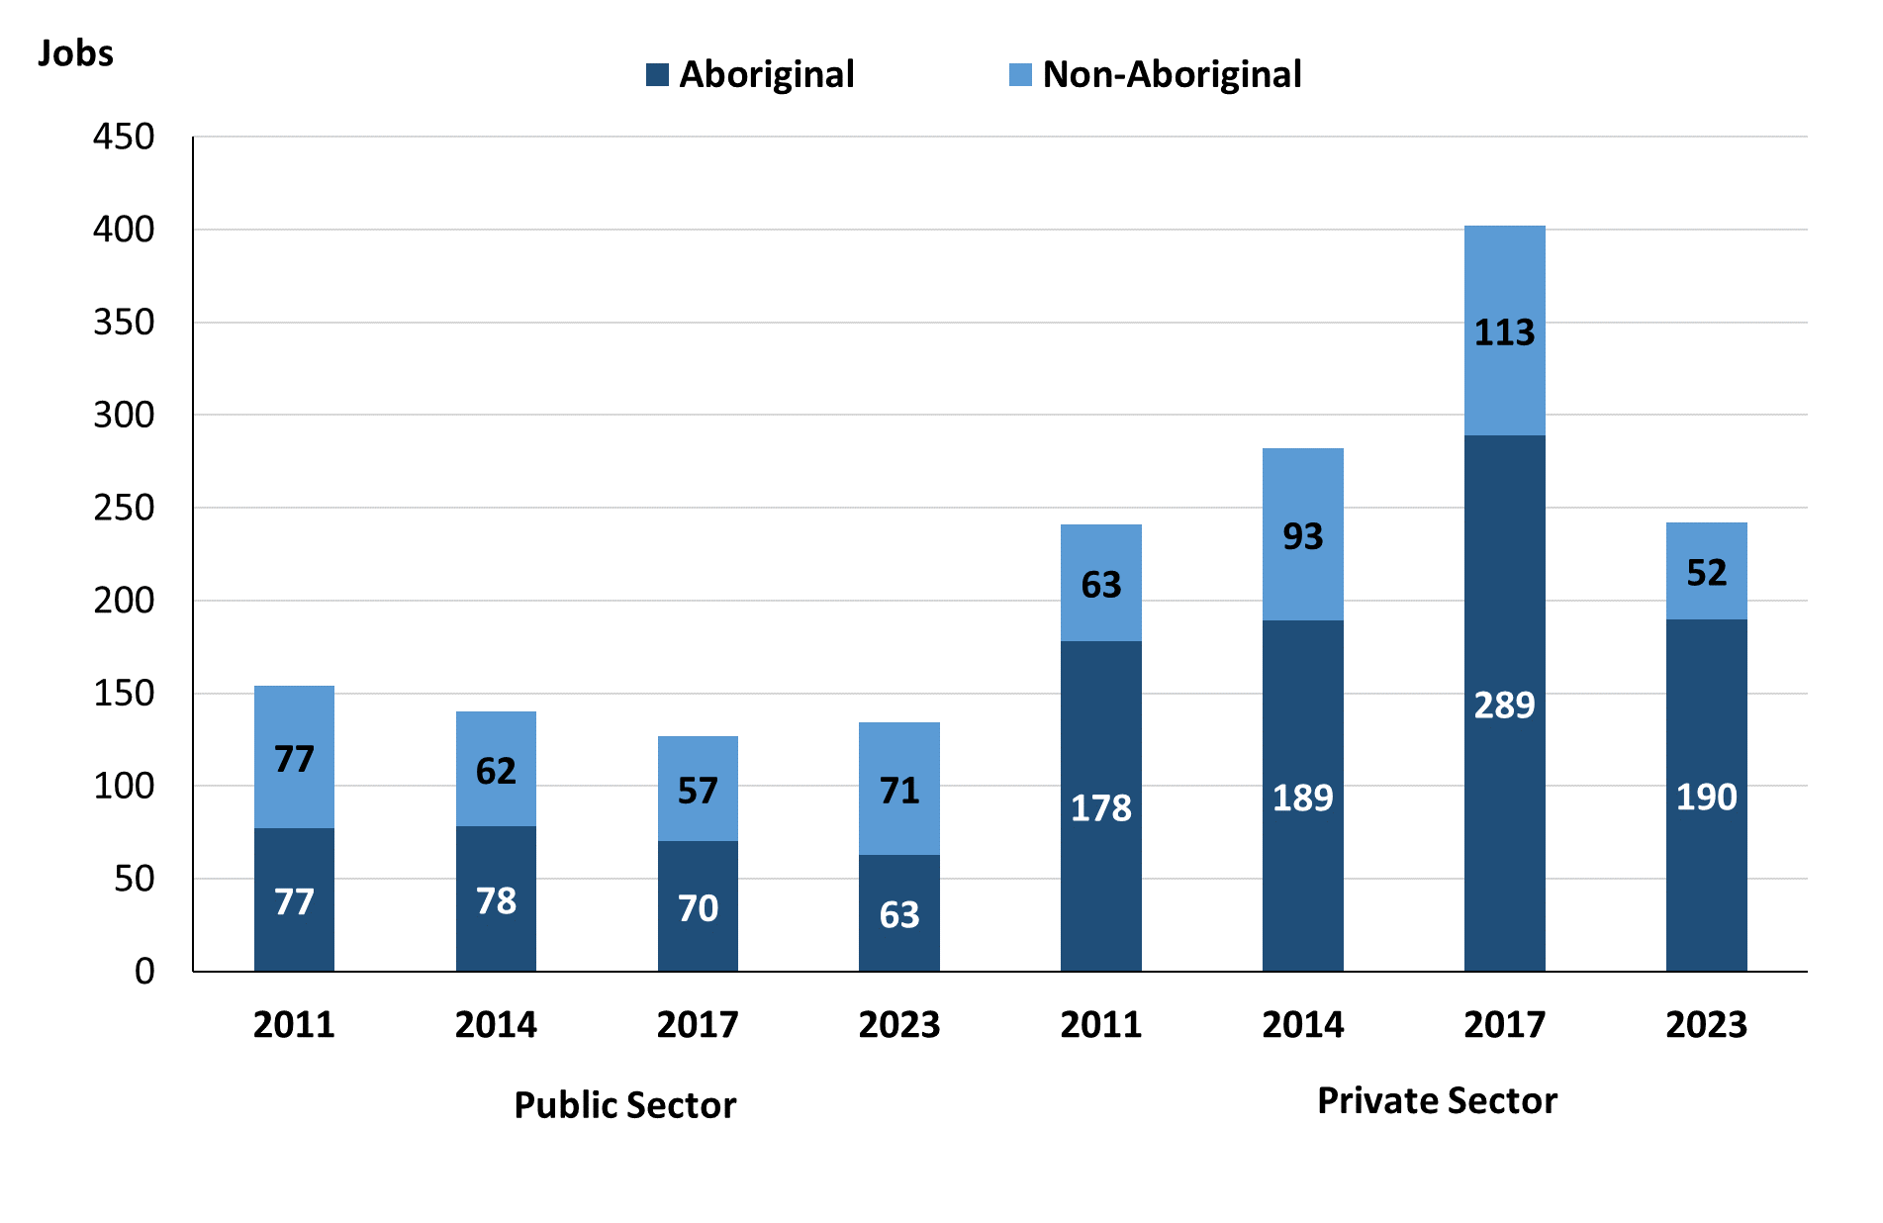

Source: Northern Territory Department of Industry, Tourism and Trade

In 2023 in Galiwin'ku:

* of the 134 jobs in the **Public Sector**:
* **Aboriginal** people filled 63 jobs, a decrease of 7 jobs from 2017 and a decrease of 15 jobs from 2014
* **non-Aboriginal** people filled 71 jobs, an increase of 14 jobs from 2017 and an increase of 9 jobs from 2014
* of the 242 jobs in the **Private Sector**:
* **Aboriginal** people filled 190 jobs, a decrease of 99 jobs from 2017 and an increase of 1 job from 2014
* **non-Aboriginal** people filled 52 jobs, a decrease of 61 jobs from 2017 and a decrease of 41 jobs from 2014.

Chart 7: Count of filled jobs by sector and full-time/part-time status, 2011, 2014, 2017 & 2023 (a)(b)(d)

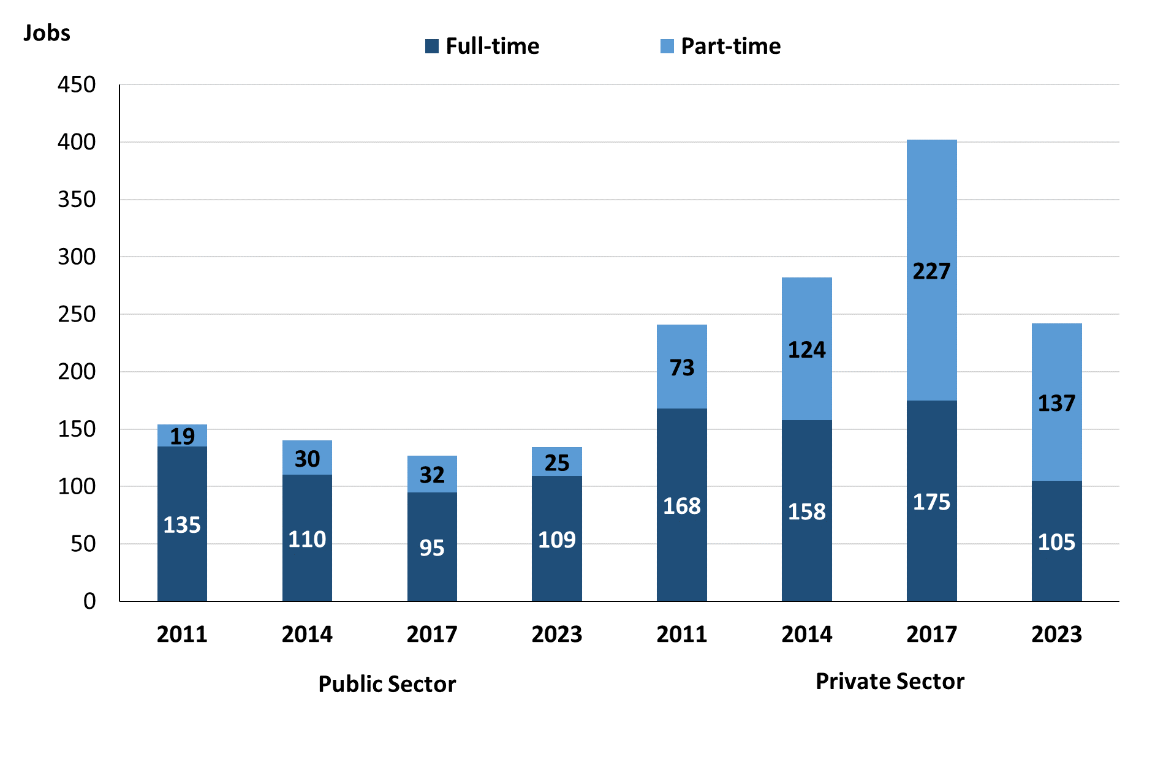

Source: Northern Territory Department of Industry, Tourism and Trade

In 2023 in Galiwin'ku:

* of the 134 jobs in the **Public Sector**:
* 109 were **full-time** jobs, an increase of 14 jobs from 2017 and a decrease of 1 job from 2014
* 25 were **part-time** jobs, a decrease of 7 jobs from 2017 and a decrease of 5 jobs from 2014
* of the 242 jobs in the **Private Sector** there were:
* 105 were **full-time** jobs, a decrease of 70 jobs from 2017 and a decrease of 53 jobs from 2014
* 137 were **part-time** jobs, a decrease of 90 jobs from 2017 and an increase of 13 jobs from 2014.

Table 4: Count of filled jobs by full-time/part-time status by sector, 2011, 2014, 2017 & 2023 (a)(b)(c)(d)

|  |  |  |  |  |  |  |  |  |  |
| --- | --- | --- | --- | --- | --- | --- | --- | --- | --- |
| **Indicator** | **2011** | | | | | | | | |
| **Aboriginal** | | | **Non-Aboriginal** | | | **Total** | | |
| **Full-time** | **Part-time** | **Total** | **Full-time** | **Part-time** | **Total** | **Full-time** | **Part-time** | **Total** |
| Public Sector | 59 | 18 | **77** | 76 | 1 | **77** | 135 | 19 | **154** |
| Private Sector | 106 | 72 | **178** | 62 | 1 | **63** | 168 | 73 | **241** |
| **Total** | **165** | **90** | **255** | **138** | **2** | **140** | **303** | **92** | **395** |

|  |  |  |  |  |  |  |  |  |  |
| --- | --- | --- | --- | --- | --- | --- | --- | --- | --- |
| **Indicator** | **2014** | | | | | | | | |
| **Aboriginal** | | | **Non-Aboriginal** | | | **Total** | | |
| **Full-time** | **Part-time** | **Total** | **Full-time** | **Part-time** | **Total** | **Full-time** | **Part-time** | **Total** |
| Public Sector | 51 | 27 | **78** | 59 | 3 | **62** | 110 | 30 | **140** |
| Private Sector | 69 | 120 | **189** | 89 | 4 | **93** | 158 | 124 | **282** |
| **Total** | **120** | **147** | **267** | **148** | **7** | **155** | **268** | **154** | **422** |

|  |  |  |  |  |  |  |  |  |  |
| --- | --- | --- | --- | --- | --- | --- | --- | --- | --- |
| **Indicator** | **2017** | | | | | | | | |
| **Aboriginal** | | | **Non-Aboriginal** | | | **Total** | | |
| **Full-time** | **Part-time** | **Total** | **Full-time** | **Part-time** | **Total** | **Full-time** | **Part-time** | **Total** |
| Public Sector | 43 | 27 | **70** | 52 | 5 | **57** | 95 | 32 | **127** |
| Private Sector | 72 | 217 | **289** | 103 | 10 | **113** | 175 | 227 | **402** |
| **Total** | **120** | **147** | **359** | **155** | **15** | **170** | **270** | **259** | **529** |

|  |  |  |  |  |  |  |  |  |  |
| --- | --- | --- | --- | --- | --- | --- | --- | --- | --- |
| **Indicator** | **2023** | | | | | | | | |
| **Aboriginal** | | | **Non-Aboriginal** | | | **Total** | | |
| **Full-time** | **Part-time** | **Total** | **Full-time** | **Part-time** | **Total** | **Full-time** | **Part-time** | **Total** |
| Public Sector | 45 | 18 | **63** | 64 | 7 | **71** | 109 | 25 | **134** |
| Private Sector | 69 | 121 | **190** | 36 | 16 | **52** | 105 | 137 | **242** |
| **Total** | **114** | **139** | **253** | **100** | **23** | **123** | **214** | **162** | **376** |

Source: Northern Territory Department of Industry, Tourism and Trade

In 2023 in Galiwin'ku:

* there were 63 jobs in the **Public Sector** filled by **Aboriginal** people, a decrease of 7 jobs from 2017 and a decrease of 15 jobs from 2014, of which:
* 45 were **full-time** jobs, an increase of 2 jobs from 2017 and a decrease of 6 jobs from 2014
* 18 were **part-time** jobs, a decrease of 9 jobs from 2017 and a decrease of 9 jobs from 2014
* 190 jobs in the **Private Sector** filled by **Aboriginal** people, a decrease of 99 jobs from 2017 and an increase of 1 job from 2014, of which:
* 69 were **full-time** jobs, a decrease of 3 jobs from 2017 and unchanged from 2014
* 121 were **part-time** jobs, a decrease of 96 jobs from 2017 and an increase of 1 job from 2014
* 71 jobs in the **Public Sector** filled by **non-Aboriginal** people, an increase of 14 jobs from 2017 and an increase of 9 jobs from 2014, of which:
* 64 were **full-time** jobs, an increase of 12 jobs from 2017 and an increase of 5 jobs from 2014
* 7 were **part-time** jobs, an increase of 2 jobs from 2017 and an increase of 4 jobs from 2014
* 52 jobs in the **Private Sector** filled by **non-Aboriginal** people, a decrease of 61 jobs from 2017 and a decrease of 41 jobs from 2014, of which:
* 36 were **full-time** jobs, a decrease of 67 jobs from 2017 and a decrease of 53 jobs from 2014
* 16 were **part-time** jobs, an increase of 6 jobs from 2017 and an increase of 12 jobs from 2014.

# Job Status: Permanent and Temporary

Table 5a: Count of filled jobs by employment status, 2011, 2014, 2017 & 2023 (a)(c)(e)

|  |  |  |  |  |  |  |  |  |  |  |  |  |
| --- | --- | --- | --- | --- | --- | --- | --- | --- | --- | --- | --- | --- |
| **Indicator** | **2011** | | | **2014** | | | **2017** | | | **2023** | | |
| **Aboriginal** | **Non-Aboriginal** | **Total** | **Aboriginal** | **Non-Aboriginal** | **Total** | **Aboriginal** | **Non-Aboriginal** | **Total** | **Aboriginal** | **Non-Aboriginal** | **Total** |
| Permanent | 187 | 92 | **279** | 163 | 125 | **288** | 157 | 76 | **233** | 221 | 93 | **314** |
| Temporary | 68 | 48 | **116** | 104 | 30 | **134** | 202 | 94 | **296** | 32 | 30 | **62** |
| **Total** | **255** | **140** | **395** | **267** | **155** | **422** | **359** | **170** | **529** | **253** | **123** | **376** |

Source: Northern Territory Department of Industry, Tourism and Trade

Table 5b: Count of filled jobs by employment status, 2011-2014, 2014-2017 & 2017-2023 (a)(c)(e)

|  |  |  |  |  |  |  |  |  |  |
| --- | --- | --- | --- | --- | --- | --- | --- | --- | --- |
| **Indicator** | **Change 2011-2014** | | | **Change 2014-2017** | | | **Change**  **2017-2023** | | |
| **Aboriginal** | **Non-Aboriginal** | **Total** | **Aboriginal** | **Non-Aboriginal** | **Total** | **Aboriginal** | **Non-Aboriginal** | **Total** |
| Permanent | -24 | 33 | **9** | -6 | -49 | **-55** | 64 | 17 | **81** |
| Temporary | 36 | -18 | **18** | 98 | 64 | **162** | -170 | -64 | **-234** |
| **Total** | **12** | **15** | **27** | **92** | **15** | **107** | **-106** | **-47** | **-153** |

Source: Northern Territory Department of Industry, Tourism and Trade

Chart 8: Count of filled jobs by employment status, 2011, 2014, 2017 & 2023 (a)(c)(e)

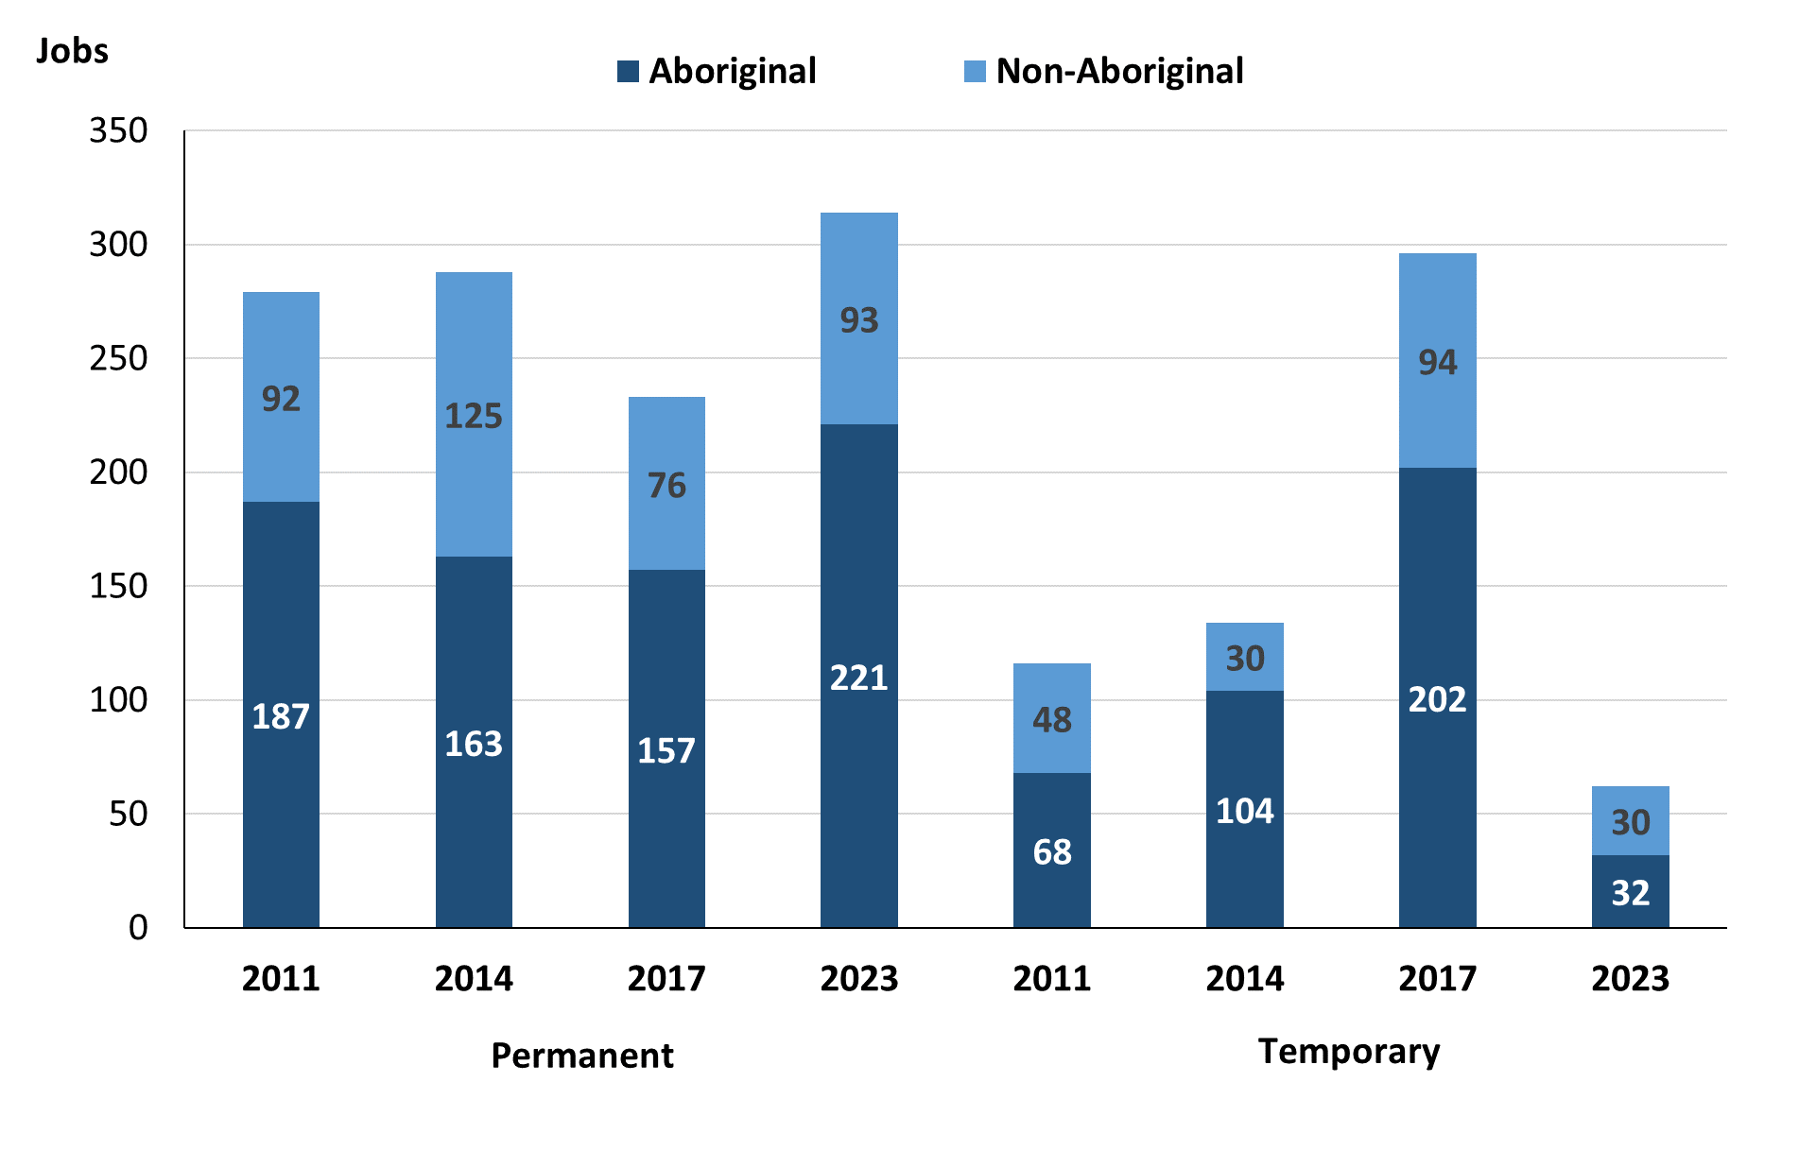

Source: Northern Territory Department of Industry, Tourism and Trade

In 2023 in Galiwin'ku:

* there were 314 **Permanent Jobs**, an increase of 81 jobs from 2017, and an increase of 26 jobs from 2014, of which:
* 221 jobs were filled by **Aboriginal** people filled 221 jobs, an increase of 64 jobs from 2017 and an increase of 58 jobs from 2014
* 93 jobs were filled by **non-Aboriginal** people filled 93 jobs, an increase of 17 jobs from 2017 and a decrease of 32 jobs from 2014
* there were 62 **Temporary Jobs**, a decrease of 234 jobs from 2017 and a decrease of 72 jobs from 2014, of which:
* **Aboriginal** people filled 32 jobs, a decrease of 170 jobs from 2017 and a decrease of 72 jobs from 2014
* **non-Aboriginal** people filled 30 jobs, a decrease of 64 jobs from 2017 and unchanged from 2014.

Table 6: Count of filled jobs by sector and employment status, 2011, 2014, 2017 & 2023 (a)(c)(d)(e)

|  |  |  |  |  |  |  |  |  |  |
| --- | --- | --- | --- | --- | --- | --- | --- | --- | --- |
| **Indicator** | **2011** | | | | | | | | |
| **Aboriginal** | | | **Non-Aboriginal** | | | **Total** | | |
| **Perm** | **Temp** | **Total** | **Perm** | **Temp** | **Total** | **Perm** | **Temp** | **Total** |
| Public Sector | 53 | 24 | **77** | 41 | 36 | **77** | 94 | 60 | **154** |
| Private Sector | 134 | 44 | **178** | 51 | 12 | **63** | 185 | 56 | **241** |
| **Total** | **187** | **68** | **255** | **92** | **48** | **140** | **279** | **116** | **395** |

|  |  |  |  |  |  |  |  |  |  |
| --- | --- | --- | --- | --- | --- | --- | --- | --- | --- |
| **Indicator** | **2014** | | | | | | | | |
| **Aboriginal** | | | **Non-Aboriginal** | | | **Total** | | |
| **Perm** | **Temp** | **Total** | **Perm** | **Temp** | **Total** | **Perm** | **Temp** | **Total** |
| Public Sector | 42 | 36 | **78** | 49 | 13 | **62** | 91 | 49 | **140** |
| Private Sector | 121 | 68 | **189** | 76 | 17 | **93** | 197 | 85 | **282** |
| **Total** | **163** | **104** | **267** | **125** | **30** | **155** | **288** | **134** | **422** |

|  |  |  |  |  |  |  |  |  |  |
| --- | --- | --- | --- | --- | --- | --- | --- | --- | --- |
| **Indicator** | **2017** | | | | | | | | |
| **Aboriginal** | | | **Non-Aboriginal** | | | **Total** | | |
| **Perm** | **Temp** | **Total** | **Perm** | **Temp** | **Total** | **Perm** | **Temp** | **Total** |
| Public Sector | 39 | 31 | **70** | 22 | 35 | **57** | 61 | 66 | **127** |
| Private Sector | 118 | 171 | **289** | 54 | 59 | **113** | 172 | 230 | **402** |
| **Total** | **157** | **202** | **359** | **76** | **94** | **170** | **233** | **296** | **529** |

|  |  |  |  |  |  |  |  |  |  |
| --- | --- | --- | --- | --- | --- | --- | --- | --- | --- |
| **Indicator** | **2023** | | | | | | | | |
| **Aboriginal** | | | **Non-Aboriginal** | | | **Total** | | |
| **Perm** | **Temp** | **Total** | **Perm** | **Temp** | **Total** | **Perm** | **Temp** | **Total** |
| Public Sector | 48 | 15 | **63** | 50 | 21 | **71** | 98 | 36 | **134** |
| Private Sector | 173 | 17 | **190** | 43 | 9 | **52** | 216 | 26 | **242** |
| **Total** | **221** | **32** | **253** | **93** | **30** | **123** | **314** | **62** | **376** |

Source: Northern Territory Department of Industry, Tourism and Trade

In 2023 in Galiwin'ku:

* there were 134 jobs in the **Public Sector**, an increase of 7 jobs from 2017 and a decrease of 6 jobs from 2014, of which:
* 98 jobs were **permanent**, an increase of 37 jobs from 2017 and an increase of 7 jobs from 2014, of which:
* **Aboriginal** people filled 48 jobs, an increase of 9 jobs from 2017 and an increase of 6 jobs from 2014
* **non-Aboriginal** people filled 50 jobs, an increase of 28 jobs from 2017 and an increase of 1 job from 2014
* 36 jobs were **temporary**, a decrease of 30 jobs from 2017 and a decrease of 13 jobs from 2014, of which:
* **Aboriginal** people filled 15 jobs, a decrease of 16 jobs from 2017 and a decrease of 21 jobs from 2014
* **non-Aboriginal** people filled 21 jobs, a decrease of 14 jobs from 2017 and an increase of 8 jobs from 2014
* 242 jobs in the **Private Sector**, a decrease of 160 jobs from 2017 and a decrease of 40 jobs from 2014, of which:
* 216 jobs were **permanent**, an increase of 44 jobs from 2017 and an increase of 19 jobs from 2014, of which:
* **Aboriginal** people filled 173 jobs, an increase of 55 jobs from 2017 and an increase of 52 jobs from 2014
* **non-Aboriginal** people filled 43 jobs, a decrease of 11 jobs from 2017 and a decrease of 33 jobs from 2014
* 26 jobs were **temporary**, a decrease of 204 jobs from 2017 and a decrease of 59 jobs from 2014, of which:
* **Aboriginal** people filled 17 jobs, a decrease of 154 jobs from 2017 and a decrease of 51 jobs from 2014
* **non-Aboriginal** people filled 9 jobs, a decrease of 50 jobs from 2017 and a decrease of 8 jobs from 2014.

# Job Vacancies

Table 7: Job vacancies, 2011, 2014, 2017 & 2023

|  |  |  |  |  |  |  |  |
| --- | --- | --- | --- | --- | --- | --- | --- |
| **Indicator** | **2011** | **2014** | **2017** | **2023** | **Change 2011-2014** | **Change 2014-2017** | **Change 2017-2023** |
| **Job vacancies** | **28** | **32** | **32** | **49** | **4** | **0** | **17** |

Source: Northern Territory Department of Industry, Tourism and Trade

Table 8a: Job vacancies by occupation, 2011, 2014, 2017 & 2023 (f)(g)

|  |  |  |  |  |
| --- | --- | --- | --- | --- |
| **Occupation (ANZSCO major group)** | **2011** | **2014** | **2017** | **2023** |
| Clerical and Administrative Workers | 4 | 3 | 8 | 9 |
| Community and Personal Service Workers | 9 | 13 | 2 | 20 |
| Labourers | 2 | 2 | 5 | 3 |
| Machinery Operators and Drivers | 0 | 1 | 1 | 0 |
| Managers | 5 | 1 | 1 | 1 |
| Professionals | 7 | 12 | 14 | 15 |
| Technicians and Trades Workers | 1 | 0 | 1 | 1 |
| **Total** | **28** | **32** | **32** | **49** |

Source: Northern Territory Department of Industry, Tourism and Trade

Table 8b: Job vacancies by occupation, 2011-2014, 2014-2017 & 2017-2023 (f)(g)

|  |  |  |  |
| --- | --- | --- | --- |
| **Occupation (ANZSCO major group)** | **Change 2011-2014** | **Change 2014-2017** | **Change 2017-2023** |
| Clerical and Administrative Workers | -1 | 5 | 1 |
| Community and Personal Service Workers | 4 | -11 | 18 |
| Labourers | 0 | 3 | -2 |
| Machinery Operators and Drivers | 1 | 0 | -1 |
| Managers | -4 | 0 | 0 |
| Professionals | 5 | 2 | 1 |
| Technicians and Trades Workers | -1 | 1 | 0 |
| **Total** | **4** | **0** | **17** |

Source: Northern Territory Department of Industry, Tourism and Trade

Table 9: Job vacancies by job title, 2023 profile (f)

|  |  |  |  |
| --- | --- | --- | --- |
| **Job Vacancy** | **No.** | **Job Vacancy** | **No.** |
| Aboriginal and Torres Strait Islander Education Worker | 7 | Handyperson | 1 |
| Aged or Disabled Carer | 2 | Health and Welfare Services Manager | 1 |
| Classroom Teacher | 9 | Liaison Officer | 8 |
| Commercial Cleaner | 2 | Media Producer | 1 |
| Community Worker | 1 | Police Officer | 1 |
| Early Childhood Teacher | 3 | Program or Project Administrator | 3 |
| Education Aide | 1 | Senior Teacher | 1 |
| Food Trade Worker | 1 | Vocational Education Teacher | 1 |
| General Clerk | 6 | **Total** | **49** |

Source: Northern Territory Department of Industry, Tourism and Trade

In 2023 in Galiwin'ku:

* there were 49 **vacancies** reported, an increase of 17 vacancies from 2017 and an increase of 17 vacancies from 2014
* Of the 49 reported **vacancies,** the largest requirements were for:
* 20 Community and Personal Service Workers, the majority of which are in the following jobs:
* Aboriginal and Torres Strait Islander Education Worker
* Aged or Disabled Carer
* Liaison Officer
* 15 Professionals, the majority of which are in the following jobs:
* Classroom Teacher
* Early Childhood Teacher
* 9 Clerical and Administrative Workers, the majority of which are in the following jobs:
* General Clerk
* Program or Project Administrator.

# Jobs by Industry

Table 10: Count of filled jobs by industry of business, 2011, 2014, 2017, 2023 and change in count of filled jobs by industry 2011-2014, 2014-2017 & 2017-2023 (a)(h)

|  |  |  |  |  |  |  |  |  |  |  |  |
| --- | --- | --- | --- | --- | --- | --- | --- | --- | --- | --- | --- |
| **Industry (ANZSIC Division)** | **2011** | | **2014** | | **2017** | | **2023** | | **Change 2011-2014** | **Change 2014-2017** | **Change 2017-2023** |
| **Total** | **% of Total** | **Total** | **% of Total** | **Total** | **% of Total** | **Total** | **% of Total** | **Total** | **Total** | **Total** |
| Accommodation and Food Services | 0 | 0.0% | 0 | 0.0% | 8 | 1.5% | 7 | 1.9% | 0 | 8 | -1 |
| Arts and Recreation Services | 6 | 1.5% | 1 | 0.2% | 4 | 0.8% | 0 | 0.0% | -5 | 3 | -4 |
| Construction | 0 | 0.0% | 0 | 0.0% | 121 | 22.9% | 12 | 3.2% | 0 | 121 | -109 |
| Education and Training | 78 | 19.7% | 87 | 20.6% | 83 | 15.7% | 74 | 19.7% | 9 | -4 | -9 |
| Electricity, Gas, Water and Waste Services | 1 | 0.3% | 10 | 2.4% | 2 | 0.4% | 0 | 0.0% | 9 | -8 | -2 |
| Financial and Insurance Services | 4 | 1.0% | 4 | 0.9% | 5 | 0.9% | 4 | 1.1% | 0 | 1 | -1 |
| Health Care and Social Assistance | 62 | 15.7% | 48 | 11.4% | 83 | 15.7% | 120 | 31.9% | -14 | 35 | 37 |
| Manufacturing |  |  |  |  |  |  | 3 | 0.8% |  |  | 3 |
| Other Services | 0 | 0.0% | 1 | 0.2% | 7 | 1.3% |  | 0.0% | 1 | 6 | -7 |
| Public Administration and Safety | 182 | 46.1% | 189 | 44.8% | 63 | 11.9% | 70 | 18.6% | 7 | -126 | 7 |
| Rental, Hiring and Real Estate Services | 0 | 0.0% | 0 | 0.0% | 0 | 0.0% | 1 | 0.3% | 0 | 0 | 1 |
| Retail Trade | 55 | 13.9% | 77 | 18.2% | 139 | 26.3% | 74 | 19.7% | 22 | 62 | -65 |
| Transport, Postal and Warehousing | 5 | 1.3% | 5 | 1.2% | 14 | 2.6% | 11 | 2.9% | 0 | 9 | -3 |
| **Total** | **395** | **100.0%** | **422** | **100.0%** | **529** | **100.0%** | **376** | **100.0%** | **27** | **107** | **-153** |

Source: Northern Territory Department of Industry, Tourism and Trade

In 2023 in Galiwin'ku:

* the Health Care and Social Assistance was the **largest industry employer**, with 120 filled jobs or 31.9% of filled jobs, an increase of 37 jobs from 2017 and an increase of 72 jobs from 2014
* **other significant** industry employers were:
* Retail Trade with 74 jobs (or 19.7% of filled jobs), a decrease of 65 jobs from 2017 and a decrease of 3 jobs from 2014
* Education and Training with 74 jobs (or 19.7% of filled jobs), a decrease of 9 jobs from 2017 and a decrease of 13 jobs from 2014
* Public Administration and Safety with 70 jobs (or 18.6% of filled jobs), an increase of 7 jobs from 2017 and a decrease of 119 jobs from 2014.

Table 11a: Count of filled jobs by industry of business, 2011, 2014, 2017 & 2023 (a)(c)(h)

|  |  |  |  |  |  |  |  |  |  |  |  |  |  |
| --- | --- | --- | --- | --- | --- | --- | --- | --- | --- | --- | --- | --- | --- |
| **Industry (ANZSIC division)** | **2011** | | | **2014** | | | **2017** | | | **2023** | | | |
| **Aboriginal** | **Non-Aboriginal** | **Total** | **Aboriginal** | **Non-Aboriginal** | **Total** | **Aboriginal** | **Non-Aboriginal** | **Total** | **Aboriginal** | **Non-Aboriginal** | **Total** |
| Accommodation and Food Services | 0 | 0 | **0** | 0 | 0 | **0** | 6 | 2 | **8** | 5 | 2 | **7** |
| Arts and Recreation Services | 3 | 3 | **6** | 1 | 0 | **1** | 3 | 1 | **4** | 0 | 0 | **0** |
| Construction | 0 | 0 | **0** | 0 | 0 | **0** | 86 | 35 | **121** | 12 | 0 | **12** |
| Education and Training | 24 | 54 | **78** | 36 | 51 | **87** | 40 | 43 | **83** | 24 | 50 | **74** |
| Electricity, Gas, Water and Waste Services | 0 | 1 | **1** | 2 | 8 | **10** | 1 | 1 | **2** | 0 | 0 | **0** |
| Financial and Insurance Services | 4 | 0 | **4** | 4 | 0 | **4** | 4 | 1 | **5** | 4 | 0 | **4** |
| Health Care and Social Assistance | 49 | 13 | **62** | 34 | 14 | **48** | 51 | 32 | **83** | 94 | 26 | **120** |
| Manufacturing | 0 | 0 | **0** | 0 | 0 | **0** | 0 | 0 | **0** | 2 | 1 | **3** |
| Other Services | 0 | 0 | **0** | 1 | 0 | **1** | 3 | 4 | **7** | 0 | 0 | **0** |
| Public Administration and Safety | 123 | 59 | **182** | 129 | 60 | **189** | 46 | 17 | **63** | 50 | 20 | **70** |
| Rental, Hiring and Real Estate Services | 0 | 0 | **0** | 0 | 0 | **0** | 0 | 0 | **0** | 0 | 1 | **1** |
| Retail Trade | 51 | 4 | **55** | 60 | 17 | **77** | 116 | 23 | **139** | 59 | 15 | **74** |
| Transport, Postal and Warehousing | 0 | 5 | **5** | 0 | 5 | **5** | 3 | 11 | **14** | 3 | 8 | **11** |
| **Total** | **255** | **140** | **395** | **267** | **155** | **422** | **359** | **170** | **529** | **253** | **123** | **376** |

Source: Northern Territory Department of Industry, Tourism and Trade

Table 11b: Count of filled jobs by industry of business, 2011-2014, 2014-2017 & 2017-2023 (a)(c)(h)

|  |  |  |  |  |  |  |  |  |  |
| --- | --- | --- | --- | --- | --- | --- | --- | --- | --- |
| **Industry (ANZSIC division)** | **Change 2011-2014** | | | **Change  2014-2017** | | | **Change 2017-2023** | | |
| **Aboriginal** | **Non-Aboriginal** | **Total** | **Aboriginal** | **Non-Aboriginal** | **Total** | **Aboriginal** | **Non-Aboriginal** | **Total** |
| Accommodation and Food Services | 0 | 0 | **0** | 6 | 2 | **8** | -1 | 0 | **-1** |
| Arts and Recreation Services | -2 | -3 | **-5** | 2 | 1 | **3** | -3 | -1 | **-4** |
| Construction | 0 | 0 | **0** | 86 | 35 | **121** | -74 | -35 | **-109** |
| Education and Training | 12 | -3 | **9** | 4 | -8 | **-4** | -16 | 7 | **-9** |
| Electricity, Gas, Water and Waste Services | 2 | 7 | **9** | -1 | -7 | **-8** | -1 | -1 | **-2** |
| Financial and Insurance Services | 0 | 0 | **0** | 0 | 1 | **1** | 0 | -1 | **-1** |
| Health Care and Social Assistance | -15 | 1 | **-14** | 17 | 18 | **35** | 43 | -6 | **37** |
| Manufacturing | 0 | 0 | **0** | 0 | 0 | **0** | 2 | 1 | **3** |
| Other Services | 1 | 0 | **1** | 2 | 4 | **6** | -3 | -4 | **-7** |
| Public Administration and Safety | 6 | 1 | **7** | -83 | -43 | **-126** | 4 | 3 | **7** |
| Rental, Hiring and Real Estate Services | 0 | 0 | **0** | 0 | 0 | **0** | 0 | 1 | **1** |
| Retail Trade | 9 | 13 | **22** | 56 | 6 | **62** | -57 | -8 | **-65** |
| Transport, Postal and Warehousing | 0 | 0 | **0** | 3 | 6 | **9** | 0 | -3 | **-3** |
| **Total** | **12** | **15** | **27** | **92** | **15** | **107** | **-106** | **-47** | **-153** |

Source: Northern Territory Department of Industry, Tourism and Trade

Chart 9: Count of filled jobs by top 5 industries, 2023 (a)(c)(h)

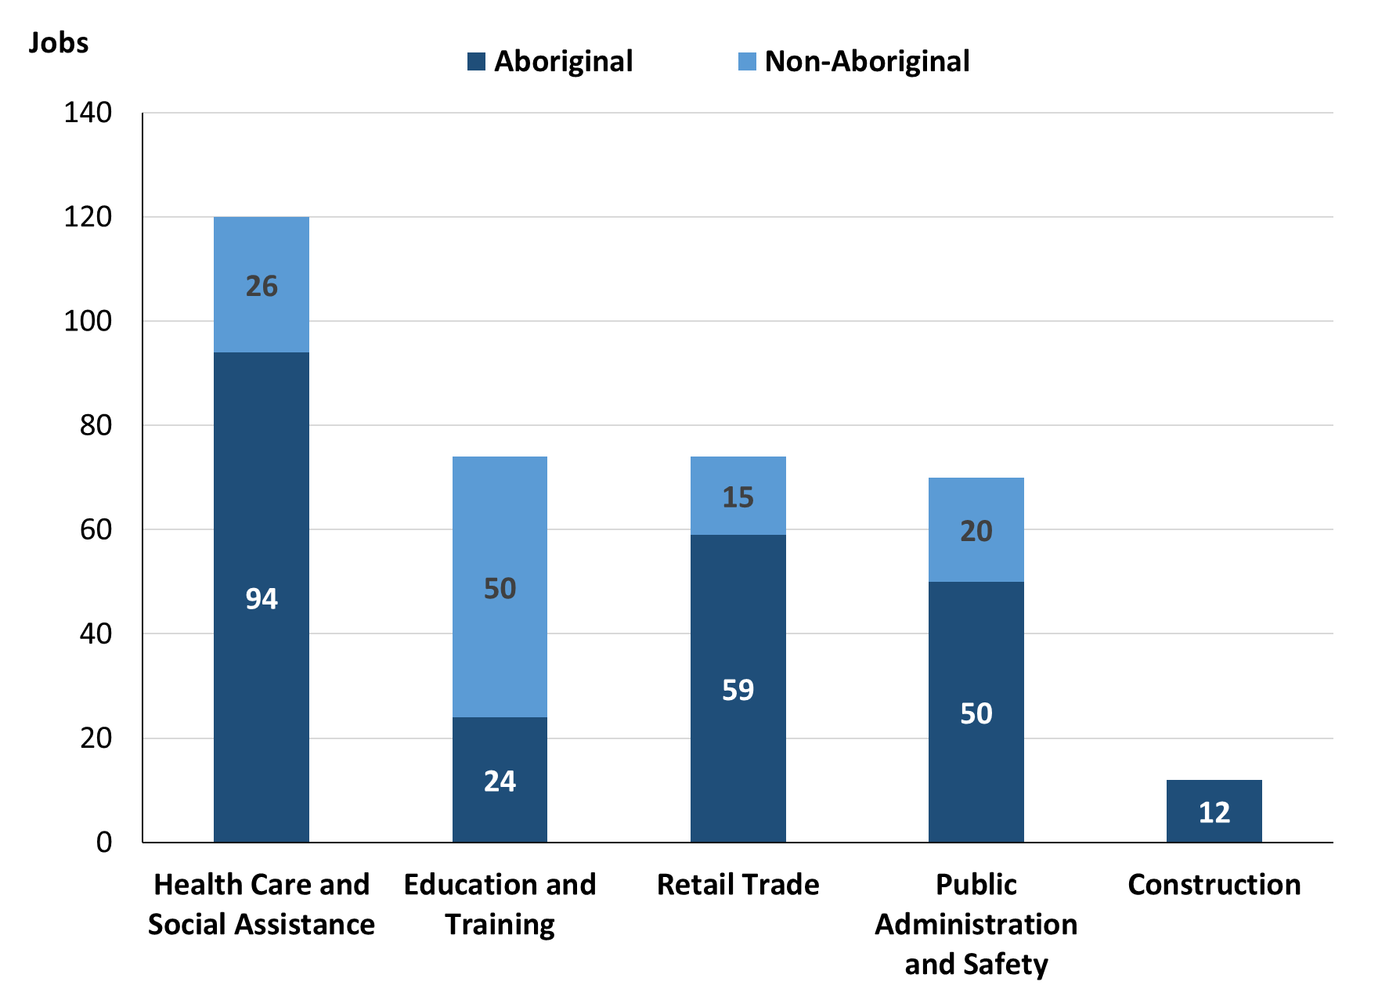

Source: Northern Territory Department of Industry, Tourism and Trade

In 2023 in Galiwin'ku:

* of the 253 jobs filled by **Aboriginal** people, there were:
* 94 jobs in Health Care and Social Assistance, an increase of 43 jobs from 2017 and an increase of 60 jobs from 2014
* 59 jobs in Retail Trade, a decrease of 57 jobs from 2017 and a decrease of 1 job from 2014
* 50 jobs in Public Administration and Safety, an increase of 4 jobs from 2017 and a decrease of 79 jobs from 2014
* of the 123 jobs filled by **non-Aboriginal** people, there were:
* 50 jobs in Education and Training, an increase of 7 jobs from 2017 and a decrease of 1 job from 2014
* 26 jobs in Health Care and Social Assistance, a decrease of 6 jobs from 2017 and an increase of 12 jobs from 2014
* 20 jobs in Public Administration and Safety, an increase of 3 jobs from 2017 and a decrease of 40 jobs from 2014.

Table 12: Count of filled jobs by industry and employment status, 2011 (a)(c)(e)(h)

|  |  |  |  |  |  |  |  |  |  |
| --- | --- | --- | --- | --- | --- | --- | --- | --- | --- |
| **Industry (ANZSIC division)** | **2011** | | | | | | | | |
| **Aboriginal** | | | **Non-Aboriginal** | | | **Total** | | |
| **Perm** | **Temp** | **Total** | **Perm** | **Temp** | **Total** | **Perm** | **Temp** | **Total** |
| Arts and Recreation Services | 3 | 0 | **3** | 0 | 3 | **3** | 3 | 3 | **6** |
| Education and Training | 10 | 14 | **24** | 25 | 29 | **54** | 35 | 43 | **78** |
| Electricity, Gas, Water and Waste Services | 0 | 0 | **0** | 1 | 0 | **1** | 1 | 0 | **1** |
| Financial and Insurance Services | 3 | 1 | **4** | 0 | 0 | **0** | 3 | 1 | **4** |
| Health Care and Social Assistance | 35 | 14 | **49** | 13 | 0 | **13** | 48 | 14 | **62** |
| Public Administration and Safety | 112 | 11 | **123** | 52 | 7 | **59** | 164 | 18 | **182** |
| Retail Trade | 23 | 28 | **51** | 0 | 4 | **4** | 23 | 32 | **55** |
| Transport, Postal and Warehousing | 0 | 0 | **0** | 1 | 4 | **5** | 1 | 4 | **5** |
| **Total** | **187** | **68** | **255** | **92** | **48** | **140** | **279** | **116** | **395** |

Source: Northern Territory Department of Industry, Tourism and Trade

Table 13: Count of filled jobs by industry and employment status, 2014 (a)(c)(e)(h)

|  |  |  |  |  |  |  |  |  |  |
| --- | --- | --- | --- | --- | --- | --- | --- | --- | --- |
| **Industry (ANZSIC division)** | **2014** | | | | | | | | |
| **Aboriginal** | | | **Non-Aboriginal** | | | **Total** | | |
| **Perm** | **Temp** | **Total** | **Perm** | **Temp** | **Total** | **Perm** | **Temp** | **Total** |
| Arts and Recreation Services | 0 | 1 | **1** | 0 | 0 | **0** | 0 | 1 | **1** |
| Education and Training | 12 | 24 | **36** | 37 | 14 | **51** | 49 | 38 | **87** |
| Electricity, Gas, Water and Waste Services | 1 | 1 | **2** | 1 | 7 | **8** | 2 | 8 | **10** |
| Financial and Insurance Services | 4 | 0 | **4** | 0 | 0 | **0** | 4 | 0 | **4** |
| Health Care and Social Assistance | 32 | 2 | **34** | 9 | 5 | **14** | 41 | 7 | **48** |
| Other Services | 0 | 1 | **1** | 0 | 0 | **0** | 0 | 1 | **1** |
| Public Administration and Safety | 89 | 40 | **129** | 59 | 1 | **60** | 148 | 41 | **189** |
| Retail Trade | 25 | 35 | **60** | 17 | 0 | **17** | 42 | 35 | **77** |
| Transport, Postal and Warehousing | 0 | 0 | **0** | 2 | 3 | **5** | 2 | 3 | **5** |
| **Total** | **163** | **104** | **267** | **125** | **30** | **155** | **288** | **134** | **422** |

Source: Northern Territory Department of Industry, Tourism and Trade

Table 14: Count of filled jobs by industry and employment status, 2017 (a)(c)(e)(h)

|  |  |  |  |  |  |  |  |  |  |
| --- | --- | --- | --- | --- | --- | --- | --- | --- | --- |
| **Industry (ANZSIC division)** | **2017** | | | | | | | | |
| **Aboriginal** | | | **Non-Aboriginal** | | | **Total** | | |
| **Perm** | **Temp** | **Total** | **Perm** | **Temp** | **Total** | **Perm** | **Temp** | **Total** |
| Accommodation and Food Services | 4 | 2 | **6** | 1 | 1 | **2** | 5 | 3 | **8** |
| Arts and Recreation Services | 3 | 0 | **3** | 1 | 0 | **1** | 4 | 0 | **4** |
| Construction | 9 | 77 | **86** | 11 | 24 | **35** | 20 | 101 | **121** |
| Education and Training | 17 | 23 | **40** | 18 | 25 | **43** | 35 | 48 | **83** |
| Electricity, Gas, Water and Waste Services | 1 | 0 | **1** | 1 | 0 | **1** | 2 | 0 | **2** |
| Financial and Insurance Services | 3 | 1 | **4** | 0 | 1 | **1** | 3 | 2 | **5** |
| Health Care and Social Assistance | 39 | 12 | **51** | 22 | 10 | **32** | 61 | 22 | **83** |
| Other Services | 2 | 1 | **3** | 2 | 2 | **4** | 4 | 3 | **7** |
| Public Administration and Safety | 25 | 21 | **46** | 6 | 11 | **17** | 31 | 32 | **63** |
| Retail Trade | 52 | 64 | **116** | 6 | 17 | **23** | 58 | 81 | **139** |
| Transport, Postal and Warehousing | 2 | 1 | **3** | 8 | 3 | **11** | 10 | 4 | **14** |
| **Total** | **157** | **202** | **359** | **76** | **94** | **170** | **233** | **296** | **529** |

Source: Northern Territory Department of Industry, Tourism and Trade

Table 15: Count of filled jobs by industry and employment status, 2023 (a)(c)(e)(h)

|  |  |  |  |  |  |  |  |  |  |
| --- | --- | --- | --- | --- | --- | --- | --- | --- | --- |
| **Industry (ANZSIC division)** | **2023** | | | | | | | | |
| **Aboriginal** | | | **Non-Aboriginal** | | | **Total** | | |
| **Perm** | **Temp** | **Total** | **Perm** | **Temp** | **Total** | **Perm** | **Temp** | **Total** |
| Accommodation and Food Services | 3 | 2 | **5** | 1 | 1 | **2** | 4 | 3 | **7** |
| Construction | 12 | 0 | **12** | 0 | 0 | **0** | 12 | 0 | **12** |
| Education and Training | 11 | 13 | **24** | 30 | 20 | **50** | 41 | 33 | **74** |
| Financial and Insurance Services | 4 | 0 | **4** | 0 | 0 | **0** | 4 | 0 | **4** |
| Health Care and Social Assistance | 79 | 15 | **94** | 21 | 5 | **26** | 100 | 20 | **120** |
| Manufacturing | 2 | 0 | **2** | 1 | 0 | **1** | 3 | 0 | **3** |
| Public Administration and Safety | 49 | 1 | **50** | 20 | 0 | **20** | 69 | 1 | **70** |
| Rental, hiring and real estate services | 0 | 0 | **0** | 1 | 0 | **1** | 1 | 0 | **1** |
| Retail Trade | 58 | 1 | **59** | 11 | 4 | **15** | 69 | 5 | **74** |
| Transport, Postal and Warehousing | 3 | 0 | **3** | 8 | 0 | **8** | 11 | 0 | **11** |
| **Total** | **221** | **32** | **253** | **93** | **30** | **123** | **314** | **62** | **376** |

Source: Northern Territory Department of Industry, Tourism and Trade

In 2023 in Galiwin'ku:

* of the 314 **Permanent Jobs,** there were:
* 100 jobs in Health Care and Social Assistance, an increase of 39 jobs from 2017 and an increase of 59 jobs from 2014, including:
* **Aboriginal** people filled 79 jobs, an increase of 40 jobs from 2017 and an increase of 47 jobs from 2014
* **non-Aboriginal** people filled 21 jobs, a decrease of 1 job from 2017 and an increase of 12 jobs from 2014
* 69 jobs in Public Administration and Safety, an increase of 38 jobs from 2017 and a decrease of 79 jobs from 2014, including:
* **Aboriginal** people filled 49 jobs, an increase of 24 jobs from 2017 and a decrease of 40 jobs from 2014
* **non-Aboriginal** people filled 20 jobs, an increase of 14 jobs from 2017 and a decrease of 39 jobs from 2014
* 69 jobs in Retail Trade, an increase of 11 jobs from 2017 and an increase of 27 jobs from 2014, including:
* **Aboriginal** people filled 58 jobs, an increase of 6 jobs from 2017 and an increase of 33 jobs from 2014
* **non-Aboriginal** people filled 11 jobs, an increase of 5 jobs from 2017 and a decrease of 6 jobs from 2014
* of the 62 **Temporary Jobs**, there were:
* 33 jobs in Education and Training, a decrease of 15 jobs from 2017 and a decrease of 5 jobs from 2014, including:
* **Aboriginal** people filled 13 jobs, a decrease of 10 jobs from 2017 and a decrease of 11 jobs from 2014
* **non-Aboriginal** people filled 20 jobs, a decrease of 5 jobs from 2017 and an increase of 6 jobs from 2014
* 20 jobs in Health Care and Social Assistance, a decrease of 2 jobs from 2017 and an increase of 13 jobs from 2014, including:
* **Aboriginal** people filled 15 jobs, an increase of 3 jobs from 2017 and an increase of 13 jobs from 2014
* **non-Aboriginal** people filled 5 jobs, a decrease of 5 jobs from 2017 and unchanged from 2014
* 5 jobs in Retail Trade, a decrease of 76 jobs from 2017 and a decrease of 30 jobs from 2014, including:
* an **Aboriginal** person filled 1 job, a decrease of 63 jobs from 2017 and a decrease of 34 jobs from 2014
* **non-Aboriginal** people filled 4 jobs, a decrease of 13 jobs from 2017 and an increase of 4 jobs from 2014.

# Jobs by Occupation

Table 16a: Count of filled jobs by occupation, 2011, 2014, 2017 & 2023 (a)(f)(g)

|  |  |  |  |  |  |  |  |  |
| --- | --- | --- | --- | --- | --- | --- | --- | --- |
| **Occupation (ANZSCO major group)** | **2011** | | **2014** | | **2017** | | **2023** | |
| **Total** | **% of Total** | **Total** | **% of Total** | **Total** | **% of Total** | **Total** | **% of Total** |
| Clerical and Administrative Workers | 57 | 14.4% | 70 | 16.6% | 70 | 13.2% | 57 | 15.2% |
| Community and Personal Service Workers | 87 | 22.0% | 120 | 28.4% | 105 | 19.8% | 60 | 16.0% |
| Labourers | 44 | 11.1% | 35 | 8.3% | 118 | 22.3% | 8 | 2.1% |
| Machinery Operators and Drivers | 5 | 1.3% | 6 | 1.4% | 8 | 1.5% | 6 | 1.6% |
| Managers | 16 | 4.1% | 26 | 6.2% | 33 | 6.2% | 16 | 4.3% |
| Professionals | 110 | 27.8% | 90 | 21.3% | 90 | 17.0% | 111 | 29.5% |
| Sales Workers | 53 | 13.4% | 58 | 13.7% | 74 | 14.0% | 64 | 17.0% |
| Technicians and Trades Workers | 23 | 5.8% | 17 | 4.0% | 31 | 5.9% | 54 | 14.4% |
| **Total** | **395** | **100.0%** | **422** | **100.0%** | **529** | **100.0%** | **376** | **100.0%** |

Source: Northern Territory Department of Industry, Tourism and Trade

Table 16b: Count of filled jobs by occupation, 2011-2014, 2014-2017 & 2017-2023 (a)(f)(g)

|  |  |  |  |
| --- | --- | --- | --- |
| **Occupation (ANZSCO major group)** | **Change 2011-2014** | **Change 2014-2017** | **Change 2017-2023** |
| **Total** | **Total** | **Total** |
| Clerical and Administrative Workers | 13 | 0 | -13 |
| Community and Personal Service Workers | 33 | -15 | -45 |
| Labourers | -9 | 83 | -110 |
| Machinery Operators and Drivers | 1 | 2 | -2 |
| Managers | 10 | 7 | -17 |
| Professionals | -20 | 0 | 21 |
| Sales Workers | 5 | 16 | -10 |
| Technicians and Trades Workers | -6 | 14 | 23 |
| **Total** | **27** | **107** | **-153** |

Source: Northern Territory Department of Industry, Tourism and Trade

Chart 10: Percentage and count of top 6 filled jobs by occupation, 2011, 2014, 2017 & 2023 (a)(f)(g)

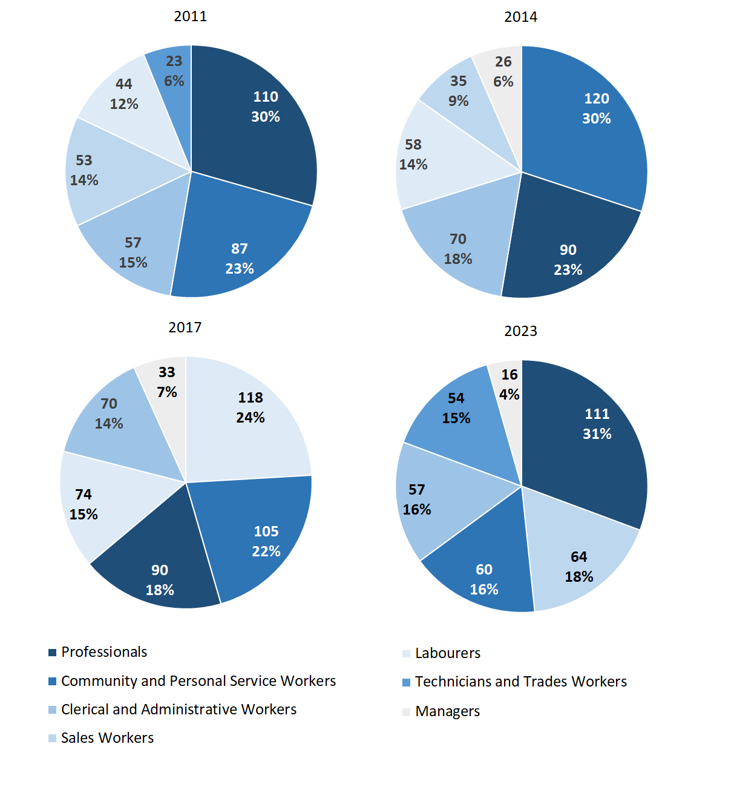

Source: Northern Territory Department of Industry, Tourism and Trade

In 2023 in Galiwin'ku:

* Professionals was the **largest occupation classification** in terms of filled jobs, accounting for 111 jobs (29.5% of total filled jobs), an increase of 21 jobs from 2017 and an increase of 21 jobs from 2014
* **other significant** occupation classifications were:
* Sales Workers account for 64 jobs or 17.0% of total jobs, a decrease of 10 jobs from 2017 and an increase of 6 jobs from 2014
* Community and Personal Service Workers account for 60 jobs or 16.0% of total jobs, a decrease of 45 jobs from 2017 and a decrease of 60 jobs from 2014
* Clerical and Administrative Workers account for 57 jobs or 15.2% of total jobs, a decrease of 13 jobs from 2017 and a decrease of 13 jobs from 2014.

**Table 17a: Count of filled jobs by ANZSCO occupation, 2011, 2014, 2017 & 2023 (a)(c)(f)(g)**

|  |  |  |  |  |  |  |  |  |  |  |  |  |
| --- | --- | --- | --- | --- | --- | --- | --- | --- | --- | --- | --- | --- |
| **Occupation (ANZSCO major group)** | **2011** | | | **2014** | | | **2017** | | | **2023** | | |
| **Aboriginal** | **Non-Aboriginal** | **Total** | **Aboriginal** | **Non-Aboriginal** | **Total** | **Aboriginal** | **Non-Aboriginal** | **Total** | **Aboriginal** | **Non-Aboriginal** | **Total** |
| Clerical and Administrative Workers | 40 | 17 | **57** | 49 | 21 | **70** | 55 | 15 | **70** | 32 | 25 | **57** |
| Community and Personal Service Workers | 72 | 15 | **87** | 102 | 18 | **120** | 90 | 15 | **105** | 52 | 8 | **60** |
| Labourers | 36 | 8 | **44** | 29 | 6 | **35** | 105 | 13 | **118** | 6 | 2 | **8** |
| Machinery Operators and Drivers | 5 | 0 | **5** | 4 | 2 | **6** | 3 | 5 | **8** | 4 | 2 | **6** |
| Managers | 1 | 15 | **16** | 3 | 23 | **26** | 8 | 25 | **33** | 5 | 11 | **16** |
| Professionals | 35 | 75 | **110** | 26 | 64 | **90** | 27 | 63 | **90** | 48 | 63 | **111** |
| Sales Workers | 53 | 0 | **53** | 52 | 6 | **58** | 66 | 8 | **74** | 57 | 7 | **64** |
| Technicians and Trades Workers | 13 | 10 | **23** | 2 | 15 | **17** | 5 | 26 | **31** | 49 | 5 | **54** |
| **Total** | **255** | **140** | **395** | **267** | **155** | **422** | **359** | **170** | **529** | **253** | **123** | **376** |

Source: Northern Territory Department of Industry, Tourism and Trade

**Table 17b: Count of filled jobs by ANZSCO occupation, 2011-2014, 2014-2017 & 2017-2023** **(a)(c)(f)(g)**

|  |  |  |  |  |  |  |  |  |  |  |  |  |
| --- | --- | --- | --- | --- | --- | --- | --- | --- | --- | --- | --- | --- |
| **Occupation (ANZSCO major group)** | **Change 2011-2014** | | | | **Change 2014-2017** | | | | **Change 2017-2023** | | | |
| **Aboriginal** | **Non-Aboriginal** | **Total** | **Aboriginal** | | **Non-Aboriginal** | **Total** | **Aboriginal** | | **Non-Aboriginal** | **Total** |
| Clerical and Administrative Workers | 9 | 4 | **13** | 6 | | -6 | **0** | -23 | | 10 | **-13** |
| Community and Personal Service Workers | 30 | 3 | **33** | -12 | | -3 | **-15** | -38 | | -7 | **-45** |
| Labourers | -7 | -2 | **-9** | 76 | | 7 | **83** | -99 | | -11 | **-110** |
| Machinery Operators and Drivers | -1 | 2 | **1** | -1 | | 3 | **2** | 1 | | -3 | **-2** |
| Managers | 2 | 8 | **10** | 5 | | 2 | **7** | -3 | | -14 | **-17** |
| Professionals | -9 | -11 | **-20** | 1 | | -1 | **0** | 21 | | 0 | **21** |
| Sales Workers | -1 | 6 | **5** | 14 | | 2 | **16** | -9 | | -1 | **-10** |
| Technicians and Trades Workers | -11 | 5 | **-6** | 3 | | 11 | **14** | 44 | | -21 | **23** |
| **Total** | **12** | **15** | **27** | **92** | | **15** | **107** | **-106** | | **-47** | **-153** |

Source: Northern Territory Department of Industry, Tourism and Trade

In 2023 in Galiwin'ku:

* of the 253 **jobs filled** by **Aboriginal** people, there were:
* 57 Sales Workers, a decrease of 9 jobs from 2017 and an increase of 5 jobs from 2014
* 52 Community and Personal Service Workers, a decrease of 38 jobs from 2017 and a decrease of 50 jobs from 2014
* 49 Technicians and Trades Workers, an increase of 44 jobs from 2017 and an increase of 47 jobs from 2014
* of the 123 **jobs filled** by **non-Aboriginal** people, there were:
* 63 Professionals, unchanged from 2017 and a decrease of 1 job from 2014
* 25 Clerical and Administrative Workers, an increase of 10 jobs from 2017 and an increase of 4 jobs from 2014
* 11 Managers, a decrease of 14 jobs from 2017 and a decrease of 12 jobs from 2014.

# Jobs by Industry by Occupation

Table 18: Count of filled jobs by industry by occupation, 2011 (a)(f)(g)(h)

|  |  |  |  |  |  |  |  |  |  |  |  |
| --- | --- | --- | --- | --- | --- | --- | --- | --- | --- | --- | --- |
| **2011** | | | | | | | | | | | |
| **Industry (ANZSIC Division)** |  | **Occupation (ANZSCO major group)** | | | | | | | | | |
| **Clerical and Administrative Workers** | **Community and Personal Service Workers** | **Labourers** | **Machinery Operators and Drivers** | **Managers** | **Professionals** | **Sales Workers** | **Technicians and Trades Workers** | **Other Occupations** | **Total** |
| Arts and Recreation Services | 2 | 0 | 0 | 0 | 1 | 3 | 0 | 0 | 0 | **6** |
| Education and Training | 6 | 25 | 3 | 0 | 1 | 43 | 0 | 0 | 0 | **78** |
| Electricity, Gas, Water and Waste Services | 0 | 0 | 0 | 0 | 0 | 0 | 0 | 1 | 0 | **1** |
| Financial and Insurance Services | 3 | 0 | 0 | 0 | 0 | 1 | 0 | 0 | 0 | **4** |
| Health Care and Social Assistance | 5 | 27 | 6 | 1 | 1 | 16 | 0 | 6 | 0 | **62** |
| Public Administration and Safety | 40 | 35 | 34 | 4 | 9 | 42 | 2 | 16 | 0 | **182** |
| Retail Trade | 0 | 0 | 0 | 0 | 4 | 0 | 51 | 0 | 0 | **55** |
| Transport, Postal and Warehousing | 1 | 0 | 0 | 0 | 0 | 4 | 0 | 0 | 0 | **5** |
| **Total** | **57** | **87** | **44** | **5** | **16** | **110** | **53** | **23** | **0** | **395** |

Source: Northern Territory Department of Industry, Tourism and Trade

Table 19: Count of filled jobs by industry by occupation, 2014 (a)(f)(g)(h)

|  |  |  |  |  |  |  |  |  |  |  |  |
| --- | --- | --- | --- | --- | --- | --- | --- | --- | --- | --- | --- |
| **2014** | | | | | | | | | | | |
| **Industry (ANZSIC Division)** |  | **Occupation (ANZSCO major group)** | | | | | | | | | |
| **Clerical and Administrative Workers** | **Community and Personal Service Workers** | **Labourers** | **Machinery Operators and Drivers** | **Managers** | **Professionals** | **Sales Workers** | **Technicians and Trades Workers** | **Other Occupations** | **Total** |
| Arts and Recreation Services | 0 | 0 | 0 | 0 | 0 | 1 | 0 | 0 | 0 | **1** |
| Education and Training | 6 | 28 | 2 | 0 | 5 | 46 | 0 | 0 | 0 | **87** |
| Electricity, Gas, Water and Waste Services | 0 | 0 | 4 | 0 | 2 | 0 | 0 | 4 | 0 | **10** |
| Financial and Insurance Services | 4 | 0 | 0 | 0 | 0 | 0 | 0 | 0 | 0 | **4** |
| Health Care and Social Assistance | 6 | 28 | 3 | 2 | 2 | 6 | 0 | 1 | 0 | **48** |
| Other Services | 0 | 0 | 0 | 0 | 0 | 1 | 0 | 0 | 0 | **1** |
| Public Administration and Safety | 52 | 58 | 26 | 2 | 12 | 31 | 0 | 8 | 0 | **189** |
| Retail Trade | 2 | 6 | 0 | 2 | 5 | 0 | 58 | 4 | 0 | **77** |
| Transport, Postal and Warehousing | 0 | 0 | 0 | 0 | 0 | 5 | 0 | 0 | 0 | **5** |
| **Total** | **70** | **120** | **35** | **6** | **26** | **90** | **58** | **17** | **0** | **422** |

Source: Northern Territory Department of Industry, Tourism and Trade

Table 20: Count of filled jobs by occupation and by industry, 2017 (a)(f)(g)(h)

|  |  |  |  |  |  |  |  |  |  |  |  |
| --- | --- | --- | --- | --- | --- | --- | --- | --- | --- | --- | --- |
| **2017** | | | | | | | | | | | |
| **Industry (ANZSIC Division)** |  | **Occupation (ANZSCO major group)** | | | | | | | | | |
| **Clerical and Administrative Workers** | **Community and Personal Service Workers** | **Labourers** | **Machinery Operators and Drivers** | **Managers** | **Professionals** | **Sales Workers** | **Technicians and Trades Workers** | **Other Occupations** | **Total** |
| Accommodation and Food Services | 0 | 2 | 4 | 0 | 1 | 0 | 0 | 1 | 0 | **8** |
| Arts and Recreation Services | 1 | 0 | 0 | 0 | 1 | 2 | 0 | 0 | 0 | **4** |
| Construction | 0 | 0 | 87 | 4 | 6 | 0 | 0 | 24 | 0 | **121** |
| Education and Training | 7 | 26 | 3 | 0 | 5 | 42 | 0 | 0 | 0 | **83** |
| Electricity, Gas, Water and Waste Services | 0 | 0 | 0 | 0 | 0 | 0 | 0 | 2 | 0 | **2** |
| Financial and Insurance Services | 5 | 0 | 0 | 0 | 0 | 0 | 0 | 0 | 0 | **5** |
| Health Care and Social Assistance | 14 | 25 | 7 | 0 | 9 | 28 | 0 | 0 | 0 | **83** |
| Other Services | 1 | 0 | 1 | 0 | 2 | 0 | 0 | 3 | 0 | **7** |
| Public Administration and Safety | 10 | 34 | 7 | 0 | 5 | 6 | 0 | 1 | 0 | **63** |
| Retail Trade | 30 | 18 | 9 | 3 | 3 | 2 | 74 | 0 | 0 | **139** |
| Transport, Postal and Warehousing | 2 | 0 | 0 | 1 | 1 | 10 | 0 | 0 | 0 | **14** |
| **Total** | **70** | **105** | **118** | **8** | **33** | **90** | **74** | **31** | **0** | **529** |

Source: Northern Territory Department of Industry, Tourism and Trade

Table 21: Count of filled jobs by occupation and by industry, 2023 (a)(f)(g)(h)

|  |  |  |  |  |  |  |  |  |  |  |  |
| --- | --- | --- | --- | --- | --- | --- | --- | --- | --- | --- | --- |
| **2023** | | | | | | | | | | | |
| **Industry (ANZSIC Division)** |  | **Occupation (ANZSCO major group)** | | | | | | | | | |
| **Clerical and Administrative Workers** | **Community and Personal Service Workers** | **Labourers** | **Machinery Operators and Drivers** | **Managers** | **Professionals** | **Sales Workers** | **Technicians and Trades Workers** | **Other Occupations** | **Total** |
| Accommodation and Food Services | 1 | 5 | 0 | 0 | 0 | 1 | 0 | 0 | 0 | **7** |
| Construction | 0 | 0 | 0 | 0 | 0 | 0 | 0 | 12 | 0 | **12** |
| Education and Training | 20 | 12 | 0 | 0 | 0 | 41 | 0 | 1 | 0 | **74** |
| Financial and Insurance Services | 4 | 0 | 0 | 0 | 0 | 0 | 0 | 0 | 0 | **4** |
| Health Care and Social Assistance | 17 | 15 | 6 | 5 | 6 | 47 | 0 | 24 | 0 | **120** |
| Manufacturing | 1 | 0 | 0 | 0 | 0 | 0 | 0 | 2 | 0 | **3** |
| Public Administration and Safety | 7 | 26 | 0 | 0 | 8 | 16 | 0 | 13 | 0 | **70** |
| Rental, Hiring and Real Estate Services | 1 | 0 | 0 | 0 | 0 | 0 | 0 | 0 | 0 | **1** |
| Retail Trade | 4 | 2 | 1 | 0 | 1 | 0 | 64 | 2 | 0 | **74** |
| Transport, Postal and Warehousing | 2 | 0 | 1 | 1 | 1 | 6 | 0 | 0 | 0 | **11** |
| **Total** | **57** | **60** | **8** | **6** | **16** | **111** | **64** | **54** | **0** | **376** |

Source: Northern Territory Department of Industry, Tourism and Trade

In 2023 in Galiwin'ku:

* The majority of jobs filled by Professionals (111), the largest occupation group, were in the Health Care and Social Assistance (47) and the Education and Training (41) industries
* all the Sales Workers (64) filled jobs, the second largest occupation group, were in the Retail Trade industry.
* Labourers showed a decrease of 110 filled jobs between 2023 and 2017, with a decrease of 87 jobs from the Construction industry
* the Construction industry showed a decrease of 109 jobs between 2023 and 2017
* Health Care and Social Assistance was the largest industry employer in 2023, with an increase of 37 jobs from 2017
* Retail Trade showed a decrease of 65 jobs between 2023 and 2017.
* The largest **occupation groups** were Professionals and Sales Workers and of the 376 **filled jobs**:
  + 111 were Professionals, an increase of 21 jobs from both 2017 and 2024
    - 47 were employed in the Health Care and Social Assistance industry, an increase of 19 jobs from 2017 and an increase of 41 jobs from 2014
    - 41 were employed in the Education and Training industry, a decrease of one job from 2017 and a decrease of 5 jobs from 2014
  + 64 were Sales Workers, a decrease of 10 jobs from 2017 and an increase 6 jobs from 2014
    - All were employed in the Retail Trade industry.
  + 8 were Labourers, a decrease of 110 filled jobs between 2023 and 2017, and a decrease of 27 from 2024
    - In 2023, 0 people were shown to be employed as labourers in the construction industry, a decrease of 87 from 2017.

In 2023 in Galiwin’ku:

* The largest **Industries** data showed:
  + The Construction industry had a decrease of 109 jobs between 2023 and 2017
  + Health Care and Social Assistance employed 120 jobs and was the largest industry employer in 2023, with an increase of 37 jobs from 2017
  + Retail Trade showed a decrease of 65 jobs between 2023 and 2017.

# Jobs by Gender

Table 22a: Count of filled jobs by gender, 2011, 2014, 2017 & 2023 (a)(c)(i)

|  |  |  |  |  |  |  |  |  |  |  |  |  |  |
| --- | --- | --- | --- | --- | --- | --- | --- | --- | --- | --- | --- | --- | --- |
| **Indicator** | **2011** | | | **2014** | | | **2017** | | | **2023** | | | |
| **Aboriginal** | **Non-Aboriginal** | **Total** | **Aboriginal** | **Non-Aboriginal** | **Total** | **Aboriginal** | **Non-Aboriginal** | **Total** | **Aboriginal** | **Non-Aboriginal** | **Total** |
| Male | 87 | 62 | **149** | 120 | 77 | **197** | 194 | 94 | **288** | 134 | 60 | **194** |
| Female | 168 | 78 | **246** | 147 | 78 | **225** | 160 | 73 | **233** | 119 | 63 | **182** |
| **Total** | **255** | **140** | **395** | **267** | **155** | **422** | **354** | **167** | **521** | **253** | **123** | **376** |

Source: Northern Territory Department of Industry, Tourism and Trade

Table 22b: Count of filled jobs by gender, 2011-2014, 2014-2017 & 2017-2023 (a)(c)(i)

|  |  |  |  |  |  |  |  |  |  |
| --- | --- | --- | --- | --- | --- | --- | --- | --- | --- |
| **Indicator** | **2011-2014 Change** | | | **2014-2017 Change** | | | **2017-2023 Change** | | |
| **Aboriginal** | **Non-Aboriginal** | **Total** | **Aboriginal** | **Non-Aboriginal** | **Total** | **Aboriginal** | **Non-Aboriginal** | **Total** |
| Male | 33 | 15 | **48** | 74 | 17 | **91** | -60 | -34 | **-94** |
| Female | -21 | 0 | **-21** | 13 | -5 | **8** | -41 | -10 | **-51** |
| **Total** | **12** | **15** | **27** | **87** | **12** | **99** | **-101** | **-44** | **-145** |

Source: Northern Territory Department of Industry, Tourism and Trade

Chart 11: Count of filled jobs by gender, 2011, 2014, 2017 & 2023 (a)(c)(i)

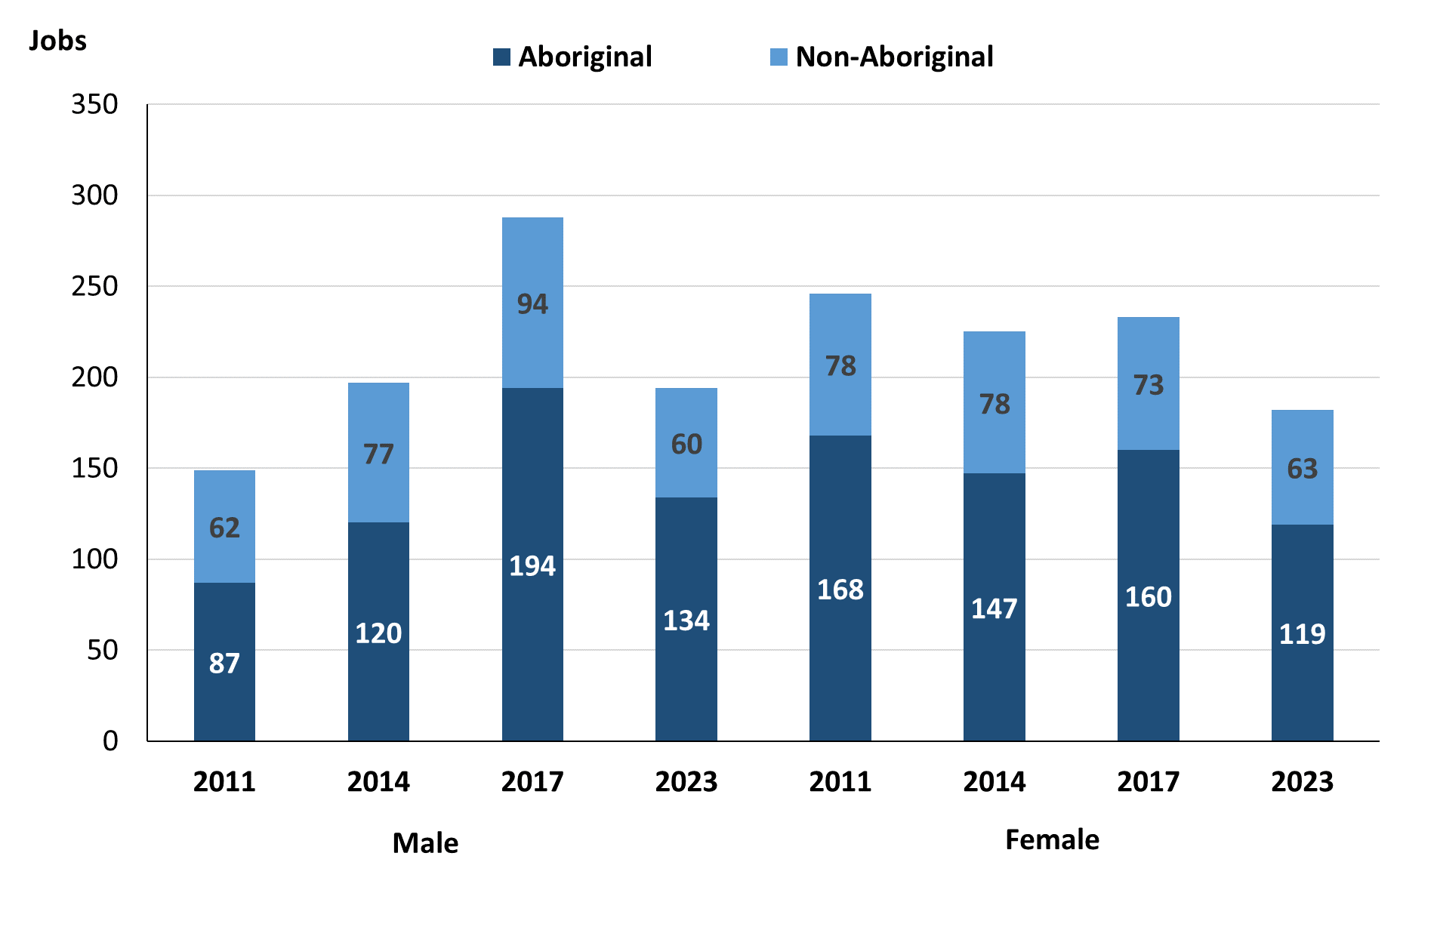

Source: Northern Territory Department of Industry, Tourism and Trade

In 2023 in Galiwin'ku:

* there were 194 **jobs filled by males**, a decrease of 94 jobs from 2017 and a decrease of 3 jobs from 2014
* of the 194 jobs **filled by males**:
* **Aboriginal males** filled 134 jobs, a decrease of 60 jobs from 2017 and an increase of 14 jobs from 2014
* **non-Aboriginal males** filled 60 jobs, a decrease of 34 jobs from 2017 and a decrease of 17 jobs from 2014
* there were 182 **jobs filled by females**, a decrease of 51 jobs from 2017 and a decrease of 43 jobs from 2014
* of the 182 jobs **filled by females**:
* **Aboriginal females** filled 119 jobs, a decrease of 41 jobs from 2017 and a decrease of 28 jobs from 2014
* **non-Aboriginal females** filled 63 jobs, a decrease of 10 jobs from 2017 and a decrease of 15 jobs from 2014.

Table 23: Count of filled jobs by gender, by full-time/part-time status, by job permanency and by sector 2011 (a)(b)(c)(d)(e)(i)

|  |  |  |  |  |  |  |  |  |  |
| --- | --- | --- | --- | --- | --- | --- | --- | --- | --- |
| **2011** | | | | | | | | | |
| **Indicator** | **Male** | | | **Female** | | | **Total** | | |
| **Aboriginal** | **Non-Aboriginal** | **Total** | **Aboriginal** | **Non-Aboriginal** | **Total** | **Aboriginal** | **Non-Aboriginal** | **Total** |
| Full-time | 63 | 62 | **125** | 102 | 76 | **178** | 165 | 138 | **303** |
| Part-time | 24 | 0 | **24** | 66 | 2 | **68** | 90 | 2 | **92** |
| **Total** | **87** | **62** | **149** | **168** | **78** | **246** | **255** | **140** | **395** |
|  | | | | | | | | | |
| Permanent | 65 | 44 | **109** | 122 | 48 | **170** | 187 | 92 | **279** |
| Temporary | 22 | 18 | **40** | 46 | 30 | **76** | 68 | 48 | **116** |
| **Total** | **87** | **62** | **149** | **168** | **78** | **246** | **255** | **140** | **395** |
|  | | | | | | | | | |
| Public Sector | 30 | 32 | **62** | 47 | 45 | **92** | 77 | 77 | **154** |
| Private Sector | 57 | 30 | **87** | 121 | 33 | **154** | 178 | 63 | **241** |
| **Total** | **87** | **62** | **149** | **168** | **78** | **246** | **255** | **140** | **395** |

Source: Northern Territory Department of Industry, Tourism and Trade

Table 24: Count of filled jobs by gender, by full-time/part-time status, by job permanency and by sector 2014 (a)(b)(c)(d)(e)(i)

|  |  |  |  |  |  |  |  |  |  |
| --- | --- | --- | --- | --- | --- | --- | --- | --- | --- |
| **2014** | | | | | | | | | |
| **Indicator** | **Male** | | | **Female** | | | **Total** | | |
| **Aboriginal** | **Non-Aboriginal** | **Total** | **Aboriginal** | **Non-Aboriginal** | **Total** | **Aboriginal** | **Non-Aboriginal** | **Total** |
| Full-time | 59 | 72 | **131** | 61 | 76 | **137** | 120 | 148 | **268** |
| Part-time | 61 | 5 | **66** | 86 | 2 | **88** | 147 | 7 | **154** |
| **Total** | **120** | **77** | **197** | **147** | **78** | **225** | **267** | **155** | **422** |
| Permanent | 88 | 58 | **146** | 75 | 67 | **142** | 163 | 125 | **288** |
| Temporary | 32 | 19 | **51** | 72 | 11 | **83** | 104 | 30 | **134** |
| **Total** | **120** | **77** | **197** | **147** | **78** | **225** | **267** | **155** | **422** |
| Public Sector | 27 | 22 | **49** | 51 | 40 | **91** | 78 | 62 | **140** |
| Private Sector | 93 | 55 | **148** | 96 | 38 | **134** | 189 | 93 | **282** |
| **Total** | **120** | **77** | **197** | **147** | **78** | **225** | **267** | **155** | **422** |

Source: Northern Territory Department of Industry, Tourism and Trade

Table 25: Count of filled jobs by gender[2], by full-time/part-time status, by job permanency and by sector 2017 (a)(b)(c)(d)(e)(i)

|  |  |  |  |  |  |  |  |  |  |  |
| --- | --- | --- | --- | --- | --- | --- | --- | --- | --- | --- |
| **2017** | | | | | | | | | | |
| **Indicator** | **Male** | | | **Female** | | | **Total** | | | |
| **Aboriginal** | **Non-Aboriginal** | **Total** | **Aboriginal** | **Non-Aboriginal** | **Total** | **Aboriginal** | **Non-Aboriginal** | **Total** |
| Full-time | 58 | 89 | **147** | 52 | 63 | **115** | 115 | 155 | **270** |
| Part-time | 136 | 5 | **141** | 108 | 10 | **118** | 244 | 15 | **259** |
| **Total** | **194** | **94** | **288** | **160** | **73** | **233** | **359** | **170** | **529** |
| Permanent | 70 | 43 | **113** | 82 | 33 | **115** | 157 | 76 | **233** |
| Temporary | 124 | 51 | **175** | 78 | 40 | **118** | 202 | 94 | **296** |
| **Total** | **194** | **94** | **288** | **160** | **73** | **233** | **359** | **170** | **529** |
| Public Sector | 25 | 26 | **51** | 40 | 31 | **71** | 70 | 57 | **127** |
| Private Sector | 169 | 68 | **237** | 120 | 42 | **162** | 289 | 113 | **402** |
| **Total** | **194** | **94** | **288** | **160** | **73** | **233** | **359** | **170** | **529** |

Source: Northern Territory Department of Industry, Tourism and Trade

Table 26: Count of filled jobs by gender, by full-time/part-time status, by job permanency and by sector 2023 (a)(b)(c)(d)(e)(i)

|  |  |  |  |  |  |  |  |  |  |  |
| --- | --- | --- | --- | --- | --- | --- | --- | --- | --- | --- |
| **2023** | | | | | | | | | | |
| **Indicator** | **Male** | | | **Female** | | | **Total** | | | |
| **Aboriginal** | **Non-Aboriginal** | **Total** | **Aboriginal** | **Non-Aboriginal** | **Total** | **Aboriginal** | **Non-Aboriginal** | **Total** |
| Full-time | 60 | 50 | **110** | 54 | 50 | **104** | 114 | 100 | **214** |
| Part-time | 74 | 10 | **84** | 65 | 13 | **78** | 139 | 23 | **162** |
| **Total** | **134** | **60** | **194** | **119** | **63** | **182** | **253** | **123** | **376** |
| Permanent | 123 | 43 | **166** | 98 | 50 | **148** | 221 | 93 | **314** |
| Temporary | 11 | 17 | **28** | 21 | 13 | **34** | 32 | 30 | **62** |
| **Total** | **134** | **60** | **194** | **119** | **63** | **182** | **253** | **123** | **376** |
| Public Sector | 30 | 37 | **67** | 33 | 34 | **67** | 63 | 71 | **134** |
| Private Sector | 104 | 23 | **127** | 86 | 29 | **115** | 190 | 52 | **242** |
| **Total** | **134** | **60** | **194** | **119** | **63** | **182** | **253** | **123** | **376** |

Source: Northern Territory Department of Industry, Tourism and Trade

In 2023 in Galiwin'ku:

* of the 194 **jobs** **filled** b**y** **males,** there were:
* **Aboriginal males** filled 134 jobs, a decrease of 60 jobs from 2017 and an increase of 14 jobs from 2014, including:
* 60 full-time jobs, an increase of 2 jobs from 2017 and an increase of 1 job from 2014
* 74 part-time jobs, a decrease of 62 jobs from 2017 and an increase of 13 jobs from 2014
* 123 Permanent Jobs, an increase of 53 jobs from 2017 and an increase of 35 jobs from 2014
* 11 Temporary Jobs, a decrease of 113 jobs from 2017 and a decrease of 21 jobs from 2014
* 30 Public Sector jobs, an increase of 5 jobs from 2017 and an increase of 3 jobs from 2014
* 104 Private Sector jobs, a decrease of 65 jobs from 2017 and an increase of 11 jobs from 2014
* **non-Aboriginal males** filled 60 jobs, a decrease of 34 jobs from 2017 and a decrease of 17 jobs from 2014, including:
* 50 full-time jobs, a decrease of 39 jobs from 2017 and a decrease of 22 jobs from 2014
* 10 part-time jobs, an increase of 5 jobs from 2017 and an increase of 5 jobs from 2014
* 43 Permanent Jobs, unchanged from 2017 and a decrease of 15 jobs from 2014
* 17 Temporary Jobs, a decrease of 34 jobs from 2017 and a decrease of 2 jobs from 2014
* 37 Public Sector jobs, an increase of 11 jobs from 2017 and an increase of 15 jobs from 2014
* 23 Private Sector jobs, a decrease of 45 jobs from 2017 and a decrease of 32 jobs from 2014
* of the 182 **jobs** **filled** **by** **females,** there were
* **Aboriginal females** filled 119 jobs, a decrease of 41 jobs from 2017 and a decrease of 28 jobs from 2014, including:
* 54 full-time jobs, an increase of 2 jobs from 2017 and a decrease of 7 jobs from 2014
* 65 part-time jobs, a decrease of 43 jobs from 2017 and a decrease of 21 jobs from 2014
* 98 Permanent Jobs, an increase of 16 jobs from 2017 and an increase of 23 jobs from 2014
* 21 Temporary Jobs, a decrease of 57 jobs from 2017 and a decrease of 51 jobs from 2014
* 33 Public Sector jobs, a decrease of 7 jobs from 2017 and a decrease of 18 jobs from 2014
* 86 Private Sector jobs, a decrease of 34 jobs from 2017 and a decrease of 10 jobs from 2014
* **non-Aboriginal females** filled 63 jobs, a decrease of 10 jobs from 2017 and a decrease of 15 jobs from 2014, including:
* 50 full-time jobs, a decrease of 13 jobs from 2017 and a decrease of 26 jobs from 2014
* 13 part-time jobs, an increase of 3 jobs from 2017 and an increase of 11 jobs from 2014
* 50 Permanent Jobs, an increase of 17 jobs from 2017 and a decrease of 17 jobs from 2014
* 13 Temporary Jobs, a decrease of 27 jobs from 2017 and an increase of 2 jobs from 2014
* 34 Public Sector jobs, an increase of 3 jobs from 2017 and a decrease of 6 jobs from 2014
* 29 Private Sector jobs, a decrease of 13 jobs from 2017 and a decrease of 9 jobs from 2014.

# Jobs by Age

Table 27a: Count of filled jobs by age, 2011, 2014, 2017 & 2023 (a)(c)(j)

|  |  |  |  |  |  |  |  |  |  |  |  |  |
| --- | --- | --- | --- | --- | --- | --- | --- | --- | --- | --- | --- | --- |
| **Indicator** | **2011** | | | **2014** | | | **2017** | | | **2023** | | |
| **Aboriginal** | **Non-Aboriginal** | **Total** | **Aboriginal** | **Non-Aboriginal** | **Total** | **Aboriginal** | **Non-Aboriginal** | **Total** | **Aboriginal** | **Non-Aboriginal** | **Total** |
| 15-24 years | 17 | 1 | **18** | 20 | 3 | **23** | 40 | 9 | **49** | 40 | 6 | **46** |
| 25-44 years | 123 | 70 | **193** | 181 | 92 | **273** | 198 | 91 | **289** | 115 | 77 | **192** |
| 45+ years | 115 | 69 | **184** | 66 | 60 | **126** | 116 | 67 | **183** | 98 | 40 | **138** |
| **Total** | **255** | **140** | **395** | **267** | **155** | **422** | **359** | **170** | **529** | **253** | **123** | **376** |

Source: Northern Territory Department of Industry, Tourism and Trade

Table 27b: Count of filled jobs by age, 2011-2014, 2014-2017 & 2017-2023 (a)(c)(j)

|  |  |  |  |  |  |  |  |  |  |
| --- | --- | --- | --- | --- | --- | --- | --- | --- | --- |
| **Indicator** | **Change 2011-2014** | | | **Change 2014-2017** | | | **Change 2017-2023** | | |
| **Aboriginal** | **Non-Aboriginal** | **Total** | **Aboriginal** | **Non-Aboriginal** | **Total** | **Aboriginal** | **Non-Aboriginal** | **Total** |
| 15-24 years | 3 | 2 | **5** | 20 | 6 | **26** | 0 | -3 | **-3** |
| 25-44 years | 58 | 22 | **80** | 17 | -1 | **16** | -83 | -14 | **-97** |
| 45+ years | -49 | -9 | **-58** | 50 | 7 | **57** | -18 | -27 | **-45** |
| **Total** | **12** | **15** | **27** | **92** | **15** | **107** | **-101** | **-44** | **-145** |

Source: Northern Territory Department of Industry, Tourism and Trade

Chart 12: Count of filled jobs by age, 2011, 2014, 2017 & 2023 (a)(c)(j)

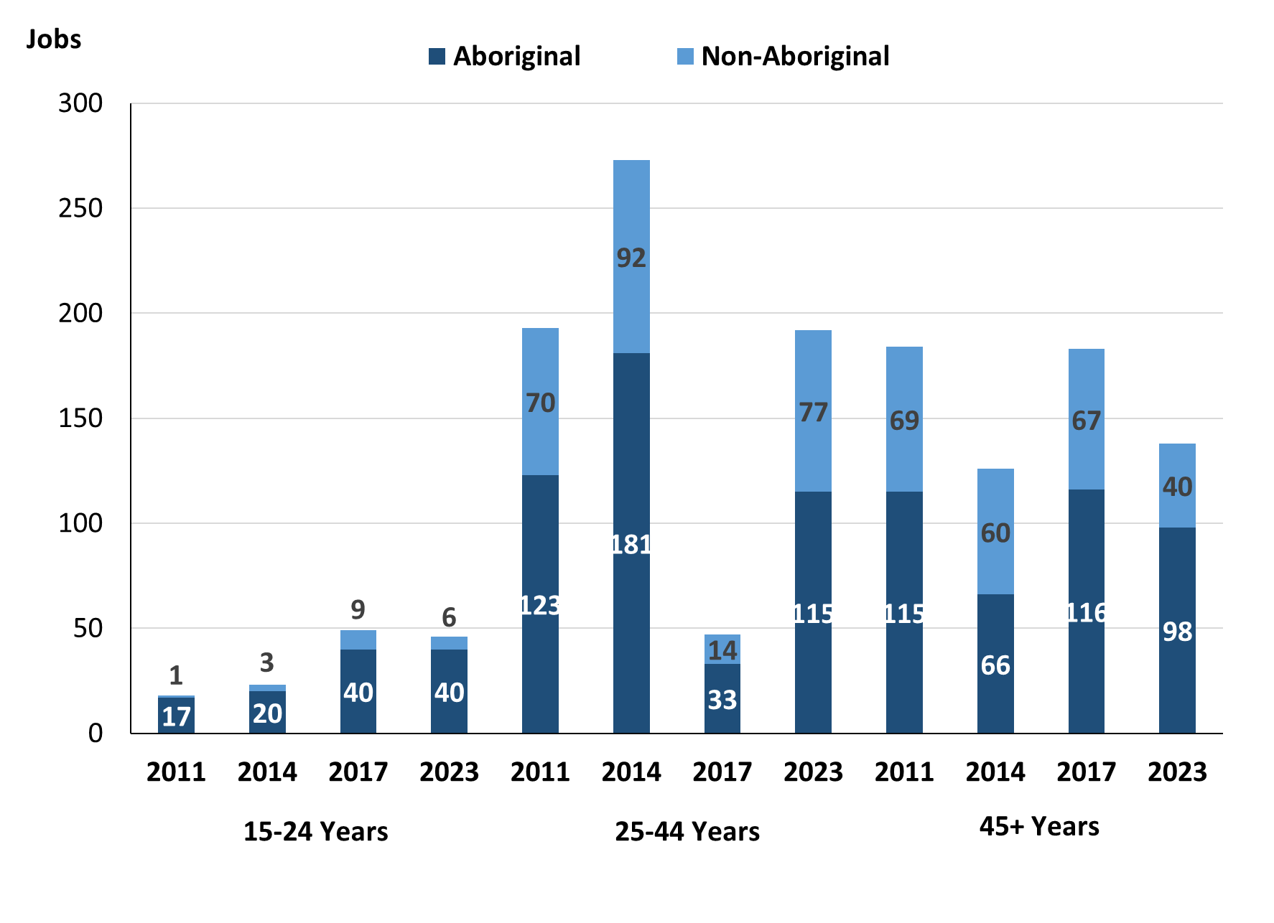

Source: Northern Territory Department of Industry, Tourism and Trade

In 2023 in Galiwin'ku:

* there were 46 **jobs** **filled** by people aged **15-24** **years**, a decrease of 3 jobs from 2017 and an increase of 23 jobs from 2014. Of these:
* **Aboriginal** people filled 40 jobs, unchanged from 2017 and an increase of 20 jobs from 2014
* **non-Aboriginal** people filled 6 jobs, a decrease of 3 jobs from 2017 and an increase of 3 jobs from 2014
* 192 **jobs** **filled** by people aged **25-44 years**, a decrease of 97 jobs from 2017 and a decrease of 81 jobs from 2014. Of these:
* **Aboriginal** people filled 115 jobs, a decrease of 83 jobs from 2017 and a decrease of 66 jobs from 2014
* **non-Aboriginal** people filled 77 jobs, a decrease of 14 jobs from 2017 and a decrease of 15 jobs from 2014
* 138 **jobs** filled by people aged **45+ years**, a decrease of 45 jobs from 2017 and an increase of 12 jobs from 2014. Of these:
* **Aboriginal** people filled 98 jobs, a decrease of 18 jobs from 2017 and an increase of 32 jobs from 2014
* **non-Aboriginal** people filled 40 jobs, a decrease of 27 jobs from 2017 and a decrease of 20 jobs from 2014.

Table 28: Count of filled jobs by age, by full-time/part-time status, by job permanency and by sector June-July 2011 (a)(b)(c)(d)(e)(i)

|  |  |  |  |  |  |  |  |  |  |  |  |  |  |
| --- | --- | --- | --- | --- | --- | --- | --- | --- | --- | --- | --- | --- | --- |
| **2011** | | | | | | | | | | | | | |
| **Indicator** | **15-24 years** | | | **25-44 years** | | | **45+ years** | | | **Total** | | | |
| **Aboriginal** | **Non-Aboriginal** | **Total** | **Aboriginal** | **Non-Aboriginal** | **Total** | **Aboriginal** | **Non-Aboriginal** | **Total** | **Aboriginal** | **Non-Aboriginal** | **Total** |
| Full-time | 13 | 1 | **14** | 83 | 69 | **152** | 69 | 68 | **137** | 165 | 138 | **303** |
| Part-time | 4 | 0 | **4** | 40 | 1 | **41** | 46 | 1 | **47** | 90 | 2 | **92** |
| **Total** | **17** | **1** | **18** | **123** | **70** | **193** | **115** | **69** | **184** | **255** | **140** | **395** |
| Permanent | 16 | 1 | **17** | 81 | 44 | **125** | 90 | 47 | **137** | 187 | 92 | **279** |
| Temporary | 1 | 0 | **1** | 42 | 26 | **68** | 25 | 22 | **47** | 68 | 48 | **116** |
| **Total** | **17** | **1** | **18** | **123** | **70** | **193** | **115** | **69** | **184** | **255** | **140** | **395** |
| Public Sector | 7 | 0 | **7** | 37 | 38 | **75** | 33 | 39 | **72** | 77 | 77 | **154** |
| Private Sector | 10 | 1 | **11** | 86 | 32 | **118** | 82 | 30 | **112** | 178 | 63 | **241** |
| **Total** | **17** | **1** | **18** | **123** | **70** | **193** | **115** | **69** | **184** | **255** | **140** | **395** |

Source: Northern Territory Department of Industry, Tourism and Trade

Table 29: Count of filled jobs by age, by full-time/part-time status, by job permanency and by sector June-July 2014 (a)(b)(c)(d)(e)(i)

|  |  |  |  |  |  |  |  |  |  |  |  |  |
| --- | --- | --- | --- | --- | --- | --- | --- | --- | --- | --- | --- | --- |
| **2014** | | | | | | | | | | | | |
| **Indicator** | **15-24 years** | | | **25-44 years** | | | **45+ years** | | | **Total** | | |
| **Aboriginal** | **Non-Aboriginal** | **Total** | **Aboriginal** | **Non-Aboriginal** | **Total** | **Aboriginal** | **Non-Aboriginal** | **Total** | **Aboriginal** | **Non-Aboriginal** | **Total** |
| Full-time | 8 | 3 | **11** | 80 | 90 | **170** | 32 | 55 | **87** | 120 | 148 | **268** |
| Part-time | 12 | 0 | **12** | 101 | 2 | **103** | 34 | 5 | **39** | 147 | 7 | **154** |
| **Total** | **20** | **3** | **23** | **181** | **92** | **273** | **66** | **60** | **126** | **267** | **155** | **422** |
| Permanent | 8 | 2 | **10** | 118 | 74 | **192** | 37 | 49 | **86** | 163 | 125 | **288** |
| Temporary | 12 | 1 | **13** | 63 | 18 | **81** | 29 | 11 | **40** | 104 | 30 | **134** |
| **Total** | **20** | **3** | **23** | **181** | **92** | **273** | **66** | **60** | **126** | **267** | **155** | **422** |
| Public Sector | 6 | 1 | **7** | 37 | 27 | **64** | 35 | 34 | **69** | 78 | 62 | **140** |
| Private Sector | 14 | 2 | **16** | 144 | 65 | **209** | 31 | 26 | **57** | 189 | 93 | **282** |
| **Total** | **20** | **3** | **23** | **181** | **92** | **273** | **66** | **60** | **126** | **267** | **155** | **422** |

Source: Northern Territory Department of Industry, Tourism and Trade

Table 30: Count of filled jobs by age, by full-time/part-time status, by job permanency and by sector June-July 2017 (a)(b)(c)(d)(e)(i)

|  |  |  |  |  |  |  |  |  |  |  |  |  |  |
| --- | --- | --- | --- | --- | --- | --- | --- | --- | --- | --- | --- | --- | --- |
| **2017** | | | | | | | | | | | | | |
| **Indicator** | **15-24 years** | | | **25-44 years** | | | **45+ years** | | | **Total** | | |
| **Aboriginal** | **Non-Aboriginal** | **Total** | **Aboriginal** | **Non-Aboriginal** | **Total** | **Aboriginal** | **Non-Aboriginal** | **Total** | **Aboriginal** | **Non-Aboriginal** | **Total** |
| Full-time | 1 | 9 | **10** | 53 | 80 | **133** | 56 | 63 | **119** | 115 | 155 | **270** |
| Part-time | 39 | 0 | **39** | 145 | 11 | **156** | 60 | 4 | **64** | 244 | 15 | **259** |
| **Total** | **40** | **9** | **49** | **198** | **91** | **289** | **116** | **67** | **183** | **359** | **170** | **529** |
| Permanent | 4 | 4 | **8** | 73 | 34 | **107** | 75 | 38 | **113** | 157 | 76 | **233** |
| Temporary | 36 | 5 | **41** | 125 | 57 | **182** | 41 | 29 | **70** | 202 | 94 | **296** |
| **Total** | **40** | **9** | **49** | **198** | **91** | **289** | **116** | **67** | **183** | **359** | **170** | **529** |
| Public Sector | 7 | 3 | **10** | 31 | 28 | **59** | 27 | 26 | **53** | 70 | 57 | **127** |
| Private Sector | 33 | 6 | **39** | 167 | 63 | **230** | 89 | 41 | **130** | 289 | 113 | **402** |
| **Total** | **40** | **9** | **49** | **198** | **91** | **289** | **116** | **67** | **183** | **359** | **170** | **529** |

Source: Northern Territory Department of Industry, Tourism and Trade

Table 31: Count of filled jobs by age, by full-time/part-time status, by job permanency and by sector September 2023 (a)(b)(c)(d)(e)(i)

| **2023** | | | | | | | | | | | | |
| --- | --- | --- | --- | --- | --- | --- | --- | --- | --- | --- | --- | --- |
| **Indicator** | **15-24 years** | | | **25-44 years** | | | **45+ years** | | | **Total** | | |
| **Aboriginal** | **Non-Aboriginal** | **Total** | **Aboriginal** | **Non-Aboriginal** | **Total** | **Aboriginal** | **Non-Aboriginal** | **Total** | **Aboriginal** | **Non-Aboriginal** | **Total** |
| Full-time | 15 | 2 | **17** | 42 | 66 | **108** | 57 | 32 | **89** | 114 | 100 | **214** |
| Part-time | 25 | 4 | **29** | 73 | 11 | **84** | 41 | 8 | **49** | 139 | 23 | **162** |
| Total | **40** | **6** | **46** | **115** | **77** | **192** | **98** | **40** | **138** | **253** | **123** | **376** |
| Permanent | 38 | 5 | **43** | 98 | 54 | **152** | 85 | 34 | **119** | 221 | 93 | **314** |
| Temporary | 2 | 1 | **3** | 17 | 23 | **40** | 13 | 6 | **19** | 32 | 30 | **62** |
| Total | **40** | **6** | **46** | **115** | **77** | **192** | **98** | **40** | **138** | **253** | **123** | **376** |
| Public Sector | 34 | 6 | **40** | 85 | 24 | **109** | 71 | 22 | **93** | 190 | 52 | **242** |
| Private Sector | 6 | 0 | **6** | 30 | 53 | **83** | 27 | 18 | **45** | 63 | 71 | **134** |
| Total | **40** | **6** | **46** | **115** | **77** | **192** | **98** | **40** | **138** | **253** | **123** | **376** |

*Source: Northern Territory Department of Industry, Tourism and Trade*

In 2023 in Galiwin'ku:

* of the 46 **jobs** **filled** by people aged **15-24 years**, there were:
* **Aboriginal** people filled 40 jobs, of which
* 15 were full-time jobs, an increase of 14 jobs from 2017 and an increase of 7 jobs from 2014
* 25 were part-time jobs, a decrease of 14 jobs from 2017 and an increase of 13 jobs from 2014
* 38 were Permanent Jobs, an increase of 34 jobs from 2017 and an increase of 30 jobs from 2014
* 2 were Temporary Jobs, a decrease of 34 jobs from 2017 and a decrease of 10 jobs from 2014
* 34 were Public Sector jobs, an increase of 27 jobs from 2017 and an increase of 28 jobs from 2014
* 6 were Private Sector jobs, a decrease of 27 jobs from 2017 and a decrease of 8 jobs from 2014
* **non-Aboriginal** people filled 6 jobs, of which:
* 2 were full-time jobs, a decrease of 7 jobs from 2017 and a decrease of 1 job from 2014
* 4 were part-time jobs, an increase of 4 jobs from 2017 and an increase of 4 jobs from 2014
* 5 were Permanent Jobs, an increase of 1 job from 2017 and an increase of 3 jobs from 2014
* 1 was a temporary job, a decrease of 4 jobs from 2017 and unchanged from 2014
* 6 were Public Sector jobs, an increase of 3 jobs from 2017 and an increase of 5 jobs from 2014
* none were Private Sector jobs, a decrease of 6 jobs from 2017 and a decrease of 2 jobs from 2014
* of the 192 **jobs** **filled** by people aged **25-44 years**, there were:
* **Aboriginal** people filled 115 jobs, of which:
* 42 were full-time jobs, a decrease of 11 jobs from 2017 and a decrease of 38 jobs from 2014
* 73 were part-time jobs, a decrease of 72 jobs from 2017 and a decrease of 28 jobs from 2014
* 98 were Permanent Jobs, an increase of 25 jobs from 2017 and a decrease of 20 jobs from 2014
* 17 were Temporary Jobs, a decrease of 108 jobs from 2017 and a decrease of 46 jobs from 2014
* 85 were Public Sector jobs, an increase of 54 jobs from 2017 and an increase of 48 jobs from 2014
* 30 were Private Sector jobs, a decrease of 137 jobs from 2017 and a decrease of 114 jobs from 2014
* **non-Aboriginal** people filled 77 jobs, of which:
* 66 were full-time jobs, a decrease of 14 jobs from 2017 and a decrease of 24 jobs from 2014
* 11 were part-time jobs, unchanged from 2017 and an increase of 9 jobs from 2014
* 54 were Permanent Jobs, an increase of 20 jobs from 2017 and a decrease of 20 jobs from 2014
* 23 were Temporary Jobs, a decrease of 34 jobs from 2017 and an increase of 5 jobs from 2014
* 24 were Public Sector jobs, a decrease of 4 jobs from 2017 and a decrease of 3 jobs from 2014
* 53 were Private Sector jobs, a decrease of 10 jobs from 2017 and a decrease of 12 jobs from 2014
* of the 138 **jobs** **filled** by people aged **45+ years**, there were:
* **Aboriginal** people filled 98 jobs, of which:
* 57 were full-time jobs, an increase of 1 job from 2017 and an increase of 25 jobs from 2014
* 41 were part-time jobs, a decrease of 19 jobs from 2017 and an increase of 7 jobs from 2014
* 85 were Permanent Jobs, an increase of 10 jobs from 2017 and an increase of 48 jobs from 2014
* 13 were Temporary Jobs, a decrease of 28 jobs from 2017 and a decrease of 16 jobs from 2014
* 71 were Public Sector jobs, an increase of 44 jobs from 2017 and an increase of 36 jobs from 2014
* 27 were Private Sector jobs, a decrease of 62 jobs from 2017 and a decrease of 4 jobs from 2014
* **non-Aboriginal** people filled 40 jobs, of which:
* 32 were full-time jobs, a decrease of 31 jobs from 2017 and a decrease of 23 jobs from 2014
* 8 were part-time jobs, an increase of 4 jobs from 2017 and an increase of 3 jobs from 2014
* 34 were Permanent Jobs, a decrease of 4 jobs from 2017 and a decrease of 15 jobs from 2014
* 6 were Temporary Jobs, a decrease of 23 jobs from 2017 and a decrease of 5 jobs from 2014
* 22 were Public Sector jobs, a decrease of 4 jobs from 2017 and a decrease of 12 jobs from 2014
* 18 were Private Sector jobs, a decrease of 23 jobs from 2017 and a decrease of 8 jobs from 2014.

# Vocational Education and Training

*Note:* *The 2010 data is in accordance with the new, standardised reporting procedures that focus on all training activities conducted in the remote town, irrespective of funding source, as compared to earlier publications. As a result, the 2010 VET data values in this publication might not match those in earlier publications.*

*The impact of the Remote Jobs and Communities Program (RJCP), established in 2013, has played a significant role in the reduction of accredited training in many remote towns across the Territory.*

Table 32a: Northern Territory Vocational Education and Training (VET) students, 2010, 2013, 2016 and 2023 (k)

|  |  |  |  |  |  |  |  |  |
| --- | --- | --- | --- | --- | --- | --- | --- | --- |
| **VET Funding Group** | **2010** | | **2013** | | **2016** | | **2023** | |
| **No.** | **% of Total** | **No.** | **% of Total** | **No.** | **% of Total** | **No.** | **% of Total** |
| Arts, Entertainment, Sports and Recreation | 0 | 0% | 28 | 11% | 14 | 3% | 1 | 0% |
| Automotive | 3 | 1% | 2 | 1% | 0 | 0% | 0 | 0% |
| Building and Construction | 98 | 26% | 25 | 10% | 136 | 33% | 41 | 14% |
| Business and Clerical | 18 | 5% | 15 | 6% | 36 | 9% | 18 | 6% |
| Community Services, Health and Education | 26 | 7% | 73 | 28% | 115 | 28% | 76 | 27% |
| Engineering and Mining | 31 | 8% | 30 | 12% | 15 | 4% | 0 | 0% |
| Finance, Banking and Insurance | 6 | 2% | 7 | 3% | 5 | 1% | 0 | 0% |
| General Education and Training | 1 | 0% | 0 | 0% | 2 | 0% | 36 | 13% |
| Primary Industry | 79 | 21% | 22 | 8% | 34 | 8% | 28 | 10% |
| Sales and Personal Services | 115 | 31% | 41 | 16% | 22 | 5% | 49 | 17% |
| Textiles, Clothing, Footwear and Furnishings | 0 | 0% | 0 | 0% | 11 | 3% | 7 | 2% |
| Tourism and Hospitality | 0 | 0% | 16 | 6% | 9 | 2% | 5 | 2% |
| Transport and Storage | 0 | 0% | 0 | 0% | 12 | 3% | 0 | 0% |
| Other | 0 | 0% | 0 | 0% | 0 | 0% | 24 | 8% |
| **Total** | **377** | **100%** | **259** | **100%** | **411** | **100%** | **247** | **100%** |

Source: Northern Territory Department of Industry, Tourism and Trade

Table 32b: Northern Territory Vocational Education and Training (VET) students, 2010-2013, 2013-2016 and 2016-2023 (k)

|  |  |  |  |
| --- | --- | --- | --- |
| **VET Funding Group** | **Change** | | |
| **2010-2013** | **2013-2016** | **2016-2023** |
| Arts, Entertainment, Sports and Recreation | 28 | - 14 | -13 |
| Automotive | - 1 | - 2 | 0 |
| Building and Construction | - 73 | 111 | -95 |
| Business and Clerical | - 3 | 21 | -18 |
| Community Services, Health and Education | 47 | 42 | -39 |
| Engineering and Mining | - 1 | - 15 | -15 |
| Finance, Banking and Insurance | 1 | - 2 | -5 |
| General Education and Training | - 1 | 2 | 34 |
| Primary Industry | - 57 | 12 | -6 |
| Sales and Personal Services | - 74 | - 19 | 27 |
| Textiles, Clothing, Footwear and Furnishings | 0 | 11 | -4 |
| Tourism and Hospitality | 16 | - 7 | -4 |
| Transport and Storage | 0 | 12 | -12 |
| Other | 0 | 0 | 24 |
| **Total** | **- 118** | **152** | -**164** |

Source: Northern Territory Department of Industry, Tourism and Trade

In 2023 in Galiwin'ku:

* there were 247 **VET students**, a decrease of 164 students from 2016 and a decrease of 12 students from 2013
* the areas of VET activity with the most students were:
  + Community Services, Health, and Education with 76 students
  + Sales and Personal Service with 49 students
  + Building and Construction with 41 students
* General Education and Training reported the largest increase with an increase of 34 students compared to 2016
* Building and Construction reported the largest decrease with a decrease of 95 students compared to 2016.

Table 33a: Northern Territory Vocational Education and Training (VET) unit enrolments, 2010, 2013, 2016 and 2023 (l)

|  |  |  |  |  |  |  |  |  |
| --- | --- | --- | --- | --- | --- | --- | --- | --- |
| **VET Funding Group** | **2010** | | **2013** | | **2016** | | **2023** | |
| **No.** | **% of Total** | **No.** | **% of Total** | **No.** | **% of Total** | **No.** | **% of Total** |
| Arts, Entertainment, Sports and Recreation | 0 | 0% | 281 | 21% | 53 | 4% | 1 | 0% |
| Automotive | 8 | 0% | 5 | 0% | 0 | 0% | 0 | 0% |
| Building and Construction | 583 | 36% | 111 | 8% | 420 | 28% | 51 | 6% |
| Business and Clerical | 41 | 3% | 140 | 10% | 178 | 12% | 63 | 7% |
| Community Services, Health and Education | 121 | 8% | 327 | 24% | 353 | 23% | 275 | 30% |
| Engineering and Mining | 137 | 9% | 75 | 6% | 15 | 1% | 0 | 0% |
| Finance, Banking and Insurance | 21 | 1% | 31 | 2% | 16 | 1% | 0 | 0% |
| General Education and Training | 2 | 0% | 0 | 0% | 5 | 0% | 94 | 10% |
| Primary Industry | 252 | 16% | 119 | 9% | 91 | 6% | 216 | 23% |
| Sales and Personal Services | 439 | 27% | 233 | 17% | 164 | 11% | 141 | 15% |
| Textiles, Clothing, Footwear and Furnishings | 0 | 0% | 0 | 0% | 66 | 4% | 14 | 2% |
| Tourism and Hospitality | 0 | 0% | 32 | 2% | 34 | 2% | 10 | 1% |
| Transport and Storage | 0 | 0% | 0 | 0% | 108 | 7% | 0 | 0% |
| Other | 0 | 0% | 0 | 0% | 0 | 0% | 62 | 7% |
| **Total** | **1 604** | **100%** | **1 354** | **100%** | **1 503** | **100%** | **927** | **100%** |

Source: Northern Territory Department of Industry, Tourism and Trade

Table 33b: Northern Territory Vocational Education and Training (VET) unit enrolments, 2010-2013, 2013-2016 and 2016-2023 (l)

|  |  |  |  |
| --- | --- | --- | --- |
| **VET Funding Group** | **Change** | | |
| **2010-2013** | **2013-2016** | **2016-2023** |
| Arts, Entertainment, Sports and Recreation | 281 | - 228 | -52 |
| Automotive | - 3 | - 5 | 0 |
| Building and Construction | - 472 | 309 | -369 |
| Business and Clerical | 99 | 38 | -115 |
| Community Services, Health and Education | 206 | 26 | -78 |
| Engineering and Mining | - 62 | - 60 | -15 |
| Finance, Banking and Insurance | 10 | - 15 | -16 |
| General Education and Training | - 2 | 5 | 89 |
| Primary Industry | - 133 | - 28 | 125 |
| Sales and Personal Services | - 206 | - 69 | -23 |
| Textiles, Clothing, Footwear and Furnishings | 0 | 66 | -52 |
| Tourism and Hospitality | 32 | 2 | -24 |
| Transport and Storage | 0 | 108 | -108 |
| Other | 0 | 0 | 62 |
| **Total** | **- 250** | **149** | **-576** |

Source: Northern Territory Department of Industry, Tourism and Trade

In 2023 in Galiwin'ku:

* there were 927 **VET unit enrolments**, a decrease of 576-unit enrolments from 2016 and a decrease of 427-unit enrolments from 2013,
* the areas of VET activity with the most unit enrolments were:
  + Community Services, Health, and Education with 275-unit enrolments,
  + Primary Industry with 216-unit enrolments,
  + Sales and Personal Service with 141-unit enrolments,
* Primary Industry reported the largest increase in unit enrolments with an increase of 125-unit enrolments compared to 2016,
* Building and Construction reported the largest decrease in unit enrolments with a decrease of 369 compared to 2016.

Table 34a: Northern Territory Vocational Education and Training (VET) nominal hours, 2010, 2013, 2016 and 2023 (m)

|  |  |  |  |  |  |  |  |  |
| --- | --- | --- | --- | --- | --- | --- | --- | --- |
| **VET Funding Group** | **2010** | | **2013** | | **2016** | | **2023** | |
| **No.** | **% of Total** | **No.** | **% of Total** | **No.** | **% of Total** | **No.** | **% of Total** |
| Arts, Entertainment, Sports and Recreation | 0 | 0% | 6 171 | 15% | 2 390 | 7% | 50 | 0% |
| Automotive | 315 | 1% | 85 | 0% | 0 | 0% | 0 | 0% |
| Building and Construction | 19 154 | 36% | 2 780 | 7% | 6 980 | 21% | 1346 | 4% |
| Business and Clerical | 920 | 2% | 5 510 | 14% | 4 320 | 13% | 2075 | 6% |
| Community Services, Health and Education | 5 168 | 10% | 11 130 | 27% | 3 917 | 12% | 10040 | 31% |
| Engineering and Mining | 4 570 | 9% | 4 742 | 12% | 280 | 1% | 0 | 0% |
| Finance, Banking and Insurance | 630 | 1% | 915 | 2% | 370 | 1% | 0 | 0% |
| General Education and Training | 180 | 0% | 0 | 0% | 0 | 0% | 5590 | 17% |
| Primary Industry | 8 840 | 17% | 1 615 | 4% | 3 100 | 10% | 6344 | 19% |
| Sales and Personal Services | 12 806 | 24% | 7 205 | 18% | 4 105 | 13% | 4620 | 14% |
| Textiles, Clothing, Footwear and Furnishings | 0 | 0% | 0 | 0% | 2 470 | 8% | 280 | 1% |
| Tourism and Hospitality | 0 | 0% | 464 | 1% | 573 | 2% | 275 | 1% |
| Transport and Storage | 0 | 0% | 0 | 0% | 4 020 | 12% | 0 | 0% |
| Other | 0 | 0% | 0 | 0% | 0 | 0% | 2215 | 7% |
| **Total** | **52 583** | **100%** | **40 617** | **100%** | **32 525** | **100%** | **32835** | **100%** |

Source: Northern Territory Department of Industry, Tourism and Trade

Table 34b: Northern Territory Vocational Education and Training (VET) nominal hours, 2010, 2013, 2016 and 2023 (m)

|  |  |  |  |
| --- | --- | --- | --- |
| **VET Funding Group** | **Change** | | |
| **2010-2013** | **2013-2016** | **2016-2023** |
| Arts, Entertainment, Sports and Recreation | 6 171 | -3 781 | -2340 |
| Automotive | - 230 | - 85 | 0 |
| Building and Construction | -16 374 | 4 200 | -5634 |
| Business and Clerical | 4 590 | -1 190 | -2245 |
| Community Services, Health and Education | 5 962 | -7 213 | 6123 |
| Engineering and Mining | 172 | -4 462 | -280 |
| Finance, Banking and Insurance | 285 | - 545 | -370 |
| General Education and Training | - 180 | 0 | 5590 |
| Primary Industry | -7 225 | 1 485 | 3244 |
| Sales and Personal Services | -5 601 | -3 100 | 515 |
| Textiles, Clothing, Footwear and Furnishings | 0 | 2 470 | -2190 |
| Tourism and Hospitality | 464 | 109 | -298 |
| Transport and Storage | 0 | 4 020 | -4020 |
| Other | 0 | 0 | 2215 |
| **Total** | **-11 966** | **-8 092** | **310** |

Source: Northern Territory Department of Industry, Tourism and Trade

In 2023 in Galiwin'ku:

* there were 32,835 **VET nominal hours** delivered, an increase of 310 nominal hours delivered from 2016 and a decrease of 7,782 nominal hours delivered from 2013,
* VET activity with the most nominal hours delivered were:
  + Community Services, Health, and Education with 10,040 nominal hours delivered,
  + Primary Industry with 6,344 nominal hours delivered,
  + General Education and Training with 5,590 nominal hours delivered,
* Community Services, Health and Education reported the largest increase in nominal hours delivered with an increase of 6,123 nominal hours compared to 2016,
* Building and Construction reported the largest decrease in nominal hours delivered with a decrease of 5,634 nominal hours compared to 2016.

Caveat: *Nominal hours are based on the hours funded through Northern Territory Department of Industry, Tourism and Trade contracts; students and units include delivery that has been funded in a previous year, fee for service or training that did not meet the funding requirements. Because of this a direct match cannot be made between hours and student/units.*

Table 35a: Northern Territory Vocational Education and Training (VET) unit completions, 2010, 2013, 2016 and 2023 (n)

|  |  |  |  |  |  |  |  |  |
| --- | --- | --- | --- | --- | --- | --- | --- | --- |
| **VET Funding Group** | **2010** | | **2013** | | **2016** | | **2023** | |
| **No.** | **% of Total** | **No.** | **% of Total** | **No.** | **% of Total** | **No.** | **% of Total** |
| Arts, Entertainment, Sports and Recreation | 0 | 0% | 175 | 26% | 47 | 4% | 1 | 0% |
| Automotive | 8 | 1% | 2 | 0% | 0 | 0% | 0 | 0% |
| Building and Construction | 224 | 22% | 15 | 2% | 261 | 25% | 51 | 6% |
| Business and Clerical | 0 | 0% | 5 | 1% | 14 | 1% | 63 | 7% |
| Community Services, Health and Education | 93 | 9% | 152 | 23% | 324 | 31% | 275 | 30% |
| Engineering and Mining | 63 | 6% | 56 | 8% | 14 | 1% | 0 | 0% |
| Finance, Banking and Insurance | 1 | 0% | 3 | 0% | 4 | 0% | 0 | 0% |
| General Education and Training | 0 | 0% | 0 | 0% | 3 | 0% | 94 | 10% |
| Primary Industry | 195 | 20% | 55 | 8% | 70 | 7% | 216 | 23% |
| Sales and Personal Services | 415 | 42% | 172 | 26% | 131 | 12% | 141 | 15% |
| Textiles, Clothing, Footwear and Furnishings | 0 | 0% | 0 | 0% | 58 | 5% | 14 | 2% |
| Tourism and Hospitality | 0 | 0% | 32 | 5% | 33 | 3% | 10 | 1% |
| Transport and Storage | 0 | 0% | 0 | 0% | 103 | 10% | 0 | 0% |
| Other | 0 | 0% | 0 | 0% | 0 | 0% | 62 | 7% |
| **Total** | **999** | **100%** | **667** | **100%** | **1 062** | **100%** | **927** | **100%** |

Source: Northern Territory Department of Industry, Tourism and Trade

Table 35b: Northern Territory Vocational Education and Training (VET) unit completions, 2010-2013, 2013-2016 and 2016-2023 (n)

|  |  |  |  |
| --- | --- | --- | --- |
| **VET Funding Group** | **Change** | | |
| **2010-2013** | **2013-2016** | **2016-2023** |
| Arts, Entertainment, Sports and Recreation | 175 | - 128 | -46 |
| Automotive | - 6 | - 2 | 0 |
| Building and Construction | - 209 | 246 | -210 |
| Business and Clerical | 5 | 9 | 49 |
| Community Services, Health and Education | 59 | 172 | -49 |
| Engineering and Mining | - 7 | - 42 | -14 |
| Finance, Banking and Insurance | 2 | 1 | -4 |
| General Education and Training | 0 | 3 | 91 |
| Primary Industry | - 140 | 15 | 146 |
| Sales and Personal Services | - 243 | - 41 | 10 |
| Textiles, Clothing, Footwear and Furnishings | 0 | 58 | -44 |
| Tourism and Hospitality | 32 | 1 | -23 |
| Transport and Storage | 0 | 103 | -103 |
| Other | 0 | 0 | 62 |
| **Total** | **- 332** | **395** | **-135** |

Source: Northern Territory Department of Industry, Tourism and Trade

In 2023 in Galiwin'ku:

* there were 927 **VET unit completions**, a decrease of 135-unit completions from 2016 and an increase of 260-unit completions from 2013,
* VET activity with the most unit completions were
  + Community Services, Health, and Education with 275-unit completions,
  + Primary Industry with 216-unit completions,
  + Sales and Personal Service with 141-unit completions,
* Primary Industry reported the largest increase in unit completions with an increase of 146-unit completions compared to 2016,
* Building and Construction reported the largest decrease in unit completions with a decrease of 210-unit completions compared to 2016.

# Population

**Table 36: Population distribution by gender and age (p)(r)**

|  |  |  |  |  |  |  |  |  |  |
| --- | --- | --- | --- | --- | --- | --- | --- | --- | --- |
| **Indicator** | **2011** | | | **2021** | | | **Change (2011-2021)** | | |
| **Male** | **Female** | **Total** | **Male** | **Female** | **Total** | **Male** | **Female** | **Total** | |
| **0-4 years** | 129 | 130 | **259** | 103 | 95 | **198** | -26 | -35 | **-61** | |
| **5-14 years** | 264 | 233 | **497** | 199 | 181 | **380** | -65 | -52 | **-117** | |
| **15-24 years** | 165 | 177 | **342** | 266 | 249 | **515** | 101 | 72 | **173** | |
| **25-44 years** | 347 | 328 | **675** | 323 | 347 | **670** | -24 | 19 | **-5** | |
| **45-64 years** | 138 | 167 | **305** | 162 | 192 | **354** | 24 | 25 | **49** | |
| **65+ years** | 20 | 26 | **46** | 33 | 42 | **75** | 13 | 16 | **29** | |
| **Total** | **1067** | **1062** | **2129** | **1090** | **1109** | **2199** | **23** | **47** | **70** | |

*Source: Australian Bureau of Statistics*

In 2021 in Galiwin'ku:

* there were an estimated 2199 people, of which:
* 1090 (49.6%) were male
* 1109 (50.4%) were female
* Between 2011 and 2021, the **overall population** in Galiwin'ku increased by 70 people from 2011, or an average of 0.3% per year compared to -0.5% across the 28 remote towns and 1.0% Territory wide
* The **male population** increased by 23 people from 2011
* The **female population** increased by 47 people from 2011
* In 2021, the **working age population** (15 years and over) in Galiwin'ku was an estimated 1614 people (73.4% of the total population) compared with 1368 people (64.3% of the total population) in 2011. Of these:
* 515 (23.4%) were between 15 and 24 years of age
* 670 (30.5%) were between 25 and 44 years of age
* 354 (16.1%) were between 45 and 64 years of age
* 75 (3.4%) were over 65 years of age
* Of the 1614 people of **working age:**
* 784 (48.6%) were male
* 830 (51.4%) were female.

There were 0.3 jobs in Galiwin'ku per working age person compared to 0.3 jobs per working age person across the 28 remote towns in the Northern Territory.

**Chart 13: Population comparison (p)(q)**

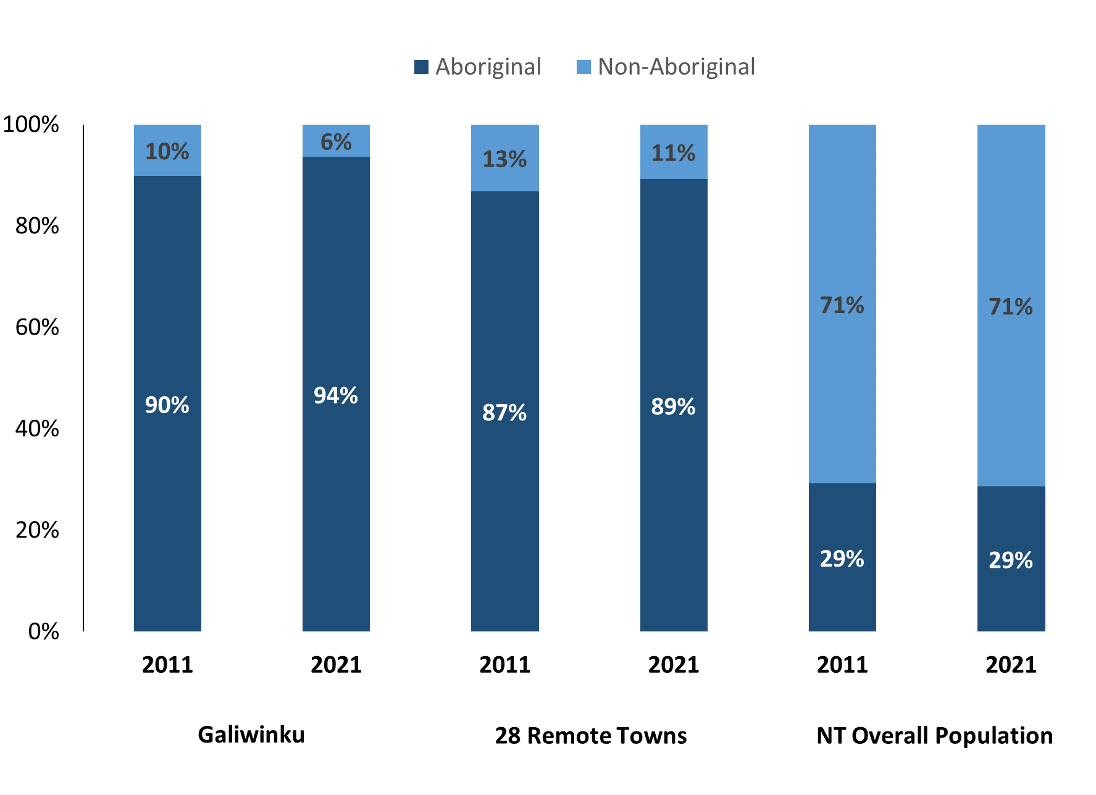

*Source: Australian Bureau of Statistics*

In 2021 in Galiwin'ku:

* 94% of the population in Galiwin'ku were **Aboriginal**, compared to 90% in 2011
* 89% of the population across the 28 remote towns were **Aboriginal**
* 29% of the NT population were **Aboriginal**.

**Table 37: Unemployment and Aboriginal participation rates (q)**

|  |  |  |  |  |  |  |
| --- | --- | --- | --- | --- | --- | --- |
|  | **Galiwin'ku** | | | **Northern Territory** | | |
| **Aboriginal** | **Non-Aboriginal** | **Total** | **Aboriginal** | **Non-Aboriginal** | **Total** |
| **Unemployment rate** | 39.0% | 0.0% | 32.0% | 20.8% | 3.2% | 5.6% |
| **Participation rate** | 34.5% | 90.9% | 50.5% | 35.4% | 78.3% | 64.9% |

Source: Australian Bureau of Statistics

In 2021 in Galiwin'ku:

* **total unemployment rate** was 32.0% compared to 5.6% for the total Northern Territory
* **Aboriginal** **unemployment rate** was 39.0% compared to 20.8% for the total Northern Territory
* **non-Aboriginal unemployment rate** was 0.0% compared to 3.2% for the total Northern Territory
* **total participation rate** was 50.5% compared to 64.9% for the total Northern Territory
* **Aboriginal participation rate** was 34.5% compared to 35.4% for the total Northern Territory
* **non-Aboriginal participation rate** was 90.9% compared to 78.3% for the total Northern Territory

# Community Development Program

**Table 38: Community Development Program Aboriginal Job Seekers, 31 December 2023 (o)**

|  |  |  |
| --- | --- | --- |
| **Indicator** | **Aboriginal** | |
| **No.** | **%** |
| **Total Aboriginal Job Seekers** | 776 | N/A |
| **Age (years)** | | |
| 15-24 | 225 | 29.0% |
| 25-44 | 385 | 49.6% |
| 45+ | 166 | 21.4% |
| **Total** | 776 | 100.0% |
| **Gender** | | |
| Male | 442 | 57.0% |
| Female | 334 | 43.0% |
| **Total** | 776 | 100.0% |
| **Employment Outcome – 1 January 2023 to 31 December 2023** | | |
| 13 Weeks | 49 | 62.0% |
| 26 Weeks | 30 | 38.0% |

*Source: Department of Prime Minister and Cabinet*

**Chart 14: Community Development Program Aboriginal Job Seekers by Gender and Age Group, 31 December 2023 (o)**

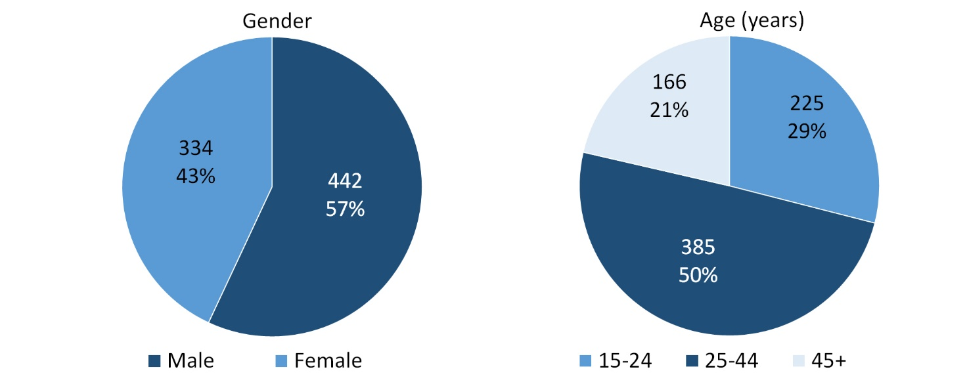

*Source: Department of Prime Minister and Cabinet*

As at 31 December 2023, in Galiwin'ku, there were 776 CDP **Aboriginal** job seekers, of these:

* 442 (57.0%) were male and 334 (43.0%) were female
* 225 (29.0%) were aged 15-24 years, 385 (49.6%) were aged 25-44 years, and 166 (21.4%) were aged 45+ years
* between 1 January 2023 to 31 December 2023, 49 had reached the 13-week reporting milestone and 30 had reached the 26-week reporting milestone.

# Businesses

**Table 39: Businesses by sector (d)(s)**

|  |  |  |  |  |
| --- | --- | --- | --- | --- |
| **Business Name** | **Reported on in 2011** | **Reported on in 2014** | **Reported on in 2017** | **Reported on in 2023** |
| **PUBLIC SECTOR** | | | | |
| **Department of Education** | Yes | Yes | Yes | **Yes** |
| Department of Human Services trading as Centrelink | Yes | Yes | Yes | No |
| Department of the Prime Minister and Cabinet | Yes | Yes | Yes | No |
| **East Arnhem Regional Council** | Yes | Yes | Yes | **Yes** |
| **National Indigenous Australians Agency** | No | No | No | **Yes** |
| **Northern Territory Police, Fire Emergency Services** | Yes | Yes | Yes | **Yes** |
| **Territory Families** | No | No | Yes | **Yes** |
| **PRIVATE SECTOR** | | | | |
| AA Electrical Pty Ltd | Yes | No | No | No |
| AEC Building Electrical & Plumbing | No | Yes | Yes | No |
| Air Frontier Pty Ltd | Yes | Yes | Yes | No |
| Batchelor Institute of Indigenous Tertiary Education (BIITE) | Yes | No | No | No |
| Deltareef Pty Ltd | No | No | Yes | No |
| **East Arnhem Real Estate** | No | No | No | **Yes** |
| Enterprise Management Group Pty Ltd trading as My Pathways | No | Yes | No | No |
| Gandhuwuy, Richard trading as Gawudal - Pudal | No | Yes | No | No |
| Garrawurra Aboriginal Corporation | No | Yes | No | No |
| **GPT Enterprises Pty Ltd (Elcho Fuel)** | No | No | Yes | **Yes** |
| Ironbark Construction Pty Ltd | No | No | Yes | No |
| Karen Sheldon Training and Development Pty Ltd | No | No | Yes | No |
| MAF International trading as Mission Aviation Fellowship | Yes | Yes | Yes | No |
| **Marthakal Business Enterprises Pty Ltd** | Yes | No | Yes | **Yes** |
| **Marthakal Homelands and Resource Centre Aboriginal Corporation** | Yes | Yes | Yes | **Yes** |
| **Marthakal Yolngu Airline Pty Ltd** | No | No | Yes | **Yes** |
| Menzies School of Health Research | Yes | No | No | No |
| **Miwatj Health Aboriginal Corporation** | Yes | Yes | Yes | **Yes** |
| MJD Foundation | No | No | Yes | No |
| **Nhawe Enterprises Pty Ltd** | No | No | Yes | **Yes** |
| **Nhawe Galiwinku Bus Services** | No | No | No | **Yes** |
| **Nhawe Manymak Ngatha Pty Ltd** | No | No | No | **Yes** |
| **Northern Land Council** | No | No | No | **Yes** |
| Probuild (NT) Pty Ltd | No | No | Yes | No |
| Steps Group Australia Limited | No | Yes | Yes | No |
| Sunrise Alliance Inc | No | Yes | No | No |
| **The Arnhem Land Progress Aboriginal Corporation - ALPA** | Yes | Yes | Yes | **Yes** |
| **The Elcho Group Pty Ltd** | No | Yes | Yes | **Yes** |
| The Trustee for AA Essential Services Trust | No | Yes | Yes | No |
| **The Trustee for Bukmak Constructions Trust - Bukmak Constructions - ALPA** | No | No | Yes | **Yes** |
| **The Trustee for Nhawe Rentals Trust (Nhawe Car Rentals)** | No | No | No | **Yes** |
| **Traditional Credit Union (TCU)** | Yes | Yes | Yes | **Yes** |
| Why Warriors Pty Ltd | No | Yes | No | No |
| Yalu Marnggithinyaraw Indigenous Corporation | No | Yes | Yes | No |

*Source: Northern Territory Department of Industry, Tourism and Trade*

*Note: Business names captured across the four survey periods have been identified by the current 2023 Business ABN name listed as of 2023.*

In 2023 in Galiwin'ku:

* there were 20 businesses reported on, of which:
* 5 businesses were from the Public Sector (25%)
* 15 businesses were from the Private Sector (75%)
* there were 6 businesses operating that were not operating in 2017.

# Notes

1. These counts represent numbers of filled jobs and not the number of people. As such the totals represent the total number of filled jobs, not the total number of employees. This count is not directly comparable to the total number of employed people as a person may have several jobs or one job may be shared by more than one person.
2. Full-time is defined as a job usually requiring 35 hours or more per week or that required 35 hours or more work during the reference week. Part-time is defined as a job usually requiring less than 35 hours per week or that required less than 35 hours work during the reference week. The reference week refers to the period that respondents were asked to provide information about. In most instances it would be the week prior to the week the questionnaire was completed. Questionnaires were predominantly conducted in June and July.
3. Care needs to be taken when analysing the counts of filled jobs by Aboriginal people. Aboriginality was reported by the business representative completing the questionnaire.
4. Sector was classified using the Standard Economic Sector of Classifications of Australia (SESCA), 2008.
5. Job permanency is classified according to what the business believes the level of job permanency is based on guidelines provided by data collectors. Those guidelines state a permanent job has paid annual and/or sick leave entitlements while a temporary job includes casual and fixed-term contract jobs.
6. Classified according to the Australian and New Zealand Standard Classification of Occupations (ANZSCO), 2006, major occupation level.
7. Other Occupations include jobs where occupation was not stated, not known or inadequately described.
8. Classified using the Australian and New Zealand Standard Industrial Classification (ANZSIC), 2006, division level.
9. Care needs to be taken when analysing the counts of filled jobs by the gender of people in the jobs. The gender of the person employed in a job is reported by the business representative completing the questionnaire.
10. Care needs to be taken when analysing the counts of filled jobs by the age of people in the jobs. The age of the person employed in a job is reported by the business representative completing the questionnaire.
11. Students represent the number of individual clients that enrolled in a Vocational Education and Training unit during the calendar year.
12. Unit enrolments represent the count of individual units that students enrolled in during the calendar year.
13. Nominal hours delivered is the sum of the nominal hours of the units commenced during the calendar year regardless of when the course enrolment commenced.
14. Unit completions are the count of all successfully completed units reported in the calendar year regardless of the year of commencement of the units.
15. The Community Development Program (CDP) supports job seekers in remote Australia to build skills, address barriers and contribute to their communities through a range of flexible activities. Under the CDP, job seekers with activity requirements are expected to do up to 25 hours per week of work-like activities that benefit their community. It should be noted that some CDP participants may be reported on within the profile if they are attached to a filled position with an employer captured in the survey. Due to confidentiality issues, data below 20 people is not published.
16. Population estimates for both 2011 and 2021 are taken from the estimated resident population (ERP) data produced by the Australian Bureau of Statistics (ABS) and based on Australian Statistical Geography Standard (ASGS) Statistical Area Level 1 (SA1) regions. ERP are official estimates of the Australian population, which link people to a place of usual residence with Australia. All ERP data sources, including the Census of Population and Housing (Census), are subject to error (including inaccuracies in collection, recording and processing data) and should be used with caution.
17. Indigenous population proportions, unemployment and workforce participation rates are based on ABS Census counts at ASGS Indigenous Locations (ILOCs) for each remote town.
18. Working-age population includes all residents aged 15 years and over (commonly referred to as the civilian population) and consists of people that are employed, unemployed or not in the labour force.
19. A ‘business’ is defined as any organisation that has undertaken productive activities in the last year, including companies, non-profit organisations, government departments and enterprises operating within the designated remote geography (town), and has one or more employees in paid employment and an Australian Business Number (ABN).

# Abbreviations and Acronyms

ABN Australian Business Number

ABS Australian Bureau of Statistics

ANZSCO Australian and New Zealand Standard Classification of Occupations

ANZSIC Australian and New Zealand Standard Industrial Classification

ASGS Australian Statistical Geography Standard

CDP Community Development Program

ERP Estimated Resident Population

ILOC Indigenous Locations

nec Not Elsewhere Classified

No. Number

Perm Permanent

ppt Percentage point

RJCP Remote Jobs and Communities Program

Temp Temporary

SA1 Statistical Area Level 1

VET Vocational Education and Training

1. The number of filled jobs does not represent the number of people as a person may have several jobs or one job may be shared by more than one person.
2. 8 filled jobs gender status not identified in 2017