**© Northern Territory of Australia 2025**

**Preferred Reference:** Department of Industry, Business and Asian Relations, 2023 Remote Towns Jobs Profiles, Northern Territory Government, January 2025, Darwin.

**Front cover image:** *Vitex rotundifolia* – known commonly as Beach Vitex

**Image credits:** Robyn Wing

**Disclaimer**

The data in this publication was collected by conducting a survey of businesses located in the 28 remote town boundaries. This body of work was completed in 2023 by the former Northern Territory Department of Industry, Tourism and Trade.

The collection methodology was created in accordance with Australian Bureau of Statistics data quality framework principles. Data in this publication is only reflective of those businesses reported on as operating in the town at the time of data collection (see table at the end of publication for list of businesses reported on). To comply with privacy legislation or where appropriate, some data in this publication may have been adjusted and will not reflect the actual data reported by businesses. As a result of this, combined with certain data not being reported by some businesses, some components may not add to totals. Changes over time may also reflect change in business propensity to report on certain data items rather than actual changes over time. Total figures have generally not been adjusted. Caution is advised when interpreting the comparisons made to the earlier 2011, 2014 and 2017 publications as the businesses identified and reported on and the corresponding jobs may differ between publications. The surveys have not always gathered data on training and jobs in the same years.

**Notes for each table and chart are alphabetically ordered and listed at the end of the publication.**

The Northern Territory of Australia exercised due care and skill to ensure that at the time of publication the information contained in this publication is true and correct. However, it is not intended to be relied on as professional advice or used for commercial purposes. The Territory gives no warranty or assurances as to the accuracy of the information contained in the publication and to the maximum extent permitted by law accepts no direct or indirect liability for reliance on its content.

Any use of this report for commercial purposes is not endorsed by the Department of Trade, Business and Asian Relations.

Contents

Alyangula 4

Introduction 5

Summary 6

Jobs Overview 7

Jobs filled by Aboriginality 8

Jobs by Sector: Private and Public 10

Job Status: Permanent and Temporary 14

Job Vacancies 16

Jobs by Industry 18

Jobs by Occupation 23

Jobs by Industry by Occupation 25

Jobs by Gender 27

Jobs by Age 30

Vocational Education and Training 34

Population 38

Community Development Program 40

Businesses 41

Notes 42

Abbreviations and Acronyms 43

# Alyangula

Alyangula is located on Groote Eylandt which is approximately 50 kilometres from the Northern Territory mainland in the Gulf of Carpentaria, with a population of 752 residents.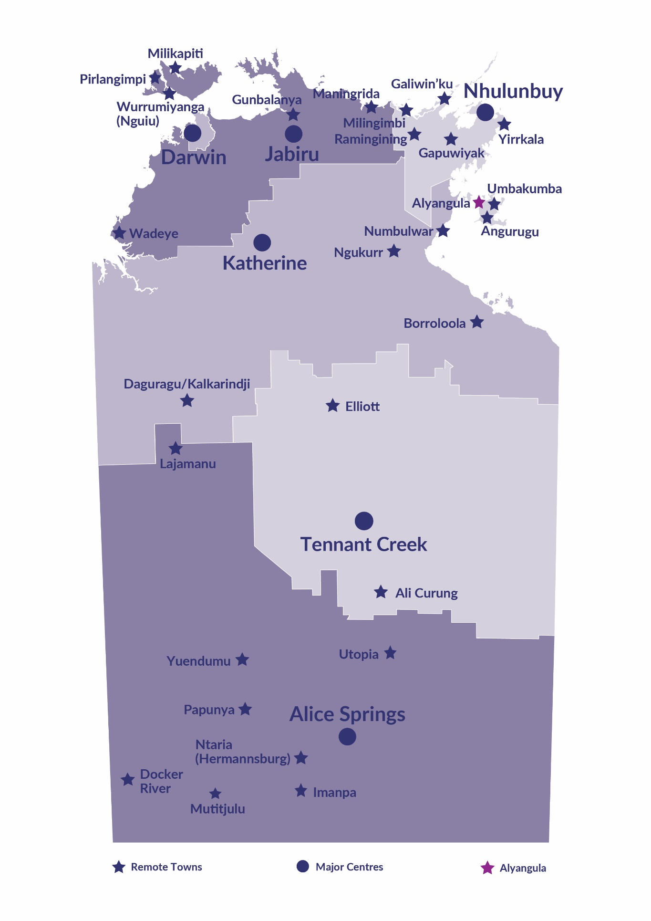

*Source: Northern Territory Department of Industry, Tourism and Trade*

# Introduction

This jobs profile provides a snapshot of jobs and the characteristics of job holders in Alyangula as of September 2023. Trends from the surveys conducted in 2011, 2014, and 2017 are also described. Additionally, it presents data on Community Development Program activity, Population, and Vocational Education and Training.

This job profile is one of 28 profiles developed for remote towns in the Northern Territory. It is anticipated these, and subsequent profiles will contribute to a robust evidence base to inform decision making in and relating to these remote Territory towns.

This profile contains information collected by the Northern Territory Northern Territory Department of Industry, Tourism and Trade from businesses operating within the town and is supplemented by other administrative data sets and information.

Each profile provides up-to-date information that is intended to inform the planning and design of current and future government programs and as an evidence base to inform decision making relating to workforce development, enterprise and job opportunities.

The profile may best be understood as a point-in-time tool. The number of business surveys from which the data was drawn is significantly less than in earlier surveys, and business participation has decreased with each survey. For Alyangula, 71% fewer businesses than in 2017 are reported here.

The data collection methodology and corresponding questionnaire were created in partnership with the Australian Bureau of Statistics (ABS) and in accordance with ABS data quality framework and survey principles.

The Northern Territory Department of Industry, Tourism and Trades’ Territory Engagement and Delivery, Skills Initiative and VET data teams collaborated with the Northern Institute at Charles Darwin University to facilitate the surveys and reports.

The information collected and reported on represents a significant goodwill investment by those businesses and organisations that participated. Each business is listed at the end of this publication.

# Summary

This 2023 jobs profile was developed based on responses from 9 businesses operating within the Alyangula town boundary not incorporating the key employer South 32, Groote Eylandt Mining Company (GEMCO).

* 6 businesses from the private sector, accounting for 140 filled jobs or 68% of total filled jobs
* 3 businesses from the public sector, accounting for 65 filled jobs or 32% of total filled jobs.

A total of 229 filled and vacant jobs in Alyangula were reported.[1]

The 2023 profile highlights:

* there were 205 filled jobs of which:
* 28 jobs (14%) were filled by Aboriginal people
* 177 jobs (86%) were filled by non-Aboriginal people
* 11% of employed Aboriginal people are working in the private sector
* 21% of total Aboriginal filled jobs are filled by Aboriginal females
* there were 24 vacant jobs, of which:
* job vacancies as a percentage of jobs is 10.5%
* job vacancies equate to 1 in 10 jobs
* Community and Personal Service Workers and Professionals areas had 9 vacancies
* Construction was the largest industry employer in 2023
* Community Services, Health and Education had the highest student numbers training activity in 2023.

The overall population in Alyangula decreased by 233 people (23.7%) between 2011 and 2021 to 752 people.

In comparison, the overall Northern Territory population increased by 9.7% between 2011 and 2021.

In 2021, the working age population (15 years and over) in Alyangula was an estimated 499 people compared to 757 in 2011 a decrease of 34.1%.

There were 0.5 jobs in Alyangula per working age person compared to 0.3 jobs per working age person across the 28 remote towns in the Northern Territory (excluding the large fly-in fly-out workforce associated with the South 32 - GEMCO resource operation).

# Jobs Overview

Table 1: Count of filled jobs and vacancies, 2017 & 2023 (a)(b)

|  |  |  |  |
| --- | --- | --- | --- |
|  | **2017** | **2023** | **Change 2017-2023** |
| **Total All Jobs** | **213** | **229** | **16** |
| **Vacancies** | **19** | **24** | **5** |
| Vacancies as % of Total All Jobs | 8.9% | 10.5% | 1.6 ppt |
| **Filled Jobs** | **194** | **205** | **11** |
| Full-time | 151 | 199 | 48 |
| Part-time | 43 | 6 | -37 |

Source: Northern Territory Department of Industry, Tourism and Trade

Chart 1: Count of vacant jobs and filled jobs by full-time/part-time status, 2017 & 2023 (a)(b)

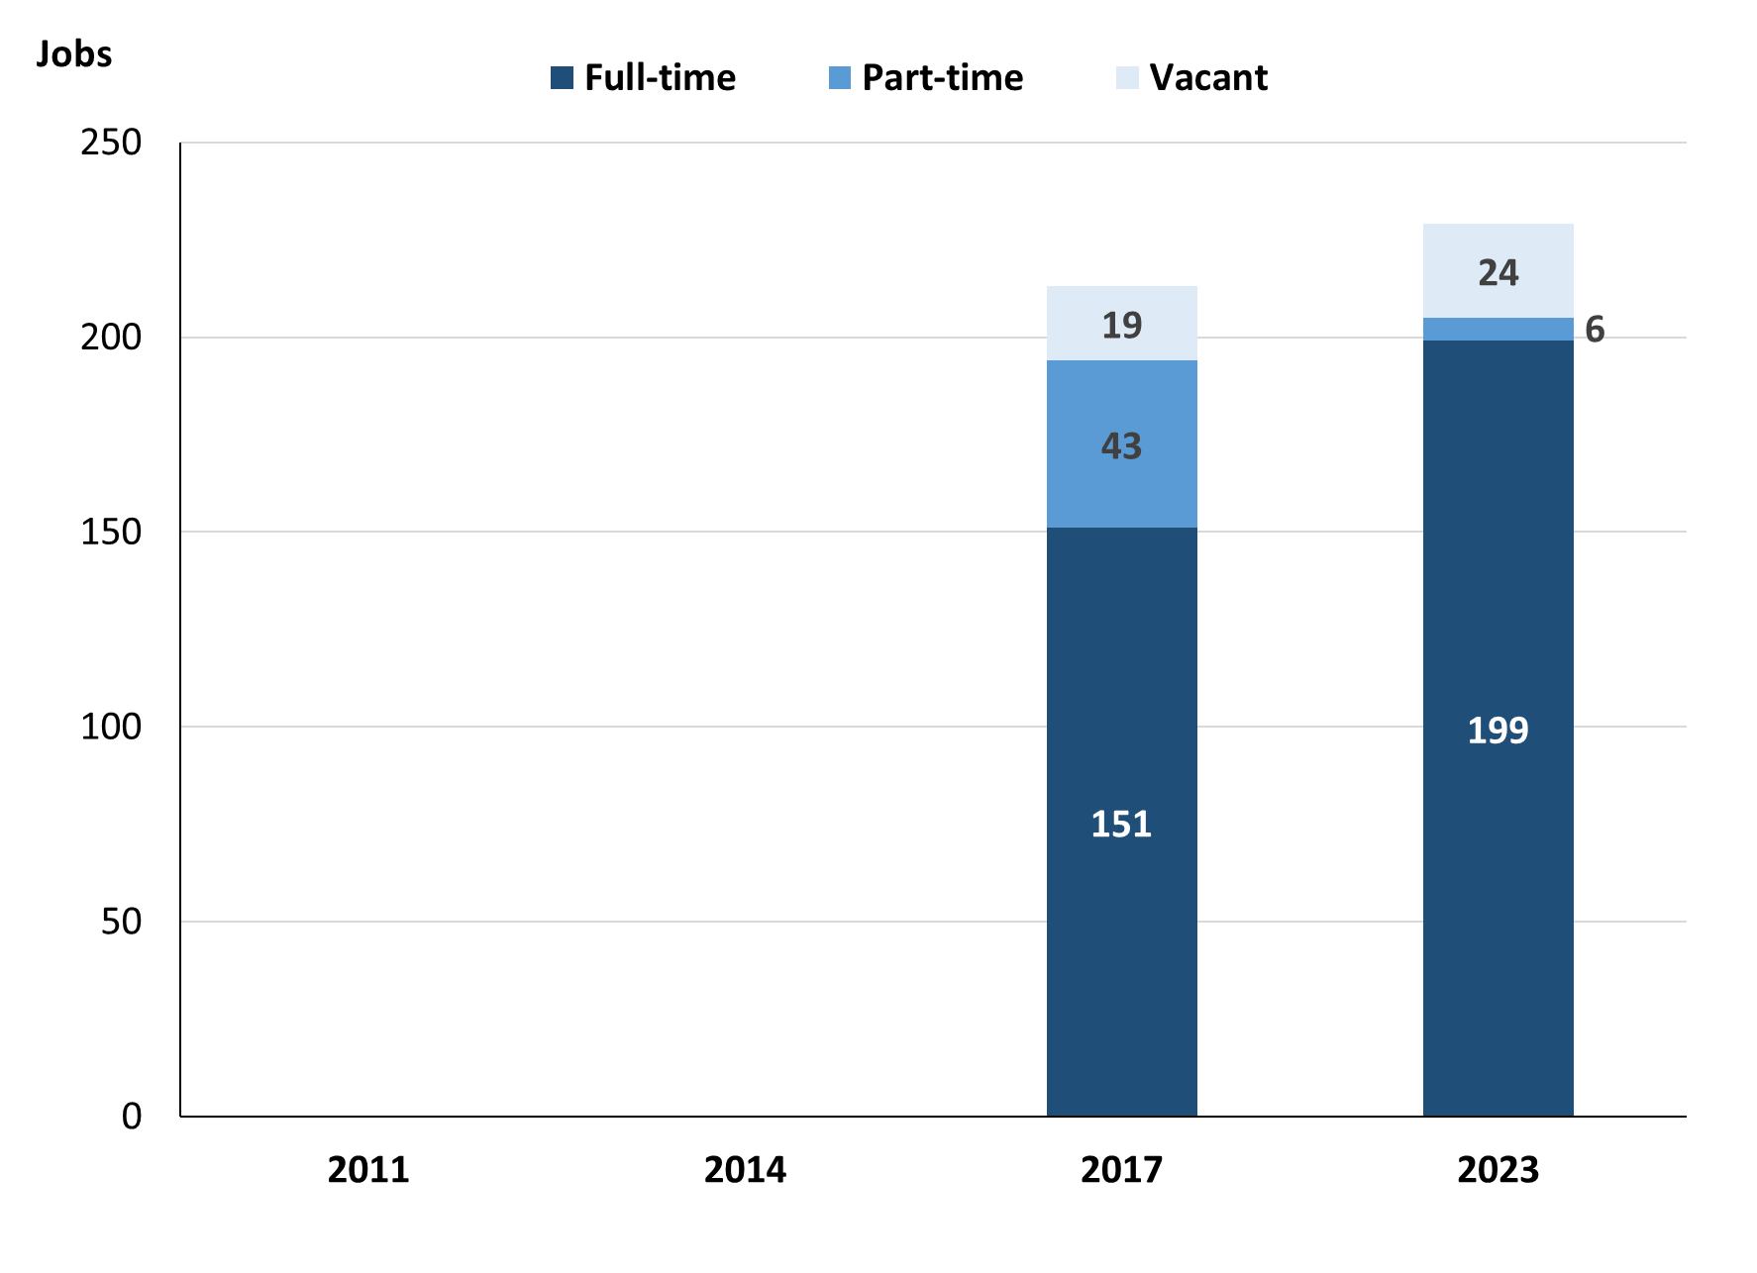

Source: Northern Territory Department of Industry, Tourism and Trade

In 2023 in Alyangula, without GEMCO:

* there was a total of 205 **filled jobs,** an increase of 11 jobs from 2017
* of the 205 filled jobs:
* 199 were **full-time** jobs, an increase of 48 jobs from 2017
* 6 were **part-time** jobs, a decrease of 37 jobs from 2017
* there were 24 total job **vacancies**, an increase of 5 job vacancies from 2017.

# Jobs filled by Aboriginality

Chart 2: Count of filled jobs by Aboriginality, 2017 & 2023 (a)(c)

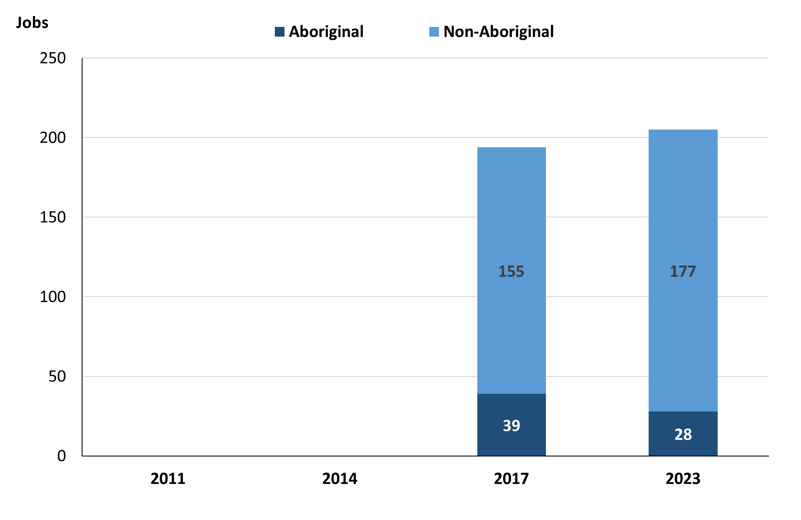

Source: Northern Territory Department of Industry, Tourism and Trade

In 2023 in Alyangula, excluding GEMCO:

* of the 205 **filled jobs**:
* 28 jobs were filled by **Aboriginal** people, a decrease of 11 jobs from 2017
* 177 jobs were filled by **non-Aboriginal** people, and increase of 22 jobs from 2017
* **Aboriginal** people accounted for 14% of job holders, compared to 20% in 2017.

Table 2: Count of filled jobs by full-time/part-time status, 2017 & 2023 (a)(b)(c)

|  |  |  |  |  |  |  |  |  |  |
| --- | --- | --- | --- | --- | --- | --- | --- | --- | --- |
| **Indicator** | **2017** | | | **2023** | | | **Change**  **2017-2023** | | |
| **Aboriginal** | **Non-Aboriginal** | **Total** | **Aboriginal** | **Non-Aboriginal** | **Total** | **Aboriginal** | **Non-Aboriginal** | **Total** |
| Full-time | 29 | 122 | **151** | 27 | 172 | **199** | -2 | 50 | **48** |
| Part-time | 10 | 33 | **43** | 1 | 5 | **6** | -9 | -28 | **-37** |
| **Total** | **39** | **155** | **194** | **28** | **177** | **205** | **-11** | **22** | **11** |

Source: Northern Territory Department of Industry, Tourism and Trade

Chart 3: Count of filled jobs by full-time/part-time status, 2017 & 2023 (a)(b)(c)

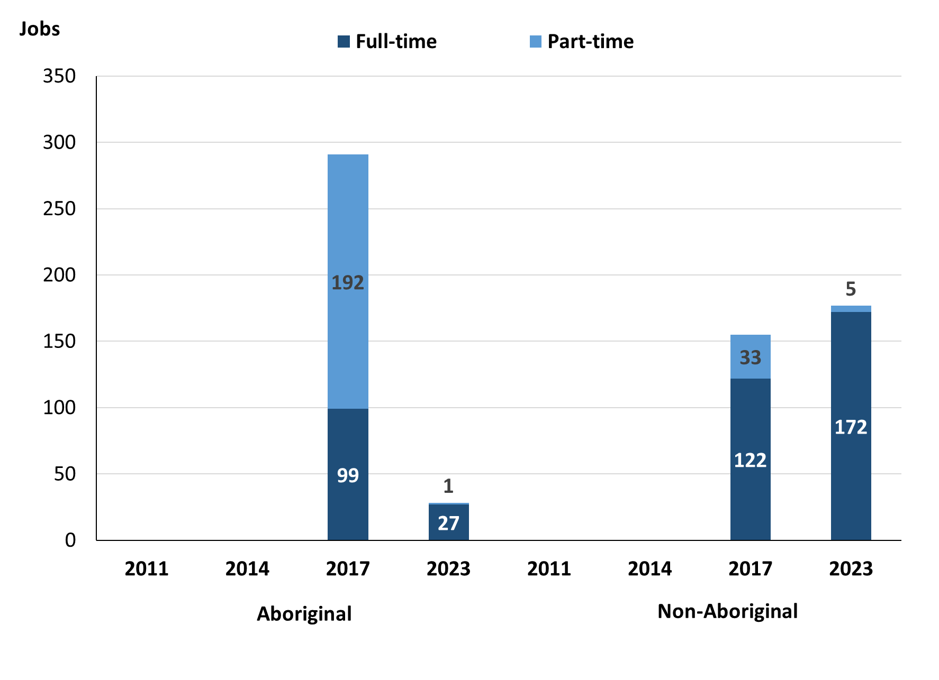

Source: Northern Territory Department of Industry, Tourism and Trade

In 2023 in Alyangula, without GEMCO:

* of the 205 filled jobs:
* 27 were **full-time** jobs filled by **Aboriginal** people, a decrease of 2 jobs from 2017
* 1 was a **part-time** job filled by an **Aboriginal** person, a decrease of 9 jobs from 2017
* 172 were **full-time** jobs filled by **non-Aboriginal** people, an increase of 50 jobs from 2017
* 5 were **part-time** jobs filled by **non-Aboriginal** people, a decrease of 28 jobs from 2017.

# Jobs by Sector: Private and Public

Table 3: Count of filled jobs by business sector, 2017 & 2023 (a)(c)(d)

|  |  |  |  |  |  |  |  |  |  |  |
| --- | --- | --- | --- | --- | --- | --- | --- | --- | --- | --- |
| **Indicator** | **2017** | | | **2023** | | | **Change**  **2017-2023** | | | |
| **Aboriginal** | **Non-Aboriginal** | **Total** | **Aboriginal** | **Non-Aboriginal** | **Total** | **Aboriginal** | **Non-Aboriginal** | **Total** |
| **Public Sector** | 11 | 43 | **54** | 6 | 59 | **65** | -5 | 16 | **11** |
| Australian Government | 1 | 1 | **2** | 0 | 0 | **0** | -1 | -1 | **-2** |
| Territory Government | 10 | 42 | **52** | 6 | 59 | **65** | -4 | 17 | **13** |
| Local Government | 0 | 0 | **0** | 0 | 0 | **0** | 0 | 0 | **0** |
| **Private Sector** | 28 | 112 | **140** | 22 | 118 | **140** | -6 | 6 | **0** |
| **Total** | **39** | **155** | **194** | **28** | **177** | **205** | **-11** | **22** | **11** |

Source: Northern Territory Department of Industry, Tourism and Trade

Chart 4: Count of filled jobs by business sector in 2023 (a)(d)

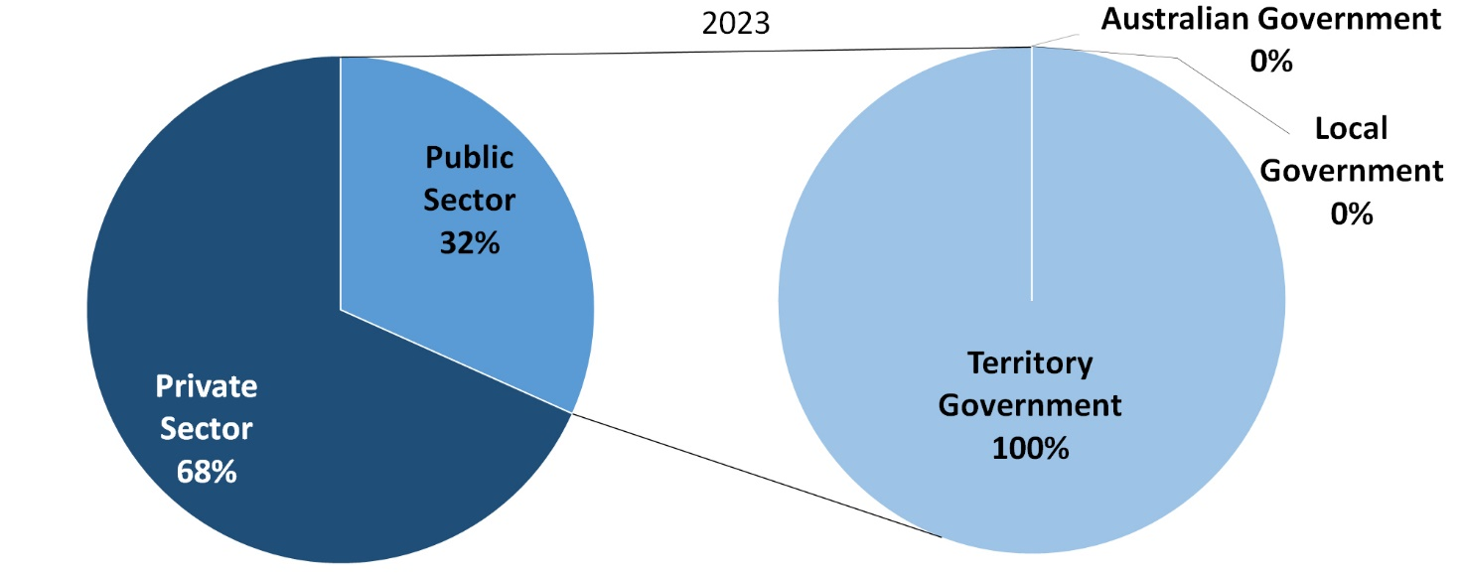

Source: Northern Territory Department of Industry, Tourism and Trade

In 2023 in Alyangula, without GEMCO:

* there were 65 jobs in the **public** **sector**, an increase of 11 jobs from 2017
* of the 65 jobs in the **public sector**:
  + none were in the Australian Government, a decrease of 2 jobs from 2017
  + 65 jobs were in the Territory Government, an increase of 13 jobs from 2017
  + none were in the Local Government, unchanged from 2017
* there were 140 jobs in the **private sector**, unchanged from 2017.

Chart 5: Count of filled jobs by sector of business, 2017 & 2023 (a)(c)(d)

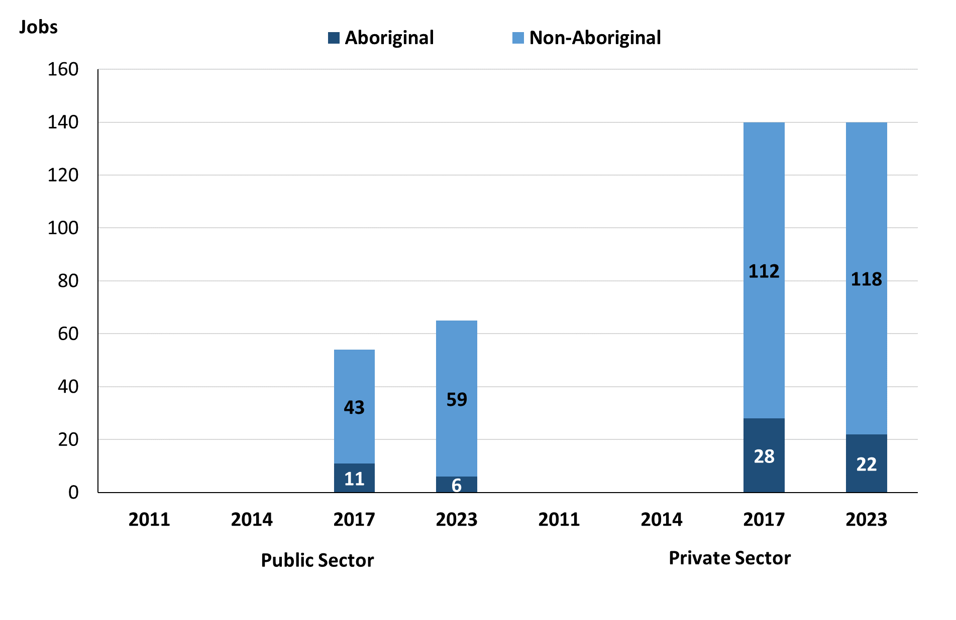

Source: Northern Territory Department of Industry, Tourism and Trade

In 2023 in Alyangula, without GEMCO:

* of the 65 jobs in the **public sector**:
* 6 jobs were filled by **Aboriginal** people, a decrease of 5 jobs from 2017
* 59 jobs were filled by **non-Aboriginal** people, an increase of 16 jobs from 2017
* of the 140 jobs in the **private sector***:*
* 22 jobs were filled by **Aboriginal** people, a decrease of 6 jobs from 2017
* 118 jobs were filled by **non-Aboriginal** people, an increase of 6 jobs from 2017.

Chart 6: Count of filled jobs by sector and full-time/part-time status, 2017 & 2023 (a)(b)(d)

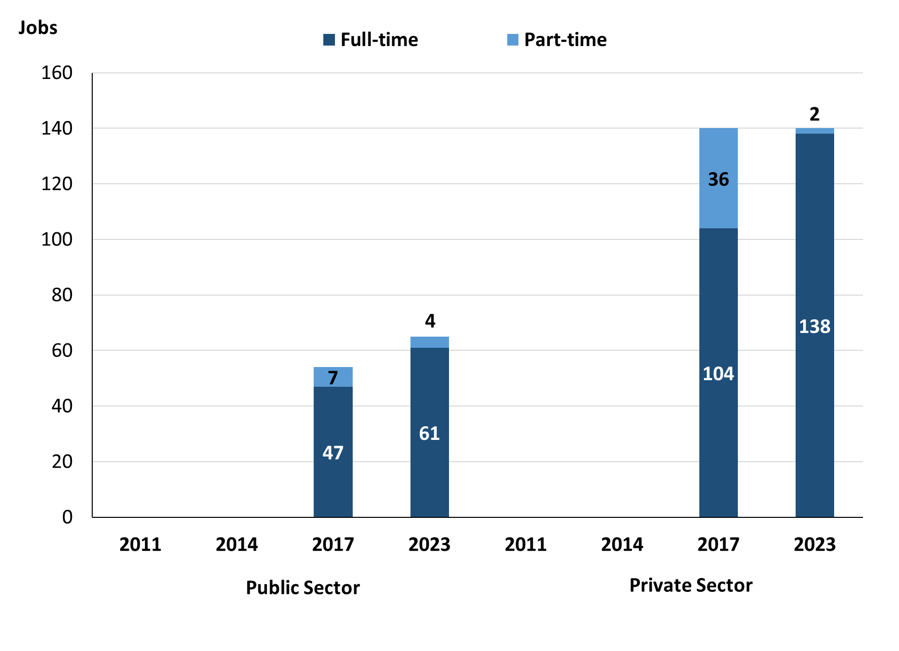

Source: Northern Territory Department of Industry, Tourism and Trade

In 2023 in Alyangula, without GEMCO:

* of the 65 jobs in the **public sector**:
* 61 were full-time jobs, an increase of 14 jobs from 2017
* 4 were part-time jobs, a decrease of 3 jobs from 2017
* of the 140 jobs in the **private sector**:
* 138 were full-time jobs, an increase of 34 jobs from 2017
* 2 were part-time jobs, a decrease of 34 jobs from 2017.

Table 4: Count of filled jobs by full-time/part-time status by sector, 2017 & 2023 (a)(b)(c)(d)

|  |  |  |  |  |  |  |  |  |  |
| --- | --- | --- | --- | --- | --- | --- | --- | --- | --- |
| **Indicator** | **2017** | | | | | | | | |
| **Aboriginal** | | | **Non-Aboriginal** | | | **Total** | | |
| **Full-time** | **Part-time** | **Total** | **Full-time** | **Part-time** | **Total** | **Full-time** | **Part-time** | **Total** |
| Public Sector | 9 | 2 | **11** | 38 | 5 | **43** | 47 | 7 | **54** |
| Private Sector | 20 | 8 | **28** | 84 | 28 | **112** | 104 | 36 | **140** |
| **Total** | **29** | **10** | **39** | **122** | **33** | **155** | **151** | **43** | **194** |

|  |  |  |  |  |  |  |  |  |  |  |
| --- | --- | --- | --- | --- | --- | --- | --- | --- | --- | --- |
| **Indicator** | **2023** | | | | | | | | | |
| **Aboriginal** | | | **Non-Aboriginal** | | | **Total** | | | |
| **Full-time** | **Part-time** | **Total** | **Full-time** | **Part-time** | **Total** | **Full-time** | **Part-time** | **Total** |
| Public Sector | 5 | 1 | **6** | 56 | 3 | **59** | 61 | 4 | **65** |
| Private Sector | 22 | 0 | **22** | 116 | 2 | **118** | 138 | 2 | **140** |
| **Total** | 27 | **1** | **28** | **172** | **5** | **177** | **199** | **6** | **205** |

Source: Northern Territory Department of Industry, Tourism and Trade

In 2023 in Alyangula, without GEMCO, there were:

* 6 jobs in the **public sector** filled by **Aboriginal** people, a decrease of 5 jobs from 2017, of which:
* 5 were full-time jobs, a decrease of 4 jobs from 2017
* 1 was a part-time job, a decrease of 1 job from 2017
* 22 jobs in the **private sector** filled by **Aboriginal** people, a decrease of 6 jobs from 2017, of which:
* 22 were full-time jobs, an increase of 2 jobs from 2017
* none were part-time jobs, a decrease of 8 jobs from 2017
* 59 jobs in the **public sector** filled by **non-Aboriginal** people, an increase of 16 jobs from 2017, of which:
* 56 were full-time jobs, an increase of 18 jobs from 2017
* 3 were part-time jobs, a decrease of 2 jobs from 2017
* 118 jobs in the **private sector** filled by **non-Aboriginal** people, an increase of 6 jobs from 2017, of which:
* 116 were full-time jobs, an increase of 32 jobs from 2017
* 2 were part-time jobs, a decrease of 26 jobs from 2017.

# Job Status: Permanent and Temporary

Table 5: Count of filled jobs by employment status, 2017 & 2023 (a)(c)(e)

|  |  |  |  |  |  |  |  |  |  |
| --- | --- | --- | --- | --- | --- | --- | --- | --- | --- |
| **Indicator** | **2017** | | | **2023** | | | **Change**  **2017-2023** | | |
| **Aboriginal** | **Non-Aboriginal** | **Total** | **Aboriginal** | **Non-Aboriginal** | **Total** | **Aboriginal** | **Non-Aboriginal** | **Total** |
| **Permanent** | 29 | 107 | **136** | 25 | 140 | **165** | -4 | 33 | **29** |
| **Temporary** | 10 | 48 | **58** | 3 | 37 | **40** | -7 | -11 | **-18** |
| **Total** | **39** | **155** | **194** | **28** | **177** | **205** | **-11** | **22** | **11** |

Source: Northern Territory Department of Industry, Tourism and Trade

**Chart 7: Count of filled jobs by employment status, 2017 & 2023 (a)(c)(e)**

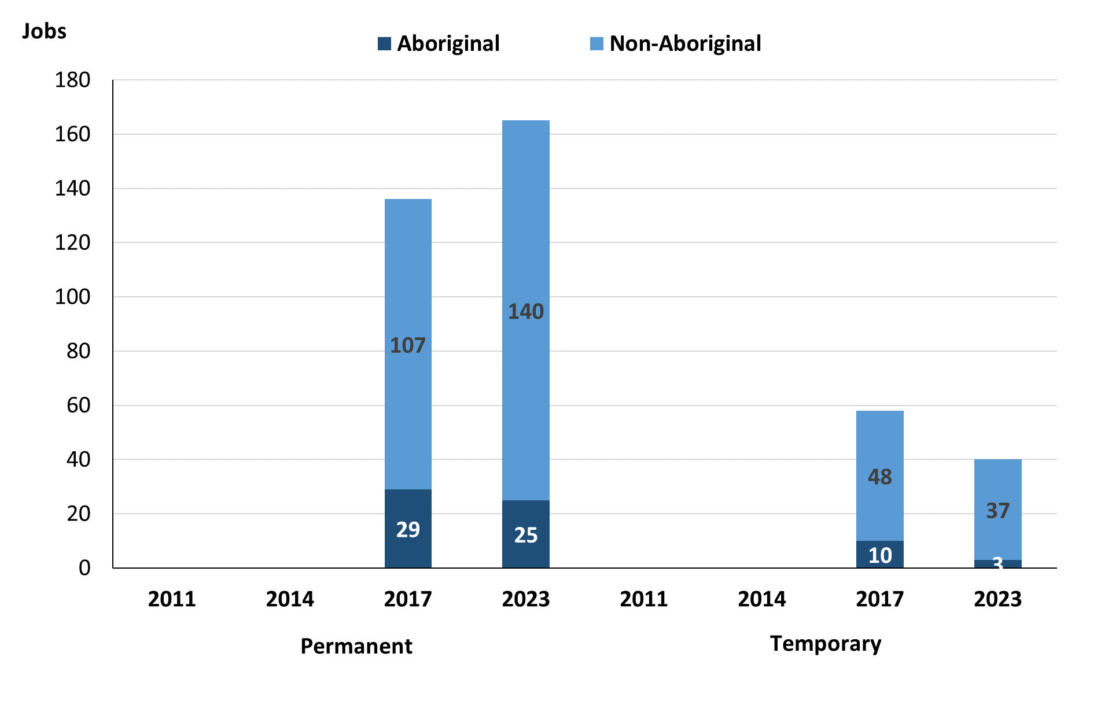

Source: Northern Territory Department of Industry, Tourism and Trade

In 2023 in Alyangula, without GEMCO:

* there were 165 **permanent jobs**, an increase of 29 jobs from 2017, of which:
* 25 jobs were filled by **Aboriginal** people, a decrease of 4 jobs from 2017
* 140 jobs were filled by **non-Aboriginal** people, an increase of 33 jobs from 2017
* there were 40 **temporary jobs**, a decrease of 18 jobs from 2017, of which:
* 3 jobs were filled by **Aboriginal** people, a decrease of 7 jobs from 2017
* 37 jobs were filled by **non-Aboriginal** people, a decrease of 11 jobs from 2017.

Table 6: Count of filled jobs by sector and employment status, 2017 & 2023 (a)(c)(d)(e)

|  |  |  |  |  |  |  |  |  |  |
| --- | --- | --- | --- | --- | --- | --- | --- | --- | --- |
| **Indicator** | **2017** | | | | | | | | |
| **Aboriginal** | | | **Non-Aboriginal** | | | **Total** | | |
| **Perm** | **Temp** | **Total** | **Perm** | **Temp** | **Total** | **Perm** | **Temp** | **Total** |
| Public Sector | 8 | 3 | **11** | 25 | 18 | **43** | 33 | 21 | **54** |
| Private Sector | 21 | 7 | **28** | 82 | 30 | **112** | 103 | 37 | **140** |
| **Total** | **29** | **10** | **39** | **107** | **48** | **155** | **136** | **58** | **194** |

|  |  |  |  |  |  |  |  |  |  |
| --- | --- | --- | --- | --- | --- | --- | --- | --- | --- |
| **Indicator** | **2023** | | | | | | | | |
| **Aboriginal** | | | **Non-Aboriginal** | | | **Total** | | |
| **Perm** | **Temp** | **Total** | **Perm** | **Temp** | **Total** | **Perm** | **Temp** | **Total** |
| Public Sector | 3 | 3 | **6** | 28 | 31 | **59** | 31 | 34 | **65** |
| Private Sector | 22 | 0 | **22** | 112 | 6 | **118** | 134 | 6 | **140** |
| **Total** | **25** | **3** | **28** | **140** | **37** | **177** | **165** | **40** | **205** |

Source: Northern Territory Department of Industry, Tourism and Trade

In 2023 in Alyangula, without GEMCO, there were:

* 65 jobs in the **public sector**, an increase of 11 jobs from 2017, of which:
* 31 jobs were **permanent**, a decrease of 2 jobs from 2017, of which:
* 3 jobs were filled by **Aboriginal** people, a decrease of 5 jobs from 2017
* 28 jobs were filled by **non-Aboriginal** people, an increase of 3 jobs from 2017
* 34 jobs were **temporary**, an increase of 13 jobs from 2017, of which:
* 3 jobs were filled by **Aboriginal** people, unchanged from 2017
* 31 jobs were filled by **non-Aboriginal** people, an increase of 13 jobs from 2017
* 140 jobs in the **private sector**, unchanged from 2017, of which:
* 134 jobs were **permanent**, an increase of 31 jobs from 2017, of which:
* 22 jobs were filled by **Aboriginal** people, an increase of 1 job from 2017
* 112 jobs were filled by **non-Aboriginal** people, an increase of 30 jobs from 2017
* 6 jobs were **temporary**, a decrease of 31 jobs from 2017, of which:
* none were filled by **Aboriginal** people, a decrease of 7 jobs from 2017
* 6 jobs were filled by **non-Aboriginal** people, a decrease of 24 jobs from 2017.

# Job Vacancies

Table 7: Job vacancies, 2017 & 2023

|  |  |  |  |
| --- | --- | --- | --- |
| **Indicator** | **2017** | **2023** | **Change 2017-2023** |
| **Job vacancies** | **19** | **24** | **5** |

Source: Northern Territory Department of Industry, Tourism and Trade

Table 8: Job vacancies by occupation, 2017 & 2023 (f)(g)

|  |  |  |  |  |
| --- | --- | --- | --- | --- |
| **Occupation (ANZSCO major group)** | **2017** | **2023** | **Change 2017-2023** | |
| Clerical and Administrative Workers | 5 | 1 | -4 | |
| Community and Personal Service Workers | 3 | 9 | 6 | |
| Labourers | 2 | 2 | 0 | |
| Managers | 0 | 1 | 1 | |
| Professionals | 7 | 5 | -2 | |
| Sales Workers | 1 | 0 | -1 | |
| Technicians and Trades Workers | 1 | 4 | 3 | |
| Other | 0 | 2 | 2 |
| **Total** | **19** | **24** | **5** | |

Source: Northern Territory Department of Industry, Tourism and Trade

Table 9: Job vacancies by job title, 2023 profile (f)

|  |  |  |
| --- | --- | --- |
| **Job Vacancy** | **No.** | |
| Aquaculture or Fisheries Technician | 2 | |
| Assistant Principal | 1 | |
| Baker | 1 | |
| Café or Restaurant Manager | 1 | |
| Classroom Teacher | 2 | |
| Education Aide | 1 | |
| Handyperson | 1 | |
| ICT Support Person | 1 | |
| Labourer | 1 | |
| Police Officer | 4 | |
| Program or Project Administrator | 1 | |
| Senior Teacher Early Childhood | 1 | |
| Teachers’ Aide | 4 | |
| Vocational Education Teacher | 1 | |
| Other (Inadequately Described) | 2 |
| **Total** | **24** | |

Source: Northern Territory Department of Industry, Tourism and Trade

In 2023 in Alyangula, without GEMCO:

* there were 24 **vacancies** reported
* of the 24 reported vacancies, the largest requirements were for:
* Community and Personal Service Workers had 9 vacancies, the majority of which are in the following jobs:
* Police Officer
* Teachers’ Aide
* Five Professionals were in the following jobs:
* Assistant Principal
* Classroom Teacher
* Senior Teacher Early Childhood
* Vocational Education Teacher
* Four Technicians and Trades Workers in the following jobs:
* Aquaculture or Fisheries Technician
* Baker
* ICT Support Technician.

# Jobs by Industry

Table 10: Count of filled jobs by industry of business, 2017 & 2023 (a)(h)

|  |  |  |  |  |  |
| --- | --- | --- | --- | --- | --- |
| **Industry (ANZSIC Division)** | **2017** | | **2023** | | **Change 2017-2023** |
| **Total** | **% of Total** | **Total** | **% of Total** | **Total** |
| Accommodation and Food Services | 32 | 16.5% | 33 | 16.1% | 1 |
| Administrative and Support Services | 0 | 0.0% | 13 | 6.3% | 13 |
| Agriculture, Forestry and Fishing | 0 | 0.0% | 4 | 2.0% | 4 |
| Construction | 0 | 0.0% | 84 | 41.0% | 84 |
| Education and Training | 21 | 10.8% | 36 | 17.6% | 15 |
| Financial and Insurance Services | 3 | 1.5% | 0 | 0.0% | -3 |
| Health Care and Social Assistance | 29 | 14.9% | 15 | 7.3% | -14 |
| Other Services | 3 | 1.5% | 0 | 0.0% | -3 |
| Public Administration and Safety | 68 | 35.1% | 14 | 6.8% | -54 |
| Rental, Hiring and Real Estate Services | 3 | 1.5% | 0 | 0.0% | -3 |
| Retail Trade | 23 | 11.9% | 6 | 2.9% | -17 |
| Transport, Postal and Warehousing | 12 | 6.2% | 0 | 0.0% | -12 |
| **Total** | **194** | **100.0%** | **205** | **100.0%** | **11** |

Source: Northern Territory Department of Industry, Tourism and Trade

In 2023 in Alyangula, without GEMCO:

* the Construction industry was the **largest** **industry** **employer**, with 84 filled jobs or 41.0% of filled jobs, an increase of 84 jobs from 2017
* **other** **significant** industry employers were:
* Education and Training with 36 jobs (or 17.6% of filled jobs), an increase of 15 jobs from 2017
* Accommodation and Food Services with 33 jobs (or 16.1% of filled jobs), an increase of 1 job from 2017
* Health Care and Social Assistance with 15 jobs (or 7.3% of filled jobs), a decrease of 14 jobs from 2017.

Table 11: Count of filled jobs by industry of business, 2017 & 2023 (a)(c)(h)

|  |  |  |  |  |  |  |  |  |  |  |
| --- | --- | --- | --- | --- | --- | --- | --- | --- | --- | --- |
| **Industry (ANZSIC division)** | **2017** | | | **2023** | | | **Change**  **2017-2023** | | | |
| **Aboriginal** | **Non-Aboriginal** | **Total** | **Aboriginal** | **Non-Aboriginal** | **Total** | **Aboriginal** | **Non-Aboriginal** | **Total** |
| Accommodation and Food Services | 3 | 29 | **32** | 2 | 31 | **33** | -1 | 2 | **1** |
| Administrative and Support Services | 0 | 0 | **0** | 5 | 8 | **13** | 5 | 8 | **13** |
| Agriculture, Forestry and Fishing | 0 | 0 | **0** | 0 | 4 | **4** | 0 | 4 | **4** |
| Construction | 0 | 0 | **0** | 15 | 69 | **84** | 15 | 69 | **84** |
| Education and Training | 1 | 20 | **21** | 3 | 33 | **36** | 2 | 13 | **15** |
| Financial and Insurance Services | 0 | 3 | **3** | 0 | 0 | **0** | 0 | -3 | **-3** |
| Health Care and Social Assistance | 3 | 26 | **29** | 2 | 13 | **15** | -1 | -13 | **-14** |
| Other Services | 0 | 3 | **3** | 0 | 0 | **0** | 0 | -3 | **-3** |
| Public Administration and Safety | 28 | 40 | **68** | 1 | 13 | **14** | -27 | -27 | **-54** |
| Rental, Hiring and Real Estate Services | 1 | 2 | **3** | 0 | 0 | **0** | -1 | -2 | **-3** |
| Retail Trade | 3 | 20 | **23** | 0 | 6 | **6** | -3 | -14 | **-17** |
| Transport, Postal and Warehousing | 0 | 12 | **12** | 0 | 0 | **0** | 0 | -12 | **-12** |
| **Total** | **39** | **155** | **194** | **28** | **177** | **205** | **-11** | **22** | **11** |

Source: Northern Territory Department of Industry, Tourism and Trade

Chart 8: Count of filled jobs by top 5 industries, 2017 & 2023 (a)(c)(h)

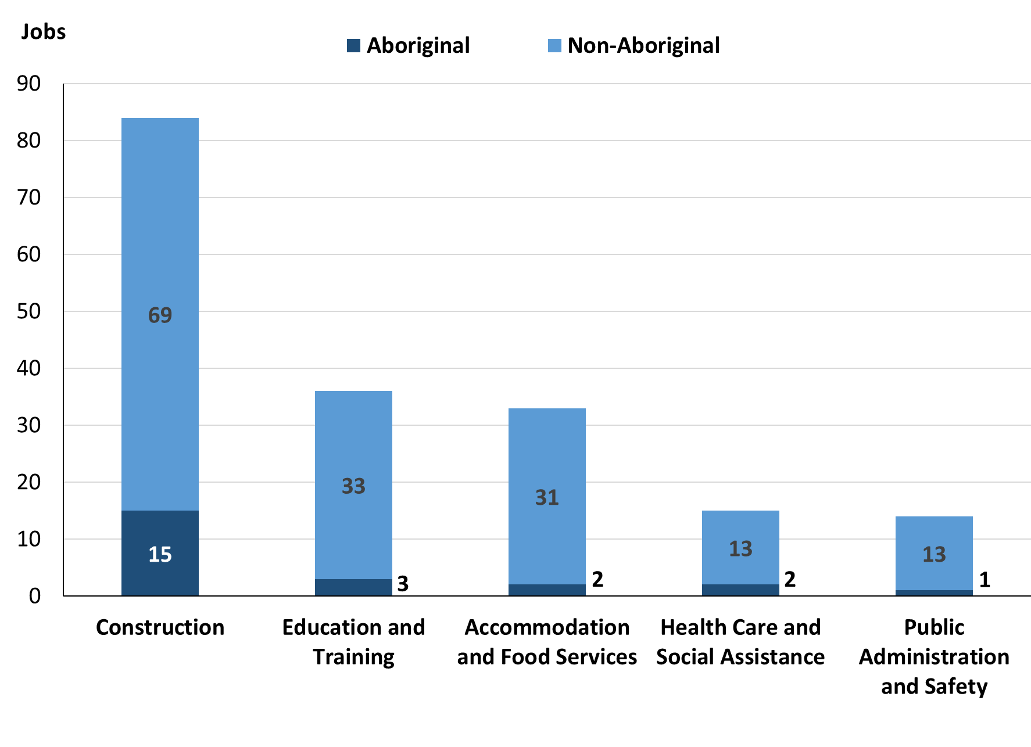

Source: Northern Territory Department of Industry, Tourism and Trade

In 2023 in Alyangula, without GEMCO:

* of the 28 jobs filled by **Aboriginal** people, there were:
* 15 jobs in Construction, an increase of 15 jobs from 2017
* 5 jobs in Administrative and Support Services, an increase of 5 jobs from 2017
* 3 jobs in Education and Training, an increase of 2 jobs from 2017
* of the 177 jobs filled by **non-Aboriginal** people, there were:
* 69 jobs in Construction, an increase of 69 jobs from 2017
* 33 jobs in Education and Training, an increase of 13 jobs from 2017
* 31 jobs in Accommodation and Food Services, an increase of 2 jobs from 2017.

Table 12: Count of filled jobs by industry and employment status, 2017 (a)(c)(e)(h)

|  |  |  |  |  |  |  |  |  |  |  |
| --- | --- | --- | --- | --- | --- | --- | --- | --- | --- | --- |
| **Industry (ANZSIC division)** | **2017** | | | | | | | | | |
| **Aboriginal** | | | **Non-Aboriginal** | | | **Total** | | | |
| **Perm** | **Temp** | **Total** | **Perm** | **Temp** | **Total** | **Perm** | **Temp** | **Total** |
| Accommodation and Food Services | 3 | 0 | **3** | 18 | 11 | **29** | 21 | 11 | **32** |
| Education and Training | 1 | 0 | **1** | 10 | 10 | **20** | 11 | 10 | **21** |
| Financial and Insurance Services | 0 | 0 | **0** | 2 | 1 | **3** | 2 | 1 | **3** |
| Health Care and Social Assistance | 1 | 2 | **3** | 13 | 13 | **26** | 14 | 15 | **29** |
| Other Services | 0 | 0 | **0** | 3 | 0 | **3** | 3 | 0 | **3** |
| Public Administration and Safety | 24 | 4 | **28** | 36 | 4 | **40** | 60 | 8 | **68** |
| Rental, Hiring and Real Estate Services | 0 | 1 | **1** | 1 | 1 | **2** | 1 | 2 | **3** |
| Retail Trade | 0 | 3 | **3** | 15 | 5 | **20** | 15 | 8 | **23** |
| Transport, Postal and Warehousing | 0 | 0 | **0** | 9 | 3 | **12** | 9 | 3 | **12** |
| **Total** | **29** | **10** | **39** | **107** | **48** | **155** | **136** | **58** | **194** |

Source: Northern Territory Department of Industry, Tourism and Trade

Table 13: Count of filled jobs by industry and employment status, 2023 (a)(c)(e)(h)

|  |  |  |  |  |  |  |  |  |  |  |
| --- | --- | --- | --- | --- | --- | --- | --- | --- | --- | --- |
| **Industry (ANZSIC division)** | **2023** | | | | | | | | | |
| **Aboriginal** | | | **Non-Aboriginal** | | | **Total** | | | |
| **Perm** | **Temp** | **Total** | **Perm** | **Temp** | **Total** | **Perm** | **Temp** | **Total** |
| Accommodation and Food Services | 2 | 0 | **2** | 30 | 1 | **31** | 32 | 1 | **33** |
| Administrative and Support Services | 5 | 0 | **5** | 8 | 0 | **8** | 13 | 0 | **13** |
| Agriculture, Forestry and Fishing | 0 | 0 | **0** | 1 | 3 | **4** | 1 | 3 | **4** |
| Construction | 15 | 0 | **15** | 69 | 0 | **69** | 84 | 0 | **84** |
| Education and Training | 0 | 3 | **3** | 11 | 22 | **33** | 11 | 25 | **36** |
| Financial and Insurance Services | 0 | 0 | **0** | 0 | 0 | **0** | 0 | 0 | **0** |
| Health Care and Social Assistance | 2 | 0 | **2** | 4 | 9 | **13** | 6 | 9 | **15** |
| Other Services | 0 | 0 | **0** | 0 | 0 | **0** | 0 | 0 | **0** |
| Public Administration and Safety | 1 | 0 | **1** | 13 | 0 | **13** | 14 | 0 | **14** |
| Rental, Hiring and Real Estate Services | 0 | 0 | **0** | 0 | 0 | **0** | 0 | 0 | **0** |
| Retail Trade | 0 | 0 | **0** | 4 | 2 | **6** | 4 | 2 | **6** |
| Transport, Postal and Warehousing | 0 | 0 | **0** | 0 | 0 | **0** | 0 | 0 | **0** |
| **Total** | **25** | **3** | **28** | **140** | **37** | **177** | **165** | **40** | **205** |

Source: Northern Territory Department of Industry, Tourism and Trade

In 2023 in Alyangula, without GEMCO:

* of the 165 **permanent jobs**, there were:
* Construction had 84 jobs, an increase of 84 jobs from 2017, including:
* 15 jobs filled by **Aboriginal** people, an increase of 15 jobs from 2017
* 69 jobs filled by **non-Aboriginal** people, an increase of 69 jobs from 2017
* Accommodation and Food Services, had 32 jobs an increase of 11 jobs from 2017, including:
* 2 jobs filled by **Aboriginal** people, a decrease of 1 job from 2017
* 30 jobs filled by **non-Aboriginal** people, an increase of 12 jobs from 2017
* Public Administration and Safety had 14 jobs, a decrease of 46 jobs from 2017, including:
* 1 job filled by an **Aboriginal** person, a decrease of 23 jobs from 2017
* 13 jobs filled by **non-Aboriginal** people, a decrease of 23 jobs from 2017
* of the 40 **temporary jobs**, there were:
* Education and Training had 25 jobs, an increase of 15 jobs from 2017, including:
* 3 jobs filled by **Aboriginal** people, an increase of 3 jobs from 2017
* 22 jobs filled by **non-Aboriginal** people, an increase of 12 jobs from 2017
* Health Care and Social Assistance had 9 jobs, a decrease of 6 jobs from 2017, including:
* No jobs filled by **Aboriginal** people, a decrease of 2 jobs from 2017
* 9 jobs filled by **non-Aboriginal** people, a decrease of 4 jobs from 2017
* Agriculture, Forestry and Fishing had 3 jobs, an increase of 3 jobs from 2017, including:
* 0 jobs filled by **Aboriginal** people, unchanged from 2017
* 3 jobs filled by **non-Aboriginal** people, an increase of 3 jobs from 2017.

# Jobs by Occupation

Table 14: Count of filled jobs by occupation, 2017 & 2023 (a)(f)(g)

|  |  |  |  |  |  |  |
| --- | --- | --- | --- | --- | --- | --- |
| **Occupation (ANZSCO major group)** | **2017** | | | **2023** | | **Change 2017-2023** |
| **Total** | **% of Total** | **Total** | | **% of Total** | **Total** |
| Clerical and Administrative Workers | 33 | 17.0% | 25 | | 12.2% | -8 |
| Community and Personal Service Workers | 41 | 21.1% | 17 | | 8.3% | -24 |
| Labourers | 24 | 12.4% | 34 | | 16.6% | 10 |
| Machinery Operators and Drivers | 0 | 0.0% | 16 | | 7.8% | 16 |
| Managers | 29 | 14.9% | 20 | | 9.8% | -9 |
| Professionals | 47 | 24.2% | 36 | | 17.6% | -11 |
| Sales Workers | 12 | 6.2% | 5 | | 2.4% | -7 |
| Technicians and Trades Workers | 8 | 4.1% | 52 | | 25.4% | 44 |
| **Total** | **194** | **100.0%** | **205** | | **100.0%** | **11** |

Source: Northern Territory Department of Industry, Tourism and Trade

Chart 9: Count of top 6 filled jobs by occupation, 2017 & 2023 (a)(f)(g)

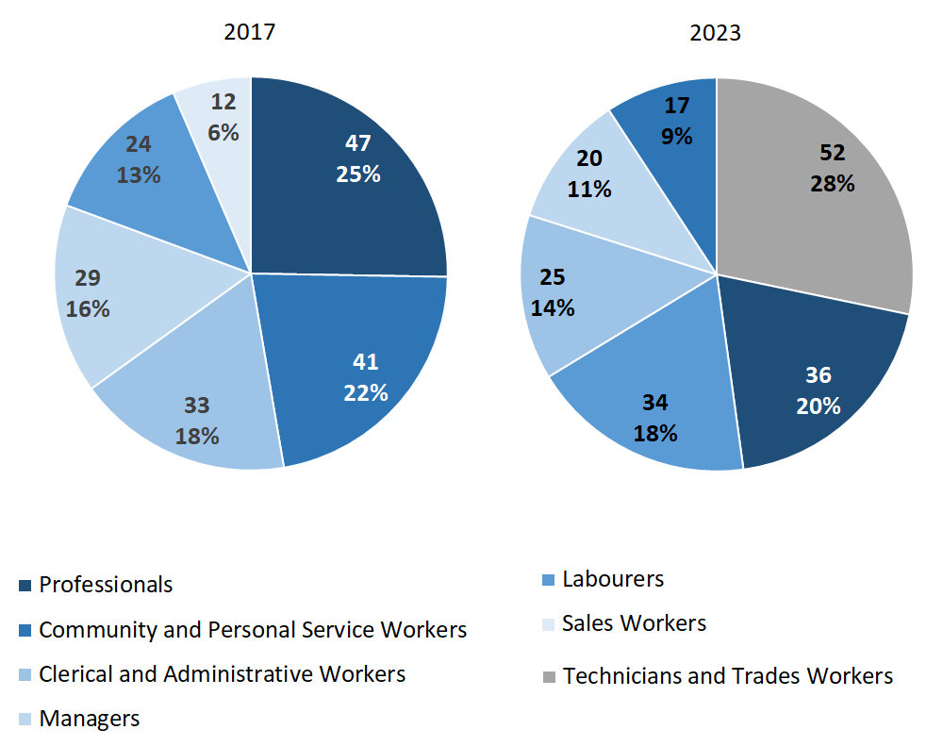

Source: Northern Territory Department of Industry, Tourism and Trade

In 2023 in Alyangula, without GEMCO:

* Technicians and Trades Workers was the **largest** **occupation** **classification** in terms of filled jobs, accounting for 52 jobs (25.4% of total filled jobs), an increase of 44 jobs from 2017
* **other** **significant** occupation classifications were:
* Professionals (36 jobs or 17.6%), a decrease of 11 jobs from 2017
* Labourers (34 jobs or 16.6%), an increase of 10 jobs from 2017
* Clerical and Administrative Workers (25 jobs or 12.2%), a decrease of 8 jobs from 2017.

**Table 15: Count of filled jobs by ANZSCO occupation, 2017 & 2023 (a)(c)(f)(g)**

|  |  |  |  |  |  |  |  |  |  |  |
| --- | --- | --- | --- | --- | --- | --- | --- | --- | --- | --- |
| **Occupation (ANZSCO major group)** | **2017** | | | **2023** | | | **Change**  **2017-2023** | | | |
| **Aboriginal** | **Non-Aboriginal** | **Total** | **Aboriginal** | **Non-Aboriginal** | **Total** | **Aboriginal** | **Non-Aboriginal** | **Total** |
| Clerical and Administrative Workers | 3 | 30 | **33** | 2 | 23 | **25** | -1 | -7 | **-8** |
| Community and Personal Service Workers | 8 | 33 | **41** | 1 | 16 | **17** | -7 | -17 | **-24** |
| Labourers | 4 | 20 | **24** | 19 | 15 | **34** | 15 | -5 | **10** |
| Machinery Operators and Drivers | 0 | 0 | **0** | 0 | 16 | **16** | 0 | 16 | **16** |
| Managers | 3 | 26 | **29** | 2 | 18 | **20** | -1 | -8 | **-9** |
| Professionals | 19 | 28 | **47** | 2 | 34 | **36** | -17 | 6 | **-11** |
| Sales Workers | 2 | 10 | **12** | 0 | 5 | **5** | -2 | -5 | **-7** |
| Technicians and Trades Workers | 0 | 8 | **8** | 2 | 50 | **52** | 2 | 42 | **44** |
| **Total** | **39** | **155** | **194** | **28** | **177** | **205** | **-11** | **22** | **11** |

Source: Northern Territory Department of Industry, Tourism and Trade

In 2023 in Alyangula, without GEMCO:

* of the 28 jobs filled by **Aboriginal** people, there were:
* Labourers had 19 Aboriginal workers, an increase of 15 jobs from 2017
* Clerical and Administrative Workers had 2 Aboriginal workers, a decrease of 1 job from 2017
* Professionals had 2 Aboriginal workers, a decrease of 17 jobs from 2017
* of the 177 jobs filled by **non-Aboriginal** people, there were:
* Technicians and Trades Workers had 50 non-Aboriginal workers, an increase of 42 jobs from 2017
* Professionals had 34 non-Aboriginal workers, an increase of 6 jobs from 2017
* Clerical and Administrative Workers had 23 non-Aboriginal workers, a decrease of 7 jobs from 2017.

# Jobs by Industry by Occupation

**Table 16: Count of filled jobs by occupation and by industry, 2017 (a)(f)(g)(h)**

|  |  |  |  |  |  |  |  |  |  |  |
| --- | --- | --- | --- | --- | --- | --- | --- | --- | --- | --- |
| **2017** | | | | | | | | | | |
| **Industry (ANZSIC Division)** |  | **Occupation (ANZSCO major group)** | | | | | | | | |
| **Clerical and Administrative Workers** | **Community and Personal Service Workers** | **Labourers** | **Machinery Operators and Drivers** | **Managers** | **Professionals** | **Sales Workers** | **Technicians and Trades Workers** | **Other occupations** | **Total** |
| Accommodation and Food Services | 0 | 8 | 12 | 0 | 7 | 0 | 0 | 5 | 0 | **32** |
| Education and Training | 5 | 0 | 1 | 0 | 2 | 13 | 0 | 0 | 0 | **21** |
| Health Care and Social Assistance | 3 | 14 | 1 | 0 | 4 | 7 | 0 | 0 | 0 | **29** |
| Public Administration and Safety | 14 | 19 | 5 | 0 | 5 | 24 | 0 | 1 | 0 | **68** |
| Retail Trade | 0 | 0 | 1 | 0 | 8 | 1 | 12 | 1 | 0 | **23** |
| Transport, Postal and Warehousing | 8 | 0 | 1 | 0 | 1 | 2 | 0 | 0 | 0 | **12** |
| **Total** | **33** | **41** | **24** | **0** | **29** | **47** | **12** | **8** | **0** | **194** |

Source: Northern Territory Department of Industry, Tourism and Trade

**Table 17: Count of filled jobs by occupation and by industry, 2023 (a)(f)(g)(h)**

|  |  |  |  |  |  |  |  |  |  |  |
| --- | --- | --- | --- | --- | --- | --- | --- | --- | --- | --- |
| **2023** | | | | | | | | | | |
| **Industry (ANZSIC Division)** |  | **Occupation (ANZSCO major group)** | | | | | | | | |
| **Clerical and Administrative Workers** | **Community and Personal Service Workers** | **Labourers** | **Machinery Operators and Drivers** | **Managers** | **Professionals** | **Sales Workers** | **Technicians and Trades Workers** | **Other occupations** | **Total** |
| Accommodation and Food Services | 2 | 0 | 7 | 0 | 7 | 0 | 0 | 17 | 0 | **33** |
| Administrative and Support Services | 0 | 0 | 4 | 0 | 5 | 2 | 0 | 2 | 0 | **13** |
| Agriculture, Forestry and Fishing | 0 | 0 | 0 | 0 | 0 | 0 | 0 | 4 | 0 | **4** |
| Construction | 12 | 0 | 18 | 16 | 8 | 2 | 1 | 27 | 0 | **84** |
| Education and Training | 5 | 5 | 3 | 0 | 0 | 23 | 0 | 0 | 0 | **36** |
| Health Care and Social Assistance | 5 | 0 | 1 | 0 | 0 | 9 | 0 | 0 | 0 | **15** |
| Public Administration and Safety | 1 | 12 | 1 | 0 | 0 | 0 | 0 | 0 | 0 | **14** |
| Retail Trade | 0 | 0 | 0 | 0 | 0 | 0 | 4 | 2 | 0 | **6** |
| Transport, Postal and Warehousing | 0 | 0 | 0 | 0 | 0 | 0 | 0 | 0 | 0 | **0** |
| **Total** | **25** | **17** | **34** | **16** | **20** | **36** | **5** | **52** | **0** | **205** |

Source: Northern Territory Department of Industry, Tourism and Trade

In 2023 in Alyangula, without GEMCO:

* Technicians and Trades Workers held the majority of jobs with 52 (the largest occupation group) and were shared across Construction with 27 jobs and the Accommodation and Food Services industries with 7 jobs
* Professionals (the 2nd largest occupation group) had the majority of jobs with 23 jobs in the Education and Training industry
* Construction, a new industry and the largest industry in 2023, had 84 filled jobs
* New industries in 2023 include Administrative and Support Services with 13 filled jobs, and Agriculture, Forestry and Fishing with 4 filled jobs.

# Jobs by Gender

**Table 18: Count of filled jobs by gender[2], 2017 & 2023 (a)(c)(i)**

|  |  |  |  |  |  |  |  |  |  |
| --- | --- | --- | --- | --- | --- | --- | --- | --- | --- |
| **Indicator** | **2017** | | | **2023** | | | **2017-2023 Change** | | |
| **Aboriginal** | **Non-Aboriginal** | **Total** | **Aboriginal** | **Non-Aboriginal** | **Total** | **Aboriginal** | **Non-Aboriginal** | **Total** |
| Male | 20 | 65 | **85** | 22 | 103 | **125** | 2 | 38 | **40** |
| Female | 18 | 90 | **108** | 6 | 73 | **79** | -12 | -17 | **-29** |
| **Total** | **38** | **155** | **193** | **28** | **177** | **205** | **-10** | **22** | **12** |

Source: Northern Territory Department of Industry, Tourism and Trade

Chart 10: Count of filled jobs by gender, 2017 & 2023 (a)(c)(i)

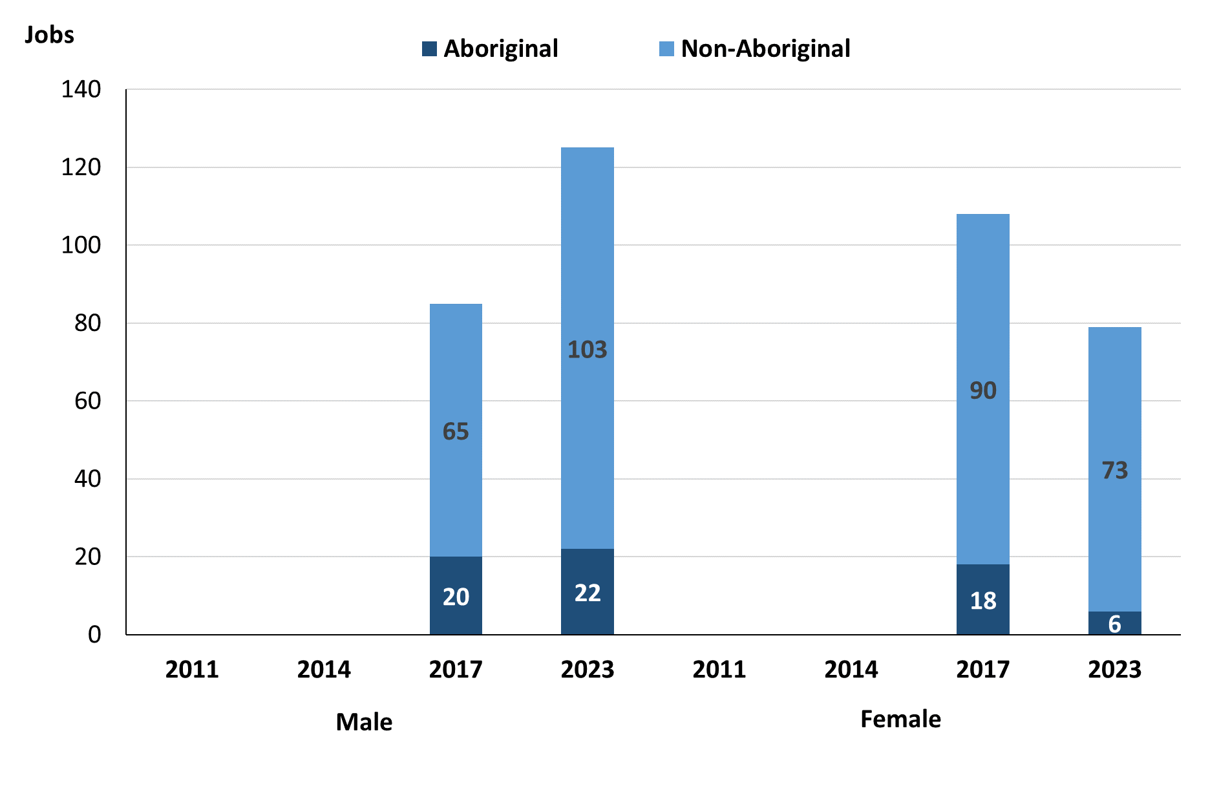

*Source: Northern Territory Department of Industry, Tourism and Trade*

In 2023 in Alyangula, without GEMCO, there were:

* 125 **jobs filled by males**, an increase of 40 jobs from 2017, of which:
* 22 were **Aboriginal**, an increase of 2 jobs from 2017
* 103 were **non-Aboriginal**, an increase of 38 jobs from 2017
* 79 **jobs filled by females**, a decrease of 29 jobs from 2017, of which:
* 6 were **Aboriginal**, a decrease of 12 jobs from 2017
* 73 were **non-Aboriginal**, a decrease of 17 jobs from 2017.

**Table 19: Count of filled jobs by gender, by full-time/part-time status, by job permanency, and by sector, 2017 (a)(b)(c)(d)(e)(i)**

|  |  |  |  |  |  |  |  |  |  |  |
| --- | --- | --- | --- | --- | --- | --- | --- | --- | --- | --- |
| **2017** | | | | | | | | | | |
| **Indicator** | **Male** | | | **Female** | | | **Total** | | | |
| **Aboriginal** | **Non-Aboriginal** | **Total** | **Aboriginal** | **Non-Aboriginal** | **Total** | **Aboriginal** | **Non-Aboriginal** | **Total** |
| Full-time | 16 | 53 | **69** | 12 | 69 | **81** | 29 | 122 | **151** |
| Part-time | 4 | 12 | **16** | 6 | 21 | **27** | 10 | 33 | **43** |
| **Total** | **20** | **65** | **85** | **18** | **90** | **108** | **39** | **155** | **194** |
| Permanent | 17 | 51 | **68** | 11 | 56 | **67** | 29 | 107 | **136** |
| Temporary | 3 | 14 | **17** | 7 | 34 | **41** | 10 | 48 | **58** |
| **Total** | **20** | **65** | **85** | **18** | **90** | **108** | **39** | **155** | **194** |
| Public Sector | 5 | 14 | **19** | 5 | 29 | **34** | 11 | 43 | **54** |
| Private Sector | 15 | 51 | **66** | 13 | 61 | **74** | 28 | 112 | **140** |
| **Total** | **20** | **65** | **85** | **18** | **90** | **108** | **39** | **155** | **194** |

Source: Northern Territory Department of Industry, Tourism and Trade

**Table 20: Count of filled jobs by gender, by full-time/part-time status, by job permanency, and by sector, 2023 (a)(b)(c)(d)(e)(i)**

|  |  |  |  |  |  |  |  |  |  |
| --- | --- | --- | --- | --- | --- | --- | --- | --- | --- |
| **2023** | | | | | | | | | |
| **Indicator** | **Male** | | | **Female** | | | **Total** | | |
| **Aboriginal** | **Non-Aboriginal** | **Total** | **Aboriginal** | **Non-Aboriginal** | **Total** | **Aboriginal** | **Non-Aboriginal** | **Total** |
| Full-time | 22 | 102 | **124** | 5 | 70 | **75** | 27 | 172 | **199** |
| Part-time | 0 | 1 | **1** | 1 | 3 | **4** | 1 | 5 | **6** |
| **Total** | **22** | **103** | **125** | **6** | **73** | **79** | **28** | **177** | **205** |
| Permanent | 22 | 92 | **114** | 3 | 48 | **51** | 25 | 140 | **165** |
| Temporary | 0 | 11 | **11** | 3 | 25 | **28** | 3 | 37 | **40** |
| **Total** | **22** | **103** | **125** | **6** | **73** | **79** | **28** | **177** | **205** |
| Public Sector | 21 | 84 | **105** | 1 | 33 | **34** | 22 | 118 | **140** |
| Private Sector | 1 | 19 | **20** | 5 | 40 | **45** | 6 | 59 | **65** |
| **Total** | **22** | **103** | **125** | **6** | **73** | **79** | **28** | **177** | **205** |

Source: Northern Territory Department of Industry, Tourism and Trade

In 2023 in Alyangula, without GEMCO:

* of the 125 **jobs filled by males**, there were:
* 22 jobs filled by **Aboriginal** males, an increase of 2 jobs from 2017, including:
* 22 full-time jobs, an increase of 6 jobs from 2017
* 0 part-time jobs, a decrease of 4 jobs from 2017
* 22 permanent jobs, an increase of 5 jobs from 2017
* 0 temporary jobs, a decrease of 3 jobs from 2017
* 21 public sector jobs, an increase of 16 jobs from 2017
* 1 private sector job, a decrease of 14 jobs from 2017
* 103 jobs filled by **non-Aboriginal** males, an increase of 38 jobs from 2017, including:
* 102 full-time jobs, an increase of 49 jobs from 2017
* 1 part-time job, a decrease of 11 jobs from 2017
* 92 permanent jobs, an increase of 41 jobs from 2017
* 11 temporary jobs, a decrease of 3 jobs from 2017
* 84 public sector jobs, an increase of 70 jobs from 2017
* 19 private sector jobs, a decrease of 32 jobs from 2017
* of the 79 **jobs filled by females**, there were:
* 6 jobs filled by **Aboriginal** females, a decrease of 12 jobs from 2017, including:
* 5 full-time jobs, a decrease of 7 jobs from 2017
* 1 part-time job, a decrease of 5 jobs from 2017
* 3 permanent jobs and, a decrease of 8 jobs from 2017
* 3 temporary jobs, a decrease of 4 jobs from 2017
* 1 public sector job, a decrease of 4 jobs from 2017
* 5 private sector jobs, a decrease of 8 jobs from 2017
* 73 jobs filled by **non-Aboriginal** females, a decrease of 17 jobs from 2017, including:
* 70 full-time jobs, an increase of 1 job from 2017
* 3 part-time jobs, a decrease of 18 jobs from 2017
* 48 permanent jobs, a decrease of 8 jobs from 2017
* 25 temporary jobs, a decrease of 9 jobs from 2017
* 33 public sector jobs, an increase of 4 jobs from 2017
* 40 private sector jobs, a decrease of 21 jobs from 2017.

# Jobs by Age

**Table 21: Count of filled jobs by age, 2017 & 2023 (a)(c)(j)**

|  |  |  |  |  |  |  |  |  |  |  |
| --- | --- | --- | --- | --- | --- | --- | --- | --- | --- | --- |
| **Indicator** | **2017** | | | **2023** | | | **Change**  **2017-2023** | | | |
| **Aboriginal** | **Non-Aboriginal** | **Total** | **Aboriginal** | **Non-Aboriginal** | **Total** | **Aboriginal** | **Non-Aboriginal** | **Total** |
| 15-24 years | 3 | 13 | **16** | 9 | 12 | **21** | 6 | -1 | **5** |
| 25-44 years | 19 | 94 | **113** | 13 | 105 | **118** | -6 | 11 | **5** |
| 45+ years | 15 | 47 | **62** | 4 | 55 | **59** | -11 | 8 | **-3** |
| **Total** | **39** | **155** | **194** | 28 | 177 | **205** | -9 | 23 | **14** |

Source: Northern Territory Department of Industry, Tourism and Trade

**Chart 11: Count of filled jobs by age, 2017 & 2023 (a)(c)(j)**

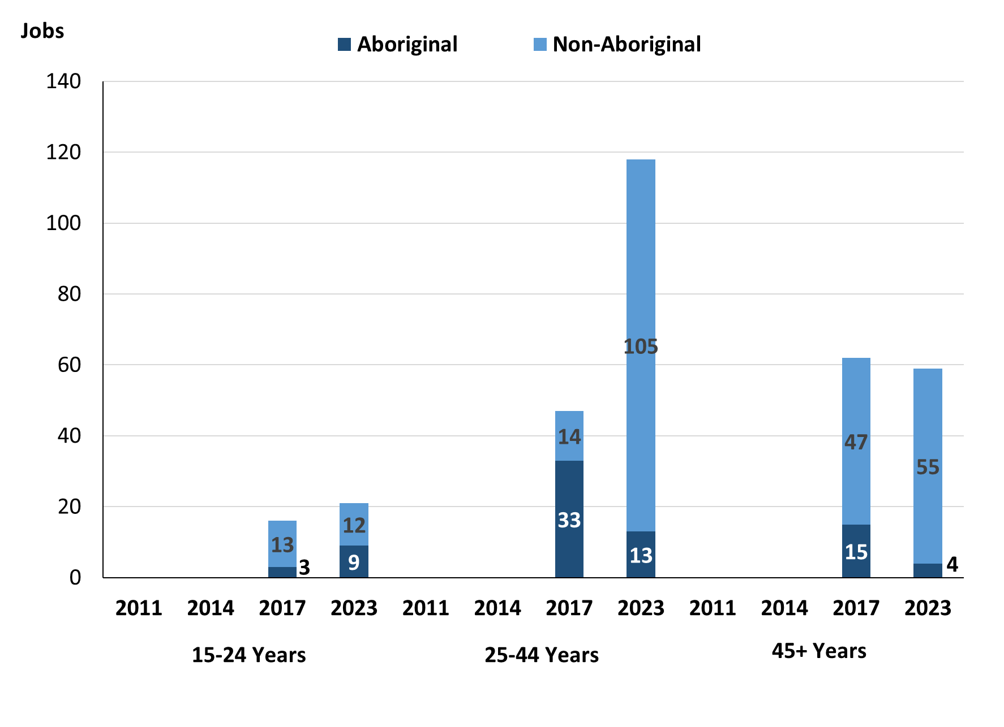

Source: Northern Territory Department of Industry, Tourism and Trade

In 2023 in Alyangula, without GEMCO, there were:

* 21 **jobs filled** by people aged **15-24 years***,* an increase of 5 jobs from 2017, of these:
* 9 jobs were filled by **Aboriginal** people, an increase of 6 jobs from 2017
* 12 jobs were filled by **non-Aboriginal** people, a decrease of 1 job from 2017
* 118 **jobs filled** by people aged **25-44 years***,* an increase of 5 jobs from 2017, of these:
* 13 jobs were filled by **Aboriginal** people, a decrease of 6 jobs from 2017
* 105 jobs were filled by **non-Aboriginal** people, an increase of 11 jobs from 2017
* 59 **jobs filled** by people aged **45+ years***,* a decrease of 3 jobs from 2017, of these:
* 4 jobs were filled by **Aboriginal** people, a decrease of 11 jobs from 2017
* 55 jobs were filled by **non-Aboriginal** people, an increase of 8 jobs from 2017.

**Table 22: Count of filled jobs by age, by full-time/part-time status, by job permanency, and by sector, July 2017 (a)(b)(c)(d)(e)(i)**

|  |  |  |  |  |  |  |  |  |  |  |  |  |  |
| --- | --- | --- | --- | --- | --- | --- | --- | --- | --- | --- | --- | --- | --- |
| **2017** | | | | | | | | | | | | | |
| **Indicator** | **15-24 years** | | | **25-44 years** | | | **45+ years** | | | **Total** | | | |
| **Aboriginal** | **Non-Aboriginal** | **Total** | **Aboriginal** | **Non-Aboriginal** | **Total** | **Aboriginal** | **Non-Aboriginal** | **Total** | **Aboriginal** | **Non-Aboriginal** | **Total** |
| Full-time | 2 | 4 | **6** | 17 | 77 | **94** | 8 | 40 | **48** | 29 | 122 | **151** |
| Part-time | 1 | 9 | **10** | 2 | 17 | **19** | 7 | 7 | **14** | 10 | 33 | **43** |
| **Total** | **3** | **13** | **16** | **19** | **94** | **113** | **15** | **47** | **62** | **39** | **155** | **194** |
|  |  |  |  |  |  |  |  |  |  |  |  |  |
| Permanent | 2 | 3 | **5** | 18 | 71 | **89** | 7 | 32 | **39** | 29 | 107 | **136** |
| Temporary | 1 | 10 | **11** | 1 | 23 | **24** | 8 | 15 | **23** | 10 | 48 | **58** |
| **Total** | **3** | **13** | **16** | **19** | **94** | **113** | **15** | **47** | **62** | **39** | **155** | **194** |
|  |  |  |  |  |  |  |  |  |  |  |  |  |
| Public Sector | 0 | 1 | **1** | 6 | 24 | **30** | 4 | 18 | **22** | 11 | 43 | **54** |
| Private Sector | 3 | 12 | **15** | 13 | 70 | **83** | 11 | 29 | **40** | 28 | 112 | **140** |
| **Total** | **3** | **13** | **16** | **19** | **94** | **113** | **15** | **47** | **62** | **39** | **155** | **194** |

Source: Northern Territory Department of Industry, Tourism and Trade

**Table 23: Count of filled jobs by age, by full-time/part-time status, by job permanency, and by sector, September 2023 (a)(b)(c)(d)(e)(i)**

| **2023** | | | | | | | | | | | | |
| --- | --- | --- | --- | --- | --- | --- | --- | --- | --- | --- | --- | --- |
| **Indicator** | **15-24 years** | | | **25-44 years** | | | **45+ years** | | | **Total** | | |
| **Aboriginal** | **Non-Aboriginal** | **Total** | **Aboriginal** | **Non-Aboriginal** | **Total** | **Aboriginal** | **Non-Aboriginal** | **Total** | **Aboriginal** | **Non-Aboriginal** | **Total** |
| Full-time | 9 | 12 | **21** | 12 | 102 | **114** | 4 | 54 | **58** | 27 | 172 | **199** |
| Part-time | 0 | 0 | **0** | 1 | 3 | **4** | 0 | 1 | **1** | 1 | 5 | **6** |
| Total | **9** | **12** | **21** | **13** | **105** | **118** | **4** | **55** | **59** | **28** | **177** | **205** |
| Permanent | 9 | 10 | **19** | 11 | 83 | **94** | 3 | 44 | **47** | 25 | 140 | **165** |
| Temporary | 0 | 2 | **2** | 2 | 22 | **24** | 1 | 11 | **12** | 3 | 37 | **40** |
| Total | **9** | **12** | **21** | **13** | **105** | **118** | **4** | **55** | **59** | **28** | **177** | **205** |
| Public Sector | 9 | 10 | **19** | 8 | 66 | **74** | 3 | 37 | **40** | 22 | 118 | **140** |
| Private Sector | 0 | 2 | **2** | 5 | 39 | **44** | 1 | 18 | **19** | 6 | 59 | **65** |
| Total | **9** | **12** | **21** | **13** | **105** | **118** | **4** | **55** | **59** | **28** | **177** | **205** |

Source: Northern Territory Department of Industry, Tourism and Trade

In 2023 in Alyangula, without GEMCO:

* of the 21 **jobs filled** by people aged **15-24 years**, there were:
* 9 jobs filled by **Aboriginal** people, of which:
* 9 were full-time jobs, an increase of 7 jobs from 2017
* none were part-time jobs, a decrease of 1 job from 2017
* 9 were permanent jobs, an increase of 7 jobs from 2017
* none were temporary jobs, a decrease of 1 job from 2017
* 9 were public sector jobs, an increase of 9 jobs from 2017
* none were private sector jobs, a decrease of 3 jobs from 2017
* 12 jobs filled by **non-Aboriginal** people, of which:
* 12 were full-time jobs, an increase of 8 jobs from 2017
* none were part-time jobs, a decrease of 9 jobs from 2017
* 10 were permanent jobs, an increase of 7 jobs from 2017
* 2 were temporary jobs, a decrease of 8 jobs from 2017
* 10 were public sector jobs, an increase of 9 jobs from 2017
* 2 were private sector jobs, a decrease of 10 jobs from 2017
* of the 118 **jobs filled** by people aged **25-44 years**, there were:
* 13 jobs filled by **Aboriginal** people, of which:
* 12 were full-time jobs, a decrease of 5 jobs from 2017
* 1 was a part-time job, a decrease of 1 job from 2017
* 11 were permanent jobs, a decrease of 7 jobs from 2017
* 2 were temporary jobs, an increase of 1 job from 2017
* 8 were public sector jobs, an increase of 2 jobs from 2017
* 5 were private sector jobs, a decrease of 8 jobs from 2017
* 105 jobs filled by **non-Aboriginal** people, of which:
* 102 were full-time jobs, an increase of 25 jobs from 2017
* 3 were part-time jobs, a decrease of 14 jobs from 2017
* 83 were permanent jobs, an increase of 12 jobs from 2017
* 22 were temporary jobs, a decrease of 1 job from 2017
* 66 were public sector jobs, an increase of 42 jobs from 2017
* 39 were private sector jobs, a decrease of 31 jobs from 2017
* of the 59 **jobs filled** by people aged **45+ years**, there were:
* 4 jobs filled by **Aboriginal** people, of which:
* 4 were full-time jobs, a decrease of 4 jobs from 2017
* none were part-time jobs, a decrease of 7 jobs from 2017
* 3 were permanent jobs, a decrease of 4 jobs from 2017
* 1 was a temporary job, a decrease of 7 jobs from 2017
* 3 were public sector jobs, a decrease of 1 job from 2017
* 1 was a private sector job, a decrease of 10 jobs from 2017
* 55 jobs filled by **non-Aboriginal** people, of which:
* 54 were full-time jobs, an increase of 14 jobs from 2017
* 1 was a part-time job, a decrease of 6 jobs from 2017
* 44 were permanent jobs, an increase of 12 jobs from 2017
* 11 were temporary jobs, a decrease of 4 jobs from 2017
* 37 were public sector jobs, an increase of 19 jobs from 2017
* 18 were private sector jobs, a decrease of 11 jobs from 2017.

# Vocational Education and Training

Table 24: Northern Territory Vocational Education and Training (VET) students, 2016 & 2023 (k)

|  |  |  |  |  |  |  |
| --- | --- | --- | --- | --- | --- | --- |
| **VET Funding Group** | **2016** | | **2023** | | **Change** | |
| **No.** | **% of Total** | **No.** | **% of Total** | **2016-2023** |
| Arts, Entertainment, Sports and Recreation | 9 | 5% | 20 | 22% | 11 |
| Building and Construction | 25 | 13% | 9 | 10% | -16 |
| Business and Clerical | 1 | 1% | 0 | 0% | -1 |
| Community Services, Health and Education | 31 | 16% | 41 | 45% | 10 |
| Engineering and Mining | 22 | 12% | 9 | 10% | -13 |
| Primary Industry | 24 | 13% | 0 | 0% | -24 |
| Process Manufacturing | 1 | 1% | 12 | 13% | 11 |
| Sales and Personal Service | 14 | 7% | 1 | 1% | -13 |
| Tourism and Hospitality | 10 | 5% | 0 | 0% | -10 |
| Transport and Storage | 51 | 27% | 0 | 0% | -51 |
| **Total** | **188** | **100%** | **76** | **100%** | **-96** |

Source: Northern Territory Department of Industry, Tourism and Trade

In Alyangula in 2023:

* there were 76 **VET student**s, a decrease of 96 students from 2016
* VET activity with the most students were Community Services and Health and Education with 41 students
* Arts, Entertainment, Sports and Recreation had 20 students
* Process Manufacturing had 12 students
* Arts, Entertainment, Sports and Recreation and Process Manufacturing reported the largest increase in students with 11 students compared to 2016
* Transport and Storage reported the largest decrease in students with 51 less students over the same period.

Table 25: Northern Territory Vocational Education and Training (VET) unit enrolments, 2016 & 2023 (l)

|  |  |  |  |  |  |
| --- | --- | --- | --- | --- | --- |
| **VET Funding Group** | **2016** | | **2023** | | **Change** |
| **No.** | **% of Total** | **No.** | **% of Total** | **2016-2023** |
| Arts, Entertainment, Sports and Recreation | 18 | 3% | 20 | 8% | 2 |
| Building and Construction | 29 | 5% | 9 | 4% | -20 |
| Community Services, Health and Education | 46 | 8% | 112 | 44% | 66 |
| Engineering and Mining | 100 | 17% | 9 | 4% | -91 |
| Finance, Banking and Insurance | 0 | 0% | 0 | 0% | 0 |
| Primary Industry | 100 | 17% | 96 | 38% | -4 |
| Process Manufacturing | 3 | 1% | 0 | 0% | -3 |
| Sales and Personal Services | 210 | 36% | 8 | 3% | -202 |
| Tourism and Hospitality | 30 | 5% | 0 | 0% | -30 |
| Transport and Storage | 47 | 8% | 0 | 0% | -47 |
| **Total** | **583** | **100%** | **254** | **100%** | **-329** |

Source: Northern Territory Department of Industry, Tourism and Trade

In Alyangula in 2023:

* there were 254 **VET unit enrolments**, a decrease of 329 student enrolments from 2016
* the VET activity with the most unit enrolments were:
  + Community Services, Health and Education with 112-unit enrolments,
  + Primary Industry with 96-unit enrolments,
  + Arts, Entertainment, Sports and Recreation with 20-unit enrolments.
* Community Services, Health and Education reported the largest increase in student numbers with 66-unit enrolments compared to 2016,
* Sales and Personal Services reported the largest decrease in unit enrolment numbers with a decrease of 202 over the same period.

Table 26: Northern Territory Vocational Education and Training (VET) nominal hours, 2016 & 2023 (m)

|  |  |  |  |  |  |
| --- | --- | --- | --- | --- | --- |
| **VET Funding Group** | **2016** | | **2023** | | **Change** |
| **No.** | **% of Total** | **No.** | **% of Total** | **2016-2023** |
| Arts, Entertainment, Sports and Recreation | 230 | 3% | 200 | 3% | -30 |
| Building and Construction | 0 | 0% | 180 | 3% | 180 |
| Community Services, Health and Education | 2141 | 26% | 2318 | 36% | 177 |
| Engineering and Mining | 1688 | 20% | 180 | 3% | -1508 |
| Primary Industry | 3140 | 38% | 3300 | 51% | 160 |
| Sales and Personal Services | 0 | 0% | 255 | 4% | 255 |
| Tourism and Hospitality | 1120 | 13% | 0 | 0% | -1120 |
| **Total** | **8319** | **100%** | **6433** | **100%** | **-1886** |

Source: Northern Territory Department of Industry, Tourism and Trade

In Alyangula in 2023:

* there were 6,433 **VET nominal hours delivered**, a decrease of 1,886 nominal hours delivered from 2016
* the areas of VET activity with the most nominal hours delivered were Primary Industry with 3,300 hours,
  + Community Services, Health and Education with 2,318 nominal hours delivered,
  + Sales and Personal Services with 255 nominal hours delivered.
* Sales and Personal Services reported the largest increase in nominal hours delivered with 255 hours delivered compared to 2016,
* Engineering and Mining reported the largest decrease in nominal hours delivered with a total 1,508 less hours over the same period.

Caveat: *Nominal hours are based on the hours funded through Northern Territory Government contracts and fee for service. Students and units include delivery that may have been funded in a previous year. Because of these factors, a direct match cannot be made between hours and student/units.*

Table 27: Northern Territory Vocational Education and Training (VET) unit completions, 2016 & 2023 (n)

|  |  |  |  |  |  |
| --- | --- | --- | --- | --- | --- |
| **VET Funding Group** | **2016** | | **2023** | | **Change** |
| **No.** | **% of Total** | **No.** | **% of Total** | **2016-2023** |
| Arts, Entertainment, Sports and Recreation | 19 | 3% | 19 | 9% | 0 |
| Building and Construction | 30 | 5% | 9 | 4% | -21 |
| Business and Clerical | 7 | 1% | 0 | 42% | -7 |
| Community Services, Health and Education | 76 | 11% | 90 | 4% | 14 |
| Engineering and Mining | 100 | 15% | 9 | 0% | -91 |
| Primary Industry | 102 | 15% | 88 | 41% | -14 |
| Sales and Personal Services | 210 | 32% | 0 | 0% | -210 |
| Tourism and Hospitality | 60 | 9% | 0 | 0% | -60 |
| **Total** | **661** | **100%** | **215** | **100%** | **-446** |

Source: Northern Territory Department of Industry, Tourism and Trade

In Alyangula in 2023:

* there were 215 **VET student completions**, a decrease of 446-unit completions from 2016
* VET activity with the most student completions were Community Services, Health and Education with a total of 90 completions,
  + Primary Industry had a total of 88 students complete,
  + Arts, Entertainment, Sports and Recreation had a total of 19 students complete.
* Community Services, Health and Education reported the largest increase in unit completions with 14 completions compared to 2016,
* Sales and Personal Services reported the largest decrease in unit completions with 210 less completions over the same period.

Population

**Table 28: Population distribution by gender and age (p)(r)**

|  |  |  |  |  |  |  |  |  |  |
| --- | --- | --- | --- | --- | --- | --- | --- | --- | --- |
| **Indicator** | **2011** | | | **2021** | | | **Change (2011-2021)** | | |
| **Male** | **Female** | **Total** | **Male** | **Female** | **Total** | **Male** | **Female** | **Total** |
| **0-4 years** | 46 | 44 | **90** | 55 | 36 | **91** | 9 | -8 | **1** |
| **5-14 years** | 77 | 68 | **145** | 85 | 74 | **159** | 8 | 6 | **14** |
| **15-24 years** | 65 | 26 | **91** | 12 | 20 | **32** | -53 | -6 | **-59** |
| **25-44 years** | 227 | 186 | **413** | 129 | 140 | **269** | -98 | -46 | **-144** |
| **45-64 years** | 157 | 88 | **245** | 96 | 76 | **172** | -61 | -12 | **-73** |
| **65+ years** | 8 | 0 | **8** | 17 | 9 | **26** | 9 | 9 | **18** |
| **Total** | **575** | **410** | **985** | **399** | **353** | **752** | **-176** | **-57** | **-233** |

*Source: Australian Bureau of Statistics*

In 2021 in Alyangula:

* there were an estimated 752 people, of which:
* 399 (53.1%) were male
* 353 (46.9%) were female
* between 2011 and 2021, the overall population in Alyangula decreased by 233 people from 2011, or an average of -2.4% per year compared to -0.5% across the 28 remote towns and 1.0% Territory wide
* the male population decreased by 176 people from 2011
* the female population decreased by 57 people from 2011
* in 2021, the working age population (15 years and over) in Alyangula was an estimated 499 people (66.4% of the total population) compared with 757 people (76.9% of the total population) in 2011. Of these:
* 32 (4.3%) were between 15 and 24 years of age
* 269 (35.8%) were between 25 and 44 years of age
* 172 (22.9%) were between 45 and 64 years of age
* 26 (3.5%) were over 65 years of age
* of the 499 people of working age:
* 254 (50.9%) were male
* 245 (49.1%) were female.

There were 0.5 jobs in Alyangula per working age person compared to 0.3 jobs per working age person across the 28 remote towns in the Northern Territory.

**Chart 12: Population comparison (p)(q)**

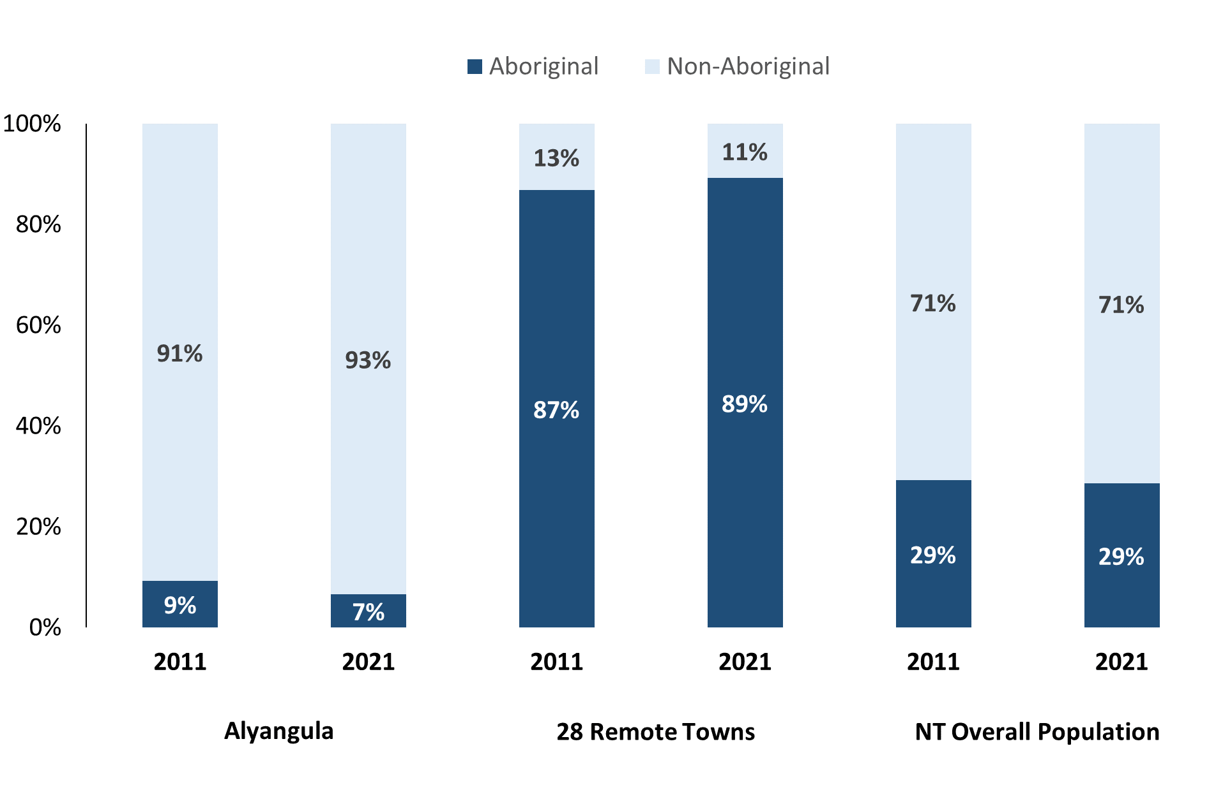

*Source: Australian Bureau of Statistics*

In 2021 in Alyangula:

* 7% of the population in Alyangula were Aboriginal, compared to 9% in 2011
* 89% of the population across all 28 remote towns were Aboriginal
* 29% of the NT population were Aboriginal.

**Table 29: Unemployment and Aboriginal participation rates (q)**

|  |  |  |  |  |  |  |
| --- | --- | --- | --- | --- | --- | --- |
|  | **Alyangula** | | | **Northern Territory** | | |
| **Aboriginal** | **Non-Aboriginal** | **Total** | **Aboriginal** | **Non-Aboriginal** | **Total** |
| **Unemployment Rate** | 0.0% | 1.4% | 1.3% | 20.8% | 3.2% | 5.6% |
| **Participation Rate** | 91.7% | 92.5% | 77.2% | 35.4% | 78.3% | 64.9% |

*Source: Australian Bureau of Statistics*

In 2021 in Alyangula the:

* **total unemployment rate** was 1.3% compared to 5.6% for the total Northern Territory (NT)
* **Aboriginal unemployment rate** was 0.0% compared to 20.8% for the total NT
* **non-Aboriginal unemployment rate** was 1.4% compared to 3.2% for the total Northern Territory
* **total participation rate** was 77.2% compared to 64.9% for the total Northern Territory
* **Aboriginal participation rate** was 91.7% compared to 35.4% for the total Northern Territory
* **non-Aboriginal participation rate** was 92.5% compared to 78.3% for the total Northern Territory.

# Community Development Program

**Table 30: Community Development Program Aboriginal Job Seekers, 31 December 2023 (o)**

|  |  |  |
| --- | --- | --- |
| **Indicator** | **Aboriginal** | |
| **No.** | **%** |
| **Total Aboriginal Job Seekers** | <20 | N/A |
| **Age (years)** | | |
| 15-24 | <20 | N/A |
| 25-44 | <20 | N/A |
| 45+ | <20 | N/A |
| **Total** | <20 | N/A |
| **Gender** | | |
| Male | <20 | N/A |
| Female | <20 | N/A |
| **Total** | <20 | N/A |
| **Employment Outcome – 1 January 2023 to 31 December 2023** | | |
| 13 Weeks | <20 | N/A |
| 26 Weeks | <20 | N/A |

*Source: Department of Prime Minister and Cabinet*

As at 31 December 2023, in Alyangula, there were less than 20 CDP **Aboriginal** job seekers, of these:

* less than 20 were male and less than 20 were female
* less than 20 were aged 15-24 years, less than 20 were aged 25-44 years, and less than 20 were aged 45+ years
* between 1 January 2023 to 31 December 2023, less than 20 had reached the 13-week and 26-week reporting milestones.

# Businesses

**Table 31: Businesses by sector (d)(s)**

|  |  |  |
| --- | --- | --- |
| **Business Name** | **Reported on in 2017** | **Reported on in 2023** |
| **PUBLIC SECTOR** | | |
| **Department of Education** | Yes | **Yes** |
| **Department of Health** | Yes | **Yes** |
| Department of the Prime Minister and Cabinet | Yes | No |
| **Northern Territory Police, Fire Emergency Services** | Yes | **Yes** |
| Territory Families | Yes | No |
| PRIVATE SECTOR | | |
| Alyangula Daycare Inc (Seagrass Learning Centre) | Yes | No |
| Alyangula Golf Club | Yes | No |
| Alyangula Kiosk and Newsagent | Yes | No |
| **Alyangula Local Post Office** | Yes | **Yes** |
| Amangara Aboriginal Corporation t/a Groote Leading Appliances | Yes | No |
| Anindilyakwa Land Council (ALC) | Yes | No |
| ANZ Bank | Yes | No |
| Arirrki Aboriginal Corporation trading as Groote Eylandt Car Rentals | Yes | No |
| Bartalumba Mini Mart Aboriginal Corporation | Yes | No |
| Canis Loopus Pty Ltd t/a Arafura Aviation | Yes | No |
| Capiteq Pty Limited t/a Airnorth | Yes | No |
| Eylandt Automotive and Marine | Yes | No |
| Fitzo Midada t/a Fitzos Boutique | Yes | No |
| Flojo Takeaway | Yes | No |
| **GEBIE Civil and Construction Pty Ltd** | No | **Yes** |
| **GEBIE Community Development Pty Ltd** | No | **Yes** |
| **Groote Aqua Aboriginal Corporation** | No | **Yes** |
| **Groote Eylandt Lodge Trust** | Yes | **Yes** |
| MJD Foundation | Yes | No |
| Nick Kenny Investments Pty Ltd trading as Active Performance | Yes | No |
| Northpharm Pty Ltd trading as Groote Eylandt Health Store | Yes | No |
| Scoffee Pty Ltd trading as The Coffee Shop | Yes | No |
| Sea Swift | Yes | No |
| South32, Groote Eylandt Mining Company Pty Ltd (not included in this profile) | Yes | No |
| **The Bakery-Groote Eylandt** | Yes | **Yes** |

*Source: Northern Territory Department of Industry, Tourism and Trade*

*Note: Business names captured have been identified by the current 2023 Business ABN name listed.*

In 2023 in Alyangula:

* there were 9 businesses reported on, of which:
* 3 businesses were from the public sector (33%)
* 6 businesses were from the private sector (67%).

# Notes

1. These counts represent numbers of filled jobs and not the number of people. As such the totals represent the total number of filled jobs, not the total number of employees. This count is not directly comparable to the total number of employed people as a person may have several jobs or one job may be shared by more than one person.
2. Full-time is defined as a job usually requiring 35 hours or more per week or that required 35 hours or more work during the reference week. Part-time is defined as a job usually requiring less than 35 hours per week or that required less than 35 hours work during the reference week. The reference week refers to the period that respondents were asked to provide information about. In most instances it would be the week prior to the week the questionnaire was completed. Questionnaires were predominantly conducted in June and July.
3. Care needs to be taken when analysing the counts of filled jobs by Aboriginal people. Aboriginality was reported by the business representative completing the questionnaire.
4. Sector was classified using the Standard Economic Sector of Classifications of Australia (SESCA), 2008.
5. Job permanency is classified according to what the business believes the level of job permanency is based on guidelines provided by data collectors. Those guidelines state a permanent job has paid annual and/or sick leave entitlements while a temporary job includes casual and fixed-term contract jobs.
6. Classified according to the Australian and New Zealand Standard Classification of Occupations (ANZSCO), 2006, major occupation level.
7. Other occupations include jobs where occupation was not stated, not known or inadequately described.
8. Classified using the Australian and New Zealand Standard Industrial Classification (ANZSIC), 2006, division level.
9. Care needs to be taken when analysing the counts of filled jobs by the gender of people in the jobs. The gender of the person employed in a job is reported by the business representative completing the questionnaire.
10. Care needs to be taken when analysing the counts of filled jobs by the age of people in the jobs. The age of the person employed in a job is reported by the business representative completing the questionnaire.
11. Students represent the number of individual clients that enrolled in a Vocational Education and Training unit during the calendar year.
12. Unit enrolments represent the count of individual units that students enrolled in during the calendar year.
13. Nominal hours delivered is the sum of the nominal hours of the units commenced during the calendar year regardless of when the course enrolment commenced.
14. Unit completions are the count of all successfully completed units reported in the calendar year regardless of the year of commencement of the units.
15. The Community Development Program (CDP) supports job seekers in remote Australia to build skills, address barriers and contribute to their communities through a range of flexible activities. Under the CDP, job seekers with activity requirements are expected to do up to 25 hours per week of work-like activities that benefit their community. It should be noted that some CDP participants may be reported on within the profile if they are attached to a filled position with an employer captured in the survey. Due to confidentiality issues, data below 20 people is not published.
16. Population estimates for both 2011 and 2021 are taken from the estimated resident population (ERP) data produced by the Australian Bureau of Statistics (ABS) and based on Australian Statistical Geography Standard (ASGS) Statistical Area Level 1 (SA1) regions. ERP are official estimates of the Australian population, which link people to a place of usual residence with Australia. All ERP data sources, including the Census of Population and Housing (Census), are subject to error (including inaccuracies in collection, recording and processing data) and should be used with caution.
17. Indigenous population proportions, unemployment and workforce participation rates are based on ABS Census counts at ASGS Indigenous Locations (ILOCs) for each remote town.
18. Working-age population includes all residents aged 15 years and over (commonly referred to as the civilian population) and consists of people that are employed, unemployed or not in the labour force.
19. A ‘business’ has been defined as any organisation that has undertaken productive activities in the last year, including companies, non-profit organisations, government departments and enterprises operating within the designated remote geography (town), and has one or more employees in paid employment and an Australian Business Number (ABN).

# Abbreviations and Acronyms

ABN Australian Business Number

ABS Australian Bureau of Statistics

ANZSCO Australian and New Zealand Standard Classification of Occupations

ANZSIC Australian and New Zealand Standard Industrial Classification

ASGS Australian Statistical Geography Standard

CDP Community Development Program

ERP Estimated Resident Population

GEMCO Groote Eylandt Mining Company

ILOC Indigenous Locations

nec Not Elsewhere Classified

No. Number

Perm Permanent

ppt Percentage point

RJCP Remote Jobs and Communities Program

Temp Temporary

SA1 Statistical Area Level 1

VET Vocational Education and Training

1. The number of filled jobs does not represent numbers of people as a person may have several jobs or one job may be shared by more than one person.
2. 1 Aboriginal filled job gender status not identified in 2017