Mineral Titles Act 2010
NOTICE OF LAND CEASING TO BE A MINERAL TITLE AREA
Title Type and Number: | Exploration Licence 28325
Area Ceased on: | 16 January 2025
Area: | 11 Blocks, 33.31 km²
Locality: | McFARLANE
Name of Applicant(s)/Holder(s): | 100% PRODIGY GOLD NL* [ACN. 009 127 020]
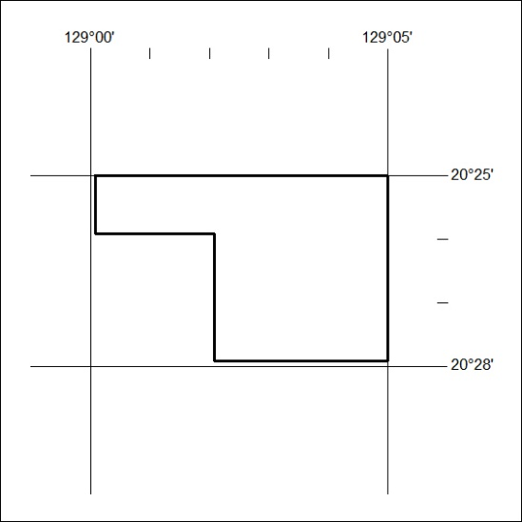
38/25

Mineral Titles Act 2010
NOTICE OF LAND CEASING TO BE A MINERAL TITLE AREA
Title Type and Number: | Exploration Licence 28327
Area Ceased on: | 16 January 2025
Area: | 20 Blocks, 62.56 km²
Locality: | PARGEE
Name of Applicant(s)/Holder(s): | 100% PRODIGY GOLD NL* [ACN. 009 127 020]
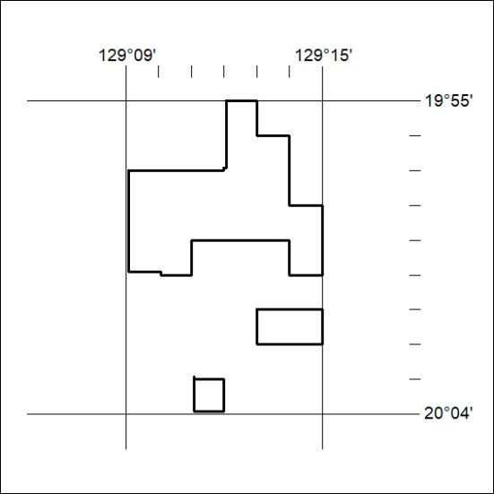
39/25

