Mineral Titles Act 2010
NOTICE OF LAND CEASING TO BE A MINERAL TITLE AREA
Title Type and Number: | Mineral Lease (Central) 591, 592, 593, 594, 595, 596 and 597
Area ceased on: | 13 December 2024
Area: | 54.00 Hectare
Locality: | TENNANT CREEK
Name of Applicants(s)Holder(s): | 100% TC8 PTY LTD [ACN. 009 644 188]
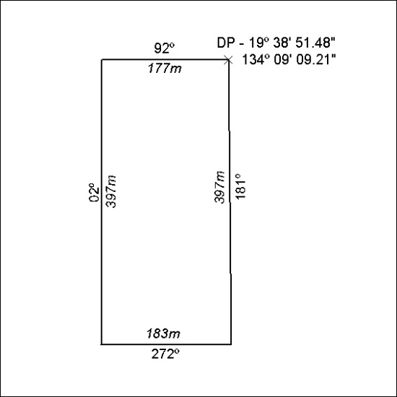
(Area now amalgamated into Mineral Lease 34037 under s102)

474/24

Mineral Titles Act 2010
NOTICE OF LAND CEASING TO BE A MINERAL TITLE AREA
Title Type and Number: | Mineral Lease (Central) 601, 602, 603, 604 and 605
Area ceased on: | 13 December 2024
Area: | 40.00 Hectare
Locality: | TENNANT CREEK
Name of Applicants(s)Holder(s): | 100% TC8 PTY LTD [ACN. 009 644 188]
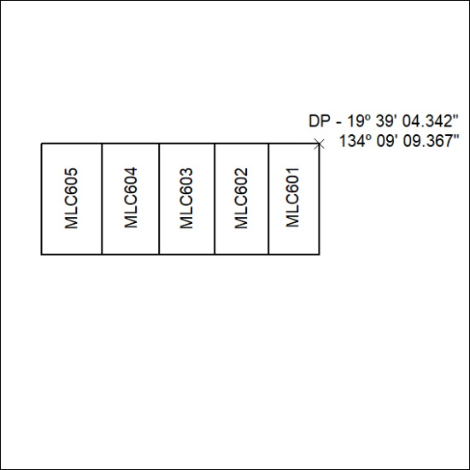
(Area now amalgamated into Mineral Lease 34038 under s102)

475/24

