Mineral Titles Act 2010
NOTICE OF LAND CEASING TO BE A MINERAL TITLE AREA

Title Type and Number: | Mineral Leases (Central) 32, 35, 36, 37, 54, 55, 56, 130, 131, 132, 133, 134, 135, 136, 137, 138, 139,140, 141, 142, 143,144, 146, 147, 148, 149, 343, 344, 345, 346, 347, 352, 353, 354, 355, 576, 577, 584, 585, 586 & 598
Area ceased on: | 27 November 2024
Area: | 22.00 Hectare
Locality: | TENNANT CREEK
Name of Applicants(s)Holder(s): | 100% SANTEXCO PTY LTD [ACN. 002 910 296]
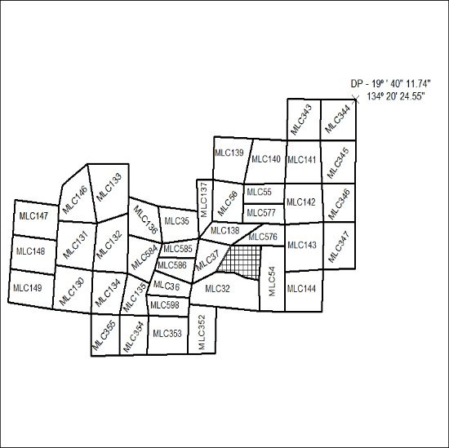
(Area now amalgamated into Mineral Lease 34014 under s102)

437/24

Mineral Titles Act 2010
NOTICE OF LAND CEASING TO BE A MINERAL TITLE AREA
Title Type and Number: | Exploration Licence 31869
Area Ceased on: | 30 November 2024
Area: | 26 Blocks, 82.90 km²
Locality: | MOUNT PEAKE
Name of Applicant(s)/Holder(s): | 100% IGO LIMITED* [ACN. 092 786 304]
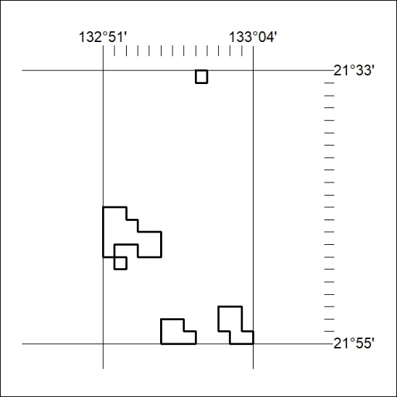
438/24
Mineral Titles Act 2010
NOTICE OF LAND CEASING TO BE A MINERAL TITLE AREA
Title Type and Number: | Exploration Licence 31874
Area Ceased on: | 30 November 2024
Area: | 1 Block, 3.20 km²
Locality: | WILLOWRA
Name of Applicant(s)/Holder(s): | 100% IGO LIMITED* [ACN. 092 786 304]
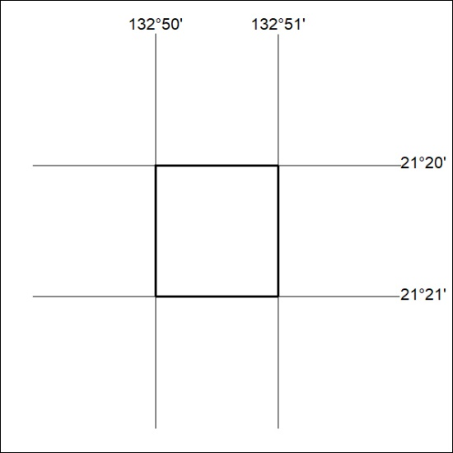

439/24

Mineral Titles Act 2010
NOTICE OF LAND CEASING TO BE A MINERAL TITLE AREA
Title Type and Number: | Exploration Licence 31889
Area Ceased on: | 30 November 2024
Area: | 1 Block, 1.99 km²
Locality: | WILLOWRA
Name of Applicant(s)/Holder(s): | 100% IGO LIMITED* [ACN. 092 786 304]
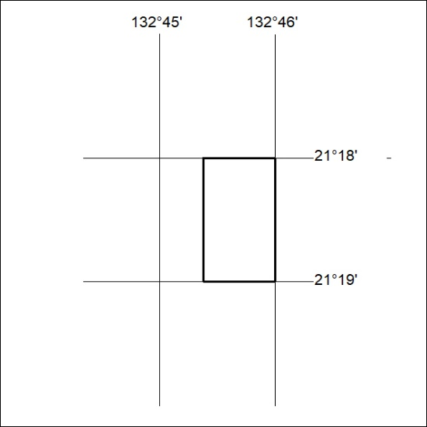

440/24

Mineral Titles Act
NOTICE OF GRANT OF A MINERAL TITLE
Title Type and Number: | Extractive Mineral Lease 33117
Granted: | 29 November 2024, for a period of 10 Years
Area: | 28.64 Hectares
Locality: | MARY RIVER
Name of Holder/s: | 100% MOUSELLIS & SONS PTY. LTD. [ACN. 009 654 791]
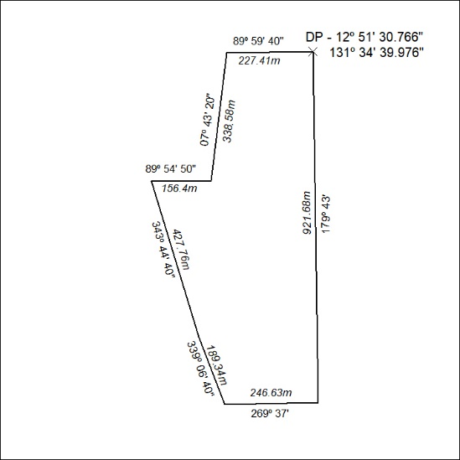

441/24

