Mineral Titles Act 2010
NOTICE OF LAND CEASING TO BE A MINERAL TITLE AREA
Title Type and Number: | Exploration Licence 32044
Area Ceased on: | 27 November 2024
Area: | 173 Blocks, 561.20 km²
Locality: | ALEXANDRIA
Name of Applicant(s)/Holder(s): | 100% MLM DRILLING PTY LTD [ACN. 130 013 562]
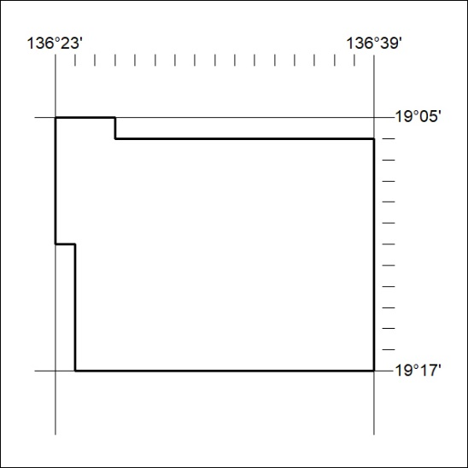

431/24

Mineral Titles Act 2010
NOTICE OF LAND CEASING TO BE A MINERAL TITLE AREA
Title Type and Number: | Exploration Licence 32045
Area Ceased on: | 27 November 2024
Area: | 223 Blocks, 717.71 km²
Locality: | ALEXANDRIA
Name of Applicant(s)/Holder(s): | 100% MLM DRILLING PTY LTD [ACN. 130 013 562]
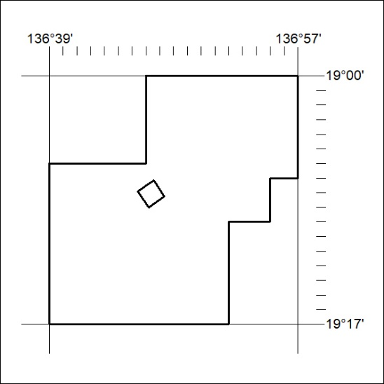

432/24

