Mineral Titles Act
NOTICE OF GRANT OF A MINERAL TITLE
Title Type and Number: | Exploration Licence 33844
Granted: | 22 November 2024, for a period of 6 Years
Area: | 246 Blocks, 710.35 km²
Locality: | TURNERS DOME
Name of Holder/s: | 100% WA1 RESOURCES LTD [ACN. 646 878 631]
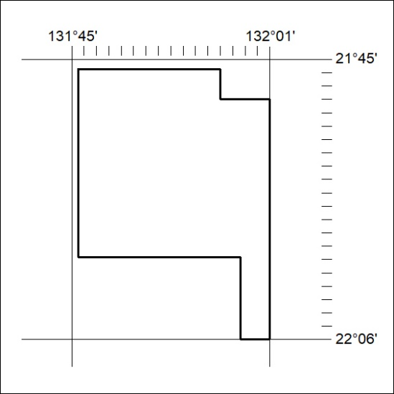
Area granted is indicated above. The titleholder is not permitted to exercise occupational rights on any land that is subject to a development title, or an application for a development title. Any land the subject of a Reserved Land gazettal under the Mineral Titles Act and all land vested in the Commonwealth of Australia is also excluded by description but not excised from the grant area.
416/24

Mineral Titles Act
NOTICE OF GRANT OF A MINERAL TITLE
Title Type and Number: | Exploration Licence 33845
Granted: | 22 November 2024, for a period of 6 Years
Area: | 213 Blocks, 668.84 km²
Locality: | GILES
Name of Holder/s: | 100% WA1 RESOURCES LTD [ACN. 646 878 631]
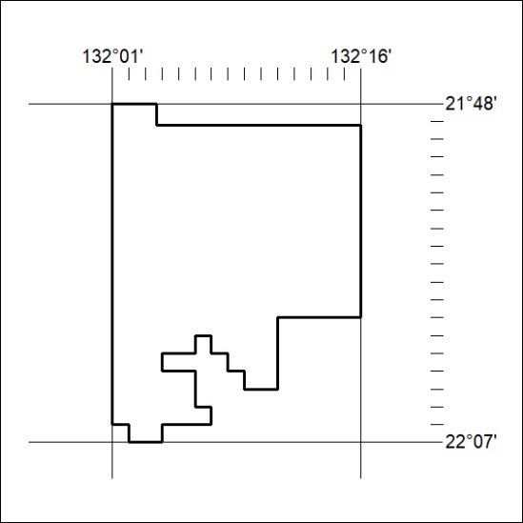
Area granted is indicated above. The titleholder is not permitted to exercise occupational rights on any land that is subject to a development title, or an application for a development title. Any land the subject of a Reserved Land gazettal under the Mineral Titles Act and all land vested in the Commonwealth of Australia is also excluded by description but not excised from the grant area.
417/24

Mineral Titles Act
NOTICE OF GRANT OF A MINERAL TITLE
Title Type and Number: | Exploration Licence 33846
Granted: | 22 November 2024, for a period of 6 Years
Area: | 27 Blocks, 86.08 km²
Locality: | CHILLA
Name of Holder/s: | 100% WA1 RESOURCES LTD [ACN. 646 878 631]
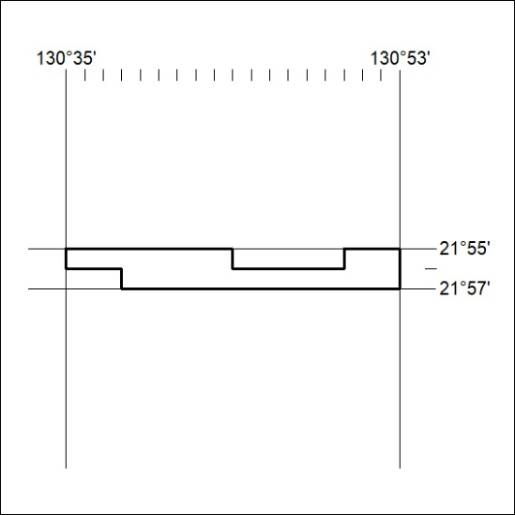
Area granted is indicated above. The titleholder is not permitted to exercise occupational rights on any land that is subject to a development title, or an application for a development title. Any land the subject of a Reserved Land gazettal under the Mineral Titles Act and all land vested in the Commonwealth of Australia is also excluded by description but not excised from the grant area.
418/24

Mineral Titles Act
NOTICE OF GRANT OF A MINERAL TITLE
Title Type and Number: | Exploration Licence 33847
Granted: | 22 November 2024, for a period of 6 Years
Area: | 7 Blocks, 22.28 km²
Locality: | DOREEN
Name of Holder/s: | 100% WA1 RESOURCES LTD [ACN. 646 878 631]
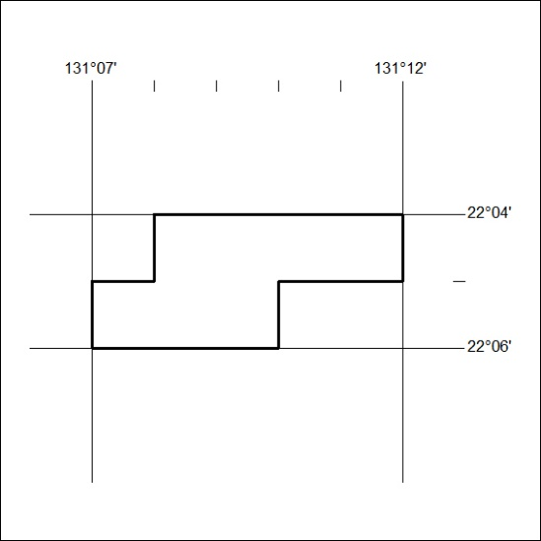
Area granted is indicated above. The titleholder is not permitted to exercise occupational rights on any land that is subject to a development title, or an application for a development title. Any land the subject of a Reserved Land gazettal under the Mineral Titles Act and all land vested in the Commonwealth of Australia is also excluded by description but not excised from the grant area.
419/24

Mineral Titles Act
NOTICE OF GRANT OF A MINERAL TITLE
Title Type and Number: | Exploration Licence 33848
Granted: | 22 November 2024, for a period of 6 Years
Area: | 32 Blocks, 96.93 km²
Locality: | GURNER
Name of Holder/s: | 100% WA1 RESOURCES LTD [ACN. 646 878 631]
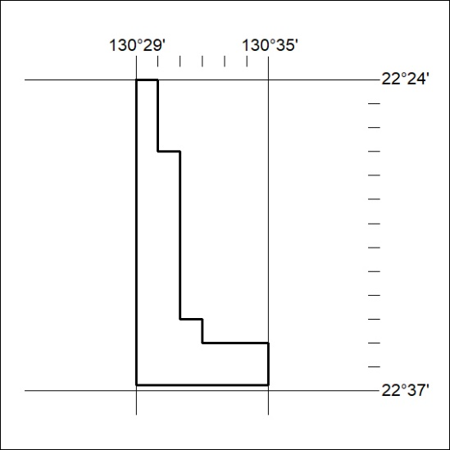
Area granted is indicated above. The titleholder is not permitted to exercise occupational rights on any land that is subject to a development title, or an application for a development title. Any land the subject of a Reserved Land gazettal under the Mineral Titles Act and all land vested in the Commonwealth of Australia is also excluded by description but not excised from the grant area.
420/24

Mineral Titles Act
NOTICE OF GRANT OF A MINERAL TITLE
Title Type and Number: | Exploration Licence 33853
Granted: | 22 November 2024, for a period of 6 Years
Area: | 67 Blocks, 217.12 km²
Locality: | FLYNN
Name of Holder/s: | 100% PAYNE GULLY GOLD PTY LTD [ACN. 638 017 731]
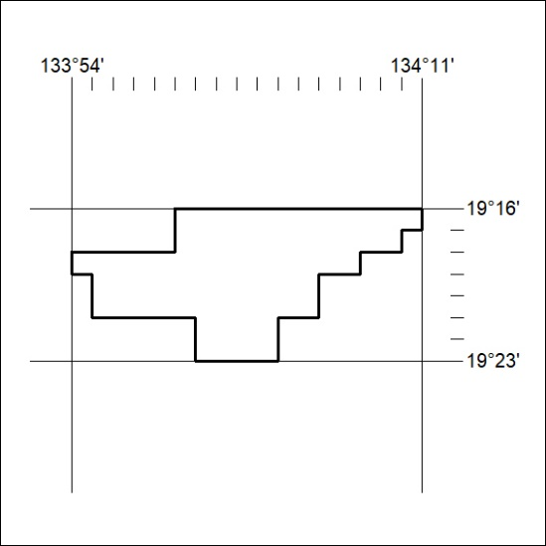
Area granted is indicated above. The titleholder is not permitted to exercise occupational rights on any land that is subject to a development title, or an application for a development title. Any land the subject of a Reserved Land gazettal under the Mineral Titles Act and all land vested in the Commonwealth of Australia is also excluded by description but not excised from the grant area.
421/24

Mineral Titles Act
NOTICE OF GRANT OF A MINERAL TITLE
Title Type and Number: | Exploration Licence 33854
Granted: | 22 November 2024, for a period of 6 Years
Area: | 111 Blocks, 351.77 km²
Locality: | KELLY
Name of Holder/s: | 100% TENNANT EXPLORATION PTY LTD [ACN. 653 670 332]
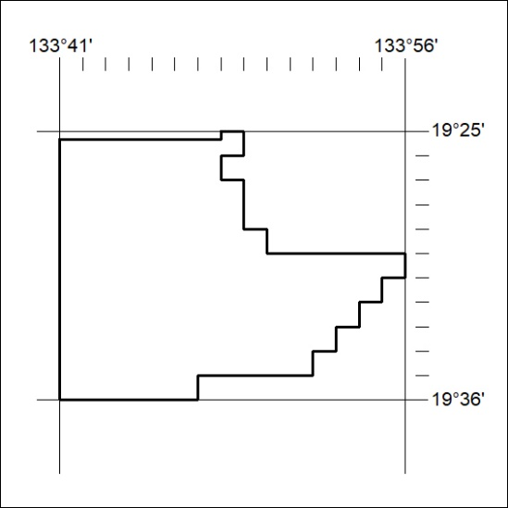
Area granted is indicated above. The titleholder is not permitted to exercise occupational rights on any land that is subject to a development title, or an application for a development title. Any land the subject of a Reserved Land gazettal under the Mineral Titles Act and all land vested in the Commonwealth of Australia is also excluded by description but not excised from the grant area.
422/24

Mineral Titles Act
NOTICE OF GRANT OF A MINERAL TITLE
Title Type and Number: | Exploration Licence 33855
Granted: | 22 November 2024, for a period of 6 Years
Area: | 58 Blocks, 184.85 km²
Locality: | KELLY
Name of Holder/s: | 100% TENNANT EXPLORATION PTY LTD [ACN. 653 670 332]
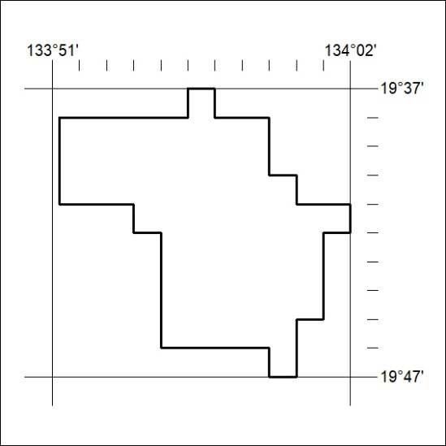
Area granted is indicated above. The titleholder is not permitted to exercise occupational rights on any land that is subject to a development title, or an application for a development title. Any land the subject of a Reserved Land gazettal under the Mineral Titles Act and all land vested in the Commonwealth of Australia is also excluded by description but not excised from the grant area.
423/24

Mineral Titles Act
NOTICE OF GRANT OF A MINERAL TITLE
Title Type and Number: | Exploration Licence 33856
Granted: | 22 November 2024, for a period of 6 Years
Area: | 11 Blocks, 35.59 km²
Locality: | TENNANT CREEK
Name of Holder/s: | 100% TENNANT EXPLORATION PTY LTD [ACN. 653 670 332]
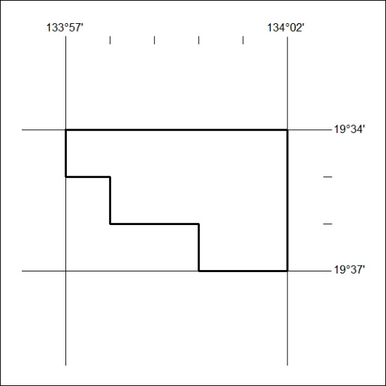
Area granted is indicated above. The titleholder is not permitted to exercise occupational rights on any land that is subject to a development title, or an application for a development title. Any land the subject of a Reserved Land gazettal under the Mineral Titles Act and all land vested in the Commonwealth of Australia is also excluded by description but not excised from the grant area.
424/24

Mineral Titles Act
NOTICE OF GRANT OF A MINERAL TITLE
Title Type and Number: | Exploration Licence 33857
Granted: | 22 November 2024, for a period of 6 Years
Area: | 6 Blocks, 19.43 km²
Locality: | FLYNN
Name of Holder/s: | 100% TENNANT EXPLORATION PTY LTD [ACN. 653 670 332]
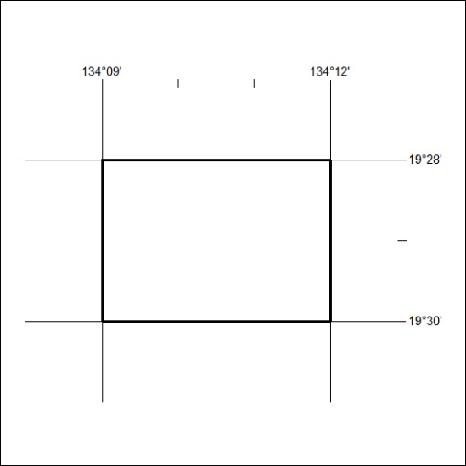
Area granted is indicated above. The titleholder is not permitted to exercise occupational rights on any land that is subject to a development title, or an application for a development title. Any land the subject of a Reserved Land gazettal under the Mineral Titles Act and all land vested in the Commonwealth of Australia is also excluded by description but not excised from the grant area.
425/24

Mineral Titles Act
NOTICE OF GRANT OF A MINERAL TITLE
Title Type and Number: | Exploration Licence 33858
Granted: | 22 November 2024, for a period of 6 Years
Area: | 5 Blocks, 16.20 km²
Locality: | FLYNN
Name of Holder/s: | 100% TENNANT EXPLORATION PTY LTD [ACN. 653 670 332]
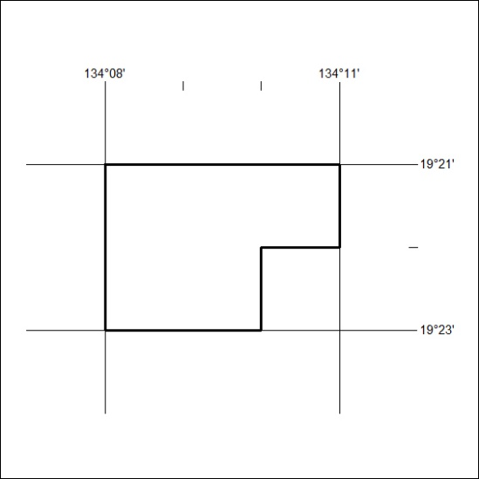
Area granted is indicated above. The titleholder is not permitted to exercise occupational rights on any land that is subject to a development title, or an application for a development title. Any land the subject of a Reserved Land gazettal under the Mineral Titles Act and all land vested in the Commonwealth of Australia is also excluded by description but not excised from the grant area.
426/24

