Mineral Titles Act 2010
NOTICE OF LAND CEASING TO BE A MINERAL TITLE AREA
Title Type and Number: | Mineral Leases (Central) 45, 46, 47, 68, 154, 155, 578 & 579
Area ceased on: | 05 September 2024
Area: | 80.00 Hectare
Locality: | TENNANT CREEK
Name of Applicants(s)Holder(s): | 100% TENNANT CONSOLIDATED MINING GROUP PTY LTD [ACN. 645 263 547]
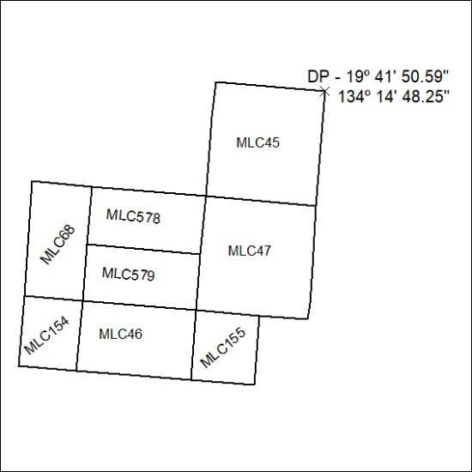
(Area now amalgamated into Mineral Lease 33777 under s102)

303/24

