Mineral Titles Act
NOTICE OF GRANT OF A MINERAL TITLE
Title Type and Number: | Exploration Licence 33231
Granted: | 07 August 2024, for a period of 6 Years
Area: | 31 Blocks, 94.83 km²
Locality: | KILLARNEY
Name of Holder/s: | 100% WRIGHT Anthony
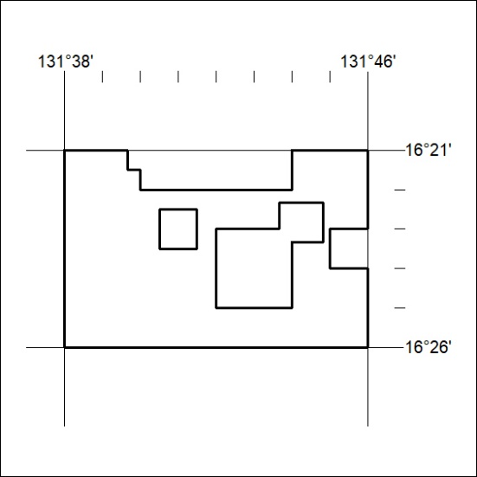
Area granted is indicated above. The titleholder is not permitted to exercise occupational rights on any land that is subject to a development title, or an application for a development title. Any land the subject of a Reserved Land gazettal under the Mineral Titles Act and all land vested in the Commonwealth of Australia is also excluded by description but not excised from the grant area.
238/24

Mineral Titles Act
NOTICE OF GRANT OF A MINERAL TITLE
Title Type and Number: | Mineral Lease 32553
Granted: | 07 August 2024, for a period of 6 Years
Area: | 36.52 Hectares
Locality: | RIDDOCH
Name of Holder/s: | 100% KAPITANY Tamas
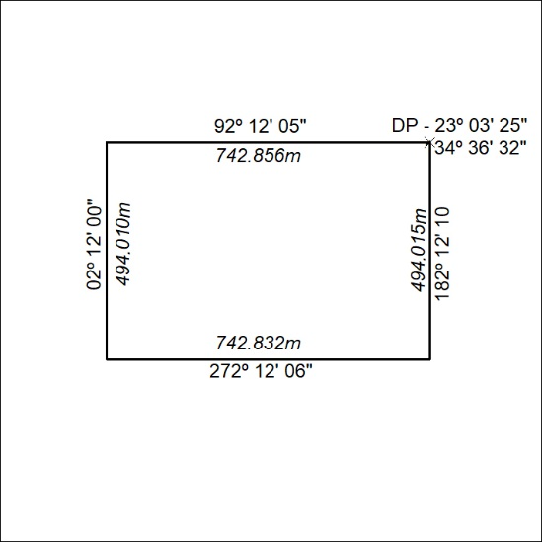
239/24

Mineral Titles Act 2010
NOTICE OF LAND CEASING TO BE A MINERAL TITLE AREA
Title Type and Number: | Exploration Licence 31793
Area Ceased on: | 07 August 2024
Area: | 7 Blocks, 22.16 km²
Locality: | NAPPERBY
Name of Applicant(s)/Holder(s): | 100% MIOXIDE NT PTY LTD [ACN. 636 686 747]
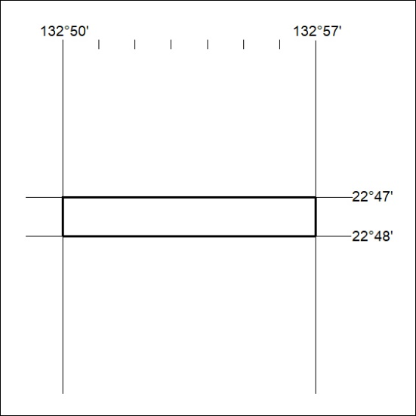
240/24

Mineral Titles Act 2010
NOTICE OF LAND CEASING TO BE A MINERAL TITLE AREA
Title Type and Number: | Exploration Licence 32175
Area Ceased on: | 08 August 2024
Area: | 143 Blocks, 470.19 km²
Locality: | GLYDE
Name of Applicant(s)/Holder(s): | 100% TECK AUSTRALIA PTY LTD [ACN. 091 271 911]
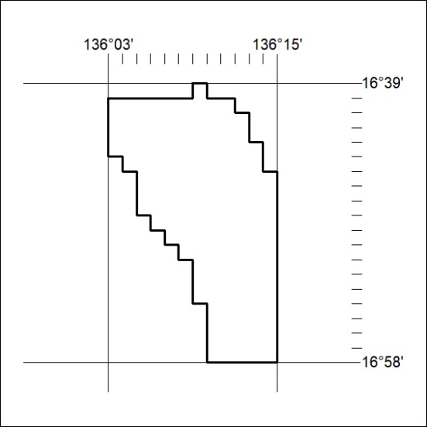
241/24

Mineral Titles Act 2010
NOTICE OF LAND CEASING TO BE A MINERAL TITLE AREA
Title Type and Number: | Exploration Licence 32347
Area Ceased on: | 08 August 2024
Area: | 57 Blocks, 165.09 km²
Locality: | BORROLOOLA
Name of Applicant(s)/Holder(s): | 100% TECK AUSTRALIA PTY LTD [ACN. 091 271 911]
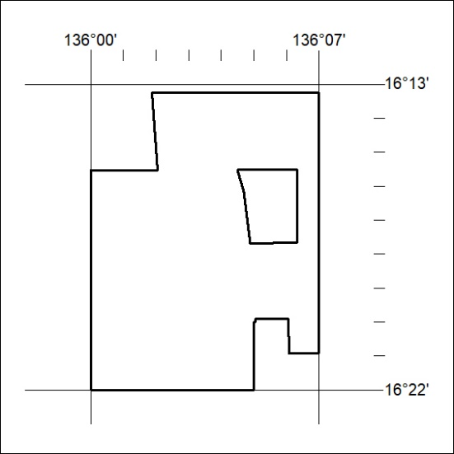
242/24

Mineral Titles Act 2010
NOTICE OF LAND CEASING TO BE A MINERAL TITLE AREA
Title Type and Number: | Exploration Licence 32581
Area Ceased on: | 08 August 2024
Area: | 167 Blocks, 493.60 km²
Locality: | LAKE WOODS
Name of Applicant(s)/Holder(s): | 100% BAUDIN RESOURCES PTY LTD [ACN. 618 455 593]
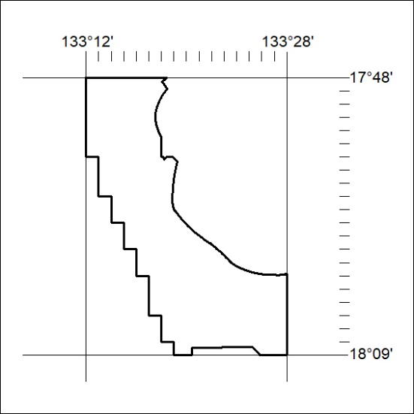
243/24

Mineral Titles Act 2010
NOTICE OF LAND CEASING TO BE A MINERAL TITLE AREA
Title Type and Number: | Exploration Licence 33443
Area Ceased on: | 08 August 2024
Area: | 247 Blocks, 784.97 km²
Locality: | HELEN
Name of Applicant(s)/Holder(s): | 100% PVW TANAMI PTY LTD [ACN. 626 175 586]
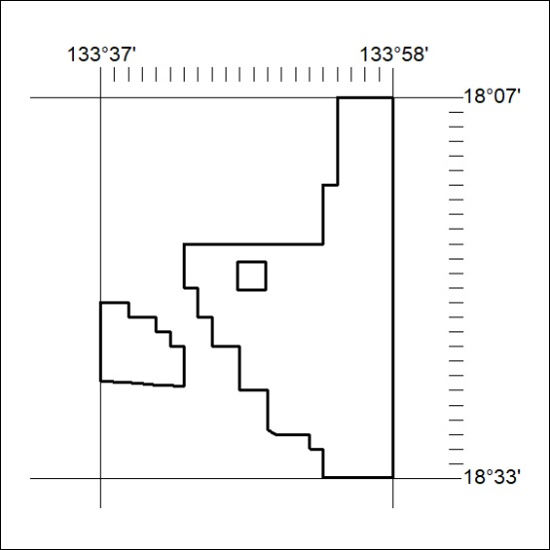
244/24

Mineral Titles Act 2010
NOTICE OF LAND CEASING TO BE A MINERAL TITLE AREA
Title Type and Number: | Exploration Licence 33444
Area Ceased on: | 08 August 2024
Area: | 248 Blocks, 807.45 km²
Locality: | MONMOONA
Name of Applicant(s)/Holder(s): | 100% PVW TANAMI PTY LTD [ACN. 626 175 586]
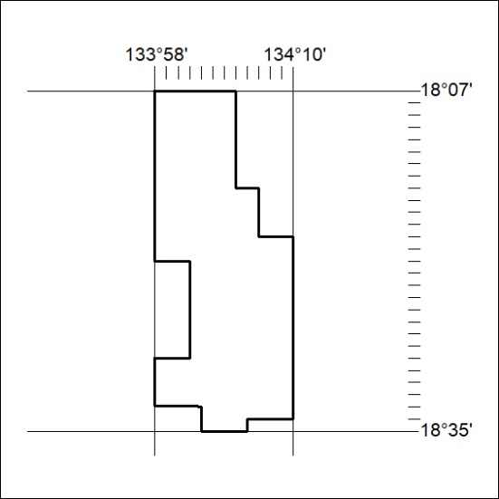
245/24

