Mineral Titles Act
NOTICE OF GRANT OF A MINERAL TITLE
Title Type and Number: | Extractive Mineral Exploration Licence 33700
Granted: | 24 May 2024, for a period of 2 Years
Area: | 4 Blocks, 13.16 km²
Locality: | DUNMARRA
Name of Holder/s: | 100% TAMBORAN INFRASTRUCTURE PTY LTD [ACN. 163 215 156]
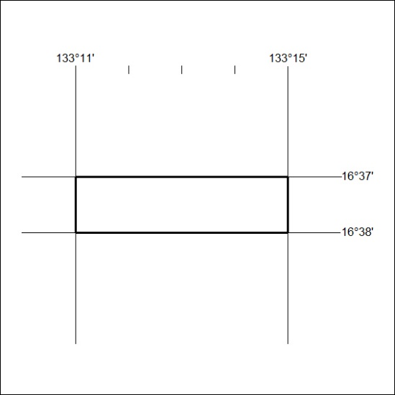
Area granted is indicated above. The titleholder is not permitted to exercise occupational rights on any land that is subject to a development title, or an application for a development title. Any land the subject of a Reserved Land gazettal under the Mineral Titles Act and all land vested in the Commonwealth of Australia is also excluded by description but not excised from the grant area.
221/24

Mineral Titles Act
NOTICE OF GRANT OF A MINERAL TITLE
Title Type and Number: | Extractive Mineral Exploration Licence 33701
Granted: | 24 May 2024, for a period of 2 Years
Area: | 4 Blocks, 13.16 km²
Locality: | DUNMARRA
Name of Holder/s: | 100% TAMBORAN INFRASTRUCTURE PTY LTD [ACN. 163 215 156]
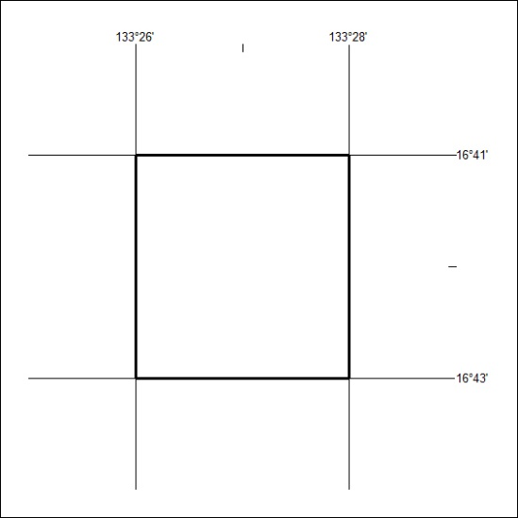
Area granted is indicated above. The titleholder is not permitted to exercise occupational rights on any land that is subject to a development title, or an application for a development title. Any land the subject of a Reserved Land gazettal under the Mineral Titles Act and all land vested in the Commonwealth of Australia is also excluded by description but not excised from the grant area.
222/24

Mineral Titles Act
NOTICE OF GRANT OF A MINERAL TITLE
Title Type and Number: | Extractive Mineral Exploration Licence 33702
Granted: | 24 May 2024, for a period of 2 Years
Area: | 4 Blocks, 13.16 km²
Locality: | WARRAMBAN
Name of Holder/s: | 100% TAMBORAN INFRASTRUCTURE PTY LTD [ACN. 163 215 156]
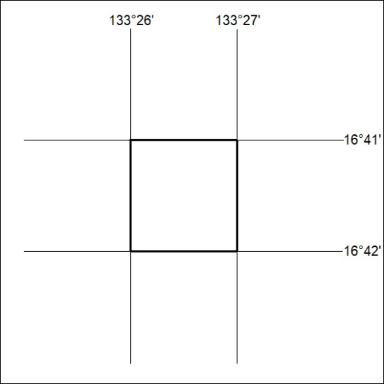
Area granted is indicated above. The titleholder is not permitted to exercise occupational rights on any land that is subject to a development title, or an application for a development title. Any land the subject of a Reserved Land gazettal under the Mineral Titles Act and all land vested in the Commonwealth of Australia is also excluded by description but not excised from the grant area.
223/24

Mineral Titles Act
NOTICE OF GRANT OF A MINERAL TITLE
Title Type and Number: | Extractive Mineral Exploration Licence 33703
Granted: | 24 May 2024, for a period of 2 Years
Area: | 4 Blocks, 13.16 km²
Locality: | WARRAMBAN
Name of Holder/s: | 100% TAMBORAN INFRASTRUCTURE PTY LTD [ACN. 163 215 156]
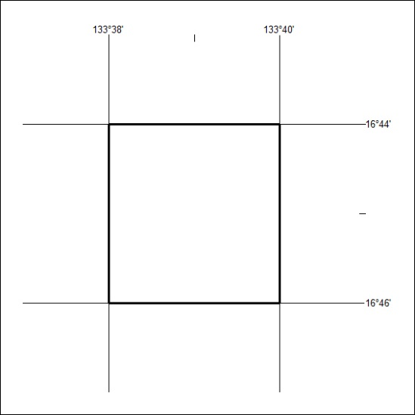
Area granted is indicated above. The titleholder is not permitted to exercise occupational rights on any land that is subject to a development title, or an application for a development title. Any land the subject of a Reserved Land gazettal under the Mineral Titles Act and all land vested in the Commonwealth of Australia is also excluded by description but not excised from the grant area.
224/24

Mineral Titles Act
NOTICE OF GRANT OF A MINERAL TITLE
Title Type and Number: | Extractive Mineral Exploration Licence 33704
Granted: | 24 May 2024, for a period of 2 Years
Area: | 4 Blocks, 13.15 km²
Locality: | WARRAMBAN
Name of Holder/s: | 100% TAMBORAN INFRASTRUCTURE PTY LTD [ACN. 163 215 156]
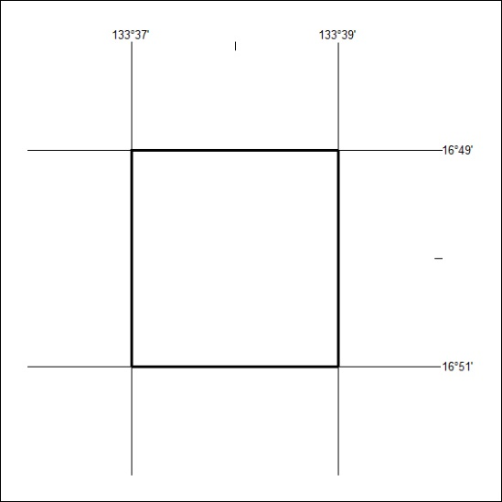
Area granted is indicated above. The titleholder is not permitted to exercise occupational rights on any land that is subject to a development title, or an application for a development title. Any land the subject of a Reserved Land gazettal under the Mineral Titles Act and all land vested in the Commonwealth of Australia is also excluded by description but not excised from the grant area.
224/24

Mineral Titles Act
NOTICE OF GRANT OF A MINERAL TITLE
Title Type and Number: | Extractive Mineral Exploration Licence 33705
Granted: | 24 May 2024, for a period of 2 Years
Area: | 4 Blocks, 13.15 km²
Locality: | DUNMARRA
Name of Holder/s: | 100% TAMBORAN INFRASTRUCTURE PTY LTD [ACN. 163 215 156]
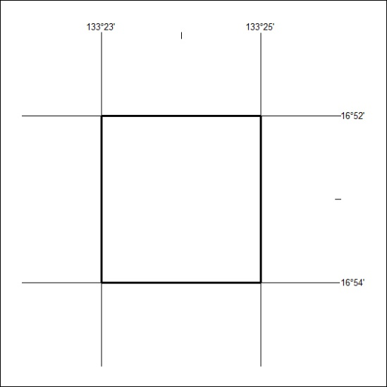
Area granted is indicated above. The titleholder is not permitted to exercise occupational rights on any land that is subject to a development title, or an application for a development title. Any land the subject of a Reserved Land gazettal under the Mineral Titles Act and all land vested in the Commonwealth of Australia is also excluded by description but not excised from the grant area.
225/24

Mineral Titles Act
NOTICE OF GRANT OF A MINERAL TITLE
Title Type and Number: | Extractive Mineral Exploration Licence 33706
Granted: | 24 May 2024, for a period of 2 Years
Area: | 4 Blocks, 13.15 km²
Locality: | DUNMARRA
Name of Holder/s: | 100% TAMBORAN INFRASTRUCTURE PTY LTD [ACN. 163 215 156]
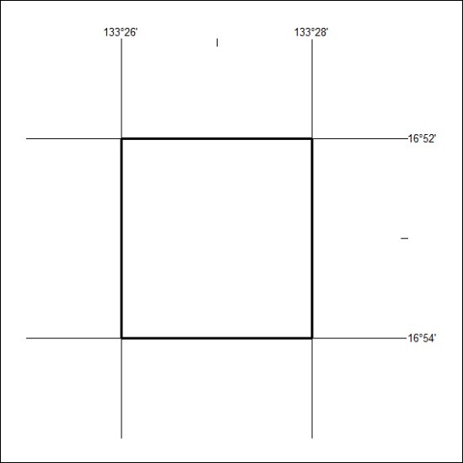
Area granted is indicated above. The titleholder is not permitted to exercise occupational rights on any land that is subject to a development title, or an application for a development title. Any land the subject of a Reserved Land gazettal under the Mineral Titles Act and all land vested in the Commonwealth of Australia is also excluded by description but not excised from the grant area.
226/24

Mineral Titles Act
NOTICE OF GRANT OF A MINERAL TITLE
Title Type and Number: | Extractive Mineral Exploration Licence 33707
Granted: | 24 May 2024, for a period of 2 Years
Area: | 4 Blocks, 13.15 km²
Locality: | WARRAMBAN
Name of Holder/s: | 100% TAMBORAN INFRASTRUCTURE PTY LTD [ACN. 163 215 156]
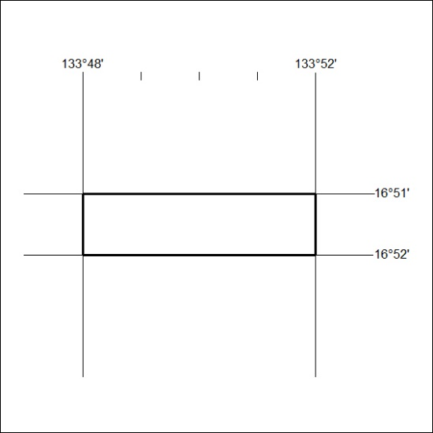
Area granted is indicated above. The titleholder is not permitted to exercise occupational rights on any land that is subject to a development title, or an application for a development title. Any land the subject of a Reserved Land gazettal under the Mineral Titles Act and all land vested in the Commonwealth of Australia is also excluded by description but not excised from the grant area.
227/24

Mineral Titles Act
NOTICE OF GRANT OF A MINERAL TITLE
Title Type and Number: | Extractive Mineral Exploration Licence 33708
Granted: | 24 May 2024, for a period of 2 Years
Area: | 4 Blocks, 13.15 km²
Locality: | WARRAMBAN
Name of Holder/s: | 100% TAMBORAN INFRASTRUCTURE PTY LTD [ACN. 163 215 156]
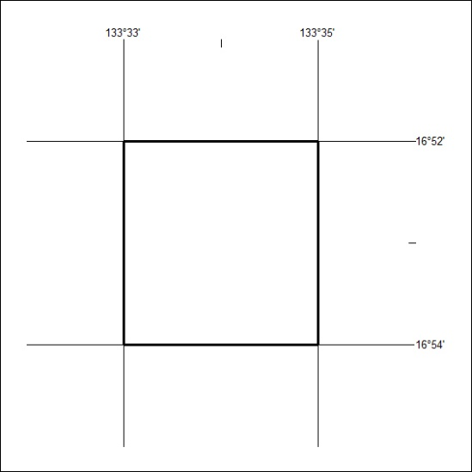
Area granted is indicated above. The titleholder is not permitted to exercise occupational rights on any land that is subject to a development title, or an application for a development title. Any land the subject of a Reserved Land gazettal under the Mineral Titles Act and all land vested in the Commonwealth of Australia is also excluded by description but not excised from the grant area.
228/24

Mineral Titles Act
NOTICE OF GRANT OF A MINERAL TITLE
Title Type and Number: | Extractive Mineral Exploration Licence 33709
Granted: | 24 May 2024, for a period of 2 Years
Area: | 4 Blocks, 13.14 km²
Locality: | NEWCASTLE WATERS
Name of Holder/s: | 100% TAMBORAN INFRASTRUCTURE PTY LTD [ACN. 163 215 156]
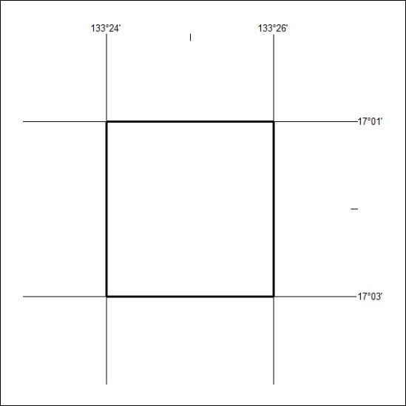
Area granted is indicated above. The titleholder is not permitted to exercise occupational rights on any land that is subject to a development title, or an application for a development title. Any land the subject of a Reserved Land gazettal under the Mineral Titles Act and all land vested in the Commonwealth of Australia is also excluded by description but not excised from the grant area.
229/24

Mineral Titles Act
NOTICE OF GRANT OF A MINERAL TITLE
Title Type and Number: | Extractive Mineral Exploration Licence 33710
Granted: | 24 May 2024, for a period of 2 Years
Area: | 4 Blocks, 13.13 km²
Locality: | NEWCASTLE WATERS
Name of Holder/s: | 100% TAMBORAN INFRASTRUCTURE PTY LTD [ACN. 163 215 156]
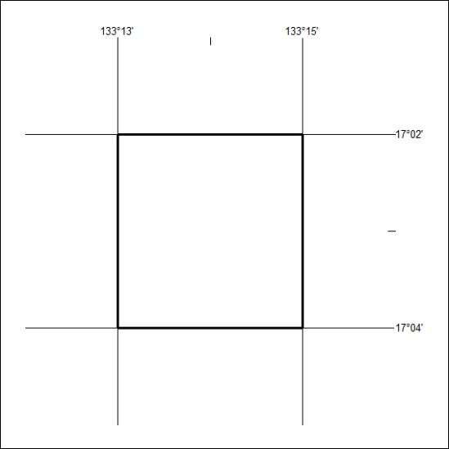
Area granted is indicated above. The titleholder is not permitted to exercise occupational rights on any land that is subject to a development title, or an application for a development title. Any land the subject of a Reserved Land gazettal under the Mineral Titles Act and all land vested in the Commonwealth of Australia is also excluded by description but not excised from the grant area.
230/24

Mineral Titles Act
NOTICE OF GRANT OF A MINERAL TITLE
Title Type and Number: | Extractive Mineral Exploration Licence 33711
Granted: | 24 May 2024, for a period of 2 Years
Area: | 4 Blocks, 13.16 km²
Locality: | DUNMARRA
Name of Holder/s: | 100% TAMBORAN INFRASTRUCTURE PTY LTD [ACN. 163 215 156]
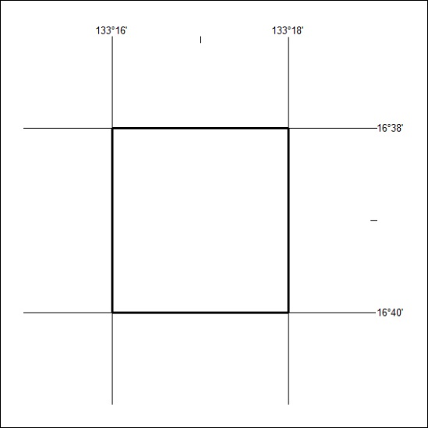
Area granted is indicated above. The titleholder is not permitted to exercise occupational rights on any land that is subject to a development title, or an application for a development title. Any land the subject of a Reserved Land gazettal under the Mineral Titles Act and all land vested in the Commonwealth of Australia is also excluded by description but not excised from the grant area.
231/24

