Mineral Titles Act
NOTICE OF GRANT OF A MINERAL TITLE
Title Type and Number: | Extractive Mineral Permit 31876
Granted: | 22 February 2024, for a period of 5 Years
Area: | 54.44 Hectares
Locality: | KOOLPINYAH
Name of Holder/s: | 100% OSTOJIC GROUP PTY LTD* [ACN. 009 629 805]
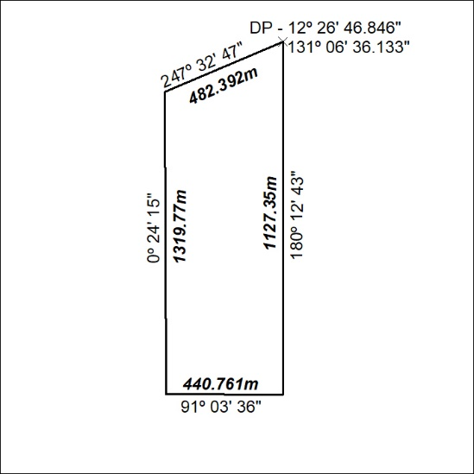
44/24

Mineral Titles Act
NOTICE OF GRANT OF A MINERAL TITLE
Title Type and Number: | Extractive Mineral Permit 31877
Granted: | 22 February 2024, for a period of 5 Years
Area: | 73.04 Hectares
Locality: | KOOLPINYAH
Name of Holder/s: | 100% OSTOJIC GROUP PTY LTD* [ACN. 009 629 805]
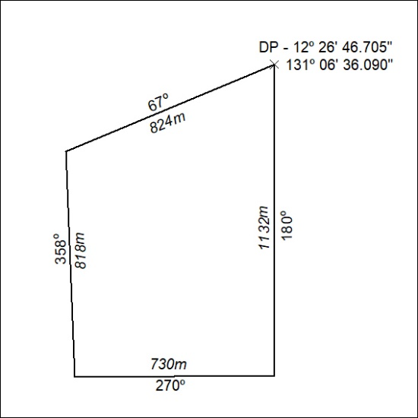
45/24

