Mineral Titles Act 2010
NOTICE OF LAND CEASING TO BE A MINERAL TITLE AREA
Title Type and Number: | Exploration Licence 32794
Area Ceased on: | 12 February 2024
Area: | 115 Blocks, 348.43 km²
Locality: | NAPIER
Name of Applicant(s)/Holder(s): | 100% OMNIA PANTON PTY LTD [ACN. 648 190 934]
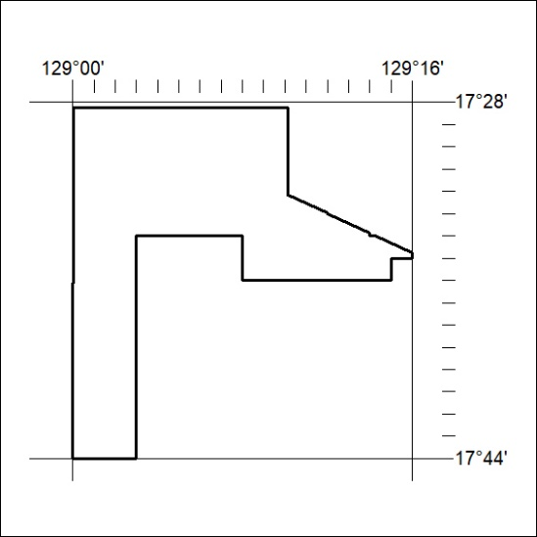

37/24

