Mineral Titles Act 2010
NOTICE OF LAND CEASING TO BE A MINERAL TITLE AREA
Title Type and Number: | Extractive Mineral Permit 31056
Area ceased on: | 24 October 2023
Area: | 14.00 Hectare
Locality: | BYNOE
Name of Applicants(s)Holder(s): | 100% SETH PTY LTD [ACN. 062 084 119]
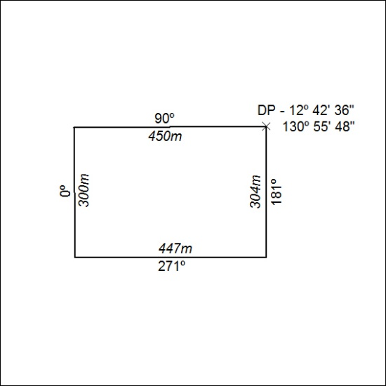

446/23

