Mineral Titles Act 2010
NOTICE OF LAND CEASING TO BE A MINERAL TITLE AREA
Title Type and Number: | Exploration Licence 31983
Area Ceased on: | 25 July 2023
Area: | 20 Blocks, 52.97 km²
Locality: | LAUGHLEN
Name of Applicant(s)/Holder(s): | 100% MATSON Paul Richard
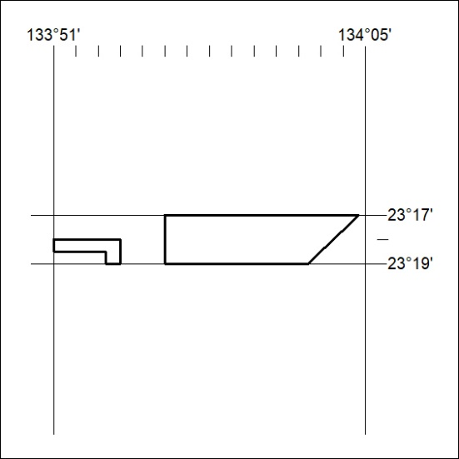

314/23

Mineral Titles Act 2010
NOTICE OF LAND CEASING TO BE A MINERAL TITLE AREA
Title Type and Number: | Exploration Licence 32427
Area Ceased on: | 25 July 2023
Area: | 5 Blocks, 15.79 km²
Locality: | BURT
Name of Applicant(s)/Holder(s): | 100% MATSON Paul Richard
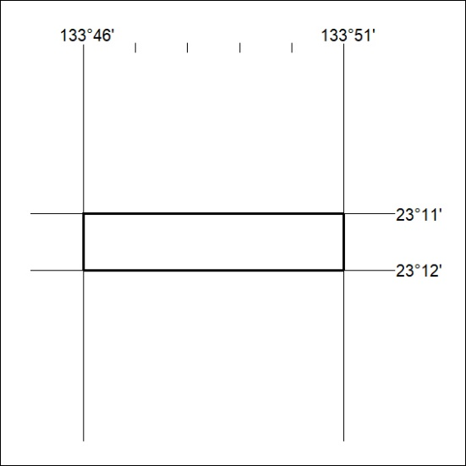

315/23

Mineral Titles Act 2010
NOTICE OF LAND CEASING TO BE A MINERAL TITLE APPLICATION AREA
Title Type and Number: | Extractive Mineral Lease 31093
Area ceased on: | 27 July 2023
Area: | 100.00 Hectare
Locality: | NOONAMAH
Name of Applicants(s)Holder(s): | 100% GOSSAN RESOURCES PTY LTD [ACN. 161 395 964]
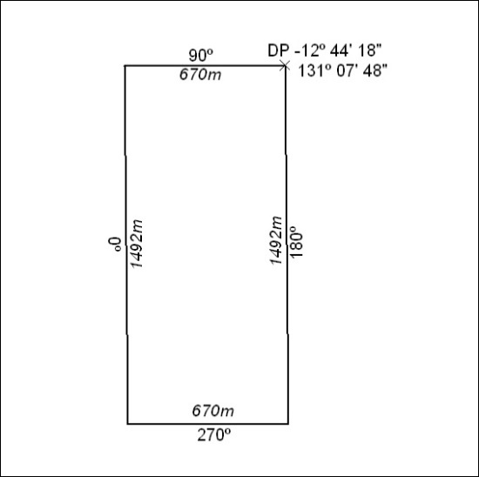

316/23

Mineral Titles Act 2010
NOTICE OF LAND CEASING TO BE A MINERAL TITLE APPLICATION AREA
Title Type and Number: | Extractive Mineral Permit 31094
Area ceased on: | 27 July 2023
Area: | 100.00 Hectare
Locality: | NOONAMAH
Name of Applicants(s)Holder(s): | 100% GOSSAN RESOURCES PTY LTD [ACN. 161 395 964]
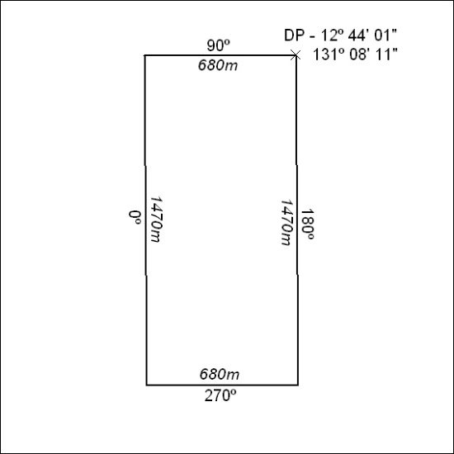

317/23

Mineral Titles Act 2010
NOTICE OF LAND CEASING TO BE A MINERAL TITLE APPLICATION AREA
Title Type and Number: | Extractive Mineral Permit 31584
Area ceased on: | 27 July 2023
Area: | 50.00 Hectare
Locality: | MARY RIVER
Name of Applicants(s)Holder(s): | 100% GOSSAN RESOURCES PTY LTD [ACN. 161 395 964]
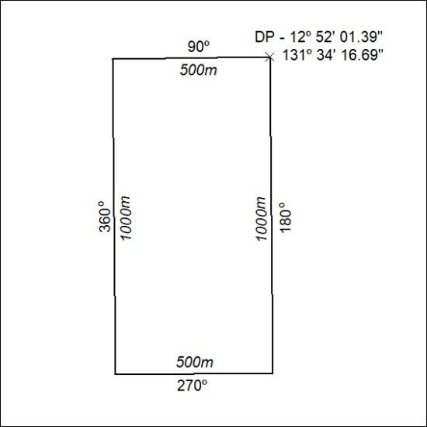

318/23

Mineral Titles Act 2010
NOTICE OF LAND CEASING TO BE A MINERAL TITLE APPLICATION AREA
Title Type and Number: | Extractive Mineral Permit 31585
Area ceased on: | 27 July 2023
Area: | 49.00 Hectare
Locality: | MARY RIVER
Name of Applicants(s)Holder(s): | 100% GOSSAN RESOURCES PTY LTD [ACN. 161 395 964]
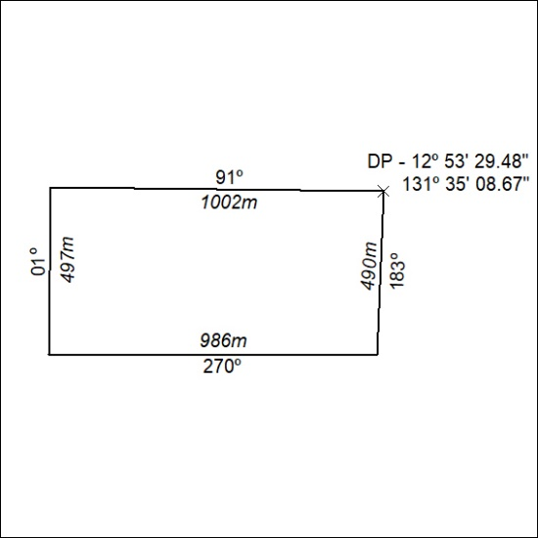

319/23

Mineral Titles Act 2010
NOTICE OF LAND CEASING TO BE A MINERAL TITLE APPLICATION AREA
Title Type and Number: | Extractive Mineral Permit 31586
Area ceased on: | 27 July 2023
Area: | 49.00 Hectare
Locality: | MARY RIVER
Name of Applicants(s)Holder(s): | 100% GOSSAN RESOURCES PTY LTD [ACN. 161 395 964]
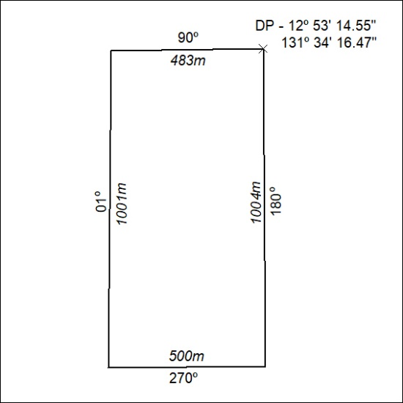

320/23

Mineral Titles Act
NOTICE OF GRANT OF A MINERAL TITLE
Title Type and Number: | Exploration Licence 33421
Granted: | 26 July 2023, for a period of 6 Years
Area: | 166 Blocks, 490.59 km²
Locality: | GOSSES BLUFF
Name of Holder/s: | 100% EVEREST METALS CORPORATION LTD [ACN. 119 978 013]
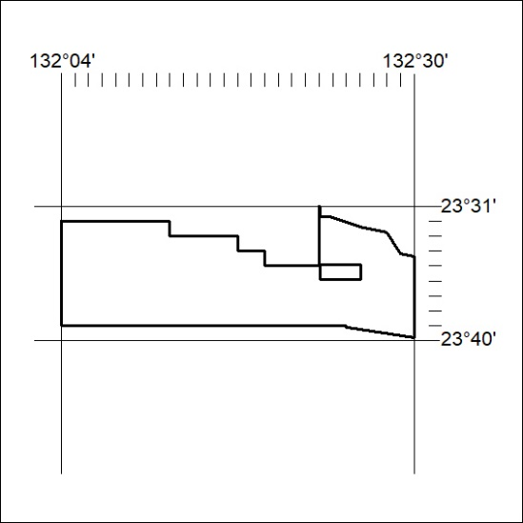
Area granted is indicated above. The titleholder is not permitted to exercise occupational rights on any land that is subject to a development title, or an application for a development title. Any land the subject of a Reserved Land gazettal under the Mineral Titles Act and all land vested in the Commonwealth of Australia is also excluded by description but not excised from the grant area.

321/23

Mineral Titles Act
NOTICE OF GRANT OF A MINERAL TITLE
Title Type and Number: | Exploration Licence 33422
Granted: | 26 July 2023, for a period of 6 Years
Area: | 250 Blocks, 733.22 km²
Locality: | MACDONALD DOWNS
Name of Holder/s: | 100% EVEREST METALS CORPORATION LTD [ACN. 119 978 013]
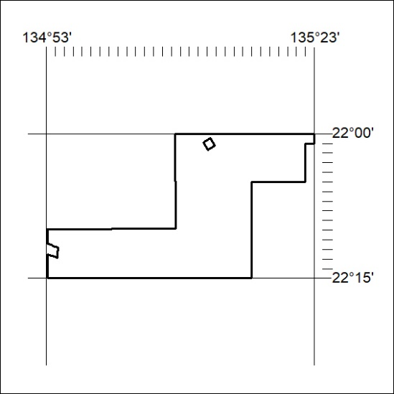
Area granted is indicated above. The titleholder is not permitted to exercise occupational rights on any land that is subject to a development title, or an application for a development title. Any land the subject of a Reserved Land gazettal under the Mineral Titles Act and all land vested in the Commonwealth of Australia is also excluded by description but not excised from the grant area.
322/23

Mineral Titles Act
NOTICE OF GRANT OF A MINERAL TITLE
Title Type and Number: | Exploration Licence 33423
Granted: | 26 July 2023, for a period of 6 Years
Area: | 250 Blocks, 767.60 km²
Locality: | AMMAROO
Name of Holder/s: | 100% EVEREST METALS CORPORATION LTD [ACN. 119 978 013]
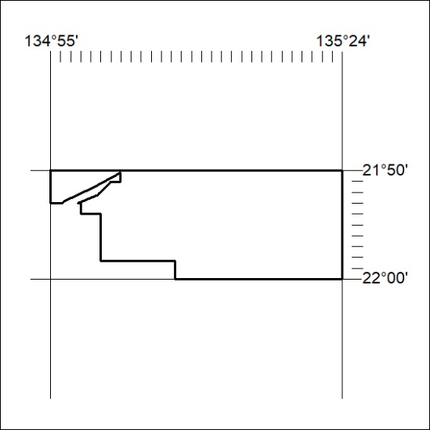
Area granted is indicated above. The titleholder is not permitted to exercise occupational rights on any land that is subject to a development title, or an application for a development title. Any land the subject of a Reserved Land gazettal under the Mineral Titles Act and all land vested in the Commonwealth of Australia is also excluded by description but not excised from the grant area.
323/23

Mineral Titles Act
NOTICE OF GRANT OF A MINERAL TITLE
Title Type and Number: | Exploration Licence 33424
Granted: | 26 July 2023, for a period of 6 Years
Area: | 176 Blocks, 471.37 km²
Locality: | UTOPIA
Name of Holder/s: | 100% EVEREST METALS CORPORATION LTD [ACN. 119 978 013]
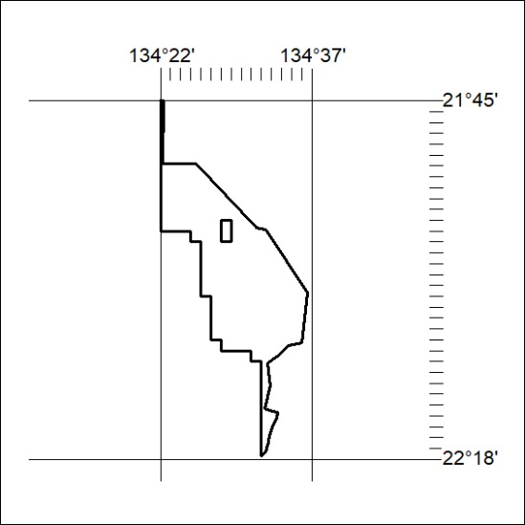
Area granted is indicated above. The titleholder is not permitted to exercise occupational rights on any land that is subject to a development title, or an application for a development title. Any land the subject of a Reserved Land gazettal under the Mineral Titles Act and all land vested in the Commonwealth of Australia is also excluded by description but not excised from the grant area.
324/23

Mineral Titles Act
NOTICE OF GRANT OF A MINERAL TITLE
Title Type and Number: | Exploration Licence 33433
Granted: | 26 July 2023, for a period of 6 Years
Area: | 250 Blocks, 748.90 km²
Locality: | AMMAROO
Name of Holder/s: | 100% EVEREST METALS CORPORATION LTD [ACN. 119 978 013]
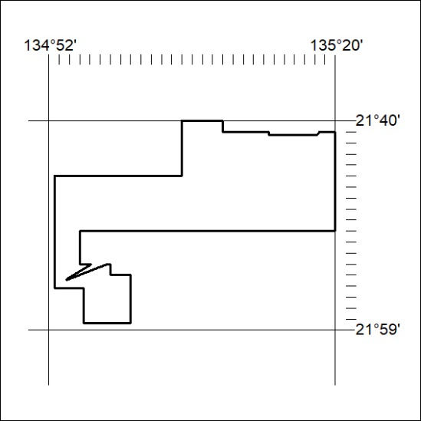
Area granted is indicated above. The titleholder is not permitted to exercise occupational rights on any land that is subject to a development title, or an application for a development title. Any land the subject of a Reserved Land gazettal under the Mineral Titles Act and all land vested in the Commonwealth of Australia is also excluded by description but not excised from the grant area.
325/23

Mineral Titles Act
NOTICE OF GRANT OF A MINERAL TITLE
Title Type and Number: | Exploration Licence 33439
Granted: | 26 July 2023, for a period of 6 Years
Area: | 97 Blocks, 209.84 km²
Locality: | LURAPULLA
Name of Holder/s: | 100% EVEREST METALS CORPORATION LTD [ACN. 119 978 013]
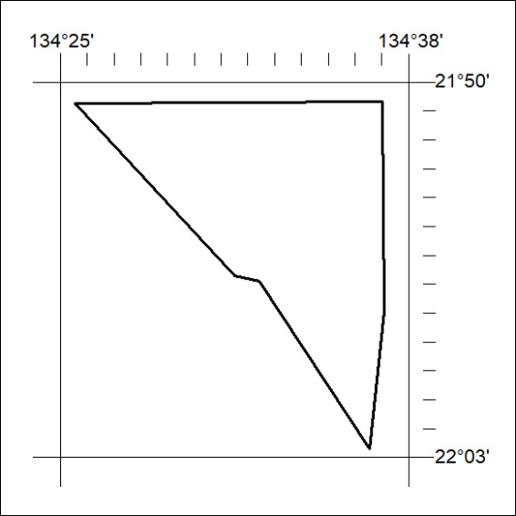
Area granted is indicated above. The titleholder is not permitted to exercise occupational rights on any land that is subject to a development title, or an application for a development title. Any land the subject of a Reserved Land gazettal under the Mineral Titles Act and all land vested in the Commonwealth of Australia is also excluded by description but not excised from the grant area.
326/23

