Mineral Titles Act
NOTICE OF GRANT OF A MINERAL TITLE
Title Type and Number: | Exploration Licence 33448
Granted: | 24 July 2023, for a period of 6 Years
Area: | 142 Blocks, 449.99 km²
Locality: | TARLTON
Name of Holder/s: | 100% WALHALLOW CREEK NO 2 PTY LTD [ACN. 626 076 471]
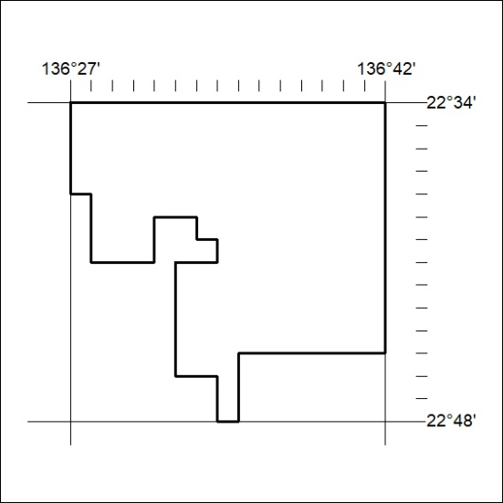
Area granted is indicated above. The titleholder is not permitted to exercise occupational rights on any land that is subject to a development title, or an application for a development title. Any land the subject of a Reserved Land gazettal under the Mineral Titles Act and all land vested in the Commonwealth of Australia is also excluded by description but not excised from the grant area.
304/23

Mineral Titles Act
NOTICE OF GRANT OF A MINERAL TITLE
Title Type and Number: | Extractive Mineral Exploration Licence 33352
Granted: | 21 July 2023, for a period of 2 Years
Area: | 4 Blocks, 11.37 km²
Locality: | BYNOE
Name of Holder/s: | 100% AKJ SERVICES PTY LTD [ACN. 625 846 031]
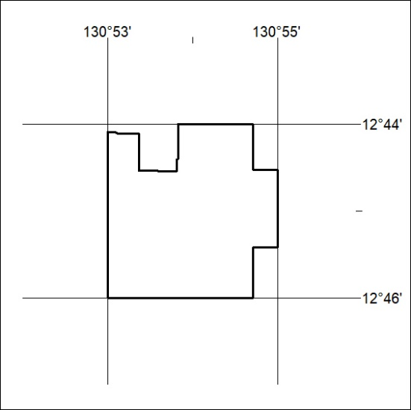
Area granted is indicated above. The titleholder is not permitted to exercise occupational rights on any land that is subject to a development title, or an application for a development title. Any land the subject of a Reserved Land gazettal under the Mineral Titles Act and all land vested in the Commonwealth of Australia is also excluded by description but not excised from the grant area.
305/23

Mineral Titles Act
NOTICE OF GRANT OF A MINERAL TITLE
Title Type and Number: | Extractive Mineral Exploration Licence 33353
Granted: | 21 July 2023, for a period of 2 Years
Area: | 4 Blocks, 12.65 km²
Locality: | BYNOE
Name of Holder/s: | 100% AKJ SERVICES PTY LTD [ACN. 625 846 031]
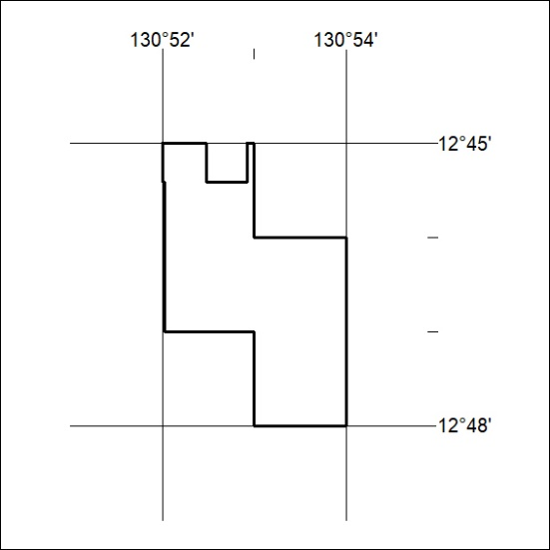
Area granted is indicated above. The titleholder is not permitted to exercise occupational rights on any land that is subject to a development title, or an application for a development title. Any land the subject of a Reserved Land gazettal under the Mineral Titles Act and all land vested in the Commonwealth of Australia is also excluded by description but not excised from the grant area.
306/23

Mineral Titles Act
NOTICE OF GRANT OF A MINERAL TITLE
Title Type and Number: | Extractive Mineral Exploration Licence 33354
Granted: | 21 July 2023, for a period of 2 Years
Area: | 3 Blocks, 8.05 km²
Locality: | BYNOE
Name of Holder/s: | 100% AKJ SERVICES PTY LTD [ACN. 625 846 031]
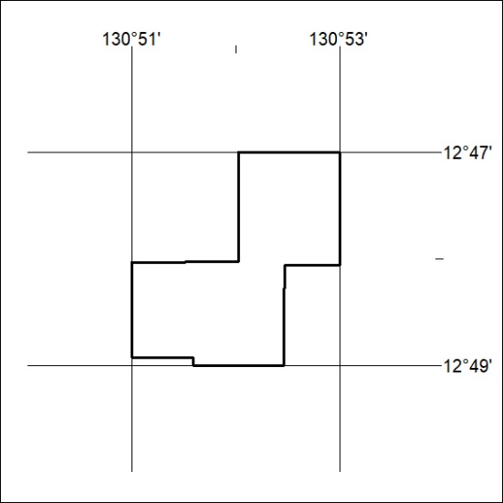
Area granted is indicated above. The titleholder is not permitted to exercise occupational rights on any land that is subject to a development title, or an application for a development title. Any land the subject of a Reserved Land gazettal under the Mineral Titles Act and all land vested in the Commonwealth of Australia is also excluded by description but not excised from the grant area.
307/23

Mineral Titles Act
NOTICE OF GRANT OF A MINERAL TITLE
Title Type and Number: | Extractive Mineral Exploration Licence 33355
Granted: | 21 July 2023, for a period of 2 Years
Area: | 3 Blocks, 7.12 km²
Locality: | BYNOE
Name of Holder/s: | 100% AKJ SERVICES PTY LTD [ACN. 625 846 031]
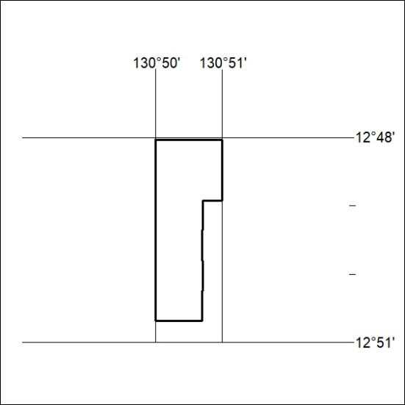
Area granted is indicated above. The titleholder is not permitted to exercise occupational rights on any land that is subject to a development title, or an application for a development title. Any land the subject of a Reserved Land gazettal under the Mineral Titles Act and all land vested in the Commonwealth of Australia is also excluded by description but not excised from the grant area.
308/23

Mineral Titles Act
NOTICE OF GRANT OF A MINERAL TITLE
Title Type and Number: | Extractive Mineral Exploration Licence 33356
Granted: | 21 July 2023, for a period of 2 Years
Area: | 3 Blocks, 5.01 km²
Locality: | BYNOE
Name of Holder/s: | 100% AKJ SERVICES PTY LTD [ACN. 625 846 031]
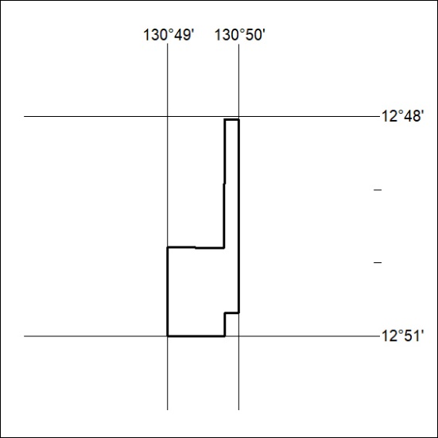
Area granted is indicated above. The titleholder is not permitted to exercise occupational rights on any land that is subject to a development title, or an application for a development title. Any land the subject of a Reserved Land gazettal under the Mineral Titles Act and all land vested in the Commonwealth of Australia is also excluded by description but not excised from the grant area.
309/23

