Mineral Titles Act
NOTICE OF GRANT OF A MINERAL TITLE
Title Type and Number: | Extractive Mineral Exploration Licence 33501
Granted: | 19 July 2023, for a period of 2 Years
Area: | 2 Blocks, 0.10 km²
Locality: | MANBULLOO
Name of Holder/s: | 100% HY-TEC INDUSTRIES (NORTHERN TERRITORY) PTY LTD [ACN. 096 310 824]
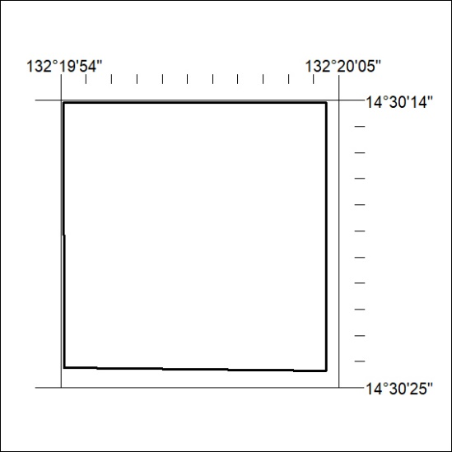
Area granted is indicated above. The titleholder is not permitted to exercise occupational rights on any land that is subject to a development title, or an application for a development title. Any land the subject of a Reserved Land gazettal under the Mineral Titles Act and all land vested in the Commonwealth of Australia is also excluded by description but not excised from the grant area.

289/23

Corrigendum
Notice Number 232/23 appearing in MN071/23 on 28 June 2023 is hereby cancelled and replaced by the following:

Mineral Titles Act 2010
NOTICE OF LAND CEASING TO BE A MINERAL TITLE AREA
Title Type and Number: | Exploration Licence 32052
Area Ceased on: | 28 June 2023
Area: | 91 Blocks, 296.40 km²
Locality: | MT WINNECKE
Name of Applicant(s)/Holder(s): | 100% OAKAJEE EXPLORATION PTY LTD [ACN. 629 544 912]
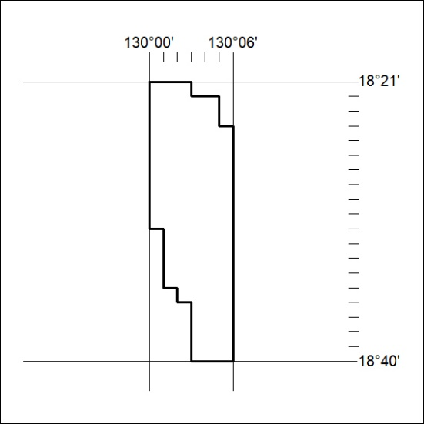

290/23

