Mineral Titles Act 2010
NOTICE OF LAND CEASING TO BE A MINERAL TITLE AREA
Title Type and Number: | Exploration Licence 32532
Area Ceased on: | 06 July 2023
Area: | 210 Blocks, 681.81 km²
Locality: | NAPIER
Name of Applicant(s)/Holder(s): | 100% TRANSITION MINERALS LIMITED* [ACN. 641 565 139]
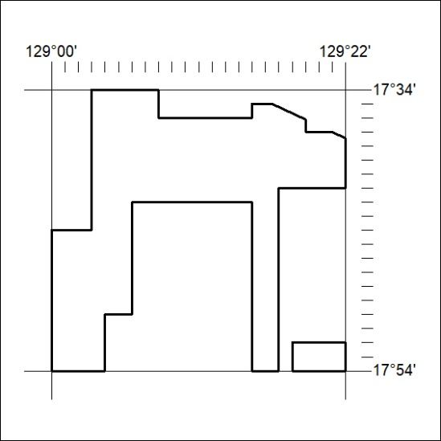

259/23

Mineral Titles Act 2010
NOTICE OF LAND CEASING TO BE A MINERAL TITLE AREA
Title Type and Number: | Exploration Licence 32534
Area Ceased on: | 06 July 2023
Area: | 221 Blocks, 722.54 km²
Locality: | INVERWAY
Name of Applicant(s)/Holder(s): | 100% TRANSITION MINERALS LIMITED* [ACN. 641 565 139]
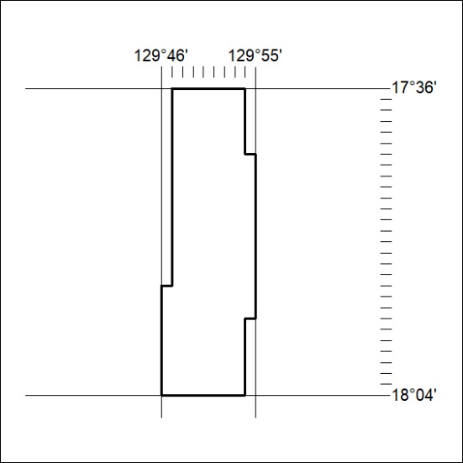

260/23

Mineral Titles Act 2010
NOTICE OF LAND CEASING TO BE A MINERAL TITLE AREA
Title Type and Number: | Exploration Licence 32535
Area Ceased on: | 06 July 2023
Area: | 221 Blocks, 722.42 km²
Locality: | INVERWAY
Name of Applicant(s)/Holder(s): | 100% TRANSITION MINERALS LIMITED* [ACN. 641 565 139]
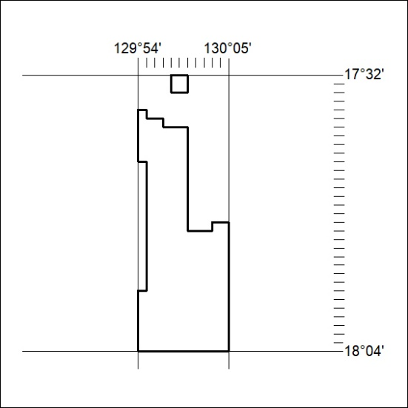

261/23

Mineral Titles Act
NOTICE OF GRANT OF A MINERAL TITLE
Title Type and Number: | Exploration Licence 32706
Granted: | 06 July 2023, for a period of 6 Years
Area: | 12 Blocks, 35.63 km²
Locality: | MUCKATY
Name of Holder/s: | 100% SCRIVEN EXPLORATION PTY LTD [ACN. 006 264 615]
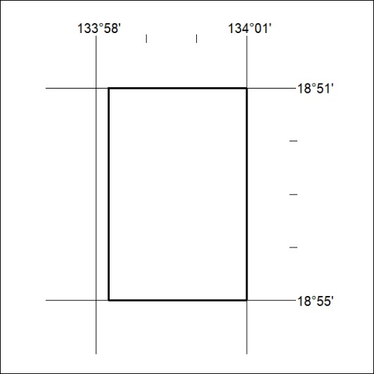
Area granted is indicated above. The titleholder is not permitted to exercise occupational rights on any land that is subject to a development title, or an application for a development title. Any land the subject of a Reserved Land gazettal under the Mineral Titles Act and all land vested in the Commonwealth of Australia is also excluded by description but not excised from the grant area.

262/23

