Mineral Titles Act 2010
NOTICE OF LAND CEASING TO BE A MINERAL TITLE AREA
Title Type and Number: | Exploration Licence 32004
Area Ceased on: | 22 June 2023
Area: | 21 Blocks, 67.83 km²
Locality: | FERGUSSON RIVER
Name of Applicant(s)/Holder(s): | 100% VISTA GOLD AUSTRALIA PTY LTD [ACN. 117 327 509]
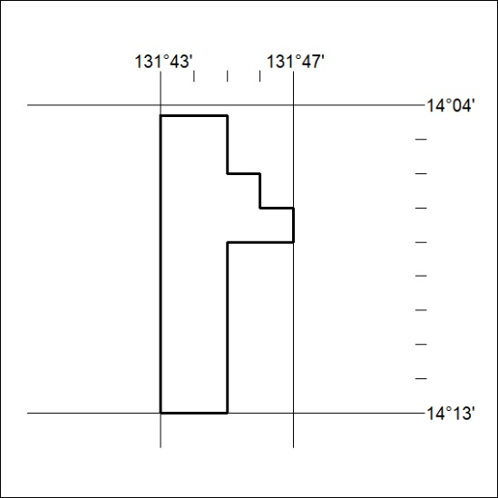

220/23

Mineral Titles Act 2010
NOTICE OF LAND CEASING TO BE A MINERAL TITLE AREA
Title Type and Number: | Exploration Licence 32985
Area Ceased on: | 22 June 2023
Area: | 22 Blocks, 71.63 km²
Locality: | PHIBBS
Name of Applicant(s)/Holder(s): | 100% AUSTRALIAN EXPLORATION PTY LTD [ACN. 640 413 823]
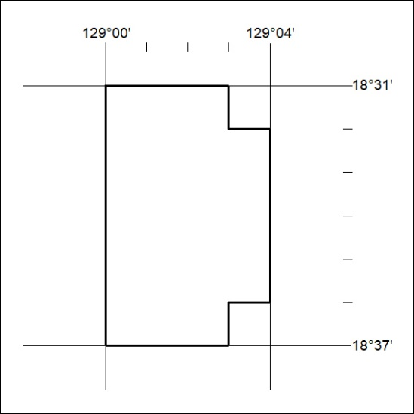

221/23

Mineral Titles Act
NOTICE OF GRANT OF A MINERAL TITLE
Title Type and Number: | Exploration Licence 33368
Granted: | 21 June 2023, for a period of 6 Years
Area: | 40 Blocks, 127.34 km²
Locality: | DOREEN
Name of Holder/s: | 100% URO CORPORATION PTY LTD [ACN. 653 927 998]
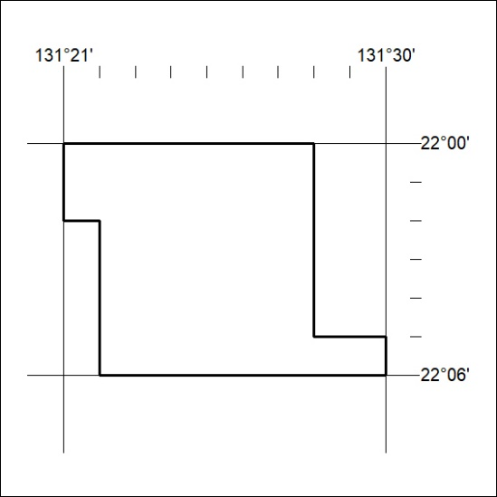
Area granted is indicated above. The titleholder is not permitted to exercise occupational rights on any land that is subject to a development title, or an application for a development title. Any land the subject of a Reserved Land gazettal under the Mineral Titles Act and all land vested in the Commonwealth of Australia is also excluded by description but not excised from the grant area.
222/23

Mineral Titles Act
NOTICE OF GRANT OF A MINERAL TITLE
Title Type and Number: | Exploration Licence 33369
Granted: | 21 June 2023, for a period of 6 Years
Area: | 48 Blocks, 135.63 km²
Locality: | YUENDUMU
Name of Holder/s: | 100% URO CORPORATION PTY LTD [ACN. 653 927 998]
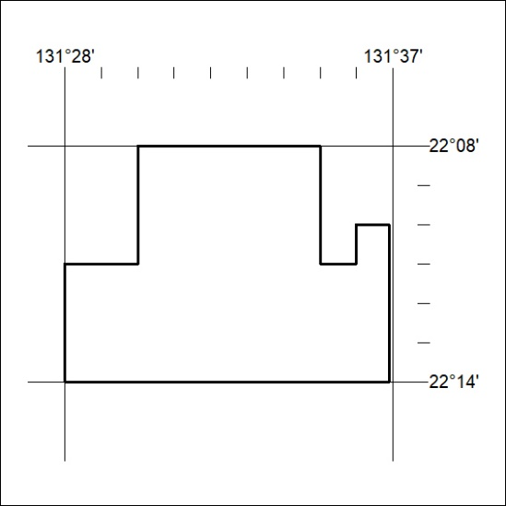
Area granted is indicated above. The titleholder is not permitted to exercise occupational rights on any land that is subject to a development title, or an application for a development title. Any land the subject of a Reserved Land gazettal under the Mineral Titles Act and all land vested in the Commonwealth of Australia is also excluded by description but not excised from the grant area.
223/23

