Mineral Titles Act 2010
NOTICE OF LAND CEASING TO BE A MINERAL TITLE AREA
Title Type and Number: | Exploration Licence 32945
Area Ceased on: | 14 June 2023
Area: | 46 Blocks, 127.31 km²
Locality: | VAUGHAN
Name of Applicant(s)/Holder(s): | 100% JALEIN PTY LTD [ACN. 124 331 157]
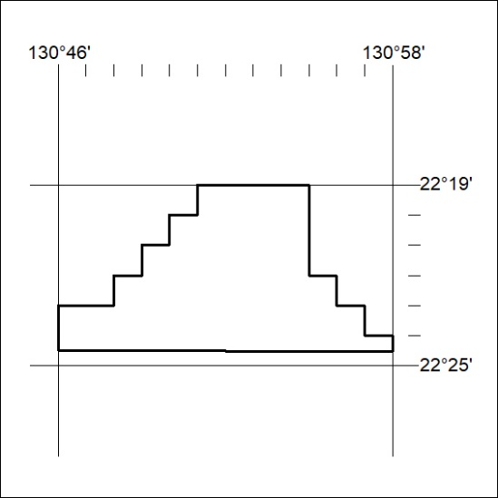

190/23

Mineral Titles Act 2010
NOTICE OF LAND CEASING TO BE A MINERAL TITLE AREA
Title Type and Number: | Exploration Licence 32948
Area Ceased on: | 14 June 2023
Area: | 54 Blocks, 171.20 km²
Locality: | NAPPERBY
Name of Applicant(s)/Holder(s): | 100% JALEIN PTY LTD [ACN. 124 331 157]
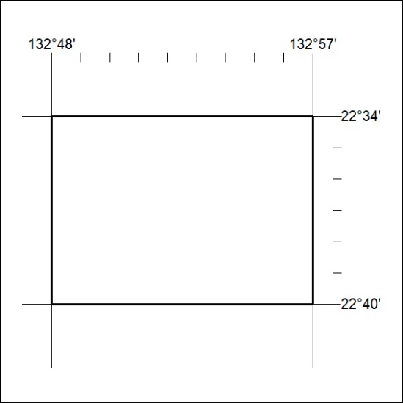

191/23
Mineral Titles Act 2010
NOTICE OF LAND CEASING TO BE A MINERAL TITLE AREA
Title Type and Number: | Exploration Licence 32997
Area Ceased on: | 14 June 2023
Area: | 11 Blocks, 35.11 km²
Locality: | ANNINGIE
Name of Applicant(s)/Holder(s): | 100% JALEIN PTY LTD [ACN. 124 331 157]
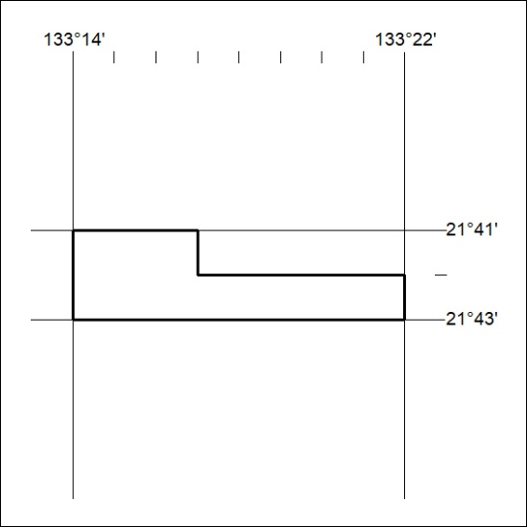

192/23

Mineral Titles Act 2010
NOTICE OF LAND CEASING TO BE A MINERAL TITLE AREA
Title Type and Number: | Exploration Licence 32998
Area Ceased on: | 14 June 2023
Area: | 6 Blocks, 19.16 km²
Locality: | ANNINGIE
Name of Applicant(s)/Holder(s): | 100% JALEIN PTY LTD [ACN. 124 331 157]
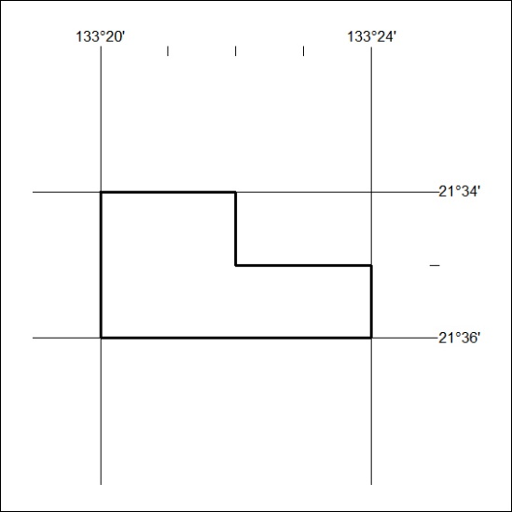

193/23

Mineral Titles Act
NOTICE OF GRANT OF A MINERAL TITLE
Title Type and Number: | Exploration Licence 33002
Granted: | 14 June 2023, for a period of 6 Years
Area: | 151 Blocks, 502.93 km²
Locality: | REYNOLDS RIVER
Name of Holder/s: | 100% URO CORPORATION PTY LTD [ACN. 653 927 998]
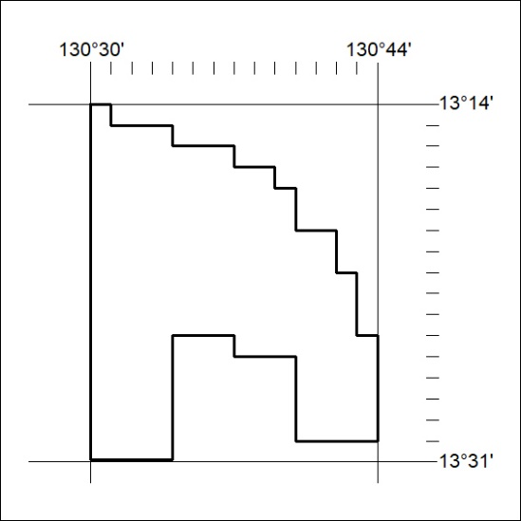
Area granted is indicated above. The titleholder is not permitted to exercise occupational rights on any land that is subject to a development title, or an application for a development title. Any land the subject of a Reserved Land gazettal under the Mineral Titles Act and all land vested in the Commonwealth of Australia is also excluded by description but not excised from the grant area.
194/23

Mineral Titles Act
NOTICE OF GRANT OF A MINERAL TITLE
Title Type and Number: | Exploration Licence 33003
Granted: | 14 June 2023, for a period of 6 Years
Area: | 146 Blocks, 486.71 km²
Locality: | DALY RIVER
Name of Holder/s: | 100% URO CORPORATION PTY LTD [ACN. 653 927 998]
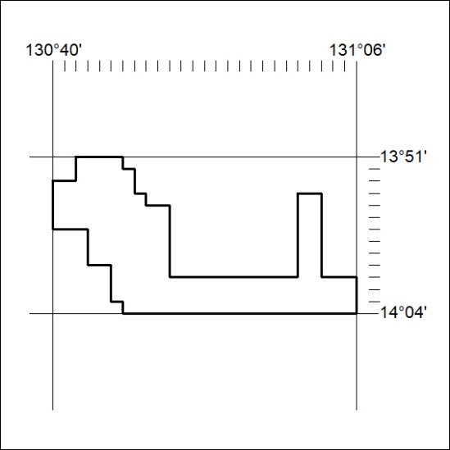
Area granted is indicated above. The titleholder is not permitted to exercise occupational rights on any land that is subject to a development title, or an application for a development title. Any land the subject of a Reserved Land gazettal under the Mineral Titles Act and all land vested in the Commonwealth of Australia is also excluded by description but not excised from the grant area.
195/23

Mineral Titles Act
NOTICE OF GRANT OF A MINERAL TITLE
Title Type and Number: | Exploration Licence 33285
Granted: | 14 June 2023, for a period of 6 Years
Area: | 84 Blocks, 273.39 km²
Locality: | REYNOLDS RIVER
Name of Holder/s: | 100% URO CORPORATION PTY LTD [ACN. 653 927 998]
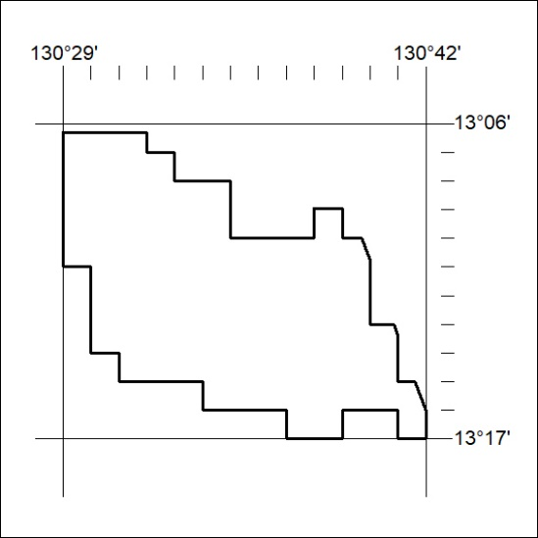
Area granted is indicated above. The titleholder is not permitted to exercise occupational rights on any land that is subject to a development title, or an application for a development title. Any land the subject of a Reserved Land gazettal under the Mineral Titles Act and all land vested in the Commonwealth of Australia is also excluded by description but not excised from the grant area.
196/23

Mineral Titles Act
NOTICE OF GRANT OF A MINERAL TITLE
Title Type and Number: | Exploration Licence 33286
Granted: | 14 June 2023, for a period of 6 Years
Area: | 28 Blocks, 88.78 km²
Locality: | DALY RIVER
Name of Holder/s: | 100% URO CORPORATION PTY LTD [ACN. 653 927 998]
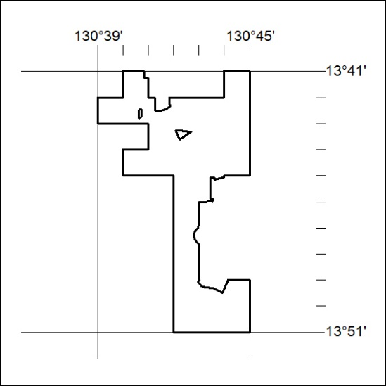
Area granted is indicated above. The titleholder is not permitted to exercise occupational rights on any land that is subject to a development title, or an application for a development title. Any land the subject of a Reserved Land gazettal under the Mineral Titles Act and all land vested in the Commonwealth of Australia is also excluded by description but not excised from the grant area.
197/23

Mineral Titles Act
NOTICE OF GRANT OF A MINERAL TITLE
Title Type and Number: | Exploration Licence 33383
Granted: | 13 June 2023, for a period of 6 Years
Area: | 123 Blocks, 380.20 km²
Locality: | YALOOGARRIE
Name of Holder/s: | 100% TERRITORY MINERALS LTD* [ACN. 121 200 299]
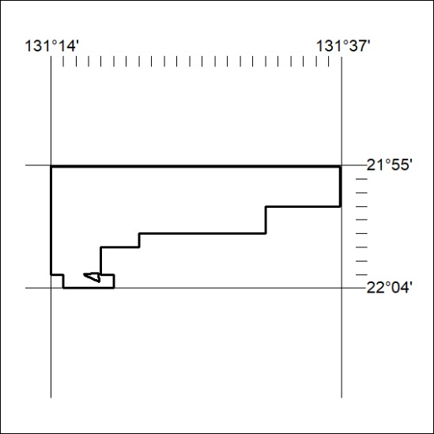
Area granted is indicated above. The titleholder is not permitted to exercise occupational rights on any land that is subject to a development title, or an application for a development title. Any land the subject of a Reserved Land gazettal under the Mineral Titles Act and all land vested in the Commonwealth of Australia is also excluded by description but not excised from the grant area.
198/23

Mineral Titles Act
NOTICE OF GRANT OF A MINERAL TITLE
Title Type and Number: | Exploration Licence 33384
Granted: | 13 June 2023, for a period of 6 Years
Area: | 250 Blocks, 789.20 km²
Locality: | ANBURLA
Name of Holder/s: | 100% TERRITORY MINERALS LTD* [ACN. 121 200 299]
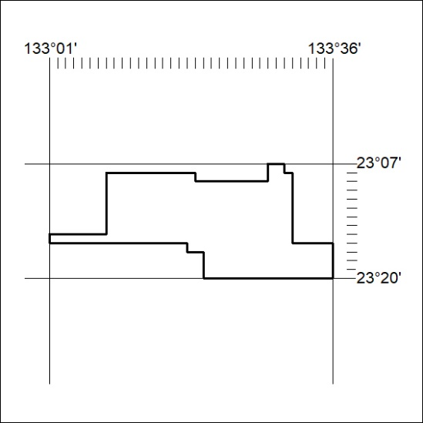
Area granted is indicated above. The titleholder is not permitted to exercise occupational rights on any land that is subject to a development title, or an application for a development title. Any land the subject of a Reserved Land gazettal under the Mineral Titles Act and all land vested in the Commonwealth of Australia is also excluded by description but not excised from the grant area.
199/23

