Mineral Titles Act
NOTICE OF GRANT OF A MINERAL TITLE
Title Type and Number: | Exploration Licence 33283
Granted: | 06 April 2023, for a period of 6 Years
Area: | 12 Blocks, 38.18 km²
Locality: | DOREEN
Name of Holder/s: | 100% TODD RIVER METALS PTY LTD [ACN. 600 314 038]
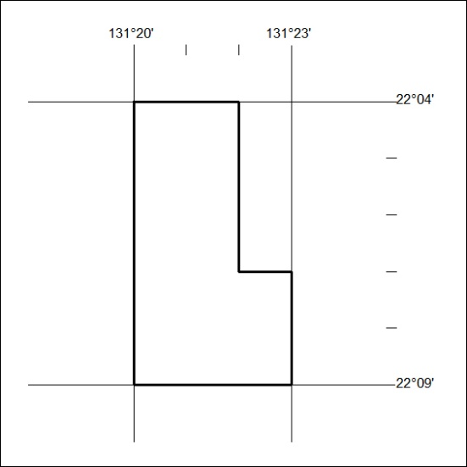
Area granted is indicated above. The titleholder is not permitted to exercise occupational rights on any land that is subject to a development title, or an application for a development title. Any land the subject of a Reserved Land gazettal under the Mineral Titles Act and all land vested in the Commonwealth of Australia is also excluded by description but not excised from the grant area.
092/23

Mineral Titles Act
NOTICE OF GRANT OF A MINERAL TITLE
Title Type and Number: | Exploration Licence 33284
Granted: | 06 April 2023, for a period of 6 Years
Area: | 17 Blocks, 53.01 km²
Locality: | TURNERS DOME
Name of Holder/s: | 100% TODD RIVER METALS PTY LTD [ACN. 600 314 038]
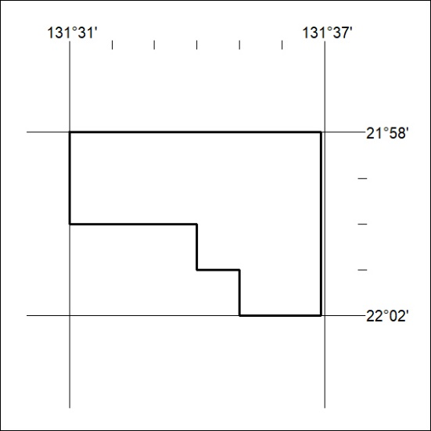
Area granted is indicated above. The titleholder is not permitted to exercise occupational rights on any land that is subject to a development title, or an application for a development title. Any land the subject of a Reserved Land gazettal under the Mineral Titles Act and all land vested in the Commonwealth of Australia is also excluded by description but not excised from the grant area.
093/23

Mineral Titles Act
NOTICE OF GRANT OF A MINERAL TITLE
Title Type and Number: | Extractive Mineral Lease 32989
Granted: | 28 March 2023, for a period of 10 Years
Area: | 5.17 Hectares
Locality: | ALICE SPRINGS
Name of Holder/s: | 100% P.F. & C.J. BROWN PTY. LTD. [ACN. 009 652 868]
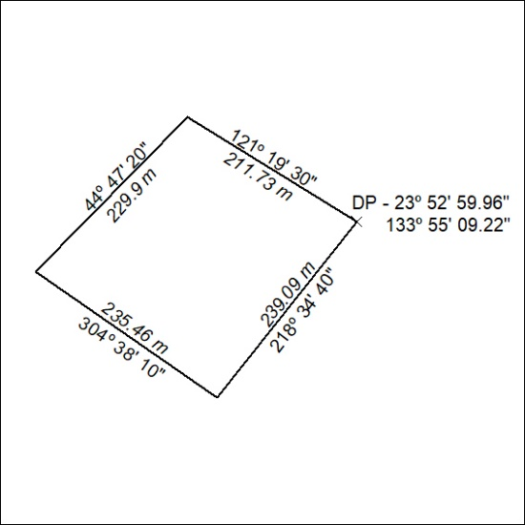

094/23

Mineral Titles Act
NOTICE OF GRANT OF A MINERAL TITLE
Title Type and Number: | Extractive Mineral Lease 32990
Granted: | 28 March 2023, for a period of 10 Years
Area: | 5.73 Hectares
Locality: | ALICE SPRINGS
Name of Holder/s: | 100% P.F. & C.J. BROWN PTY. LTD. [ACN. 009 652 868]
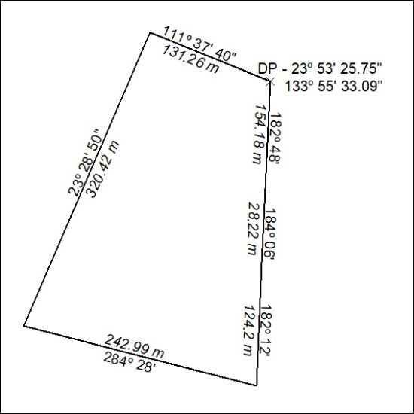

095/23

